MARKETING MANAGEMENT – ASSESSMENT 1

Student name : Ghanchi Kinjal Arjunkumar
Student id : 2124033
Module code: LCMB 7001
Lecture: Tushara Balendran
Executive Summary
Three major components of the Starbucks marketing strategy are good customer service, quality-dependent differentiation and good quality tea and coffee. This study has briefly addressed different external and internal marketing aspects of Starbucks. The communication strategy of Starbucks applies through different communication methods such as social sponsorship, public advertisement and others. This study has briefly addressed and explained the innovative promotional strategies of Starbucks which is crucial for the marketing strategy of this organization. Implementation of Keller’s brand equity model in this study has helped to understand the significance of five categories in an organization's performance. Brand perception refers to the experience, thoughts and feelings of the customer. This entire study has addressed the advantages and disadvantages of brand perception in an organisation. Customer touchpoints and customer journey maps of Starbucks have been illustrated in the diagram. A number of external strategic factors are associated with the performance of Starbucks, all of these factors have advantages and disadvantages. These factors and their influences on Starbucks have been identified through the SWOT analysis of Starbucks. This entire study has become informative as it provides effective recommendations for future improvement in Starbucks' performance.

Table of Contents

Introduction 4
Background of the organization 4
Mode of communication 5
Integrated Marketing Communication 6
New promotional strategies - online and offline 6
Keller’s brand equity diagram 8
Advantages and disadvantages 9
Customer journey description 10
Customer touchpoints - pre-purchase, purchase, post-purchase 11
SWOT analysis 12
Conclusion 14
Recommendations - new touchpoints 14
References 15
Appendices 16

Introduction
Starbucks was established in 1971 as a coffee company with a target audience of mature affluence, believing in 'coffee as a mode of service'. The company has seen astounding growth in the markets worldwide. Their reticent customer policy, embellished on a profound employee retention strategy has made them one of the most successful companies in the 21st century. The marketing strategy profounds on the beliefs of serving customers first and providing the accessibility that the customers might need in the near future. Their marketing mix believes in a constant engagement strategy so that the company can gain from the high return values. Social media engagement in the times of recent digitisation has helped customers in serving digital platforms as well. Their software department strongly believes the motive of agile and scrum processes, is to deliver customers with ease of use. The company relies on social media promotions heavily. Their marketing campaign believes in providing quality over 'just a regular coffee shop'. The company believes in employee retention as the biggest campaign and their direct incorporation with the customers' behaviours have helped the company to be deeply ingrained into customers' psycho-social behaviours. Added benefits have been obtained from the effective pricing strategy of the quality product, harvested through ethical means, and strategic campaign of the farmer-specific engagements in the urban places have helped the organisation in capturing sentiments of the globalised population.

Background of the organization
Starbucks organization is a public organization with an estimated 238,000 employees. In the United state, the organization has a notable share of the market in at least five sectors which involve the retail market for coffee, Coffee & snacks shops, Herbal production of tea, Food services and accommodation, and production of tea (Chang, 2020). This organization is a global chain of coffee houses which is based in Seattle, Washington, USA. It is one of the largest coffeehouse chains in the world. Nowadays, the organization had more than 33, 833 stores in 80 different regions, out of which 15,444 were based in the US. The firm offers its customer base hot and cold drinks, micro-ground instant coffee, caffe latte, juices, whole bean coffee, frappuccino beverages, and so on. Some of these products are seasonal, or particular to the store locality. The organization was founded in the year 1971 at Pike Place Market in Seattle (About Us: Starbucks Coffee Company, 2022). The main mission of the organization is "to inspire as well as nurture the spirit of humans - One person, one cup and one neighbourhood at a specific time." This mission statement shows what the coffee organization does for keeping its business running successfully. The vision statement of the Starbucks organization is "to set up Starbucks as the premier seller of the best as well as finest coffee across the globe while properly maintaining the organization's determined principles which the firm increases". The Starbuck organization accounted for approximately 36.7 per cent share of the market in the US alone, competing with other huge coffee sellers like McCafe, Dunkin Donuts, etc. Currently, Starbucks has a market capitalization of approximately $104 billion.

Mode of communication
The capricious nature of the international market makes it certain that every multinational organisation has to face fierce competition. In order to sustain and stay relevant in the market it has now become necessary for these organisations to perform intercultural management effectively and Starbucks is no stranger to it as well. Performing Intercultural management is not something which can be achieved without deploying proper communication strategies. Starbucks has been riding the tide of globalization and has been successful in applying a set of properly developed communication strategies in an effective manner in terms of developing a strong relationship with its customers as well as its employees. As has been identified during the study, the internal communication policies of Starbucks are aimed to bring together all its employees in accordance with the societal issues of different regions. It has further been gathered that the organisation is pretty involved when it comes to developing the best policies for its employees and it also embraces new opinions and ideas (Tikson, 2018). Starbucks encourages employees to actively participate in decision-making and develop innovative plans. The organisation ensures that it happens by performing employee engagement in such a manner that a strong communication system is developed within the workforce. Every outlet of Starbucks possesses a proper hierarchy which ensures that all the employees have a clear understanding of the communicational framework within the workforce.
The external communication strategy of the organisation is structured upon developing and fostering good communication with all its customers. The organisation acknowledges the need for customer satisfaction when it comes to ensuring growth. By deploying proper communication strategies the organisation wants to gain some insight into what the customers truly want. Customer loyalty is something which Starbucks values the most and the organisation has several policies (like the Starbucks card) in place in terms of addressing the need (Munifa, 2022). The organisation also possesses a proper social media presence and it makes use of its social media handles to interact with the customers on a regular basis.

Integrated Marketing Communication
Starbucks has used the mode of advertisement; it has adopted numerous tools, for instance, posters, magazines and certainly the usage of the internet. Starbucks has also used the pivotal message, for instance, “It’s Starbucks. Brewed for those who love Coffee”. As part of this efficacious integrated plan of marketing communication, Starbucks has focused on integrating public relations, social media and advertisement considerably, all transmitting a similar message indeed. This was quite a practical way of transversal mechanisms in order to further execute the numerous kinds of activities for the brand, for instance, operational, marketing, production and finance indeed (Dilip et al., 2021). The main focus of Starbucks has been overseen in two different components, for instance, strong branding and another one is a strong appreciation of the consumers.
Starbucks has been providing website content to its consumers, which is predominantly designed to meet the core target audiences present in the current competitive market. Consumers have been able to visit the website to locate the local outlets. Their respective benefits and pivotal campaigns indeed. Starbucks also communicates by using email to the registered consumers of the current competitive market. The messages are mainly well organized by the experts of the brand. These are visually focused and provide pivotal details of the necessary products of the brand (Dilip et al., 2021). This mainly retains maximum emphasis upon the education as well as awareness in comparison to the promotion indeed. One of the pivotal tools for the integrated marketing communication arsenal for Starbucks is its application.

New promotional strategies - online and offline
From what has been gathered, the promotional strategies of Starbucks are based on the Multi-channel promotional strategy, which means the organisation relies on implementing its website and social media handles in terms of making people and potential customers aware of new products. As has been identified the primary reason behind resorting to this strategy involves possessing a budget-friendly marketing tool. It has been identified that making use of its Facebook fan page is something that the organisation does on a regular basis in terms of performing interactions with its customers and expanding its e-commerce prospect. Starbucks has a follower count of more than 25 million on Facebook and the organisation gathers feedback from these followers continually. One might say that this promotional strategy holds tremendous potential as this tends to enhance the overall reach of the organisation when it comes to increasing brand awareness. The operational procedure of the Customer Relationship Management (CRM) of Starbucks is heavily dependent on identifying the needs and requirements of its potential customers. Other than this, the organisation further resorts to several offline promotional strategies like advertising on print media, conducting campaigns etc.
Starbucks also relies on the notion of performing customer retention. The organisation aims to trigger the application of the word-of-mouth strategy by keeping their old customers satisfied. The deployment of Starbucks cards and membership policies are the primary ways the organisation performs customer retention. Maintaining the brand image is something that the organisation has been successfully performing these days, and it is not possible without keeping the consumers happy (Jang et al., 2015). It has been identified that the organisation has now shifted from resorting to the traditional approaches to online approaches when it comes to performing interactions with potential customers.

Keller’s brand equity diagram
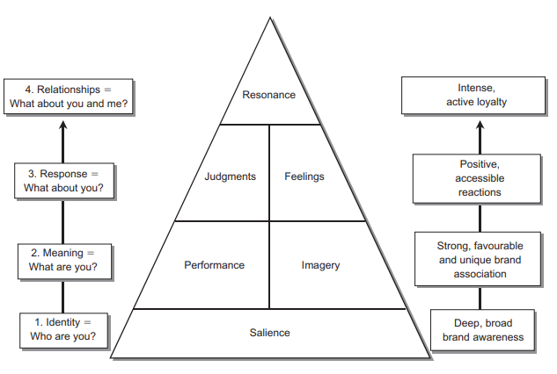
Fig: Keller’s Brand Equity Diagram
Source: (Keller, 2003)
Brand Identity
It has been witnessed that Starbucks has been able to become quite a good epitome to having the successful strategies of the depicted brand equity management indeed. By that year, it had changed the logo by dropping the words "Starbucks Coffee ". This is the mere brand that has changed its logo quite frequently in comparison to any other firms present in the current competitive market. This brand "Starbucks" is not just regarding coffee but could have quite a huge brand extension in the upcoming future as well. This has also been overseen, and this brand periodically has been introducing both the bakery and drinks as per the numerous locations, holidays, seasons and particularly significant occasions. This pivotal strategy does not merely help Starbucks prominently maintain loyal consumers but also helps in attracting new consumers who mainly like seasonal products and services. As can be seen from the above-depicted diagram, Starbucks has been prioritizing the judgements (credibility and relationship with customers), feelings (security and comfort) and salience (high-quality products and accessibility) (Dilip et al., 2021).
Brand Meaning
Starbucks can value the overall in-store experience, and this is quite a good idea for this brand in order to further establish its own music bar as well as its own book cafe. This type of environment has been proven as quite an innovative way towards making the consumers stay for quite a long period of time. This also ensures the consumers will probably be consuming more foods and drinks indeed (Dilip et al., 2021). As can be seen from the above-depicted diagram, Starbucks has been prioritizing performance (luxury coffee brand, quality customization and service) and imagery (elegant, fashion and social status).
Brand Response
This has also been overseen that Starbucks has been collaborating with different celebrities and brands in order to further introduce the latest merchandise, for instance, coffee cups. This is merely re-enhancing the affordable and modern luxury image of the brand indeed. As an epitome, by the year 2020, Starbucks has launched a special collection of foods, drinks and merchandise with BTS, which is one of the renowned South Korean Bands. This collaboration helped the brand Starbucks in order to spread brand awareness mainly among the young generation considerably (Dilip et al., 2021).
Brand Resonance
As can be seen from the above-depicted diagram, Starbucks has mainly been focusing on loyalty, the social media community, social status, and both attachment and engagement with customers. This has helped this brand Starbucks towards enhancing its service and performance towards escalating its overall business success in the current competitive market (Dilip et al., 2021).

Advantages and disadvantages
Keller’s brand equity model, also recognized as the customer-based brand equity model, is utilized for showing the way a brand’s success can be attributed to the attitude of customers in a direct manner towards that brand. There are various advantages to this model. It is a pyramid which shows organizations the ways for building brand equity by properly understanding their customers and implementing appropriate strategies accordingly (Kodrat and Melinda, 2021). If there is a link between the customer base and brand, it outcomes in positive equity of the brand and has a better chance of obtaining as well as sustaining the customer base, thus providing a large advantage to the organization and products which are considered as “brands”. This model drives higher financial gains for the organization. Marketing campaigns rolled out by a strong CCBE brand are likely to get a better response.
By utilizing this model, organizational brands understand which particular strategies to implement and the ways for providing the appropriate experiences to their audience base so that they successfully acquire the organizational goal and generate profit. In simple words, this model helps brands by guiding them in building brand equity.
This model also has some disadvantages. The current measurement of Keller’s brand equity model suffers from various limitations, which involve a lack of distinction between brand association and brand awareness.

Customer journey description
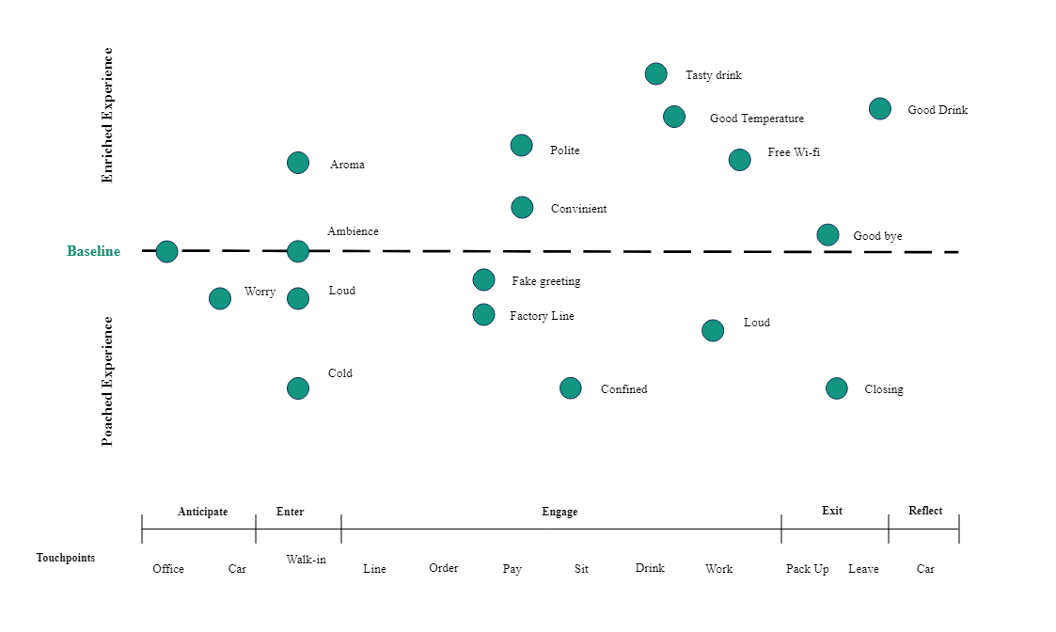
Figure: Customer Journey Map of Starbucks
Source: (Reis, 2018)
As per the statement (Reis, 2018), a custom journey map is one of the basic concepts of making diagrams that demonstrates the steps of organization consumers go through in involvement with the company. This can be a product, retail experience, online experience and any other service. The development of the customer journey map helps an organization illustrate the story of customer experiences an organization across email, social media or other specified channels (Reis, 2018).
When it comes to Starbucks, the development of the customer journey map is very crucial for the organization because this is the largest coffeehouse chain in the world. The above-mentioned diagram has illustrated the customer journey experience of Starbucks. It has been determined from the represented graph that this organization seeks feedback from its consumers regarding their visit to its outlet as well as marked their experiences in the above-mentioned graph. It has three primary components such as poached experiences that are responsible to ask its patrons to show their overall feel and their visited outlet mainly during their rush hours. Increased experience is responsible for visualizing the hostile experience of consumers and their way to resolve it thus it does not occur (Kokins et al., 2021). Another significant component is touchpoints that involve the level and amount of interaction the consumer has experienced with the customer. This can be in person through an application, website and other channels. This complete exercise is an integral part of the organization’s CRM initiatives (Kokins et al., 2021).
Thus it can be concluded that the customer journey map of Starbucks has shown each possible step of the customer who used to come to drink coffee as well as the work and emotions they feel. Customer journey mapping of Starbucks benefited in different ways such as it helps to understand the activities of prospective customers on the company's website, and the reason for purchasing their products and services.

Customer touchpoints - pre-purchase, purchase, post-purchase
The company determines the customers' behaviour and attachment through persuasive techniques both online, offline and off-store NGO-specific activities. The company's outlook towards providing the benefits of attention towards customer details, security, services, and predictability of the demand has helped the company in retaining the trust, high return rates to the stores, and reminding of the experiences through various souvenirs. The company highlights and boasts of its ethical behaviour as much as possible, through campaigns, and obtaining awards like 2014's 'World's Most Ethical Companies (Haskova, 2015) to retain as much trust in the customers and make them leverage a high return to invest in other socio-cultural activities. Customer retention strategy has been optimistic for an 'introductory cup of coffee, pushing the threshold of spending to other consumables as well (Haskova, 2015). The process of attachment soon mends into the process of devouring where quality has been the lavishness that the company relies on. The manufacturing habit has been changed from machine-delivered cupped coffees to hand-made cappuccinos, which are serving a wide variety of customers at the cost segment of mid-tier affordability (Michelli, 2009). Starbucks has not been a brand of coffee serving shops but rather wanted to be a confectionary alternative to the local cuisines that already predominated countries across Europe. The contradiction of consumption culture within the local roots has hampered the company's outlook in the areas of France, and Italy. But the company tactfully avoided the conflict by placing its shops in regions of globalised affluence (Thompson and Arsel, 2013). Their branding narrative thus changed from time to time with the modification that the company inherited through time. First-hand experiences, provided by an employee (Michelli, 2009), have demonstrated that companies thrive to connect, discover and respond to customers' needs. The recent times pandemic has seen several attachments from the direct involvement of the employees of the company. The need for the hour has been addressed by home-delivery, closing dine-in services and even providing groceries to the localities with old aged people. Starbucks' CSR strategies in reward programs have paid off during times of pandemics (Lombardi et al., 2021). Their post experiences in the domain of app-based services have helped the customers and the company in preparation of an online-focused service approach, where development in the packaged delivery can be a worthy investment for the company to maintain the promise of quality, service and hygiene in a situation of post-pandemic normalization (Shim et al., 2021).

SWOT analysis
SWOT stands for (Strength, Weakness, Opportunity and Threats). This section will present the SWOT analysis of Starbucks.
SWOT Analysis of Starbucks
Strength | Weakness
- Strong brand image  - Massive growth in restore  - Good performance in the financial sector  - Extended global supply chain  - Medium diversification  - Standardization as well as good taste and quality (Liu et al., 2022).  - Acquisitions  - Treating employees in a proper way  - Enhance initiating wage for baristas  - Effectiveness, good strategic planning as well a strategy of reinvestment  - An appropriate program of loyalty  - Restroom to maintain Gender equality | - Expensive products  - Products imitability  - Weak practices of procurement  - Basic standards for a number of products  - Avoidance of European tax  - Recall a few products due to contamination, allergen, avoidance of warning and unchecked cashew nuts.  - Bad quality holiday drink (Liu et al., 2022).
Opportunity | Threats
- Enhancement in establishing markets  - Alliances or partnerships with other organizations  - Proper diversification in business  - Adequate specification of products  - Introducing innovative products  - Implementation of trending coffee and innovative technologies  - String online channels  - Acceptance of huge differentiation in price (Liu et al., 2022).  - Good delivery service of coffee  - Subscription in coffee | - Competition with large outlets  - Strike from a third-party delivery supplier  - Competition of few companies which sells coffee at a low cost  - Independent movement of coffeehouses  - Imitation of product due to old and new rivals  - A huge controversy in the warning rule in California  - Philadelphia arrested, and arrested two African men on social media against Starbucks (Liu et al., 2022).  - COVID-19 pandemic

Conclusion
In conclusion, Starbucks organization is leading the market with its heavily dominating global presence and leadership. The experience of consumers at a Starbucks is arguably different from any other coffee shop due to its welcoming environment, intimate atmosphere and better services. This paper is mainly focused on marketing management. Various aspects which are involved in the management of marketing are properly discussed in this paper. This specific research paper helps to properly explore relevant prospects for Starbucks' organization. This study explores customer behaviour and its importance in marketing in a detailed manner. There are various factors which highly impact the behaviour of customers towards Starbucks which have been properly analyzed in this paper. This paper mainly conducted an environmental marketing analysis of Starbucks which considered the main external impacting drivers together with a proper analysis of the internal environment as well as the role that marketing plays within the firm. This paper also provides some recommendations to enhance the marketing strategy of Starbucks. This paper is important for the readers as it describes various aspects of the marketing strategy of Starbucks in a detailed and understandable manner.

Recommendations - new touchpoints
There are both ways for the company to be highly invested in the process of marketing and customer engagement. Considering the fact that society is not always formed around urban developed cityscapes, where riches are plentiful. The process navigation in the localised market with a more differentiated product approach can be effective for the organisation. The company already hosts millions of dollars in advertising campaigns. But dynamic marketing across the global periphery might make the company meet a huge revenue from 'introductory' services. Criticism of the urban-centric strategic marketing of the company can be well addressed with the implementation of software-specific platforms into the deeper integration of demographic differentiation (Fitzgerald, 2013).
Acknowledging the fact that the organisation offers quality products there is an immediate need for Starbucks to venture its way into several untapped markets, especially the Asian market. It needs to be addressed that the food habit changes from one region to another, so the organisation needs to incorporate innovation into what it offers while operating in a different country or region. Other than this it must also be acknowledged that the pricing of the products at Starbucks is a bit expensive when compared to any other multinational chain of coffee outlets. The organisation can work on that in order to bring in new customers.

References
Chang, W.J., 2020. Experiential marketing, brand image and brand loyalty: a case study of Starbucks. British Food Journal.
Dilip, D., Sinha, R., Wen, C.P., Kee, D.M.H., Ching, C.S., Er, L.K., Agarwal, S., Pandey, R., Putra, T.W., Sin, L.G. and Yan, Y.W., 2021. The Influence of Brand Equity on Consumer Purchase Decisions at Starbucks. International Journal of Accounting & Finance in Asia Pasific (IJAFAP), 4(1), pp.37-50. http://www.ejournal.aibpm.org/index.php/IJAFAP/article/download/1031/962
Fitzgerald, M., 2013. How Starbucks has gone digital. MIT Sloan Management Review, 54(4), p.1. http://aproaingenieria.es/intranet/uploads/how-starbucks-has-gone-digital.pdf
Haskova, K., 2015. Starbucks marketing analysis. CRIS-Bulletin of the Centre for Research and Interdisciplinary Study, 1, pp.11-29. http://archive.sciendo.com/CRIS/cris.2015.2015.issue-1/cris-2015-0002/cris-2015-0002.pdf
Jang, Y.T., Chang, S.E. and Chen, P.A., 2015. Exploring social networking sites for facilitating multi-channel retailing. Multimedia Tools and Applications, 74(1), pp.159-178. https://www.researchgate.net/profile/Shuchih-Ernest-Chang/publication/257627277_Exploring_social_networking_sites_for_facilitating_multi-channel_retailing/links/5630ec2208ae0530378cf848/Exploring-social-networking-sites-for-facilitating-multi-channel-retailing.pdf
Keller, K.L., 2003. Understanding brands, branding and brand equity. Interactive marketing, 5(1), pp.7-20. https://link.springer.com/content/pdf/10.1057/palgrave.im.4340213.pdf
Kodrat, D.S. and Melinda, T., 2021. CREATING A BRAND STRATEGY FOR THE FOOTWEAR INDUSTRY. https://dspace.uc.ac.id/bitstream/handle/123456789/3500/Paper3500.pdf?sequence=4&isAllowed=y
Kokins, G., Straujuma, A. and Lapiņa, I., 2021. The Role of Consumer and Customer Journeys in Customer Experience Driven and Open Innovation. Journal of Open Innovation: Technology, Market, and Complexity, 7(3), p.185. https://www.mdpi.com/2199-8531/7/3/185/pdf
Liu, X., Tang, Y. and Wang, Y., 2022, April. Consumer Satisfaction for Starbucks. In 2022 7th International Conference on Social Sciences and Economic Development (ICSSED 2022) (pp. 1475-1482). Atlantis Press. https://www.atlantis-press.com/article/125973685.pdf
Lombardi, C.V., Chidiac, N.T. and Record, B.C., 2021. Starbucks coffee corporation’s marketing response to the COVID-19 pandemic. Innovative Marketing, 17(2), p.177. https://www.businessperspectives.org/images/pdf/applications/publishing/templates/article/assets/15206/IM_2021_02_Lombardi.pdf
Michelli, J. and Hill, D., 2007. The Starbucks experience. AML/McGraw-Hill Audio. https://www.josephmichelli.com/pdf/ebook_starbucks.pdf
Munifa, H., 2022. Customer relationship management strategy in Starbucks card optimization in the Pandemic era. International Journal for Educational and Vocational Studies, 4(1), pp.19-29. https://ojs.unimal.ac.id/ijevs/article/download/6817/3639
Our Compnay. 2022. About Us: Starbucks Coffee Company. [online] Available at: <https://www.starbucks.com/about-us/> [Accessed 12 September 2022].
Reis, C., 2018. Starbucks-consumer discretionary:“a venti company, please!” (Doctoral dissertation). https://run.unl.pt/bitstream/10362/36380/1/Reis_2018.pdf
Shim, J., Moon, J., Song, M. and Lee, W.S., 2021. Antecedents of purchase intention at Starbucks in the context of COVID-19 pandemic. Sustainability, 13(4), p.1758. https://www.mdpi.com/2071-1050/13/4/1758/pdf
Thompson, C.J. and Arsel, Z., 2004. The Starbucks brandscape and consumers'(anticorporate) experiences of glocalization. Journal of consumer research, 31(3), pp.631-642. https://www.guillaumenicaise.com/wp-content/uploads/2013/10/starbucks-brandscape-and-consumers-experiences-og-glocalization.pdf
Tikson, S.D.S., 2018. Human resource policies and work culture: A case of Starbucks. JBMI (Jurnal Bisnis, Manajemen, dan Informatika), 15(1), pp.1-12. https://journal.unhas.ac.id/index.php/jbmi/article/download/1773/1795

Appendices

