University of Wales Trinity Saint David
School of Engineering

Workshop Technical Report
Engineering Applications and Study Skills M4X02063

Joshua Watson
1900149
02/02/2020

Contents
1 Introduction 1
1.1 Aims 1
2 Background Research 2
2.1 Specific Research 2
2.2 Personal Protective Equipment (PPE) 2
2.3 Health and Safety Guidelines 2
3 Methodology 3
3.1 Equipment Used 3
3.2 Process Undertaken 4
4 Discussion and Conclusions 10
4.1 What was achieved in the session? 10
4.2 Key points taken from Practical Sessions 10
5 References 11

Introduction

Aims
The aim of this report is to construct a comprehensive step by step process of the beginning stages of the rebuild of a Honda VFR 750cc motorcycle engine with images to support.

Background Research

Specific Research
The engine is from a Honda VFR 750cc motorcycle, with engine number RC36E-2410167. The engine is a V4 configuration meaning it has four cylinders but split into two banks to create a V shape, with each bank having 2 cylinders. It has 4 valves per cylinder so therefore 16 valves total. The engine is liquid cooled whilst also being accompanied by a cooling fan built in too. It is a 6-speed engine with a constant mesh gearbox. The engine’s camshafts are gear driven and are direct overhead camshafts (DOHC).

Personal Protective Equipment (PPE)
The following list of PPE is essential for any work being carried out within a workshop session:
- Workshop Overalls/Coat
- Steel Toe Cap Boots
- Latex/Nitrile Gloves (To protect from engine oil)
- Protective eyewear

Health and Safety Guidelines
The following Health and Safety guidelines should be followed and adhered to at all times when inside the workshop:
- Ensuring that the workspace is kept tidy and any loose cables, tools or trip hazards are avoided.
- Any loud noises or pieces of machinery are controlled and are used in closed areas or in an outside environment.
- All hand tools are maintained to a suitable standard so that they can be used safely and effectively for the job.
- PPE listed in section 2.2 should be worn at all times throughout the time in the workshop.
- Any electrical appliances are maintained to a high standard and are being tested regularly.
Health and safety guidelines found at (Health and Safety Executive, 2020)

Methodology

Equipment Used
- ½” Socket/Ratchet set
- ¼” Socket/Ratchet set
- 8,10,12,14mm T bars
- 5,6mm Allen keys
- Soft hammer
- Extendable magnet
- Piston ring compressor
- Latex/Nitrile gloves

Process Undertaken
To begin the rebuild of the engine, first ensure that any service parts have been replaced/serviced depending on their condition:
- Connecting rods
- Crankshaft
- Cylinders
- Cylinder head
- Pistons
- Transmission
Information found at (Honda, 1997)
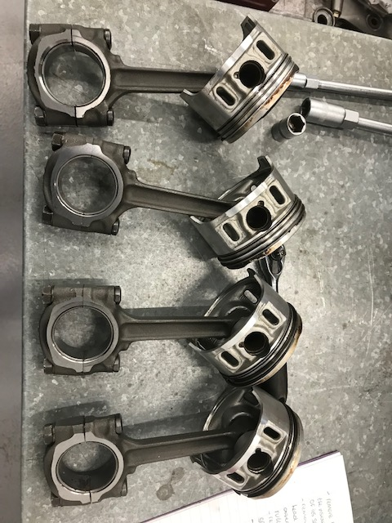
Ensure that the pistons and connecting rods are laid out in the correct order to go with their corresponding cylinders. And that each piston still has the piston rings installed ready to be installed to the cylinder.

Image 1: The 4 pistons with connecting rods and piston rings already installed.
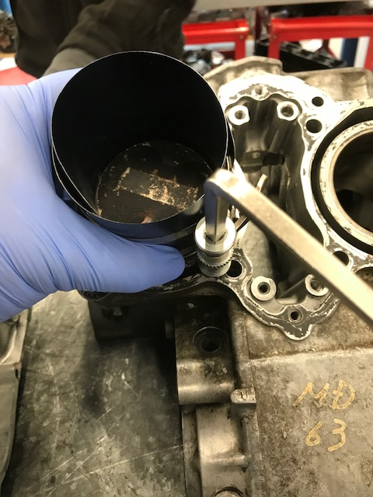
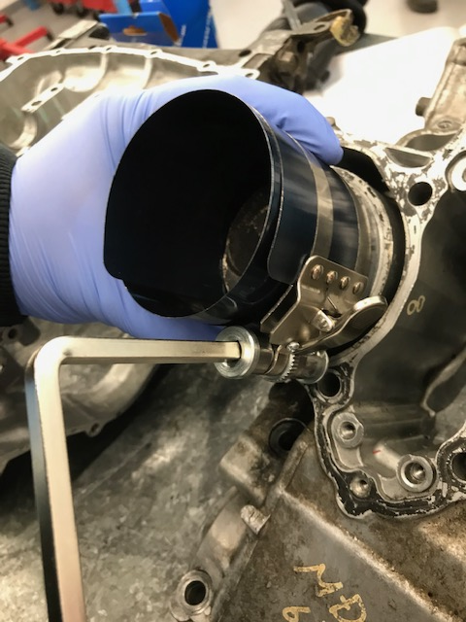
The following figure and images illustrate how to correctly use the piston ring compressor to safely install the pistons to the cylinder.

Images 2&3: Using the piston ring compressor to install the pistons to their cylinder.
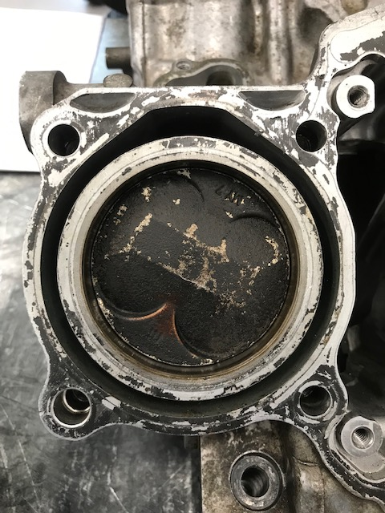
Place the piston in the cylinder so that it is only the piston head that is left to be lowered into the cylinder. Put the piston ring compressor (PRC) around the piston head and ensure that the bottom of the PRC is sitting flush with the top face of the cylinder, then using the Allen key, tighten the piston ring compressor so it tightens around the piston head and compresses the piston rings into the piston head. Then use a wooden hammer handle to gently tap the centre of the piston head down into the barrel until the PRC moves away from the cylinder, the piston has then been installed. Ensure that the PRC is properly compressed before tapping the piston down, to prevent damaging the piston rings. Repeat this sequence for all four of the pistons/cylinders.

Image 4: Piston installed within the cylinder correctly.
Take time to check that the connecting rods are facing the correct direction when they are installed, the connecting rods will be marked to make this easier. Also ensure that the oil holes are facing the opposite direction to the direction of the rotation of the crank.
Remove the connecting rod cap nuts (x8 8mm thread) and lift off the connecting rod caps, ensuring to lay them out exactly as they are removed from the connecting rod to prevent confusion when re-installing.
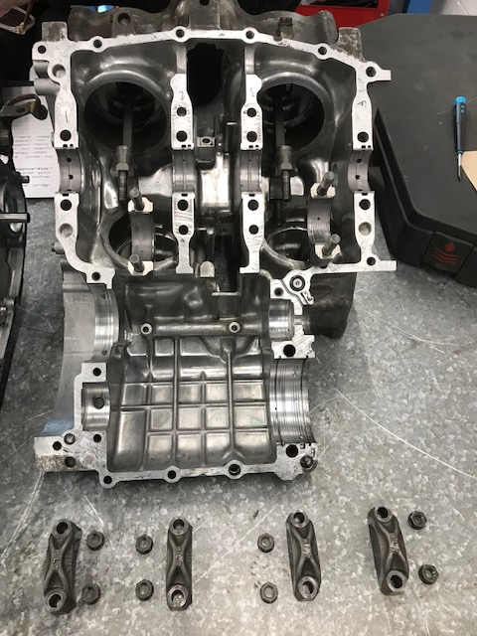

Image 5: Conrod caps and cap nuts laid exactly as they were removed from the connecting rods.
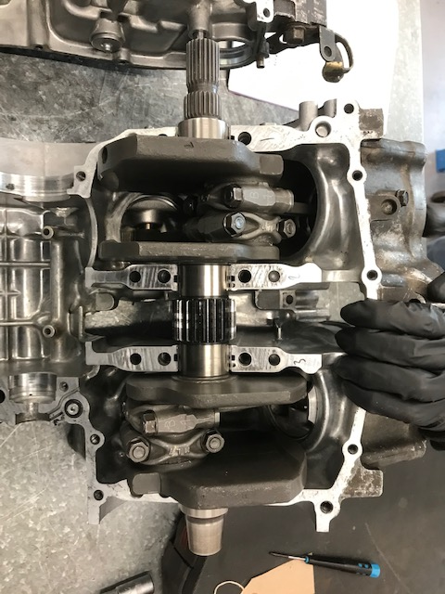
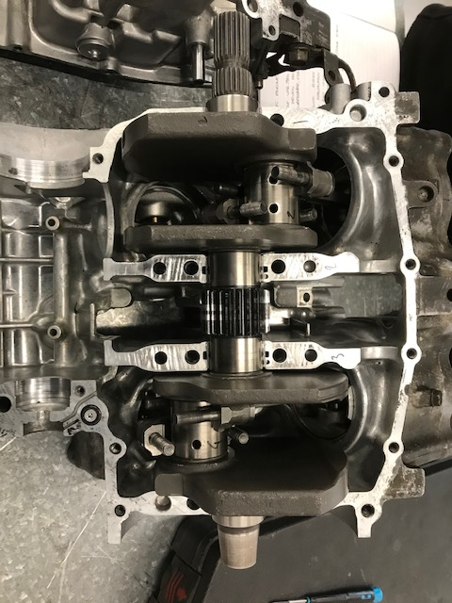
Gently lower the crank down into the connecting rods and ensure that both the crank itself and the connecting rods are seated correctly. Apply molybdenum solution to the crankshaft journal bearings and the connecting rod journal bearing surfaces (Honda, 1997). Re-install the 4 connecting rod caps and 8x 8mm thread connecting rod cap nuts and tighten each to 34nm ensuring to tighten them in an even fashion to prevent damage. (Honda, 1997)
Image 6 shows the crank re-installed to the connecting rods without the caps and Image 7 shows the connecting rod caps and nuts reinstalled.
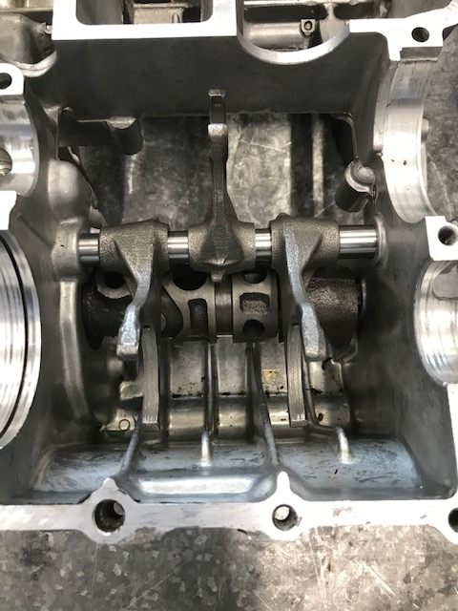
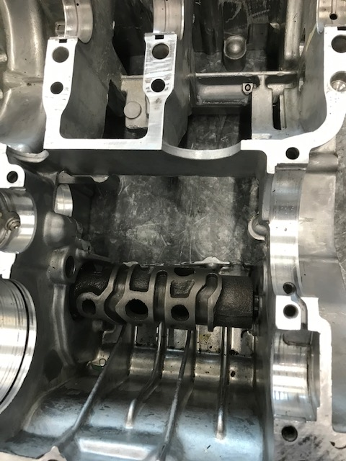
Re-install the selector drum to the crankcase by slotting it through the hole in the bottom crankcase and ensure to push the selector drum until it doesn’t go any further in to make sure it is correctly installed. Also install the selector forks. Ensuring that the selector forks are facing the correct way, the identification marks on the selector forks must be facing the right side of the crankcase.
Image 8/9: Selector drum and selector forks re-installed to the bottom crank case.
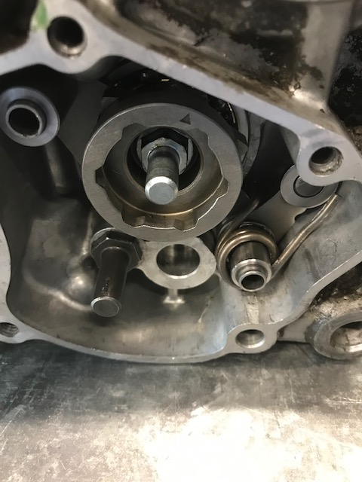
The gear selector plate and mechanism can be reinstalled behind the end of the selector drum. As this has small parts like springs and other small tabs, it is important to make sure this mechanism stays together when it is removed to make the rebuild stages easier. This component allows for gear changing.

Image 10: Gear selector mechanism re-installed on the end of the selector drum.

Lower the main gear shaft into the crankcase, ensure that it is sitting correctly and slot the selector forks into their corresponding gears, this will only work one way.
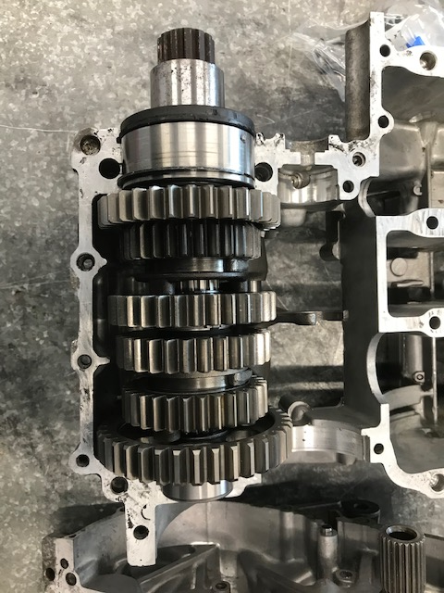

Image 11: Main gear shaft re-installed and meshed with selector forks.
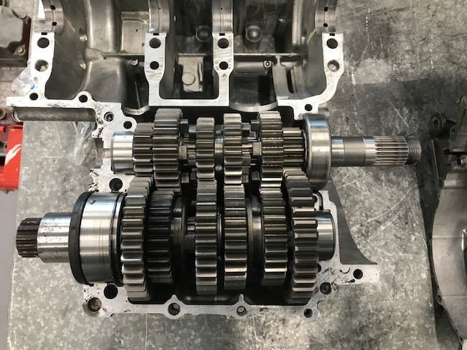
Place the secondary gear shaft into the crankcase also taking care to ensure that it is sitting within its grooves correctly, then gently mesh the remaining selector fork into the secondary shaft.

Image 12: Secondary gear shaft meshed in with rest of transmission.

Lift the two halves of the crankcase together, and gently lower the top half down onto the bottom half to be able to see if everything is positioned correctly before lowering the crankcase together completely. Ensure that the gap closes the entire way around the engine. The two crankcases aren’t re bolted together in this stage.
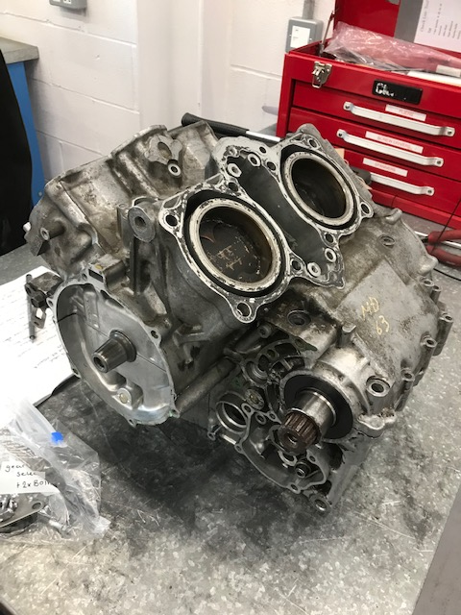
Image 13: The two halves of the crankcase are put back together but not bolted together.

Discussion and Conclusions

What was achieved in the session?
During the session, the crankshaft, transmission, selector forks have all been installed to the engine. Engine cases back together although not bolted together. Any relating hardware installed to the engine.

Key points taken from Practical Sessions
The following list of points have been taken from practical sessions undertaken:
- Organisation
- Learning the inner workings of an engine
- Improving practical methods
- Learning how to use special techniques and pieces of equipment effectively
- Working in an active workshop even more effectively
- Following suitable health and safety regulations to a higher standard

References
Health and Safety Executive, 2020. Health and Safety Executive. [Online]
Available at: https://www.hse.gov.uk/agriculture/topics/maintenance-3.htm#
[Accessed 28 January 2020].
Honda, 1997. Honda Service Manual. 90-96 VFR750F, I(1), pp. Section 7 Pages 1-4.
Kinsella, J., 2019. Workshop Queries. Swansea: John Kinsella.

