JON PRESTON

Airbnb – A case study report

BMSP6002

Introduction

The increase in innovative modern technologies available to consumers has extended the digital reach of the internet and has given access to inexpensive computer power to the wider global population This set the path for new and innovative business models, creating a competitive turbulence where resources are plenty and marginal costs are declining, disrupting the digital arena where scarcity is no longer a valid assumption (Geissinger, Laurell, & Sandström, 2020). In October 2007 the founders of what was then known as Air Bed and Breakfast (due to the early mattresses being airbeds on the floor) launched their $80 per night Digital Accommodation Platform now globally known as Airbnb (Botsman & Capelin, 2015). This report will explore it’s current position in the marketplace and through analytical tools will provide some outcomes to consider key recommendations for future growth and profitability whilst addressing some of it current and predicted challenges.

Business Model
As a concept the sharing economy is based on the practice of collaborative consumption enabling access to markets to promote a more sustainable society. By using a wide variation of systems, individuals, corporations, non-profit organisations and government agencies can access information efficiently and provide a means by which they can redistribute any overcapacity of goods and services (Heinrichs, 2013). In the case of Peer to Peer accommodation provision Airbnb uses a web based platform to provide a service to both the customer and the service provider which optimizes the choice of available accommodation to guests and bookings for providers that may otherwise have not been booked.

With a reported $120 million worth of funding Airbnb can invest in is infrastructure and marketing promotions. Through clever advertising via the Google Display Network Airbnb have showcased travellers with an alternative way to travel, visit and take vacations. Customers readily bought into this new concept and Airbnb on-line searches increased by 120%. Consequently, Airbnb’s bookings (and revenue) increased exponentially (Wu, Lee, & Renard, 2012). This his period of growth reflects the current trends within the sharing economy. As a direct result of advances in information technology Airbnb has grown rapidly to become a digital marketplace for travellers (Li & Tabari, 2019).

Business Model Canvass (Appendix.1 )
Key partners
Airbnb differentiate between their Key Partners who are critical to their operation and all other partners. Their critical partners are their hosts who create the supply and support the delivery of value proposition to the guests who provide the demand. Hosts who can achieve certain criteria can be awarded the status of ‘Super hosts’ which provides additional opportunities for increased visibility, revenue, rewards and bonuses (Uenlue, 2020).
Key activities
Key activities may vary depending on regulatory and market conditions i.e. Lobbying. However to remain on a positive trajectory, maintain consistency, value propositions and growth the key activities shown in the Business Model Canvass will be critical in delivering a quality and profitable service (Uenlue, 2020).

Key resources
As a digital platform Airbnb must reduce the possibility of any negative feedback. As a key resource the website requires expert IT engineers to maintain the systems of the platform and for IT analysts to identify valuable insights from the data and algorithms. (Uenlue, 2020) Maintaining the network between supply and demand (Hosts and Guests) is critical for Airbnb’s business operation and for the reputation of their brand.
Customer segments
The guests and the hosts are the primary customer segments of Airbnb, however freelance photographers are a large part of their network. In most, if not all major cities in the world freelance photographer will capture images of the property. Airbnb will then select the highest quality image and pay the photographer directly (Singla, 2021).
Channels
Airbnb does not use conventional travel agencies as a sales channel. Third party supply is channelled through to their platform via technical interfaces. Airbnb also has a dedicated website and smartphone application.
Digital ads and promotions can also be shared through social media and Google advertising Media coverage, particularly social media which reaches a valuable demographic and is cost effective. The positive experiences that are shared by hosts and guests could also fall into the category of ‘word of mouth’ recommendations.
Customer relationships
Positive customer relationships are a vital element of the business which can be nurtured through encouraging customer input and feedback, providing personalised packages and recommendations. The customer has full control of any transaction but has 24-hour support if required. As a digital global community Airbnb is connected and engaged with its customers but there is some evidence of cultural challenges in different parts of the world.

Cost structure
For Airbnb to maintain its market position it will have to continue to invest in areas such as development and the continual improvement of its platform. Infrastructure costs along with retaining the right people will mean paying good salaries to its employees. It also faces challenges as it seeks to operate in different countries and regions which will require legal expertise including consultation on the different regulations that it will need to navigate its operation through.

Revenue streams

The main revenue streams of Airbnb are generated by the fees paid by the guests and the hosts. However additional revenue is made from the sale of experiences such as cooking or painting classes.
The Sharing Economy
Operating as part of the Sharing Economy Airbnb is an established trading model which makes use of underutilised goods and services (accommodation and experiences) and gives priority to accessibility rather than to ownership (Fang et al., 2016). Airbnb’s business model has evolved by providing its members with access to listings without charging hosts or guests for membership. No payments are due until a booking is made and a reservation fee is charged to the guest. Airbnb has laid the foundations of success by ensuring its brand is one of trust, reliability and satisfaction. It has achieved this by investing in systems to verify users, authenticate reviewers and by protecting their clients through comprehensive insurance policies (Wu, Lee, & Renard, 2012). Guests are charged for the accommodation at the time of booking. Airbnb then benefits from receiving payment prior to providing the service. In some cases, customers book well in advance of their stay enabling Airbnb to be in receipt of that revenue as an asset. On a large scale this type of booking trend would present a lucrative opportunity for Airbnb to manage its cash flow.
Supply & Demand
The Peer to Peer business model has been found to be based on trust, where the trust lies within the experience and trust in the hosts as opposed to trust in the actual transaction itself (Liang, Choi, & Marion Joppe, 2018).Airbnb has quicky become the alternative to conventional hotel booking and has expanded its services to a global market. This has had substantial impact on the accommodation providing industry. Without it owning any property for letting Airbnb is fast becoming the world’s largest short-term accommodation provider in the world. Through collaboration Airbnb has identified supply and matched it to demand displaying how a successful business operates in the sharing economy (Li & Tabari, 2019).

Strategy
In terms of a business strategy there now exists a need to recognise Information Technology within its own context as a functional strategy which is aligned to business strategy. This strategy is no longer a supporting element of a business strategy it has become a strategy within its own right, created by the fusion of business strategy and IT strategy which is now termed as Digital Business Strategy (Bharadwaj, 2013). Without a robust and resilient digital marketing strategy opportunities can be missed and business lost. By developing a strategy Airbnb can make informed executive decisions and focus their resource’s accordingly. (Ryan & Jones, 2009). In a marketplace that is continuously evolving it remains critical that it understands its customers, brand and direction of travel. With the arrival of new competition and problematic legal/consumer issues, Airbnb must prioritize a series of strategic options.
Airbnb continues to benefit as the pioneering digital temporary global accommodation provider. However, to maintain the inertia of a rapidly expanding business it will need to optimize its competitive edge within the sector and secure its future.

Unique Selling Point
Currently lacking any sustainable advantage Airbnb will need to develop a unique selling point in addition to its existing business model. There may exist an opportunity to target resource’s at finding solutions to being able to operate in areas where Peer to Peer accommodation letting is unlawful. It can also expand its collaboration with other providers who offer product and services which would be attractive or desired by travellers and guests driving up sales through collaborative consumption. (Wu, Lee, & Renard, 2012) Global trade enabled Airbnb to evolve rapidly during its early years when it enjoyed its position as the prominent digital temporary accommodation platform. However, more recent years have seen the rise in other companies competing for a share of the market. For example, another similar platform ‘Tripping’ claims to be the world’s largest search engine for accommodation rentals. It has access to over 12 million rentals across at least 10 international accommodation providers with price comparisons (Chan, 2020) This presents a challenge for Airbnb to be competitive on price whilst maintaining its quality of service. Airbnb will need to increase and improve its reach in the Peer to Peer accommodation network by establishing key hubs in major cities worldwide if it is to continue to retain its position as the market leader.

Target Groups
Airbnb’s targeting and positioning of its customers is termed as ‘segmentation’. Customers are grouped and identified for specific targeting. This provides a mechanism to match the needs of the customers with the supply of goods and services. Airbnb uses Multi- segment positioning and anticipatory positioning. Multi-segment positioning may involve listing cost effective packages for travellers on a small budget but also providing a more expensive package such as Airbnb Plus and Airbnb Luxe for customers who have a larger budget. Anticipatory positioning may involve developing services for a market segment that may currently have a low turnover but has the potential to increase its turnover in the future. (Dudovskiy, 2019). This is more aligned with experiences such as hobbies and crafts which feed into the sharing economy model.

Current position
Airbnb is recognised as the front runner in Digital Peer to Peer accommodation provision. However, it is not immune to competition and recognises that innovation does not stand still, and it continues to explore options for extended collaborative consumption opportunities.

Challenges
When Airbnb launched in 2007 regulatory frameworks and procedures were not designed for a Peer to Peer platform which operated in a digital environment. Challenges have been made regarding authorisation, rental laws and planning matters. Due to the global nature of Airbnb it must abide by the laws of the country or area where it is operating. The laws governing short term letting have presented significant obstacles for its operation, as an example the limiting of the number of times a property or space could be let out per year. Airbnb have responded in lobbying to amend the regulations for short term rental in larger cities such as London (Crommelin, Martin, Pettit, & Troy, 2018). See SWOT analysis (Appendix.2)
Airbnb currently enjoys a strong market position in a buoyant industry. With continued improvement and investment, it could continue this trajectory. The SWOT analysis ( Appendix ) illustrates how Airbnb is holding this position, but also what it needs to address in terms of competitors, security and improving customer relations going forward.

Strategy formulation framework (Appendix.3 )
It has been argued that the strategy formulation framework requires precise and accurate assessments from qualified individuals who also include their assumptions in arriving at their conclusions (Torlak & Şanal, 2007). There are similarities between this school of thought and the term used to express the notion that in IT and other spheres, erroneous or poor-quality input will inevitably produce faulty output. According to the Oxford University Press this is known as GIGO (Garbage in, Garbage out). In the case of the strategy formulation process the quality of the outputs can only be good as the information and analysis on which they are based. Also as a tool the strategy formulation process can be manipulated to reflect what the researcher would like it to reflect, for example a paid consultant could show ‘evidence’ of their positive contribution to the success of a strategic plan (Torlak & Şanal, 2007).

Conclusion
From this research it is evident that Airbnb is maintain a strong market position. However, there are challenges that it will need address as it moves towards its twentieth year in business. Information will continue to evolve and with it new ambitious and innovative entrepreneurs will enter the market and compete for its share. Airbnb can only remain at the forefront of the market if it embarks on a journey of continuous improvement. It needs to address it security issues and maintain the confidence of its customers. This is an area where technology may be key. There also exists opportunities to engage with the wider travel market and to work collaboratively by sharing resources and improving customer experience.

References
(2005). In The Oxford Dictionary of Phrase and Fable (2 ed.) . Oxford: Oxford University Press.
Airbnb. (2021). Airbnb Fees. Retrieved from Airbnb Help Centre: https://www.airbnb.co.uk/help/article/1857/what-are-airbnb-service-fees
Bharadwaj, A. E. (2013). Digital Business Strategy: Toward a Next Generation of Insights. MIS Quarterly, 471-482.
Botsman, R., & Capelin, L. (2015). AIRBNB:BUILDING A REVOLUTIONARY TRAVEL COMPANY. Oxford: Saïd Business School Case.
Business Strategy Hub. (2021). Airbnb Business Model | How does Airbnb make money? Retrieved from Business Strategy Hub: https://bstrategyhub.com/airbnb-business-model-how-does-airbnb-make-money/
Chan, P. (2020, September 30). 9 Airbnb Competitors That You Should Know About. Retrieved from Tripping: https://www.tripping.com/industry/rental-companies/9-airbnb-competitors-that-you-should-know-about
Crommelin, L., Martin, C., Pettit, C., & Troy, L. (2018). Is Airbnb a Sharing Economy Superstar? Evidence from Five Global Cities. Urban Policy and Research, 1-16.
Dudovskiy, J. (2019, September 10). Airbnb Segmentation, Targeting & Positioning. Retrieved from Business Research Methodology: https://research-methodology.net/airbnb-segmentation-targeting-positioning/
Ismail, M. (2017, Febuary 25). Airbnb, Inc. Strategic Plan 2017-2021 MBA - Strategic Management Assignment - Havard case study. Retrieved from Slideshare: https://www.slideshare.net/mohieismail9/airbnb-inc-strategic-plan-20172021-mba-strategic-management-assignment-harvard-case-study-june-2017
Li, L., & Tabari, S. (2019). Impact of Airbnb on customers' behaviour in the UK hotel industry - Tourism Analysis 24 (1). Sheffield Hallam University Research Archive, 13 - 26.
Liang, L. J., Choi, H. C., & Marion Joppe. (2018). Exploring the relationship between satisfaction, trust and switching intention, repurchase intention in the context of Airbnb. International Journal of Hospitality Management, 41-48.
Ryan, D., & Jones, C. (2009). Understanding Digital Marketing. London ; Philadelphia: Kogan Page.
Singla, S. (2021, March 7). Insights into Business & Revenue Model. Retrieved from How Airbnb Works: https://jungleworks.com/airbnb-business-model-revenue-insights/
Torlak, N. G., & Şanal, M. (2007). THE EXAMPLE OF TURKISH AIRLINES ON DOMESTIC AIR TRANSPORTATION: DAVID’S STRATEGY FORMULATION FRAMEWORK IN ACTION. Istanbul Ticaret Üniversitesi Fen Bilimleri Dergisi, 81 - 114.
Uenlue, M. (2020, September 15). Airbnb Business Model Canvas. Retrieved from Innovation Tactics: https://innovationtactics.com/
Wu, S., Lee, F., & Renard, J. (2012). Collaborative Consumption Movement - Airbnb. UCLA ECONOMICS .

Appendix. 1
Business Model Canvass

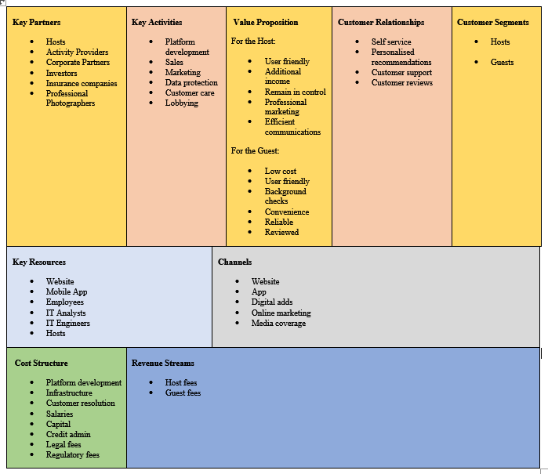

(Appendix.2) SWOT Analysis
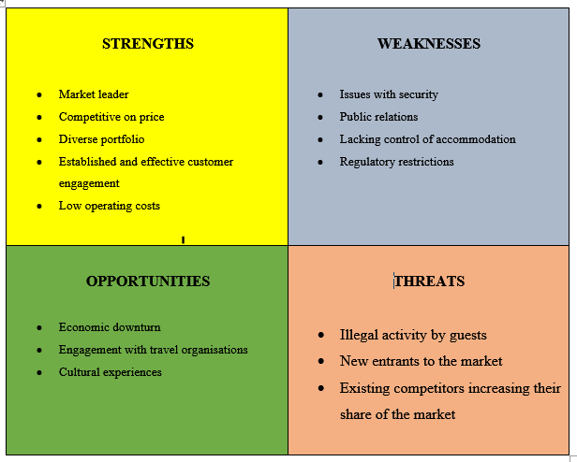
Appendix 3


