Advanced Construction technology
Case Study Report with Drawings

Mark Preston – ID 2223676
HND / BSc Construction Management

Executive Summary

The Alex Building in Swansea is a Grade II listed educational facility with complex operational demands arising from its heritage fabric, mixed-use spaces, and ageing mechanical and electrical systems. This report critically evaluates how modern construction technologies including Building Information Modelling (BIM), digital twins, artificial intelligence (AI), drones, laser scanning, augmented reality (AR), and smart building systems can enhance planning, maintenance, retrofit, and whole-life performance. Drawing on academic literature, industry case studies, and site-visit observations, the report demonstrates that digital technologies can significantly reduce risk, improve energy efficiency, and optimise facilities management.

The analysis identifies key challenges including inaccessible internal gutters, inconsistent comfort levels, noise intrusion, and the absence of an effective defect-reporting system. BIM and laser scanning are shown to be essential for accurate modelling of heritage fabric, while drones and AR improve inspection safety and reduce operational risk. Smart building technologies particularly IoT sensors, AI-driven predictive maintenance, and digital twins offer substantial benefits for energy optimisation and long-term asset management.

A heritage-sensitive retrofit strategy is proposed, incorporating IoT sensors, drone inspections, AR-assisted maintenance, infrared heating solutions, and a full digital twin of the building. These interventions would support long-term conservation, operational efficiency and the experience of people using the building, while still respecting its architectural significance. The report concludes that integrating modern technologies into the Alex Building’s facilities management framework will significantly enhance whole-life performance and ensure the building remains fit for purpose in a contemporary educational context.

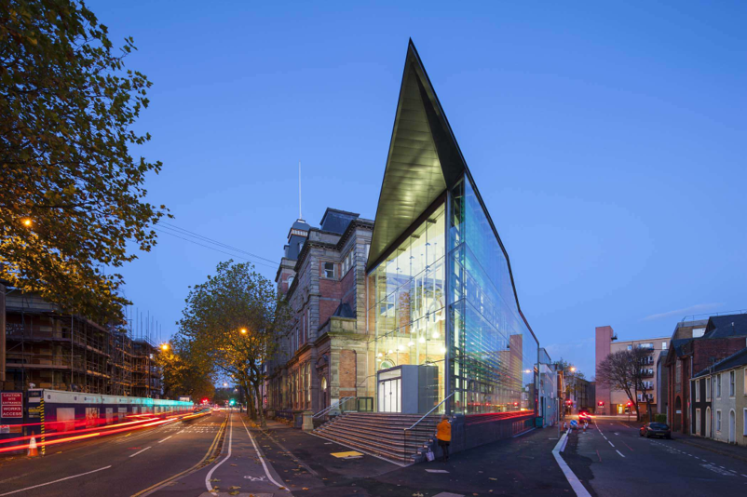
(Powell Dobson, n.d.)

Table of Contents
Executive Summary 1
Table of Contents 2
1.Introduction 4
2. BIM and Digital Technologies for Planning, Risk Mitigation, Maintenance and Retrofit 5
2.1 BIM for planning and risk mitigation 5
2.2 BIM for maintenance and asset management 5
2.3 Laser scanning and point cloud modelling 6
2.4 Drones for inspection and risk reduction 7
2.5 AR for planning and refurbishment 7
3. Smart Buildings, AI, Digital Twins and Scanning for Energy and Whole-Life Performance 8
3.1 Smart building principles 8
3.2 IoT Sensors for Real-Time Monitoring 9
3.3 AI for predictive maintenance and safety 9
3.4 Digital Twins for Whole-Life Performance 10
3.5 Laser scanning for energy modelling 11
3.6 Drones for thermal imaging 11
3.7 Case studies of smart buildings 11
4. Retrofit Strategy for the Alex Building 12
4.1 Heritage-Sensitive Retrofit Principles 12
4.2 Digital twin implementation 12
4.3 Smart Defect-Reporting System 13
4.4 IoT sensors for building performance 13
4.5 Energy retrofit options 13
4.6 Drone-Based Maintenance Programme 14
4.7 AR for maintenance staff 14
4.8 Timetabling and Space-Use Optimisation 14
4.9 Recommendation Hierarchy and Feasibility 15
5. Conclusion 16
6. References 17
7. Appendices 20
Appendix A - Smart Technology Application by Space: Alex Building 20
Appendix B - Phased Implementation Plan 22
Appendix C - Risk and Technology Assessment Matrix 23
Appendix D - Site Observation Defect and Facilities Management Log 25
Appendix E - Suggested Implementation Timeline 27
Appendix F - Lifecycle Cost and Feasibility Notes 28
Appendix G – The Alex Building (Site Visit Photographs) 29

1.Introduction

The Alex Building is located on Alexandra Road in Swansea and forms part of the historic public-building group within the Alexandra Road conservation area. The former Central Library building was refurbished, restored and extended to create the Institute for Sustainable Design, with the circular reading room restored and the contemporary extension providing teaching, workshop and design-studio space (City and County of Swansea, n.d.; AluK, n.d.; Powell Dobson, n.d.).

Today, the Alex Building contains a mix of teaching, workshop, gallery and office uses. This mixed use creates facilities-management complexity, especially alongside heritage constraints and difficult access to high-level fabric such as roof and gutter areas. From the site visit, blocked gutters, road noise and uneven comfort levels appeared to be the most relevant operational issues, showing the need for more proactive and data-led maintenance.

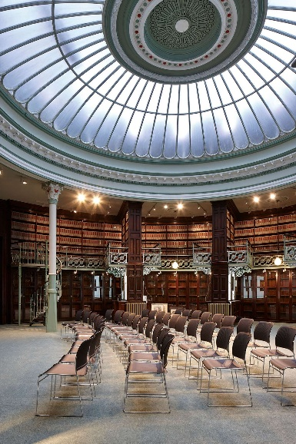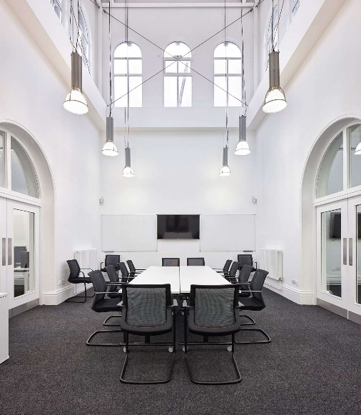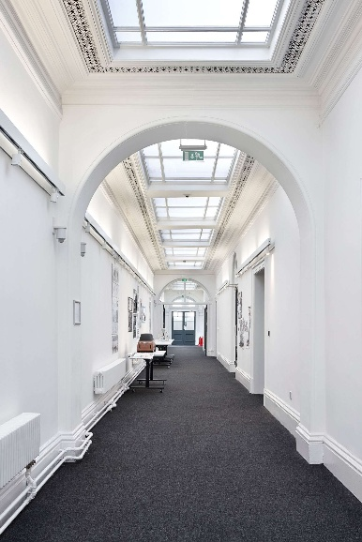
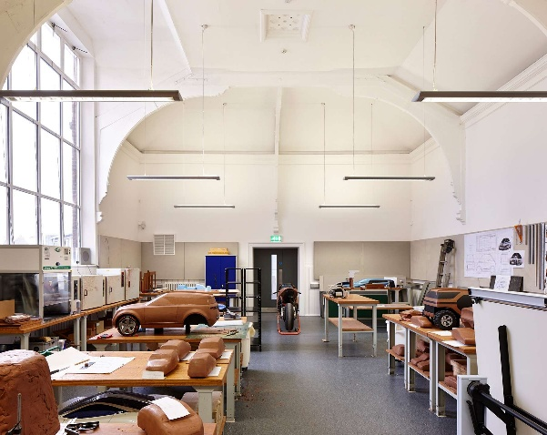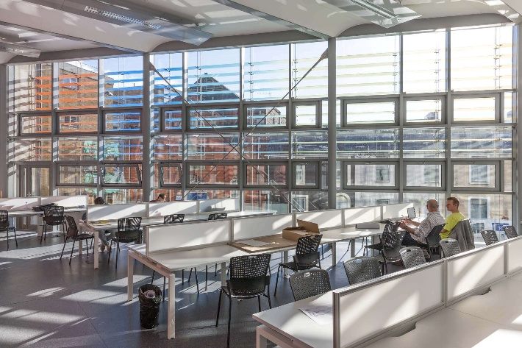
(Powell Dobson, n.d.)

Heritage buildings require careful maintenance and retrofit because decisions should be based on understanding significance, managing change reasonably and documenting decisions (Historic England, 2008). This report therefore evaluates BIM, scanning, drones, AR, IoT, AI and digital twins as practical FM tools rather than technology for its own sake.

2. BIM and Digital Technologies for Planning, Risk Mitigation, Maintenance and Retrofit

2.1 BIM for planning and risk mitigation

BIM provides a structured digital record of a building’s physical and functional information, supporting planning, coordination and risk management. In refurbishment, where unknown conditions are common, BIM can improve clash detection, sequencing and the coordination of architectural, structural and M&E information (Volk et al., 2014).

Heritage buildings often lack accurate documentation, making BIM particularly valuable. Laser-scanned point clouds can be integrated into BIM to create highly accurate models of irregular geometries (Volk, Stengel and Schultmann, 2014). This is essential for the Alex Building, where walls are unlikely to be plumb and previous alterations may not be recorded.

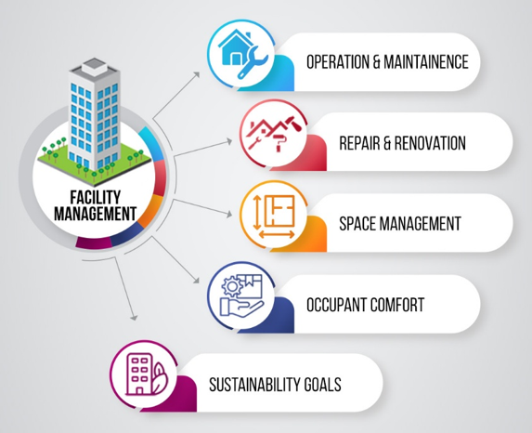
Advenser (n.d.)

ISO 19650 supports information management across the asset life cycle and promotes a common approach to information exchange. For the Alex Building, this would help avoid disconnected surveys, drawings, O&M manuals and maintenance records, allowing FM staff to find reliable information before repairs or refurbishment are planned (BSI, n.d.).

2.2 BIM for maintenance and asset management

Effective maintenance requires accurate asset information, structured documentation, and clear access to building systems. BIM supports this by integrating:

- Digital asset registers
- Maintenance schedules
- O&M manuals
- Spatial information for plant and equipment

BIM also supports predictive maintenance by linking sensor data to asset information. For example, IoT sensors installed in plant rooms can feed data into the BIM model, enabling early detection of anomalies such as overheating kilns or humidity spikes in gallery spaces.
However, BIM is only useful if maintained. In my view, the Alex Building needs a practical Asset Information Model containing information that Facilities Management (FM) staff will actually use, rather than an over-detailed model that becomes outdated and costly to manage.

From a practical point of view, the University would also need clear ownership of the model, staff training and a simple update process after maintenance works. Without this, the BIM model could quickly become another static record rather than a useful facilities management tool.

2.3 Laser scanning and point cloud modelling

Laser scanning provides highly accurate spatial data, overcoming limitations of traditional hand measurements. Academic studies show that laser scanning significantly improves accuracy in heritage buildings, where walls are rarely plumb and undocumented alterations are common (Volk, Stengel and Schultmann, 2014). The Dylan Thomas Centre case study demonstrated how RTC360 scanning produced a 9.3-billion-point dataset, later refined into a usable point cloud.

For the Alex Building, laser scanning would:

- Capture detailed geometry of the domed reading room
- Identify structural irregularities
- Support accurate BIM modelling
- Enable precise planning of retrofit works
- Reduce risk associated with unknown conditions


(Udemy, 2026)

2.4 Drones for inspection and risk reduction

Drones equipped with high-resolution cameras and thermal sensors can inspect roofs, gutters, façades, and hard-to-reach areas without requiring scaffolding or manual access. Research shows that drones significantly reduce inspection time and improve safety (Siebert & Teizer, 2014). This is particularly relevant to the Alex Building, where internal gutters are inaccessible and prone to blockage.
Drone benefits include:

- Safe inspection of heritage fabric
- Early identification of leaks, cracks, and thermal bridging
- Reduced maintenance costs
- Real-time progress monitoring during refurbishment

While drone technology offers significant advantages, there are limitations that should be considered. Specialist operators may be required, weather conditions can restrict inspections, and there are legal requirements associated with flying drones around occupied buildings. Despite these challenges, the benefits are likely to outweigh the drawbacks for the Alex Building because access to roofs and gutters is currently difficult and potentially hazardous.

Routine drone inspections can form part of a planned preventative maintenance strategy, creating repeatable inspection records that assist facilities managers in monitoring deterioration and identifying potential defects before they become significant maintenance issues.

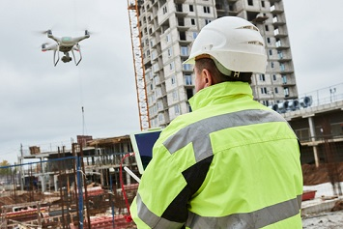
(Sipe, 2024)

2.5 AR for planning and refurbishment

Augmented Reality (AR) overlays digital information onto the physical environment, supporting:

- Visualisation of proposed retrofit works
- On-site verification of construction sequencing
- Safety hazard identification
- RFI and defect overlays

AR could help contractors visualise heritage-sensitive interventions and compare planned work against site conditions. However, AR should be treated as a support tool rather than a replacement for verified survey information, because published reviews identify implementation barriers such as hardware limitations, interoperability issues and cost (Marinho et al., 2026).

The limitation is that AR would only add value if the underlying BIM and asset data are accurate. If service routes or isolation points are incorrectly recorded, AR could create false confidence rather than reduce risk. For this reason, AR should be a later-stage tool for the Alex Building, used after laser scanning, asset verification and staff training have been completed.

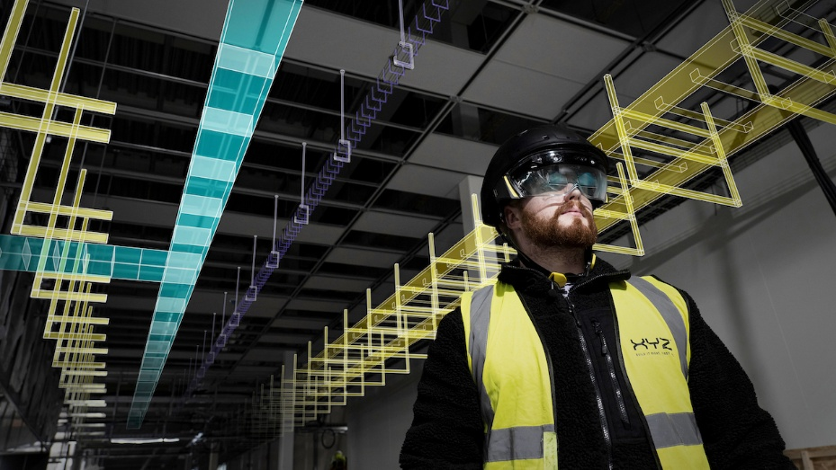
(Construction Management, n.d.)

3. Smart Buildings, AI, Digital Twins and Scanning for Energy and Whole-Life Performance

3.1 Smart building principles

Smart buildings use IoT sensors, automation and data analysis to improve energy management, monitoring and building performance. Reviews of IoT in building energy systems identify sensors, actuators, monitoring, forecasting and control strategies as key components (Yaïci et al., 2021). Key features include:

- Energy-efficient HVAC
- Automated lighting
- Occupancy-based control
- Predictive maintenance
- Enhanced safety and security
- Data-driven decision-making

Smart buildings can also support a better user experience by adapting environmental conditions to patterns of use and occupant needs. The Alex Building already contains elements of smart-building thinking. Powell Dobson states that the facade buffers light, air, heat and noise through the seasons and adjusts through sensors and a BMS to minimise peak heating and cooling loads (Powell Dobson, n.d.). The smart-building priority should therefore be to measure, verify, tune and maintain the existing passive and active design intent rather than simply adding technology for its own sake.

3.2 IoT Sensors for Real-Time Monitoring

IoT sensors can be deployed throughout the Alex Building to monitor:

- Temperature
- Humidity
- Occupancy
- Window status
- Air quality
- Energy consumption

These sensors could feed into a central Building Management System (BMS) or digital twin, supporting better monitoring and control. Sensor deployment should be targeted rather than uniform: studios and teaching spaces would benefit from occupancy, CO2 and temperature monitoring; workshops from extraction, equipment-load and temperature monitoring; gallery and reading-room areas from discreet wireless temperature and humidity sensors; and roof/gutter risk areas from moisture alerts or linked inspection records (Yaïci et al., 2021).

Wireless sensors are preferable in sensitive areas because they can reduce drilling, chasing and cable routes through historic fabric. However, the sensor strategy must include maintenance, calibration and clear responsibility for responding to alerts, otherwise poor-quality data could create false confidence.

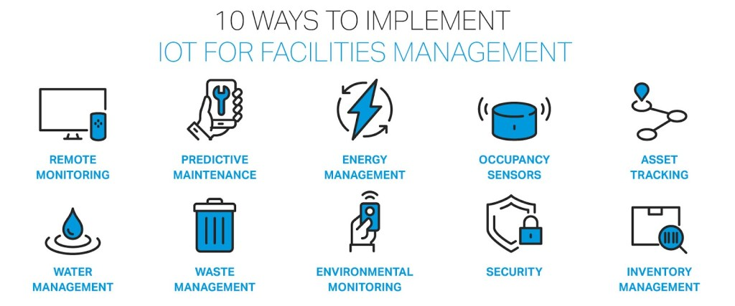
(A&A Elevated Facility Solutions, n.d.)

3.3 AI for predictive maintenance and safety

Artificial intelligence can support predictive maintenance by analysing performance data from building systems and identifying patterns that may indicate developing faults. A machine-learning approach to building facilities maintenance has been shown to use data from HVAC installations, IoT devices and building automation systems to support failure prediction, although data availability can be a barrier (Bouabdallaoui et al., 2021).

AI can also support space-use optimisation by analysing occupancy patterns and recommending changes to timetabling or room allocation. AI should be introduced only after the building has reliable asset information, defect history and sensor data. Once that foundation exists, analytics could identify abnormal plant behaviour, repeated comfort complaints, unusual energy use, workshop extraction issues or moisture alerts following heavy rain. This would help move FM from reactive repair to planned intervention while keeping human judgement central.

However, AI should not be viewed as a replacement for experienced facilities managers. Predictions are only as reliable as the quality of data available, and poor maintenance records or inaccurate sensor information could result in incorrect recommendations. For this reason, AI should be used to support decision-making rather than automate decisions entirely.

3.4 Digital Twins for Whole-Life Performance

A digital twin is a real-time virtual replica of a physical building. It integrates BIM, IoT data, and analytics to simulate performance and predict future behaviour. Research shows that digital twins significantly improve energy efficiency and maintenance planning (Opoku et al., 2021).
For the Alex Building, a digital twin could:

- Monitor energy use across mixed-use spaces
- Identify inefficient zones
- Simulate retrofit options
- Support long-term conservation planning
- Provide real-time defect reporting

Whole-life performance should include operational carbon, embodied carbon, lifecycle cost, maintenance planning, user comfort, conservation value and resilience. UKGBC states that the built environment is directly responsible for 25% of UK carbon emissions and that its roadmap sets a pathway to net zero by 2050 (UKGBC, 2021). This supports prioritising operational tuning and maintenance before major replacement works are proposed. A full digital twin would be valuable but expensive and data-intensive, so it should follow a staged approach: first HBIM/AIM, then a digital logbook and targeted sensors, and only later AI analytics once reliable data exists.

In my judgement, this makes a full digital twin a later-stage investment rather than an immediate priority. A small pilot linked to one workshop area, the roof/gutter risk zones and the main BMS data would be more defensible because benefits could be measured before wider rollout.

3.5 Laser scanning for energy modelling

Laser-scanned point clouds support accurate thermal modelling by identifying:

- Air leakage paths
- Thermal bridging
- Insulation gaps
- Window performance issues

3.6 Drones for thermal imaging

Thermal drones can detect:

- Heat loss through roofs
- Moisture ingress
- Overheating plant rooms
- Faulty insulation

This would support targeted retrofit interventions.

3.7 Case studies of smart buildings

International precedents show how smart-building technologies can improve energy use, asset reliability and facilities management, but they must be interpreted carefully for the smaller, listed Alex Building. The following examples are therefore used as transferable lessons rather than direct copy-and-paste solutions.

Case study | Relevant smart-building evidence | Lesson for the Alex Building
The Edge, Amsterdam | BREEAM case-study evidence describes an energy-positive office with smart systems that continually measure occupancy and movement; Bloomberg also reports approximately 28,000 sensors and app-based workspace allocation. | Use occupancy and environmental data to improve room use and BMS control, but apply it at a smaller and less intrusive scale. (BRE Group, 2022; Randall, 2015)
Glumac Shanghai HQ | The project is documented as a high-performance office using biophilic design, solar photovoltaics and real-time indoor/outdoor air-quality information through a RESET app. | Supports targeted air-quality monitoring in workshops, studios and heritage-sensitive spaces, particularly where user wellbeing and ventilation are important. (Terrapin Bright Green, 2016; Wang, 2014)
Burj Khalifa | Honeywell’s Outcome Based Service uses real-time field data, anomaly identification and predictive/prescriptive maintenance for HVAC mechanical assets. | Shows why AI should be introduced only after reliable asset and sensor data exist; the Alex Building should begin with simpler asset records and monitoring. (Tomás, 2018)
Heathrow Airport digital twin | NATS describes Demand Capacity Balancer as a digital twin that models operational performance in near real time and now supports environmental performance planning. | Useful precedent for phased digital twins: first collect reliable data, then use modelling to test operational decisions and reduce waste. (NATS, 2024)
Sydney Opera House FM digitalisation | Okana describes a BIM4FM system linking a constantly updated digital model to engineering, maintenance and control systems; QUT also identifies Sydney Opera House as a BIM-for-FM exemplar. | Most relevant heritage precedent because it shows how BIM/FM integration can support a culturally significant building with complex services. (Okana, n.d.; CRC Construction Innovation, 2007)

These case studies demonstrate that smart technologies can transform building performance, but the Alex Building requires a proportionate heritage-sensitive strategy. The most useful precedents are therefore structured asset information, targeted environmental monitoring, occupancy-based control, proactive maintenance and phased digital-twin implementation, supported by project-specific sources such as Powell Dobson, AluK, Swansea Council and Historic England.

4. Retrofit Strategy for the Alex Building

4.1 Heritage-Sensitive Retrofit Principles

Retrofit proposals must comply with conservation principles, ensuring that interventions are:

- Reversible
- Non-intrusive
- Respectful of historic fabric
- Supported by compelling evidence

4.2 Digital twin implementation

A digital twin should be created using:

- Laser-scanned point cloud
- BIM model
- IoT sensor network
- Energy modelling software

This would provide a central platform for facilities management, enabling:

- Real-time monitoring
- Predictive maintenance
- Occupancy-based control
- Long-term conservation planning

The first operational dashboard should focus on a small number of high-value issues: gutter/moisture alerts, workshop environmental conditions, energy use and repeated comfort complaints. This would keep the system manageable and avoid collecting data that facilities staff do not have time to act on.

4.3 Smart Defect-Reporting System

The current defect-reporting process is inefficient. A new system could include:

- QR codes in each room
- Mobile app integration
- Automated logging into FM software
- Linking defects to BIM model locations

4.4 IoT sensors for building performance

Sensors should be installed to monitor:

- Internal gutters (blockage detection)
- Window status (open/closed)
- Humidity in kiln and plant rooms
- Temperature in galleries
- Occupancy in study rooms

The highest-value sensor locations are the double-skin facade, studios, workshops, gallery/reading-room areas, plant spaces, roof/gutter risk zones and circulation spaces. This targeted approach avoids data overload and supports heritage-sensitive installation by using only sensors that have a clear FM purpose.

4.5 Energy retrofit options

Heritage-sensitive energy improvements include:

- Infrared heating panels disguised as mirrors (National Trust case study)
- Infrared heating mats embedded in plaster
- Smart thermostats linked to occupancy sensors
- Automated lighting dimmers in lecture halls
- Improved insulation where permissible

Energy retrofit should begin with operational optimisation because the building already includes sustainable design features. Powell Dobson identifies Project Alex as having a contemporary extension to the Grade II listed former Central Library, while AluK describes the twin-wall façade and its passive climatic-control role (Powell Dobson, n.d.; AluK, n.d.). Before intrusive fabric works are considered, the University should review BMS schedules, sensor calibration, window operation, heating setpoints, lighting controls and occupancy patterns.

Potential improvements include occupancy-based lighting, daylight dimming, zone-based heating, demand-controlled ventilation and energy sub-metering. More intrusive fabric retrofit, such as insulation, improved airtightness or secondary glazing, should be assessed carefully through survey, hygrothermal review and conservation advice.

4.6 Drone-Based Maintenance Programme

Routine drone inspections should monitor:

- Roof condition
- Gutter blockages
- Façade deterioration
- Thermal performance

4.7 AR for maintenance staff

AR headsets or tablets could overlay:

- Service routes
- Hidden M&E systems
- Safety hazards
- Maintenance instructions

4.8 Timetabling and Space-Use Optimisation

CELCAT timetabling could integrate with occupancy sensors to:

- Identify underused spaces
- Improve room allocation
- Reduce energy waste
- Support long-term space planning

Occupancy and timetable data should be used at room level to improve building performance, not to monitor individuals. Anonymous room-use patterns could help reduce heating, lighting and ventilation in unused spaces, schedule maintenance around workshop activity and align environmental control with exhibition opening hours.

4.9 Recommendation Hierarchy and Feasibility

To make the retrofit strategy realistic, the technologies should be prioritised according to cost, implementation risk and likely impact on facilities management. This also helps avoid the report appearing as a list of technologies rather than a justified strategy for the Alex Building. The cost levels are indicative rather than a formal cost plan, but they show the relative feasibility of each option and support the phased recommendation.
Priority | Recommendation | Indicative cost | Likely impact | Justification
1 | Laser scan, condition survey and HBIM/AIM | Medium | High | Creates reliable existing information for heritage fabric, services, roof drainage and future works.
2 | QR-based defect reporting linked to room/asset data | Low | High | Directly improves day-to-day FM and captures repeated comfort, leak and equipment issues.
3 | Targeted IoT sensors and BMS optimisation | Medium | High | Supports energy, comfort and maintenance decisions without intrusive alteration of listed fabric.
4 | Drone inspection programme | Low-Medium | Medium-High | Reduces access risk and improves monitoring of roofs, gutters and high-level facade areas.
5 | Digital twin and AI analytics | High | High long-term | Should follow only after verified asset data and sensor history exist; otherwise benefits may not justify cost.

Overall, the strongest short-term distinction between the options is that low-cost information and reporting improvements are likely to deliver quicker benefits than advanced AI. The recommended strategy is therefore to prioritise accurate information, defect capture and targeted monitoring first, then use these foundations to justify a later digital twin.

5. Conclusion

The Alex Building clearly meets the brief as a complex construction-technology case study because it combines listed heritage fabric, specialised art and design spaces, existing sustainable design features and practical facilities-management problems. The most appropriate improvement strategy is not to add every available technology at once, but to use digital tools in a staged and evidence-led way.

The first priority should be laser scanning, a condition survey, HBIM/AIM development and a simple digital logbook because these provide reliable information for later work. The second priority should be low-cost FM improvements such as QR-based defect reporting, targeted sensors and BMS optimisation. Drones should also be used for planned inspection of roofs, gutters and high-level fabric because this directly responds to access and maintenance risks identified during the site visit.

A full digital twin and AI analytics would offer long-term benefits for predictive maintenance, space planning and whole-life performance. However, they should only be introduced once the University has accurate asset data and enough sensor history to make the outputs meaningful.

If implemented in this way, modern technologies could improve the Alex Building's maintenance planning, energy management, user comfort and conservation outcomes while respecting its listed status. The proposed strategy therefore supports both learning outcomes by critiquing design and production processes for a complex building and by recognising whole-life performance, care and management as central to successful refurbishment.

6. References

A&A Elevated Facility Solutions (n.d.) IoT in Facilities Management: Improve Cleaning and Productivity. Available at: https://aaefs.com/iot-in-facilities-management-improve-cleaning-and-productivity/ (Accessed: 27 July 2026).

Advenser (n.d.) BIM for Facility Management. Available at: https://www.advenser.net/bim-facility-management (Accessed: 27 July 2026).

AluK (n.d.) The Alex House Project. Available at: https://www.aluk.com/en/projects/the-alex-house-project (Accessed: 27 July 2026).

Author's own photograph (2026) Alex Building, Swansea. Taken during site visit to UWTSD Alex Building, 2026.

Boje, C., Guerriero, A., Kubicki, S. and Rezgui, Y. (2020) ‘Towards a semantic Construction Digital Twin: Directions for future research’, Automation in Construction, 114, 103179. doi: https://doi.org/10.1016/j.autcon.2020.103179.

Bouabdallaoui, Y., Lafhaj, Z., Yim, P., Ducoulombier, L. and Bennadji, B. (2021) ‘Predictive Maintenance in Building Facilities: A Machine Learning-Based Approach’, Sensors, 21(4), 1044. doi: https://doi.org/10.3390/s21041044.

BRE Group (2022) The Edge Amsterdam. Available at: https://bregroup.com/case-studies/the-edge-amsterdam (Accessed: 27 July 2026).

BSI (n.d.) ISO 19650 – Managing Information with Building Information Modelling (BIM). Available at: https://www.bsigroup.com/en-GB/products-and-services/standards/iso-19650-building-information-modelling-bim/ (Accessed: 27 July 2026).

CRC Construction Innovation (2007) Adopting BIM for Facilities Management: Solutions for Managing the Sydney Opera House. Available at: https://eprints.qut.edu.au/27582/ (Accessed: 27 July 2026).

City and County of Swansea (n.d.) Conservation area - Alexandra Road. Available at: https://www.swansea.gov.uk/conservationarea1?lang=en (Accessed: 27 July 2026).

Historic England (2008) Conservation Principles, Policies and Guidance: For the Sustainable Management of the Historic Environment. Available at: https://historicengland.org.uk/images-books/publications/conservation-principles-sustainable-management-historic-environment/ (Accessed: 27 July 2026).

Kassem, M., Kelly, G., Dawood, N., Serginson, M. and Lockley, S. (2015) ‘BIM in facilities management applications: a case study of a large university complex’, Built Environment Project and Asset Management, 5(3), pp. 261–277. doi: https://doi.org/10.1108/BEPAM-02-2014-0011.

Marinho, J., Sá, F., Durães, J., Fonseca, I. and Martins, N.C. (2026) ‘A Systematic Literature Review of Augmented Reality’s Development in Construction’, Electronics, 15(1), 225. doi: https://doi.org/10.3390/electronics15010225.

NATS (2024) New technology to allow Heathrow to prioritise emission targets. Available at: https://www.nats.aero/news/new-technology-to-allow-heathrow-to-prioritise-emission-targets/ (Accessed: 27 July 2026).

Okana (n.d.) Sydney Opera House. Available at: https://www.okana.global/case-studies/sydney-opera-house/ (Accessed: 27 July 2026).

Opoku, D.-G.J., Perera, S., Osei-Kyei, R. and Rashidi, M. (2021) ‘Digital twin application in the construction industry: a literature review’, Journal of Building Engineering, 40, 102726. doi: https://doi.org/10.1016/j.jobe.2021.102726.

Powell Dobson (n.d.) Project Alex. Available at: https://www.powelldobson.com/projects/oakleigh-house/ (Accessed: 27 July 2026).
Randall, T. (2015) The Smartest Building in the World. Bloomberg. Available at: https://www.bloomberg.com/features/2015-the-edge-the-worlds-greenest-building/ (Accessed: 27 July 2026).

Siebert, S. and Teizer, J. (2014) ‘Mobile 3D mapping for surveying earthwork projects using an Unmanned Aerial Vehicle (UAV) system’, Automation in Construction, 41, pp. 1–14. doi: https://doi.org/10.1016/j.autcon.2014.01.004.

Sipe, C. (2024) Top Uses of Drones and Robots for Facilities. Facilities Management Advisor, 25 September. Available at: https://facilitiesmanagementadvisor.com/maintenance-and-operations/top-uses-of-drones-and-robots-for-facilities/ (Accessed: 27 July 2026).

Terrapin Bright Green (2016) Glumac Shanghai Office. Available at: https://www.terrapinbrightgreen.com/wp-content/uploads/2016/11/Glumac-Shanghai-Office-Fall-2016.pdf (Accessed: 27 July 2026).

Tomás, J.P. (2018) How Honeywell helped the Burj Khalifa become a smart building. RCR Wireless News, 14 May. Available at: https://www.rcrwireless.com/20180514/internet-of-things/burj-khalifa-smart-building (Accessed: 27 July 2026).

Udemy (2026) Mastering BIM Information Management & ISO 19650 Leadership. Available at: https://www.udemy.com/course/mastering-bim-information-management-iso-19650-leadership/ (Accessed: 27 July 2026).

UKGBC (2021) Net Zero Whole Life Carbon Roadmap. Available at: https://ukgbc.org/our-work/topics/whole-life-carbon-roadmap/ (Accessed: 27 July 2026).

Volk, R., Stengel, J. and Schultmann, F. (2014) ‘Building Information Modeling (BIM) for existing buildings — Literature review and future needs’, Automation in Construction, 38, pp. 109–127. doi: https://doi.org/10.1016/j.autcon.2013.10.023.

Wang, L. (2014) Glumac’s pioneering net-zero Shanghai office paves the way to greener buildings in China. Inhabitat, 17 December. Available at: https://inhabitat.com/glumacs-pioneering-net-zero-shanghai-office-paves-the-way-to-greener-buildings-in-china/ (Accessed: 27 July 2026).

Yaïci, W., Krishnamurthy, K., Entchev, E. and Longo, M. (2021) ‘Recent Advances in Internet of Things (IoT) Infrastructures for Building Energy Systems: A Review’, Sensors, 21(6), 2152. doi: https://doi.org/10.3390/s21062152.

7. Appendices

Appendix A - Smart Technology Application by Space: Alex Building

Due to the mixed-use nature of the Alex Building, different smart building technologies are required across individual spaces. The table below adapts the smart-building principles to the actual spaces and operational needs of the Alex Building.

Building area | Operational characteristics | Smart technologies | Example improvement | FM benefit
Design studios | Variable teaching use, solar gain, equipment use and changing occupancy. | Occupancy sensors, temperature sensors, CO2 monitoring, smart lighting and BMS-linked control. | Heating, lighting and ventilation respond to actual use rather than fixed schedules. | Improves comfort and reduces wasted energy.
Double-skin facade | South-facing glazed facade with thermal buffer, louvres, sensors and BMS control. | Facade temperature monitoring, actuator status checks, BMS trend logs and weather-linked review. | Facilities staff can identify whether the facade is performing as intended. | Protects the sustainable design intent and supports energy tuning.
Circular reading room / gallery space | Heritage-sensitive space with public, exhibition and teaching potential. | Wireless temperature and humidity sensors, occupancy monitoring and discreet lighting control. | Environmental data supports stable conditions without intrusive installation. | Supports conservation-led operation and user comfort.
Workshops | Specialist processes including casting, glass processing, sandblasting, enamelling, cutting, turning and 3D printing. | Extraction monitoring, equipment energy monitoring, temperature sensors and fault alerts. | Abnormal equipment performance or extraction issues are flagged earlier. | Improves safety, planned maintenance and energy control.
Study rooms and seminar spaces | Timetabled use with periods of low occupancy. | Occupancy-linked lighting, smart heating schedules and room-use analytics. | Services reduce when spaces are unused. | Supports lower running costs and better room allocation.
Circulation areas | Intermittent movement through corridors and stair zones. | Motion-controlled lighting and daylight-responsive controls. | Lighting levels respond to movement and available daylight. | Reduces unnecessary electricity consumption.
Roof, gutters and high-level fabric | Difficult access and potential water-ingress risk. | Drone surveys, photographic records, moisture alerts and BIM-linked defect history. | Blocked gutters or high-level defects can be identified before internal damage occurs. | Improves planned maintenance and reduces reactive repairs.
Plant and service areas | Mechanical/electrical systems require planned maintenance and fault visibility. | Asset sensors, BMS trend logs, digital logbook and predictive maintenance analytics. | Plant running hours and abnormal performance can be reviewed. | Improves asset reliability and maintenance planning.
Whole building | Multiple uses, fragmented information risk and heritage constraints. | HBIM/AIM, CDE, digital logbook, dashboards and phased digital twin. | Information is managed in one structured system. | Supports long-term whole-life asset management.

Appendix B - Phased Implementation Plan

Phase | Action | Purpose | Output
1 | Laser scan and condition survey | Create verified existing information for listed fabric, facade, workshops and plant. | Point cloud, condition record and survey drawings.
2 | Develop HBIM/AIM and digital logbook | Turn survey and O&M information into usable FM data. | Asset register, CDE and digital logbook.
3 | Install targeted wireless sensors | Monitor priority spaces without damaging heritage fabric. | Temperature, humidity, CO2, occupancy, energy and moisture data.
4 | Optimise BMS and controls | Use measured data to improve comfort and reduce waste. | Revised control settings and live dashboards.
5 | Create a digital twin | Connect model, assets, defects, BMS and sensor data. | Operational digital twin for FM decision-making.
6 | Introduce AI analytics | Identify patterns, predict faults and support planned maintenance. | Predictive maintenance alerts and performance reports.

Appendix C - Risk and Technology Assessment Matrix

This appendix expands the recommendation hierarchy by linking each observed or likely building issue to a technology response, expected benefit, limitation and final decision.

Issue / risk | Technology response | Expected benefit | Limitation / risk | Decision / priority
Blocked gutters and high-level access | Drone survey, photographic inspection records and moisture alerts | Reduces working-at-height risk and allows repeated comparison of roof/gutter condition | Weather, permissions, battery life and operator competence may restrict inspections | Immediate priority because water ingress can cause fabric damage
Fragmented building records | Laser scanning, point-cloud survey and HBIM/AIM development | Creates reliable existing information for fabric, services, access routes and future refurbishment | Requires initial cost, staff training and a clear owner to keep records updated | High priority before intrusive retrofit or major maintenance
Uneven comfort in occupied rooms | Targeted temperature, CO2 and occupancy sensors linked to BMS review | Supports evidence-based changes to heating, ventilation and room scheduling | Poor calibration or too many sensors could create unreliable or unused data | Pilot in studios, workshops and spaces with repeated complaints
Energy waste from fixed schedules | BMS optimisation, dashboard reporting and sub-metering where feasible | Helps reduce unnecessary heating, lighting and ventilation when rooms are unused | Savings depend on staff reviewing dashboard outputs and acting on findings | High value because it improves performance before costly fabric interventions
Workshop equipment reliability | Asset register, equipment-load monitoring and later AI-supported predictive maintenance | Can identify abnormal running patterns and improve planned maintenance | AI is only reliable once there is enough good-quality asset and fault data | Phase 2 or 3 after basic monitoring and records are established
Heritage-sensitive spaces | Discreet wireless environmental monitoring | Allows humidity and temperature review without intrusive cabling or damage to fabric | Wireless sensors still need battery replacement, calibration and maintenance | Medium priority but important for conservation-led FM
Defect reporting delays | QR-code reporting linked to rooms/assets | Captures defects at source and highlights repeated problems by location | Requires a clear response process so reports do not sit unresolved | Low-cost early action with high practical value
Digital twin ambition | Staged digital twin pilot using verified BIM, BMS and sensor data | Supports whole-life performance, scenario testing and long-term FM decisions | High cost and data requirements mean benefits may be weak if introduced too early | Later-stage investment after data foundations are proven

Appendix D - Site Observation Defect and Facilities Management Log

This appendix records the type of FM issues that should be captured in a planned maintenance system. It is not a full condition survey, but it demonstrates how site observations can be translated into practical digital maintenance actions.

Location / area | Observation or defect risk | Likely cause / FM concern | Digital or technical response | Priority
Roof and gutters | Blockage and difficult high-level access | Restricted inspection access may delay detection of water ingress | Drone inspection, moisture alerts and BIM-linked photographic defect history | High
External facade / high-level fabric | Potential difficulty inspecting deterioration and junctions | High access requirements can make minor defects expensive to review | Planned drone survey from consistent viewpoints and asset-tagged image storage | Medium-High
Studios | Variable comfort during different occupancy patterns | Fixed schedules may not reflect changing teaching use | Occupancy, CO2 and temperature monitoring linked to BMS review | High
Workshops | Specialist processes and equipment loads | Extraction, energy use and maintenance demand may change by activity | Equipment-load monitoring, extraction checks and fault reporting dashboards | High
Gallery / circular reading room | Heritage-sensitive environment | Need to balance conservation, comfort and low-impact installation | Discreet wireless humidity and temperature monitoring | Medium
Double-skin facade | Existing passive design feature requiring tuning | Controls may drift from intended performance over time | Facade temperature monitoring, actuator status checks and BMS trend review | Medium
Plant and service areas | Need for consistent asset information | Unplanned downtime and fragmented O&M information | HBIM/AIM asset register, digital logbook and later predictive maintenance analytics | Medium-High
Teaching and seminar rooms | Periods of underuse | Energy may be wasted if rooms are heated or lit when empty | Timetable integration, occupancy analytics and room-use reporting | Medium
Whole building | Defects may be reported inconsistently | Repeated issues may not be analysed by room, asset or priority | QR defect reporting linked to location, asset type and response status | High

Appendix E - Suggested Implementation Timeline

This implementation timeline supports a phased strategy. The first stage focuses on low-cost, high-impact actions and reliable information. More advanced digital twin and AI tools are delayed until the University has enough verified data to make them useful.

Phase | Indicative period | Main actions | Output | Success indicator
1 | 0-6 months | Confirm FM objectives, agree asset information requirements, set up QR defect-reporting trial | Clear information brief and simple defect capture system | Defects can be logged by room/asset and reviewed by priority
2 | 6-12 months | Laser scan, condition survey and initial HBIM/AIM development | Verified existing information and asset register | FM staff can locate key fabric, plant and access information
3 | 12-18 months | Targeted sensors in studios, workshops, roof/gutter risk zones and heritage-sensitive areas | Operational data for comfort, moisture, occupancy and equipment loads | Repeated comfort or moisture issues can be identified using evidence
4 | 18-24 months | BMS optimisation, dashboard setup and planned drone inspection programme | Performance dashboard and repeatable high-level inspection records | Energy and maintenance decisions are supported by live or recent data
5 | 24-36 months | Pilot digital twin linking verified BIM, BMS, sensors and defect records | Limited but usable operational digital twin | The pilot produces decisions or savings that justify wider rollout
6 | 36 months onwards | AI analytics, predictive maintenance and wider integration with FM processes | Predictive alerts and whole-life performance reporting | Reactive maintenance reduces and long-term planning improves

Appendix F - Lifecycle Cost and Feasibility Notes

This appendix records the lifecycle-cost and feasibility points that support the main report without increasing the main word count. It shows that the proposed technologies should be adopted because they deliver whole-life value, not simply because they are modern.

Investment area | Capital cost pressure | Operational benefit | Feasibility concern | Whole-life judgement
Laser scanning and HBIM/AIM | Survey and modelling costs at the start of the project | Reduces uncertainty and supports future maintenance and refurbishment | Model must be maintained after works are complete | Justified early because reliable information supports all later stages
QR defect reporting | Low system/setup cost compared with major digital technologies | Improves defect capture and allows repeated issues to be analysed | Needs ownership and response times to avoid unresolved reports | High-value early improvement
IoT sensor pilot | Medium cost depending on number and quality of sensors | Improves comfort, energy review and targeted maintenance | Too many sensors can create data overload | Start with targeted priority spaces only
Drone inspection programme | Low to medium recurring cost depending on contractor/operator | Reduces access risk and improves roof/gutter evidence | Weather and permission constraints apply | Useful where conventional inspection is difficult or costly
Digital twin | High software, integration and data-management cost | Supports long-term FM, scenario testing and whole-life performance review | Weak value if introduced before verified data exists | Defer until HBIM/AIM, BMS data and sensors are reliable
AI analytics | High cost if bespoke or poorly integrated | Can support predictive maintenance and pattern recognition | Dependent on data quality and human review | Later-stage tool, not an immediate priority

Appendix G – The Alex Building (Site Visit Photographs)

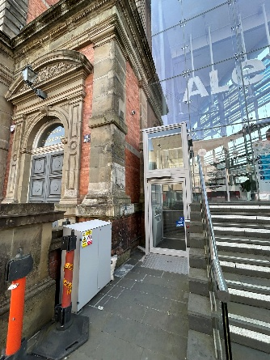 | 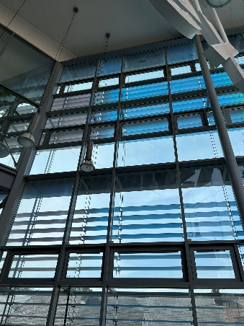 | 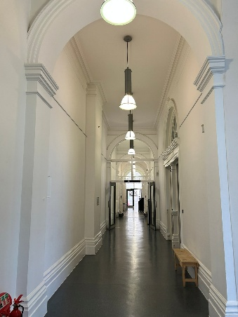 | 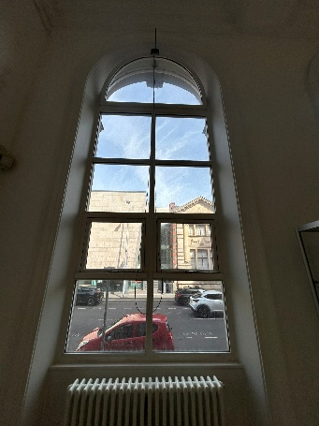
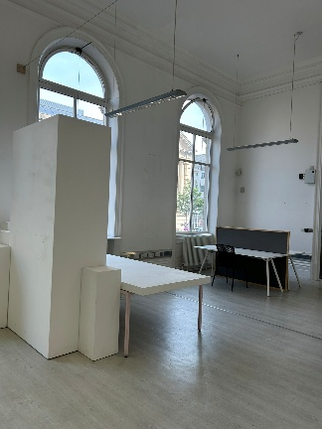 | 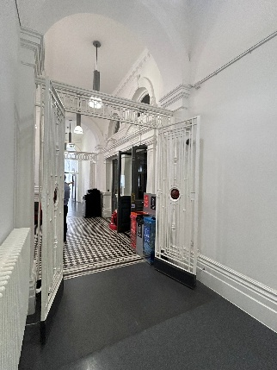 | 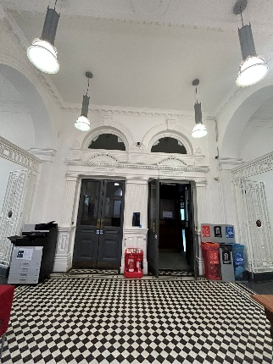 | 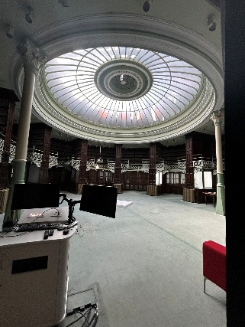
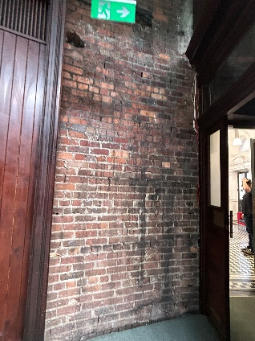 | 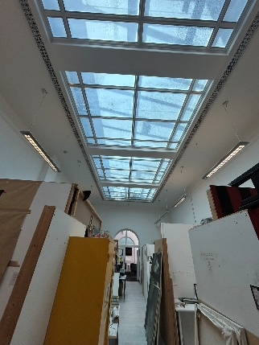 | 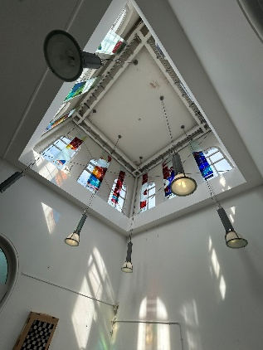 | 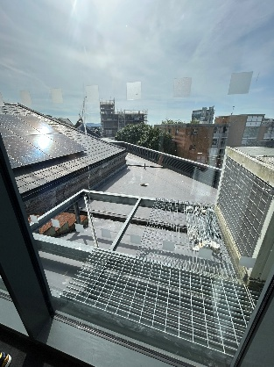
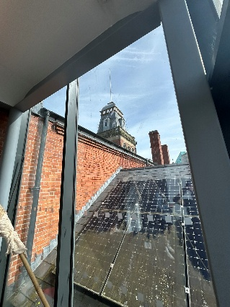 | 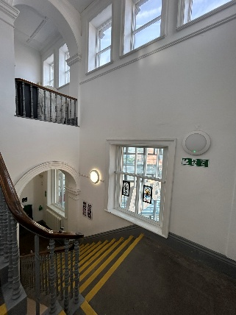 | 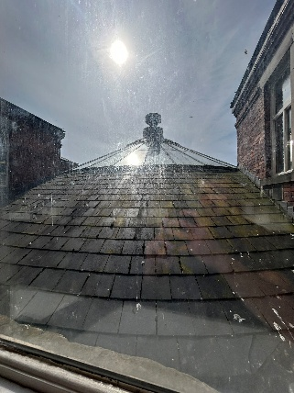 | 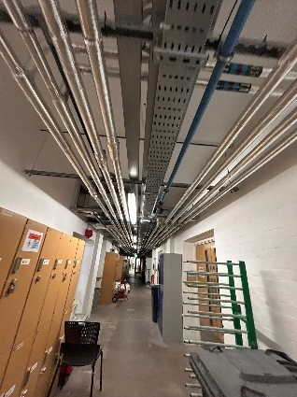

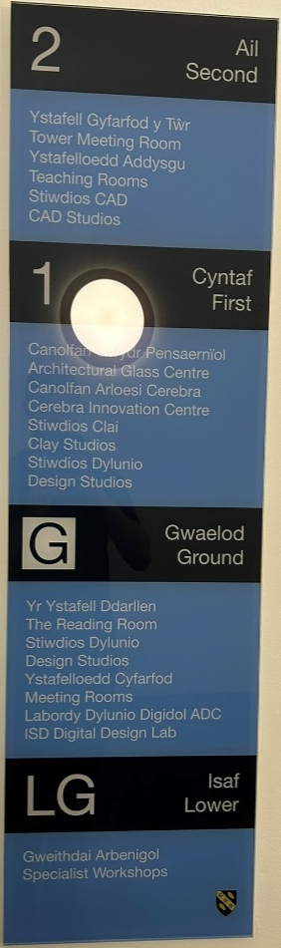 | 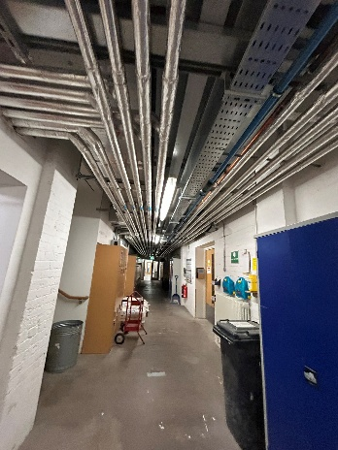  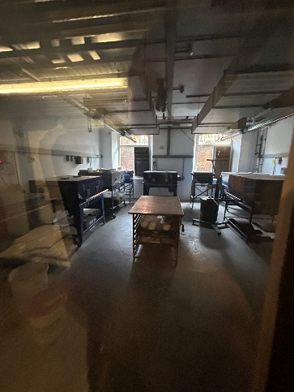 | 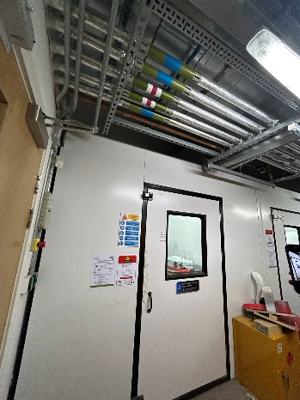  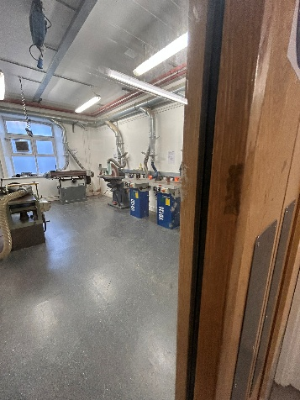 | 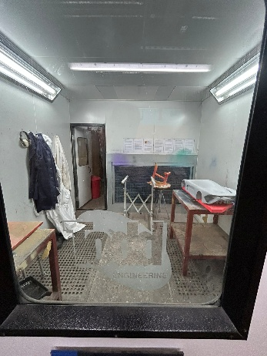  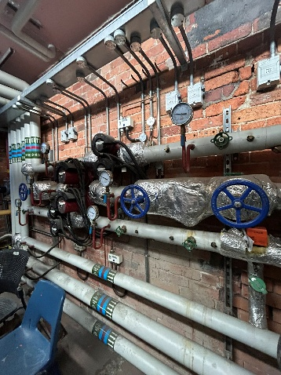
 | 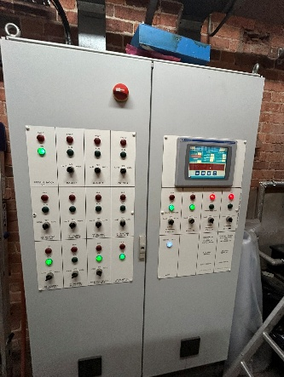 | 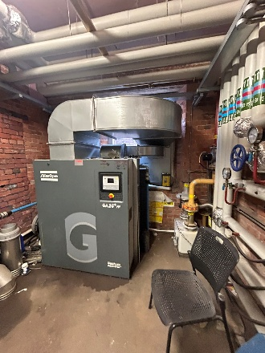 | 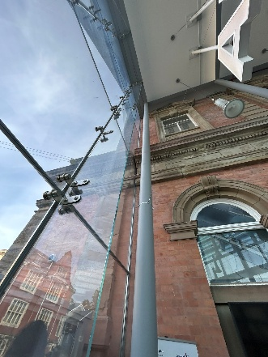
 | 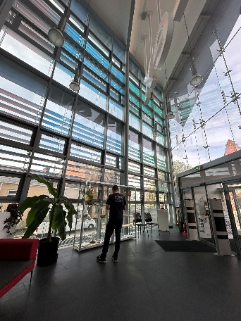 | 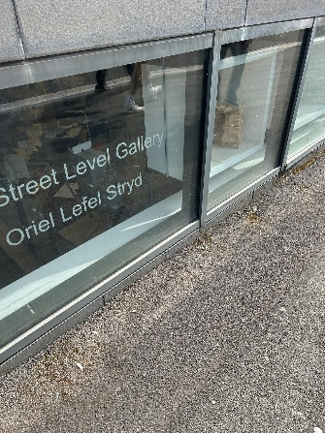 | 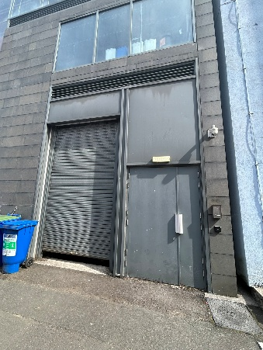
(Author’s own photographs, 2026)

