Witness Interview Theft Task Sheet
Scenario 2 Theft by Shoplifting Screw fix - Witness brief

Witness Brief
Witness details: (use your own name)
Witness address: (you live above the shop)
Location: Unit 3 John Baker Close, Bridgend Industrial Estate, Bridgend
Time of the incident: This incident occurred an hour before the witness came in to give their statement

You work as a shop assistant in Screwfix shop in Bridgend. Your main duties are serving customers and taking payments over the counter. The shop has CCTV fitted but this system does not record. You were working this morning when the incident happened
!! Watch the film clip !!

The suspect has taken a packet of screwdrivers worth £28.99 and left the store without offering any payment.

You recognised this person as someone who attended your school. They were not in the same year as you but was well known in the school as they were in trouble so often. Use the name provided to you by your trainer.

Aims of the Scenario

- The aim of investigative interviewing is to obtain accurate and reliable accounts from victims, witnesses or suspects about matters under police investigation.
- Investigators must act fairly when questioning victims, witnesses or suspects. Vulnerable people must be treated with particular consideration at all times.
- Investigative interviewing should be approached with an investigative mind-set. Accounts obtained from the person who is being interviewed should always be tested against what the interviewer already knows or what can reasonably be established.
- When conducting an interview, investigators are free to ask a wide range of questions in order to obtain material which may assist an investigation.
- Investigators should recognise the positive impact of an early admission in the context of the criminal justice system.
- Investigators are not bound to accept the first answer given. Questioning is not unfair merely because it is persistent.
- Even when the right of silence is exercised by a suspect, investigators have a responsibility to put questions to them.

Outcome of the Scenario

- Aim: To Provide interviewers with the competence to prepare and plan interviews with suspects.
- Objectives
- Assess information gathered about suspect(s)
- Assess the type and current condition of the suspect to inform the approach to the interview in accordance with legal requirements.
- Establish the correct interview approach utilising the engage and explain phase aide memoir
- Identify the nature of the allegation and identify investigative important information
- Produce a written interview plan that takes account of the suspect assessment , the needs of the investigation and legal requirements
- Select and set up the necessary interview location, resources and personnel.

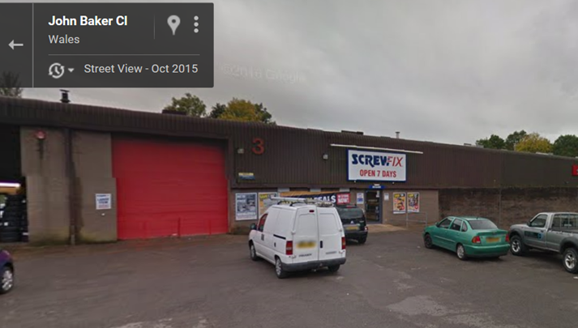

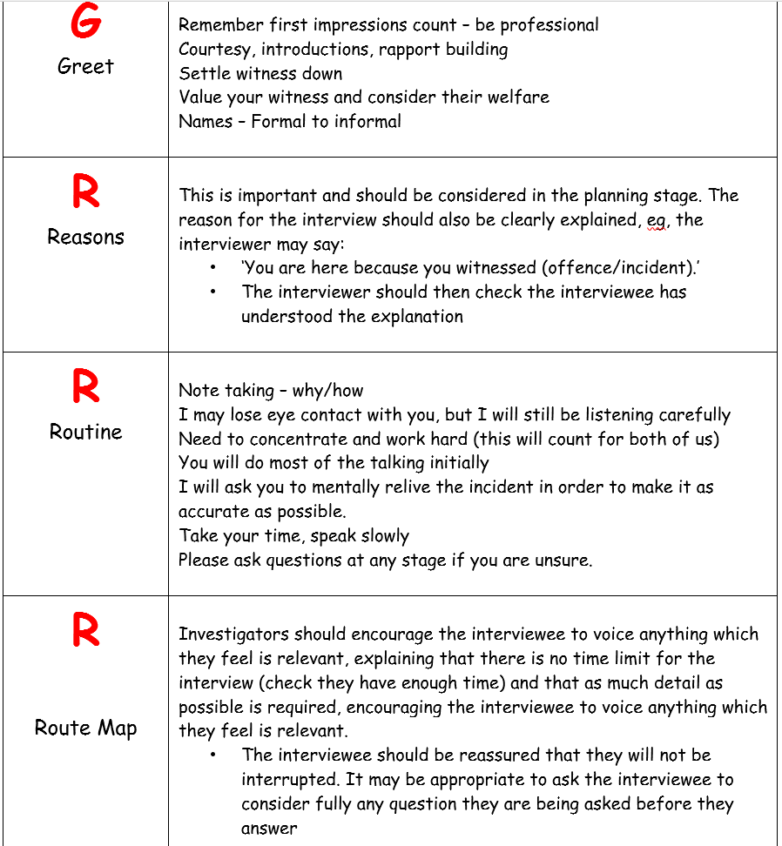

Section 1 of the Theft Act 1968 provides the legal definition of theft.
1(1) A person is guilty of theft if he dishonestly appropriates property belonging to another with the intention of permanently depriving the other of it and 'thief' and 'steal' shall be construed accordingly.
1(2) It is immaterial whether the appropriation is made with a view to gain, or is made for the thief's own benefit.
1(3) the five following sections of this Act shall have effect as regards the interpretation and operation of this section (and, except as otherwise provided by this Act, shall apply only for purposes of this section).
Notes
(i) The wording which makes the above an offence is found in section 7 of the Act. All five of these elements must be proved to obtain a conviction. The term 'property' in this Act is not the same as that in the offence of criminal damage.
(ii) Immigration officers have a power of arrest for theft (see section 14 of the Asylum and Immigration (Treatment of Claimants, etc.) Act 2004). This power is available to an immigration officer who uncovers evidence of this (and other offences) whilst in the course of their usual duties (investigating immigration matters).
(iii) A secure network which protects jewellery, watches and other treasured items, providing the police with a nationwide database to search and trace the owners of recovered items can be found at www.police.e-register.net.
(iv) Please see the document on carjacking, where the offence of theft may be applicable.
(v) There are a substantial number of cases concerning the different terms used as part of the definition of theft. These cases are not listed under this document, but under the documents containing the definition of that particular term. For example, cases relating to the meaning of 'property' can be found by accessing document D4 on the subject of 'property in theft' and viewing a list of cases from that document. Any case listed in this document is only concerned with the general concept of stealing and not the specific terminology. This principle applies to other topics broken down in this way.
(vi) With reference to subsection 1(2), an example might be, an oil tanker is parked at the side of the road and a suspect releases its valve. The oil pours out and down the drains. Has the suspect gained anything? No - apart from the dubious satisfaction of seeing the oil wasted. Providing he fulfils the requirement for 'dishonesty' then he has 'appropriated property' (oil) 'belonging to another' (the oil company) 'with the intention of permanently depriving the other of it' (pouring it down the drains).

