Component 1 – Report on effective teamworking for business success
Student Name: Livia Dragan
Student Number: 2130234
Lecturer Name: Hafiz Rahmani
BMSW4002_BIRM
Effective team working and communication.

Executive summary
My purpose in this report was to review the large body of research on teams and teamwork, summarize the value of teams and team skills, illustrate the problem of using teams for the sake of having group projects and provide an overview of the benefits within a team.
We were given a case study on the massive online retailer Amazon, which wants to add three new warehouses in Europe. Tom Jackson was instructed to form a team to carry out this project and share responsibility. But their inability to communicate and lack of dedication were their issues from the start. This report explains the idea of teams, discusses typical team issues, and lists the prerequisites for successful teams. Teams acquire a shared identity and a common purpose when they move through predictable stages of development as individuals come together and create trust.

Contents
1. Introduction 1
2. Models of team development 1
3. Team roles 2
3.1. What are the roles needed to create a cohesive and effective team? 3
3.2. Theories relating to team roles when selecting a team 3
3.3. Why is it important to consider these roles when selecting a team? 4
4. Discussion 4
5. Conclusion and recommendations 5
6. Reference List 6

Introduction
In this report I will present the large body of research on teams and teamwork, summarize the value of teams and team skills, illustrate the problem of using teams for the sake of having group projects and provide an overview of the benefits within a team. This report explains how to create a model that can pinpoint the characteristics of effective teams.
I will also illustrate my favorite model of team development as well as a secondary model and how team roles have an impact on the team’s success.
In current society, when interpersonal contact is required, teamwork is highly valued. A team is made up of individuals who cooperate to achieve a common objective.
The success of a team or individual depends on how well they can collaborate with others. Successful teams are made up of a variety of attributes and skills that work well together.
Any organisation or institution must have a strong sense of collaboration in order to succeed considering it allows people to grow personally and professionally and learn the best methods for completing jobs effectively. Teams have the potential to produce remarkable outcomes, but they also have the potential to degenerate into disgruntled, helpless, and unproductive team of individuals.
Numerous studies have demonstrated that team workers can be more effective than those who work alone (Jones et al, 2007). An individual becomes more productive when working in a team because through constant learning, collaboration, and exchanging ideas and experiences, they develop or improve their valuable vocational abilities. Consequently, teamwork is crucial to the growth and operation of any company or institution.
Positive communication, confidence, and effective leadership are the key components to overcoming some collaborative challenges. Without these elements, developing an effective partnership is all but impossible.
The following factors are crucial for teamwork competency and effectiveness:
- Mutual trust between team members.
- Learning to stick to decisions and plans of action.
- Being well-prepared to participate in varied intellectual disputes.
- Effective team structure, with well-defined roles and duties for each team member.
- Appropriate team member performance review, along with rewards and recognition for exceptional work.
- Concentrating on accomplishing group goals.

Models of team development
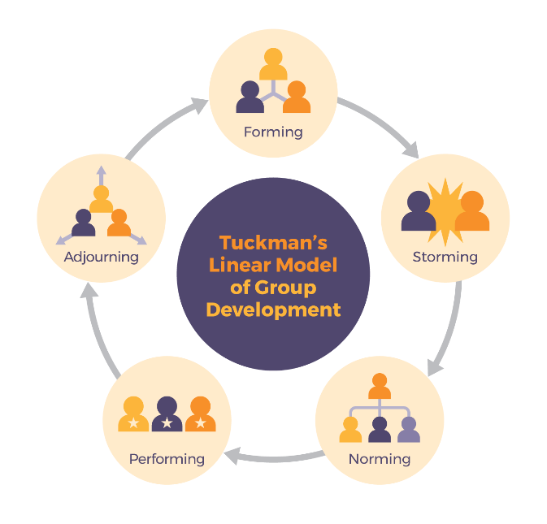
According to Bruce Tuckman's (1965) FSNP model, highly effective teams go through five stages.
Figure 1: The Stages of the Tuckman Model (1965)
The initial phase of team formation is called "forming." People get to know one another as well as the team's aims and objectives.
Storming: Difficulties appear at this point. These could be concerns with co-workers or problems with the project. This phase is necessary for the best group cohesion and functioning, despite being uncomfortable for some people.
Norming: During this phase, the team develops its identity, has tested its boundaries, and (hopefully) grows closer after experiencing disagreement. At this point, teams solidify their relationships while also becoming more well-organized. While job efficiency rises, relationships get deeper. The storming phase has now officially been replaced by a renewed dedication to the group's objectives, leading to the analysis and revision of standards, roles, and relationships.
Performing: This phase shows the team operating at its most effective and productive level. Sadly, not all teams are able to reach this successful stage. Many groups are still trapped in an earlier stage.
Groups are getting ready to break up at the adjourning stage of group development as it has completed its mission. Plans for joint initiatives in the future may be present at this point.
To build a productive team, a manager should take the initiative and apply a methodical strategy, such as a model of team development like Tuckman’s model.
A comparable linear model with many of the same features as Tuckman’s model was later created by Susan Wheelan (1999) which could also be successfully applied to our case study.
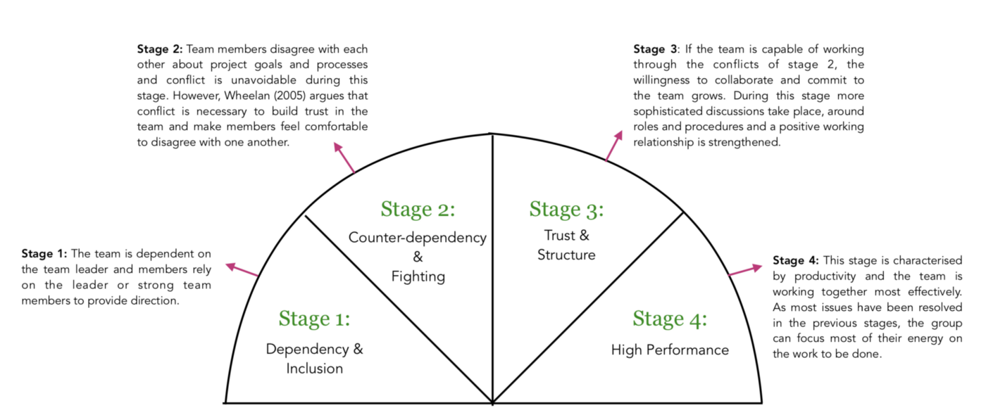
Figure 2: Integrated Model of Group Development | Source: Wheelan (2005)
Tom could use this model as an alternative considering they are quite similar. However, it confirms maturity through time by assessing how long a group has been together, their verbal behavior in relation to this, as well as the perceived stage of team development.
- Team roles
Members of teams fulfil a variety of tasks and duties as they work toward shared objectives to support the group effort. According to Belbin (1981), a team's success depends on each member's tasks and responsibilities, and he outlines nine roles for teams as can be seen from the table below.
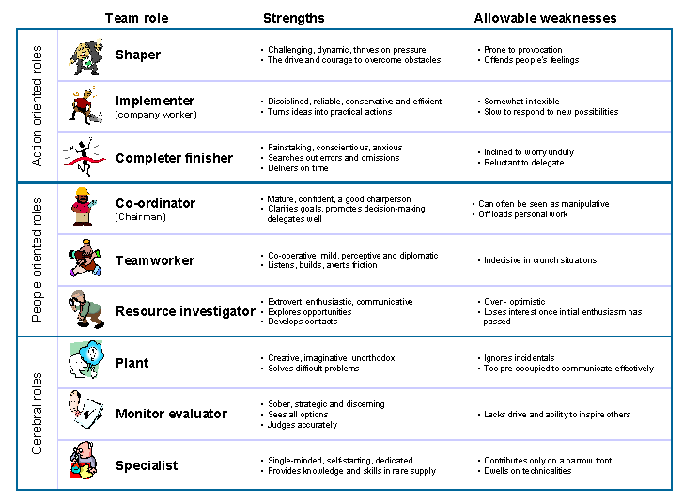
Figure 3: Belbin’s team role model (1981)

What are the roles needed to create a cohesive and effective team?
All nine team roles should be fairly distributed across an ideal team. A strong coordinator, a plant, a monitor evaluator, and one or more implementers, team workers, resource investigators, or completer finishers are typical members of strong teams. Instead of having both, a shaper should be an alternative to a co-ordinator. The ideal situation rarely arises in reality, so it might be helpful for a team to determine which team functions are either overrepresented or absent as well as the individual’s secondary roles.

Theories relating to team roles when selecting a team
Understanding the task that the team is expected to complete is the first step in team formation. Once that has been determined, it is time to start choosing and recruiting the team members who will provide the group with the best chance of achieving its goals. The variety of team roles is crucial because it helps teams (Pollock, 2009) define roles, innovate, and offer a clear understanding of the duties and team goals. A balanced team is generally more productive in terms of leadership, competence, motivation, goal attainment, communication, skills, and creativity, according to academics. Diverse teams are more likely to succeed, especially when working on projects that demand originality and imagination.
While task-related expertise should be taken into account when selecting potential members, excellent candidates also need to have excellent interpersonal skills.
Scott Page (2007) compares diversity to a toolkit to describe it. He says that each person has a unique toolkit, as well as a unique set of viewpoints and cognitive abilities.

Why is it important to consider these roles when selecting a team?
Each team member should ideally have knowledge and abilities relevant to their tasks as well as collaborative abilities. Members become frustrated and performance suffers when duties are vague and unclear. However, miscommunications and process losses can be reduced when everyone is aware of their place within the group.
Team members' roles are clarified and assigned effectively when they:
- Encourage the team to establish high expectations for the quality of the work that each member contributes.
- Are willing to work outside of their defined duties when necessary.
- Make sure that team members' tasks are distributed equally.
- Openly debate and agree upon what each team member's responsibilities will be.

Discussion
Research from the past has demonstrated that teams that are diverse in terms of roles and personality types perform better. Teams must have clearly defined roles in place when high levels of interdependence are necessary for success (Allen, Sargent, & Bradley, 2003).
Teams have many advantages, but most of these advantages can only be attained in strong teams. When the team works together and divides the job, it may enhance work organization, boost motivation, and increase production. Frequently, teams will be more knowledgeable than a single person is on any given topic. Additionally, the process of team meetings and deliberation can encourage critical thinking and introspection, which can result in decisions of high quality and better problem-solving.
To function at their best, teams must establish trust, identity, and efficacy as they embark on their journey together (Griffith & Dunham, 2015, p6).
Five distinct difficulties or team dysfunctions that frequently inhibit groups from reaching their potential have been identified by Lencioni (2002, 2005).
The lack of confidence in teams is one of the most damaging issues he has seen. When team members have confidence in their teammates' abilities, diligence, and dedication to the group, trust is created. In contrast, a lack of trust fosters a stressful atmosphere where people hold back and are hesitant to work toward common objectives or communicate openly. Without trust, teams are hesitant to address critical problems, which makes team members fear conflict.
Lack of commitment to the group is then brought on by a fear of speaking up and challenging the status quo. The avoidance of accountability results from members not offering their utmost effort due to a lack of commitment. People don't like to be held responsible; thus, they don't hold other group members responsible for achieving the group's objectives. Lastly, without shared accountability and commitment, team members will frequently prioritize their own agendas over the needs of the whole and show a lack of interest in outcomes, which is the case of Mihaela and Spencer.
The degree of each member's dedication helps to the group's overall power. Effective leaders pay close attention to group dynamics from the start to evaluate each member's degree of commitment and deal with those whose engagement is inadequate.
Work distribution within a team has a significant impact on how well it performs. Before assigning tasks, groups should consider how they will handle the workload in order to minimise issues with work equity.
Misunderstandings and irritation can frequently result from variations in how individuals interact. Fortunately, once they are identified, many prevalent interpersonal issues can be reduced. Conflict, however, frequently has an impact on both team members and the environment of the team, even in the best of conditions. Nevertheless, not every conflict is negative.
Strong cohesion and team success can result from the proper kind of conflict, which is a defining trait of high-performing teams. The quality of group decisions can be raised, innovation can be sparked, and a team's cohesion and trust can be strengthened when conflict is handled well.
Tom must choose the correct team members for the project, with diverse skills beneficial in addressing any issues because one may easily fill in for the other or share the other's tasks that contribute to the project's success. Additionally, they must establish trust, agree on duties, and actively concentrate on achieving the team's goal, only in this way they can pass from the storming stage they are in, to the next stage and collaborate well. Conflict is important to create a culture where members appreciate the benefits of disagreement like in the case of Mihaela and Spencer and they can overcome any issue through communication.
- Conclusion and recommendations
To conclude, I believe that a team must go through each stage of Tuckman's model because that is how a team generally develops to maximize performance and results, furthermore this model can be used on a small team.
A balanced mix of team members' attributes and the availability of the resources required to accomplish the team's objectives are essential for its success. Tom needs to conduct group meetings regularly and provide a proper means of communication for them to use and share information, such as an email address so they can communicate any issues they have, given that they are in the initial stages of the team development. Active listening and assertiveness are two communication qualities that contribute to more transparent information processing and in my point of view the most important strategy for getting things done.

- Reference List
Aranzabal, A., Epelde, E. and Artetxe, M. (2022). Team formation on the basis of Belbin’s roles to enhance students’ performance in project based learning. Education for Chemical Engineers, 38, pp.22-37.
Beal D. J., Cohen R. R., Burke M. J., McLendon C. L. (2003). Cohesion and performance in groups: A meta-analytic clarification of construct relations. Journal of Applied Psychology, 88, 989–1004.
Bressler, K., Ishibashi, R. and Mancini, E. (2020). A Kick of Productivity for Teams: Determining Effective Teamwork.
Casey-Campbell M., Martens M. L. (2009). Sticking it all together: A critical assessment of the group cohesion–performance literature. International Journal of Management Reviews, 11, 223–246.
Chiocchio F., Essiembre H. (2009). Cohesion and performance: A meta-analytic review of disparities between project teams, production teams, and service teams. Small Group Research, 40, 382–420.
Coyle, D., (2018). The culture code: The secrets of highly successful groups. Bantam.
Figure 1: Ifm.eng.cam.ac.uk. (2022). Belbin's team roles. [online] Available at: https://www.ifm.eng.cam.ac.uk/research/dmg/tools-and-techniques/belbins-team-roles/ (Accessed 11 October 2022)
Figure 2: Medium, (2022). Managing International Project Teams. [online] Available at: https://medium.com/@alex.schwartz/managing-international-project-teams-f78406179def (Accessed 16 October 2022)
Figure 3: Last, S. (2022) 4.2 Five Models for Understanding Team Dynamics. [online] Pressbooks.bccampus.ca. Available at: https://pressbooks.bccampus.ca/technicalwriting/chapter/understandingteamdynamics/ (Accessed 16 October 2022)
Eve Ash, & Seven Dimensions (2020). Open Communication and Teamwork. [video] Available at: https://video.alexanderstreet.com/watch/open-communication-and-teamwork. Melbourne, Victoria: Seven Dimensions.
Griffith, B.A. and Dunham, E.B. (2014). Working in teams: Moving from high potential to high performance. Sage Publications.
Jones, A., Richard, B., Paul, D., Sloane K., and Peter, F. (2007).” Effectiveness of team building in organizations” Journal of Management.
Lencioni, P. (2002). The five dysfunctions of a team: A leadership fable. San Franscisco, CA: Jossey-Bass.
Lencioni, P. (2004). Death by meeting. San Francisco, CA: Jossey-Bass.
Lencioni, P. (2005). Overcoming the five dysfunctions of a team: A field guide for leaders, managers, and facilitators. San Francisco, CA: Jossey-Bass.
Parker, G.M. (2008) Team players and team work : new strategies for developing successful collaboration. 2nd ed. San Francisco, CA: Jossey-Bass.
Pollock, M. (2009). Investigating the relationship between team role diversity and team performance in information systems teams. Journal of Information Technology Management, 20(1), pp.42-55.
Sanyal, S. and Hisam, M.W. (2018). The impact of teamwork on work performance of employees: A study of faculty members in Dhofar University. IOSR Journal of Business and Management, 20(3), pp.15-22.
Tseng, T., Huang, C., Chu, H. and Gung, R. (2004). Novel approach to multi-functional project team formation. International Journal of Project Management, 22(2), pp.147-159.
University of Cambridge (2022). Belbin's team roles. [online] Available at: https://www.ifm.eng.cam.ac.uk/research/dmg/tools-and-techniques/belbins-team-roles/ (Accessed 11 October 2022)

