Report on Elizabeth Line Assigment 1
Mirela L Andrei 1918400
LCBB5005
Dr Molly Jack

TABLE OF CONTENTS
Introduction 3
Main body 3
Conclusion 9
References 11

Introduction
Project management is the process that involves the planning and organization of the company's resources to move a particular task towards completion (San Cristóbal, et al. 2018). Cross rail is a railway construction project which is majorly in central London. The main goal of the above construction project is to facilitate a high-frequency hybrid commuter rail facility for the public. The project is known as the Elizabeth Line in the hand of Crossrail limited company which is responsible for the construction and delivery of the project (Crossrail, 2022). It is the new railway for London and the South East that runs from reading and heat throw in the west. It will run through 42KM of new tunnels under central London to Shenfield and abbey wood in the east. The idea of the Elizabeth Crossrail project comes from the failed initial attempt to cross the London railway in 1990 (Crossrail, 2022).
The idea has developed by Transport for London, and the Department of Transport started in the year 2001. The Crossrail Elizabeth line project was expected to be completed in the year 2008 (Crossrail, 2022). The primary purpose of the above-selected project is to increase the capacity of the central London rail service by at least 10%. The railway line will be able to bring approx 1.5 billion people across London within only 45 minutes and cut the journey time. The Crossrail Elizabeth line is required to provide relief to commuters who travel on overcrowded rail lines on a daily basis. It also unlocks thousands of homes and jobs across the country.

Main body
The Crossrail is designed to connect the National Rail Networks in Surrey and Hertfordshire through an underground tunnel that runs across London. The project will drastically transform the connectivity capabilities of the regions, including the Euston and Victoria Junctions. Other than this, the Elizabeth line has been introduced to streamline the connectivity over London and cut the journey line (ITVNews, 2022). It is the historic railway line to transform the railway network that will play a crucial to London's recovery from the pandemic to provide new journey options for the capital. The Elizabeth line has the capacity to carry 270000 people at the time of peak morning each weekday. It also complements other national transports such as High Speed 2. The design of Elizabeth railway line is built to reduce crowding and journey times in 160-mile corridors (Crossrail, 2022).
The railway line was supposed to start in 2008 but due to some significant reasons. Hence this delay in the opening of the railway line has run the entire process slow and increased the completion time of the project. There were various reasons behind the uncertainty of the project that made a project delay with year and a half.
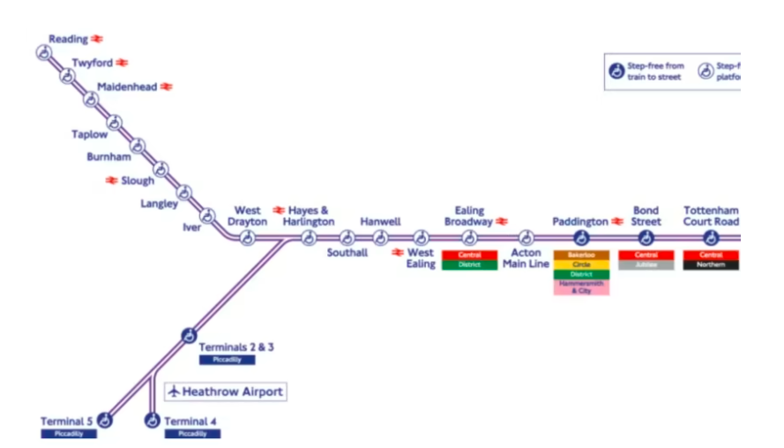
Figure 1: New Elizabeth Line
(Source: ITVNews, 2022)
After a year and a half of delay, the railway line opened on 24th May 2022 and was confirmed by Transport for London. After the introduction of the Elizabeth railway line, the rise in the UK economy can be seen on high. Hence it can be said that the cross-rail line has provided an economic legacy to the country. It is supporting the regeneration of the country by providing jobs and new transport links to the people through different stations. The new railway line will add approx £bn to the UK’s economy (Crossrail, 2022). There is no service for Sunday the railway line will also work on weekdays as on Sundays the railway line will be under testing. The engineers work on software updating for high intensity of services.
At the peak time, the railway line provides 22 trains per hour and 16 trains per hour during off-peak time. As per the view of Muruganandan, et al. (2022), the important thing about the Elizabeth railway line is that it maintains a transition between the central section and the surface section of the capital. The railway line has excellent operational safety performance, which is currently far better than the set target. Safety measure has been the top priority throughout the project completion.
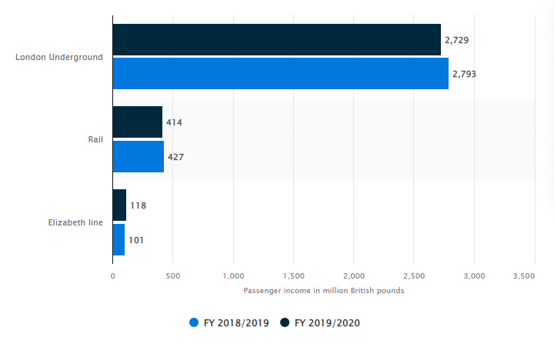
Figure 2: Income by Segment on TFL
(Source: Statista 2022)
The above figure represents the passenger income facilitated by TFL, which indicates that after the introduction of the Elizabeth railway line; there was a decrease in the passenger income in London Underground and TFL over the period. The figure represented an increase in passenger revenue and reached 118 million pounds (Statista 2022).
However, Hamalwa, (2019) argued that with the unique and high capacity of the Elizabeth railway line, there are some people who are pointing out some issues with the cross rail trains. Further, it has been recorded that the London transport chief has come out that there are some issues and challenges with cross rail trains, but there is no risk presented for passengers and workers.
After the issues pointed out by people, the problem has risen in the meeting of the London Assembly that the door of the cross railway line is made of a metal box, and it has blown off the hinges at the time of testing, which leads to the fear of any injury (Chen, et al. 2018). The issue was settled as there is a rare risk of any harm, and the door has zero potential for any danger.
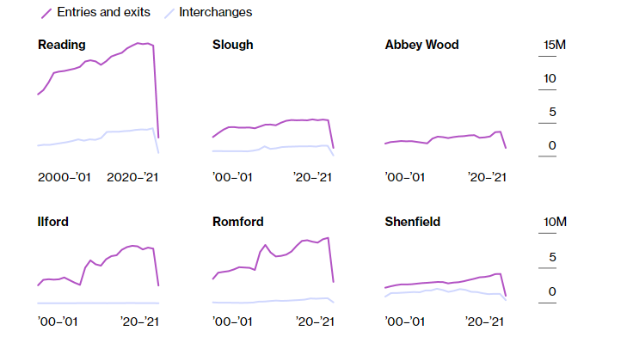
Figure 3: Increase in Annual Passenger at Commuter
(Source: Bloomberg, 2022)
With the development of the Elizabeth Crossrail way line, there has been a high increase in the annual number of passengers as it connects outer suburbs directly to the string of new stations in the capital (Bloomberg, 2022). Moreover, a number of commuters are able to reach their home from straight stations without the requirement of transfer to the Tube.
However, Nyambayo, et al. (2020) opposed that the entire management of the cross railway line was affected due to the delay. The main reason behind the uncertainty of the project was the pandemic. Almost all of the work of the project has been affected due to the occurrence of a pandemic. It has been observed that the pandemic has added an extra cost of £234 million to the project budget. The original budget of the project was £14.8bn which has proved wrong, and the scheme failed to meet its December 2018 opening date (ITVNews, 2022).
Other than this, the development of the Elizabeth cross railway line will make a better life for the communities and other stakeholders. The Crossrail line will add 30 fully accessible stations to the network and cut the average time to travel by 20%. As the region has filled with aged people, and the ageing population is increasing over the period and will reach 79% by the year 2037. Hence the Elizabeth cross railway project will provide opportunities to aged people and people with disability (RailwayTechnology, 2022).
After the increase in the cost of the project, it was expected to be open in 2021, but later it was recorded that the railway line would open on the first of 2022. Another reason for the delay in the opening of the Elizabeth cross railway line is that the safety measures and testing take an extended period, which has increased the timeline of the project completion. The work for safety measures and testing started before the arrival of the pandemic but later took too much time. The singling system, which was required to integrate with the cross line, went through various testing measures that also led to the delay of the cross railway line. It has also been evaluated that the reason that made the development of the project was delayed was the performance of stakeholders (McNaughton and Banks, 2021). The stakeholders who were involved in the development of the Elizabeth cross railway line were not performing their tasks well. The Elizabeth project was one of the most significant projects that happened in the country, which needed the eye of every stakeholder to complete in the desired manner. The designs and the map of the project were not available at the time, which increased the time period of the project.
Other than this, the changes in the legal and political environment were also responsible for to delay in the Elizabeth project in the year 2010. This year due to the changes in the political environment, the budget for the respective project was cut down by £1bn which slowed down the entire process and the speed of the project. Later the National Audio Office of the UK announced that the opening of the Elizabeth crossline would delay (Milillo, et al. 2018). Along with this as the project has associated with different risk that leads to further uncertain and undesired incidents that harm the workforce of the project management. The uncertain incidents and accidents result in various unnecessary legal procedures against the company, and the company has to pay a considerable amount as compensation. Thus after the undesired accidents, the working environment of the project has affected as each, and every stakeholder and the workers were in threat of their life (Trilla Cisa and Barros, 2021).
Other than this, there was several risk factors that were associated with the project and made it process slower, which led to delays in the completion of the project. The workers who were working in the tunnel were at a high risk as there were vast chances of occurrence of any uncertain accident and event. The UK is considered the leading country for building unique and transformational infrastructure across the world. Hence working on the largest project, the TFL was expected to finish the work on time, within budget and required facilities (Newlove-Eriksson, 2020). The UK has been facing a housing crisis that makes life harder for millions of people and limits the future growth of the country. The Confederation of British Industry has recorded that 59% of businesses consider housing as the challenge that makes the recruitment and retention of employees more complex and difficult.
The development of the Elizabeth cross railway line project has increased the development of housing by 85%, and the number of housing has been built in every kilometre of a Tube station across London. Hence with the development of cross railway lines and increasing transport connections, the capital will lead to 200000 new homes. As per the report of property consultancy, GVA recorded that the Elizabeth project will be a catalyst for the regeneration of the capital. As per the report, a huge number of new homes with 90000 have predicted with route by the year 2021, and it will reach get double and reach 180000 by the year 2026 (Crossrail, 2022).
Other than this, the project has provided the cheapest locations for the local people of the capital to buy a house or flat along the Crossrail route.
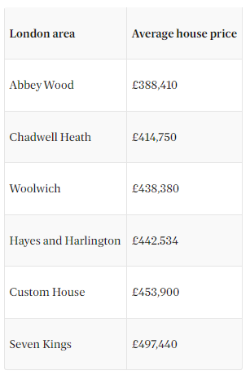
Figure 4: Cheapest Crossrail Locations for House
(Source: PropertyNews, 2022)
Abbey Wood in south London was the cheapest location to buy a house or flat along the Elizabeth line. In the case of buying flats, the Abbey wood locations were on the fifth rank that has the lowest price for flats (PropertyNews, 2022). The location of Abbey Wood has gained strong growth in the price of the house due to the redevelopment and regeneration of the area with the introduction of Elizabeth across the railway line.
On the other side, the Elizabeth cross railway line has added a new level to the entire railway network in London. The carriages are spacious and wider and stretch over 200 meters long with a capacity of 1500 passengers. The trains provide a facility in place to alert and speak to the driver in case of any emergency. The main positive thing about the stations of the Elizabeth cross railway line is that all the stations are available for full access from day one. There are various features such as wide access gates and the installation of help points at every platform.
However, Macchiarulo, et al. (2019) contended that there is no lack and negative point about the design of the project, but the only negative point is that the TFL were unable to meet the request of people about toilet on board. The older and disabled people are unable to find usable toilets, which leads the stress and anxiety in aged people. Another drawback about the Elizabeth cross railway line is that the grab poles are black and silver in colour, which troubles the people who are suffering from visual impairment to see them (Muruganandan, et al. 2022). Other than this, the plan has been effectively implemented and contributes to the economy of the country.
Moreover, the development of the Elizabeth project has improved the travel experience of passengers and made it more comfortable as it serves spacious trains and newly refurbished stations. Other than this, the stations are staffed from the first train to the last train, along with turn up and go service provides to any passenger that needs assistance. The new journey option of the Elizabeth project will help the capital ignore car-led travel from the pandemic and improve the redevelopment of the country (Lawrence, Menkiti and Black, 2018). The project also provides job and business opportunities to the population. Approx 1.5 million people get the opportunity through the project.

Conclusion
Hence from the above analysis, it can be concluded that the Elizabeth cross railway line was the largest project in London. It has been identified that the project includes new stations, infrastructure and new stations. Along with this, it has increased the railway network across the capital and enhanced the capacity of the railway network. The introduction of the respected project has decreased the travel time and cut the journey time as it connects the east to the west railway network. It has been determined that the Elizabeth project has experienced various challenges and issues through which the entire project gets delayed. There were several reasons behind the delay in the opening of the project. Due to the issues and the challenges, the budget of the project went out of control. Due to the imbalance in the budget, the efficiency of the project has been affected, and each step has become slow, which leads the delay. It has been discovered that the key reason this project opening failed was the occurrence of covid 19 pandemic. Other than this, the safety design and signalling system of the project that takes a lot of time and repeated tests were required in the project. It has been determined that the Elizabeth cross railway line has provided new home opportunities to the local people of the capital. The project enhanced the growth of underserved areas of the capital by linking transportation across London. This growth of underserved areas has increased the regeneration of the areas and enhanced the quality of the areas. Other than this, it has been determined that the Elizabeth cross railway line offered employment to the local people in London and increased business opportunities that contributed to the economy of the country. The respected project has boosted the capacity of the significant stations, including Waterloo Street, which creates space for other services in the capital. It has been discovered that the cross-line project has leveraged the capacity of rail services at each step as it increases various features that were not presented in the existing system of railway network. It leads the number of passengers who travel on a daily basis from Heathrow to Shenfield and increases the revenue of the entire railway system.

Recommendations
Below are the recommendations to the management department of the Crossrail:
- It is recommended to the Cross rail and Hackney to southwest London routes that they should restructure the scheme development so that the project can be completed on time and as per the expectations (Lawrence, Menkiti and Black, 2018). The restructuring of the scheme will help the department to gain the objective of project management.
- It is suggested that the cross rail department should implement a procurement strategy that should be aligned with the vision and value of the project. It will help the TFL for the next ten years program of the Elizabeth Crossrail line in London (Chen, et al. 2018). Other than this, implementation of this strategy will improve decision-making through design, construction and commissioning and reduce the impact of the project.

References
Bloomberg, 2022. Increase in Annual Passenger at Commuter. [Online]. Accessed through: < https://www.bloomberg.com/graphics/2022-uk-elizabeth-tube-line-opening/v>. [Accessed on: 30th August 2022].
Chen, Y., Biscontin, G., Pillai, A.K. and Nicholson, D.P., 2018. Back-analysis of Crossrail deep excavations using 3D FE modelling—development of BRICK parameters for London Clay. In Numerical Methods in Geotechnical Engineering IX (pp. 1145-1153). CRC Press.
Crossrail, 2022. Building the Elizabeth Line. [Online]. Accessed through: < https://www.crossrail.co.uk/project/ >. [Accessed on: 30th August 2022].
Crossrail, 2022. Delivering the Elizabeth Line. [Online]. Accessed through: < https://www.crossrail.co.uk/project/our-plan-to-complete-the-elizabeth-line/ >. [Accessed on: 30th August 2022].
Crossrail, 2022. Number of Homes and Jobs Created by Elizabeth Line. [Online]. Accessed through: < https://www.crossrail.co.uk/news/articles/number-of-homes-and-jobs-created-by-delivery-of-elizabeth-line-far-exceeds-predictions >. [Accessed on: 30th August 2022].
Crossrail, 2022. Crossrail Project Elizabeth Line. [Online]. Accessed through:< https://www.crossrail.co.uk/project/our-plan-to-complete-the-elizabeth-line/>. [Accessed on: 30th August 2022]
Hamalwa, J., 2019. The use of life cycle cost analysis in determining the cost effectiveness of railway lines' design and maintenance options for railway lines through windblown sandy desert in Namibia: Case study of the Aus-Luderitz railway line (Doctoral dissertation, University of Namibia).
ITVNews, 2022. New Elizabeth Line. [Online]. Accessed through: < https://www.itv.com/news/london/2022-05-04/elizabeth-line-opening-date-announced-but-railway-will-be-shut-one-day-a-week >. [Accessed on: 30th August 2022].
Lawrence, U., Menkiti, C.O. and Black, M., 2018. Regional-scale groundwater investigations for the Crossrail project. Quarterly Journal of Engineering Geology and Hydrogeology, 51(1), pp.31-37.
Lawrence, U., Menkiti, C.O. and Black, M., 2018. Regional-scale groundwater investigations for the Crossrail project. Quarterly Journal of Engineering Geology and Hydrogeology, 51(1), pp.31-37.
Macchiarulo, V., Giardina, G., Milillo, P., González Martí, J., Sánchez, J. and DeJong, M.J., 2019. Settlement-induced building damage assessment using MT-InSAR data for the Crossrail case study in London. In International Conference on Smart Infrastructure and Construction 2019 (ICSIC) Driving data-informed decision-making (pp. 721-727). ICE Publishing.
McNaughton, A. and Banks, N., 2021, February. HS2 railway, UK: route optioneering. In Proceedings of the Institution of Civil Engineers-Transport (Vol. 174, No. 1, pp. 12-24). Thomas Telford Ltd.
Milillo, P., Giardina, G., DeJong, M.J., Perissin, D. and Milillo, G., 2018. Multi-temporal InSAR structural damage assessment: The London crossrail case study. Remote Sensing, 10(2), p.287.
Muruganandan, K., Davies, A., Denicol, J. and Whyte, J., 2022. The dynamics of systems integration: Balancing stability and change on London's Crossrail project. International Journal of Project Management, 40(6), pp.608-623.
Muruganandan, K., Davies, A., Denicol, J. and Whyte, J., 2022. The dynamics of systems integration: Balancing stability and change on London's Crossrail project. International Journal of Project Management, 40(6), pp.608-623.
Newlove-Eriksson, L., 2020. Accountability and patchwork governance in urban rail interchanges: junctions of London Crossrail and Stockholm City Line compared. Public Works Management & Policy, 25(2), pp.105-131.
Nyambayo, V., Chandrashekharaiah, N., Gray, C., Allum, D., Koka, E. and Asare, M., 2020, August. West Anglia main line upgrade–a geotechnical perspective. In Proceedings of the Institution of Civil Engineers-Transport (Vol. 173, No. 4, pp. 258-272). Thomas Telford Ltd.
PropertyNews, 2022. Cheapest Crossrail Locations for House. [Online]. Accessed through: < https://www.standard.co.uk/homesandproperty/property-news/elizabeth-line-launch-cheapest-places-to-buy-house-flat-crossrail-b1001853.html >. [Accessed on: 30th August 2022].
RailwayTechnology, 2022. A Timeline of Crossrailway delay. [Online]. Accessed through: < https://www.railway-technology.com/analysis/timeline-crossrail-delays/#:~:text=March%202020%3A%20the%20pandemic%20leads%20to%20further%20delays&text=After%20saying%20that%20costs%20had,of%20the%20Covid%2D19%20pandemic. >. [Accessed on: 30th August 2022].
San Cristóbal, J.R., Carral, L., Diaz, E., Fraguela, J.A. and Iglesias, G., 2018. Complexity and project management: A general overview. Complexity, 2018.
Statista 2022. Income by Segment on TFL. [Online]. Accessed through: < https://www.statista.com/statistics/1169750/transport-for-london-passenger-income-by-rail-segment/ >. [Accessed on: 30th August 2022].
Trilla Cisa, D. and Barros, J., 2021. Ex-ante evaluation of accessibility impacts of Crossrail projects in London.

