LCBB6000 Dissertation

Student Name: Anton Antonov
Student ID:

Abstract
Social media marketing is the most important factor to consider for hotel business in the hospitality industry, where it needs to ensure a large community with customers worldwide. This study aims to assess the impact of social media marketing in the hospitality industry in the light of Premier Inn of London. For this research purpose, the primary data has been collected from a sample set of 50 employees of Premier Inn within the London hotel chain, and the samples are selected through snowball sampling. From the data analysis, some key findings are found, such as the awareness of SMM among the employees. The company uses various SMM tools, including Facebook, YouTube, TripAdvisor, and LinkedIn, to share content, seasonal marketing, and create influencers. This platform seems advantageous for the business, although it also creates some challenges.

Acknowledgement
Firstly, I would like to express my gratitude to my course instructor, who has provided the opportunity to conduct research, helped me choose the topic, and provided the guidelines to complete it properly. Then, I want to thank Premier Inn employees (respondents) who have provided valuable time to contribute to my research. At last, I thank all of my friends and classmates who helped me complete this research.

Table of Contents
Abstract 2
Chapter 1: Introduction 7
1.1 Background of the Study 7
1.2 Rationale of the Study and Literature Gap 8
1.3 Research Aim, Objectives, and Questions 8
1.4 Structure of the Dissertation 8
Chapter 2: Literature Review 10
2.1 Social Media Marketing and its Characteristics 10
2.2 How Hotels Maintain Social Media Marketing 11
2.2.1 Global Social Media Strategies 11
2.2.2 Media-Specific Social Media Strategies 12
2.3 Honeycomb Model of Premier Inn 13
2.4 Race Model of Premier Inn 14
2.5 Advantages of Social Media Marketing 15
2.6 Disadvantages of Social Media Marketing 15
2.7 Summary 16
Chapter 3: Methodology 17
3.1 Research Onion 17
3.2 Research Philosophy 18
3.3 Research Approach 18
3.4 Data Type 18
3.5 Sampling Method, Size, and Type 18
3.6 Data Collection and Analysis Methods 19
3.7 Ethical Considerations 19
3.8 Summary 20
Chapter 4: Data Analysis and Findings 21
4.1 Data Analysis 21
Demographic Description 21
Analysis 1: Awareness of Social Media Marketing concept 22
Analysis 2: Usage of Social Media Marketing tools 23
Analysis 3: Preferable Ways to ensure Social Media Marketing 23
Analysis 4: Preferable Media-specific Social Media Marketing Strategies 24
Analysis 5: Advantages of Social Media Marketing 24
Analysis 6: Disadvantages of Social Media Marketing 25
4.2 Findings and Discussion 26
Chapter 5: Conclusion and Recommendations 28
5.1 Conclusion 28
5.2 Recommendations 28
Chapter 6: Further Research 29
References 30
Appendix 32
Questionnaire 32

List of figures:
Figure 1. Social Media Marketing Model 9
Figure 2. Honeycomb Model 12
Figure 3. RACE Model 13
Figure 4. research Onion 16
Figure 5. Gender of Respondents 20
Figure 6. Age of Respondents 20
Figure 7. Work experience of respondents 21
Figure 8. Awareness of Social Media Marketing concept 21
Figure 9. Usage of Social Media Marketing tools by Premier Inn 22
Figure 10. Preferable Ways to ensure Social Media Marketing by Premier Inn 22
Figure 11. Preferable Media-specific Social Media Marketing Strategies by Premier Inn 23
Figure 12. Advantages of Social Media Marketing for Premier Inn 23
Figure 13. A disadvantage of Social Media Marketing for Premier Inn 24

Title: To Explore the Impacts of Social Media Marketing Within the Hospitality Sector in London: A Study on Premier Inn

Chapter 1: Introduction
In modern technology, social media marketing has gained huge growth and grabbed the attention of business people. Social media marketing has established an image that it can increase the sales and revenue of a business entity irrespective of the business type and size (Carvell, 2020). Moreover, technological advancements or blessings are behind such attention to social media marketing. The rate of online users is increasing a great deal, and at the same time, the business people are developing their online business sites by investing in their IT departments more and more (Chan and Guillet, 2017). So, now the businesses are based on data, information, and content, and such things are reached to the buyers or consumers through social media marketing. So, this study will show how social media is used for marketing in the hospitality industry and how it impacts businesses.

1.1 Background of the Study
Social media is a relatively new media for marketing purposes, but the popularity it has gained within the short period is undeniable. There is also great potential for social media marketing in the hospitality industry (Choi and Fowler, 2015). The hospitality industry seemed international from the beginning as the tourists visited the tourist places and stayed in the hotels or resorts. Moreover, business people must attract people to visit and stay there (Gbadeyan, 2021). So, to cross the international barriers easily and grab the attraction of international tourists, social media platforms' efforts are beyond telling. Among the hospitality industry, the hotel and resort businesses are greatly using social media to market their services, accommodation packages, special packages, discounts, and offers to the people of concern through Facebook, YouTube, Twitter, Flickr, Tour Advisor, Blogger, Etc. For video advertisements, hotels mostly depend on YouTube to show the tourists or clients the distinct features of their hotels and resorts (Guillet and Kucukusta, 2015).
Premier Inn, one of the largest hotel chains in the United Kingdom, headquartered in London, also has a presence on the online social media marketing platforms to provide information to the consumers, attract them, and invite them to come, visit, and stay at the hotels in their leisure periods and it ensures them to provide a lively and enthusiastic holiday experience to them (Guillet and Kucukusta, 2015).

1.2 Rationale of the Study
According to Ibrahim (2021), the marketing activities for the hotel industry are compulsory to do by using social media platforms. This marketing platform helps the businessman engage with the customers directly and can be a part of their tour or next holiday plans. Also, there is a review system on the websites of the hotels and resorts where the clients can show the reviews of other stayers and take an immediate decision to stay there or not. According to Khmiadashvili (2019), the marketers need to ensure there are no customers who are dissatisfied with the hotel services because any small negative review can discourage the potential customers of the hotel from selecting this hotel to spend their leisure period. According to Kim (2018), the marketer must effectively use social media to encourage tourists to visit and book the accommodation facilities. According to Mohammed and Al-Swidi (2019), this study aims to get an in-depth insight into the impacts of social media marketing on the hospitality industry where the focus area will be the strategies used by hotel industries and the areas of inadequacy where they need to improve it.

Literature Gap:
From the secondary data study, it is come to know that for the hotel business and hospitality industry, the impact of social media marketing is indispensable, and it helps the businesses to engage with customers and retain them with the brand. Thus, this study will figure out how social media marketing impacts the hospitality industry and what strategies are effective in this concern.

1.3 Research Aim, Objectives, and Questions
Research Aim: The research aims to assess the effects of social media marketing on the hospitality industry in terms of the Premier Inn hotel chain.
Research Objectives: To achieve the aim, some specific objectives have been formulated, which are given as follows-
- To gain insights about social media marketing.
- To analyse the different social media marketing strategies implemented by hotel businesses?"
- To assess the advantages and disadvantages of social media marketing for Premier Inn.
- To assess the impact of social media marketing on the overall hotel businesses.
Research Questions: to meet the specific objectives, some research questions are formulated, which are given as follows-
- What is social media marketing?
- What are the different social media marketing strategies implemented by hotel businesses?"
- What are the advantages and disadvantages of social media marketing for Premier Inn?
- What is the impact of social media marketing on overall hotel businesses?

1.4 Structure of the Dissertation
The entire dissertation is conducted by maintaining 6 separate chapters. Chapter one shows the background of the research, rationale, purpose, aim, objectives, and questions. The 2nd chapter shows the theoretical parts to support the objectives in the light of existing literature where the concept of social media marketing, ways of maintaining social media marketing by hotels, and the advantages and disadvantages are shown. Chapter three will focus on the research methodologies, including the research onion, philosophy, approach, data type, sample size and method, data collection method, and data analysis tools. Chapter 5 will analyse the primary data collected from 50 employees using graphs, charts, and tables. Chapter 6 will discuss the major findings based on the analysis part in the light of the literature review. Moreover, chapter six will conclude the research findings for overall hotel businesses and mention the required recommendations for improvement areas.

Chapter 2: Literature Review
According to Mohammed and Al-Swidi (2019), organizations are utilizing far-reaching technology in their hospitality or especially the hotel businesses, in terms of marketing, promotional, and advertising activities, and thus, the businesses are now situated in the centre place around the customers. According to Nuseir and Elrefae (2022), through social media marketing, marketers primarily focus on innovation and creativity to make a convenient way to broadcast content. This section will provide an overview of social media marketing (SMM) and its features, various strategies, or tools of SMM, and the advantages and disadvantages of SMM in the light of hotel businesses such as Premier Inn.

2.1 Social Media Marketing and its Characteristics
According to Nuseir and Elrefae (2022), social media marketing or SMM is adopting promotional activities for any products and services using the social media platforms such as Facebook, WhatsApp, YouTube, Instagram, LinkedIn, Etc. According to Reginold, Gnanabasharan, and Sivanenthira (2019), the promotional or marketing activities start with selecting the appropriate marketing strategy of how the marketing content will be delivered to the customers, developing content for the products or services that must be attracting, simple, and easy to understand, then implementing the content that is promised to the customers, tracking and measuring the success of the content, and at last analysing the results and making adjustments if any. This is how marketers are involved in social media marketing.
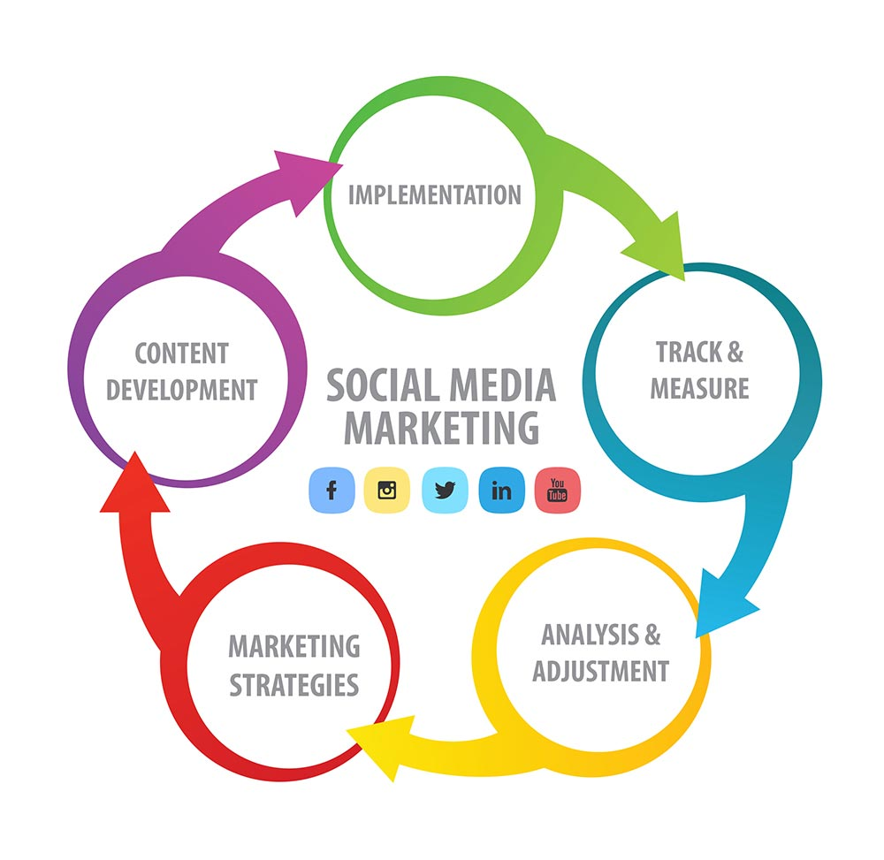
Figure 1. Social Media Marketing Model
Source: (Samanta, 2020)
There are distinct characteristics that must be present in social media marketing. Otherwise, the marketing purpose will not be implanted well. According to Samanta (2020), First of all, social media marketing enhances the participation of the wider audiences through their contributions or feedback where they can add their valuable ideas through engaging in online conversations and get a feel of engagement and impact of them in the marketing process. According to Singh and Diamond (2016), secondly, as the media helps to engage customers and organizations in a 2-way communication process, it ensures a reliable and friendly relationship between them and can increase their belongingness to the business in a fair way. The marketing activities must be transparent or open to the customers. That is what the business is doing, and what it says must be consistent and open to the customers. According to Stevenson, Hack-Polay, and Tehseen (2022), the marketing activity must ensure reliability for the company to the customers, and the business should build a trustworthy relationship with the audiences. Through social media, businesses can quickly build a community through Facebook pages or groups where like-minded people can share their interests in the products or services. According to Zimmerman and Ng (2012), and at last, the marketer needs to provide special care to the customer services through real-time responses, Etc.

2.2 How Hotels Maintain Social Media Marketing
According to Zimmerman and Ng (2012), hotel or resort businesses use almost 10 social media marketing strategies, which are grouped into 2 sub-groups: global social media marketing strategies and media-specific social media marketing.

2.2.1 Global Social Media Strategies
- Plan according to Seasonality: According to Carvell (2020), hotel businesses are mostly dependent on seasons, and they categorize seasons into 3 periods such as low seasons, mid-seasons, and peak seasons, and they need to keep different marketing contents in different seasons, such as, in low season, they need to advertise as 'Place to be' so people can plan for the next holidays there.
- Reputation Management: According to Gbadeyan (2021), the online platform is not only about providing booking or other services to the people. Rather, it helps to determine what aspects the hotel is excelling in and what areas they lack and provides ways to improve them. Such as, it puts both negative and positive reviews on the websites so that the customers can understand that their word is valuable.
- Creating Human Connection: According to Ibrahim (2021), the marketing should be in a way that can give a face of the hotel to the customers that are engaging more enthusiastic representatives to contact customers, creating contests and polls, and engaging with them through feedback or reviews.
- Understanding the Power of Influencers: According to Khmiadashvili (2019), the influencers are the pinpoint of the hotel business, and keeping healthy relations with them is also a part of marketing, and in the social media, they influence the potential customers to visit where they had gone before and for that they need to get special care by the marketers.
- Video Contents: According to Samanta (2020), there is a proverb that a picture can say a thousand words, but people do not catch the actual content when there is a large number of pictures in content, so they use video content with audio descriptions so that they can get it very interesting.

2.2.2 Media-Specific Social Media Strategies
- According to Khmiadashvili (2019), Facebook is very effective for the hotel marketing media in terms of cost and reach because it has no limits regarding words and videos, and it is a platform of vast online users and keeps them on track is easy here. The marketers can post stories, live videos, and share pictures of the hotels, location, room facilities, etc. to encourage tourists greatly.
- LinkedIn: According to Carvell (2020), it is the platform for sharing professional content regarding the hotel businesses because it is a place where there is a large conference of professionals, and the content regarding contests or conferences can be shared here to connect the other businesses in terms of partnerships or collaborations.
- TripAdvisor: According to Gbadeyan (2021), this media is essential for hotel business marketing. It is a great community of followers of the hotel website. The more followers, the more bookings, and the more bookings can make more reviews, and the more positive reviews can encourage more people to make more bookings. So, it is an organic way of marketing through word-of-mouth.
- Instagram: According to Ibrahim (2021), it is the most popular app after Facebook, and the Instagrammers constantly engage with each other. The hotel marketing staff can repost, provide a platform for questions and answers, provide updates, and highlight recent offers, discounts, freebies, Etc. The marketer can also share the tour guides, such as from planning to reaching the destinations, and they need to keep a business account to go far.
- According to Samanta (2020), YouTube is considered the largest search engine after Google, and social media marketing cannot be completed without YouTube. It can be used as traffic of direct channels to reach the potential customers through sharing videos of tours, destinations, time plans, alternative plans, guides, or showing the special services to the customers or tourists.

2.3 Honeycomb Model of Premier Inn
According to Lammers (2021), the honeycomb model is the process of discovering the most important determinants of social media concern that will help marketers and other users establish plans according to the important forces. In this model, there are 7 factors which should be considered to plan social media marketing activities by the marketers of hotel businesses.
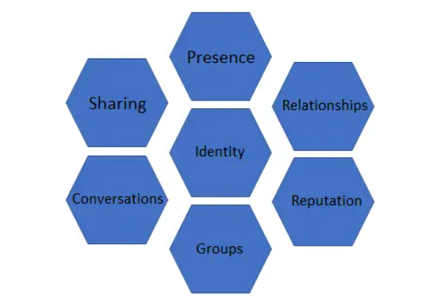
Figure 2. Honeycomb Model
Source: (Lammers, 2021)
According to Mohammed and Al-Swidi (2019), sharing implies the exchange, distribution, and reaching the information by the users and premier inn hotel chain shares recent videos, content, and various offers on the social media to reach the customers. Presence implies how well the customers know that the company's online presence is available. According to Khmiadashvili (2019), such customers of premier inn know well that it has a wider presence online through websites, webpages, Facebook groups and pages, Etc. Relationship implies how closely the customers and marketers are related to each other. Premier inn hotel chain engages its customers by providing them with the opportunity to keep reviews, and it values them. Reputation implies how to reach the company on social media platforms. According to Ibrahim (2021), Premier Inn is a very reputed hotel chain in offline and online media with lower negative reviews. Groups imply that people of similar interests form a community. Premier Inn has a Facebook community group and TripAdvisor community group where tourists interact with each other. The conversation has occurred between the customers and representatives of the company where the representatives of Premier inn help the customers by providing necessary and reliable information. According to Mohammed and Al-Swidi (2019), identity implies how well the marketers and consumers can reveal themselves as part of the company. The customers of Premier inn are marked with members of the hotel web groups.

2.4 Race Model of Premier Inn
According to Sestino, Prete, and Piper (2021), the RACE model implies how the marketers plan for a digital marketing strategy and what step needs to be done sequentially. To plan social media marketing, the marketer of Premier Inn needs to follow some steps-
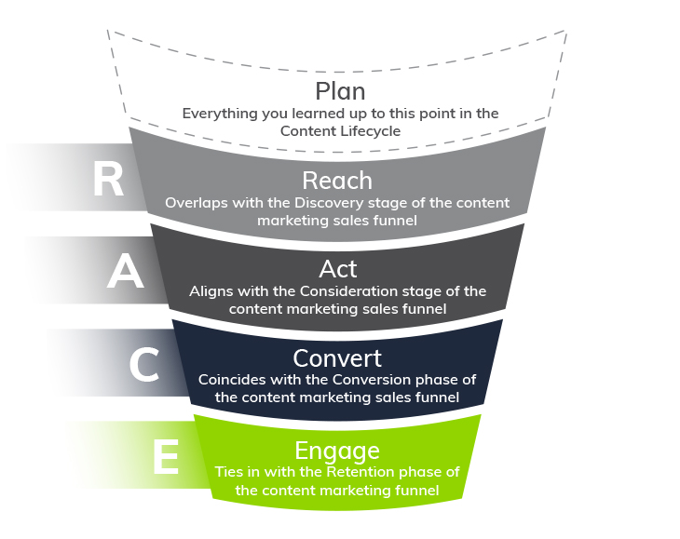
Figure 3. RACE Model
Source: (Sestino, Prete and Piper, 2021)
According to Mohammed and Al-Swidi (2019), the first step is to 'reach' where premier inn creates brand awareness among the offline through reputation and identity and by ensuring presence on websites, webpages, Etc. The second step is to 'act' where the hotel marketers share content on those online pages and sites to make the customers visit the websites to see the facilities, offers, packages, and pricing. According to Khmiadashvili (2019), the third step is to 'convert' where marketers want to convert the visitors into the purchasers by conversations with them about their queries. After that, they try to 'engage' the customers with the business by creating groups or communities where people can share their both positive and negative experiences with others.

2.5 Advantages of Social Media Marketing
Hotel businesses can get several advantages using social media marketing activities. According to Samanta (2020), SMM helps to create better customer satisfaction because through the social media advertisements, the company can directly talk with the clients, and from the advertisements, they can get their answers to relevant phases or through personalized conversations. It helps to create brand awareness because the people are mostly connected with the social media platforms, and to introduce a new brand or enhance the brand image of an existing business seems very effective. Also, people are engaging in this process by sharing brands with others. According to Stevenson, Hack-Polay, and Tehseen (2022), it helps the hotel organizations to gain market insights because it creates a 2-way communication platform, and the company can know about the needs and preferences of the customers and can design the accommodation or other features like themes, Etc. Accordingly, it is also very cost-effective because the company uses Facebook groups and pages regarding the business without any costs, and it is also cost-effective for the customers. According to Nuseir and Elrefae (2022), it can boost the inbound traffic by making the interested people the final customers by experiencing them in the marketing tunnel. To create the traffic, the marketer needs to adopt the right content and strategy.

2.6 Disadvantages of Social Media Marketing.
SMM has many advantages for hotel management but also some disadvantages. According to Singh and Diamond (2016), it is a very time-consuming process because sharing frequent content to the pages or groups is very time-consuming, and engaging people in that content is also a slow-motion task. When the content is shared with many audiences, there may be a competitor in the crowd of the customers who can copy the content for their marketing. According to Stevenson, Hack-Polay, and Tehseen (2022), to manage the online relationship with the clients or customers, there is a need for skilled, competent, and qualified staff; otherwise, they cannot satisfy the queries of the customers, and the conversation will not be effective. It can put a vulnerable situation for the brand image because there are a lot of negative reviews besides the positive reviews, and the negative reviews can discourage people from visiting the hotel and may reduce the brand image. According to Nuseir and Elrefae (2022), the results or incomes through social media marketing are very slow, and many markets do not want to invest on this platform where the return is slow.

2.7 Summary
Social media marketing is a very effective platform as it creates a reliable relationship, ensures transparency, and can ensure a community of customers by making them participate in the process and providing effective customer services. The strategies of the hotel industry to ensure social media marketing is taking the help of media such as Facebook, TripAdvisor, Instagram, YouTube, and LinkedIn. Although it is a very time-consuming process, a slow return process may reduce a brand image, may hinder confidentiality, and maybe failed by incompetent staff. Rather it is very advantageous such as creating customer relationships and satisfaction and promoting brand awareness, and it is very cost-effective.

Chapter 3: Methodology
Research methodology implies how the entire research has been conducted step by step, from the research planning to a conclusion. It is the most important task for the researcher to adopt or exercise the right methodology process concerning the research objectives and questions so that no mismatch can happen, or the purpose of the research may be in vain (Chilisa, 2016). This section describes the research onion, research approach, philosophy, data type, data collection method, sample size and technique, data analytics tools, and the ethical considerations with a close justification of the research purpose.

3.1 Research Onion
The research onion implies what strategies and ways to select the appropriate strategies for the research should be selected by the researcher. The research onion has 7 layers, and each of the layers indicates a distinct research strategy that is needed to be undertaken by the researcher step by step (Chilisa, 2016).
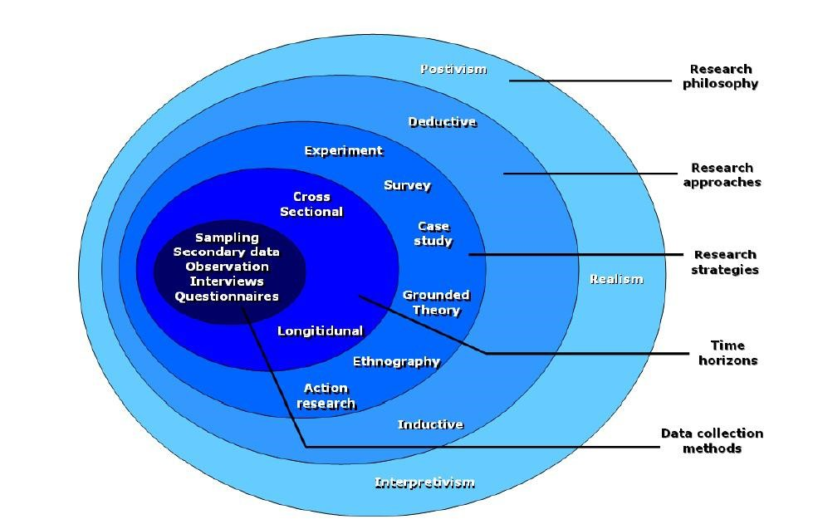
Figure 4. research Onion
Source: (Colwell, 2006)
The first layer is about selecting the research topic where the researcher must have interests relevant to the academic discipline and must be a specific problem, not a general one. The second layer indicates formulating research objectives and questions according to the research problem (Colwell, 2006). The third layer indicates the type of survey used to collect research data. The fourth layer indicates what type of data will be used, quantitative or qualitative. The fifth layer indicates how much time it will take to complete the research, such as 10 weeks for this paper. Moreover, the sixth layer indicates how the questionnaire will be designed, such as 10 questions for this research survey (Diaz-Diaz, 2021).

3.2 Research Philosophy
There are 4 types of research philosophies available to conduct research: positivism, interpretivism, realism, and pragmatism. Here, this research matches the positivism philosophy (Griffin, 2007). Positivism philosophy is considered as the basic pillar of the research, which indicates the data and information collected for the research purpose are collected from the data elements but based on their personal experiences or judgments such as, for this research data is gathered from the employees of premier inn based on their work experience (Johnson and Clark, 2006). Such data and information are termed natural data, and there is a relationship between the data and the contents provided to collect the data.

3.3 Research Approach
Two approaches are available to conduct research under this approach: the inductive approach and the deductive approach (Saldanha, 2015). The inductive approach implies that preliminary research finds the basic theories or assumptions for further research purposes based on a general phenomenon. The deductive approach implies that the research uses the available or predetermined theories, models, or assumptions to match them in a real scenario, indicating that the research is very much applied (Johnson and Clark, 2006). This research to assess the impact of social media marketing on the hospitality industry is a deductive research approach because the consequences are based on practices of the Premier inn hotel chain (Saldanha, 2015).

3.4 Type of Investigation
There are 2 types of investigations available to conduct research properly including the primary research and the secondary research. Primary research implies that the data and information required for the research are generated from the real subject elements of the research as a form of raw and first-hand data. For this research purpose, primary data has been collected from the respondents through questionnaire survey (Griffin, 2007). Secondary research implies that the required data and information have been gathered by reviewing exiting or already published literature sources such as articles, magazines, books, newspapers, journals, websites, etc. For this research purpose secondary data has been conducted through literature review from books, journals, articles, and website sources (Colwell, 2006).

3.5 Choices
Research can be done using two types of data and information: quantitative and qualitative. Quantitative data implies that the information is collected in a numeric form that can be analysed through statistical tools and techniques (Chilisa, 2016). Another type of data, the qualitative data, implies that information is gathered in a descriptive form based on judgments, personal opinions, and perceptions, and such type of data is very open-ended in nature and required to describe the quantitative data. The researcher is only collecting one type of data which is quantitative therefore the mono method is chosen.

As quantitative research is considered as the scientific method, it provides reliable, accurate, and numeric results that can be used to find out appropriate research results and give the way to generalize the findings more accurately. But there are some disadvantages also, such as, it is time-consuming, needs technical or software literacy and expertise to do it accurately, and it cannot analyse the qualitative data which are the personal views, opinions, and perceptions of the respondents (Griffin, 2007).
Time horizon cross-sectional research: time horizon of cross-sectional research implies that data has been collected from several groups at a time. For this research purpose, primary research has been conducted from the respondents or samples from both male and female employees, who are of different experienced level and different authorities, responsibilities, and jobs within the organization (Griffin, 2007).

3.6 Sampling Method, Size, and Type
Sampling Size and Type: as the population or the total employees and their list are not known, the population is all the employees who worked in all the hotels of Premier Inn around the world, but the target population is the employees who worked in the Premier hotels in London for the ease of reaching them. The sample size is 50 employees who will get 15 minutes to participate in the data collection process (Griffin, 2007)

Sampling Method and Type: for this research purpose, to collect the quantitative data, a questionnaire survey will be conducted among the employees of Premier Inn (Colwell, 2006). As the researcher has not found any sampling frame that is the list of employees of Premier Inn, the sampling has been done through the non-probability sampling method, and among the various type of non-probability sampling method, the snowball sampling type is selected as the employees will refer other employees to collect data from them. Moreover, also, there is no probability of each element of the population being selected equally (Griffin, 2007).

In the case where samples are critical to find out, snowball sampling is very useful as one sample finds out the other and it continues, and the researcher can get the desired samples. But there are also some disadvantages such as, it is very time-consuming, costly process, and sometimes, the researcher fails to find out desired samples (Colwell, 2006).

3.7 Data Collection and Analysis Methods
Data Collection: there are 2 types of data collection methods, including primary and secondary data (Johnson and Clark, 2006). Primary data implies the raw data collected from the research's actual subject elements for this study. The primary data is collected from the employees of Premier Inn by providing them with a questionnaire which includes 9 close-ended questions and is constituted of 4 parts, including the demographics of the employees, the SMM awareness, the strategy part of how the hotel uses social media marketing, and the impact part which will indicate the advantages and disadvantages of social media marketing (Saldanha, 2015). The participants will have 15 minutes to answer the questionnaire.
Secondary data implies when the data is collected from a source other than subject elements such as journals, publications, articles, books, websites, Etc. For this research, the secondary data has been collected from several articles, journals, books, and websites (Griffin, 2007).
Data Analysis: the quantitative primary data will be analysed through MS Excel using tables, charts, and graphs to present the data in an understandable form, and the findings will be described through secondary data.

3.8 Ethical Considerations
First, the research is written wholly by the researcher, no data has been copied unethically, and the works of other researchers or philosophers are cited, quoted, and referenced. This paper is free from plagiarism issues, as paraphrasing has been used to avoid plagiarism. From the data collection part, the employees are selected unbiasedly, and they are not being forced to provide their opinions for this research, as well as full confidentiality has been ensured to them. Their given information will not be licked or accessible by others except the researcher, and the data will be removed after reaching the research purpose.

3.9 Summary
From the methodology part, it can be concluded that this research is deductive research based on positivism philosophy. Both quantitative and qualitative data have been used, which are collected from both primary and secondary sources. The primary data has been collected from the 50 employees of Premier Inn, which were selected using the snowball sampling method through a 9 close-ended questionnaire, and the collected data have been analysed using the MS Excel software.

Chapter 4: Data Analysis and Findings

Data Analysis
The section will analyse the primary data collected from the 50 employees of Premier Inn about their opinions regarding social media marketing and its impact on hotel businesses. The first part of this section will show the demographic analysis of the respondents, and the 2nd part will show the analysis of social media awareness, impact, and strategies.
Response rate: Total responses/ total sample size*100= 50/50*100= 100%

Demographic Description

Figure 5. Gender of Respondents
Of the 50 employees selected as a sample for this research, about 80% of them are males, and the rest 20% are females, which implies that most of the employees of Premier Inn are male.

Figure 6. Age of Respondents
Among the selected 50 employees of Premier Inn, about 40% are below 30 years, 30% are between 30 to 40 years, 20% are between 40 to 50 years, and the rest, 10% are above 50 years. Such an age demographic implies that most employees are below 30 years or from the new generation.
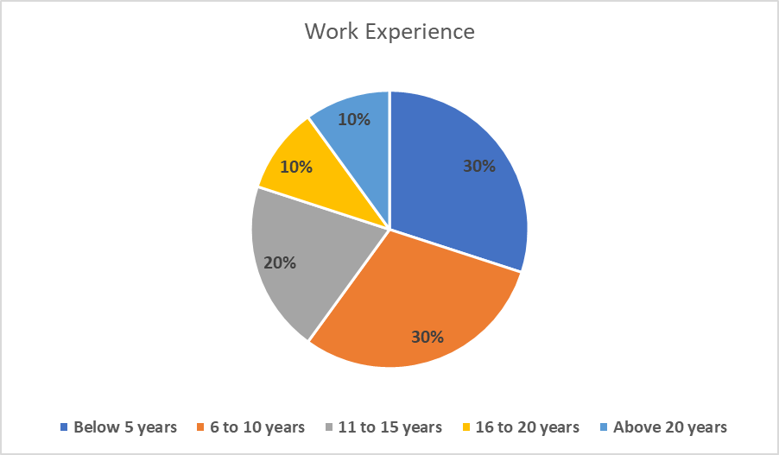
Figure 7. Work experience of respondents
Of the 50 respondents who are employees of Premier Inn, about 30% of them have work experience of below 5 years, another 30% of them have work experience between 6 to 10 years, 20% of them have 11 to 15 years of work experience, 10% of them have 16 to 20 years of work experience, and the rest 10% of them have above 20 years of experience which indicates most of the respondents are experienced between 5 to 15 years.

Analysis 1: Awareness of Social Media Marketing concept
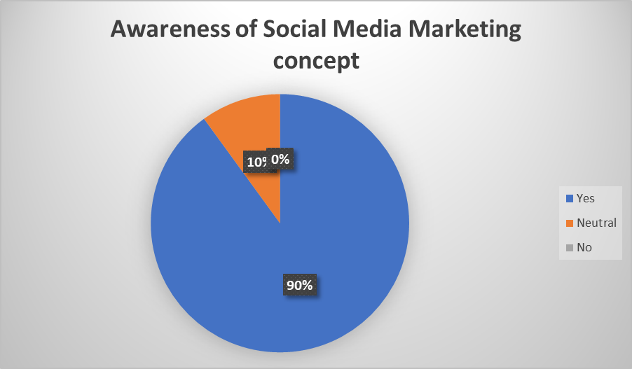
Figure 8. Awareness of Social Media Marketing concept
Among the 50 employees, 90% voted for yes, 10% were neutral, and none voted for no when asked whether they were aware of social media marketing. Moreover, the response implies they are aware enough of it.

Analysis 2: Usage of Social Media Marketing tools
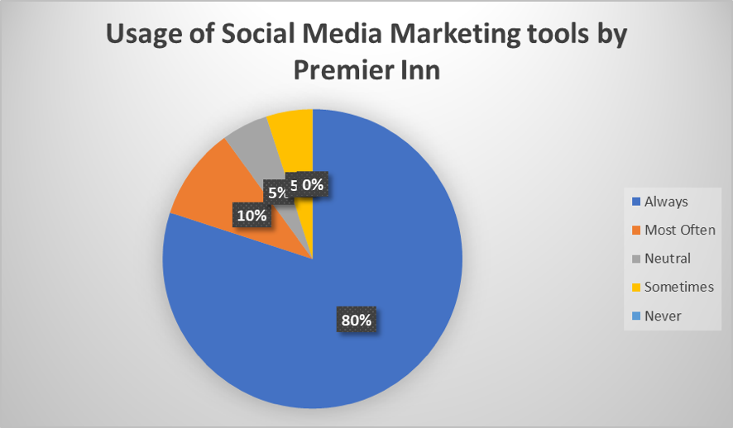
Figure 9. Usage of Social Media Marketing tools by Premier Inn
When it is asked the employees whether Premier Inn ever uses the social media marketing tools or not, among the 50 respondents, 80% of them said always, 10% of them said most often, 5% of them were neutral, another 5% said sometimes, but none said never. The response implies Premier Inn uses social media marketing tools.

Analysis 3: Preferable Ways to ensure Social Media Marketing
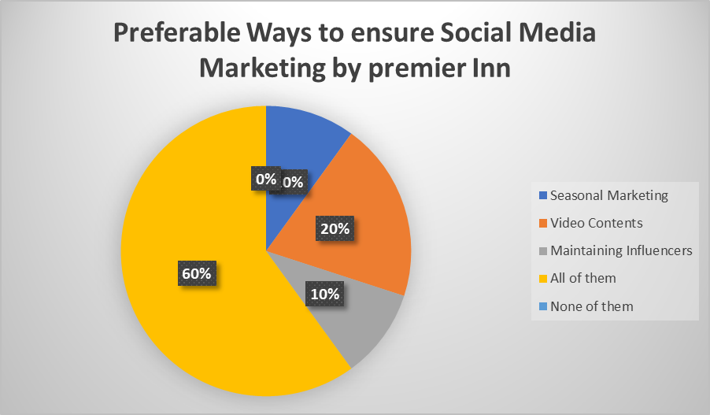
Figure 10. Preferable Ways to ensure Social Media Marketing by Premier Inn
When it is asked the employees who have mostly used the social media marketing area of the company, among the 50 employees, 10% voted for seasonal marketing, 20% voted for video content, 10% voted for maintaining influencers, and 60% for them voted for all the options, and none voted for the option of 'none of them. The response implies that Premier Inn uses all the areas of SMM.

Analysis 4: Preferable Media-specific Social Media Marketing Strategies
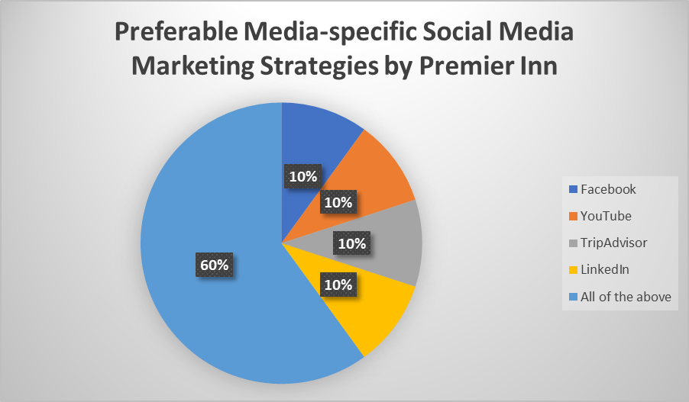
Figure 11. Preferable Media-specific Social Media Marketing Strategies by Premier Inn
Among the 50 employees of Premier Inn, 10% of them voted for Facebook, 10% of them voted for YouTube, 10% of them voted for TripAdvisor, 10% of them voted for LinkedIn, and the rest 60% of them voted for all the options that imply the company uses all the social media platform for ensuring SMM.

Analysis 5: Advantages of Social Media Marketing
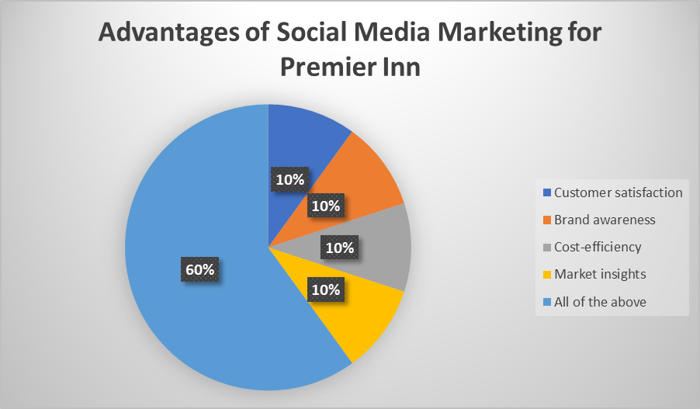
Figure 12. Advantages of Social Media Marketing for Premier Inn
When it is asked the employees what advantage they get from SMM, 10% said customer satisfaction, 10% said brand awareness, 10% said cost-efficiency, 10% of them said market insights, and the rest 60% said all the options of advantages are found from using the SMM strategies.

Analysis 6: Disadvantages of Social Media Marketing
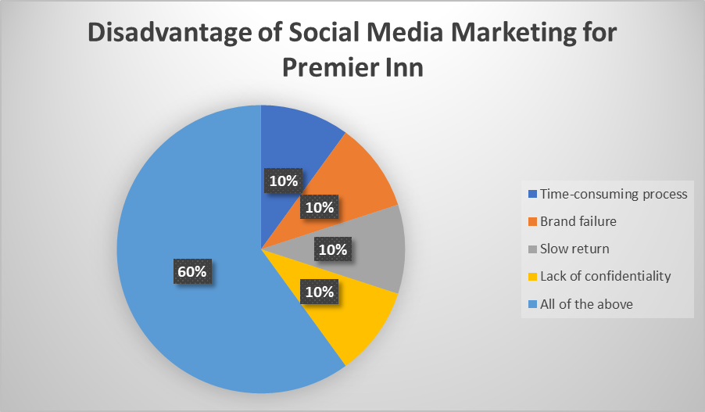
Figure 13. A disadvantage of Social Media Marketing for Premier Inn
Among the 50 employees, 10% voted for a time-consuming process, 10% voted for brand failure, 10% voted for a slow return option, 60% voted for time-consuming process and 10% voted for confidentiality loss option as the disadvantages faced by the company of Premier Inn due to poor SMM practices.

4.2 Discussion.
From the analysis above, there are some key findings. The first finding is that social media marketing is quite familiar among people inside and outside the hotels and resorts businesses. The second finding is that almost every hotel business is aware enough to ensure its presence on the social media platform regarding marketing and promotional activities. They do so to reach people worldwide with time and cost-efficiency. There are no other methods to be more successful as people nowadays use social media apps in full bloom (Carvell, 2020). The third finding is that the hotel companies prefer the marketing areas, including video content, seasonal marketing, and maintaining the marketing influencers to ensure social media marketing is very useful and effective. Through video content, they can engage the people or potential customers about their services and packages as if they are physically visiting the hotel or resort as the videos are made standing on the customers' shoes (Choi and Fowler, 2015). Through seasonal marketing, the hotels or resorts are telling the people that in this season or the upcoming season, it is the best place to spend their leisure with comforts and chilling. Maintaining influencers, the people, existing customers, or any other business that collaborates with the hotel businesses is very effective as they influence potential customers to check in the resorts or hotels (Gbadeyan, 2021). The fourth finding is that the hotels or resorts mostly use Facebook, TripAdvisor, YouTube, and LinkedIn platform to ensure social media marketing. Businesses use Facebook because it is not expensive and can reach many people simultaneously, as most people on social media are active in Facebook. So, creating a community or group for the hotels and resorts here is very easy and effective (Guillet and Kucukusta, 2015). By using YouTube, the businesses are sharing or posting their video content as it is now the second search engine after Google, and the contents here are also effective. Through TripAdvisor, the businesses are engaging people with the hotels on their websites, where people can put opinions and reviews. The fifth finding is the advantages of hotel businesses can grab from social media marketing, including customer satisfaction, brand awareness, cost-efficiency, and market insights (Khmiadashvili, 2019). By using social media marketing tools, the hotel and resorts can create a customer community where they can create awareness of the brand of the hotels as well as get enough market insights of what the customers are demanding and modify their services according to and can ensure higher customer satisfaction (Kim, 2018). The sixth finding is about what disadvantages the businesses can face in the SMM, including brand failure, slow return, lack of confidentiality, and time-consuming process. In SMM, the hotels and resorts need to create frequent contents, which is time-consuming, and among the customer crowd, there may be competitors who can copy the content, providing a slow return for the businesses moreover, because some negative reviews by the customers on the website can reduce brand image (Mohammed and Al-Swidi, 2019).

Chapter 5: Conclusion and Recommendations
5.1 Conclusion
In this modern era of globalization, people are connected irrespective of geographical distances through social media platforms. So, businesses are taking this advantage to use the social media platform for marketing or any other activities. The hospitality industry uses this SMM in full bloom in various industries. In this industry, the hotel or resort businesses use social media platforms such as Facebook, YouTube, TripAdvisor, and LinkedIn for marketing purposes such as sharing video content, ensuring seasonal marketing, and maintaining the social media influencers effectively. Using these platforms, the businesses are getting advantages such as customer satisfaction and engagement, brand image and awareness, cost-efficiency, and wide market insight. Although this marketing platform has some disadvantages, including it is a time-consuming process, it can reduce a brand image, it can hinder confidentiality, and it can return on investment on the marketing process very slow, the social media marketing is very important for hotel businesses.
5.2 Recommendations
There are some recommendations of how the hotel chain of Premier Inn can improve its presence on social media marketing-
- The hotel business needs to define a SMART goal first regarding the social media marketing in terms of increasing web traffic, or it wants to convert its media platform from one app to another in the next month or create new followers to the social media or whatever the goal is, it needs to more specific, measurable, attainable, reliable, and timely.
- The hotel business needs to identify the target consumers online first to know which social media will be the best option to reach them immediately and to engage them with the business community for a longer period (Guillet and Kucukusta, 2015).
- The business needs to choose the right SMM strategy for specific marketing purposes. However, the popular platforms are Facebook, LinkedIn, YouTube, Etc. However, it needs to know the use of each platform effectively. Such as, if it wants to promote offerings through video advertisement, the best platform will be YouTube and Pinterest.
- The business needs to look closely at its contents, whether they are understandable to the people or not. The marketer not only posts something as usual, and the content should be meaningful, should generate a good idea of the hotel, and the contents should be consistent (Choi and Fowler, 2015).

Chapter 6: Further Research
The research scope is very narrow as it is done by collecting the data from a small sample size of 50 employees of Premier Inn from the London hotel chain. As Premier Inn has hotel chains worldwide, data should be collected from the company's employees from all the countries. It has its presence to generalize the findings well. Also, the sample size needs to be larger to ensure the probability of acceptability and reliability in generalizing the research findings.

References
Carvell, P., 2020. Media relations — What can the hotel industry learn? Journal of Vacation Marketing, 3(1), pp.81-88.
Chan, N. and Guillet, B., 2017. Investigation of social media marketing: how does the hotel industry in hong kong perform marketing on social media websites? Journal of Travel &amp; Tourism Marketing, 28(4), pp.345-368.
Chalisa, B., 2016. Indigenous research methodologies. 7th ed. Oxford: Sage.
Choi, E. and Fowler, D., 2015. Social media marketing: applying the uses and gratifications theory in the hotel industry. Journal of Hospitality Marketing &amp; Management, 25(7), pp.771-796.
Colwell, R., 2006. MENC Handbook of Research Methodologies. New York: Oxford University Press.
Diaz-Diaz, C., 2021. New Materialist Methodologies. [S.l.]: Springer.
Gbadeyan, B., 2021. Impact of social media in the online advertisement industry. International Journal of Social Science and Human Research, 04(08), p.135.
Griffin, 2007. Business and management research methodologies. London: Sage.
Guillet, B. and Kucukusta, D., 2015. An examination of social media marketing in china: how do the top 133 hotel brands perform on the top four Chinese social media sites? Journal of Travel &amp; Tourism Marketing, 33(6), pp.783-805.
Ibrahim, B., 2021. The nexus between social media marketing activities and brand loyalty in hotel Facebook pages. Tourism, 69(2), pp.228-245.
Johnson, P. and Clark, M., 2006. Business and management research methodologies. London: SAGE.
Khmiadashvili, L., 2019. Digital marketing strategy based on hotel industry study in Tbilisi. IJASOS- International E-journal of Advances in Social Sciences, 1(1), pp.922-927.
Kim, W., 2018. What does big data reveal about social media use in the hotel industry? International Journal of Tourism Management and Sciences, 33(5), pp.257-273.
Mohammed, A. and Al-Swidi, A., 2019. The influence of CSR on perceived value, social media and loyalty in the hotel industry. Spanish Journal of Marketing - ESIC, 23(3), pp.373-396.
Nuseir, M. and Elrefae, G., 2022. The effect of social media marketing, compatibility and perceived ease of use on marketing performance: Evidence from the hotel industry. International Journal of Data and Network Science, 6(3), pp.885-894.
Reginold, S., Gnanabasharan, K. and Sivanenthira, S., 2019. Manager perception towards adoption of social media marketing: With special reference to hotel industry in Jaffna District. South Asian Journal of Marketing &amp; Management Research, 9(10and11), p.18.
Saldanha, G., 2015. Research methodologies in translation studies. Routledge.
Samanta, I., 2020. The impact of e-customer relationship marketing in the hotel industry. International Journal of Knowledge and Learning, 5(3/4), p.333.
Singh, S. and Diamond, S., 2016. Social media marketing. 5th ed. Oxford: SAGE.
Stevenson, S., Hack-Polay, D. and Tehseen, S., 2022. Social media influencers, the new advertising agency? International Journal of Public Sociology and Sociotherapy, 2(1), pp.1-21.
Zimmerman, J. and Ng, D., 2012. Social media marketing is all-in-one for dummies. 6th ed. London: SAGE.

Appendix

Questionnaire
No. | Question | Response
Demographics
1. | Gender |  |  |  | Male |  |  |  |  |  |  |  |  |  |  |  |  | Female
2. | Age |  |  |  | Below 30 years |  |  |  |  |  | 30-40 years |  |  |  |  |  |  | 40-50 years |  |  |  |  |  |  | Above 50 years
3. | Work Experience |  |  |  | Below 5 years |  |  |  | 6 to 10 years |  |  |  |  |  |  | 11 to 15 years |  |  |  | 16 to 20 years |  |  |  |  |  |  | Above 20 years
Social Media Marketing
4. | Are you aware of the social media marketing concept? |  |  |  | Yes |  |  |  |  |  |  |  |  | Neutral |  |  |  |  |  |  |  |  |  |  | No
5. | Do you think Premier Inn ever uses enough social media marketing tools? |  |  |  |  | Always |  |  |  |  | Most Often |  |  |  |  |  |  | Neutral |  |  |  |  |  | Sometimes |  |  |  |  | Never
Social Media Marketing Strategies
6. | Which strategies are mostly used by Premier Inn for social media marketing worldwide? |  |  | Seasonal Marketing |  |  |  |  |  | Video Contents |  |  |  |  |  |  | Maintaining Influencers |  |  |  |  |  | All of them |  |  |  |  | None of them
7. | Which social media platform mostly influences customers to choose Premier Inn ? |  | Facebook |  |  |  | YouTube |  |  |  |  | TripAdvisor |  |  |  |  |  |  |  |  | LinkedIn |  |  |  |  | All of the above
Impact of Social Media Marketing
8. | Do you think social media marketing benefits your company's growth? |  | Customer satisfaction |  |  |  |  | Brand awareness |  |  |  |  |  |  | Cost-efficiency |  |  |  |  |  |  | Market insights |  |  |  |  | All of the above
9. | What disadvantage do you face in social media marketing? |  | Time-consuming process |  |  |  |  | Brand failure |  |  |  |  | Slow return |  |  |  |  |  | Lack of confidentiality |  |  |  |  |  |  |  | All of the above

