

STUDENT NAME: JOELLY OYONO KIRSTY
STUDENT ID: 2317543

MODULE NAME:
INTRODUCTION TO HEALTH AND SOCIAL CARE
MODULE NUMBER: LCHS4003
MODULE LEADER: PATRONELLA GANZA
SUBMISSION DATE: 13 MAR, 2024.

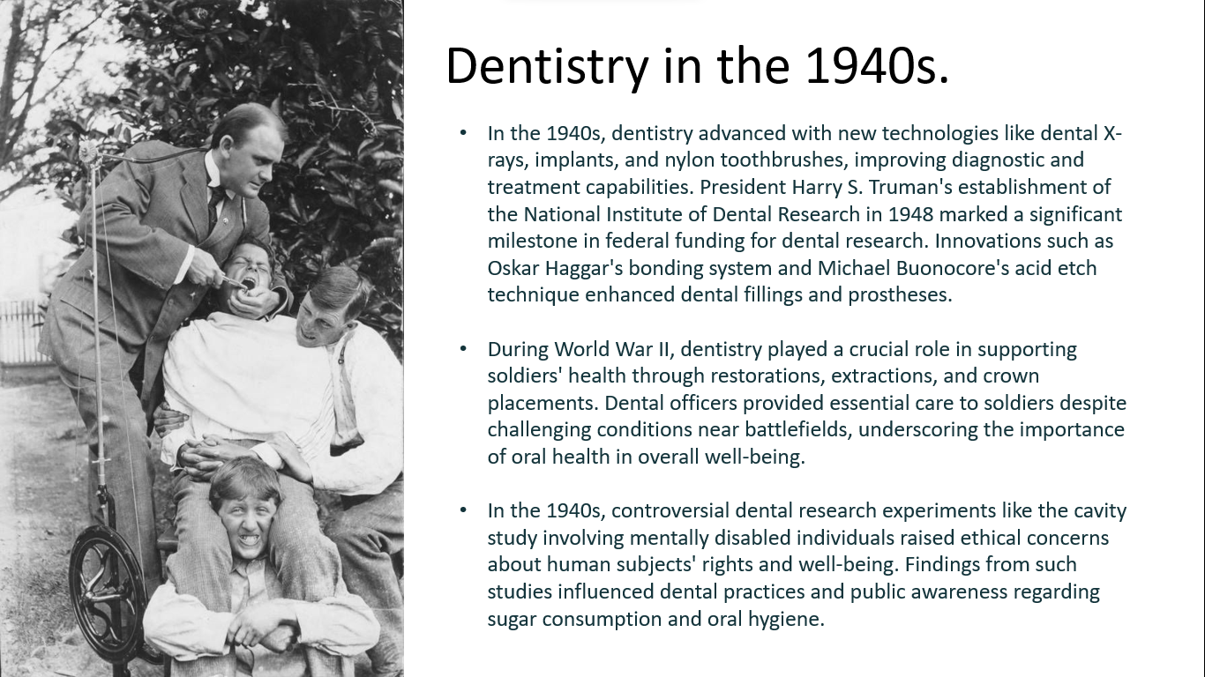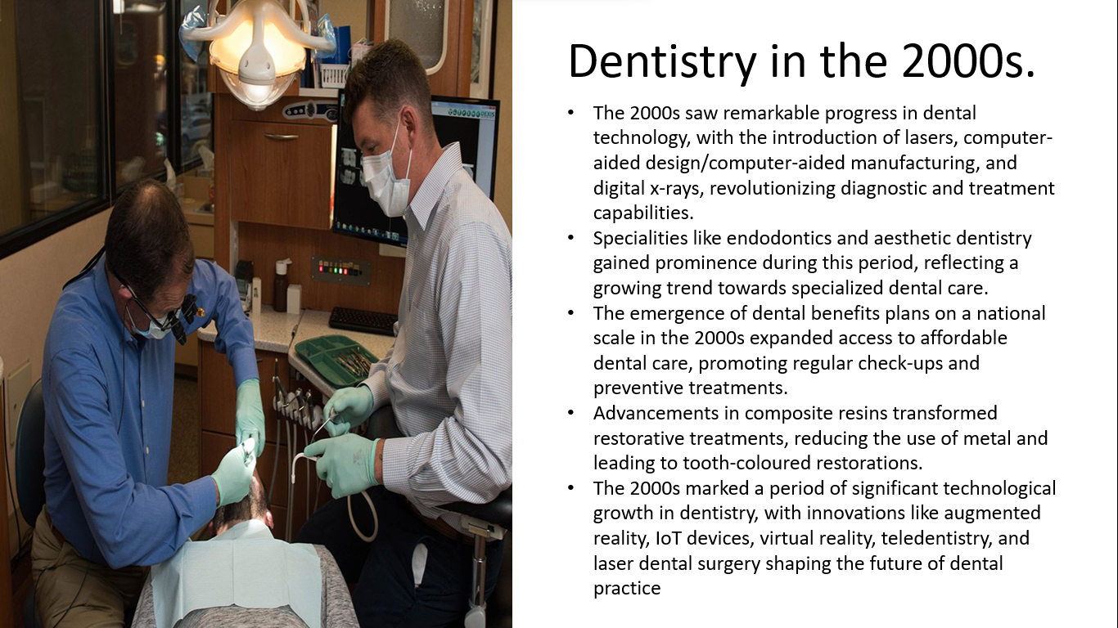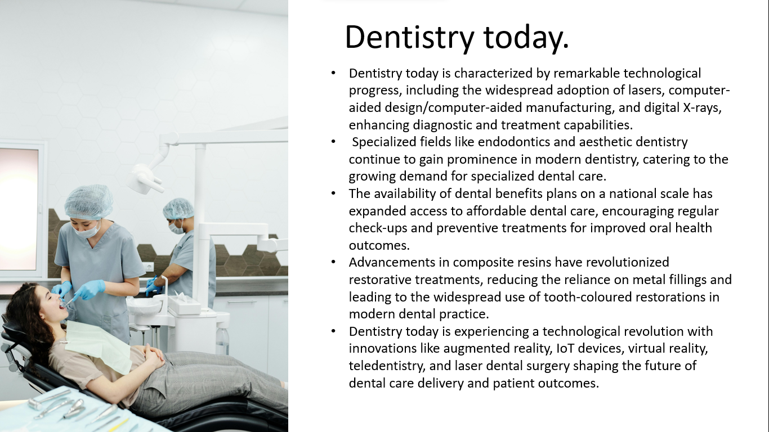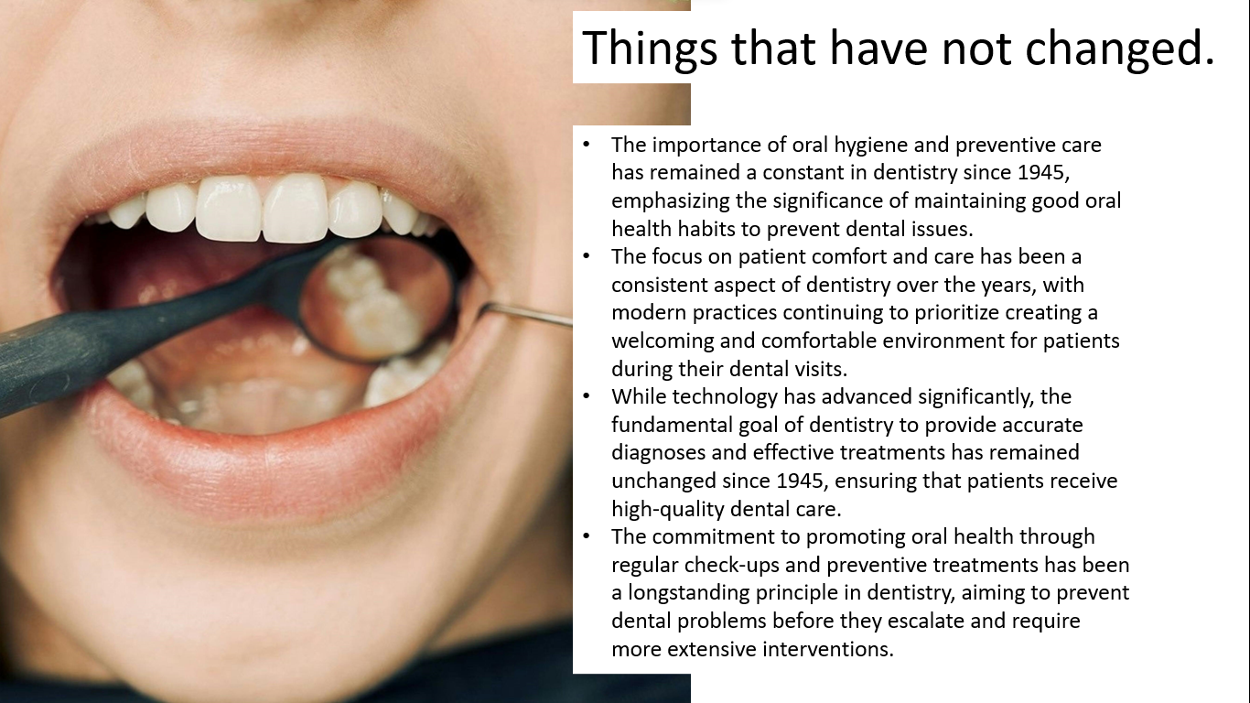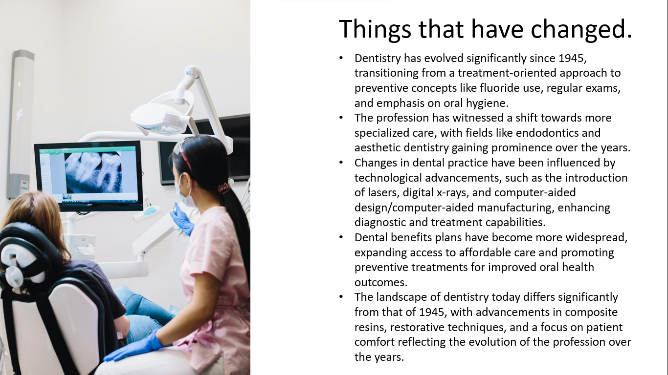
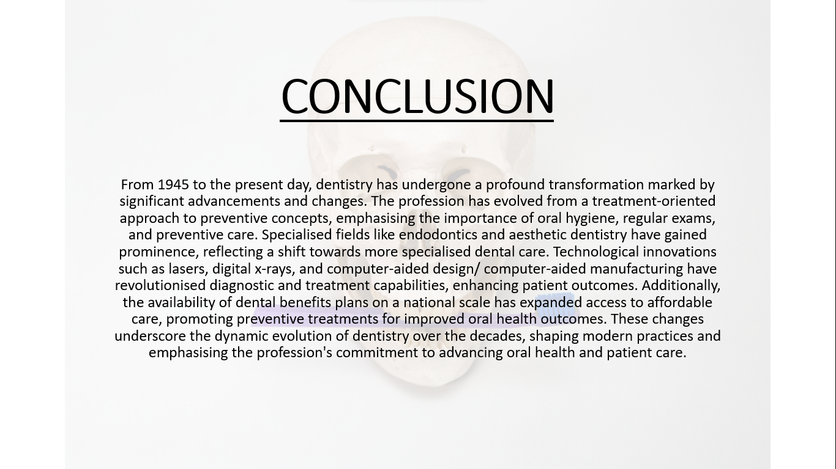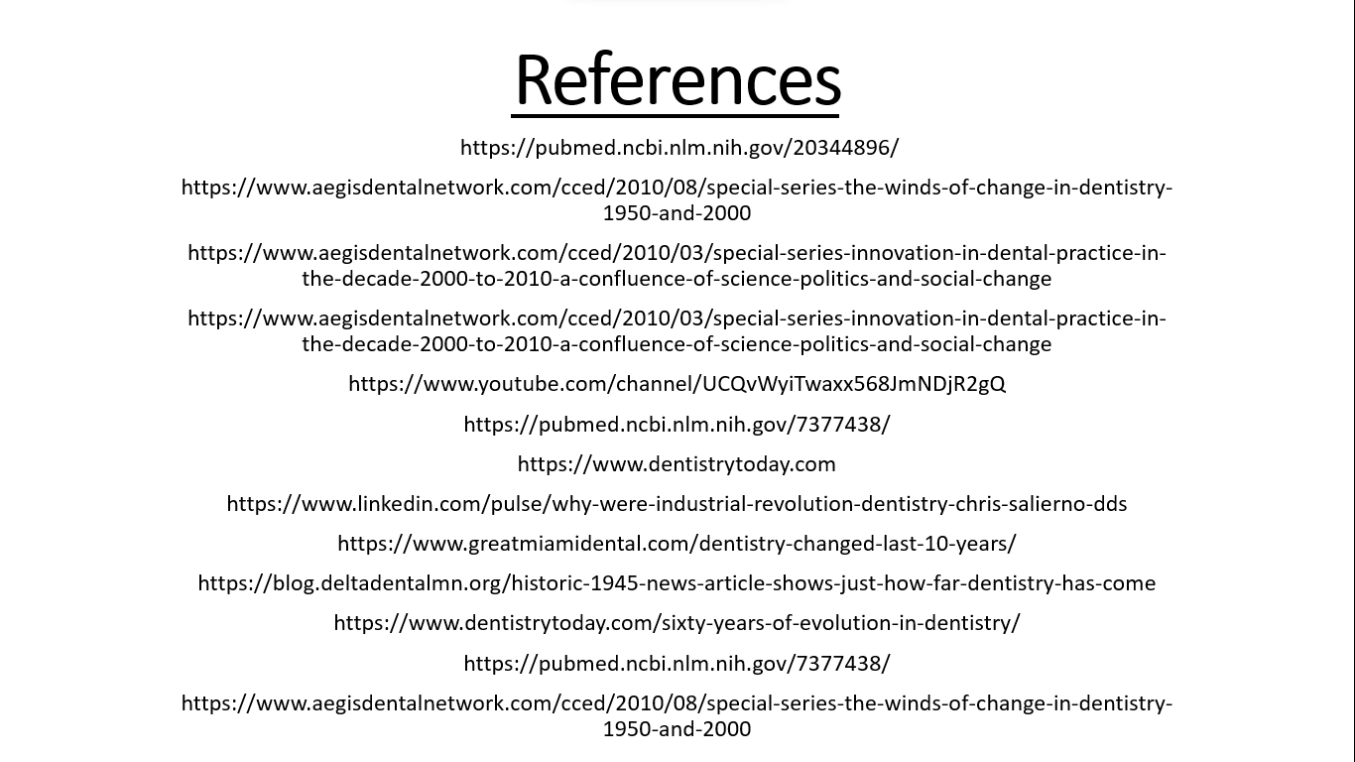

TASK 2
THE CHALLENGES NHS IS CURRENTLY FACING.

1. Workforce Crisis and Staff Shortages: The NHS is currently grappling with a critical workforce crisis characterized by severe shortages of essential healthcare professionals, including nurses, doctors, and support staff. This shortage stems from a combination of factors such as an ageing healthcare workforce, challenges in recruitment and retention, increased demand for healthcare services driven by population growth and demographic shifts, uncertainties related to Brexit impacting the healthcare workforce, and pension tax issues prompting senior doctors to reduce their working hours or retire prematurely. These staff shortages have far-reaching implications for the NHS, leading to overburdened healthcare workers, heightened workloads, increased burnout rates, compromised quality of patient care, extended waiting times for treatments and appointments, and difficulties in effectively meeting the healthcare needs of the population. (The facts and figures about the challenges facing the NHS in 2023, 2023)

2. Financial Pressures and Resource Allocation: Financial constraints present a significant challenge for the NHS, affecting its capacity to allocate resources effectively and maintain quality standards across the healthcare system. Budget limitations result in hospitals and healthcare facilities being underfunded, causing delays in treatments and surgeries, inadequate staffing levels, insufficient equipment and resources for patient care, and challenges in meeting the rising demand for healthcare services. The COVID-19 pandemic has further exacerbated financial pressures on the NHS, necessitating additional resources for pandemic response efforts while simultaneously dealing with existing financial constraints. (Challenges and Solutions in the National Health Service (NHS), 2024)

Possible Solutions and Recommendations:
1. Investment in Workforce Development: The NHS should prioritize workforce development by offering competitive salaries, enhancing training opportunities, and implementing retention strategies to address staff shortages. Additionally, promoting a positive work environment and providing mental health support for healthcare professionals can improve staff morale and reduce burnout. (National library of medicine, 2023)

2. Efficiency Improvements and Cost Reduction: Implementing efficiency measures within the NHS can help optimize resource utilization and reduce unnecessary costs. This includes streamlining administrative processes, enhancing procurement practices for drugs and equipment, and leveraging technology to improve operational efficiency.

3. Integration of Technology: Embracing digital technology can enhance healthcare delivery within the NHS by improving patient access, streamlining communication between healthcare providers, and facilitating remote consultations. Investing in interoperable IT infrastructure and telehealth solutions can help bridge gaps in service delivery and improve patient outcomes. (The future of the NHS: what are the key issues?, n.d.)

4. Collaboration with External Partners: Strengthening partnerships with local governments, social care providers, and community organizations is essential for addressing broader health challenges such as social isolation, mental health issues, and lifestyle-related diseases.

References
(2023, May). Retrieved from National library of medicine: https://www.ncbi.nlm.nih.gov/pmc/articles/PMC10240167/
Challenges and Solutions in the National Health Service (NHS). (2024, July). Retrieved from European medical journal: https://www.emjreviews.com/general-healthcare/news/challenges-and-solutions-in-the-national-health-service-nhs/
The facts and figures about the challenges facing the NHS in 2023. (2023, January). Retrieved from Deloitte: https://blogs.deloitte.co.uk/health/2023/01/the-facts-and-figures-about-the-challenges-facing-the-nhs-in-2023.html
The future of the NHS: what are the key issues? (n.d.). Retrieved from The guardian jobs: https://recruiters.theguardian.com/advice/future-of-nhs-what-key-issues

