With reference to present day examples, evaluate the implications of climate change for business (100 marks)

Environmental change affects both individuals and businesses. Global warming and climate change affect our natural resources, water and food chain. It also affects our rising sea levels, floods and droughts. This causes us to be aware of the health and safety of ourselves and businesses. Environmental change affects businesses by the cost and demand from regulations and to protect their business from climate control. Businesses burn fossil fuels and produce harmful chemicals which pollute the air. The polluted air is then breathed in by the population and this has a direct impact on individuals. Air pollution can kill up to 7million people each year according to the World Health Organisation. Companies’ climate responses focus primarily on measures that have short-term cost saving effect and a thorough understanding of climate risks is rare. Few companies have governance and steering mechanism in place to develop and implement comprehensive climate strategies, they also have targets for carbon emission reductions are usually not aligned with the Paris agreement. The Paris Agreement is a legally binding international treaty on climate change, its goal is to limit global warming to well below 2 Degrees Celsius to achieve this long-term temperature goal, countries aim to reach global peaking of greenhouse gas emissions as soon as possible to achieve a climate neutral world by mid-century.

Many countries are taking action to reduce their greenhouse gas emissions to reach their goals of the Paris Agreement. The Paris Agreement provides a framework in three parts which are financial, technical and capacity- building. This agreement makes developed countries should take the lead in providing financial assistance to countries that are less endowed and more vulnerable. Climate finance is required for mitigation due to large scale investments are needed to reduce emissions. Finance is important for adaptation to reduce the impacts of climate change. Technology is an important part the Paris Agreement because it allows us to improve resilience to climate change and reduce GHG emissions. The mechanism is increasing technology development and helps transfer policies and implementation plans. Capacity- building helps developing countries deal with many of the challenges created by climate change. More countries are trying to create carbon neutral targets. The Paris agreement plans to have zero-carbon solutions could be competing in sectors over 70% of global emissions by 2030 and has made new business opportunities for newcomers. Some strategies in place are to develop low carbon technologies and improve energy efficiency which change the behaviour of sustainable development.

There are multiple impacts of climate change on businesses for example exposing them to transition risks which are caused by society’s reasoning to climate change such as changes in technologies markets and regulations that can increase business costs. Companies that emit greenhouse gases are increasing in legal cases which can mean business can’t afford to keep their businesses due to legal cases against climate change. Climate change does offer businesses opportunities, for example it allows businesses to plan their productivity e.g. increase their energy efficiency which would reduce their costs. The stress of competing with other businesses on climate change does encourage innovation of new products and services which produce less carbon. Business could also look at their supply chains to find renewable energy resources which creates more competition with other companies and new market opportunities. Climate Change can put pressure on businesses because they have to follow regulations to avoid legal cases and avoid the pressure from their stakeholders. The pressure on businesses channels more money towards climate-friendly business activities which has encouraged more than 60 countries to adopt zero carbon emission targets.

Most businesses are only taking action of reducing climate change is the short-term cost-saving effect however most businesses are increasing their energy efficiency and using more climate-friendly equipment. More businesses are looking are trying to engage with other companies within their supply chain to reduce carbon emissions to help climate change however not all businesses are doing this which could be due to a lack of financial support. Lack of financial support causes a problem for businesses especially small businesses trying to compete with bigger companies. These are some tips on that might help businesses with climate change, businesses should understand the risks of climate change and see the opportunities that are part of climate change. Secondly, they should analyse the scale of necessary emission reductions and see how they can be achieved. Businesses should calculate how much emission reduction and adaptation efforts cost their business and how they can improve them. Lastly, they should position the risks and opportunities of climate change within the governance structure ensure a strategic measurable approach. Climate change is making consumers, employees and shareholders evaluate businesses and how they can help interact with them. Most businesses don’t measure their exposure to climate-related risks which could be an implication to their business, and this could be where they should incorporate climate change into their strategic plans, if they don’t do this, this could undermine the sustainability of their business.

Lastly, businesses should be aware of the environmental implications of their production processes and the supplies that they use. Businesses should look at the at the products that are unrecyclable types of plastic will contribute to the amount of landfill in the ocean. Businesses should look at the transportation of their produce in their business because of how much greenhouse gasses they emit and how many fossil fuels they burn to cause air pollution. When businesses analyse how much emissions they are polluting the air with they can see where they can cut down and try and make a positive impact onto the environment, an example of this could be if a business looks at their carbon footprint and sees their transportation is causing too many greenhouse gases they could see where they could cut down on their transportation. Another thing they could change in their business is to try and use more sustainable materials where possible by not harming the surrounding environment, also climate change could affect a business with the governments regulations and how they operate to ensure they comply with relevant laws.

Words – 1,013

Referring to examples explain how a circular economy approach can benefit the economy of a country/ countries (100 marks)

Circular economy aims to redefine growth, focusing on positive society-wide benefits. The main principles of circular economy are to design out waste and pollution, keep products and materials in use and regenerate natural systems. The concept of the circular economy is aimed at reducing the negative impacts of the linear economy and represents long term resilience, generates business and economic opportunities, and provides environmental and societal benefits. In circular economy there are technical and biological cycles. Consumption happens only in biological cycles, where food and biologically based materials for example wood or cotton are designed to feed back into the system through the process of composting. Technical cycles recover and restore products for example reuse, repair, remanufacture and recycling.

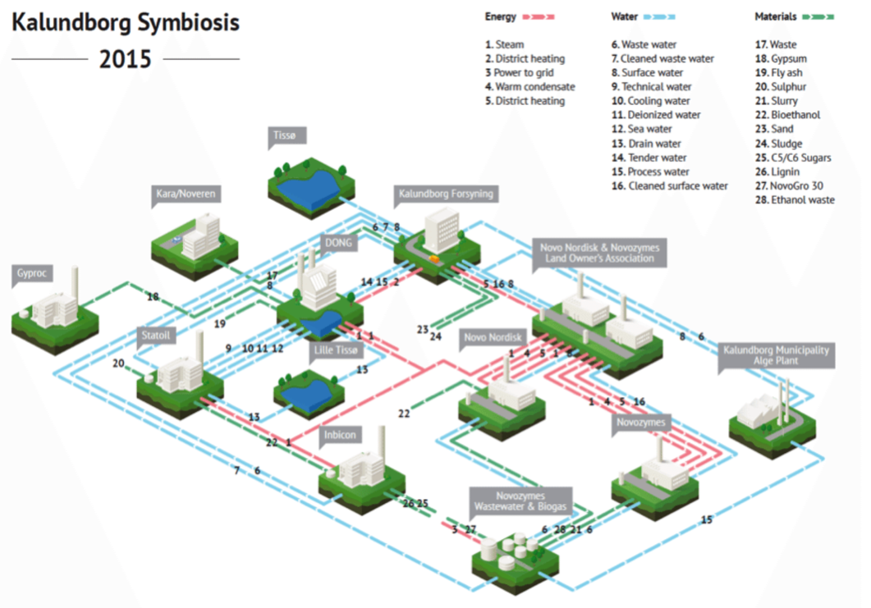
A main part of circular economy is the Kalundborg Symbiosis which is the world’s first example of industrial symbiosis where a by-product or residual product of one enterprise is used as a resource by another enterprise. This began in 1961 with the area’s water supply, it wasn’t officially referred to as ‘industrial symbiosis’ until 1989 which created the smart business. Kalundborg Symbiosis was built on core values which made successful partnerships for example trust, confidentiality, openness, equality and cooperation. These values made it possible to renew and strengthen Kalundborg Symbiosis which connected the flows of energy, water and materials. This industrial symbiosis merges the logic of nature’s ecosystems with the rationales of the economic system. During public and private enterprises buying and selling residual products from each other this benefited both the economy and environment. The Kalundborg Symbiosis started over 40 years ago and is a very successful and well-known industrial symbiosis. This has encouraged individuals to produce more for less. The main benefits of Kalundborg Symbiosis are cost reductions and less emissions, growth for less resources, more competitive enterprises and more resilient societies and enterprises. The main results of Kalundborg Symbiosis meant that every year the partners have benefitted from bottom line savings of 24 million, 14 million in socio-economic savings, 635,000 tons of CO2, 3.6million m3 water, 100 GWh of energy and 87,000 tons of materials.

A part of circular subscription concept was VIGGA which is a new way of consuming based upon sharing and circulating high-quality products. VIGGA provides high-quality children’s clothes which are produced under proper conditions at an attractive price. The outcome of wearing and spending money on high quality clothing is because they will be worn by several children which benefits the circular economy due to re-using products. The main concept of the circular subscription is for a monthly subscription fee, the customers get 20 pieces of clothes in their child’s size, when the clothes get too small, they get replaced with new sets of clothes one size bigger. After the clothes are sent back, they have a quality inspection and get washed professionally for re-use which results in a circular process. This concept makes an incentive for clothing companies to produce their clothes at a high quality which means the more children that use the piece of clothing the higher the profit becomes. This concept has reduced textile waste by 70%-85% and has avoided 350,000 tonnes of garments worth an estimated £140million ending up in landfill. VIGGA’s subscription concept benefits pregnant women and saves them stressing about finding new clothes for the child and they can help the environment from using this subscription service. VIGGA’s clothing is ethically made in organic fabrics in unisex designs and as soon as the child outgrows the new-born stage, they are supplied with the next size up which are environmentally friendly dry cleaned and ready for another baby.

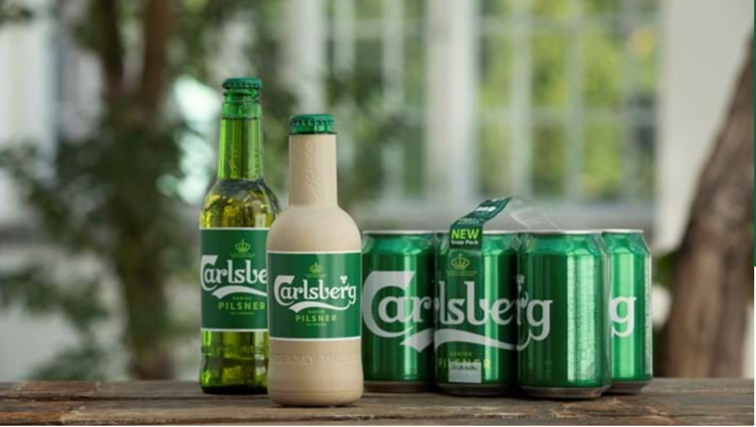
An example of circular economy is developing the world’s first biodegradable beer bottle, Carlsberg Group is a company that is focusing on their packaging, they have found that 45% of their CO2 emissions come from their packaging. They would like to make customers recycle more to reduce the number of CO2 emissions and minimise material usage by creating new environmentally friendly packaging. They are working on developing the world’s first ‘paper’ beer bottle made from wood fibres which are 100% biodegradable and fully recyclable. Carlsberg have made two types of prototypes for the ‘paper’ beer bottle and have been made with an inner barrier to allow the bottle to contain beer. Another prototype has a thin PET foil barrier to attempt a fully biodegradable polymer-free bottle. Carlsberg have been joined by other partners for example, The Coca-Cola Company, The Absolut Company and L’Oréal in the paper bottle community which was created by Paboco®. This will benefit the economy by reducing the amount of CO2 emissions companies are producing by advancing sustainable packaging, offering high quality products and it encourages individuals to recycle. In 2018 they launched a range of improvements including their labelling using greener ink and selling their multi-packed cans being glued instead of being wrapped in plastic.

A segment of circular economy is Grundfos pumps contribute to energy saving heating and cooling. Pumps are an example of the types of materials used in industrial applications, they play an important role in dairies, breweries, textile and chemical production, power stations and shipping. Most pumps installed today are inefficient and take up 60% too much energy. If we replaced inefficient pumps, we would benefit the economy by significant savings, reduce energy waste and minimise environmental footprint. The company called Grundfos in Japan switched out the main pump that delivered water to their main production line which reduced energy costs by more than 50% which has also reduced CO2 emissions. Also, from switching these pumps Grundfos annual energy consumption has reduced by more than 8.000.000 kWh. Grundfos offer commercial pumps to hotels, hospitals, office towers and airports, each commercial pump offers a range of water and hvac pumps that have high performance and energy efficiency. It also offers a range of applications for example, air conditioning, cooling, heating, fire protection, wastewater and water disinfection. Grundfos help the circular economy by reducing energy usage, saves money for the economy and reduces C02 emissions.

Words – 1,001

