Assignment 1:HTML & CSS Web Development
L4 - Introduction to Web and Database Concepts
Tom Owen (2520277)
2025
Contents
Introduction 2
Requirements 2
Implementation 3
Evaluation 6
Conclusion 8
References 9
Appendices 9

Figure 1 Home Page 3
Figure 2 What’s to See Page 4
Figure 3 Places to stay Page 4
Figure 4 Contact Page 5
Figure 5 HTML Validation 5
Figure 6 CSS Validation 6

Introduction
This report covers the process and purpose of the creation of a website for tourists about visiting Swansea, called “Visit Swansea”. It outlines the reasons for choosing the theme and target audience relevant to the website about Visiting Swansea, along with the key requirements and features that needed to be included across the site’s pages. The report describes the navigation of the design and development process when building the website, including screenshots showcasing the layout and appearance of each of the web pages. It also presents the results of the HTML and CSS validation, including any errors that were encountered and how they were corrected. The website is evaluated in terms of its usability, provisions made for accessibility and search engine optimisation (SEO), using information gathered from academic research of these area’s. An assessment of the website’s overall effectiveness, including its strengths and what parts of it could benefit with improvement in the future. Finally, the report comparers two websites BBC News and ITV News, on their usability, accessibility, SEO and mobile responsiveness, and a full reference list and appendices containing all HTML and CSS code used in the project.

Requirements
The “Visit Swansea” website was created with the purpose of promoting Swansea and it’s surrounding areas as an attractive tourist destination. The website highlights the key attractions of the city and places to stay within the area and providing key contact information a tourist would need. All in a form of providing clear and accessible information for tourists.
The theme of the website focuses on tourism and showcases well known attractions such as Mumbles pier, Rhossili Bay and the National Waterfront Museum. Swansea was chosen as it is a well-known and popular coastal city to visit offering a wide range of activities and events suitable for a broad age range.
The intended target audience was tourists visiting Swansea for the first time. Whether it was for tourists planning holidays or short visits. Or even for families looking for day trips, and for students new to the area who would like to know more about Swansea. The website is designed in a way that is simple and clear, making it easy for visitors to find information they need quickly.
To meet the project requirements the website has 4 pages meeting the expected minimum of 3, a consistent navigation bar so users can easily move between the different pages. And relevant multimedia content in the form of images and embedded Google Maps. Each of these pages provide essential information to guide users when planning a visit. For non-functional requirements, this included making sure the website was responsive, readable and accessible with validated HTML and CSS to maintain web standards.

Implementation
Website pages
The Visit Swansea website contains main 4 pages: Home, What’s to see, Places to stay and Contact. Each page maintains a consistent layout, with the header containing the site title and navigation menu, a central content area which contained mostly text and images, and a footer.
The home page introduces Swansea as a vibrant coastal city, giving a brief overview of what Swansea has to offer to tourists. It includes images of Swansea Bay, accompanied by introductory text welcoming visitors and highlighting the appeal of the area. (Figure 1)
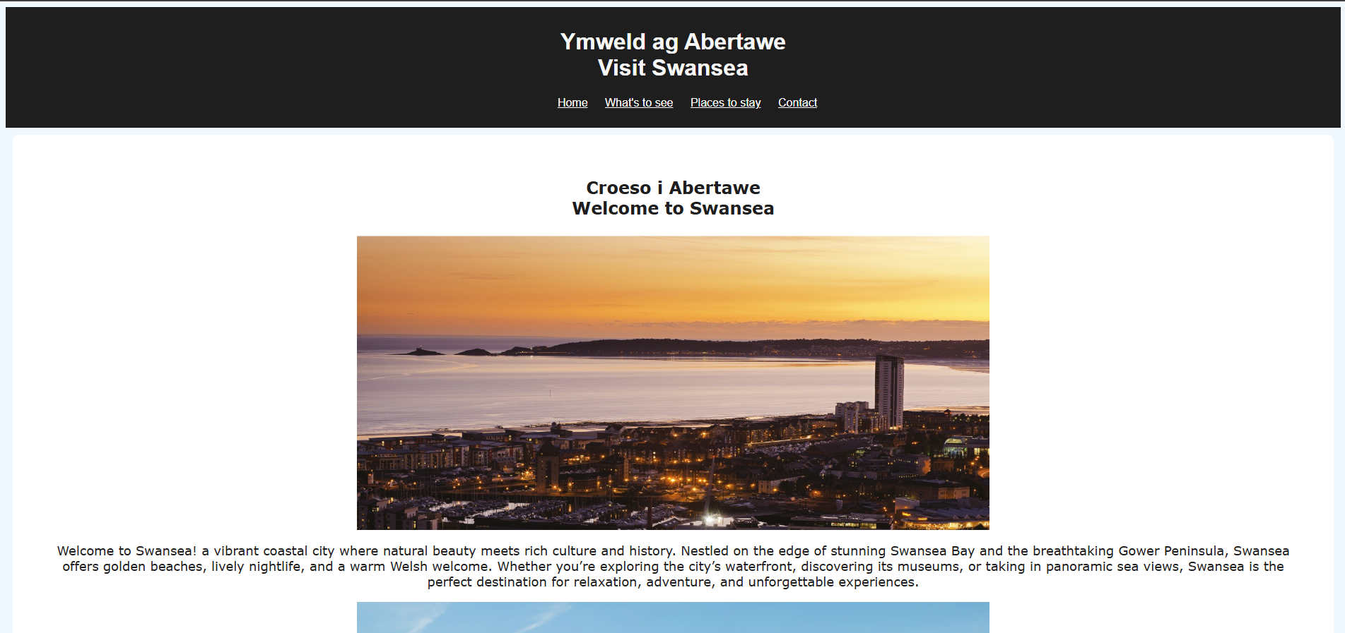
Figure 1 Home Page
The What’s to see page focuses on some of the key attractions in Swansea, including Mumbles Pier, the National Waterfront Museum and Rhossili Bay. Each of the attractions are presented with an image of the attraction, a heading and is accompanied by a descriptive paragraph helping visitors understand what each location offers. (Figure 2)
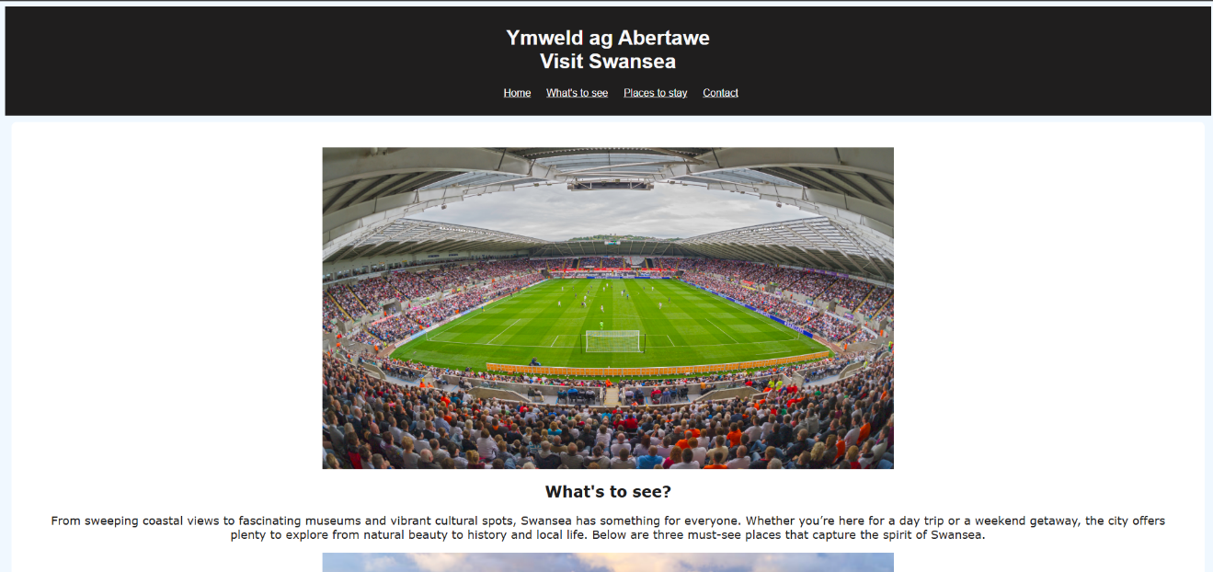
Figure 2 What’s to See Page
The Places to stay page provides recommendations of local accommodations, such as The Dragon Hotel, Morgans Hotel, and The King’s Head Inn. For each option, the page includes an image, a short description, and a button linking to the hotel’s official website, allowing users to find more detailed information they may need. (Figure 3)
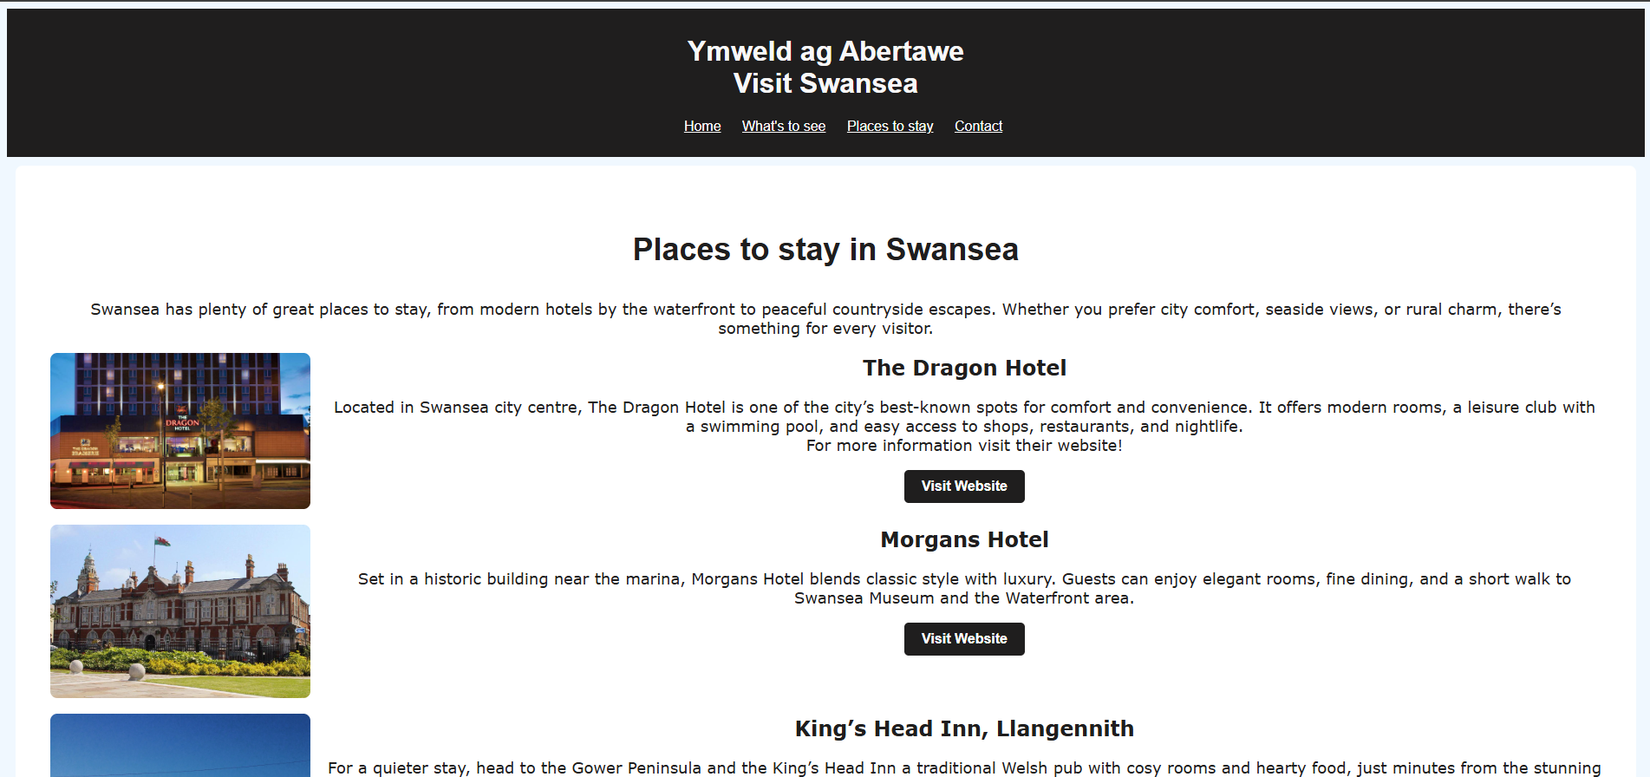
Figure 3 Places to stay Page
The Contact page offers practical information to find Visit Swansea’s main base of operations. On the page visitors can find contact information such as an email and telephone number in the case that they need further information or clarification from Visit Swansea. And an address is provided if they need to visit them directly or write to them via letter. (Figure 4)
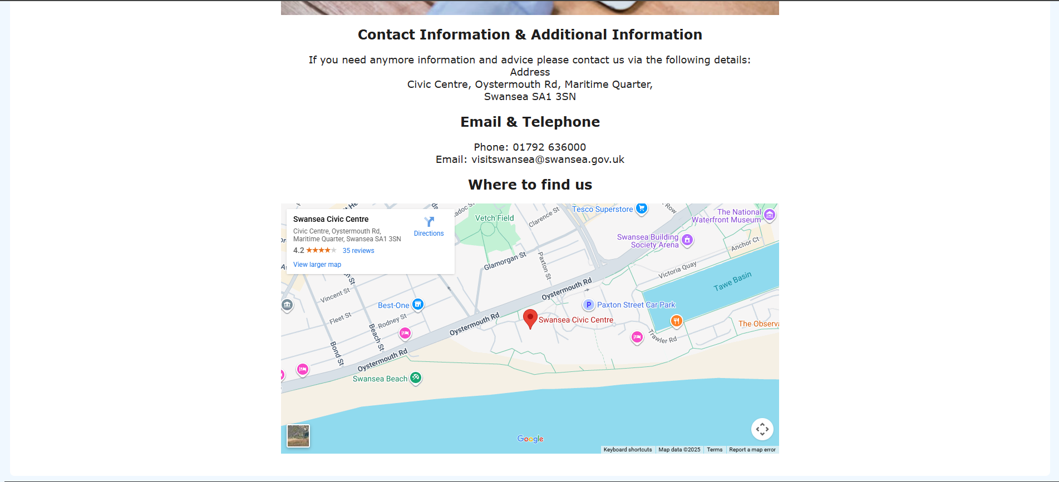
Figure 4 Contact Page

HTML Validation
The HTML of the Home page was checked using the W3C Markup Validation Service. Initially the validator reported problems with the names of the webpages as they did not make use of _ to show spacing between the titles resulting in an illegal character. To correct this the file names were updated to prevent error’s from showing again, for example “Places to Stay” page was changed to “places_to_stay”. After making these corrections the page was revalidated and there were no further errors reported.
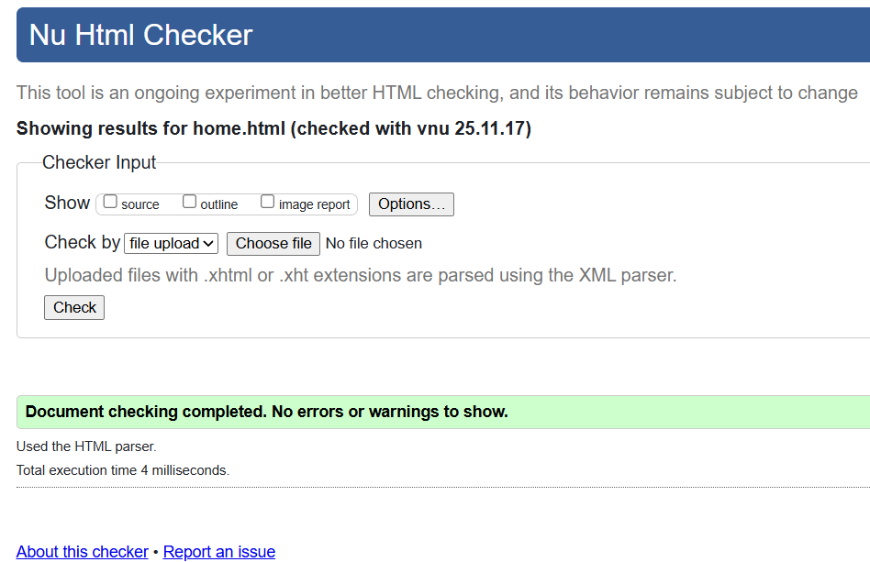
Figure 5 HTML Validation

CSS Validation
The websites main style sheet was validated using the W3C CSS validation service using the upload file option. The validator reported no error’s confirming that the stylesheet complies with the current CSS standards. (Figure 6)
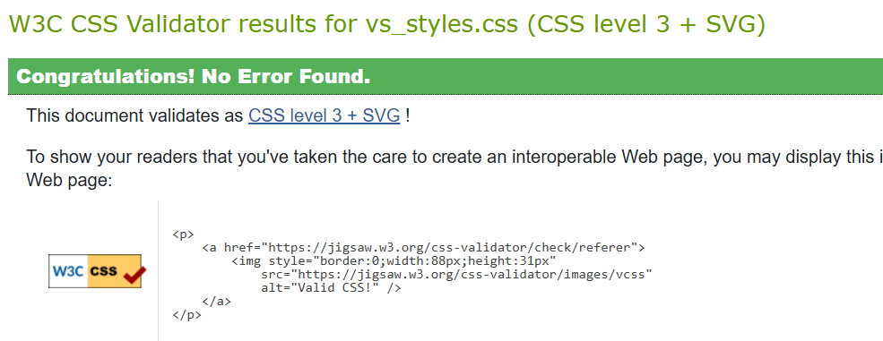
Figure 6 CSS Validation

Evaluation
Usability
Usability means how easy it is for users to understand, navigate and interact with a website. Garrett [1] explains that high usability websites increase user engagement and improve revisit rates, demonstrating that usability of a website has a direct impact on how effectively it supports its users. When it comes to tourism websites usability is key, as visitors have the expectation of being able to find and locate information quickly without confusion.
The Visit Swansea website incorporates usability principles by making use of a simple navigation bar, a consistent page structure, readable text, and clear headings. This enables users to easily find attractions, accommodation, and contact details without difficulty.
Accessibility
When refereeing to accessibility when it comes to the websites it applies to a wide range of individuals with abilities including those with disabilities. Abou-Zahra [2] explains that accessible websites should follow guidelines such as the Web Content Accessibility Guidelines, which are based on four principles: Perceivable, Operable, Understandable, and Robust also referred to as POUR. These principles are set out to ensure that users can access and interact with content effectively.

The Visit Swansea website supports accessibility by including descriptive alt text on all included images, using clear headings, maintaining readable colour contrast, and ensuring consistent page layout.
Search Engine Optimisation (SEO)
Search Engine Optimisation refers to the techniques used to increase a websites visibility in search engines results such as Google. Ahmad et al [3] highlights the importance of on page SEO factors such as metadata, use of clear content structure, and relevant keywords, all of which help search engines interpret and rank webpages more effectively.
Visit Swansea website makes use of several on page SEO techniques, such as including the use of descriptive page titles, meta descriptions on each page, alt text on all images, and a consistent and logical heading structure using tags <h1>, <h2> and <h3>. These features help search engines understand the purpose and content within each of the pages, improving discoverability.
Evaluation of My Website
Overall, my website meets its intended purpose by providing clear and structured information about Swansea’s and its surrounding areas attractions, accommodation options, and contact details to reach the organisation itself. Its consistent navigation bar and simple layout makes it intuitive for users to move between pages, with the use of images enhancing engagement. The embedded Google Maps iframe adds practical value for users to have an idea where the organisation is located and where Swansea is located on a map.
However, there are areas where there could have been improvement. Some improvements that could be made in the future is the inclusion of interactive elements such as videos, or a place for visitors to leave reviews and share their experiences and advice, thus increasing the ability for users to engage with the site. Additionally, there could be improvement on using a more distinctive colour scheme to make the site more visually appealing, and better image and text layout to make the website appear more modern and advanced. Furthermore, there are plenty of other attractions and locations that weren’t included on the website which would have been of benefit for visitors to know about.
Comparisons of Two Live Websites (BBC News vs ITV News)
This section compares the BBC News and ITV News website in terms of their usability, accessibility, SEO, and mobile responsiveness.

Useability:
BBC News presents a clear and well structured website with easy to navigate categories. However, ITV News has more of an image focused design with small titles which makes it harder to scan as quickly as the BBC News site.
Accessibility:
Using the WAVE accessibility tool to check for errors, BBC News showed fewer errors than ITV News, particularly regarding missing alt text and colour contrast issues. This suggests that the BBC maintains a stronger compliance with accessibility standards.
SEO:
BBC News uses clearly structured headings such as <h1>. <h2> and descriptive metadata, which improves search engine optimisation by making it easier for the search engine to interpret. ITV however relies more heavily on images and uses less descriptive alt text which affects the SEO effectiveness.
Mobile responsiveness:
Both websites are optimised well for phone screens, but BBC News provides a more stable layout with better content spacing and faster loading on smaller devices.
Conclusion:
To conclude, BBC News performs better across usability, SEO, and mobile responsiveness, making it more effective for a wide range of users.

Conclusion
The Visit Swansea website successfully meets the requirements specified in the assignment brief by providing clear, accessible, and well structured information for tourists intending to visit Swansea. The development process involved designing four interlinked pages, implementing responsive layouts, and applying usability, accessibility, and SEO principles supported by academic research. Validation checks confirmed that the website met recognised HTML and CSS standards. Overall, the project demonstrates effective planning and implementation, while also highlighting opportunities for future improvement such as improving mobile responsiveness and expanding on interactive features to increase user engagement. The website provides a strong foundation for further development and offers useful information for visitors seeking more information about Swansea.

References
[1]
R. Garett, J. Chiu, L. Zhang, and S. D. Young, “A Literature Review: Website Design and User Engagement,” Online journal of communication and media technologies, vol. 6, no. 3, p. 1, Jul. 2016, Available: https://pmc.ncbi.nlm.nih.gov/articles/PMC4974011/?
[2]
W3C, “Introduction to Web Accessibility,” Web Accessibility Initiative (WAI), Mar. 07, 2024. https://www.w3.org/WAI/fundamentals/accessibility-intro/
[3]
U. F. Ahmad, J. Mahdee, and N. A. Bakar, “Search engine optimisation (SEO) strategy as determinants to enhance the online brand positioning,” F1000Research, vol. 11, no. 2, pp. 714–714, Feb. 2024, doi: https://doi.org/10.12688/f1000research.73382.2.

Appendices
  - Appendix A HTML
Home.html
<!DOCTYPE html>
<html lang="en">
<head>
<meta charset="UTF-8">
<meta name="viewport" content="width=device-width, initial-scale=1.0">
<meta name="description" content="Discover Swansea attractions, hotels, coastal views and visitor information.">
<title>Visit Swansea-Home</title>
<link rel="icon" type="image/x-icon" href="../images/welsh_icon.png">
<link rel="stylesheet" href="vs_styles.css">
</head>

<body>
<header>
<h1>Ymweld ag Abertawe <br> Visit Swansea</h1>
<nav>
<ul>
<li><a href="home.html">Home</a></li>
<li><a href="what_to_see.html">What's to see</a></li>
<li><a href="places_to_stay.html">Places to stay</a></li>
<li><a href="vs_contact.html">Contact</a></li>
</ul>
</nav>
</header>
<div class="card">
<main>

<h2>Croeso i Abertawe <br> Welcome to Swansea</h2>

<img src="../images/T4_Main_Larger-Swansea-Bay-at-sunset.jpg" alt="Image of Swansea"
width="1460" class="center">

<p>Welcome to Swansea! a vibrant coastal city
where natural beauty meets rich culture and history.
Nestled on the edge of stunning Swansea Bay
and the breathtaking Gower Peninsula,
Swansea offers golden beaches, lively nightlife,
and a warm Welsh welcome. Whether you’re exploring
the city’s waterfront, discovering its museums,
or taking in panoramic sea views,
Swansea is the perfect destination for
relaxation, adventure, and unforgettable experiences.</p>

<img src="../images/Swansea_City_drone_shoot_5bec1585-e2c7-470d-a162-b3e36d0d945f.jpg" alt="Image of Swansea #2"
width="900" class="center" >

<h2> Places to visit and things to do in Swansea</h2>
<p>A visit to Swansea is a must: take in the sweeping waterfront of Swansea Bay leading to Mumbles and onto the beautiful Gower Peninsula.
Not complete without trying one of the famous Welsh-Italian ice cream parlours.</p>

</main>
</div>

<footer>
<p>&copy; 2025 Visit Swansea</p>
</footer>
</body>
</html>
What to see.html
<!DOCTYPE html>
<html lang="en">
<head>
<meta charset="UTF-8">
<meta name="viewport" content="width=device-width, initial-scale=1.0">
<meta name="description" content="There is plenty to see in Swansea and it’s surrounding area">
<title>Visit Swansea-What's to See</title>
<link rel="icon" type="image/x-icon" href="../images/welsh_icon.png">
<link rel="stylesheet" href="vs_styles.css">
</head>

<body>
<header>
<h1>Ymweld ag Abertawe <br> Visit Swansea</h1>
<nav>
<ul>
<li><a href="home.html">Home</a></li>
<li><a href="what_to_see.html">What's to see</a></li>
<li><a href="places_to_stay.html">Places to stay</a></li>
<li><a href="vs_contact.html">Contact</a></li>
</ul>
</nav>
</header>
<div class="card">
<main>
<img src="../images/SVW-C46-1112-0056-small.webp.webp" alt="Image of Liberty Stadium"
width="898" class="center">

<h2>What's to see?</h2>
<p>From sweeping coastal views to fascinating museums and vibrant cultural spots, Swansea has something for everyone.
Whether you’re here for a day trip or a weekend getaway, the city offers plenty to explore from natural beauty to
history and local life. Below are three must-see places that capture the spirit of Swansea.</p>

<img src="../images/Mumbles pier.avif" alt="Image of Mumbles Pier"
width="900" class="center">
<h2>Mumbles Pier</h2>
<p> A beloved Swansea landmark since 1898, Mumbles Pier is the perfect place for a seaside stroll.
Enjoy sweeping views of Swansea Bay, visit the family arcade, or relax with an ice cream by the shore.
With its mix of traditional charm and modern attractions, it’s a must-see spot that captures the spirit of the Welsh coast.</p>

<img src="../images/National_Waterfront_Museum_(19125415205).jpg" alt="Image of National Waterfront Museum"
width="900" class="center">

<h2>Swansea National Waterfront Museum</h2>
<p>Located in the heart of the city’s maritime quarter, Swansea Marina is a lively area filled with boats,
cafés, and waterfront walks. At its centre stands the National Waterfront Museum, where interactive
exhibits tell the story of Wales’s industrial and seafaring past. It’s the perfect blend of history,
leisure, and stunning harbour views.</p>

<img src="../images/thumbnail_IMG_0349.jpg" alt="Rhossili Bay on the Gower Peninsula"
width="900" class="center">

<h2>Rhossili Bay</h2>
<p> Stretching for nearly three miles, Rhossili Bay is one of the most breathtaking beaches in the UK.
With its golden sand, dramatic cliffs, and the iconic Worm’s Head peninsula, it’s a favourite spot
for walkers, surfers, and photographers alike. Whether you’re after a peaceful coastal walk or
simply want to take in the incredible sea views, Rhossili Bay is an unforgettable part of Swansea’s charm. </p>
</main>
</div>
<footer>
<p>&copy; 2025 Visit Swansea</p>
</footer>
</body>
</html>
Places to stay.html
<!DOCTYPE html>
<html lang="en">
<head>
<meta charset="UTF-8">
<meta name="viewport" content="width=device-width, initial-scale=1.0">
<meta name="description" content="Find some of the best places to stay in Swansea">
<title>Places to stay</title>
<link rel="icon" type="image/x-icon" href="../images/welsh_icon.png">
<link rel="stylesheet" href="vs_styles.css">
</head>

<body>
<header>
<h1>Ymweld ag Abertawe <br> Visit Swansea</h1>
<nav>
<ul>
<li><a href="home.html">Home</a></li>
<li><a href="what_to_see.html">What's to see</a></li>
<li><a href="places_to_stay.html">Places to stay</a></li>
<li><a href="vs_contact.html">Contact</a></li>
</ul>
</nav>
</header>
<div class="card">
<main>
<h3>Places to stay in Swansea</h3>

<p>Swansea has plenty of great places to stay, from modern hotels by the waterfront to peaceful countryside escapes.
Whether you prefer city comfort, seaside views, or rural charm, there’s something for every visitor.</p>

<img src="../images/dragon hotel.jpg" alt="Image of Dragon Hotel In Swansea"
width="898" class="float-left">
<h2>The Dragon Hotel</h2>
<p>Located in Swansea city centre, The Dragon Hotel is one of the city’s best-known spots for comfort and convenience.
It offers modern rooms, a leisure club with a swimming pool, and easy access to shops, restaurants, and nightlife. <br>
For more information visit their website! </p>
<a href="https://www.dragon-hotel.co.uk/" target="_blank" class="btn">Visit Website</a>
<div class="clear"></div>

<p></p>

<img src="../images/morgans hotel.jpg" alt="Image of Morgan Hotel In Swansea"
width="898" class="float-left">
<h2>Morgans Hotel</h2>
<p>Set in a historic building near the marina, Morgans Hotel blends classic style with luxury.
Guests can enjoy elegant rooms, fine dining, and a short walk to Swansea Museum and the Waterfront area.</p>
<a href="https://www.morganshotel.co.uk/" target="_blank" class="btn">Visit Website</a>
<div class="clear"></div>

<p></p>

<img src="../images/kings head.webp" alt="Image of King’s Head Inn, Llangennith In Gower"
width="898" class="float-left">
<h2>King’s Head Inn, Llangennith</h2>
<p>For a quieter stay, head to the Gower Peninsula and the King’s Head Inn a traditional Welsh pub with cosy rooms
and hearty food, just minutes from the stunning Rhossili Bay. Perfect for walkers and nature lovers.</p>
<a href="https://kingsheadgower.co.uk/" target="_blank" class="btn">Visit Website</a>
<div class="clear"></div>

</main>
</div>

<footer>
<p>&copy; 2025 Visit Swansea</p>
</footer>

</body>
</html>
vs contact.html
<!DOCTYPE html>
<html lang="en">
<head>
<meta charset="UTF-8">
<meta name="viewport" content="width=device-width, initial-scale=1.0">
<meta name="description" content="Need anymore information, or need to find us? Find us or contact here">
<title>Contact</title>
<link rel="icon" type="image/x-icon" href="../images/welsh_icon.png">
<link rel="stylesheet" href="vs_styles.css">
</head>

<body>
<header>
<h1>Ymweld ag Abertawe <br> Visit Swansea</h1>
<nav>
<ul>
<li><a href="home.html">Home</a></li>
<li><a href="what_to_see.html">What's to see</a></li>
<li><a href="places_to_stay.html">Places to stay</a></li>
<li><a href="vs_contact.html">Contact</a></li>
</ul>
</nav>
</header>
<div class="card">
<main>

<img src="../images/contact us.avif" alt="Image of Swansea"
width="1460" class="center">

<h2>Contact Information & Additional Information</h2>
<p>If you need anymore information and advice please contact us via the following details: <br>
Address<br>
Civic Centre, Oystermouth Rd, Maritime Quarter, <br>
Swansea SA1 3SN <br>
</p>

<h2>Email & Telephone</h2>
<p>Phone: 01792 636000<br>
Email: visitswansea@swansea.gov.uk</p>

<h2>Where to find us</h2>

<iframe src="https://www.google.com/maps/embed?pb=!1m18!1m12!1m3!1d2477.4969080840688!2d-3.9483806!3d51.6141061!2m3!1f0!2f0!3f0!3m2!1i1024!2i768!4f13.1!3m3!1m2!1s0x486e8acb88949b27%3A0x64b773f7e35ccf9f!2sSwansea%20Civic%20Centre!5e0!3m2!1sen!2suk!4v1762817096832!5m2!1sen!2suk" width="600" height="450" style="border:0;" allowfullscreen="" loading="lazy" class="center" referrerpolicy="no-referrer-when-downgrade"></iframe>
</main>
</div>
<footer>
<p>&copy; 2025 Visit Swansea</p>
</footer>
</body>
</html>
  - Appendix B
h1 {
color:rgb(248, 248, 248);
font-family:Arial, Helvetica, sans-serif;

}

h2{
color: #1f1e1e;
font-size: 24px;
font-family:Verdana, Geneva, Tahoma, sans-serif;
text-align: center;

}

h3 {
color: #1f1e1e;
font-size: 36px;
font-family: Arial, Helvetica, sans-serif, Geneva, Tahoma, sans-serif;
text-align: center;
}

p{
color: #1f1e1e;
font-size: 18px;
font-family:Verdana, Geneva, Tahoma, sans-serif;
text-align: center;
}
body{
background-color:#f0f8ff;
font-family: sans-serif;
color: #333;
}
header {
background-color: #1f1e1e;
color:white;
padding: 10px;
text-align: center;
}
nav ul li {
display: inline;
margin: 0 10px;
}
nav ul li a {
color: white
}
main {
padding: 20px;
}

footer {
background-color: #333;
color: rgb(238, 233, 233);
text-align: center;
padding: 10px;
position: static;
bottom: 0;
width: 100%;

}

.card {
background: white;
padding: 20px;
margin: 10px;
border-radius: 8px;
text-align: center;
}

.center {
display: block;
margin-left: auto;
margin-right: auto;
width: 50%;
}

footer, footer p {
color: white !important;
}

.float-left {
float: left;
width: 300px;
height: auto;
margin-right: 20px;
border-radius: 8px;
}

.clear { clear: both; }

.btn {
display: inline-block;
background-color: #1f1e1e;
color: white;
padding: 10px 20px;
text-decoration: none;
border-radius: 5px;
font-weight: bold;
transition: background-color 0.3s ease;
}

.btn:hover {
background-color: #555;
}

