Assessment 5 Transcription Exercise
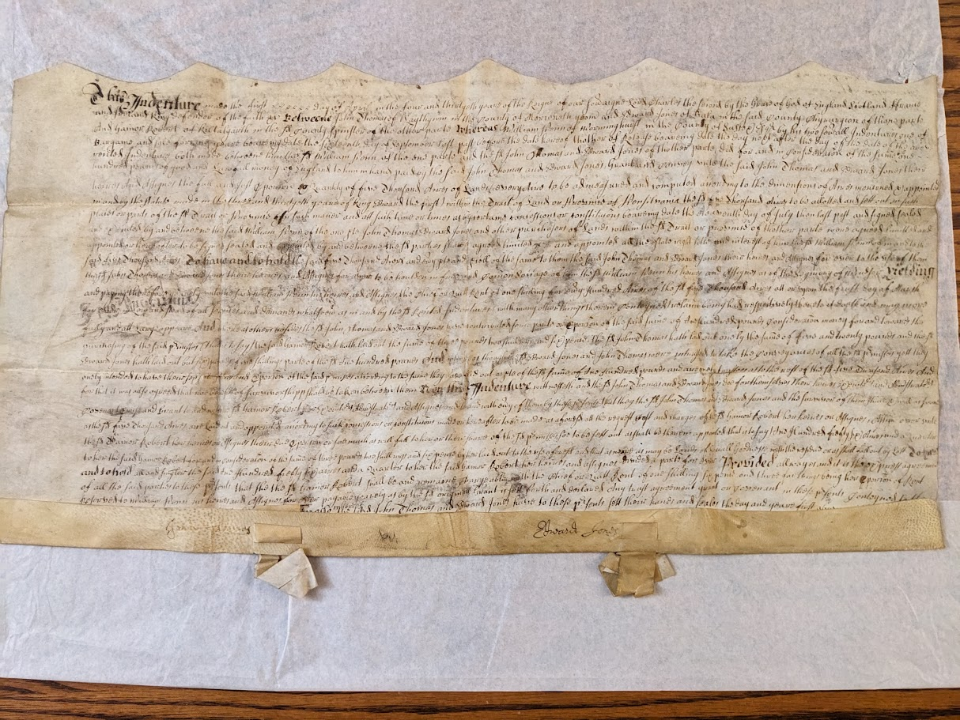
This transcription is of an indenture dated to 1682 between William Penn, the founder of the Province of Pennsylvania, John Thomas, Edward Jones, and Gainor Roberts. My transcription, below the photographs, is presented in normal font, with my expansions added in square brackets. Although I have transliterated the indenture accurate to 17th century spelling, I have expanded some common contractions using square brackets to aid the transcription’s readability. Words that are bolded in the indenture I have likewise placed in bold type. Additionally, each paragraph represents one line of the indenture, helping to keep track of the reader’s place.
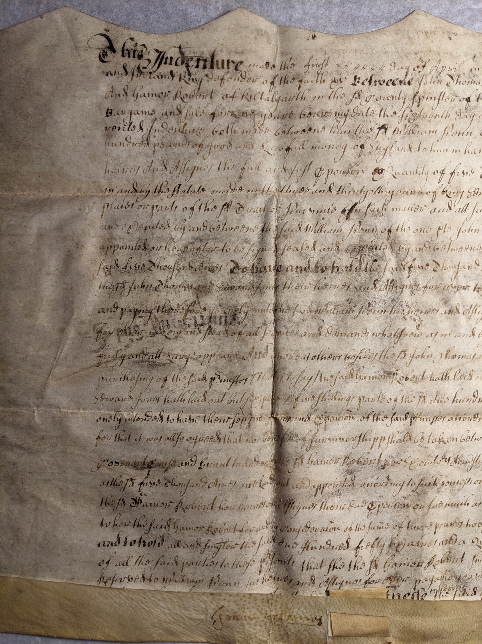
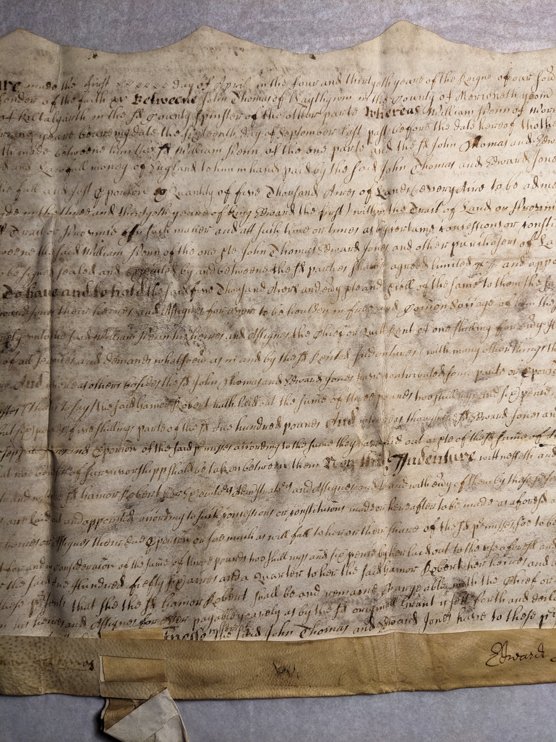
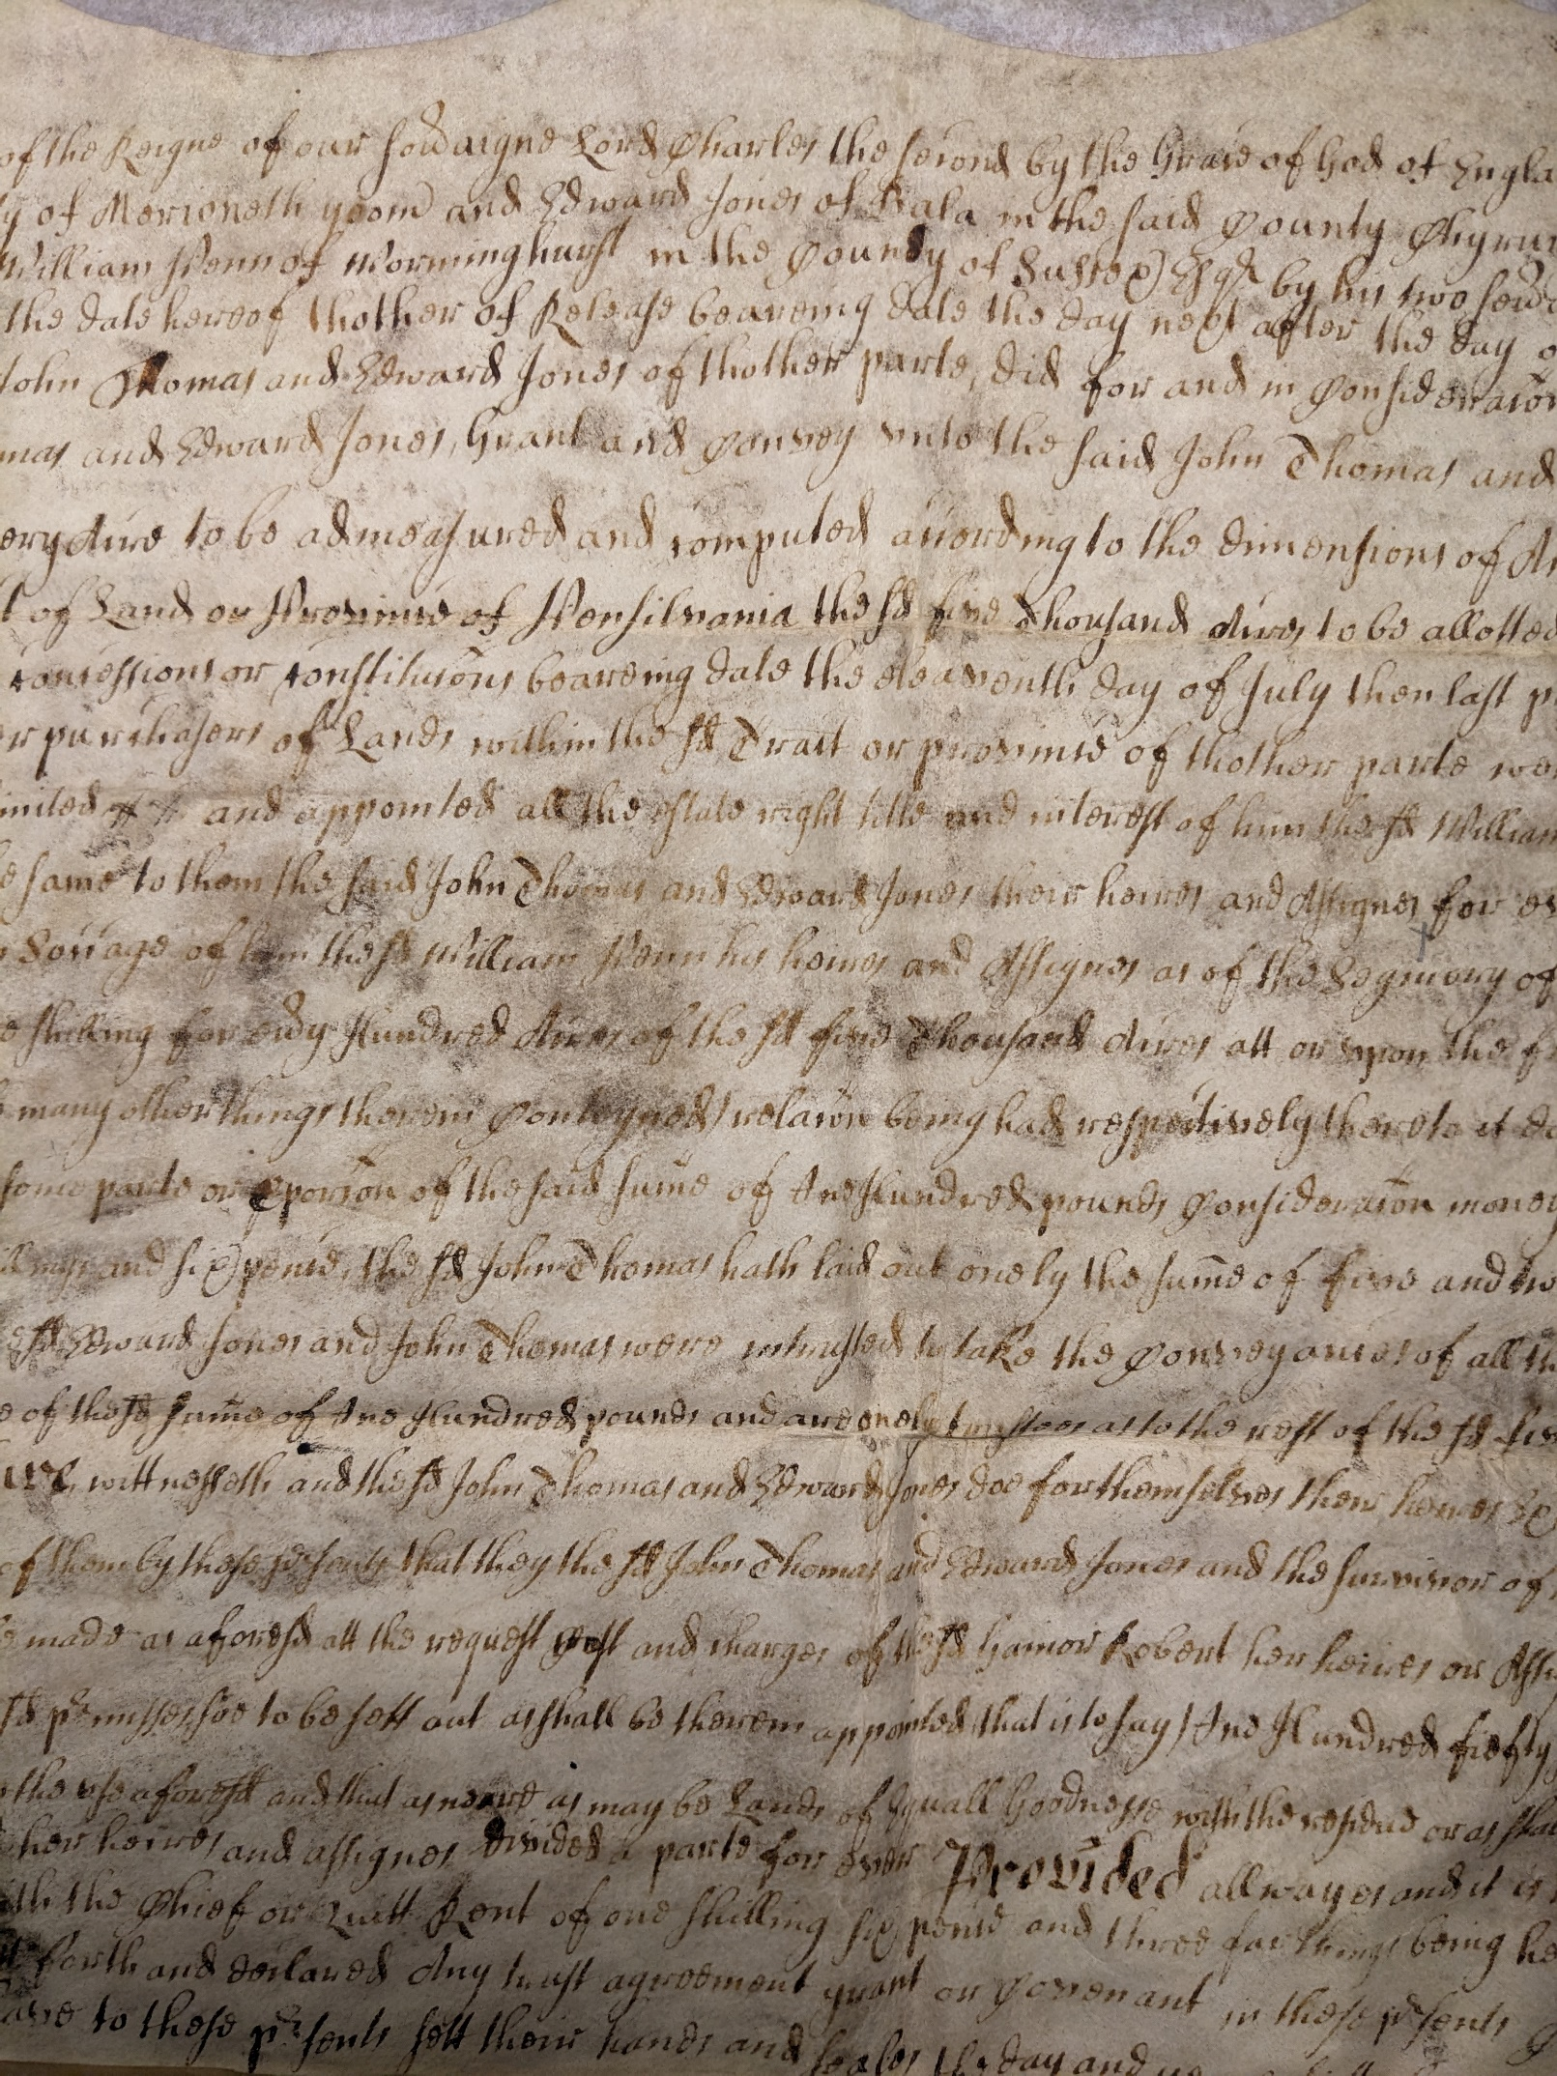
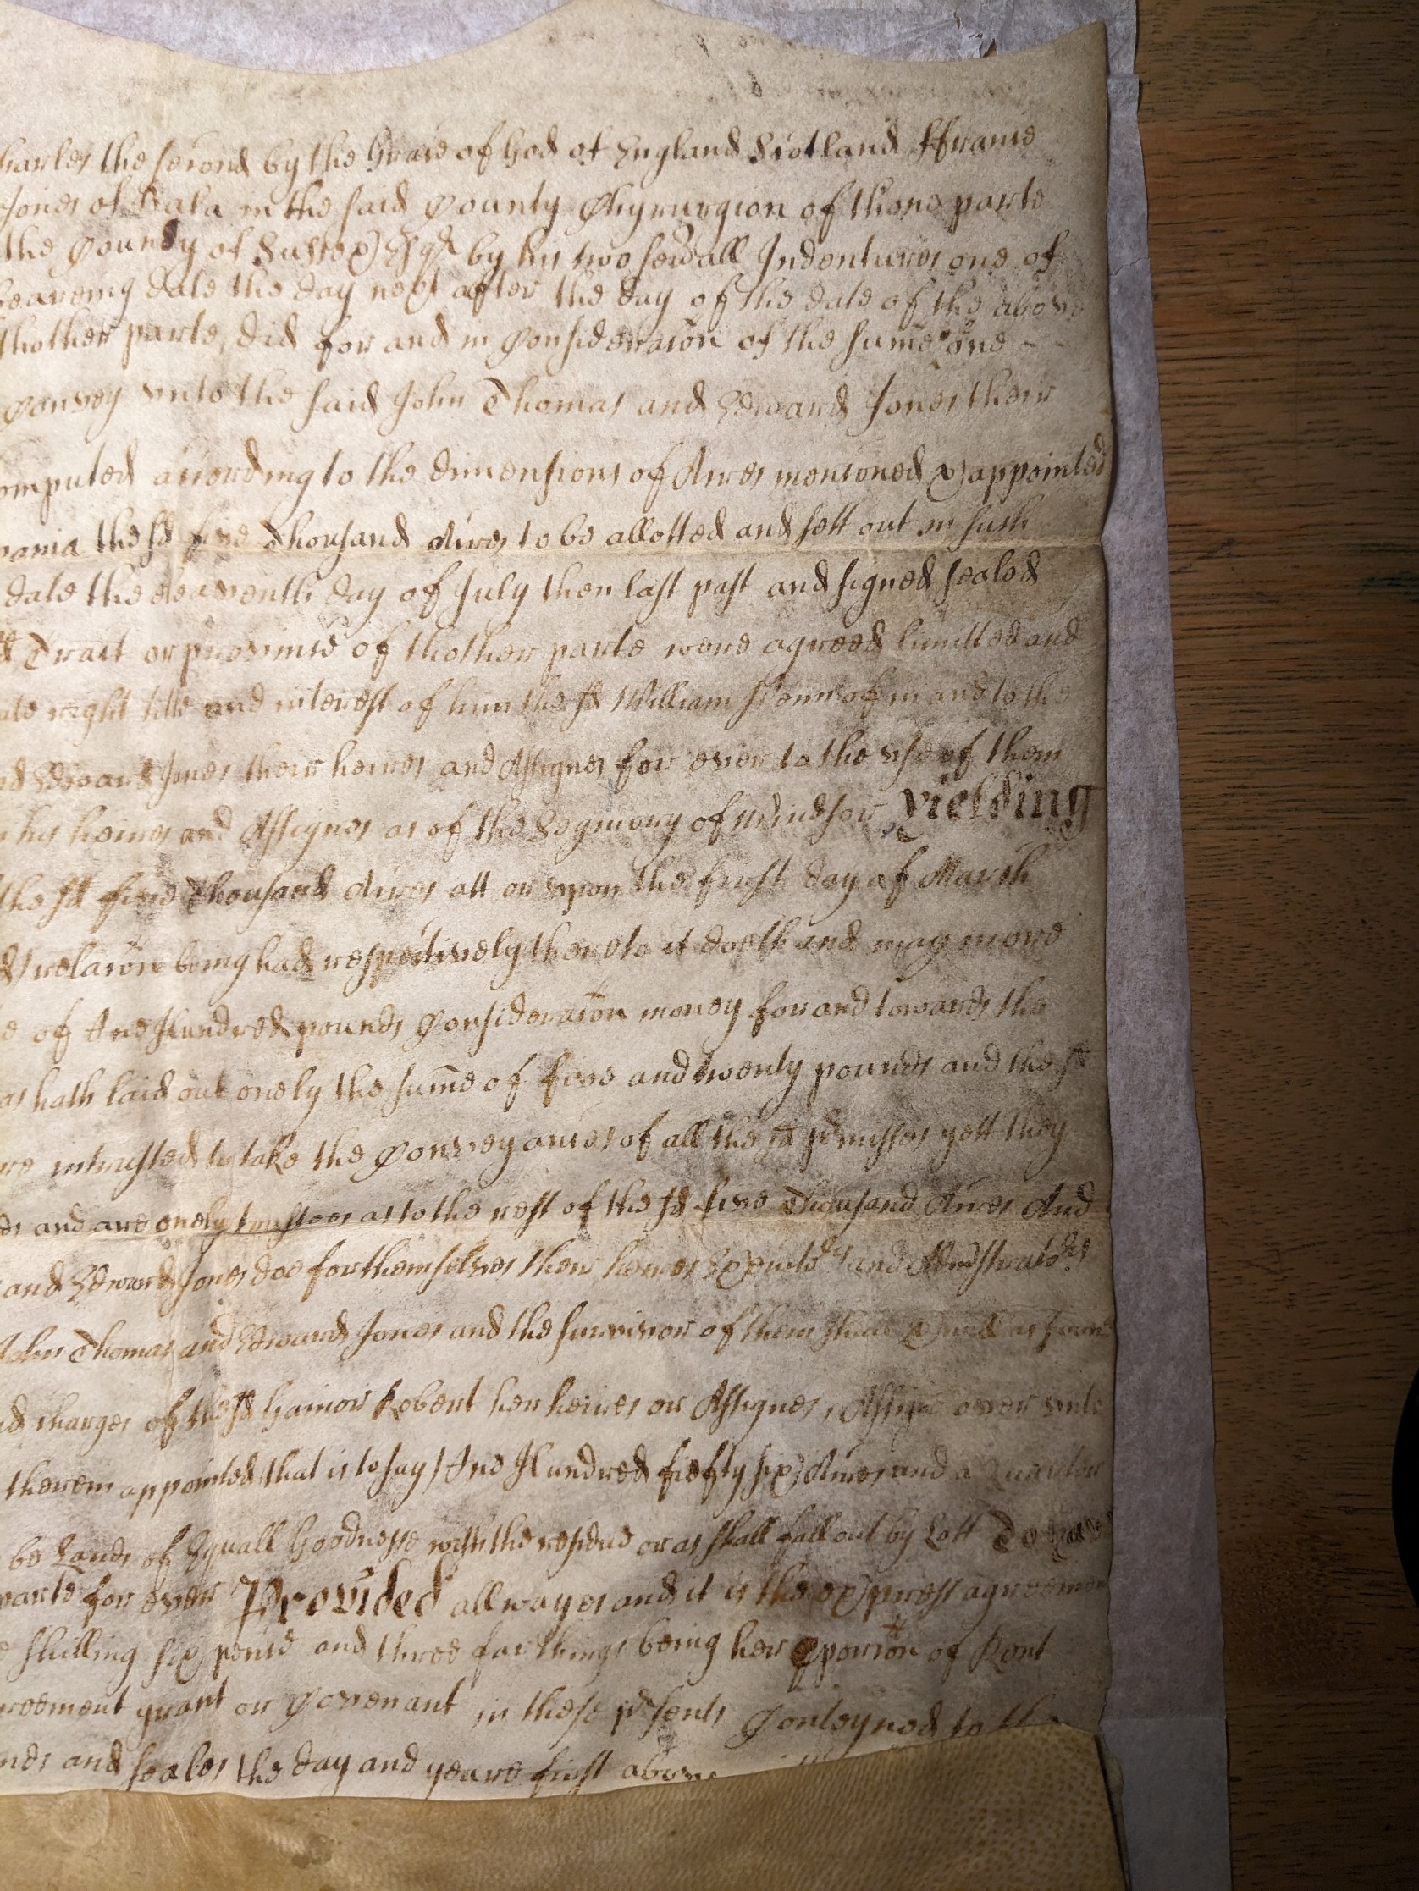
Transcription
This indenture made the first x x x x x x day of April in the four and thirtyeth yeare of the Reigne of our Sov[er]aigne Lord Charles the Second by the Grace of God of England Scotland Ffrance
and Ireland King defender of the faith that Betweene John Thomas of Llaythgwm [Llaithgwm] in the county of Merioneth yeom[en] and Edward Jones of Bala in the said county chyrurgion of th[e]one parte
And Gainor Robert of Kiltalgarth in the s[ai]d county spinster of the other parte whereas William Penn of Worminghurst [Warminghurst] in the county of Sussex Esq[uire] by his two se[ver]all indentures one of
Bargaine and sale for one yeare beaereing date the sixteenth day of September last past befour the date hereof thother [the other] of Release beareing date the day next after the day of the date of the above
recited Indenture both made betweene him the s[ai]d William Penn of the one parte and the s[ai]d John Thomas and Edward Jones of thother parte, did for and in consideiration of the same one
hundred pounds of good and Lawfull money of England to him in hand paid by the said John Thomas and Edward Jones, Grant and convey unto the said John Thomas and Edward Jones their
heires and Assignes the full and just p[ro]portion and Quantity of five Thousand Acres of Land (every Acre to be admeasured and computed according to the dimensions of Acres ment[i]oned and appointed
in and by the statute made in the third and thirtieth yeare of King Edward the first) within the Tract of Land or Province of Pensilvania the s[ai]d five thousand Acres to be allotted and sett out in such
places or parts of the s[ai]d Tract of Province in such maner and att such time or times as by certaine concessions or constitutions beareing date the eleaventh day of July then last past and signed sealed
and executed by and between the said William Penn of the one p[ar]te John Thomas Edward Jones and other purchasers of Land within the s[ai]d Tract or province of thother parte were agreed limitted and
appointed or hereafter to be signed sealed and executed by and betweene the s[ai]d parties shalle agreed limited x x and appointed all the estate right tithe and interest of him the s[ai]d William Penn of in and to the
said Five Thousand Acres To have and to hold the said five Thousand Acres and every p[ar]te and p[ar]cell of the same to them the said John Thomas and Edward Jones their heires and Assignes for ever to the use of them
the s[ai]d John Thomas and Edward Jones their heires and Assignes for ever to be houlder in free and com[m]on soccage of him the s[ai]d William Penn his heires and Assignes as of the Se[i]gniory of Windsor yielding
and paying therefore yearely unto the said William Penn his heires and assignes the chief or quitt rent of one shilling for ev[er]y Hundred Acres of the s[ai]d five Thousand Acres att or upon the first day of March
for ever in lew and stead of all services and demands whatsoev[er] as in and by the s[ai]d Recited indentures with many other things therein conteyneds relat[i]on being had respectively thereto it doeth and may more
fully and att large appeare And where as others besides the s[ai] John Thomas and Edward Jones have contributed some parte or [pro]portion of the said sume of One Hundred considerat[i]on money for and towards the
purchasing of the said [pre]misses (that is to say) the said Gainor Robert hath laid out the sume of three pounds two shillings and six pence, the s[ai] John Thomas hath laid out onely the sume of five twenty pounds and the s[ai]d
Edward Jones hath laid out but six pounds five shillings parte of the s[ai]d One hundred pounds And whereas though the s[ai]d Edward Jones and John Thomas were intrusted to take the conveyances of all the s[ai]d [pre]misses yett they
onely intended to have their sepparate shares[?] and [pro]port[i]on of the said [pre]misses according to the sume they have laid out as p[ar]te of the s[ai]d sume of One Hundred pounds and are onely trustees as to the rest of the s[ai]d five Thousand Acres And
for that it was allso agreed that no benefit of survivorshipp sho[u]ld be taken between them Note This[?] Indenture, wittnesseth and the s[ai]d John Thomas and Edward Jones doe for themselves their heires executors and Administrators
covenant prise and Grant to and with the s[ai]d Gainor Robert heir[es?] executives administrators and Assisgnes and to[?] and with every of them by these [pre]sent that they the s[ai]d John Thomas and Edward Jones and the survivor of them shall execute[?] as soone
as the s[ai]d five thousand Acres are laid out and appointed according to such concessions or constitutions made or hereafter to be made as afores[ai]d att the request cost and charges of the s[ai]d Gainor Robert her heires or Assignes, assigne over unto
the s[ai]d Gainor Roberts her heires and Assignes their due proportion or soemuch as will fall to her or their share of the s[ai]d premisses soe to befell as shall be therein appointed (that is to say) One Hundred fiefty six Acres and a quarter
to her the said Gainor Robert for and in consideration of the sume of three pounds two shillings and sixpence by her laid out to the s[ai]d afores[ai]d and that as [a]nd [a]re as may be Lands of equall Goodnesse with the residue or as shall fall out by Lott to have
and to hold all and sing[u]ler the said One Hundred fiefty six acres and a quarter to her the said Gainor Robert her heires and assignes divided a parte for ever provided allwayes and it is the express agreement
of all the said parties to these p[re]sents that she the s[ai]d Gainor Robert shall be and remaine chargeable with the chief or quitt rent of one shilling sixpence and three farthings being her p[ro]portion of rent
reserved to William Penn his heires and Assignes for ever payable yearely as by the s[ai]d original Grant is sett forth and declared Any trust agreement grant or covenant in these p[re]sents conteyned to the
contrary thereof in any wise not withstanding In Witnesse the said John Thomas and Edward Jones have to these p[re]sente sett their hands and seales the day and yeare first above written Anno Domini[?] 1682.

Commentary
This document is an indenture between William Penn, John Thomas, Edward Jones, and Gainor Roberts. In 1681, the English Quaker William Penn was granted land in North America by Charles II, naming it Pennsylvania. During this same time, hostility and persecution of Quakerism in England and particularly Wales resulted in many Quaker families desiring to resettle in North America, and as William Penn himself was a Quaker, the province of Pennsylvania was a desirable location. In light of this, this document signifies the purchase of 5,000 acres for £100 by a company of Quakers looking to emigrate from North Wales, represented by two individuals, John Thomas and Edward Jones. While these two individuals are the purchasers of the 5,000 acres, they are explicitly described as trustees, instructed to purchase the land on behalf of the group of Quakers. The document describes how the 5,000 acres are to be allocated to each individual according to the amount of money they contributed to the £100-pound total fee. John Thomas contributed £25, Edward Jones contributed £6 5s, and Gainor Roberts contributed £3 2s 6d. As this document appears to be focused most specifically on Gainor Roberts’ allocated land, it shows that she received 156 and a quarter acres of land in return for her financial contribution.
This indenture is located in the Lower Merion Historical Society archives in Bala Cynwyd, Pennsylvania, and dates to the first of April 1682. While at the archive, I was informed that the document is made from a goatskin parchment. The document's author is unknown, although a secretary or solicitor probably wrote it on behalf of those mentioned. As it is currently located in the United States, it is possible it was first written in North America. That said, secondary sources reveal that John Thomas and company were not scheduled to depart for Pennsylvania until 1683 and would have still lived in North Wales at the time of this document’s creation. Therefore, it is also possible that it was written in England or Wales and transported to Pennsylvania by the Quakers company in 1683 as proof of purchase.
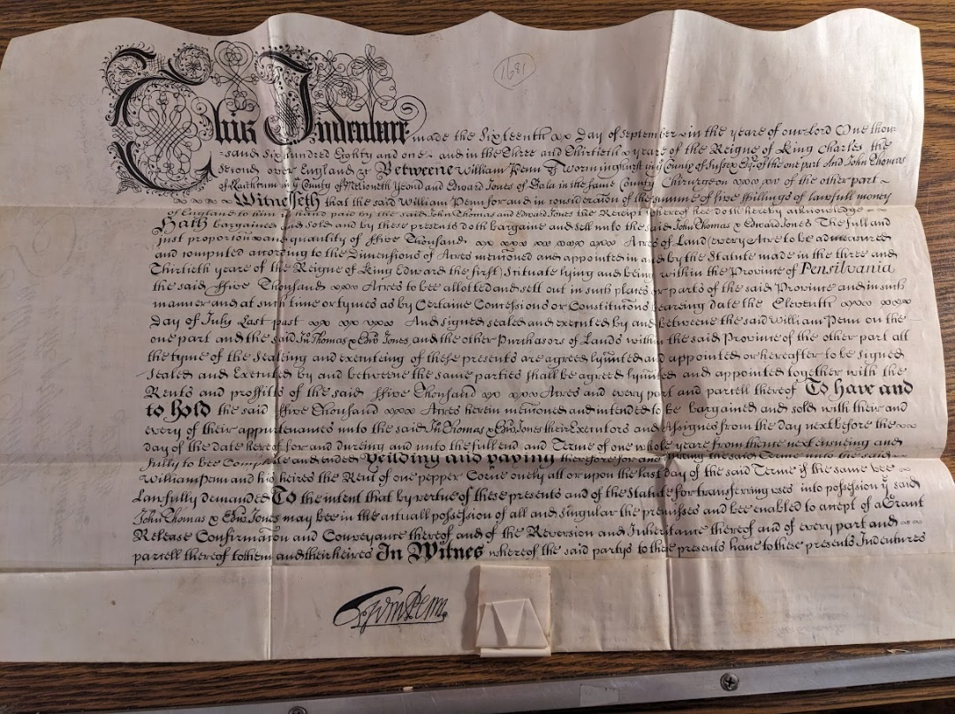
As discussed above, the author was likely a secretary or solicitor, and as such the document is written in secretary hand. Compared to other indentures created around the same period, this indenture lacks neat penmanship and artistic flourishment. The picture above is of an earlier September 1681 indenture mentioned in the 1682 transcription, also found in the Lower Merion Historical Society Archives. Although it is a 19th-century copy of the original, it nevertheless preserves the original penmanship. Additionally, the 1681 indenture was witnessed and signed by William Penn himself, whereas the 1682 indenture was only witnessed by John Thomas and Edward Jones. This could mean that it was a first edition drafted to be shown to William Penn for him to witness and sign an official indenture of land, perhaps revealing why it has been produced to a lower standard.
To aid my transcription, I cross-referenced many harder-to-read words, symbols, and abbreviations with an article written by the Board of Certification of Genealogists. This article highlighted common spellings, symbols, and abbreviations in 17th-century English and American documents. Some of the spellings found in the indenture include the addition of a terminal e and the omission of the terminal e when the following word begins with an appropriate vowel, such as thother for the other. Additionally, there is a doubling of consonants such as t and l. The most common contraction was the ai in said. Other common contractions included the ar in parte, the ro in proportion, the t, and the re in presente/s. Only two symbols were used that I could identify throughout the document, the first being the symbol for that, and the second, a symbol for and. Interestingly, both symbols are only used once towards the start of the text and are written fully throughout the rest of the document.
Overall, the document was moderately challenging to transcribe due to the reliance on photographs, creases in the parchment, and faded text parts. However, the commonplace repetitive turns of phrases or names helped me transcribe the trickier parts of the document by identifying individual letters I knew to be correct and making note of their distinct shape as well as what other letters commonly preceded and succeeded them. An example is the author’s style for a lowercase c, which can be mistaken for the letter i if not for apostrophic stroke marks above the letter. By identifying this technique early on in the document in the phrase Charles the Second, I could correctly identify where c was used throughout the text.

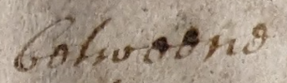
Between, spelt with a terminal e.
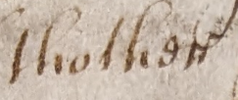
The other, spelt with an omission of the terminal e.
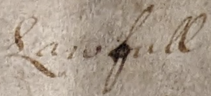
Lawful, spelt with a double l.
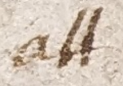
At, spelt with a double t.
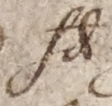
Said, spelt with a contracted ai.
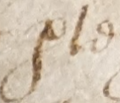
Part, spelt with a terminal e and a contracted ar.
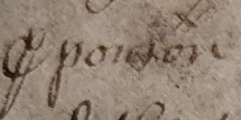
Proportion, spelt with a contracted ro.

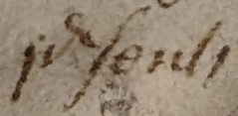
Presents, spelt with a contracted re.

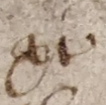
Symbol for that.
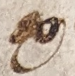
Symbol for and.

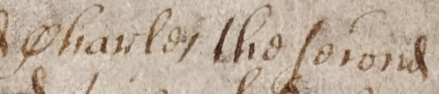
Charles the Second, spelt with two differing C’s, the lowercase with an apostrophic flick.

Bibliography:
Hill, Ronald A. “Interpreting the Symbols and Abbreviations in Seventeenth Century English and American Documents.” https://bcgcertification.org/wp-content/uploads/2013/05/Hill-W141.pdf.
Levick, James. “John Ap Thomas and his Friends.” The Pennsylvania Magazine of History and Biography, Vol. 4, No. 3 (1880): 301-328. https://www.jstor.org/stable/20084463?seq=2.

James Levick, “John Ap Thomas and his Friends,” The Pennsylvania Magazine of History and Biography, Vol. 4, No. 3 (1880): 301-328, https://www.jstor.org/stable/20084463?seq=2.
Ronald A. Hill, “Interpreting the Symbols and Abbreviations in Seventeenth Century English and American Documents,” https://bcgcertification.org/wp-content/uploads/2013/05/Hill-W141.pdf.

