Acknowledgments
Jessica Shore, Supervisor, UWTSD
Gabriel Fisher, Student Support Worker, UWTSD
‘South Beach, Tenby’ (Samuel, 2020)
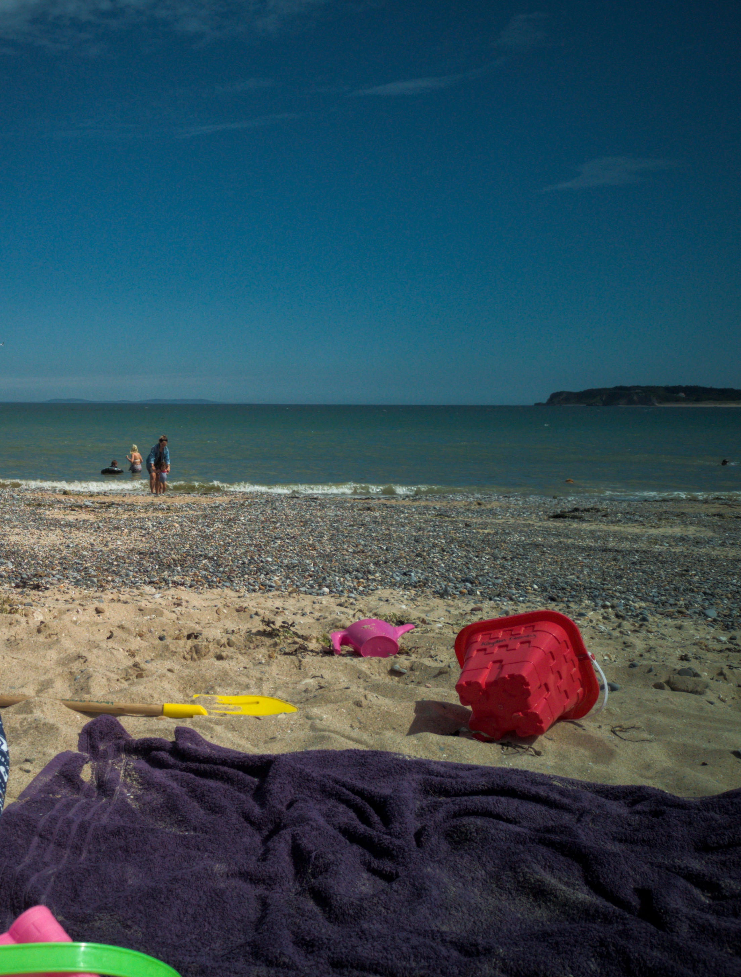  The Resilience of welsh hospitality  How the Welsh tourism and hospitality industries were impacted by COVID-19 | Abstract  This study aims to investigate how the tourism and hospitality industries of Wales have been affected by the ongoing COVID-19. It addresses the gap in research due to the newness and magnitude of the virus, and how businesses within these industries have, or in some cases have not, shown resilience when facing the issues posed by such extreme circumstance, without sufficient guidance. It demonstrates the industry’s ability to diversify and become more sustainable, and how they can achieve that, but also highlights what needs to be done to provide appropriate support in the case of a future crisis. Providing recommendations for industry leaders, business owners/managers and governing bodies.  Jennifer Hughes-Cooke (2015101)  BA Business & Management

Table of Contents
1.Introduction 2
2.Literature Review 2
2.1 Introduction 2
2.2 Zika Virus Literature 3
2.3 Foot and Mouth Disease Literature 3
2.4 COVID-19 Literature 4
2.5 Wales as a destination 5
2.6 Conclusions 6
3.Methodology 7
3.1 Aims 7
3.2 Chosen Methods 7
3.3 Analysis 8
3.4 Obstacles 9
3.5 Evaluation 9
4. Findings, Analysis & Discussion 10
4.1 Questionnaire Results 10
4.2 Personal Observations 15
4.3 #HashtagResearch 18
4.4 Discussion 19
4.4.1 Government Handling 19
4.4.2 Applying COVID-19 to Tourism Disaster Framework 20
4.4.3 The Five Arches Tavern STEEPLE & SWOT Analysis 23
4.4.4 Moving Forward 23
5. Conclusions & Proposals 24
6. References 24
7. Appendices 24
Appendix 1. 24

1.Introduction
In early 2020, the news began to spread of a new virus, now known as COVID-19, gripping China, by March 11th, 2020 the World Health Organisation declared it a global pandemic, 2 weeks later the UK went into a national lockdown and all unnecessary travel was banned. While many had the virus itself to fear, those who work and live in Wales’s tourism hotspots were facing the prospect of a summer, usually the hight of season, where they were unable to open and gain income. Many businesses faced the prospect of closure altogether as, regardless of the global pandemic, bills had to be paid. While scientists across the world assembled to understand the characteristics of the virus and develop a vaccine, businesses within the tourism and hospitality industries had to develop new and innovative ways of generating revenue, while travel and social contact is restricted. During the early stages of the pandemic, the UK, and Welsh Governments had to tackle both the public health implications of the pandemic, while avoiding economic instability and the collapse of industries, they devised rescue plans and an employment retention scheme, but these can only go so far. In Wales, the tourism and hospitality industries play a crucial role in the country’s economic stability, welcoming over 10 million visitors, annually (Wales.com, 2021), it is responsible for £6.2b of Welsh GDP (WTA, 2021), so it would be fair to describe COVID-19 as a crisis for the industry. With an unclear path out of the pandemic, businesses within these industries have had to try and diversify, altering business strategies without guidance and support. The purpose of this study is to identify the ways in which the Welsh tourism and hospitality industry have shown resilience during the COVID-19 Pandemic, and identify the key issues faced by businesses while on the road to recovery, developing recommendations to aid the industries when facing a crisis of this magnitude in the future. The study will look at the impact of other health and safety related disasters (e.g., Zika Virus, South America, 2016 and FMD, UK, 2001) on the industries, and recommendations that followed during the recovery period, and attempt to draw similarities to work from. The study will analyse and discuss, in depth, the impact of the COVID-19 Pandemic on Welsh tourism and hospitality reliant businesses. This will be done by gathering evidence using a Questionnaire made available to Welsh businesses within the industry quantifying their experiences so far, backed up with written responses of participants. It will also include a Personal Observations Analysis of a Public House in Tenby, the crown jewel of Welsh tourism, carried out by the author, this research will offer first-hand experiences and insights of the hospitality industry. The research will also include a simplistic form of Social Media Hashtag (#) Research, used to understand the overall mood within the industry. The study will identify themes within the research analysis, such as the seemingly agreed opinion that the UK and Welsh Governments could have done more for the industries during this time, or how community has been key for many businesses survival. Highlighting links to research done during the early stages of the pandemic by Gössling et al (2020) and Qiu et al (2020), that discuss the importance of community and sustainability in developing recovery plans for the industry. A gap in research is identified as we know little about COVID-19, due to this it is expected that businesses have little guidance on how to diversify and continue moving forward. Drawing conclusions from these findings, on ways to diversify, community inclusion and government guidance, the study will then address the key issues faced by offering a selection of recommendations for industry leaders and governing bodies. If successfully implemented, these recommendations could aid Welsh businesses involved in tourism and hospitality to diversify and become more sustainable. These recommendations could also be developed further, using lessons learned from COVID-19 to prepare the tourism industry for another global crisis, something experts believe we could see happening more often.

2.Literature Review

2.1 Introduction
As the Novel Coronavirus (COVID-19) pandemic continues to limit the social lives and leisure travel of the everyday consumer, the hospitality industry is still baring the worst of the impacts. Businesses need to find ways to adapt to a ‘new normal’, and as this pandemic is the first major world crisis in recent history, it is difficult to know what the ‘right thing’ to do is. In the case of Wales and their own tourism and hospitality industry, there is fortunately, or unfortunately for them, an abundance of literature in relation to the prior 2001 UK Foot and Mouth Disease (FMD) outbreak. This outbreak had a significant impact on UK wide tourism, as the most popular areas to visit were included in land belonging to the National Trust, or protected countryside, that had to be closed and treated to fight human transmission. There is also literature available in relation to the Zika virus, spread by mosquitos, outbreak in south America, at the time of the Rio 2016 Olympic Games. Again, on a smaller scale, like FMD, the Zika Virus had slowed the flow of visitors to the countries and impacted upon their tourism industries. However, in both these instances, the overall impact on the hospitality industries were limited and short lived, in contrast to our current circumstances with COVID-19. Patient Zero was identified in Wu-Han, China, in December 2019, and following that the world went into a global lockdown. Although there is some available literature relevant to COVID-19 impact on tourism and hospitality, daily changes to restrictions and an unclear future leaves room for continued research and analysis.

2.2 Zika Virus Literature
The Zika virus is a disease, normally found in hotter climates, that is transmitted via mosquito bites. Although the virus itself is largely harmless with flu-like symptoms, it has been linked to microcephaly, other congenital abnormalities and still birth if contracted by pregnant women. There are also links to neurological diseases in adults. As outbreaks of the Zika virus usually occur in popular holiday destinations, the literature investigating the economic impact may give insights into how health related crisis have been overcome in different demographics. Puerto Rico, a popular sun seeker destination, suffered a large downturn in tourism following the 2016 mass outbreak, discussed in Feldberg. S (2016) article for Travel Weekly, and researchers investigating social media trends around the #Babymoon tag found less and less expectant mothers booking a pre-baby break in South America (Gallivan, Mark, Oppenheim, Ben, Madhav & Nita K, 2019). The most interesting study found, discusses what contributes to decision-making when looking to travel when health and disease is a concern. The study, carried out by Nicole J. Olynk Widmar et, al (2017) used the Zika Virus outbreak of 2015-2016 and US tourists as the focal point of understanding what influences travellers when booking to visit high risk areas. There are many other studies and articles regarding Zika Virus and its impact upon tourism, but as established, this is not an issue for Wales. The relevance of the literature, while not being UK-based, is that it can offer a comparison when studying previous examples. Aside from originating in South American, the Zika Virus did not force a complete lockdown of travel to and from the effected countries, or the complete closure of industries; therefore, any impact felt would have been minimal in comparison to COVID-19.

2.3 Foot and Mouth Disease Literature
Foot and Mouth Disease is a devastating infection that primarily affects cloven-hoofed animals. It is rarely passed to humans but can be easily transmitted by our clothing, footwear, and motor vehicles, causing it to quickly spread from area to area. Agriculture is hugely impacted (Thompson et al., 2002) when there is a FMD outbreak, with hundreds of thousands of livestock being destroyed. However, in 2001 an outbreak in the UK had an unexpected hit on the tourist industry at the time. With vast areas of the British coast and countryside shut off from the public, holidays to popular destinations across the UK hit a massive low, as campsites were forced to close to decontaminate and coastal and country footpaths were blocked off (Brown, 2001). Graham A. Miller & Brent W. Ritchie (2003) define crisis and disaster and discuss the 2001 FMD outbreak and its impact on UK tourism. The article is an interesting read as it applies the FMD outbreak to Faulkner’s (2001) Tourism Disaster Framework model, the framework was developed when a lack of disaster management strategies for the tourism industry were identified. Although the model has its limitations, it may be helpful when assessing future disasters. The UK Government’s Department for Culture, Media and Sport released a report following the FMD outbreak, in October 2001. The report, Tourism-The Hidden Giant-And Foot and Mouth, looks at how FMD tested the support structures in place for the industry, and what (if any) changes they could make for a future crisis. It will be interesting to see how the UK Government has developed their strategies over time and compare the effectiveness of the support offered in present day with previous years. Research from Blake et al. (2003, p.450) was the first of its kind, as they developed the CGE model, a model that enabled them to quantify the impact of FMD on UK tourism. This model would provide a way to assess economic changes upon both agriculture and tourism, bringing each sector’s roles into policymaking to understand the direct and indirect implications for all concerned. It may be useful to apply the CGE model when assessing the impacts of COVID-19.

2.4 COVID-19 Literature
The COVID-19 world pandemic has been an unprecedented crisis globally. Humanity has not faced anything like it in recent history, with it being likened to the Spanish Flu pandemic of 1918 (BBC News, 2020). COVID-19 is a viral infection that attacks the respiratory system of the sufferer, though most people infected will only have mild symptoms, for some it has been a dangerous, life changing, and fatal disease. The disease is transmitted via vapour droplets from an infected person’s saliva/mucus and can live on hard surfaces for days at a time (Gray, 2020). The pandemic itself is still ongoing, and so comes with it continuing research into its impacts outside of health and medicine. As countries of the world, one by one, went into lockdown, the global economy almost came to a standstill. Even still international and local travel has been extremely limited, so as Wales heads into its second summer of social restrictions, it will be interesting to look back over the previous 12 months and understand the impact COVID-19 has had on the tourism and hospitality sectors of the country. Research into the impact of FMD on UK tourism includes an opinion piece by Hitt. C (2021) drawing comparisons between 2001’s crisis and the current COVID-19 pandemic. The article highlights the similarities faced by frontline workers, it also highlights the similarities in what the public saw during these events, especially the Wales/Westminster divide when dealing with a crisis, whether it be health or economically based.
Welsh tourism and hospitality industries have been one of the hardest hit through this pandemic, and it is no secret that there is unrest between the devolved Welsh Government and Westminster when handling their approaches to re-opening the industries and the restrictions in place (Masters, 2020). Businesses in Wales have been vocal on how supported they have felt throughout COVID-19, and although the UK Governments Furlough Scheme (Bernal, 2021) and the Welsh Governments industry grant schemes (Business Wales, 2021) have proved popular and helpful, the general lack of clarity from governments still causes issues. An updated Office for National Statistics (ONS) report from Roberts (2021) correlates data from business performance and the labour market, to analyse how tourism related industries have been affected by COVID-19. This report has been valuable in assessing findings, when looking at Wales tourism industry. In the early stages of the COVID-19 pandemic, Gössling et al. (2020, p.13) outlined some predictions for tourism- related industries, providing an overview of problems that could arise and ways to overcome them. The assessment challenges traditional means of tourism vs. sustainable tourism, and how COVID-19 may impact our traditional ideas of travel and holidays. It will be interesting to see if any of these predictions have come true, and if sustainable tourism is the way to move forward into a ‘new normal’. Research from Qiu et al. (2020) considers the impact of the pandemic from the perspective of residents of tourist destinations, it discusses the balance of cost to economy vs. the cost of public health risks. The article is also helpful in considering recovery strategies for the future.

2.5 Wales as a destination
Wales has solidified itself as a small but mighty tourist destination, popular across the globe, with families, adventure seekers, history enthusiasts, urban explorers and those who enjoy the tranquillity of the countryside. VisitWales.com (2021) believes that Wales’ huge popularity is down to its ‘over 600 castles, three national parks, eleven great little steam trains, award winning beaches, lots of colourful market towns and Cardiff, our capital city.’ According to Wales.com (2021) Wales welcomes approximately 10 million visitors a year, 1 million of those are international visitors. Statistics published by Wales Tourism Alliance state that tourism contributes over £6.2b to Welsh GDP and creates over 172,000 jobs (2021). As well as offering everything you could ask for in a holiday destination, Wales is also home to many sporting events, such as the infamous and gruelling IRONMAN Wales triathlon, and others alike, that can attract up to 2,400 athletes, and their families, from across the globe (BBC News, 2019). These events are also a huge boost for our economy and really puts Wales on the map as the place to visit. It is evident that not only hospitality, but retailers, entertainment/attraction providers, and many other industries within Wales, all rely heavily on tourism, whatever form it presents itself (Magnussen, 2020). In the months that have followed UK Prime minister, Boris Johnsons first national lockdown (Prime Minister’s Office, 10 Downing Street, 2020) businesses in Wales have had to find ways to overcome the issues posed by the pandemic and diversify their strategies to become more resilient to changes going forward. Some Welsh businesses have shown resilience by changing how they provide their services. Many businesses began offering takeaway/delivery food and drink services, Fablas Ice-Cream Parlour in Porthcawl, on the south coast, began offering a local delivery service that was so successful, they plan to expand nationally (Neary, 2021). But following a shortened and restricted high season in 2020, many Welsh businesses are facing a make-or-break summer in 2021 (Harries, 2021).

2.6 Conclusions
Until recently there has been limited research that can aid businesses that trade in tourism and hospitality related industries in extreme circumstances. The COVID-19 pandemic is unlike anything we have dealt with, while the public, scientists, government officials and business leaders alike are scratching their heads as to find long-term solutions to cope with an ever-evolving situation. Although the research and articles identified have been useful in giving a broad comparison to the ongoing situation, there is a gap in research that holds its focus upon Wales and its tourism and hospitality industries. As the pandemic continues there is no concrete evidence of when it will cease, any research and studies that can not only aid in a successful recovery for Wales and its hospitality and tourism industries now, but also act as a template for future crisis, should be welcomed.

3.Methodology

3.1 Aims
The aim of this research is to investigate and assess how the COVID-19 pandemic has impacted the Welsh tourism and hospitality industries, how business owners have shown resilience, or not, in the face of these unprecedented circumstances, and pose recommendations in preparedness for any future crisis. To collect relevant data, I have used both qualitative and quantitative research methods, a mixed-method approach, including research of relevant past literature, a personal observation piece (from the author), social media research, and a questionnaire with both written and multiple-choice answers. When carrying out research ethical aspects have been considered, including data handling requirements, allowing anonymity when carrying out the questionnaire and advising that the content may be upsetting for those who have struggled throughout the pandemic. Once data is collected and collated, the results will be interpreted and analysed to establish any patterns or trends within the industries that have having an effect, for better or for worse.

3.2 Chosen Methods
As stated, both qualitative and quantitative research methods have been utilised. Research will be conducted in a mixed-method approach to offer a broader response from participants, providing both numerical evidence and individual insights that will display both the emotional and economical toll on the industries. This research consists of examining existing related literature, analysing social mood, and creating a questionnaire made available to managers and owners of Welsh businesses within the tourism/hospitality industries.
Qualitative
A Personal Observation approach has been used by examining my own work experience over the previous 12 months, within a family run public house, analysing the implications of the changes we had to make and the shutdown of the hospitality industry in Wales. I have chosen to include this research as it will provide crucial, first-hand experience of the pandemic, in one of Wales most popular resort towns.
The use of social media ‘hashtags’ such as #TourismWales will be explored to try and gather an idea of the general mood of the industry via discourse, notably over platforms such as LinkedIn. The use of social media by businesses in Wales allows them to keep current and prospective customers updated on any relevant changes, and keeps their names in the heads of customers, ensuring return custom when restrictions allow. It also allows owners/managers space to express their feelings toward the situation on informal platforms. Analysing relevant posts may give an idea of industry mood/moral, posts were then coded and transferred to quantitative data.
Within the questionnaire open questions that require a written response have been included, this practice is to gain unique insights to back up numerical data gained, highlighting some of the issues they have faced and where they have shown resilience. These insights will also be useful for comparison with the personal observations.
Quantitative
The questionnaire, appendix 1.1, created and published through Microsoft Forms, will gather numerical data regarding businesses in Wales that benefit from the tourism industry, while participants look back at their most difficult year. The questions ask owners/managers about the most difficult to tackle issues they faced, any surprising effects, business strategy changes and support from governing bodies. This research was included as I want to hear from businesses across Wales, giving a broad range of responses, allowing identification of any key trends.
The coded social media posts will be tallied then transferred into a graph, using Microsoft Excel, to divide the posts into percentage of negative or positive, providing quantitative data results.

3.3 Analysis
To create the questionnaire Microsoft Forms will be used. This software was chosen as it offers the ability to build pathways through the questionnaire, depending on the participants response. MS Forms also has ‘insight’ features that can identify trends in responses, aiding in the analysis process. Using MS Forms means the numerical data is already organised into graphs and charts, making for easy comparison with existing data made available by the ONS and Welsh Government. This data includes statistics relating to the performance of the hospitality and tourism industries within Wales during 2019.
The qualitative research will be analysed, looking for similarities between businesses across the country, with the first-hand experience of the personal observations, posts on social media platforms, and written responses on the questionnaire.

3.4 Obstacles
When conducting the research, one key obstacle found is the closing of businesses of both the tourism and hospitality industries. It has been incredibly difficult to observe how businesses have had to adapt to the changes made in both external and internal environments, as a blanket closure in itself is the most difficult change that could be made and can grind trades to a halt.
Finding participants for the questionnaire may be difficult as there will be a reliance on digital communications and that people may not want to engage due to dealing with pressures from the COVID-19 pandemic. The sample therefore may be small. It will provide usable data but due to its size may not present a true reflection of tourism and hospitality businesses across Wales at the current time. As aforementioned, the lack of questionnaire responses may be due to low morale within the industries, as businesses may be struggling with COVID-19 and with another uncertain summer ahead, owners may not be comfortable talking about the issues they have been facing. The lack of responses may also be because I did not advertise my questionnaire in relevant areas, I could have possibly found more channels to explore when looking for participants, therefore covering a larger demographic.

3.5 Evaluation
The COVID-19 pandemic has certainly made life hard for many people, be it in their health or financially. Being able to obtain data has been extremely difficult, as social distancing, lockdown rules and the closure of the hospitality and tourism industries since Christmas 2020, has hindered potential research progress. Circumstances considered; these approaches are justified as there was little that could be done to change external forces. I am unsure if the data from the questionnaire will be effective in analysing the impacts of the COVID-19 pandemic as the participation level was low. Including the personal observations will be useful when comparing with questionnaire data, as the findings should back each other up. Including the ‘#’ research will then be used to see if the findings reflect the mood of the industry online. Overall, the research process for this investigation has been effective, but could have been executed with my ease if circumstances had allowed.

4. Findings, Analysis & Discussion

4.1 Questionnaire Results
Overview
The questionnaire was made available for public access in January 2021, and ran until late April of the same year, it was shared amongst online communities for Welsh tourism, either on social media, or via Email to the chamber of trade groups within popular welsh towns. In total the questionnaire gathered 83 responses from businesses all over Wales.
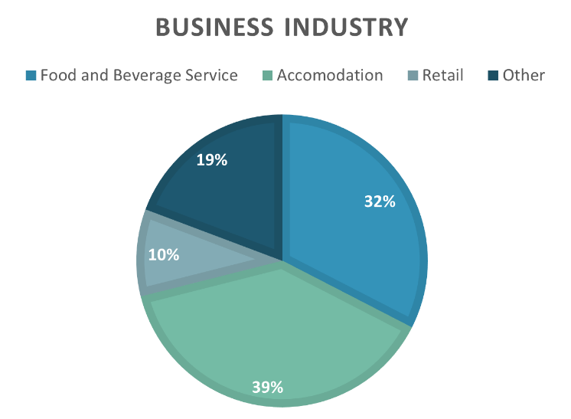
Results
Question 1 asked for the Business name, this was optional to answer, and many chose not to. Question 2 (fig 1.1) asked what industry area they operate in. The majority of respondents identified as either ‘Accommodation’ or ‘Food and Beverage’ providers, indicating that a large portion of the Welsh tourism industry involves Hospitality premises. The participants who answered ‘Other’ consisted of Taxi Services, Entertainers and Local Attractions, displaying the broad reach of tourism reliant business in Wales.
Figure 1.1
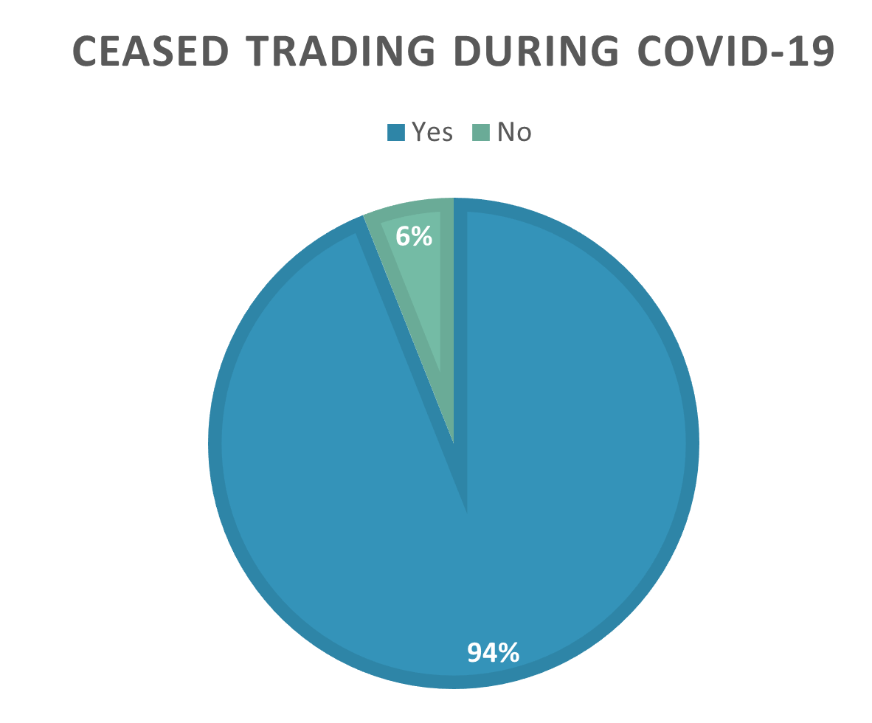
Question 3 (fig 1.2) then asked if the COVID-19 pandemic had forced them to close down and cease all trading, emphasising that they should answer ‘No’ is they have only temporarily closed during lockdown measures. This indicates that the majority of businesses have been able to stay afloat despite the issues faced. Participants who answered ‘Yes’ were redirected to Question 4, ‘No’ to Question 6.
Figure 1.2
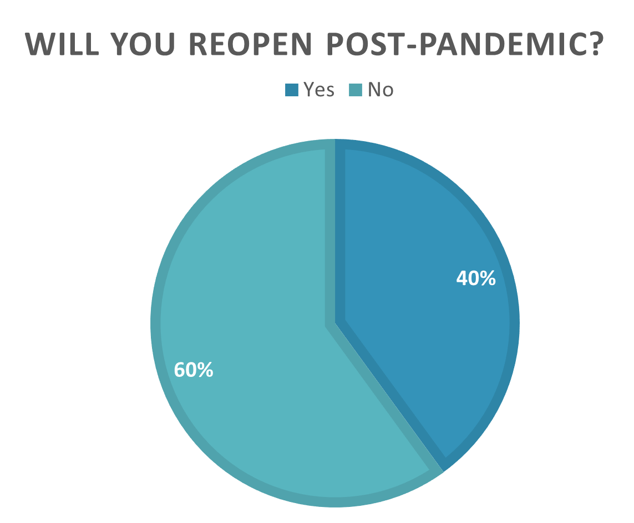
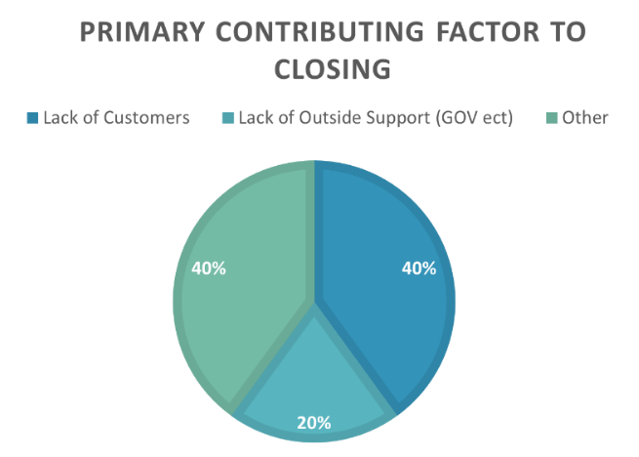
Question 4 (fig 1.3) asked those who had closed, what they felt was the primary force behind it. The responses highlight the ‘lack of support’ felt by business owners, from the Welsh, and UK Governments. They also highlight the obvious effect of a national lockdown, wherein consumers cannot use the businesses due to staying at home. The participants that answered other identified the inability to pay rent and other bills as the reason for closure. When asked in Question 5 (fig 1.4) whether they intended to re-open post-pandemic, only 40% said they would. Participants were then directed to the end of the survey.
Figure 1.4
Figure 1.3

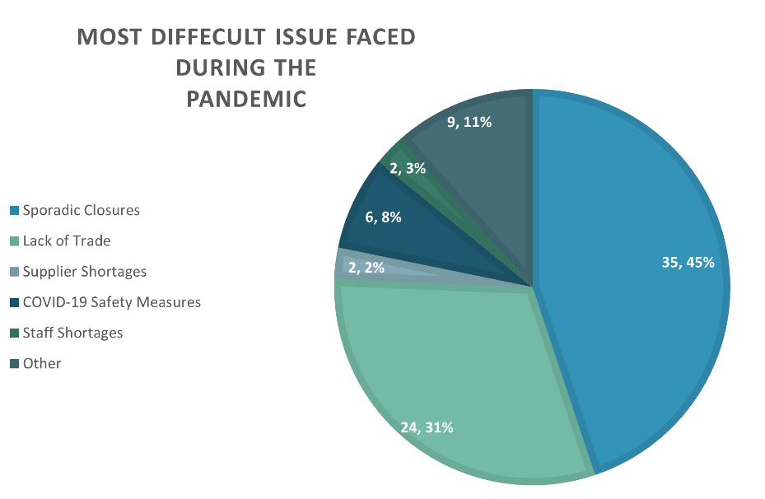
Question 6 (fig 1.5) asked the respondents who were still trading, what they felt was the most difficult issue they have faced during the pandemic. 45% of respondents identified the sporadic closures and changes made to regulations as the most difficult issue, closely followed by a lack of trade opportunities. These results are unsurprising as they have had to change how and when they provide their services and products with little time to adjust. The most surprising result from this question is that only 8% of respondents felt the COVID-19 safety measures were the most difficult issue faced. This is surprising because the general feel is that the public are unhappy with the safety measures in place, such as mask wearing and limitations on group numbers.
Figure 1.5
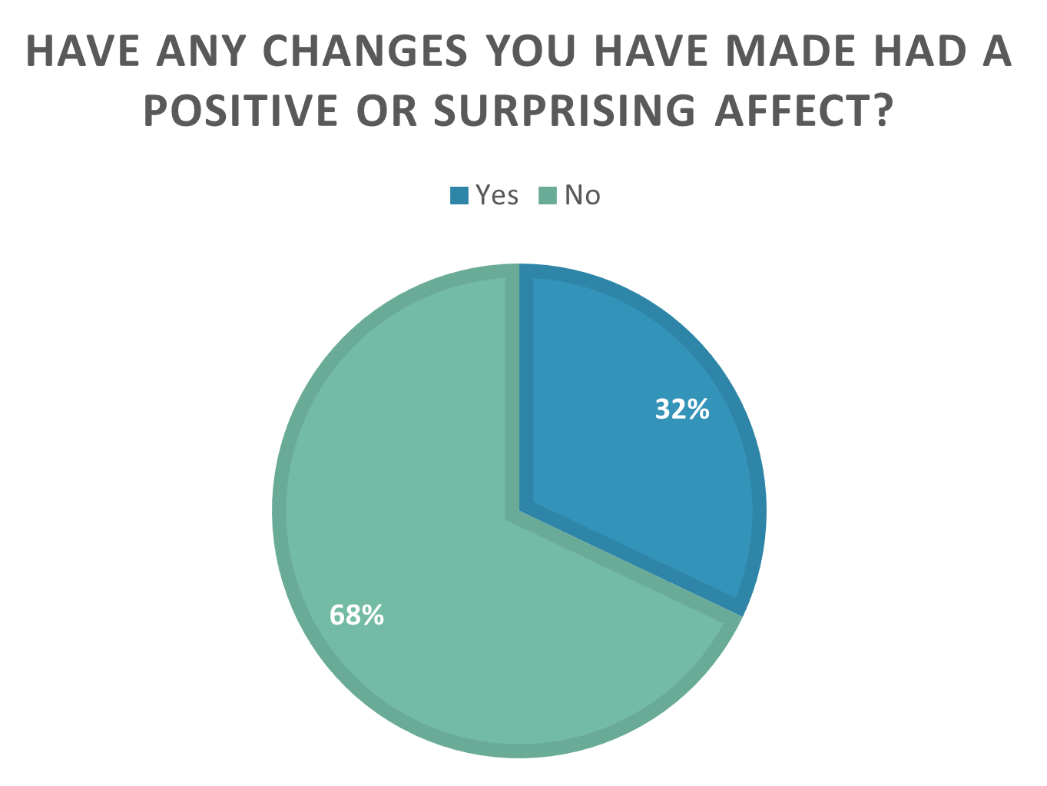
Question 7 (fig 1.6) asks if the participants if they have found if changes made have had a positive effect, with Question 8 asking them to elaborate on how. Just over a third of businesses said they had seen positive results since implementing changes. Several businesses felt the enhanced cleaning protocols encouraged staff productivity and provided customers with an extra sense of safety during the pandemic. Others found that looking for online avenues, to gain custom and brand recognition to be successful. One accommodation company took the opportunity to develop new technology systems for booking, invoicing and balance checking, another chose to change their target demographic, advertising to key workers and contractors that were in desperate need of accommodation.
Figure 1.6
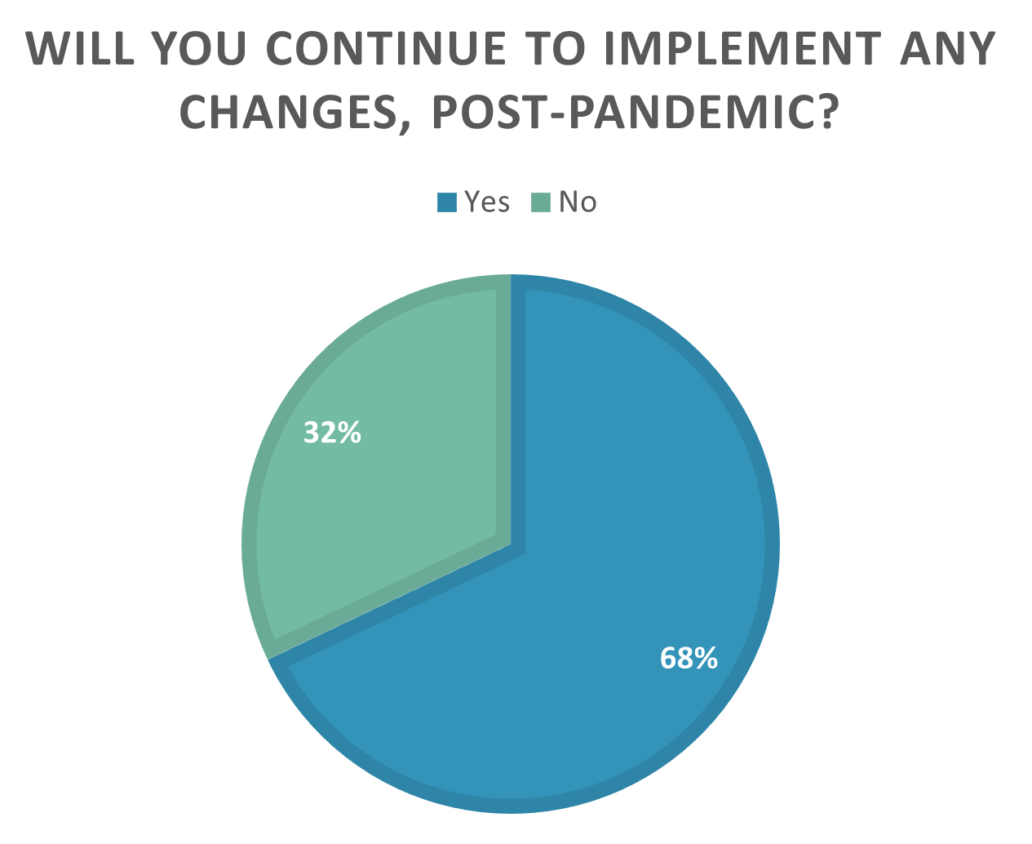
Question 9 (fig 1.7) asks if respondents will continue to implement changes, post-pandemic, with Question 10 asking them to specify. In contrast to question 7, two thirds of respondents said they will continue to implement some of the changes made. When specifying what changes they will keep, almost all of them involved COVID-19 safety measures, the rest mentioned intending to keep their new online or delivery services going.
Figure 1.7
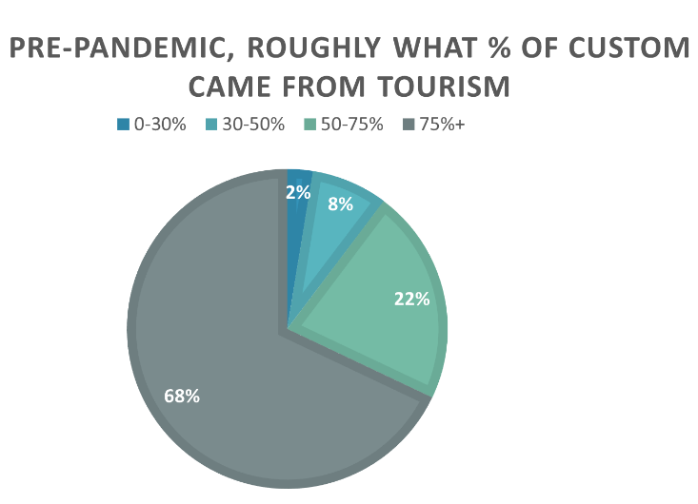
Question 11 (fig 1.8) asks for a rough idea of what percentage of the respondent’s custom comes from tourism. The Majority, 68%, said that 75%+ of their customers came from tourism. This figure is expected to be high due to the volume of accommodation related businesses to participate, but it does highlight exactly how much businesses in Wales rely on tourism, with 90% stating over half of custom is from tourism.
Figure 1.8
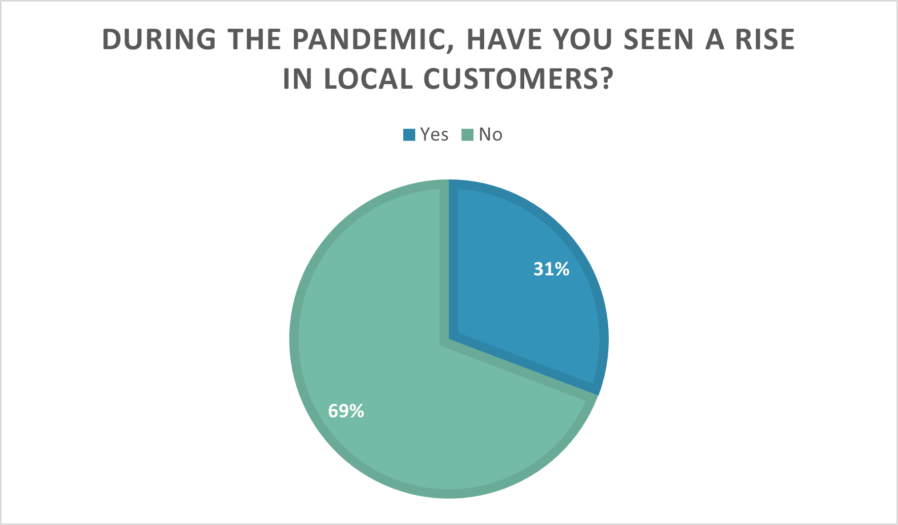
Question 12 (fig 1.9) asks respondents if they have seen a rise in local customers during the pandemic. 69% responded ‘No’, again the volume of accommodation businesses who answered should be considered here, as it would be difficult to rent holiday accommodation to people already living in the area. However, it does highlight that some businesses could benefit from support when adjusting their strategies to fit changing environments.
Figure 1.9
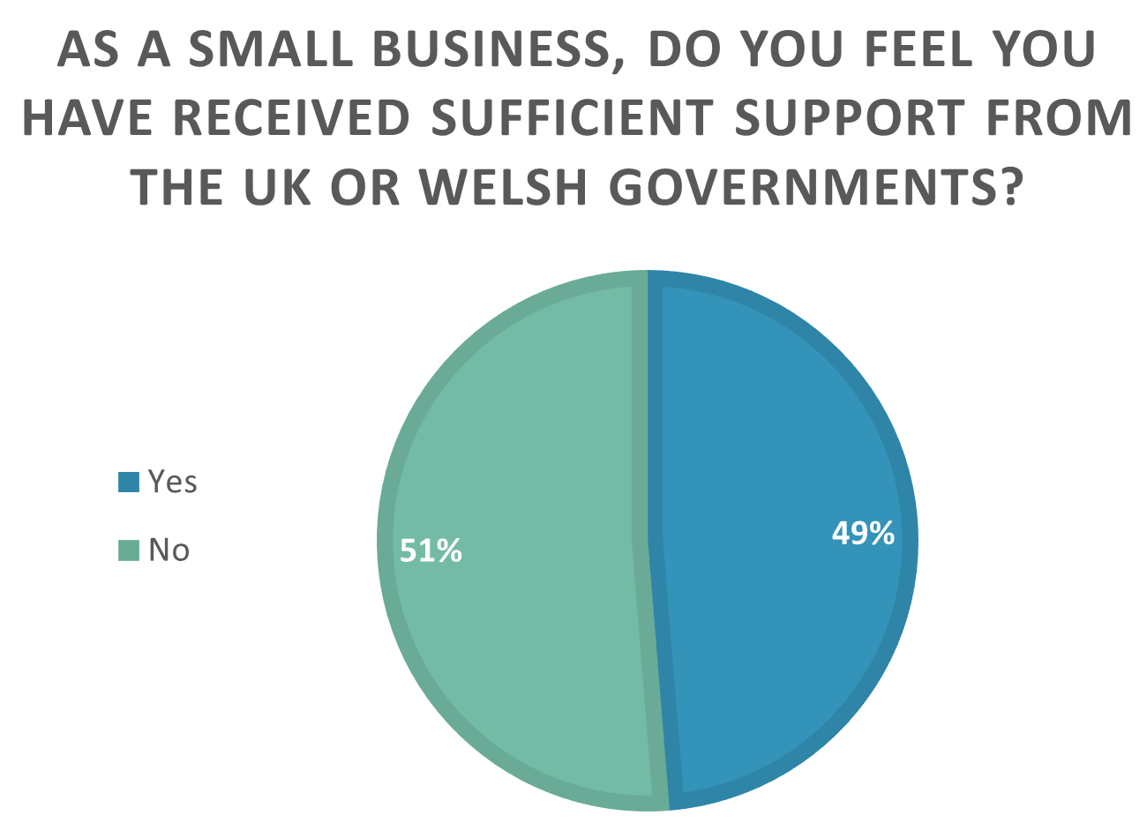
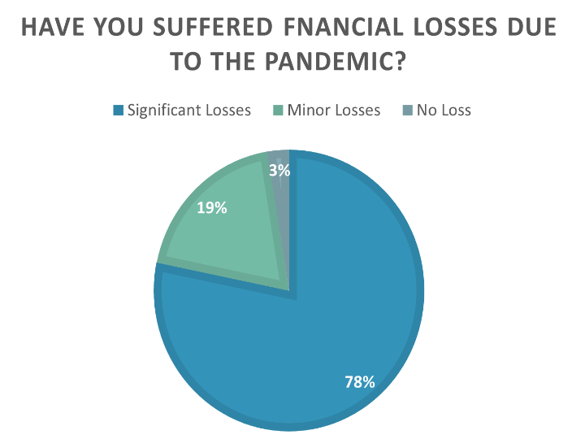
Question 13 (fig 1.10) asks, broadly, how much of a financial loss they have suffered due to the pandemic. The answers are presented in this way to allow businesses to keep exact figures private. Unsurprisingly, 97% of participants suffered some form of financial loss due to the pandemic, with 78% of participants reporting significant losses. This reenforces the need to find ways to grow businesses when facing crisis, to avoid further losses and closures.
Figure 1.10
Question 14 (fig 1.11) asks respondents if they feel they have been sufficiently supported by either The Welsh Government or The UK Government. This question gained an almost evenly split response. Coupled with one third of shutdown businesses blaming lack of government support for their closure, we must consider whether the authorities in question have done enough to ensure a future for the industry in Wales.
Figure 1.11
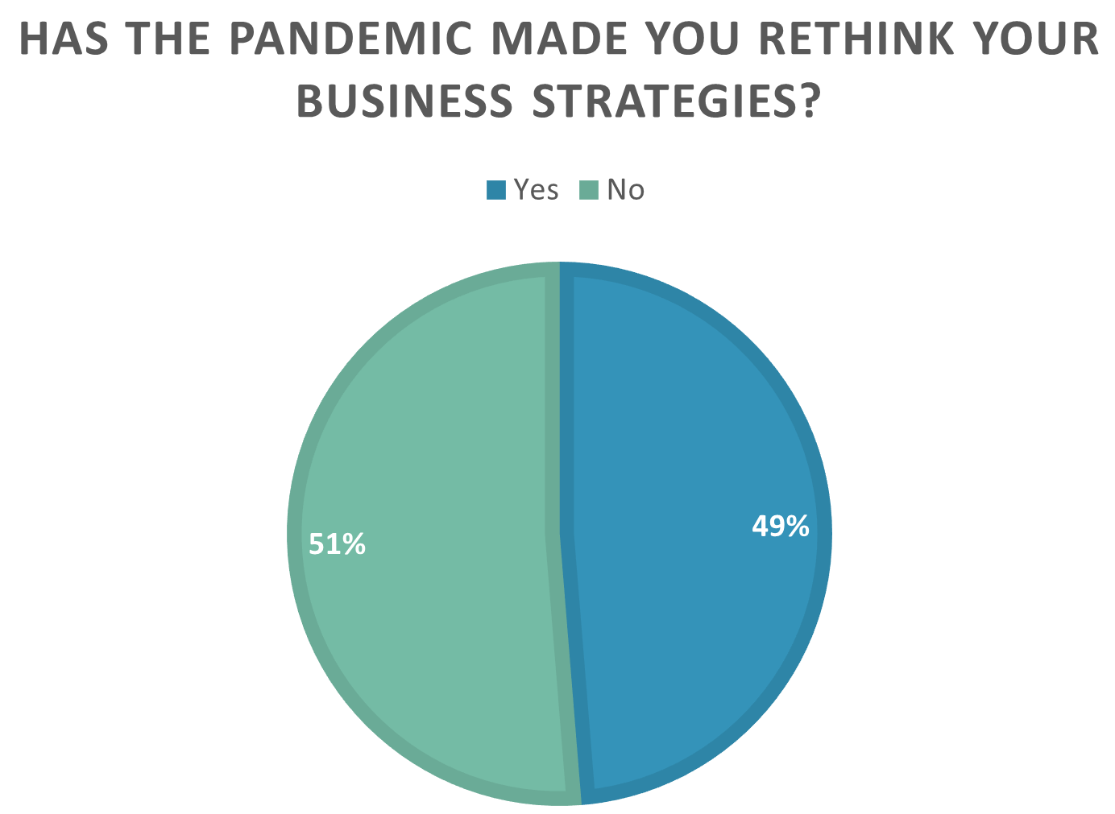
Question 15 (fig 1.12) asks respondents if the pandemic has made them re-think their business strategies, Question 16 then asks them to elaborate on how. Again, this question gained a split response, with 49% of participants willing to adjust strategies to fit circumstances. Many of the responses given for Question 16 mirror those given in Question 8. Respondents have said how the pandemic has shown them ways to implement technology, different sales avenues, and become more sustainable in their buying, planning and general operations. Some businesses felt that the pandemic has highlighted a need for better PR with local consumers, realising that they are missing out on a large demographic that can provide custom throughout the year. The need to diversify for customer retention is also a recurring theme through the responses, reflecting the actions of some businesses in Wales, see Ch. 2.5.
Figure 1.12
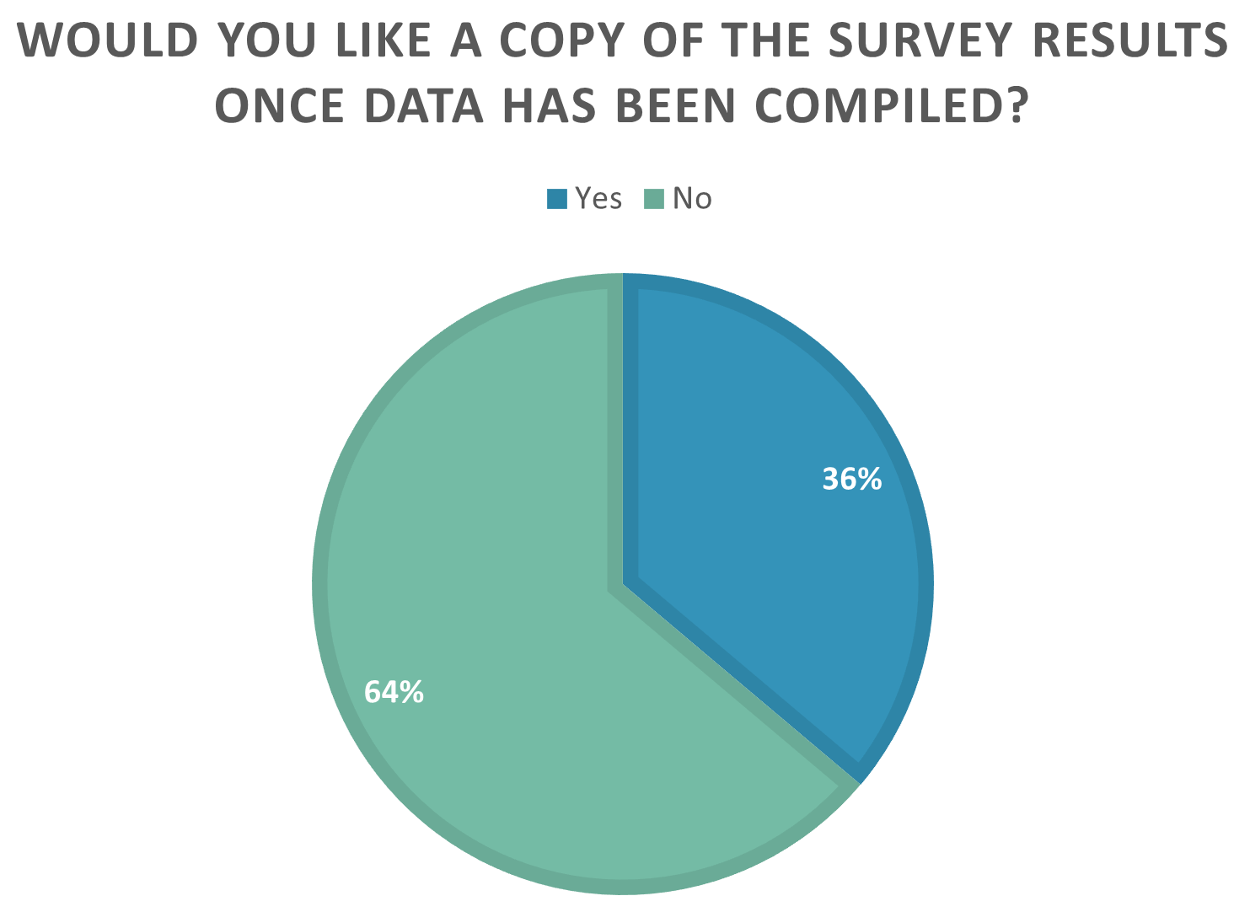
Question 17 (fig 1.13) gave participants to option to receive a copy of the Questionnaire results when the study was complete. 64% of all participants responded ‘Yes’ here. This is interesting as it highlights that many welsh businesses involved in tourism are actively investing time into R&D for the future.
Figure 1.13

4.2 Personal Observations
Overview
The personal observation research took place in The Tavern/The Five Arches Tavern, a public house within the town walls of Tenby, Pembrokeshire. The building itself is a Grade II listed building (British Listed Buildings.co.uk, n.d.) built using the same stones that make the famous town walls, dating back to the 15th Century. The building is privately owned and leased out to the family who manage. The pub is managed and staffed by members of the same family, including myself. My role includes covering shifts for absent staff, event assistant, marketing, and bar dressing. The observations took place during my time spent in The Tavern, at 3 different and pivotal time periods for the hospitality industry. These are categorised as Summer 2020: the period of opening post 1st UK wide lockdown, Autumn 2020: the period of opening post Wales Firebreak lockdown, and 2021 Onward: the post-Christmas 2020 period that the hospitality industry has closed for. During these periods I took field notes observing the staff, management, and customers, I also observed the difference in footfall, customer spending and changes made to adhere to legislative measures to combat the spread of COVID-19. Tenby is a well-known tourist destination on the West Wales coastal path, popular with families, couples, and adult groups alike (Visit Wales, n.d.). In normal circumstances, Tenby is a thriving town during high season (approximately May-October) with flourishes of busy weekends through the remainder of the year. The COVID-19 pandemic has brought many difficulties for tourism and hospitality in Tenby. With foreign travel very limited, staycations have become a growing trend while out of national lockdown, this has posed quite the conundrum as general visitor numbers seemed to grow day by day (Harries, 2020), when businesses in the town had to impose heavy restrictions on capacity and staff numbers, thus unable to make the most of the increase in demand. Working within hospitality in this way, put me in a position to understand the impact of COVID-19 from the differing viewpoints of management, staff, and customers.
Summer 2020
Following the announcement of first UK wide lockdown, The Five Arches Tavern had to consider the financial losses they were facing, they had already had to pour multiple barrels of wasted beer down the drain, and it looked as though they would be closed for a large proportion of the high tourism season. The time gave them chance to redecorate, install new payment systems and design a new bar layout for optimum safety. The Tavern reopened its doors on August 3rd, 2020, with some major changes in place. Capacity was reduced by 2/3, allowing as much seating as possible with plenty of space between tables. Track and trace forms were made available from opening, this allowed management to be prepared if they were informed of infectious contact within the premises. Multiple sanitising stations were placed around the bar area and extra cleaning times were scheduled for the toilets. A skeleton staff rota was drawn up and staff were expected to always wear a mask or visor when on shift and maintain the cleanliness of tables between customers. A separate entrance and exit were identified, and a table service strategy was imposed. The following weeks brought large crowds, so, doing things differently and avoiding taking bookings, making the tables available on a first come first serve basis, was more appropriate and manageable for staff in a wet pub (no food), also allowing customers to relax as they were not time restricted. Problems were encountered when customers felt there was space for them after being refused entry, many did not like to share personal details on the track and trace forms, and many were impatient with the staff while waiting to be served. Overall, the customers reaction to the restrictions and changes in place was welcoming, the layout of the bar area allowed bubbles and staff to converse in a friendly manner without breaking the 2m social distancing rules. Customers commented on how safe they had felt there, as they felt the rules were being properly adhered to and the staff and managements attitude toward the ‘new normal’ brought an overall inviting atmosphere. Although capacity was reduced, average spend per customer went up, customers would find a table early in the day and would stay there until closing, and the personal touches of staff gained day by day return custom through the season.
Autumn 2020
In October 2020, the First Minister for Wales, Mark Drakeford, announced a Firebreak lock down across Wales, once again closing the tourism and hospitality industries. Pubs could reopen on November 9th, 2020, but under even stricter rules, including compulsory implementation of Track and Trace, the wearing of facial coverings, and no access to the bar and closing by 10pm. As these autumn months tend to be quieter, a dip in custom was to be expected, but with the Welsh Assemblies new legislation halving the working day for the pub, it dropped significantly during the weekdays, we had now lost a whole demographics of local workers who would frequent The Tavern for an end of day drink after work. The weekends showed some improvement, retaining the familiar flow of customers seen through the summer, but many felt disheartened that their time in the pub was restricted. Again, we encountered problems with customers who did not appreciate the changes made, and the overall moral of customers, staff and management was low. The holiday period began to look bleak with no sign of the usual Christmas party or New Year’s Eve bookings. There was an air of uncertainty when closing for Christmas as we felt we had had no guidance from either the Senedd or Westminster on our future. At this point customers, staff and management are all frustrated with the lack of clarity and the seemingly nonsensical rules imposed.
2021 Onward
In late December 2020, Wales was placed back into full lockdown (Jahshan, 2020), as The Tavern had already closed due to a ban on the sale of alcohol (BBC News, 2020), we took the news with a heavy heart, knowing that we, once again, had no idea where this lockdown would take us. We looked at ways we could generate revenue through lockdown, but with the kitchen in disrepair and no available cash to invest in a takeaway food service, we were at a complete loss. There was no clarity on job security or business support, waiting for the weekly announcements, hoping for a positive update for the industry. In a conversation with Manager Paula Cooke, she mentioned she felt ‘like a scape goat, being penalised, after following all the rules meticulously, and with no scientific evidence that the hospitality industry was the cause for a rise in COVID-19 cases’. We retained customer support through our Facebook page, finding fun content to post, sending well wishes during St Dwynwen, Valentines, and the Six Nations rugby tournament, and updating and checking in on our patrons. The lease holders at the time also owned another restaurant, leaving the management and staff team to run The Tavern, while only handling the banking and accounts. It was during this time they chose to find a buyer for the lease. The uncertainty they faced in the coming months with a significant drop in revenue meant they could no longer viably keep the business going. Fortunately, a new lease holder was found in the partner of a family member, a retired financial advisor. With prospects looking up for the summer, cash injections from the Welsh Government and investment from a well-known brewery and supplier, meant we can carry out some much-needed repair work and get the kitchen back up and running. The proposed ‘traffic light’ system for foreign travel (Calder, 2021), should lead to a rise in international visitors again, or alternatively, lead to a rise in staycations. Hopefully, this will bring a prosperous summer, not only for ourselves, but all businesses in our industry in Wales.

4.3 #HashtagResearch
Overview
To conduct this research, I needed to identify appropriate, commonly used Hashtags, relevant to my discussion. After careful consideration I chose to search for social media posts containing ‘#COVIDWales’, ‘#HospitalityWales’, and ‘#TourismWales’, as they provided the most useful social media posts. I then wanted to list whether the post contained negative or positive thoughts/opinions on the subject. I chose to look through posts on the platforms LinkedIn, Twitter, and Instagram, typing each ‘#’ into the search bar and looking through posts from 31st March 2021 back to 31st March 2020. Once I had filtered out the posts that were irrelevant to tourism/hospitality in Wales during COVID-19, I created a tally of each positive and negative posts for each ‘#’. I then transferred the data into a table and graph (fig 2.1) using Microsoft Excel. The results show an overall negative mood among discourse of the online communities of the tourism industry. Posts from both businesses and customers express distain in the handling of the crisis by authorities regarding tourism and hospitality. However, each ‘#’ had just over 50% negative posts attached, but no more than 63%, this indicates that businesses do not feel completely at a loss. Many state how they are looking forward to summer 2021, as they feel they are more prepared to handle pressures this time around.
Figure 2.1
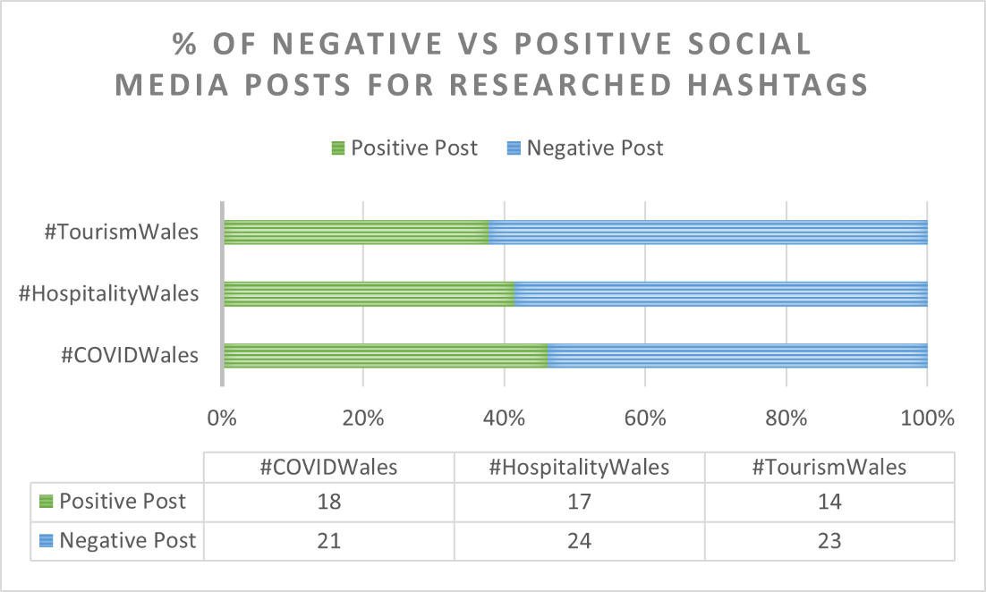

4.4 Discussion

4.4.1 Government Handling
As identified in Chapter 2.3, both the Welsh and UK Governments have been under increased scrutiny due to their handling of the COVID-19 Pandemic. The unwillingness to work together from both parties has cast a harsh shadow over the public’s faith in their decision making. The lack of clarity from leaders has made future planning for the tourism and hospitality industries near impossible, leaving managers and owners to make huge assumptions when strategizing to allow for COVID-19 restrictions. There is belief that if the Governments in question had acted sooner, much of the economic impact of the pandemic could have been avoided. Businesses in tourism and hospitality feel they have continuously been unfairly treated throughout the pandemic, with having the most restrictions put in place on them. However, many feel that, without the Furlough scheme and the grants made available by both governments, they would not have survived 2020, and praise the effort made here. This is reflected in both questionnaire results (Ch 4.1 Fig?), in Personal Observation Findings (Ch 4.2) and in the overall negative social media posts studied (Ch 4.3).

4.4.2 Applying COVID-19 to Tourism Disaster Framework
In his article, Faulkner (2001, pg. 136) addresses how we should identify whether an event is a ‘Disaster’ or ‘Crisis’ when applying his Tourism Disaster Framework. Faulkner highlights how we can do this, using a simple spectrum of events (2001, pg. 137), although implications may arise if it is unclear whether damage is caused primarily by uncontrollable factors or human mismanagement. Using this spectrum (Fig 3.1) we can attempt to identify whether the COVID-19 pandemic is a ‘Crisis’ or ‘Disaster’ for the Welsh tourism and hospitality industries.
Figure 3.1 Crisis/Disaster Matrix
CRISIS
Induced Natural Phenomena or External Human Action
Induced by the Actions or
Inactions of the Organisation
DISASTER
Scale or Magnitude of the Event
Legend
- Examples used by Faulkner (2001)
- Examples Mentioned in this paper.
- COVID-19
Lockerbie
Chernobyl
Katherine Earthquake (AUS)
Kobe Earthquake
Swiss Canyon
Exxon Valdez
COVID-19?
FMD 2001
Zika Virus 2016

Identifying what term to use when describing the COVID-19 Pandemic is difficult as although the fast and unpredictable nature of the pandemic took most by surprise, many would argue that the disease itself would not have been as destructive if it had been handled better. The positioning of COVID-19 on this diagram reflects the scale of the pandemic, accounting for the global reach of the disease, the loss of life, and the resulting effects economically and socially. The virus is, of course, an ‘Induced Natural Phenomena’ and if addressed appropriately can be contained, many believe that if countries such as UK had acted in similar ways to the likes of New Zealand, they may have been already on the road to recovery. Investigations into the UK & Welsh Governments handling of the pandemic would need to be carried out to decide if this is the case. If the authorities are following frameworks such as Faulkner’s (2001) to aid in their recovery plans, then it would be fair to expect a high standard of successful planning, with many contributors involved. An example taken from Faulkner’s (2001, pg. 144) article in Figure 3.2 displays the ‘…generic framework for tourism disaster strategies’. When implementing The Tourism Disaster Management Framework, it is important to remember the Prerequisites for effective planning (Faulkner,2001); ‘Coordinated Team Approach’, ‘Consultation’, ‘Commitment’. Faulkner (2001) also identifies the key ingredients of the ‘tourism disaster management planning process’ as; ‘Risk Assessment’, ‘Prioritisation’, ‘Protocols’, ‘Community Capabilities Audit’, ‘Disaster Management Command Centre’, ‘Media and Monitoring Activities’, ‘Warning systems’, ‘Flexibility’, ‘Involvement, Education and Review’. When considering these key aspects of Tourism Disaster Management, and how the Welsh and UK Governments have been perceived to have handled the pandemic by the public, and through online discourse, it would be fair to suggest they have not shown the ability to support the tourism and hospitality industries of Wales. This is also reflected through the ‘#’ Research and Questionnaire responses. However, as we are still in the throes of the pandemic, with little clarity and information available, it would be wise to research more into the response, strategies, and planning of these governing bodies in order to back up any assumptions with fact.

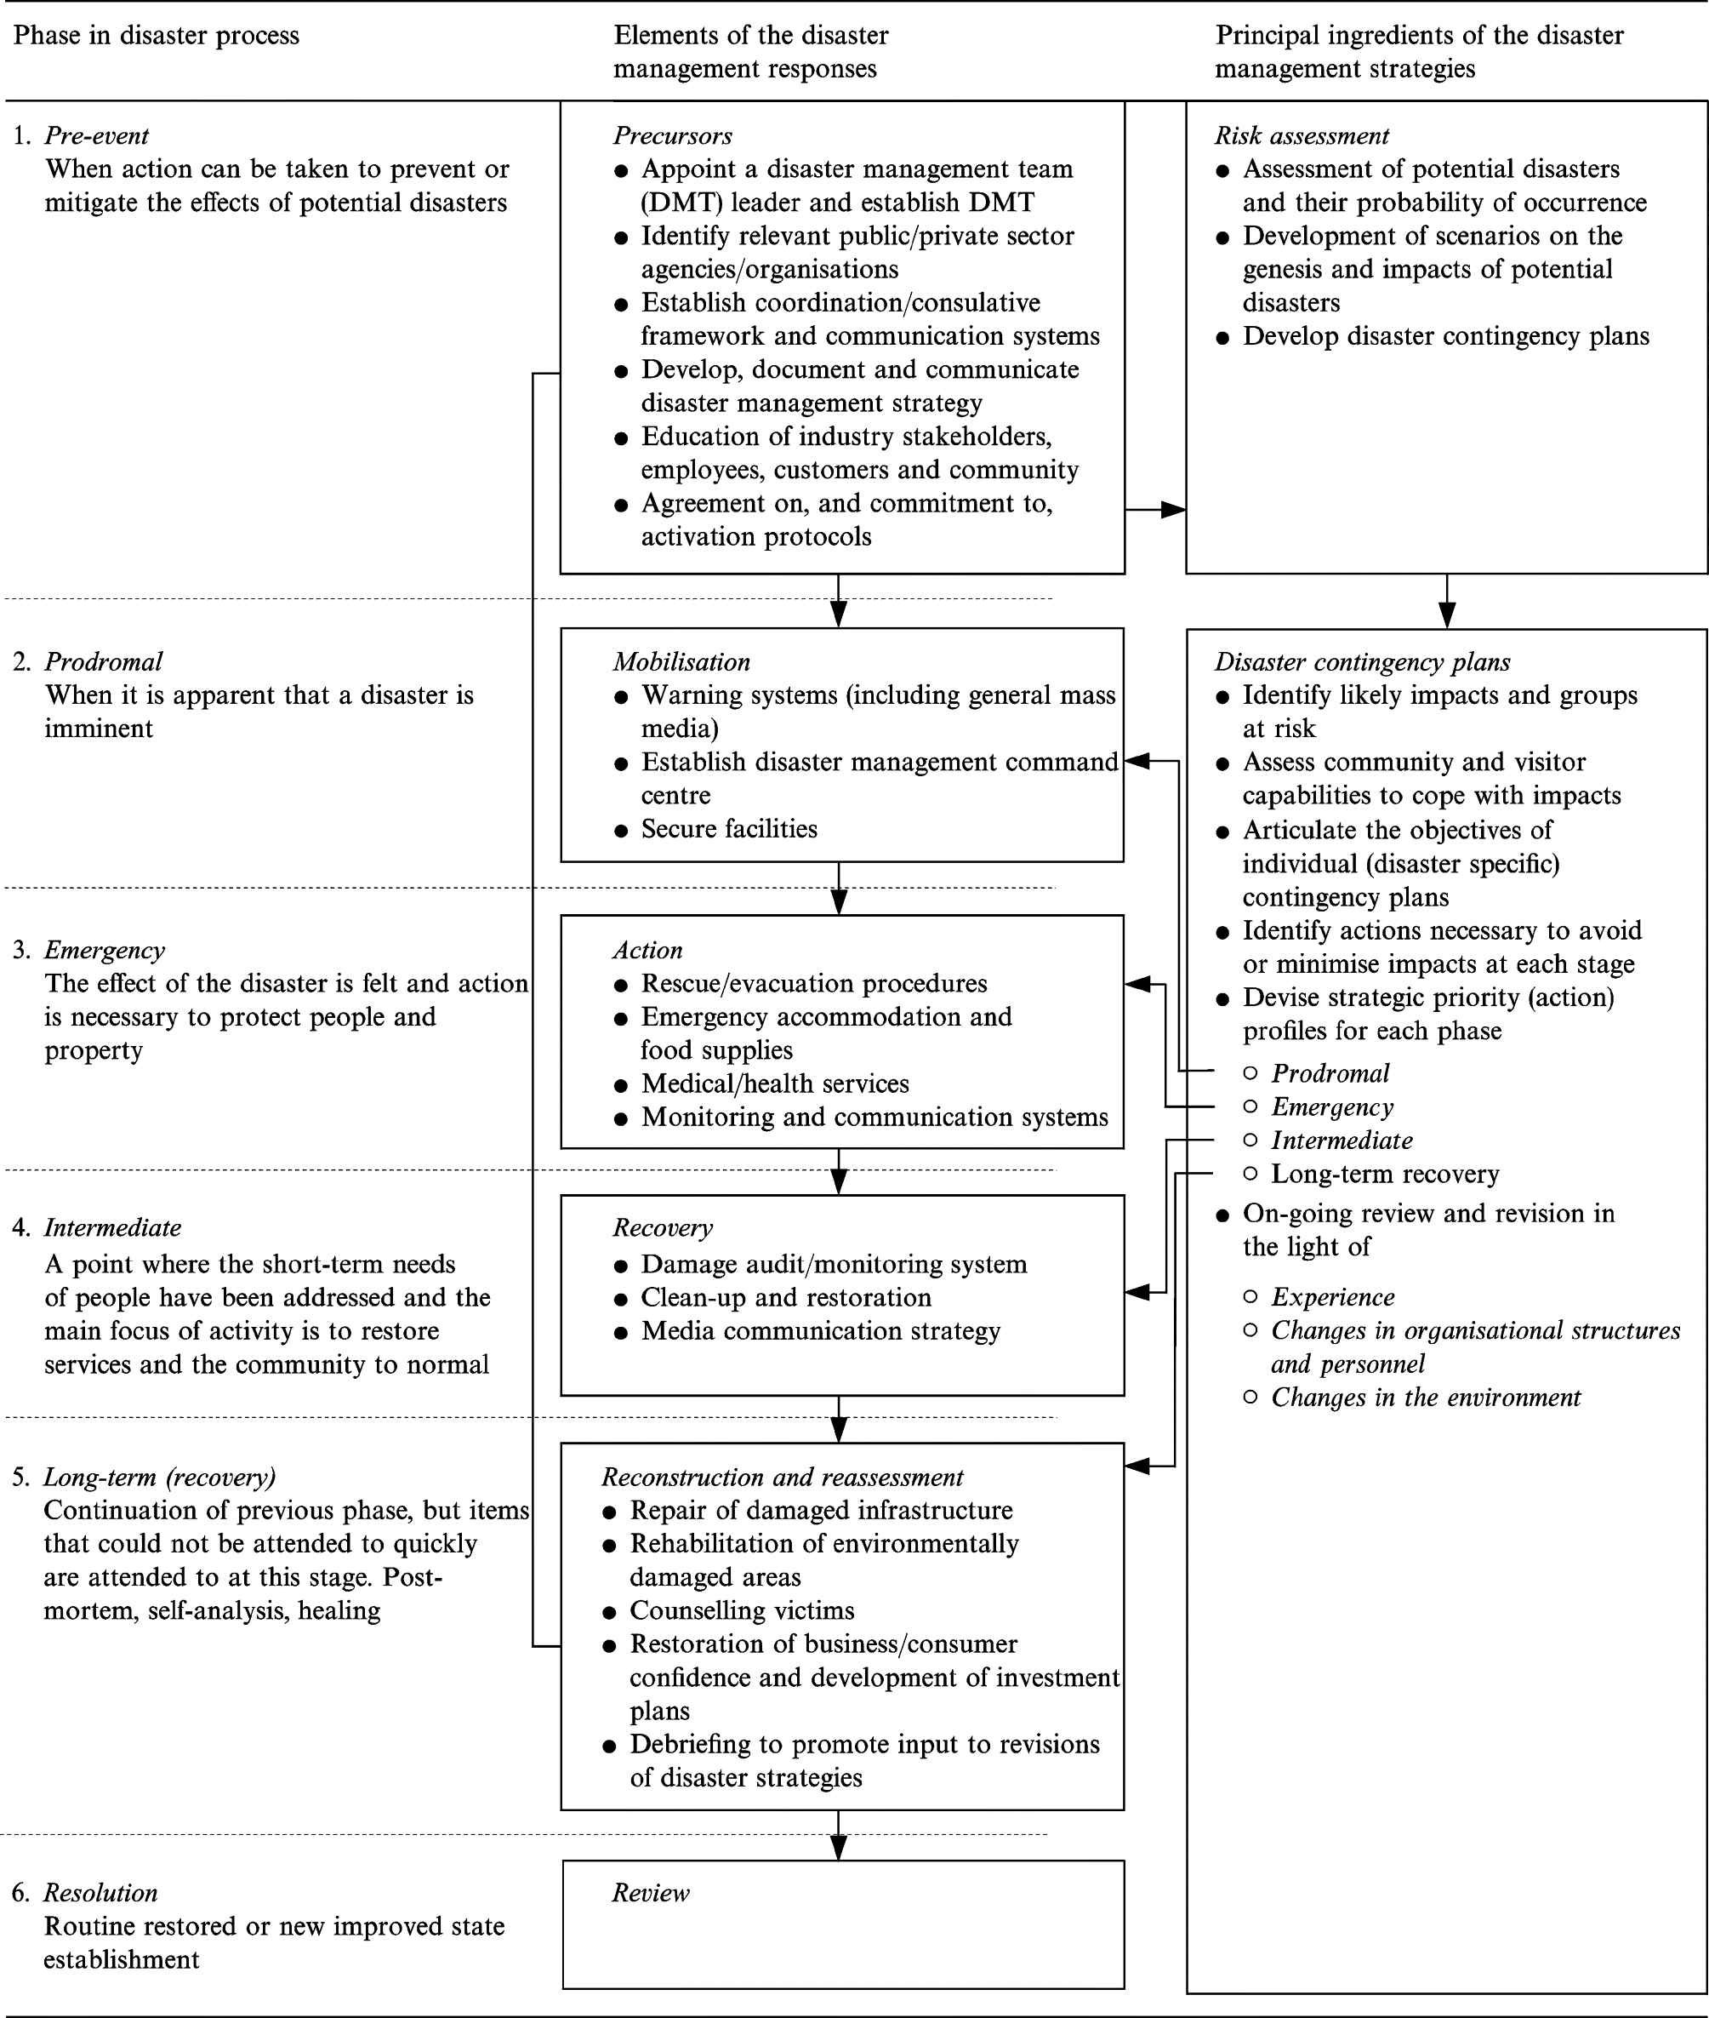
Figure 3.2 Tourism Disaster Management Framework
(fig 3.2 taken from, Faulkner (2001, pg.144))

4.4.3 The Five Arches Tavern STEEPLE & SWOT Analysis
The Five Arches Tavern is positioned well within the Tourism and Hospitality industries in Wales, as a popular public house located in one of the country’s most sought-after resorts. Due to this, a STEEPLE (Appendix 2) and SWOT (Appendix 3) analysis are an appropriate and helpful way to assess the circumstances of the business and identify the driving forces in their internal and external environments, as these types of analysis allow us to include a breadth of factors that will have had an impact on tourism and hospitality businesses during the pandemic.
Table 1.1 the Five Arches Tavern STEEPLE Analysis
Social/Socio-Economical | Reduced opening hours caused disruption to UK traditional drinking habits. Friction between local and tourism customers. Customers attitude toward changes. Social distancing measures dampened atmosphere of pub.
Technological | Forced to update accepted payment methods. Improved social media marketing for customer engagement when closed.
Economical | Beer wastage due to unexpected rule changes/closures. Loss of trade during lockdowns. Limitations on capacity reducing opportunities for custom.
Environmental | Hygiene, health, and safety at a higher standard. Higher consumption of non-recyclable waste due to cleaning rules.
Political | Lack of consistency between UK & Welsh govt. Differing rules & unclear guidance cause confusion for public & business. Loss of faith in govt. Financial support helpful in maintaining staff, bills and providing cashflow for repairs.
Legal | Social distancing and Covid safety measures forced changes in layout, service, and capacity. Restrictions on alcohol sales forced closure during the Christmas period
Ethical | Raised questions about refusing vulnerable people (e.g., Pregnant women) entry to use facilities without purchasing. Sectioning off areas specifically for local customers. Public using loophole of medical exemption to avoid mask wearing but cannot ask them to prove it.

The STEEPLE analysis of the Five Arches Tavern identifies 3 key themes in their attempts to tackle COVID-19, these are the government handling and lack of clarity regarding travel, COVID-19 safety measures and industry opening; The opportunities to diversify and adapt strategies for future resilience and sustainability, and issues faced in doing so; The importance of Public Relations in the industry, with both local public and prospective travellers.
Government handling is called into question when considering each STEEPLE force as most relate back to COVID-19 safety measures, however, the Political forces highlight industry wide opinion that although financial support from the Welsh Government has eased some concerns, businesses still feel restrictions have unfairly impacted them. The industry has lost faith in the abilities of both Welsh and UK Governments to work together and questions the devolved relationship between them.
During the first UK lockdown the Five Arches Tavern took the time to deep clean and repaint the premises, they also spent time carefully designing a new layout that would both provide plenty of space for social distancing, optimum capacity, and still have a welcoming appearance. When allowed to reopen they had devised improved cleaning schedules, using less products with higher results, and developed a table service system in to avoid any unnecessary need to walk around the bar. They were also forced to update their accepted payment methods to allow for contactless purchases and installed a new back-office system that made stock control easier and reduced over ordering. All of these changes have proved cost effective and aids to a more sustainable and resilient future.
Public mood has been considerably low during the COVID-19 Pandemic, many have felt lost and unsupported at such a trying time. As mentioned in Qui et al (2020) there is an importance on maintaining a balance between public safety, the well-being of the local occupants of tourist destinations and being able to maintain income. This can only be achieved by the collaboration of businesses, communities, and authorities. The Five Arches Tavern witnessed unsavoury behaviour from many of its customers during the open periods of the pandemic. Many showed arrogances toward COVID-19 safety measures and felt they should not have to adhere to them as they were deemed ‘silly’. It became hard to police the measures within the premises as customers took advantage of loopholes in government guidelines, claiming they had medical exemption when they did not want to wear their masks anymore following a few drinks. Local customers began to feel pushed out, so the manger cornered off an area of the bar just for local customers, allowing those who could not get a table elsewhere to enjoy a drink. This caused friction between tourism customers and bar staff, although the change worked in the long term as new local customers chose the Five Arches Tavern over others during the quieter season as a result. In small towns like Tenby a business’s reputation can be quickly tarnished within the local community, the Five Arches Taverns choice here displays strategic risk taking to benefit the overall success of the business, while maintaining relationships with both local and tourism customers.

Table 1.2 the Five Arches Tavern SWOT Analysis
Strengths  Customer service & rapport  Ability & willingness to adapt to COVID safety measures.  Layout of bar & seating allows for social distancing while being able to socialise with other customers (safe & friendly) | Weaknesses  Kitchen in disrepair, unable to use.  Lack of outdoor space.  Unwilling to take strategic risks to diversify and adapt.
Opportunities  Time to undertake repairs (kitchen) and cosmetic refreshment.  Revaluation of business strategies (e.g., table service and development of app for booking & ordering, and a website.  Menu developed for summer 2021 relaunch. | Threats  Nature of business causes higher risk of infection, due to number of different people served each day.  Further lockdowns or alcohol bans may cause the business to become unviable (costs and wastage)  Travel restrictions causing a reduction in custom from tourism.

The SWOT analysis of the Five Arches Tavern mirrors the themes identified in the previous STEEPLE analysis and also highlights areas that they can develop planning for continued success while navigating the COVID-19 pandemic.
Their strengths include their already positive reputation for excellent customer service, their ability to adapt to the COVID-19 safety measures swiftly and effectively and their ability to maintain their friendly and welcoming atmosphere while reducing capacity and allowing for social distancing. These factors all display the ability to adapt and change and provides a good foundation to build from.
The weaknesses identified include the lack of outdoor space, and an unusable kitchen, this puts them at a disadvantage when looking for ways to overcome government restrictions. A working kitchen would provide another avenue for income when alcohol sales are restricted and outdoor space would allow less restrictions on opening and capacity. Another weakness identified is the lack of willingness from initial licence owners to take strategic risks to diversify, many other food and beverage establishments in the area took to offering takeaway drinks services when their premises had to close. This diversification would involve licence changes that the owners felt were not cost effective at the time, unfortunately the questionnaire results along with countless new reports displayed how this change could have been a turning point for the business.
The COVID-19 Pandemic has presented the Five Arches Tavern with opportunities to make positive changes to the business and business strategies. Although closures have had a financial impact on the business, they have utilised the time to make much needed repairs, undertake cosmetic refreshments and refurbish the kitchen to a high standard, making it environmentally friendly and taking time to develop a menu for the 2021 summer relaunch. The pandemic has also highlighted the need to diversify business strategies, the Five Arches Tavern has always been a traditional wet pub and has not deviated from that business plan for many years, COVID-19 has shown how the business needs to modernise to move forward. They have made huge technological updates from their payment systems, booking and ordering platform, to a new automated cellar system. These demonstrate the importance and ease of future proofing in hospitality and tourism.
The threats faced by the Five Arches Tavern during the pandemic are the risk of further lockdowns, travel restrictions and stricter measures imposed on the hospitality industry that may make the business unviable to continue trading. Another important threat facing the Five Arches Tavern is the heightened risk of catching COVID-19, the nature of the hospitality and tourism industries make the businesses within them high risk, due to the volume of people dealt with on a day-to-day basis. Although these threats come from forces out of the control of the business, it is wise to consider them when future planning.
The STEEPLE and SWOT analysis of the Five Arches Tavern has identified that with the effective analysis and an ability to diversify and adapt businesses strategies, those within the tourism and hospitality industries can limit the impact felt by a crisis such as COVID-19, continuing to trade viably while showing resilience. However, the analysis does highlight the inevitable financial, health, and ethical risks involved in operating a business within these industries during such extreme circumstances. The use of STEEPLE and SWOT analysis in this way could also be implemented for other business areas within the industry, such as accommodation and attractions/entertainment venues, if accompanied by business specific prompt questions.

4.4.4 Moving Forward.
In his article Gössling et al (2020, pg. 3) highlights how, overall, the global tourism industry is usually resilient to shocks, this is also reflected in the research that followed the FMD 2001 outbreak and the Zika Virus 2016 outbreak, wherein in retrospect, recovery for the industries required very little as the disasters effects lasted for a limited time. Although Disasters such as those named previously, have provided some guidance on adjusting strategies, nothing in-depth has prepared us for such drastic changes. Gössling, et al (2020, pg.3) believes that the COVID-19 Pandemic highlights the need to abandon the outdated idea that, success in tourism = growth in numbers. It discusses what part the tourism industry, directly or indirectly, plays in climate change, and how businesses on a global scale have taken the time provided by the pandemic to become more sustainable, such as ‘airlines phasing out old crafts’ (Faulkner, 2020, pg. 14). On a smaller scale, responses from the questionnaire, Ch. 4.1, also identify how changes in cleaning, ordering, technology, and sales, made for the purpose of COVID-19, have been surprisingly beneficial for many, and have taken the opportunities posed by the pandemic to improve sustainability throughout their business in a post-pandemic future.
Qiu, et al (2020), interestingly, investigates the socio-economic impact of the COVID-19 Pandemic, from the perspective of the local people of the destination area. The study discusses business owner’s willingness to bare the financial burdens of reducing risk factors if it allows them to continue trading with little disruption. It also discusses the importance of inclusion during times of crisis, highlighting how the ‘tech-savvy’ youth of the areas aided the community by using their insights to keep the older generations informed. Qiu et al (2020) emphasise how community involvement is critical during recovery, in order to find a balance between public safety and continuing to generate revenue. Although it is wise to consider this study was conducted in China, the source of the pandemic, the questionnaire responses, Ch 4.1, and personal observations, Ch 4.2, indicate the same emotion and opinion in the Welsh tourism community.

5. Conclusions & Proposals

Conclusions/Proposals
Throughout this research project, it has become clear that the COVID-19 Pandemic has highlighted the need for businesses to become more resilient for the future, businesses must include contingencies for unexpected crisis circumstances, when undertaking strategic planning. The negative economic effects of the pandemic may be felt for years to come, and with so much uncertainty surrounding the future of the pandemic, businesses within the tourism and hospitality industries of Wales should continue to be aware of the risks facing them involving COVID-19 safety measure and restrictions and the possibility of further lockdowns. The research has highlighted the innovative ways in which businesses have chosen to diversify to adjust to the changing environment, such as providing delivery and takeaway services and investment in technological infrastructure. However, accommodation providers have the most difficult time here as their customer range becomes limited with travel restrictions, and they may benefit from a way to source prospective, professional clients. The pandemic has also given businesses the opportunity to trail and implement strategies for sustainability within their business operations, these include phasing out aged or high carbon infrastructure, identifying areas to reduce food and drink waste and working from home wherever possible, displaying the ease of becoming sustainable post-pandemic.
The handling of the Covid-19 pandemic, by the Welsh and UK Governments, has been called into question many times throughout this research. In the aftermath of the 2001 FMD outbreak, committees were assembled to review and analyse the impacts on the UK economy, including on the tourism industry. While at the time, committee members seemed to back the idea that support measures should be the responsibility of both local government and industry leaders with some higher governmental backing available if needed, no recommendations allowed for a crisis of this magnitude. Previous research from Gössling et al (2020) & Qui et al (2020) highlight the need for community involvement, supported by industry leaders and government representatives, to achieve a balanced and successful recovery process. It would be wise to remember that the research uses examples of personal opinion and news articles when discussing issues with the UK and Welsh Governments handling of the pandemic, and, as the pandemic is ongoing, further independent research of the government handling would be beneficial.
Going forward, the following recommendations are suggested to ensure businesses within the tourism and hospitality industries have preparations in place and can effectively implement sustainable diversification when facing extreme circumstances such as the COVID-19 Pandemic.
- Industry specific ‘Future Crisis Committee’- Assemble a committee that will aid in the development of the further suggestions. The committee should be made up of, Representatives of communities within tourism destinations including town chamber of trade members and workers, Industry leaders, and representatives from the local and national governments.
- Crisis Resilience Training & Handbook- Future Crisis Committee will develop a ‘Resilience & Diversification’ training program and handbook to be provided to businesses within the tourism and hospitality industry. To include industry specific prompts and suggestions, lessons learnt from COVID-19 and examples of COVID success stories, and a step-by-step STEEPLE and SWOT analysis guide, to help businesses identify areas for improvement, and opportunities to take advantage of. Training will include a basic strategic management refresher session, followed by a session on identifying a crisis and what opportunities a crisis may pose for businesses within tourism and hospitality.
- Professional Travellers Register- The development of an opt-in register for key workers, contractors, drivers, and business travellers that would benefit from the availability of private short term accommodation during times of crisis. Accommodation providers, such as hotels, caravan parks and holiday lettings would also be invited to register, listing prices for accommodation. An app or online platform, similar to Airbnb, will then be developed to match users with accommodation providers.
- Community Crisis Hubs- An online/physical hub for community members in tourist destinations, to share skills, ideas and make suggestions that will benefit the businesses and communities in these areas. The Community Crisis Hubs will have direct representation within the Future Crisis Committee, ensuring communities and businesses are being heard and allowing a free flow of available information at both sides.
Implementation of these recommendations should be considered moving forward, to allow for better preparation of further crisis scenarios, encouraging community inclusion in future developments, and a direct route to government representatives for business owners and managers within the industry. These will also provide businesses with relevant information and guidance to apply to their strategic planning.
Overall, when considering the research title, the study backs up previous literature that the tourism and hospitality industries are integral to Wales economic growth, and crises like the COVID-19 Pandemic can and will have a huge impact on businesses within these industries. The study also displays the capabilities of Welsh businesses when needing to diversify in the face of adversity. The tourism and hospitality industries in Wales have been innovative when adjusting business strategies, and with the financial support of the Welsh Government, used the lockdown periods to invest in sustainable infrastructure and business operations. With the implementation of the above recommendations, and the appropriate support and guidance, tourism in Wales could be a trailblazer in global industry strategic developments. Showing preparedness and readiness for another crisis, as when you consider the Webster dictionaries (Miriam Webster, n.d.) definition of crisis ‘A turning point, for better or for worse…’, a ‘Crisis’ becomes an opportunity for change.

6. References
- BBC News. (2019, January 14). Tenby’s Ironman Wales sells out in record time. https://www.bbc.co.uk/news/uk-wales-46863664
- BBC News. (2020a, May 10). Coronavirus: How they tried to curb Spanish flu pandemic in 1918. https://www.bbc.co.uk/news/in-pictures-52564371
- BBC News. (2020b, December 9). Covid: Can I meet friends as Wales’ pubs shut early? https://www.bbc.co.uk/news/uk-wales-54777431
- Bernal, N. (2021, April 20). The UK’s coronavirus furlough scheme, explained. WIRED UK. https://www.wired.co.uk/article/uk-furlough-scheme-job-protection
- Blake, A., Sinclair, M. T., & Sugiyarto, G. (2003). Quantifying the Impact of Foot and Mouth Disease on Tourism and the UK Economy. Tourism Economics, 9(4), 449–465. https://doi.org/10.5367/000000003322663221
- British Listed Buildings.co.uk. (n.d.). The Five Arches Public House, Tenby, Pembrokeshire. British Listed Buildings. Retrieved 3 April 2021, from https://britishlistedbuildings.co.uk/300006237-the-five-arches-public-house-tenby#.YIR6eB-SlPY
- Brown, B. G. D. J. A. H. C. I. B. (2001, February 28). The day they closed the countryside. The Telegraph. https://www.telegraph.co.uk/news/uknews/1324428/The-day-they-closed-the-countryside.html
- Business Wales. (2021, January 12). Financial Support and Grants. https://businesswales.gov.wales/coronavirus-advice/support/financial-support-and-grants
- Calder, S. (2021, March 22). ‘Traffic light travel’: how a red, amber and green scheme could work. The Independent. https://www.independent.co.uk/travel/news-and-advice/traffic-light-travel-holiday-restrictions-b1820523.html
- Facts and information about. (n.d.). Wales. Retrieved 2 February 2021, from https://www.wales.com/about/facts-about-wales
- Faulkner, B. (2001). Towards a framework for tourism disaster management. Tourism Management, 22(2), 135–147. https://doi.org/10.1016/s0261-5177(00)00048-0
- Gössling, S., Scott, D., & Hall, C. M. (2020). Pandemics, tourism and global change: a rapid assessment of COVID-19. Journal of Sustainable Tourism, 29(1), 1–20. https://doi.org/10.1080/09669582.2020.1758708
- Gray, R. (2020, March 17). Covid-19: How long does the coronavirus last on surfaces? BBC Future. https://www.bbc.com/future/article/20200317-covid-19-how-long-does-the-coronavirus-last-on-surfaces
- Harries, R. (2020, August 10). ‘It’s as if they’ve forgotten about Covid-19’: Life in Tenby as lockdown eases. WalesOnline. https://www.walesonline.co.uk/news/wales-news/tenby-beach-wales-lockdown-coronavirus-18733050
- Harries, R. (2021, April 18). The Welsh seaside communities barely touched by the pandemic facing a make-or-break 2021. WalesOnline. https://www.walesonline.co.uk/news/wales-news/welsh-seaside-communities-barely-touched-20393900
- Jahshan, E. (2020, December 16). Wales to enter full lockdown for the 3rd time after Christmas. Retail Gazette. https://www.retailgazette.co.uk/blog/2020/12/wales-to-enter-full-lockdown-for-the-3rd-time-after-christmas/
- Magnussen, B. (2020, May). Wales Tourism Performance Report: January to December 2019. Statistics for Wales/Welsh Government. https://gov.wales/sites/default/files/statistics-and-research/2020-06/wales-tourism-performance-january-to-december-2019-208.pdf
- Masters, A. (2020, May 18). Welsh and UK Government tensions are simmering over coronavirus decisions. ITV News. https://www.itv.com/news/wales/2020-05-18/welsh-and-uk-government-tensions-are-simmering-over-coronavirus-decisions
- Miriam Webster. (n.d.). crisis. The Merriam-Webster.Com Dictionary. Retrieved 20 April 2021, from https://www.merriam-webster.com/dictionary/crisis
- Neary, H. (2021, January 2). Fablas ice cream business to roll out UK-wide delivery after lockdown trial. WalesOnline. https://www.walesonline.co.uk/whats-on/food-drink-news/fablas-ice-cream-porthcawl-delivery-19369981
- Prime Minister’s Office, 10 Downing Street. (2020, March 23). Prime Minister’s statement on coronavirus (COVID-19): 23 March 2020. GOV.UK. https://www.gov.uk/government/speeches/pm-address-to-the-nation-on-coronavirus-23-march-2020
- Qiu, R. T., Park, J., Li, S., & Song, H. (2020). Social costs of tourism during the COVID-19 pandemic. Annals of Tourism Research, 84, 102994. https://doi.org/10.1016/j.annals.2020.102994
- Roberts, D. (2021, February 15). Coronavirus and the impact on the UK travel and tourism industry - Office for National Statistics. ONS. https://www.ons.gov.uk/businessindustryandtrade/tourismindustry/articles/coronavirusandtheimpactontheuktravelandtourismindustry/2021-02-15
- Samuel, S. W. (2020). South Beach, Tenby [Photograph]. In Personal Copy.
- Ten reasons to select Wales as a destination. (n.d.). VisitWales. Retrieved 2 February 2021, from https://www.visitwales.com/info/travel-trade/useful-information/toolkit/why-Wales-ten-reasons
- THOMPSON, D., MURIEL, P., RUSSELL, D., OSBORNE, P., BROMLEY, A., ROWLAND, M., CREIGH-TYTE, S., & BROWN, C. (2002). Economic costs of the foot and mouth disease outbreak in the United Kingdom in 2001. Revue Scientifique et Technique de l’OIE, 21(3), 675–687. https://doi.org/10.20506/rst.21.3.1353
- Visit Wales. (n.d.). Things to do in Tenby. Retrieved 17 April 2021, from https://www.visitwales.com/destinations/west-wales/pembrokeshire/things-do-tenby

7. Appendices
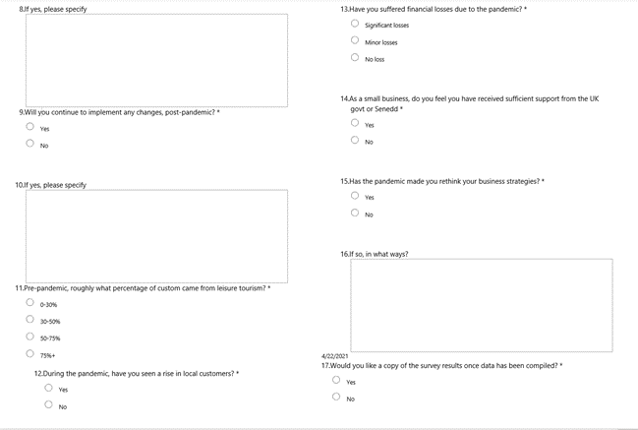

Appendix 1.
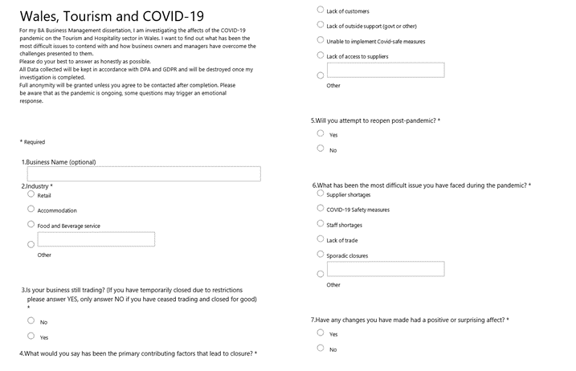

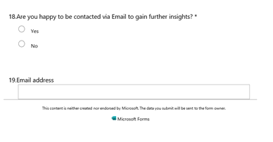

Appendix 2
A STEEPLE analysis is a helpful tool used by many business leaders to identify the Social/Technologial/Economical/Environmental/Political/Legal/Ethical forces affecting a business or industry.

Appendix 3
A SWOT analysis is a helpful tool used by many business leaders to identify the Strengths/Opportunities/Weaknesses/Threats of a business.

