
12/20/2020

Name: Nour Srihini
Module Name: PLC’s

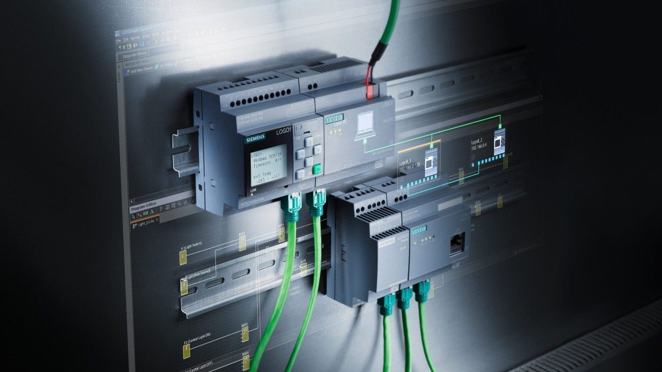

[1]

Table of Contents

Introduction 2
PLC 3
PLC Manufactures : 4
Mitsubishi plc 4
Rockwell automation : 4
Schneider : 5
Omron Automation: 5
Plc advantages and dis advantages in general: 6
Schneider Electric’s Modicon pors and cones: 6
Allen Bradley plcs pors and cones 7
Automation Direct’s Do more pors and cons 7
Factory design: 7
Plc design: 11
Screens: 11
My design explanation: 12
Timers: 13
Flow chart: 15
Conclusion: 16
References 17

Introduction
In this assignment I been asked to complete six tasks in the first task I will be researching for different plc’s products and manufacturers and I will be creating a table to provide pros and cons in my opinion for serval plc’s the ones are currently used in industry.
In the second task I will start working on my factory io design which need to be containing the requirements of this assignment that by using the factory io, then in task three I will be using the tai plc to br creating a ladder logic program to control my factory. Also I need to incoprate a HMI device into my factory and my plc program that I created.
In task five I will be designing three different screens with navigation control on tomy hmi pluse the error and warnungs and the engineering screens.
I willproduce a flow chart explaining who my factory works and what each device.
Finally ending my report with a conclusion and a table of referencing for all the sources I been used.

PLC
Plc is stand for a Programmable Logic controller, the model 084 is the first plc which was found in 1969 by Dick Morley .The plc is an industrial computer control system which can regulary tracks the state of the devices input and it makes decisions and managing the state output devices based on a custom program. Using this control system all the production lines or any computer operation and machines function have the chance to be greatly improved. The greatest advantage of the plc that is the ability to adjust and repeat the operation or procedure when gathering and transmiting critical information. Also as the plc is a modular, so in order to better suit an application it can mix and match the inputs and output types of the devices.
It been designed especially for efficient service in harsh manufacturing environments like high temperatures, rainy and dry dusty conditions.
The typical block of plc has got five parts ( power supply module, input and output module, (cpu) central processing unit , rack or chassis and communication interface module. [2]
To operate a plc there are four basic steps needed, input scan to sense all the input devices state that connected to the plc, the program scan which defends the program logic generated by its user, the output scan is where the output devices (the ones connected to the plc) be energized or de energize and the last step is the Housekeeping which including all the communications with the terminals of the programming and the internal diagonostic. [3]

PLC Manufactures :
There are so many different types of manufactures but I will be listing the most used ones
Siemens: it has 30% to 40% market share, it can make many PLC products lines in SIMATIC S7, the simatic s7 family has got four plc types S7-200, S7-300 and S7-400.
For automation the step 7 is very robust integrated software it also has the environment program for siemens PLCs, also it has a powerful , unique and useful tools with a range of benefits such as architecture structured program, creation of re useable logic.
There are two types of siemens PLC which is compact the i/o number fixed and the Moldular i/o (can be selected as per selection.
S7-200 | S7-300 | S7-400
Compact type | Compact & modular type | Modular type
Small scall industry use | Small & medium scale industry use | Large scale industry use
Cpu 212 to cpu 226 | Cpu 312 to cpu 318 | Cpu 412 to cpu 418
Dp port not available | Dp port not available | Dp port available
The capacity of Digital i/o 256 and 38 for the analog | The capacity of Digital i/o 1024 and 256 for the analog | The capacity of Digital i/o 16384 and 4000 for the analog
The communication driver is the point to pointinterface (PPI) | Simatic manager is the programming software | Simatic manager is the programming software

Mitsubishi plc
A global Japanese company which produce electronics and electrical devices, it based in Tokyo.one of its products is the progeammable controllers.
MELSEC Programmable controllers:
- MELSEC iQ-R series
- MELSEC Iq-f series
- MELSEC-Q series
- MESLSEC-L series
- MELSEC-F series
- MELSEC-Q/WS series

Rockwell automation :
American provider of the automation and the technology information which has two brands The Allen Bradley and the Factory talk software. This company has got more than 23,000 employee and it has the ability to serve more than 100 countries.
The company found by Lynde Bradley and Stanton Allen, both invest $1000 for it .
The allen bradley provides control system, information software, industrial control components, sensing devices, safety technology, industrial security and control coponents and its one of the largest PLC companies in the wold.
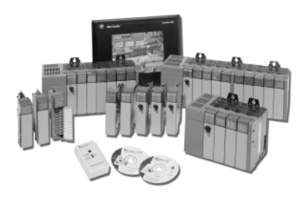
Rockwell Automation's compact chassis-based, modular family of programmable controllers (PLCs) and chassis-based I/O is the Allen-Bradley SLC 500. It is made up of processors, I/O and peripheral equipment. With a broad range of communication settings, functions, and memory options, this processor family provides power and versatility.

SLC500 series(Slick): is very famous PLC it is Quick, efficient
memory processors up to 64K, High-speed concealed
capability and advanced I/O capability.
Its as flexible on small facoty as on the big one
s and very useful to do the big jobs.
its as a small PLC or programmable logic controller, the SLC500 is one of the smaller PLCs that yet provides complete functionality and advanced options that are entirely capable of performing almost everything that larger programmable logic controllers can do. [4]

Schneider :
Schneider Electric – a French company – officially hires 135,000 employees, has a market
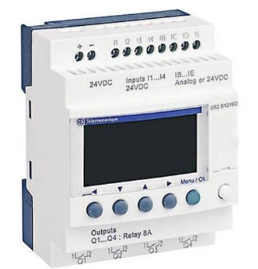
value of about $55 billion and produces annual sales of more than €27 billion.
Modicon is a one of the schneider electrics brands which created the
first plc in the us in 1968 Then the scheinder electric appeared in
1999 in a number of megers and acquisitions. [5]

Omron Automation:
This Japanese company frequently releases hundreds of products in one go and is an
expert in PLCs, it has a wide variety of offerings, including factory robots and sensors. Omron PLC
range contains both micro and modular models and all told, potentially has the
largest number of individual units. [6]
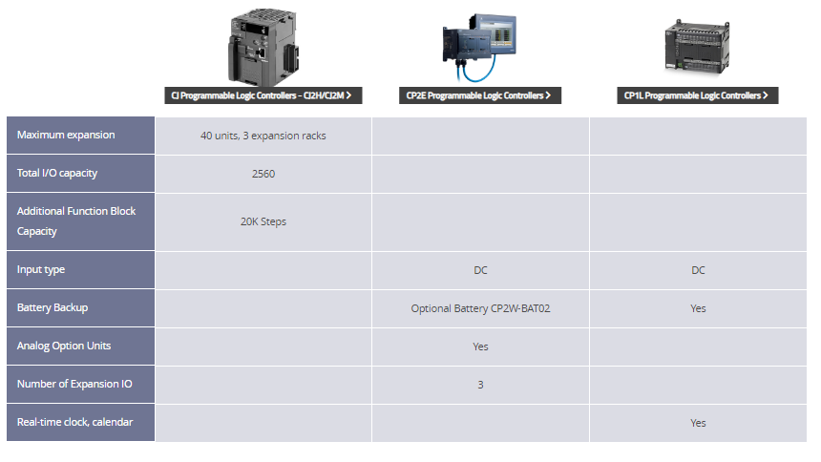

Figure 1

Plc advantages and dis advantages in general:
Advantages | Dis-advantages
Very fast csan time | It takes long tie when problem occurs
Capable to communication with computer in plant | Can not work in high temperature condition
Very good computational capabilities | Ca not work in vibration condition
Easy to learn- no need for long training | Accident can be happened if the plc turned on as some of them works when power restored.
Big range of control applications
Costs can be calculated accurately
Small size
Very flexible to program and reprogram
Reliability in operation
Reference : [7]

Schneider Electric’s Modicon pors and cones:
Advantages | Disadvantages
Unifies 5 different plc languages | Expensive ( more pricey than other non hardened plc’s)
Allow the engineers to ix and match between : function block diagram,ladder logic, sequential function chartand structured text | Hard to find its equipment
Its hardware is haerened for industrial enviroments | Difficult to fix minor issues
Long manufacturers warranty which is 18 months | Have to pay extra for certified schnedier electric techs or control vedors

Allen Bradley plcs pors and cones
Advantages | Disadvantages
High maintainability and reliability | Have to pay for any repair or replacment
They have very good backward compatibility and also legacy support | Expensive
Its products is easier than the others to use | Complicated security system
Easy and quiq to repair or replace as they have very good service | Only one year warranty
Has its own global OEM support(easy to contact)

Automation Direct’s Do more pors and cons
Advantages | Disadvantages
Cheap | Sall range of product
Easy | New company
Free programming softwares available

Factory design:
Figure 2 : the factory
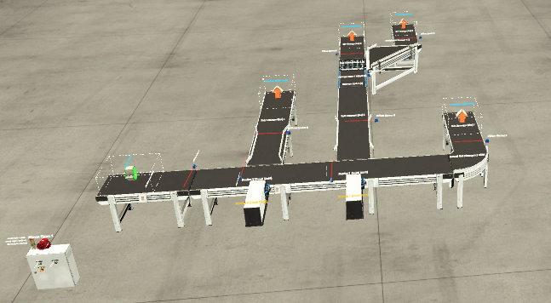

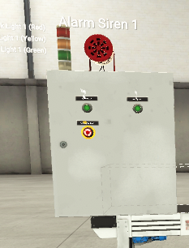
This is the electric switch-board where I placed two start button
and the emergency one.
Putting the stack light with three colores of lights
(green, yellow and red lights) on it next to theAlarm siren.

Figure 3:electric switch board

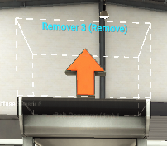
I placed four Removers at all the ends of the conveyors this where all the boxes be removed.

Figure 4:remover

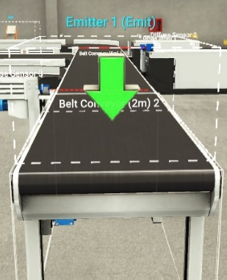
at the first conveyor I placed an Emitter where all the boxes meant to be placed on manually

Figure 5 : Emitter

As it shown in figure 5 I used this sorter after the scale where the medium boxes be sorted either forward or to the right depending on its weight.
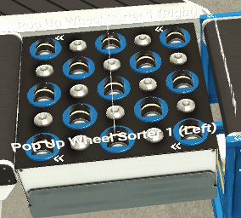

Figure 6: sorter

In the picture below I used this scale to weight all the medium boxes.
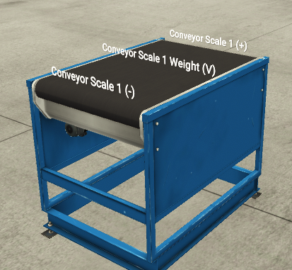

Figure 7: conveyor scale weight
I used the 1 straight spur conveyor, four 2m belt conveyors, two 4m belt conveyors, one 6m belt conveyor and one curved belt conveyor.
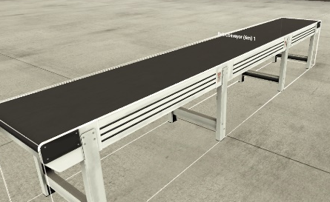
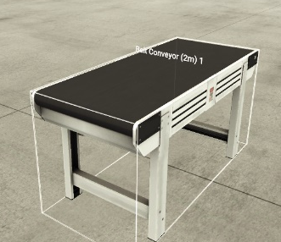
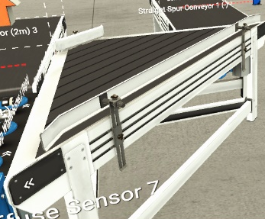

Figure 8:straight spur conveyor Figure 9:2m belt conveyor Figure 10:6m belt conveyor
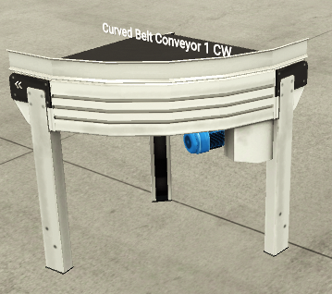
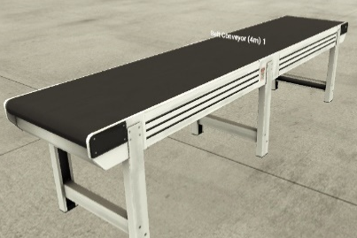

Figure 11: 4m conveyor belt Figure 12:curved belt conveyor

9 diffuesd sensors as counters and to know the size of the boxes.
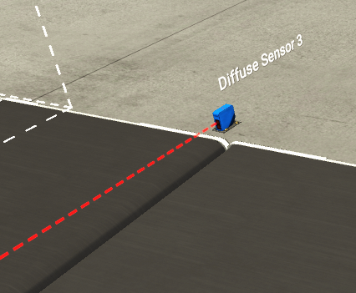

Figure 13:diffuse sensor
On the 6m conveyor belt I placed to pushers
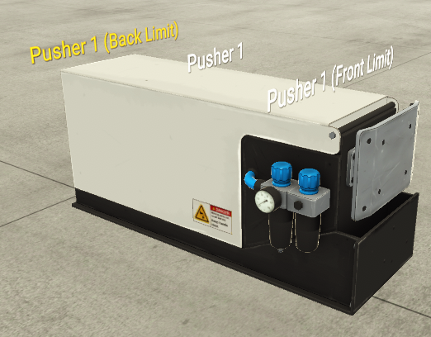

Figure 14: pusher

Plc design:

Screens:
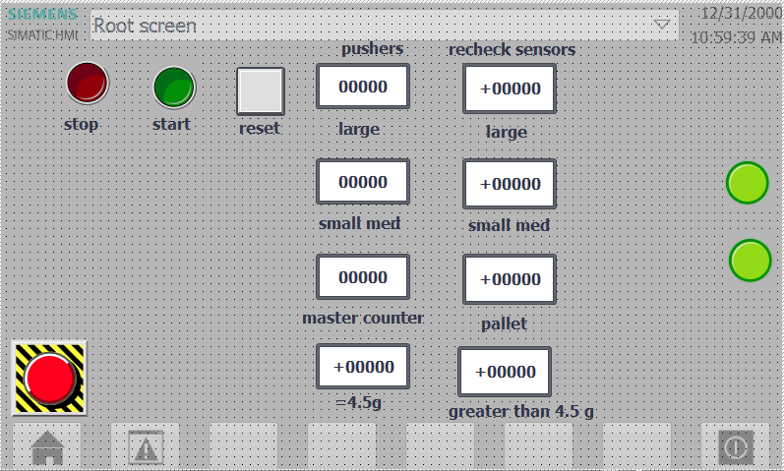

Figure 15:root screen
The root screen contains all counters and the start and stop buttons with the emergency one.
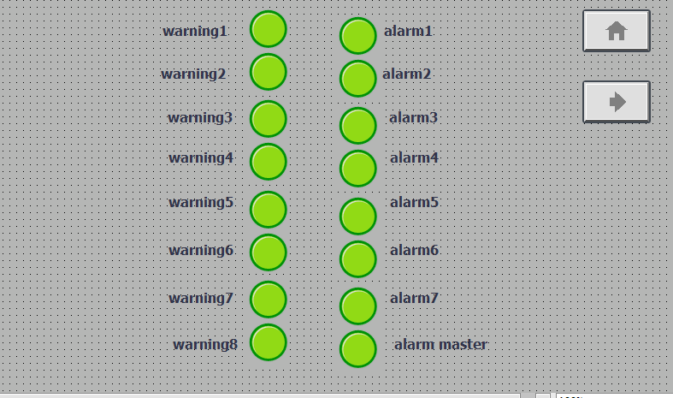

Figure 16: alarm and warnings screen
This screen has all the Alarms and the warnings .

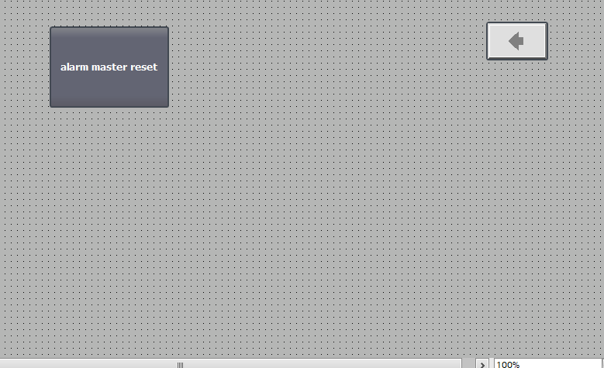

Figure 17: Engineering screen

My design explanation:
Press the emergency button then the start button, green light in the stack will be on. The emitter 1 will start dropping boxes on the first conveyor which is 2m conveyor belt 2, to know the number of the boxes and the sizing I placed two diffuse sensors on the conv 2 and one before the pusher 2.
If the box was large the pusher will be active and will extend to push it on the conveyor belt 4m (1) going through the diffuse sensor 6 which will add it to the counter of the large boxes,then complete its way forward remover 3.
If the box was’nt large it will carry on the conveyor belt 6 (1) going through the diffuse sensor 1 which going to detect the size of it either small or medium sized as it will add it to the counter . if the box was medium sized the pusher (1) will be on so its going to extend to push it to the conveyor belt belt 4 m (2). Going through diffuse sensor 5 will add it to the to the counter of medium sized boxes, continue on the conveyor scale 1 weight, so knowing if it was heavier than 4.5g or lighter. Ifthe box wax was =4.5g or lighter it will carry on the popup wheel sorter 1 and going forward on belt conveyor 2m 3 reaching the diffuse sensor which will add it to the counter going on the remover (2). If the boxes was heavier 4.5g the sorter will push itto the right on the straight spur conveyor 1 then to the belt conveyor 2m 4 reaching the diffuse sensor 8 the one will add it to the counter then going to the remover 4.
If the box was small sized the pusher one will not extend and the box will carry on the conveyor 6m then to the curved belt conveyor 1 ccw then to the belt conveyor 2m 1 reaching the diffuse sensor 4 to add it to the counter then will be removed on the remover one.
Warnings and alarms:
When the alarms on, the red light will be on and all the system going to be off. However, when any of the warnings on the yellow light will be switched on.
On each sensor (counters) an alarm and a warning will be set so if the number of the counter is grater than the number I set on the limit the alarm will be on with the red light and all the system will be off. But if the number of boxes was close to the maximum number of the limit so a warning will be on with te yellow light.

Timers:
When starting the system the siren alarm will be on so I set a timer for three seconds to let the first conveyor belt to run which is 2m (2)
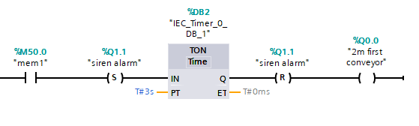
Figure 18: timer1

Both TP timers been set in network 4 the first one is for 1.5 s to control the diffuse sensor and the last one wich is also TP timer for the pusher it is set for 250ms.
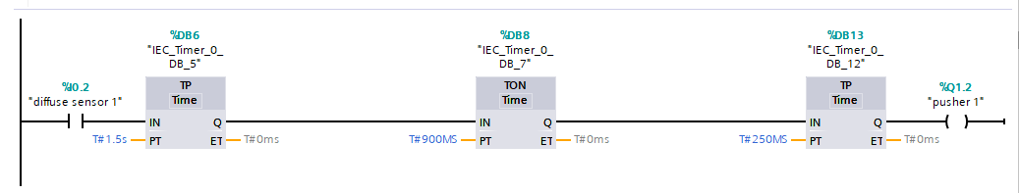
The ton timer is set for 900ms this is the difference between the timing of the other two timers.

Figure 19:pusher timer

I did the same thing for the other pusher as showen in both figures. However I did set different timeng measurs as needed so the diffuse sensor timing equals 1s, the ton thimer ( how long will it take the box to reach the pusher) 700s and 50ms to the pusher.
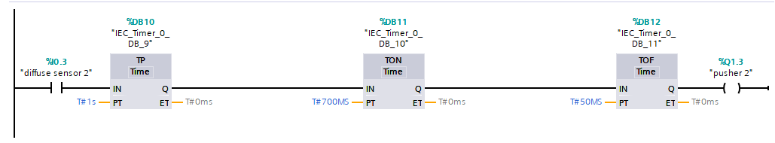

Figure 20: pusher timer

I placed 6 timers so one on each diffuse sensor ( the ones count). All the timers are set on 800ms this measurements is to control the diffuse sensors.
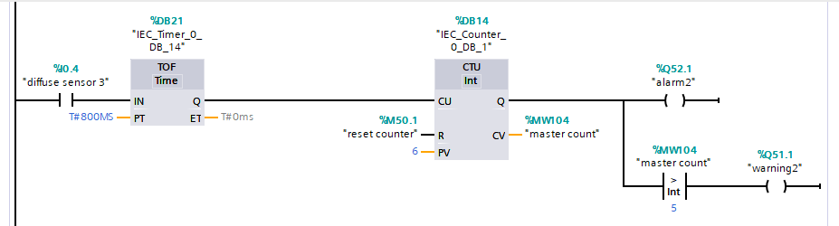

Figure 21:diffuse sensors timers

Two timers in network 9 the tof timer is for the diffuse sensor which is 400ms and the ton timer is to control the timing of the scale for 1 second

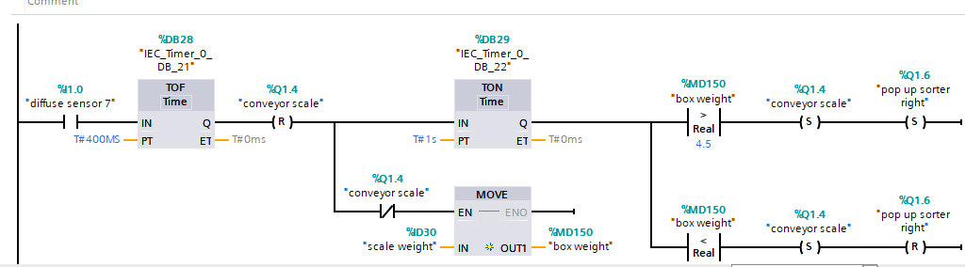

Figure 22:scale timer

Flow chart:
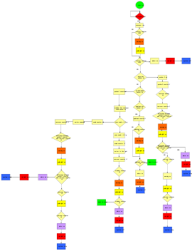
Figure 23

I used the yEd app to create the flow chart so I will be able to submit it as a file with the report.

Conclusion:
In this assignment I did 5 tasks, firstly I have designed a factory using the semiens factory i/o the writ a ladder program to control it. In this task i learnt how to use the factory i/o as it was the first time I use it and enjoyed writing the program to control it. However, it was not easy as I had some technical issues that cause lack of time and was very stressful to done all the requirements on time.
By using the yEd I managed to produce a flow chart for my program .
Also I did some research on the plc’s in the market and their features to be able to compare between them.
In this report I provided som screen shots from my factory and program to explain what been done,
Finally I did all the referencing needed for all the sources of the researches.

References

[1] | “bubbleautomation,” 2020. [Online]. Available: https://bubbleautomation.net/?utm_medium=cpc&utm_source=microsoft_search&_vsrefdom=ms&msclkid=3295e351aff113af9834bc8b1b1b7845. [Accessed 17 12 2020].
[2] | “electrical4u,” 2020. [Online]. Available: https://www.electrical4u.com/programmable-logic-controllers/. [Accessed 2 12 2020].
[3] | “Advanced Micro Controls,” 2020. [Online]. Available: https://www.amci.com/industrial-automation-resources/plc-automation-tutorials/what-plc/#:~:text=A%20PROGRAMMABLE%20LOGIC%20CONTROLLER%20(PLC,the%20state%20of%20output%20devices.&text=That%20is%2C%20you%20can%20mix,to%20best%20suit%20your%20application.. [Accessed 3 12 2020].
[4] | “roboticsandautomationnews,” 2020. [Online]. Available: https://roboticsandautomationnews.com/2020/07/15/top-20-programmable-logic-controller-manufacturers/33153/. [Accessed 18 12 2020].
[5] | “fruugo,” 2020. [Online]. Available: https://www.fruugo.co.uk/schneider-electric-sr2-b201bd-1040026-plc-controller-24-v-dc/p-5628801-12658127?language=en&ac=bing&msclkid=a0e1c07ecf911b920e3a9fa0d451a4be&utm_source=bing&utm_medium=cpc&utm_campaign=9082_GB&utm_term=4575136607599539&utm_content. [Accessed 18 12 2020].
[6] | automation omron, 2020. [Online]. Available: https://automation.omron.com/en/us/products/families/programmable-logic-controllers?filters=type==product&filters=category==programmable-logic-controllers&pageSize=10. [Accessed 17 12 2020].
[7] | polytechnichub, 2020. [Online]. Available: https://www.polytechnichub.com/advantages-disadvantages-programmable-logic-controller-plc/. [Accessed 18 12 2020].

