Secondary Research Report on Rehabilitation centres during COVID-19
Krystal Gardner
2027750
Mr Alfred Mensah
BMSW4003
Digital Skills and Research Methods

Table of content
Abstract
Introduction
Rationale
Research objective
Literature review
Methodology
Analysis and discussion
secondary data Analysis
Recommendation
Conclusion
References
Appendix

Abstract
The purpose of the secondary research report is to demonstrate how rehabilitation technology is the application of technology to suit the requirements of persons who are disabled. In education, rehabilitation, employment, transportation, living at home, and recreation, rehabilitation technology removes barriers and expands opportunities for persons with disabilities. This study report will concentrate on various contact tactics and the use of technology in the rehabilitation context.

Introduction
I used Microsoft forms to develop a survey in which I asked a number of people a series of questions regarding how they communicated using new technology versus old technology. I also inquired as to how they liked to be contacted and whether they thought the usage of new technology to be beneficial. I will provide my findings in the form of graphs and statistics, and I will look for more study on different types of technology and its applications in the rehabilitation context.

Rationale
I will be conducting my report using secondary data from rehabilitation centres, and I will be gathering information relevant to people who work or have people who work in rehabilitation centres. I would like to work in this setting in the future because it has always been a passion of mine, and I believe that collecting as much data as possible will help me gain a better understanding of people's needs and thoughts, from online bookings to ordering medication and scheduling appointments.
Research Objective
This data report will show secondary data research on various findings, such as how health care workers feel about how technology is being used and how communication is being done. This could include a number of people who found it easy or difficult to access online meetings, order medication, and how long it takes to do so.
Secondary data sources are extremely useful. They allow researchers and data analysts to build large, high-quality databases that help solve business problems. By expanding their datasets with secondary data, analysts can enhance the quality and accuracy of their insights. Most secondary data come from external organizations. However, secondary data also refers to that collected within an organization and then repurposed. (careerfoundry.com, n.d.)
The significance of this data is to determine how staff and patients felt about their online booking systems. Also, to better understand people's thoughts when using the online system, I created an online questionnaire using Microsoft forms as a data gathering tool, then used the results to write my report.
Rehabilitation technology is a relatively new and growing field, experiencing some of the same developmental challenges seen during the history of conventional rehabilitation practice. Its development has been strongly influenced by motor learning principles, in particular massed practice, and explicit learning paradigms. (Fasoli, 2016)
Literature review
As soon as Covid-19 appeared, the entire planet was compelled to go into lockdown in order to prevent the virus from spreading. Rehabilitation centres introduced a full telephone triaging strategy, allowing healthcare providers to treat more of their patients via phone and video consultations. As a result, the number of face-to-face consultations and visits on the wards will be reduced. Because the volume of calls was unsustainable, healthcare workers sought for other ways to stay in touch with their loved ones, such as team calls. However, this would be considerably more difficult for persons with medical issues, such as the blind. The NHS app has both pros and disadvantages, according to online sources. Using this strategy, many health professionals have had to learn quickly in a short amount of time, with some professionals not being well trained.
COVID-19 has shaken the world. It is a virus that is highly contagious and can, unfortunately, be fatal to those who have a weaker immune system. Therefore, medical professionals all over the world are doing the best that they can to tend those who require their attention. Considering this, telehealth, a way to provide medical consultation through telecommunications, is stepping forward more than ever before. The need for continued medical care coupled with the risk of infection has caused many people to consider the benefits and limitations of telehealth. (Brown, 2020)
"The NHS App has played a central role in the fight against COVID-19 helping to enable international travel and access to major events. It has also changed the way millions of adults in England access healthcare services in the three years since its launch, with people using the NHS App to book GP appointments, order repeat prescriptions, access the NHS COVID Pass service and register organ donation decisions.” (NHS Digital, 2021)

Many of us appreciate how communications technology has helped us to stay in touch with family and friends. Furthermore, greater technology has aided in the improvement of our healthcare system by allowing professionals to remotely monitor patients' health, allowing people to obtain prescriptions online and access their COVID-19 immunisation data, and making events and travel safer.
The move to remote ways of working has been one of the key changes made in primary care during the COVID-19 pandemic. It has been essential in trying to keep patients and staff safe, especially those who are vulnerable. It has also transformed patient access to services. It is likely that remote consultations will remain part of a GP’s working day, but this does present new challenges and new medicolegal risk. (Articles, 2021)
Rehabilitation, employment, transportation, living at home, and recreation, rehabilitation technology removes barriers and expands opportunities for persons with impairments. Devices, aides, and upgrades utilised in rehabilitation technology are referred to as assistive technology. Rehabilitation technology can help people with severe mobility, learning, emotional, visual, hearing, neurological, neuromuscular, and other disabilities gain function
by removing barriers in the home and workplace.
Methodology
In my study, I will look for information from a variety of sources, including government websites and other websites, as well as data acquired by rehabilitation centres, which may include newspaper or newsletter pieces, among other things. Based on a questionnaire I designed for a survey, this report will present this in the form of charts and reports.
The research report will display the nine questions from the questionnaire I produced using Microsoft forms as a data collection method, and then used the results to construct this report. I received nine responses from employees and others. As a result, these responses will be used in this report.

Analysis and discussion
The goal of this survey was to obtain information from rehabilitation centres in order to learn about their perspectives on how to be contacted digitally or via mail, as well as team calls and telephone communication. The following are some of the questions I asked in the survey, along with their responses.
People of various ages answered these questions, and I wanted to see which ages found it easier or more difficult, thus 33 percent were aged 18-30, 30-60 replied 67 percent, and 60+ did not respond.

Secondary Data Analysis
A number of staff and others were asked the following questions. I will summarise my findings below. I asked a total of nine questions.

Question 1
Did you feel you was supported during lockdown?
This grid reveals that 44 percent felt supported during lockdown, whereas 33 percent claimed they were not, and 22 percent stated they were not sure and replied maybe.

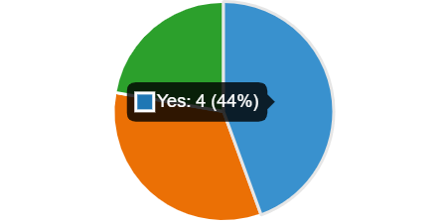
Yes four
No three
2

Question 2
How was your contacted during lockdown?
I inquired as to how they were notified during the lockdown. This grid reveals that 22% said letter, 22% said phone, and 56% said email, indicating that email was the most efficient point of interaction.
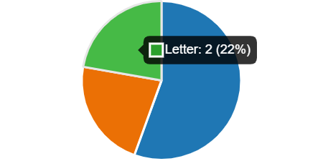
Email five
Phone two
Letter two

Question 3
Do you feel enough was communicated?
I inquired if you thought enough had been communicated. According to this grid, 44 percent said yes, and 56 percent said no.
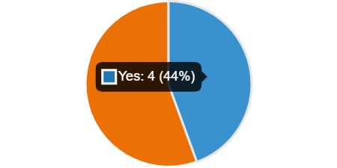

Yes four
No five

Question 4
How did you find conducting meetings via Teams?
I inquired about their experiences with team meetings. In this grid, 11 percent of respondents were unsatisfied, while 89 percent were satisfied.

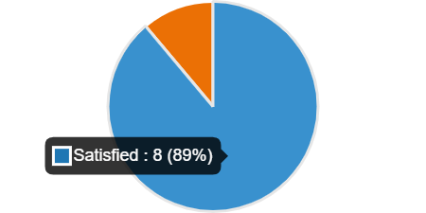
Satisfied eight
Unsatisfied one

Question 5
How did you find communication over the phone with staff?
I inquired about the experience of communicating with personnel over the phone. According to this grid, 33% of respondents said poor and 67% said good.
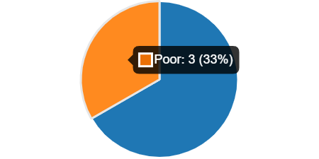
Good six
Poor three

Question 6
How did you find ordering Medication?
I inquired about your experience ordering medications. This grid reveals that 22% said it was easy and 78% said it was difficult. 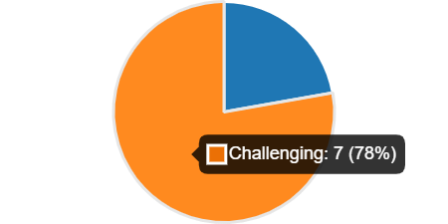
Easy two
Challenging seven

Question 7
How was the network whilst on a team call?
When I asked how the network was during a team call, 22 percent claimed it was poor and 78 percent said it was good. 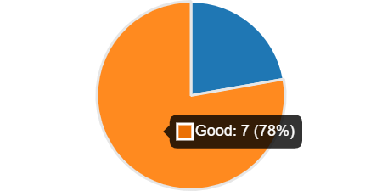

poor two
Good seven

Question 8
Age range
I wanted to know the age range since it would give me a better understanding of the age range of people who use technology. This grid reveals that 33% of people were between the ages of 18 and 30, and 67 percent were between the ages of 30 and 60. I suggested 60+ but no one responded. 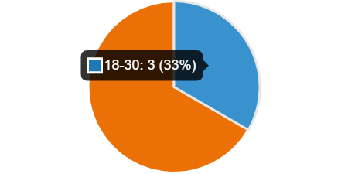

18-30 three
30-60 six
60+ zero

Question 9
How was medication ordered
I also inquired as to how medication was ordered, namely if it was done using an app, over the phone, or through another method. This grid reveals that 22% of orders were placed by app, 33% via phone, and 44% via another method. 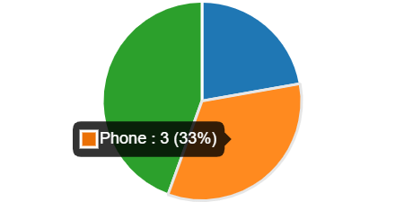
App two
Phone three
Other four

Recommendations
The National Health Service (NHS) should give sufficient training to staff and other healthcare professionals so that they can better manage primary care for their patients remotely via the internet. Furthermore, better information and assistance should be available for those who find using this system difficult, primarily service users and staff with hearing or vision problems.

Conclusion
To conclude this study, my secondary research indicates that the majority of individuals prefer to be contacted by email and also prefer to get a phone call over communication via apps and other digital methods. I have previously talked about how digital technology has changed the way we study and how it helped us during Covid 19. While there are advantages and disadvantages to digital learning, it is vital in today's climate for people to participate.
The majority of respondents said they were pleased with their experiences receiving emails and ordering medication using the web app, and that they would use the system again. However, some argue that ordering medications over the phone is a preferable option.
As a result, for most people, this epidemic has provided an excellent chance for virtual team calls and NHS app to seek medical assistance. However, the high level of satisfaction with online consultations among patients and healthcare professionals suggests that this approach may become more popular in the future, even after the COVID-19 pandemic restrictions are lifted.
I've included a link to my Questionnaire below.
https://forms.office.com/Pages/DesignPageV2.aspx?origin=NeoPortalPage&subpage=design&id=-REPTm4EBUWcuNshUjEeIY0K7D8RX5ZAnOSvnsOttstUOElTQ0wxVEpQUkdKM1Q4OVZSVEkyTk9BWS4u&analysis=true

References

careerfoundry.com. (n.d.). What is Secondary Data? [Examples, Sources & Advantages]. [online] Available at: https://careerfoundry.com/en/blog/data-analytics/what-is-secondary-data/. (Assessed 27 Mar 2022)

fasoli, S.E. (2016). Rehabilitation Technology - an overview | ScienceDirect Topics. [online] Sciencedirect.com. Available at: https://www.sciencedirect.com/topics/medicine-and-dentistry/rehabilitation-technology. (Assessed 28 Mar 2022)

Brown, C. (2020). Pros And Cons of Telehealth During the Covid-19 Crisis. [online] Bit Rebels. Available at: https://bitrebels.com/technology/pros-cons-telehealth-during-covid-19-crisis/ (Accessed 28 Apr. 2022).

NHS Digital. (2021). NHS App turns three with 22 million users. [online] Available at: https://digital.nhs.uk/news/2021/nhs-app-turns-three-with-22-million-users.

Articles. (2021). Remote consultations – what are the benefits and risks? [online] Available at: https://www.medicalprotection.org/uk/articles/remote-consultations-what-are-the-benefits-and-risks (Accessed 28 Apr. 2022).

