
Embracing Sustainability: A Collective Responsibility for a Thriving Future

MBA Sustainability Leadership
Challenge of Sustainability
BMSP7001
2nd Assignment
Alhasan Mahmood
23173166
Dr. Laura James
5th January 2023

Title: Embracing Sustainability: A Collective Responsibility for a Thriving Future

In a world increasingly facing environmental challenges, the wisdom of Abraham Lincoln, the 16th President of the United States continues to ring true: "You cannot escape the responsibility of tomorrow by evading it today."
His leadership during a period of intense national turmoil, particularly during the Civil War, stands as a striking example of this approach. He consistently navigated a myriad of complex and demanding decisions, with a keen eye on the long-term implications and the greater good. Lincoln’s approach transcended mere short-term decision-making; it encompassed a deep consideration of how his actions would shape the future. His profound statement emphasises the inescapable nature of responsibility and the interconnectedness of our actions today with the consequences they bring tomorrow.

Undoubtedly, one of the most urgent global issues we are facing today is environmental consciousness. To ensure sustainability and reach the target of zero carbon emissions, governments everywhere are actively leading massive initiatives and carefully crafting accords and detailed plans.

Lincoln’s timeless philosophy highlights the urgent need for proactive and responsible action in the pursuit of sustainability. The journey toward sustainability is neither smooth nor easy. It is a collaborative effort from governments, businesses, and society, particularly in the context of global warming and Scope 3 emissions.

- Introduction

“You cannot escape the responsibility of tomorrow by evading it today.”

Lincoln’s enduring belief in confronting challenges and responsibilities head-on, without delay or evasion clearly reflects the urgency and joint efforts around the world to put a limit to the pollution, particularly pressing is the issue of global warming and the associated increase in greenhouse gas emissions, including Scope 3 emissions. These emissions, which are indirect and often occur in the value chain of a company, are notoriously difficult to measure and manage. However, their impact on the environment is significant. Reducing these emissions is essential in mitigating climate change and ensuring environmental sustainability.

Environmental deterioration has an impact on social, economic, and political spheres among others. Future generations' and current generations' quality of life could be gravely harmed by these repercussions. The effect of Scope 3 emissions on the environment and human population is one important facet of this problem. It becomes increasingly important to comprehend and reduce the effects of these emissions as firms work to become more sustainable. It's about building a more sustainable, circular economy that benefits all stakeholders, not just about cutting their carbon footprint.

A holistic approach involving businesses, governments, and society is essential for ensuring a sustainable future. Each entity plays a unique and indispensable role.
Governments, as the key architects of policies, hold the power to set standards that guide corporate and individual actions. More sustainable solutions are being applied by businesses. A lot of companies are using/manufacturing eco-friendly products and following rules that lessen their carbon footprint. Individual initiatives for sustainability play a key role in shaping a more environmentally conscious world. The impact of individual contributions should not be underestimated. Each small step taken, be it reducing personal carbon footprint, practicing responsible consumption, using renewable energy, or advocating for environmental causes, contributes to a larger movement towards sustainability. These actions create massive effect, inspiring others and fostering a culture of eco-consciousness. They demonstrate that change begins at a personal level and can collectively lead to substantial positive transformations for the planet. Encouraging and supporting individual initiatives for sustainability is fundamental in creating a sustainable future for generations to come.

"We do not inherit the Earth from our ancestors; we borrow it from our children." – Native American Proverb

- Background

The term "global warming" reflects the gradual rise in Earth's average surface temperature that is mostly caused by human activity. The emission of greenhouse gases, including carbon dioxide, methane, and nitrous oxide, is closely associated with this occurrence. Rising sea levels, changed weather patterns, and other environmental effects are caused by global warming [1].

In contrast, Scope 3 emissions are categorised as indirect emissions within the value chain of a reporting company. These emissions are a specific type of indirect greenhouse gas emissions tied to a company’s business activities, encompassing both the supply and distribution chains. Unlike emissions directly produced or resulting from a company's energy use, Scope 3 emissions stem from sources not owned or directly controlled by the company. Scope 3 emissions often represent the largest portion of a company’s carbon footprint, originating from various stages such as procurement, manufacturing, transportation of goods, and the use of the company's products and services post-sale [2].
The concept of sustainability can be characterised as the conscientious utilisation of resources in a manner that ensures their ongoing availability and preserving access for future generations. This notion is fundamentally anchored in the triumvirate pillars of sustainability, encompassing environmental, economic, and social aspects. Environmental sustainability focuses on prudent resource management and conservation to mitigate climate change and environmental degradation. Economic sustainability focuses on practices that promote long-term economic stability and growth, avoiding short-term gains with lasting detrimental effects. Social sustainability involves the equitable distribution of resources and opportunities to benefit all segments of society [3][4][5].

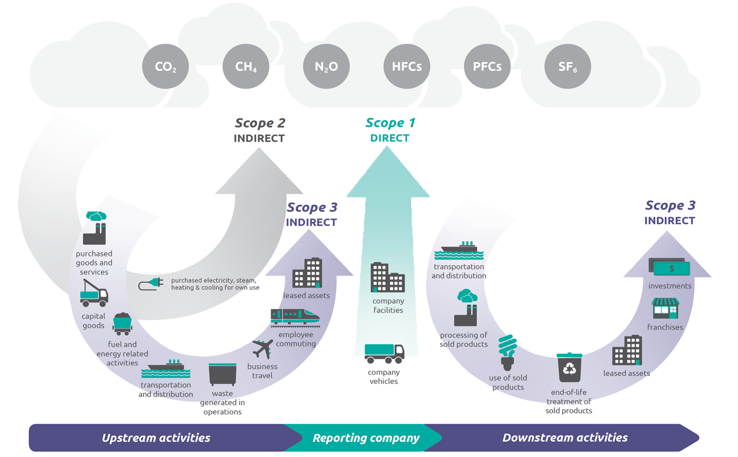
The various types of emissions [source: Scope 3 Standard, page 5.]

The Brundtland Report (1987), also known as "Our Common Future" by the World Commission on Environment and Development, introduced and popularised the concept of sustainable development [3].
Furthermore, sustainable business practices are actions and strategies employed by companies that consider their impact on the environment and society, not just profitability. These practices include reducing carbon footprints, improving labour policies, ethical sourcing, and embracing the principles of corporate social responsibility (CSR). Elkington's (1997) concept of the "Triple Bottom Line" emphasises the need for businesses to focus on people (social), planet (environmental), and profit (economic) dimensions [6].

A circular economy is an economic system aimed at eliminating waste and continually using resources. Circular systems employ reuse, sharing, repair, refurbishment, remanufacturing, and recycling to create a closed-loop system, minimising resource inputs and waste, pollution, and carbon emissions. The Ellen MacArthur Foundation is a leading proponent of this concept, providing comprehensive insights into the principles and applications of a circular economy [7].
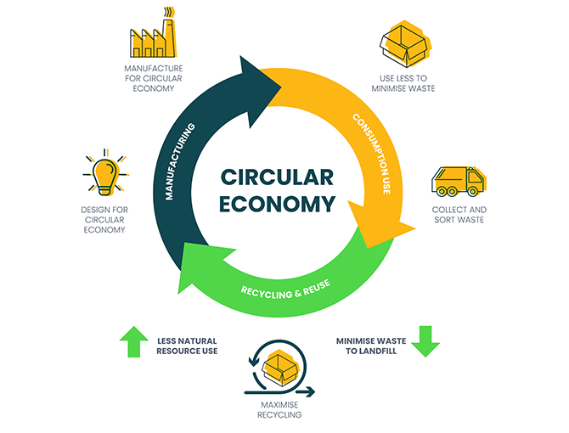

The stages of circular economy [source: Ellen Macarthur Foundation.]

The United Nations established a series of objectives known as "The Sustainable Development Goals" (SDGs) in 2015 in acknowledgement of the pressing need to embrace sustainability and sustainable practices for the welfare of present and future generations. These objectives provide a strategic framework for tackling global issues including greenhouse gas emissions and climate change, with an emphasis on Scope 3 emissions in business value chains. The integration of SDGs 13 (Climate Action) and 12 (Responsible Consumption and Production) through government policies that support recycling and sustainable resource use is the cornerstone of this strategy. SDG 13 calls on companies to transition to renewable energy and efficient supply chains. Collaboration under SDG 17 is vital, bringing together governments, NGOs, and corporations to foster innovation and green technologies. The transition to clean energy, as outlined in SDG 7, requires investments in renewable projects.
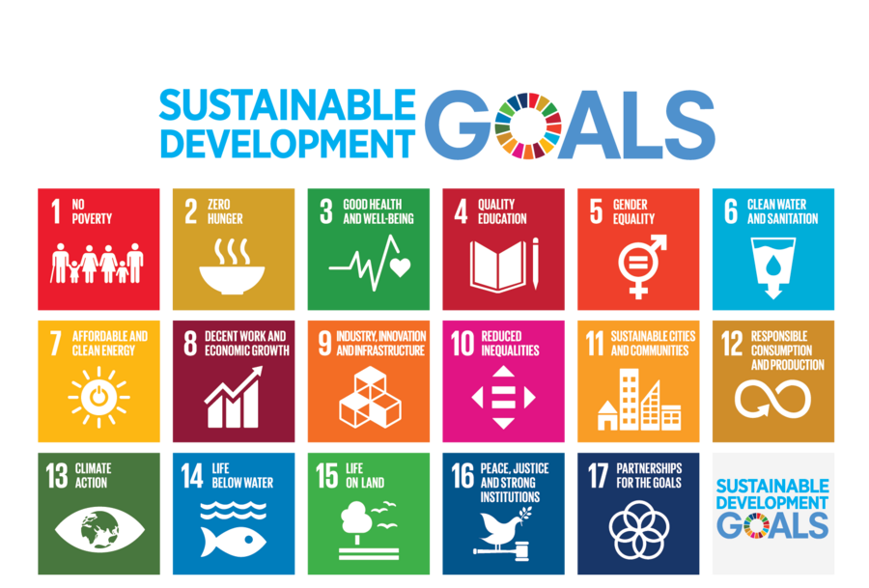
Engaging society in sustainability and influencing consumer behaviour are also key components alongside technology development under SDG 9 for emission reduction in the industry. Global and regional cooperation, aligned with agreements like the Paris Agreement, is essential for sharing sustainable practices and technologies worldwide. This holistic integration of SDGs necessitates a united effort from governments, businesses, and communities to effectively combat global warming and reduce Scope 3 emissions [8] [9 DBA Paper]. Addressing major challenges to humanity requires collaboration among various key players and stakeholders, including governments, corporations, societies, and individuals. Moreover, it necessitates tailored and effective techniques and strategies to equip decision-makers with the necessary skills and tools for well-informed and effective decision-making in business [10].
Sustainable Development Goals [source: United Nations Department of Economic and Social Affairs.]

Governments play a crucial role in steering society toward sustainability, primarily through the development and enforcement of realistic yet effective policies and legislation. This involves setting stringent environmental standards that are guided by frameworks like the United Nations' Sustainable Development Goals (SDGs) and the International Organisation for Standardisation (ISO) environmental management standards.
Additionally, governments are responsible for incentivising green technologies using tools such as subsidies and tax credits to promote innovation in line with the principles of a green economy. Critical in this endeavour is the balance between economic growth and ecological preservation, a concept echoed in the Brundtland Report's definition of sustainable development and the World Business Council for Sustainable Development’s (WBCSD) emphasis on eco-efficiency. This approach requires integrating biodiversity conservation into national policies, aligning with international agreements like the Convention on Biological Diversity (CBD), to ensure that development meets present needs without compromising future generations' ability to meet theirs [3] [4].

Businesses and corporations also play a vital role in humanity's path toward sustainability and sustainable practices. In the modern context, businesses are pivotal in shaping a sustainable future, encapsulated in the idea of Corporate Social Responsibility (CSR). Companies are expected to operate in an environmentally sustainable, socially equitable, and economically viable manner. This can be achieved through investments in sustainable practices, such as reducing carbon footprints, embracing renewable energy, and ensuring fair labour practices. In this approach, businesses can lead the way in creating a more sustainable future, understanding that evading these responsibilities today can lead to severe ecological and social consequences tomorrow, which can, in turn, impact the business environment itself.

According to The Yale Ledger article, there are five strategies to integrate sustainability into corporate practices. Firstly, it emphasises developing a corporate culture focused on sustainability through employee education and leadership involvement. Secondly, it advocates for eco-friendly operational changes such as reducing energy consumption and waste. Thirdly, building sustainable supply chains by partnering with like minded suppliers is highlighted. Fourthly, it discusses the importance of engaging in CSR initiatives that reflect the company's values. Lastly, it underscores the need for measuring and reporting on sustainability performance to ensure transparency and continuous improvement. This approach aligns with the concept of businesses playing a key role in driving sustainable futures [11].
Another example from Saudi Arabia, where both public and private sectors are working for a sustainable future. A very interesting approach from an Energy and chemical producers, Aramco strongly integrates sustainability within its corporate strategy and operations, making a net positive impact as a main goal [12]. Private sector, mainly Automotive is also pioneer the call for sustainability with their Hybrid and fully electric mobility solutions.

Societal influence can be seen in consumer behaviour trends that prioritise sustainable products and grassroots movements that push for environmental action. According to the American Society for Quality (ASQ), social responsibility is "a pathway to sustainability," highlighting the need for ethical behaviour and consideration of stakeholders' expectations by organisations. This approach contributes to sustainable development and encompasses principles like accountability and transparency [13].

Additionally, the World Bank emphasises on social sustainability and inclusion, stressing its importance in poverty reduction and creating inclusive, resilient societies. This comprehensive approach, which integrates social, economic, and environmental aspects, is essential for sustainable development and shared prosperity [14]. These insights collectively reinforce the pivotal role of society, including individuals and communities, in advocating for sustainable practices and holding businesses and governments accountable, thereby shaping a collective sustainable ethos critical for long-term ecological balance.

- Discussion

The adoption and implementation of sustainable practices in daily life and business practices have become mandatory and urgent topics that require immediate action from key players and stakeholders, including governments, businesses, and societies. Sustainability and sustainable practices are not off-the-shelf products; they are systematic processes that demand well-designed steps and unified efforts to bring about the necessary changes for a more sustainable planet. This transformation must consider the quality of life for both current and future inhabitants of the planet.

The journey toward sustainability begins with a shift in individual mindsets by encouraging people to think holistically and to embrace sustainable solutions in every aspect of life. Individuals are at the core of every entity on this planet. They are involved in the processes of forming governments, making decisions, and ultimately shaping societies. Therefore, the first step is to educate and raise awareness about the urgency of sustainability. This can be done in various forms, such as educating individuals about resource scarcity, promoting responsible consumption of resources like water and energy, and emphasising the rights of future generations to a sustainable planet.
As mentioned earlier, this path toward sustainability needs a systematic and unified effort to cultivate individuals' mindsets regarding the importance and urgency of adopting and implementing sustainability and sustainable practices in daily life. Individuals are the foundation of governments and are responsible for creating the necessary frameworks and regulations to govern countries effectively. Government systems and governance structures play vital roles in ensuring that the right individuals are elected to run governments.

For instance, the elected government of the UK and England, operating based on democratic elections, actively pursues Sustainable Development Goals (SDGs) set by the United Nations in 2015. The government has committed to delivering on these goals by incorporating them into various sectors. Its approach is multifaceted, addressing challenges such as environmental sustainability, economic growth, and social justice. The UK is committed to reducing greenhouse gas emissions to net zero by 2050, aligning with SDG 13 on climate action. England's strategy regarding the SDGs involves aligning national policies with global goals and not only focusing on internal development but also contributing to international efforts toward sustainability. Such actions are effective because the government is composed of individuals with mindsets that recognise the importance of sustainability in all aspects of life [15][16] [my activity].

Another significant example on the collaborative efforts and united vision of sustainable future sits in the Middle East. Saudi Arabia is a great manifestation of Lincoln’s philosophy of shaping tomorrow through today’s actions. Government, businesses, organisations and individuals are taking sustainability seriously and willing to address climate change in every aspect.
By 2060, Saudi hopes achieve Net Zero emissions through its Vision 2030 initiative. Saudi is leading the effort to address energy and climate challenges with creative solutions like the Circular Carbon Economy (CCE) and a more varied energy mix, whereby 50% of energy will come from renewable sources by 2030. The Kingdom is dedicated to clean energy and sustainability approach [17].
Conversely, high-level initiatives are underway, such the Saudi Green Initiative. The three primary goals of SGI's activities are emissions reduction, land and marine preservation, and afforestation [18].

In the world of corporate business, playing a key role in the development and implementation of sustainable practices has become increasingly crucial. This involves creating strategies that support and promote sustainable business practices. Across the globe, numerous corporations and companies are now focusing on integrating sustainability and social responsibility into their core business models.

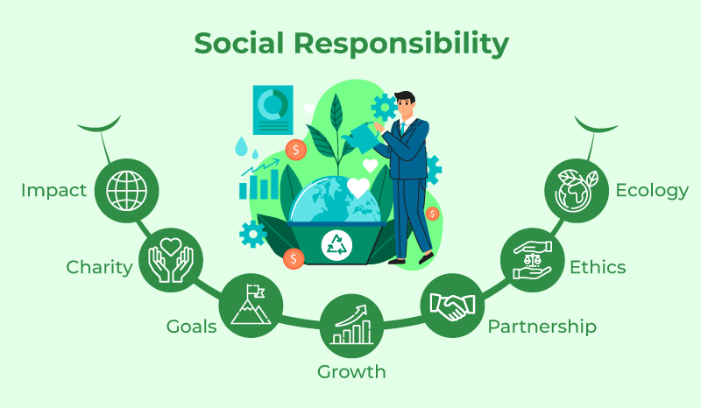

A significant part of the shift to sustainability is played by societies. People can adopt several important steps to embrace sustainability and sustainable activities. Employing renewable energy sources, including wind and solar electricity, has the dual benefits of lowering harmful emissions and reducing society's reliance on fossil fuels. Encouraging people to drive less and use public transportation, walk, ride bikes, or take the bus can greatly reduce traffic and pollution.
Another important component is conserving water, which may be done by using techniques like collecting rainwater, practicing water-efficient agriculture, and installing water-saving appliances in public and residential areas. These techniques lower energy usage in addition to saving water. A love of the environment can be developed by getting the community involved in environmental projects like wildlife preservation, local clean-up campaigns, and tree planting. Societies may take major steps towards sustainability, which will benefit the environment and future generations, by cooperating and embracing these environmentally friendly practices.
While discussions about sustainability and the adoption of sustainable practices may sound positive and encouraging, the reality is far from simple. The journey towards sustainability is marked by challenges and obstacles that make the path anything but smooth. For example, the democratic election of government officials is essential to ensure that the right individuals have a fair opportunity to lead and implement sustainable policies.
However, it's not enough for governments to be elected democratically; they must also possess the will and effective strategies to confront the real-world challenges associated with adopting sustainability and sustainable practices Businesses and Corporations also face a fundamental transformation where they must acknowledge that change is inevitable, and that sustainability is the only viable path forward.
Balancing sustainability with profitability requires a complete revaluation of the equation. Businesses need to exhibit flexibility and dynamism in allocating resources and funds to develop products and solutions that align with market demand and address current and future sustainability challenges. This task is far from easy, given the presence of traditional government regulations, the substantial investments required, and the extended timeframes involved. Furthermore, the task of shifting societal and individual mindsets and perspectives towards sustainability is a complex and non-linear mission. It demands patience and a significant amount of time to effectively communicate the importance of sustainability and the urgency of its implementation in daily life.

In conclusion, it is imperative to emphasise the critical importance of embracing sustainability and sustainable practices in our contemporary world. Abraham Lincoln's philosophy of facing challenges directly rather than deferring them serves as a vital guiding principle in our quest for a sustainable future. The interconnectedness of our actions today with their consequences tomorrow underscores the urgency of addressing issues like global warming and Scope 3 emissions.
Global warming, rooted in human-induced greenhouse gas emissions, poses an existential threat to our planet. As Earth's average surface temperature continues to rise, the repercussions impact weather patterns, sea levels, and the overall health of our environment. The challenge of Scope 3 emissions, in particular, highlights the complexity of this issue, as these emissions are not only significant but are also challenging to manage due to their indirect nature. To address these daunting challenges, the roles of governments, businesses, and societies are pivotal.
Governments must create conducive policies and frameworks that encourage sustainable practices, as demonstrated by the UK's commitment to aligning national policies with the UN's Sustainable Development Goals. Businesses play a crucial role in shaping a sustainable future by incorporating Corporate Social Responsibility (CSR) and embracing sustainable practices. Societies, including individuals and communities, can adopt sustainable habits and practices that reduce their environmental footprint and contribute to a more sustainable planet.
The temporary drop in carbon emissions during the times of lockdown due to Covid-19 shows and confirms that the weight and responsibility of managing the climate change is defiantly a collaborative effort that doesn’t exclude any institution or individual. According to UNEP, carbon dioxide emissions are rapidly recovering after a temporary blip due to the economic slowdown and are nowhere close to reduction targets. Greenhouse gas concentrations in the atmosphere continue at record levels, committing the planet to dangerous future warming, according to a new multi-agency United in Science 2021 report [19].

The path toward sustainability is a collective journey that demands the concerted efforts of all stakeholders. As individuals, we are the core of governments, businesses, and societies. Our mindset and actions set the tone for the larger-scale changes needed. Education and awareness about sustainability, coupled with a willingness to adopt and implement sustainable practices in our daily lives, are the first steps toward this transformation.

Clearly, the next generation who represents tomorrow's leaders, business pioneers, and a valuable societal asset, will confront a challenging environmental future. However, today's youth show a remarkable awareness of the importance of sustainability. Empowering them to contemplate and implement mindful choices in their daily lives is crucial for forging a cleaner and more sustainable future.
Abraham Lincoln was a visionary, and his advice to face the difficulties of the future head-on applies to most, if not all, facets of life. You cannot escape the responsibility of ensuring clean air, water, and healthy environment for tomorrow’s generations, by evading this responsibility and carrying on with the destructive techniques that are being used now.

References:

- IPCC (2021). Climate Change 2021: The Physical Science Basis. [online] www.ipcc.ch. Available at: https://www.ipcc.ch/report/ar6/wg1/.

- ‌ Corporate Value Chain (Scope 3) Accounting and Reporting Standard Supplement to the GHG Protocol Corporate Accounting and Reporting Standard. (n.d.). Available at: https://ghgprotocol.org/sites/default/files/standards/Corporate-Value-Chain-Accounting-Reporing-Standard_041613_2.pdf.

- ‌ Brundtland, G.H. (1987). Report of the World Commission on Environment and Development: Our Common Future. [online] United Nations. Available at: https://sustainabledevelopment.un.org/content/documents/5987our-common-future.pdf
- . United Nations (2023). Sustainable Development Goals. [online] United Nations Sustainable Development. Available at: https://www.un.org/sustainabledevelopment/sustainable-development-goals/.

- US EPA (2019). Learn About Sustainability | US EPA. [online] US EPA. Available at: https://www.epa.gov/sustainability/learn-about-sustainability#what.
- Elkington, J. (1997). Cannibals with Forks: The Triple Bottom Line of 21st Century Business. New Society Publishers.
- Ellen MacArthur Foundation (2013). Towards the circular economy Vol. 1: an economic and business rationale for an accelerated transition. [online] www.ellenmacarthurfoundation.org. Available at: https://www.ellenmacarthurfoundation.org/towards-the-circular-economy-vol-1-an-economic-and-business-rationale-for-an.
- Anon, (n.d.). Scope 3 Emissions. [online] Available at: https://www.unglobalcompact.org.uk/scope-3-emissions/#:~:text=Scope%203%20emissions%3A%20all%20indirect
[Accessed 3 Jan. 2024].
- Berrone, P., Rousseau, H.E., Ricart, J.E., Brito, E. and Giuliodori, A. (2023). How can research contribute to the implementation of sustainable development goals? An interpretive review of SDG literature in management. International Journal of Management Reviews. doi:https://doi.org/10.1111/ijmr.12331.

- Kourula, A., Pisani, N. and Kolk, A. (2017). Corporate sustainability and inclusive development: highlights from international business and management research. Current Opinion in Environmental Sustainability, 24, pp.14–18. doi:https://doi.org/10.1016/j.cosust.2017.01.003.
- campuspress.yale.edu. (n.d.). 5 Key Strategies for Embedding Sustainability in Corporate Practices – Ledger. [online] Available at: https://campuspress.yale.edu/ledger/5-key-strategies-for-embedding-sustainability-in-corporate-practices/ [Accessed 4 Jan. 2024].
- Aramco, Sustainability report 2022 https://www.aramco.com/-/media/downloads/sustainability-report/report-2022/2022-minimizing-environmental-impact-en.pdf
- American Society for Quality (2010). What is Social Responsibility (SR)? | ASQ. [online] Asq.org. Available at: https://asq.org/quality-resources/social-responsibility.
- Sivaraman, A. (2020). Five Things You Need to Know About Social Sustainability and Inclusion. [online] World Bank. Available at: https://www.worldbank.org/en/news/feature/2020/09/02/five-things-about-social-sustainability-and-inclusion.
- UK Government (2021). Implementing the Sustainable Development Goals. [online] GOV.UK. Available at: https://www.gov.uk/government/publications/implementing-the-sustainable-development-goals/implementing-the-sustainable-development-goals--2.
- Manclossi, S. (2021). Sustainable Development Goals data update, UK - Office for National Statistics. [online] www.ons.gov.uk. Available at: https://www.ons.gov.uk/economy/environmentalaccounts/articles/sustainabledevelopmentgoalstakingstockprogressandpossibilities/december2021.
- www.vision2030.gov.sa. (n.d.). Environment & Nature. [online] Available at: https://www.vision2030.gov.sa/en/progress/environment-nature/.
- Saudi & Middle East Green Initiatives. (n.d.). Information About Saudi Green Initiative. [online] Available at: https://www.greeninitiatives.gov.sa/about-sgi/#:~:text=Three%20overarching%20targets%20guide%20SGI%27s
[Accessed 2 Jan. 2024]
- UNEP (2021). COVID-19 caused only a temporary reduction in carbon emissions – UN report. [online] UN Environment. Available at: https://www.unep.org/news-and-stories/press-release/covid-19-caused-only-temporary-reduction-carbon-emissions-un-report.
- Spiliakos, A. (2018). What Does ‘Sustainability’ Mean in Business? [online] Harvard Business School Online. Available at: https://online.hbs.edu/blog/post/what-is-sustainability-in-business.
- US EPA (2016). Scope 3 Inventory Guidance. [online] www.epa.gov. Available at: https://www.epa.gov/climateleadership/scope-3-inventory-guidance.
- https://www.fortna.com/insights-resources/adopting-a-circular-economy-approach/
- www.myclimate.org. (n.d.). What are the 17 Sustainable Development Goals (SDGs)? | myclimate. [online] Available at: https://www.myclimate.org/en/information/faq/faq-detail/what-are-the-sustainable-development-goals-sdgs/.
- GeeksforGeeks. (2022). Social Responsibilities of a Business and its Need. [online] Available at: https://www.geeksforgeeks.org/social-responsibilities-of-a-business-and-its-need/.
- companieshouse.blog.gov.uk. (2023). Going green is good for business - Companies House. [online] Available at: https://companieshouse.blog.gov.uk/2023/07/21/going-green-is-good-for-business/.

