Identity and Approaches to Applied Business Research

Assignment 1

Jiaqi Hu 2005204

Report 1: Investigate ideas for a viable research proposal
This report would firstly evaluate previous research and study process of the author, then make a list of sources that could be related with further research area. The currency, reliability and validity of these sources would be discussed and evaluated.
My undergraduate subject was English translation and literature, which completed with a primary level thesis about the novel Godfather. Then I chose rural tourism for my postgraduate study area, for which I did a survey on a ancient village, then finished my thesis called "Study on the Development Strategy of Rural Tourism in Ancient Didi Village in Ebian Yi Autonomous County of Sichuan Province".
As a postgraduate thesis, I chose the region because I had access to local cultural and tourism department, and also a luxury hotel which was built in Didi traditional village. For data collection, local government officer and village committee provided me with related administrative reports and policy paper. Then I had a half-year internship in the hotel, during which I collected first-hand data by two sets of questionnaire and qualitative interviews.
By this case of study, I read a certain amount of Chinese literature about rural tourism, and had experience of field visit in this area. In my DBA research, I plan to keep focusing on rural tourism, based on my former work. Although I have not decided a specific topic of my final thesis yet. For this assignment, I would like to try to continue my reading and study on Chinese ethnic rural tourism.
For this topic, I have read and collected literature about Chinese rural tourism, poverty-alleviation tourism, ethnic toursim, and working motivation in both English and Chinese. For English literature, most of my sources are peer-reviewed articles and come from journals like Annals of Tourism Research and Tourism Management, which are 4 stars journals in AJG and ABS. The authority and high-standard academic requirement of journals could probably prove the reliability and validity of these sources to some extent.
Rural tourism has become an important resource for rural area to develop endogenous economy by using natural heritage and rural culture. (Ionela et al, 2015, P.1051; Torre et al, 2017, P. 106; Wijijayanti et al, 2020, P. 5) And it is becoming an important part of rural livelihood.(Lan and Kerstetter, 2019, P. 416) In different areas, rural tourism shows different advantages, features, and also issues. Local engagement and seasonal trends could be typical problems.(Nicely and Syndor, 2015; Guzman-parra et al, 2015) Researchers also notice that there could be both good and ill in rural tourism development, which requires sustainable framework. (Su et al, 2019, P. 272) In China, rural tourism is considered to be a key approach of poverty alleviation and rural revitalizing. (Qian et al, 2017, P. 221; Gao and Wu, 2017) Compared to western scholars, Chinese researchers often take part in destination planning, and they consider more about economy development than resident right. (Li et al, 2016, P. 240) Thus, conflicts-solving and local engagement improvement are worthy to discuss. (Zheng et al, 2019; Wang and Yotsumoto, 2019)
Ethnic tourism is defined as the tourism industry marketed to the public in terms of the ‘quaint’ customs of indigenous and often exotic people.(Smith, 1977, P.2) Cultural and natural experience and featured service and entertainments are believed to be main attractions of ethnic tourism.(Li et al, 2021; Saiken et al, 2017) Some researchers believe that local minority people are a supplementary attraction, and are arguably part of the landscape, or of that part of the landscape that denotes special meanings for that landscape. (Yang et al, 2013, P. 54) However, it is probably not fair to treat local residents as a part of landscape. They shall be actors and practitioners, who make profit from local tourism. Development methods of rural tourism shall depend on different types of ethnic traditional villages, meanwhile there could be inrreversible influence on these traditional villages during rural tourism development, especially on environment and livelihood.(Yang, 2016, P.6; Li et al, 2016; Hoang et al, 2020) Hence, sustainable development is one of the research emphasis nowadays.(Prevolsek et al, 2020; Li et al, 2018)
My core theoritical framework, namely IRT (Integrated Rural Tourism), are firstly proposed by Brian Ilbery and Gunjan Saxena in 2007. The currency of their articles is not the best, but it could be a suitable framework for three reasons. Firstly, their original research object is English-Welsh cross-border region, which has similar ethnic and regional issues with minority area in China. Secondly, several articles about IRT theory, such as ‘Integrated Rural Tourism in the English-Welsh Cross-border Region: An Analysis of Strategic, Administrative and Personal Challenges’ and ‘Evaluating `best practice' in integrated rural tourism:case examples from the England - Wales border region’. They were both peer-reviewed and published on Regional Studies and Environment and Planning A, which were 3 stars and 4 stars journals on AJG. Thirdly, they were still quoted by ‘Revitalizing traditional villages through rural tourism: A case study of Yuanjia Village, Shaanxi Province, China’, which was published on Tourism Management in 2017. In a word, IRT theory could be reliable and useful for my research area. Like Gao suggests that IRT as an innovative concept has integrated multiple disciplines and stakeholders, and thus provides a useful analytical framework.(Gao, 2017, P. 225)
I also choose some Chinese literature as a supplement. Although articles in Chinese is not fully proper for DBA academic writing standard, they do include first-hand data, policy analysis and emprical materials, which could closer and deeper about complicated situation of China in some perspectives.
Two articles are chosen from journals with lower level in AJG, namely‘ How to improve rural tourism development in Chinese suburban villages? Empirical findings from a quantitative analysis of eight rural tourism destinations in Beijing’, written by Dai, and et al. And ‘Rural stay: a new type of rural tourism in China’, written by Cheng, and et al. I read these kind of articles critically. Even though they show lower validity and reliability because of sampling methods, research design or other reasons,
as a primary doctorate researcher, I still could learn from their advantages and disadvantages by comparison and criticizing.

Report 2: Evaluate a core theory and its application to several possible lines of investigation
IRT(Intergrated Rural Tourism) would be employed as a core theory of my research. It was firstly proposed by Brian Ilbery and Gunjan Saxena in 2007, which is defined as tourism explicitly linked to the economic, social, cultural, natural, and human structures of the localities in which it takes place (Saxena et al., 2007; also Saxena and Ilbery, 2008). It was originally developed and employed to analyze rural tourism of England-Wales cross-border region. Saxena concludes that cross-border regions faced complicated existence of different cultural, economical and political situations.(Saxena and Ilbery, 2011, P. 1141)
IRT theory bases on SPRITE (Supporting and Promoting Integrated Tourism in Europe’s Lagging Rural Regions (LRRs)), which is funded under the European Commission’s ‘Quality of Life and Management of Living Resources programme’.(Saxena, 2011, P. 1142) IRT is defined as a means of thinking critically and comprehensively about the actors, resources and relationships involved in this notoriously fragmented industry. These kinds of networks of actors could also be called stakeholders networks.(Nogueira and Pinho, 2015, P. 327) The term ‘integration’ of IRT could involve integration of human resource, policy, society, areas and institutions. And there are 5 benefits of IRT on rural tourism development, namely Direct economic benefits, Experiential benefits, Conservation benefits, Developmental benefits, Synergistic benefits.(Saxena et al, 2007, P. 350-352)
The key concept of IRT theory is networks with different characteristics, which consists of 3 pairs of converse conditions (In table 1). By making banlance of these characterisitcs, self-awareness, pride, self-confidence and solidarity among local actors could be improved.(Saxena et al, 2007, P. 362) IRT also contains three elements: local actors, networks and relationships, which are at the same time influenced by formal and informal institutional arrangements.(Gao and Wu, 2017, P. 225)

Table 1. Binary understandings of network characteristics(Saxena, 2007, P. 353)
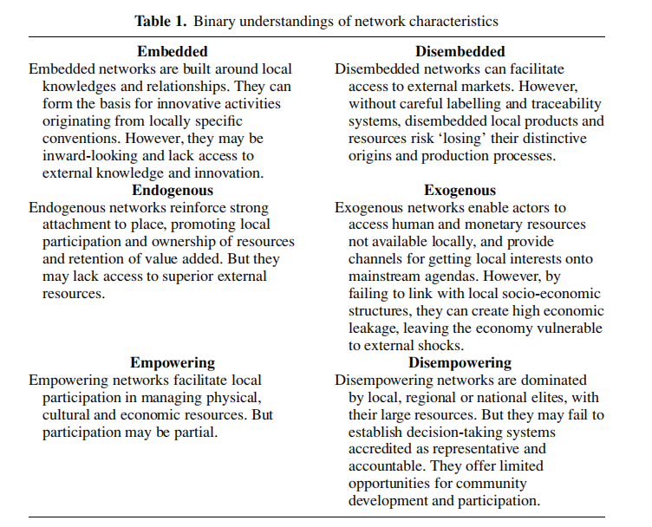

By investigating on actors and networks in rural tourism, a general situation of local tourism development could be summarized in an integrated perspective. a concept map is developed to gather factors together.(Table 2)

Table 2. Concept map of IRT on Chinese ethnic rural tourism
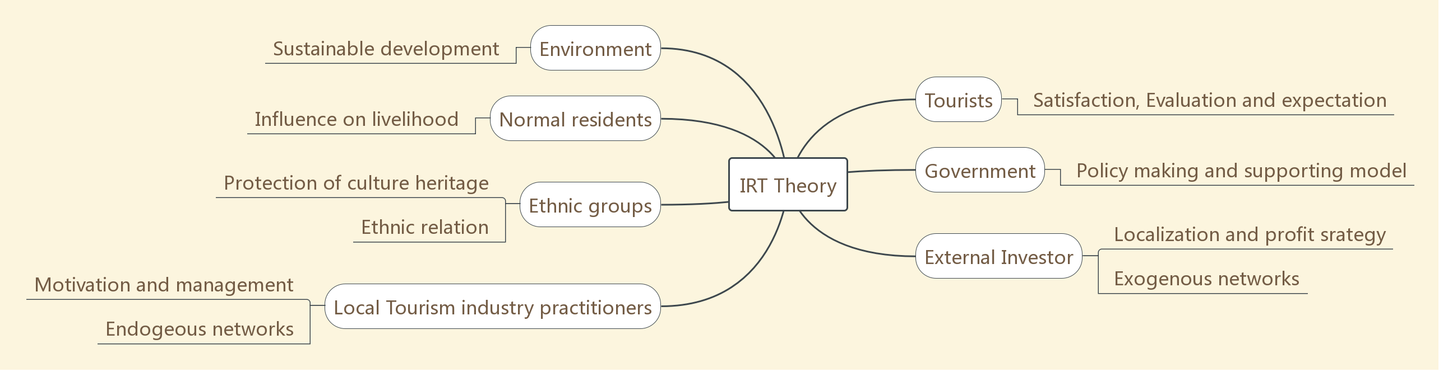

On Chinese ethnic rural tourism research, advantages of IRT theory could be obvious, which might show in three aspects: characteristics of Chinese ehnic rural area, integrated perspective and sustainable ideology. IRT was originally developed through study on lagging boarder-area between England and Wales.(Saxena, 2007; Saxena and Ilbery, 2008; Saxena and Ilbery, 2009) This certain object gives IRT a unique perspective to make banlance of not only cultural, economical and political barriers, but also internal and external relations, which are called networks. Similar kinds of issues could also exist in ethnic minority areas in China, because of complex geographical condition and huge economic disparity among areas. If we take Ebian Yi Ethnic Minority Autonomous County as an example, which was my research object, it is located in the Xiaoliangshan area in southwestern Sichuan. Due to its location on the border and difficult natural conditions, it has always been a deeply impoverished county with difficulty in getting rid of poverty. And there does exist policy, culture and market barriers because of isolated mountain-area location and undeveloped society state. Ethnic featured tourism resource could be one of the limited advantages of traditional villages in Ebian County. Hence, there could be tensions during development of rural tourism in Chinese ethnic area, which are summarized by Yang and Wall as State regulation versus ethnic autonomy, Cultural exoticism versus modernity, Economic development versus cultural preservation, Authenticity versus cultural commodification.(Yang and Wall, 2009, P. 561) Also, IRT emphasizes endogeous networks and relationships. Some of these personal relationships or networks are called Guanxi in China, which could to some extent shape tourism industry of Chinese villages.(Chen, 2017, P. 389) Also, Interactions between minority host and guests could a core attraction of local rural tourism.(Zhang, 2016, P. 735) Besides, There is a relevant model developed by Chinese researchers.(Table 3) This model draws a circle in which actors play their proper roles: villagers as the core, government as the guide, corporations as the drive, village committee as the tie. By interaction of multiple roles, higher level of interaction would be achieved, so that a integrated develop trend could be forged, and the traditional villages would keep active during tourism development, which is sustainable.

Table 3. 4C+4D model of excitation and interaction in rural tourism (Huang et al, 2018, P.124 )
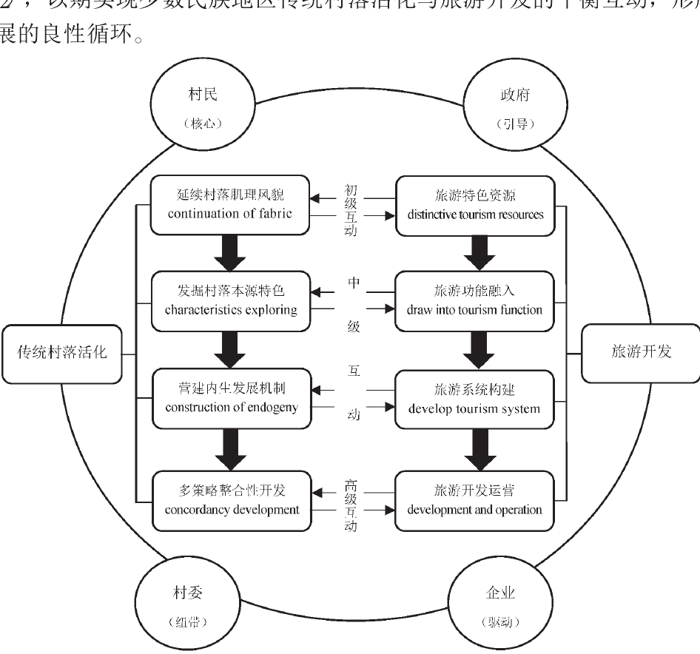

Therefore, the process of ethnic rural tourism development could be integrated, which makes IRT theory suitable for it, since IRT emphasizes both regional sustainable development and mutual adaption.(Saxena and Ilbery, 2009)
On the other hand, weaknesses and limitations also exist in IRT guided research. For exploring integrated relationship of multiple actors, a huge amount of subjective data would be collected. However, it could still be hard to testify the significance of findings, which means it could be not powerful enough in strategy development. Hence, coding and transcribing interview context shall be important and the researchers should keep the attention on established questions.(Berg and Stuwerg, 2017, P. 118)
Besides, IRT research cost could be high, because multiple kinds of resource need to be collected. Qualitative interviews and group seminars have higher demands of time, journey capacity and organization capacity. For local assistance and Secondary data, to local government, companies and village committee shall be necessary.( Gao and Wu, 2017, P. 227)
In Chinese ethnic rural area, travel and communication could be much more difficult than in UK. According to my own research experience, each time I went to Didigu village in Ebian took me 3.5 hours on dangerous mountain roads fulfilled with over-loaded trucks.
Therefore, proper time period and funding budget shall be planned before the survey start. And the researcher shall contact with related officers and managers ahead of schedule to make sure that willingly assistance would be provided.

Report 3: Identify one possible research theme and a discussion of research methods to achieve stated objectives

For this assignment, I choose to propose a study on how to improve working motivation of local employees in Chinese ethnic rural tourism, based on the case of Yi ethnic traditional villages in Ebian county. As I discussed in former parts, this topic was found during my last survey. Absenteeism and negative working attitude exist in local employees. The manager suggested that the reason could be lagging social develop level of the village, which leads to psychological resistance to regular daily work. Like a research on Jamaica rural tourism suggests, cultural elements that could explain community members’ limited engagement in their community’s tourism industry, such as their lack of civic duty, initiative, self-confidence; limited education; and their general aversion to risk. One explanation of this could be the area’s history of producing wealth for others. (Nicely and Syndor, 2015, P.726)
However, the issue might not be recognized and fixed only from the perspective of manager. According to IRT theory, local employees could be part of local residents and human resource. The relationships of local employees/ external managers, and local employees/ the hotel involve all six kinds of networks in IRT theory. Hence, a survey on multiple actor shall be employed to explore significant causes and solutions of this issue.
Qualitative research methods tend to use words and open-ended questions to form a complex report consisting of individual meanings, while quantitative methods prefer numbers and close-ended questions to testify a series of general hypothesis. Mixed methods require two sets of data collection and produce more complete results.(Creswell, 2014, P.32) Previous IRT researches mainly use qualitative methods for data collection and analysis, but mixed way could also be used. IRT theory emphasizes integration of multiple actors in a region, which needs feedback from different individuals or units. Qualitative methods have naturally advantages for this aim. However, qualitative results often reflect reality in multiple perspectives, which could be subjective and complicated. As a supplementary, quantitative methods could probably help IRT researchers to testify the results and develop general suggestions or strategies.(Panyik et al, 2011, P. 1355)
For study region selection, mapping exercise could be used, such as tourism brochures, directories, and websites. For comparatively exploration, selected study regions shall have different types of landscapes, ethnic structure or main industries(Ilbery and Saxena, 2009, P. 2254) Qualitative interviews and group seminars could be used to collect data. (Saxena and Ilbery, 2009 and 2011; Panyik et al, 2011; Gao and Wu, 2017). As Saxena suggested, tourists, institutions, businesses, resource controllers, gatekeepers and host communities could be survey objects. (Saxena et al, 2007, P. 360) Members of organizations and local government officers that are involved in SPRITE project were interviewed for England-wales boarder region study, for their major roles in industry development. Their comments on impact of policy and institution on rural tourism are collected.There were also two seminars for 50 participants with professional background, to discuss and examine the findings. (Ilbery and Saxena, 2011, P. 1144) Tour guides could be both helper and participants in the survey. (Ilbery and Saxena, 2009, P. 2255) Snowball sampling could be used to randomly select participants. For example, managers could suggest other informative practitioners after interview. (Panyik et al, 2011, P. 1355) Saxena suggested four criteria for sampling: difference in business sectors, difference in correlation degree; difference in regions; difference in old and new business. (Saxena and Ilbery, 2007, P. 241)
During the field visit, researchers shall stay in local hotel or rural home-stay, which is called Nongjiale in China. This could also be a participatory experience which provides opportunities for deep observation.( Gao and Wu, 2017, P. 227)
Questionnaires could also be employed, which might collect data that easier to be analyzed in quantitative methods. Likert scale could be used for quantification of participants attitudes.(Panyik et al, 2011, P. 1355)
Residents in some ethnic area possibly could not speak Mandarin, which might affect the validity of data collection. IRT focus on integration of different actors in rural tourism, which means more survey objectives required. When large amount of data collected, there could be a risk of representativeness during selecting, which means losing reliability. (Saxena and Ilbery, 2008, P. 251) And if the research choose one actor’s view as a base, it might reduce the relation with other actors. For example, Panyik collected information of visitors from suppliers, which could be a limitation of the research design. (Panyik et al, 2011, P. 1361)
Hence, a general research proposal could be carried out. Three traditional villages in Ebian county would be selected, with luxury hotel, natural hot spring and Yi featured food service as their main industry. According to government documents, there shall be a Yi majority village, a Han majority village and one village which consists of Yi and Han people equally in the amount. Semi-structured interviews and home-visit interviews shall be employed. The former ones aim at village committee, managers, volunteered tourists and officers in culture-tourism department of the county. The later ones involve local employees and residents. Snowball sampling could be used. For local practitioners, a pilot survey must be done, for making sure all participants could fully understand interviews and questionnaires context and have qualified professional knowledge to answer them. A set of questionnaires would also be designed, for local employees in three villages, which focuses on their attitudes to IRT factors that affect their motivations.
Quantitative questionnaire design could learn from researches on working motivation. Items related to cultural competence, job satisfaction and culture congruence shall be involved.(Huang and Rundle, 2014, P. 199) Leadership style, work engagement, HR practise, and service willingness could also be considered. (Tuan, 2018, P. 199) Tourism in Ebian has seasonal feature for its mountain-area climate, this could be a factor that affect working motivation.(Lundberg et al, 2009, P. 893) Combining with IRT theory, chosen items could probable be divided into 6 kinds of networks
SPSS could be used for quantitative data analysis, to testify reliability and correlation. Regression analysis and EFA shall be helpful for capture the key factors. (Jun and Yoong, 2018. P. 502)
Ethical challenges exist in different occasions of survey, especially for qualitative methods.(Houghton et al, 2010; Madak, 1994, pp. 12) There could also be risks of offending of ethnic tradition and residents’ privacy during research since many of traditional ethnic villages in China develop rural tourism by offering living experience with local people. As ethical researchers, care of culture and tradition of participants shall be paid.(Roth and Unger, 2018.) And principles of autonomy, beneficence and justice shall be obeyed.(Orb, 2001, P.95 ) When having interviews with local villagers, dialogue and context shall be deigned to be simple, so that change of mind of participants during the interview could be avoided.(Husband, 2020)
It shall be noticed that some of information probably belongs to trade secret. Especially when researchers would communicate with multiple actors in different business units and villages. Therefore, basic knowledge of the survey shall be informed to participants and local guides would be necessary.

Reference List
BERG, A. V. D. and STRUWIG, M, 2017. Guidelines for Researchers Using an Adapted Consensual Qualitative Research Approach in Management Research. Electronic journal of business research methods, 15(2), pp. 109-119.
CHEN, X., (2017). ‘A phenomenological explication of guanxi in rural tourism management: A case study of a village in China’. Tourism management (1982), 63, pp. 383-394.
CHENG, H., YANG, Z. and LIU, S. J. (2020) ‘Rural stay: a new type of rural tourism in China. Journal of travel & tourism marketing’, 37(6), pp. 711-726.
CRESWELL, J. W. (2014) Research Design: Qualitative, quantitative and mixed approaches. 4th edn. California: Sage publications ltd.
DAI, L.L., WAN, L., XU, B. X. and WU, B.H. (2017). ‘How to improve rural tourism development in Chinese suburban villages? Empirical findings from a quantitative analysis of eight rural tourism destinations in Beijing. Area’ (London 1969), 49(2), pp. 156-165.
DHAR, R.L., (2015). ‘Service quality and the training of employees: The mediating role of organizational commitment. Tourism management’ (1982), 46, pp. 419-430.
FOLARIN O,ADENIYI O., (2015). ‘Does Tourism Reduce Poverty in Sub-Saharan African Countries ?’.Journal of Travel Research, 59(1), pp. 140–155.
GAO, J. and WU, B., (2017). ‘Revitalizing traditional villages through rural tourism: A case study of Yuanjia Village, Shaanxi Province, China’. Tourism management (1982), 63, pp. 223-233.
GILLI M and FERRARI S.(2018) ‘Tourism in multi-ethnic districts: The case of Porta Palazzo market in Torino’. Leisure Studies, 37(2), pp. 146-157.
GUZMAN-PARRA, V.F., QUINTANA-GARCÍA, C., BENAVIDES-VELASCO, C.A. and VILA-OBLITAS, J.R., (2015). ‘Trends and seasonal variation of tourist demand in Spain: The role of rural tourism’. Tourism management perspectives, 16, pp. 123-128.
HUANG, Y. and RUNDLE-THIELE, S., (2014). ‘The moderating effect of cultural congruence on the internal marketing practice and employee satisfaction relationship: An empirical examination of Australian and Taiwanese born tourism employees.’ Tourism management (1982), 42, pp. 196-206.
HUSBAND, G., (2020). ‘Ethical Data Collection and Recognizing the Impact of Semi-Structured Interviews on Research Respondents’. Education sciences, 10(8), pp. 206-218.
HOANG, T.T.H., VAN ROMPAEY, A., MEYFROIDT, P., GOVERS, G., VU, K.C., NGUYEN, A.T., HENS, L. and VANACKER, V., (2020). ‘Impact of tourism development on the local livelihoods and land cover change in the Northern Vietnamese highlands. Environment’, development and sustainability, 22(2), pp. 1371-1395.
HOUGHTON, C. E., SHAW, D. and MURPHY, K. (2010), ‘Ethical challenges in qualitative research: examples from practice’. Nurse researcher, 18(1), pp. 15-25
ILBERY, B. and SAXENA, G., (2011). ‘Integrated Rural Tourism in the English-Welsh Cross-border Region: An Analysis of Strategic’, Administrative and Personal Challenges. Regional studies, 45(8), pp. 1139-1155.
ILBERY, B. and SAXENA, G., (2009). Evaluating ‘Best Practice’ in Integrated Rural Tourism: Case Examples from the England-Wales Border Region. Environment and planning. A, 41(9), pp. 2248-2266.
IONELA, G., CONSTANTIN, B.M. and DOGARU, L., (2015). Advantages and Limits for Tourism Development in Rural Area (Case Study Ampoi and Mureş Valleys). Elsevier BV.
ISLAM, F. and CARLSEN, J., 2016. Indigenous communities, tourism development and extreme poverty alleviation in rural Bangladesh. Tourism economics : the business and finance of tourism and recreation, 22(3), pp. 645-654.
JUNG, H.S. and YOON, H.H., 2018. Improving frontline service employees' innovative behavior using conflict management in the hospitality industry: The mediating role of engagement. Tourism management (1982), 69, pp. 498-507.
KARATEPE, O.M. and BADDAR, L., 2006. An empirical study of the selected consequences of frontline employees’ work–family conflict and family–work conflict. Tourism management (1982), 27(5), pp. 1017-1028.
KHANYA, P.U. and AFRICA, S., 2004. Pro-poor Tourism: Harnessing the World’s Largest Industry for the World’s Poor; Turning the Rhetoric into Action for Sustainable Development and Poverty Reduction. Survival for a Small Planet. Routledge, pp. 333-349.
KLEHE, U. and ANDERSON, N., 2007. Working Hard and Working Smart. Journal of applied psychology, 92(4), pp. 978-992.
LAN X and DEBORAH K.(2019) Rural Tourism and Livelihood Change: An Emic Perspective. Journal of Hospitality & Tourism Research. 43(3), pp. 416–437.
WEI, L. and KHAN, N.U., 2018. Analysis of Sustainable Tourism Development at Huangdu Dong Ethnic Cultural Village in China. Journal of Marketing Development and Competitiveness, 12(3), pp. 56-68.
Li Y. J, YU, H., CHEN T, et al. (2016) Livelihood changes and evolution of upland ethnic communities driven by tourism: a case study in Guizhou Province, southwest China. Journal of Mountain Science 13(7). DOI: 10.1007s11629-015-361-6
LI, P., RYAN, C. and CAVE, J., 2016. Chinese rural tourism development: Transition in the case of Qiyunshan, Anhui. – 2008–2015. Tourism management (1982), 55, pp. 240-260.
LI, X., XIE, C., MORRISON, A.M. and NGUYEN, T.H.H., (2021). ‘Experiences, Motivations, Perceptions, and Attitudes Regarding Ethnic Minority Village Tourism’. Sustainability (Basel, Switzerland), 13(4), pp. 2364.
LOR, J.J., KWA, S. and DONALDSON, J.A., 2019. Making ethnic tourism good for the poor. Annals of tourism research, 76, pp. 140-152.
LUNDBERG, C., GUDMUNDSON, A. and ANDERSSON, T.D., 2009. Herzberg's Two-Factor Theory of work motivation tested empirically on seasonal workers in hospitality and tourism. Tourism management (1982), 30(6), pp. 890-899.
MADAK, P.R., 1994. Ethical Considerations when using Qualitative Methods in Evaluation. Canadian journal of program evaluation, 9(2), pp. 1-13.
MARUYAMA, N and WOOSNAM, M., 2015. Residents' ethnic attitudes and support for ethnic neighborhood tourism: The case of a Brazilian town in Japan. Tourism Management, 50, pp. 225-237.
MILLÁN-VAZQUEZ DE LA TORRE, MARIA GENOVEVA, ARJONA-FUENTES, J.M. and AMADOR-HIDALGO, L., 2017. Olive oil tourism: Promoting rural development in Andalusia (Spain). Tourism management perspectives, 21, pp. 100-108.
NOGUEIRA, S. and PINHO, J.C., 2015. Stakeholder Network Integrated Analysis: The Specific Case of Rural Tourism in the Portuguese Peneda‐Gerês National Park. The international journal of tourism research, 17(4), pp. 325-336.
ORB, A., EISENHAUER, L. and WYNADEN, D., 2001. Ethics in Qualitative Research. Journal of nursing scholarship, 33(1), pp. 93-96.
NICELY, A. and SYNDOR, S., 2015. Journal of Travel Research, 54(6), pp. 717–729
PANYIK, E., COSTA, C. and RÁTZ, T., 2011. Implementing integrated rural tourism: An event-based approach. Tourism management (1982), 32(6), pp. 1352-1363.
PREVOLŠEK, B., MAKSIMOVIĆ, A., PUŠKA, A., PAŽEK, K., ŽIBERT, M. and ROZMAN, Č, (2020). ‘Sustainable Development of Ethno-Villages in Bosnia and Herzegovina—A Multi Criteria Assessment’. Sustainability (Basel, Switzerland), 12(4), pp. 1399.
QIAN, C., SASAKI, N., JOURDAIN, D., KIM, S.M. and SHIVAKOTI, P.G., 2017. Local livelihood under different governances of tourism development in China – A case study of Huangshan mountain area. Tourism management (1982), 61, pp. 221-233.
ROSTOM B.(2019) Rural Tourism and Sustainable Development. Management Studies, 2019,7(5), pp.443-446.
ROTH, W. M. and UNGER, V. H., 2018. Current Perspectives on Research Ethics in Qualitative Research. Forum, qualitative social research, 19(3), DOI: http://dx.doi.org/10.17169/fqs-19.3.3155.
SAIKEN, A., YANG, Z. P.., MAZBAYAV, O., DUISSEMAYEV, A., IZENBAYEV, B., NASSANBEKOVA, S. (2017). ‘Ethnic cultural tourism resources evaluation and development: Kazakh cultural tourism resources analysis’. Journal of Environmental Management and Tourism, Volume VIII, Spring, 2(18): 467 - 475. DOI:10.14505/jemt.v8.2(18).20
SAXENA, G., CLARK, G., OLIVER, T. and ILBERY, B., 2007. Conceptualizing Integrated Rural Tourism. Tourism geographies, 9(4), pp. 347-370.
SAXENA, G. and ILBERY, B., 2008. Integrated rural tourism a border case study. Annals of tourism research, 35(1), pp. 233-254.
STAMOLAMPROS, P., KORFIATIS, N., CHALVATZIS, K. and BUHALIS, D., 2019. Job satisfaction and employee turnover determinants in high contact services: Insights from Employees’Online reviews. Tourism management (1982), 75, pp. 130-147.
SU, M.M., WALL, G., WANG, Y. and JIN, M., 2019. Livelihood sustainability in a rural tourism destination - Hetu Town, Anhui Province, China. Tourism management (1982), 71, pp. 272-281.
TRISETIA WIJIJAYANTI, YULI AGUSTINA, AGUNG WINARNO, LULU NURUL ISTANTI and BUYUNG ADI DHARMA, 2020. Rural Tourism: A Local Economic Development. Australasian accounting, business &amp; finance journal, 14(1), pp. 9-13.
TUAN, L.T., 2018. Driving employees to serve customers beyond their roles in the Vietnamese hospitality industry: The roles of paternalistic leadership and discretionary HR practices. Tourism management (1982), 69, pp. 132-144.
WANG, L. and YOTSUMOTO, Y., 2019. Conflict in tourism development in rural China. Tourism management (1982), 70, pp. 188-200.
YANG, J., RYAN, C. and ZHANG, L., 2013. Ethnic minority tourism in China – Han perspectives of Tuva figures in a landscape. Tourism management (1982), 36, pp. 45-56.
YANG, L. and WALL, G., 2009. Ethnic tourism: A framework and an application. Tourism management (1982), 30(4), pp. 559-570.
ZHANG, J., XU, H. and XING, W., 2017. The host-guest interactions in ethnic tourism, Lijiang, China. Current issues in tourism, 20(7), pp. 724-739.
ZHENG, D., RITCHIE, B.W., BENCKENDORFF, P.J. and BAO, J., 2019. Emotional responses toward Tourism Performing Arts Development: A comparison of urban and rural residents in China. Tourism management (1982), 70, pp. 238-249.
ZOPIATIS, A., CONSTANTI, P. and THEOCHAROUS, A.L., 2014. Job involvement, commitment, satisfaction and turnover: Evidence from hotel employees in Cyprus. Tourism management (1982), 41, pp. 129-140.
冯伟林,冉龙权.(FENG, W. L. and RAN, L. Q.) 2017.基于社区参与的西南民族地区旅游扶贫机制构建——以重庆武陵山片区为例(Poverty-alleviation tourism in Southwestern ethnic area based on community engagement- a case study on Wulin Mountain area in Chongqing).江苏农业科学(Jiangsu agricultural science),45(16), pp. 304-307.
黄杰,李晓东,谢霞(HUANG, J. Li, X. D. and XIE, X.). 2018.少数民族传统村落活化与旅游开发的互动性研究(Ethnic traditional village integrated tourism development research).广西民族研究(Guangxi ethnic research),2018(05), pp.119-128.
李羽佳,赵长轶(LI, Y. J. and ZHAO. C. Y.). 2018. 精准扶贫背景下四川偏远民族地区乡村旅游发展对策研究(A study on rural tourism development lagging ethnic area of Sichuan in targeted poverty alleviation perspective).决策咨询(Decision Consultation),2018(02). pp. 39-41+46.
刘静佳(L. J, J.). 2018. 论民族地区乡村参与旅游发展的路径选择(Path-choosing of rural tourism development om ethnic area).云南民族大学学报(哲学社会科学版)(Journal of Yunnan Ethnic University, Social Science Version), 35(04), pp. 75-80.
刘文颖,蔡永云(LIU, W. Y, and CAI, Y. Y.).2018. 云南民族地区乡村旅游精准扶贫模式研究(A study on targeted poverty alleviation tourism model in ethnic area in Yunnan).大理大学学报(Journal of Dali University), 3(09). pp. 27-32.
杨军辉(YANG, J). 2016. 资源—环境—区位视域下民族村寨旅游开发研究(A study on ethnic village tourism development in Resource-Environment-Region perspectives).西北大学 (Northwest University, Doctorate Thesis).
杨军辉(YANG, J.). 2015. 国内民族村寨旅游研究特征与进展(Development and features of Chinese ethnic village tourism). 旅游论坛(Tourism Forum), 8(4), pp. 51-58

