Marketing plan written for

Premier Inn

Student Name

Trasc Ovidiu-Mario

Student ID number
2206244

Marketing Essentials BMIH4005

Lecturer

Luciana Suardi

Word count: 1197 words
Introduction:
The purpose of the marketing plan is to attract new customers to Premier Inn hotels. The geographical area of the chosen hotel is South Wales, more precisely Premier Inn Cardiff City Centre, located on Helmont House, 10 Churchill Way, Cardiff. (Premier Inn, 2022)
The category of clients to whom this campaign is addressed is represented by families with children, especially families who want to travel, visit or maybe just solve certain personal or work tasks. The strategy involves creating a playground for children and a baby parking system for children aged from 6 months to 12 years.
Premier Inn hotel chain has over 800 hotel all over UK, offering to their guests comfy beds, food to start and end every day, a range of flexible rates that suit everyone and friendly team members. (Whitbread, 2022)
The method used in the development of the marketing plan is SOSTAC. SOSTAC sums up the key elements of a marketing communication plan that leads to an easy fixation in the manager's memory and includes the following: strategy analysis, objectives, strategy, tactics, actions and control. (Smith & Ze, 2020, p.264)
Situation Analysis
5 'C's
-Company: SWOT analysis (Micro analysis)

STRENGHTS | WEAKNESSES
- Occupancy rate  - Small prices, cheap  - Good number of hotels  - Locations ( near airports and tourist attractions)  - Brand image ( kid friendly, bike friendly, free wi-fi) (Premier Inn, 2022)  - Easy to book online  - Various deals on online booking | - Limited global presence  - Refund issues  - Big issues with hygiene  - Intense competition
OPPORTUNITIES | THREATS
- New markets  - New design for rooms and reception area  - Investing in digital marketing  - Building brand value | - Competitors  - Legal threats  - Lockdowns  - BREXIT
-Customers: Customer profile is represented by travellers and backpackers.
The main objective is to give value as the requirements and expectations of customers in all fields are constantly changing. (Jobber and Ellis-Chadwick, 2020, p.14)
Premier Inn has very high guest scores, and market-leading brand and value for money ratings. Premier Inn has a long track-record of winning industry awards in recognition of their customer focus, and they have also taken the top spot in some new awards for the first time in 2021. (Whitbread, 2022)
-Competitors: The main competitors for Premier Inn are Ibis, Travel Lodge, Holiday Inn and Best Western. (Whitbread, 2022)
-Collaborators:
The partners of Premier Inn are: Hub by Premier Inn, Zip by Premier Inn, Brewers Fayre, Beefeater, Bar+block, Cookhouse Pub, Thyme Bar&Grill, Whitbread Inns. (Whitbread, 2022)
-Climate: PESTLE (Macro analysis)
Big changes in any Pestel component can lead to a major impact with a good or bad result on the hospitality industry, as a result, hotels have set a rules of limits on Pestel's influences. (Bowie et al. 2017, p.13)
POLITICAL | ECONOMICAL | SOCIAL | TEHNOLOGICAL
- Brexit  - Elections  - Wars  - Tax Rates  - Covid 19  - Levels of corruption | - Unemployment  - Recession  - Economic instability  - Conversion rate | - Population growth  - Social influencer  - Population health  - Education | - Level of innovation  - CCTV  - Security alarms  - Social media

From a political point of view, an important factor was represented by the pandemic caused by Covid 19. “ The World Travel & Tourism Council, a trade body, this summer increased its forecast of the number of travel jobs that will be lost because of the pandemic worldwide to 197.5m, or around 60% of the total before coronavirus hit.” (Economist, 2020)

Objectives:
-SMART target:
“ Smart objectives provide managers with clear targets to achieve, and act as a control mechanism in determining whether they have been effective.” ( Bowie et al. 2017, p.376)

Smart meanings are the following: S from Specific, M from Measurable, A from Actionable, R from Relevant, T from Time-Bound. For the proposed marketing plan, the smart target it is:
S: To increase room occupancy from 68.3% to 71.3% within 12 months.
M: The hotel wants to accomplish this target by the end of the year.
A: The hotel determinates where its advertising will be most effective.
R: The play area it is scheduled to be functional starting with 01 May 2023 in as much locations as possible.
T: Until September, it is desired to make a report with the number of new customers in order to be able to implement new attractions if necessary, which will lead to the intended purpose.
Strategy:
Consist in making a play area for customers’s kids and a baby parking system. The playground will be for children aged between 6 months and 12 years. It will be equipped with equipment that complies with safety rules, and the hotel staff will ensure the safety of the little ones. They will also be supported by small theatrical performances, games and other activities. The playare will be open daily from 8am to 10pm.
Establishing the indoor/outdoor playground space.
Establishing a budget.
Purchase of children's play assemblies.
Employment of specialized personnel.
Installation of video surveillance system with access for parents

Tactics
Marketing mix:
“We will look at the benefits that brands can enjoy should they get there performance marketing plans right and develop a successful programme.” (Ryan, 2017, p.326)
-Product - Besides the comfort of a restful sleep in the hotel rooms at the Premier Inn, the new playground facility offers parents a time to relax outside the hotel without worrying about children.
-Place (Distribution) – Customers can book rooms directly via the hotel’s website. Likewise, they can do so via third parties such as Booking.com, Lastminute.com, and some others. Premier Inn prefers online booking; however, customers can use the phone to make their reservations. Services for the baby parking system can be booked online in the same time as the booking of the hotel room.
-Price – Premier Inn is using different pricing strategies like Flex, Semi-Flex, Advance, Standard, and Non-Flex rates. Customers has different options to choose from with those. Flex is the most flexible option which allow customers to cancel or amend their stay up to 1pm on the same day they are due to start their stay. (Premier Inn, 2022) To attract new customers the hotel offers the following discount categories: for reservations between 1 and 3 nights a discount of 5%, for reservations between 4 and 6 nights a discount of 7%, and over 7 nights a discount of 10%.
-Promotion – Over 338 000 people follow the Premier Inn Facebook page. (Premier Inn, 2022) However, its Instagram page has just over 28 thousand followers. (Premier Inn, 2022) Having regard to these, Premier Inn needs to increase presence on more social media platforms. Attractive advertising posters will be designed in flashy colours placed both in public transport and in shopping centres, as well as bright posters placed on buildings.
Action:
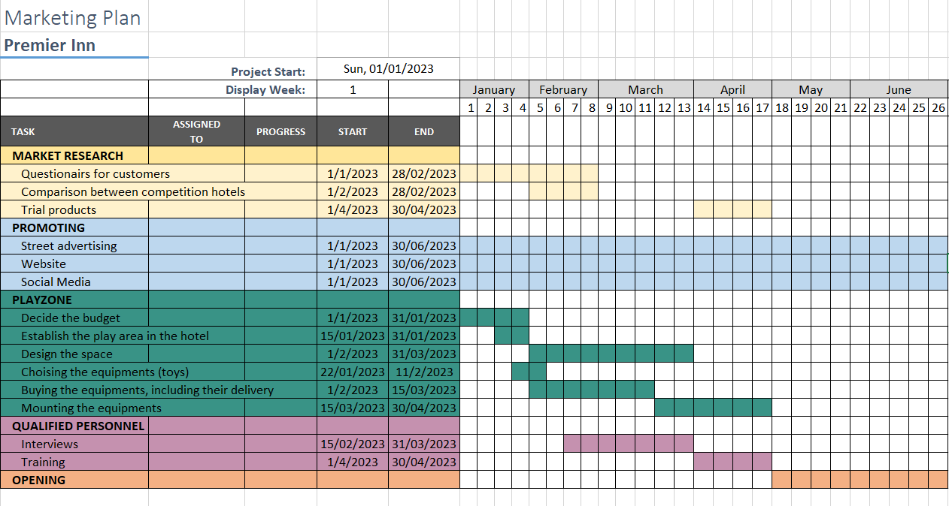
-Gannt chart of the marketing plan:
In the attached Gannt chart is highlighted the plan from the concept to the opening, taking into account the opinions of the clients and their feedback. The promotion was made on the most accessed ways by the targeted customers.
Conclusion:
After the first year of the inauguration, it is desired to implement this strategy in other locations of the hotel chain, as the playground and the baby parking system are bringing value to the customer and it is an improvement and the benefits brought are more important than the investment necessary for the realisation of the play area and baby parking in as many locations as possible.

References
Bowie, D. et al (2017) Hospitality Marketing, 3th edition, Oxon: Routledge.
Jobber,D. and Ellis-Chadwick,F.(2020) Principles and practice of marketing, 9th edition, London: McGraw-Hill education
Premier Inn (2022) About us. Available at: About us | Premier Inn (Accessed: 21 November 2022)
Premier Inn (2022) Cardiff Bay Hotel. Available at: Cardiff Bay Hotel | Premier Inn (Accessed: 28 November 2022)
Premier Inn (2022) [Instagram] Available at: Premier Inn (@premierinn) • Instagram photos and videos ( Accessed: 20 November 2022)
Premier Inn (2022) Premier Inn. Available at: Premier Inn | Facebook ( Accessed: 20 November 2022)
Premier Inn (2022) Our rates. Available at: Our rates | Premier Inn (Accessed: 20 November 2022)
Ryan,D. (2017) Understanding Digital Marketing: Marketing Strategies for Engaging The Digital Generation, 4th edition, London: Kogan Page
Smith, P. and Zook, Z. (2020) Marketing Communications Integrating online and offline, customer engagement and digital technologies, 7th edition, London: Kogan Page

Walls, T. (2020) ‘Staycationers are saving hotels and Airbnb from covid-19’, Economist, 31st August. Available at: Staycationers are saving hotels and Airbnb from covid-19 | The Economist ( Accessed: 27 November 2022)
Whitbread PLC (2022) Annual Report and Accounts 2021/22.Internal Whitbread PLC Report, Published
Whitbread (2022) Our brands. Available at: Our brands - Whitbread PLC ( Accessed: 22 November 2022)



