ASSESSMENT 2 MARKET
RESEARCH & WEBSITE
Digital Skills & Research Methods

Name: Andreea Lungu
Student number: 1918110

Website login details

Email address: 1918110.student@gmail.com
Password: university2021

Introduction

The report is about a new and unique line of skin care products to the market. In order to understand customer needs and expectations, a questionnaire was made with purpose of getting accurate insights from people who actively buy beauty products. This questionnaire activity demonstrates that company will learn more about target audience. For the exact purpose of obtaining more feedbacks from possible clients, a Website has been created to ensure the people have a bigger picture of what business Health in a box, offers.
The primary purpose of the questionnaire will be to analyse the primary questionnaire data to identify trends and pertinent information garnered from that questionnaire. Having a questionnaire represents a big market advantage. Which skin care products do people use at least once a week? What factors go into choosing daily care products? How willing are people to try different natural products? Getting feedback from target customers will help business to deliver a successful skin care product.
The knowledge and understanding obtained from this questionnaire is used to create a targeted website. Gathering information’s about age and location makes company to understand on which category of age should they focus on and where the campaign for promotion should consider to have place.

Questionnaire design & analysis

“the questionnaire designers are required to be familiar with the vocabulary of respondents. Understanding of the vocabulary of target population makes questions simple and easily answerable. Furthermore, a questionnaire might contain items related to more than one general topic. The topics of questionnaire are if specifically categorised into sections that makes questionnaire more practical and easier to administration.” (Bidhan Acharya, 2010)
A case study made by GCL attested that “The beauty of primary research is that you can carry it out directly with your customers, prospects or even your competitors. It may take the form of telephone interviews, focus groups or email surveys and it allows you to ask those key questions about what makes them tick, what motivates them to buy and basically anything you want to ask that will have a bearing on how you may want to act in the future.” (GCL, 2020)
The top benefits of using primary research are: the accuracy of data by gathering the information easily to access and found, deeper Insight by recording the thoughts, words and feelings from primary data, business can understand what the prospects, clients or competitors wish to obtain, is gives more control by the fact that primary research gives more authority in collecting the data and gives different possibilities in how to use it to get the response wanted, results gather can be relied on as primary research is a tested and proven method of an efficient research, ownership because the research is unique and the meaning of it can give to company Health in a box an step ahead over the competitors.
Primary market research is a sure way of getting direct feedback from clearly defined target groups and allows businesses to ask very precise questions to a very specific group of people. It can also be used to develop new marketing and customer profiling as possible strategies.

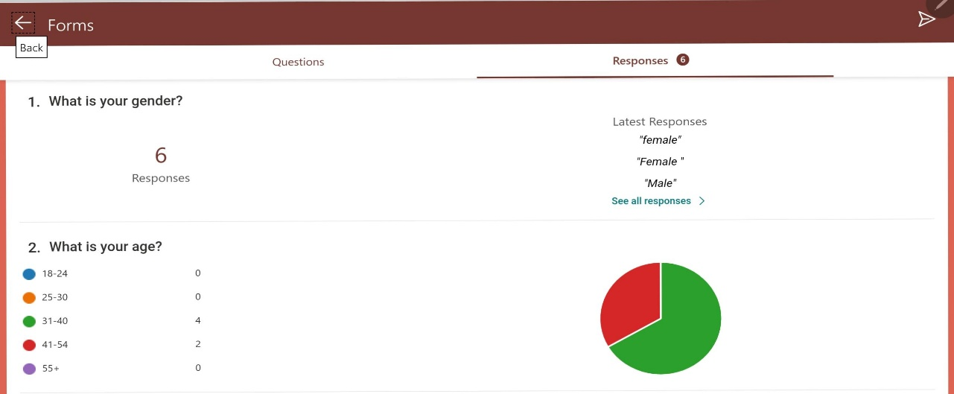

Analysing the findings from the below questions, we can clearly see that 6 from 5 responses are from women and fall between the ages of 31-54. Using this info, we can suggest that they got already some experience in using care products for their body and also, they have an idea about the brands on the market. What business Health in a box need to do for getting their attention is to come with unique products, something that they haven’t seen yet and that’s why the key element is to use natural products that can’t affect them and can be used for baby’s because at this age they should have families. Also, judging by the age, is possible that they have some bones problems so for that reason company must to extend the vision to some therapeutic treatments.

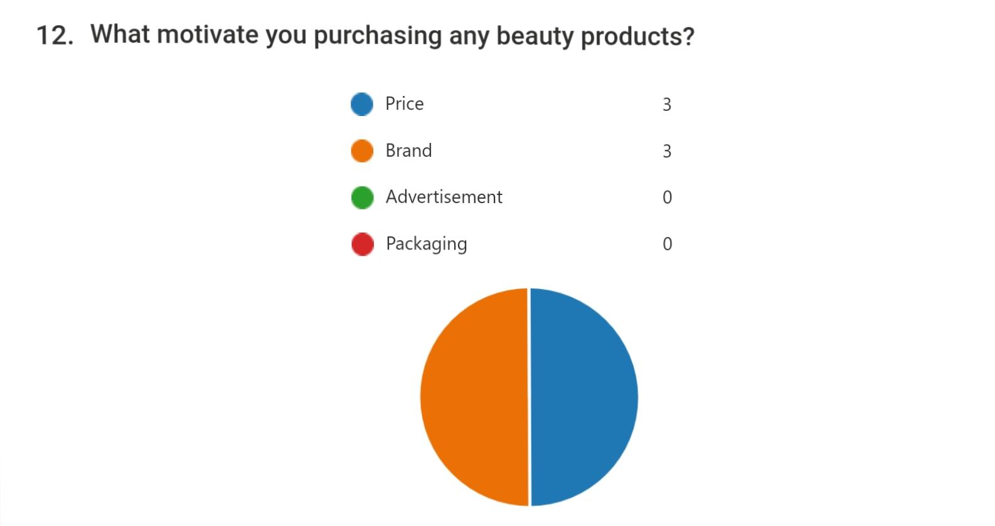

Along the line of information there can be seen two variations when purchasing beauty products. These are price and brand. According to the data obtained from this questionnaire, the products will be selling with an accessible price and in this way the customers will afford to purchase and use, test the product. In this way, company will create a relationship based on honesty and loyalty to all the clients and the brand will be recommended to friends and relatives. The reputation will increase and the brand will be recognised. This action is requiring time due to prestigious brands on the market.

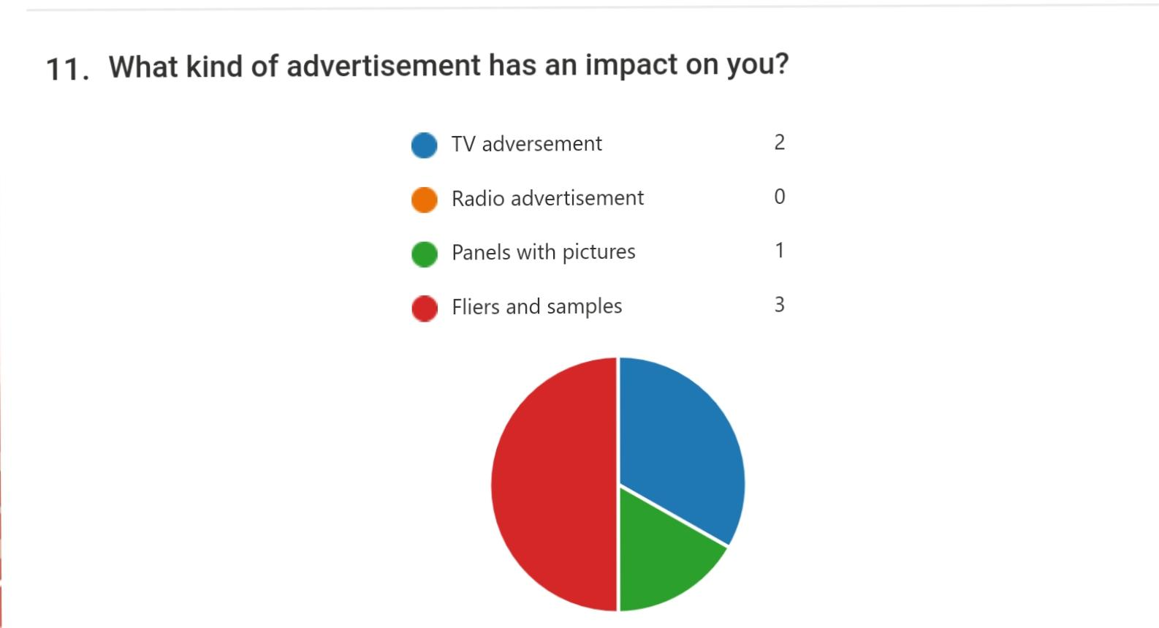

According to this survey the advertisement that should be considered for promotion are: fliers and samples, TV advertisements and panels with pictures. This information gives company the opportunity to become a successful brand and to get the customers appreciation. This actively demonstrate that business should create a campaign door to door and deliver fliers and samples with the purpose to obtain credibility. Also, there will be TV advertisements with doctors recommending and test the product and in all populated areas from Cardiff will be implemented posters with the motto of the organisation “ Here you will find a healthy land from the seeds to the product in your hand “ and the mane of it, Health in a box.
To sum up everything that has been registered the objectives of this questionnaire were making some important decisions in opening the new line of natural products. Although existing literature suggests that factors such as age have an impact on buying behaviour, the results showed that it does not have that big of an impact on the purchasing behaviour of Cardiff women related to daily care skin care products. However, the research findings of this study can definitely benefit the
company in their business actions.

Website design

“Customers expect websites to be designed differently, depending on the task and purpose associated with the website.” (Monideepa Tarafdar, Jie Zhang 2016)
The information obtained within the questionnaire has helped shape and create the
Website. Obtaining all the data from the possible clients, website was designed to give them more answers and hear what they want: solutions for all skin problems with 100% effects from first week. Knowing these needs and expectations was helping to identify the areas that are and aren’t driving results. The purpose of creating the questionnaire was to understand how to set new priorities and goals for future online activity.
For the description of website will be used a couple Key words with the purpose of obtaining more feedbacks and more attention from people searching for natural products: “natural healing” which alludes to the fact that aging or maturing is something to be proud of, instead of words like anti-aging because these starts to feel outdated as we move towards a culture of celebrating who we are as we are. anything that.
Key words like “Use, Reuse, recycling” will be used due to the fact that more conscious consumers are looking for clean ingredients, authenticity and sustainable packaging. Health in a box think that zero-waste and plastic-free initiatives will be of huge interest in the near future as well that is why products will be delivered in glass bottle which can be reused, “aging well” indicates that more women embrace aging, and it is not about going against it, but about feeling good and healthy as we age by preserving the balance and use natural products, "skin microbiome” sustain the importance of the microbiome. The skin microbiome is a whole community of organisms that live on the skin that includes bacteria, viruses and fungi. Essentially, this little ecosystem controls a lot about skin, from how well products are absorbed to the overall health of the skin, informative words that show consumers that they are dealing with products that will bring out all of their skin’s potential. Another key words will be "quality instead of quantity," "natural beauty," and "buying what your body really needs", this also embrace organic materials and the idea of a healthy community.
Using the colours is one of the most powerful tools in a website design. It can be used to attract people attention, express some feelings, create desire to purchase the product, and even earn a customer’s loyalty. Good colour choices take careful planning in order to achieve the customers attention. “A web designer must use color in an efficient way that will present, on the internet, information, services, organizations and products. Colors have great impact on the human psyche. By using color along with various techniques web clients can be influenced to buy (products or information) and can even be inspired.” (Ionel Alexandru; Petrescu Ligia, 2010)
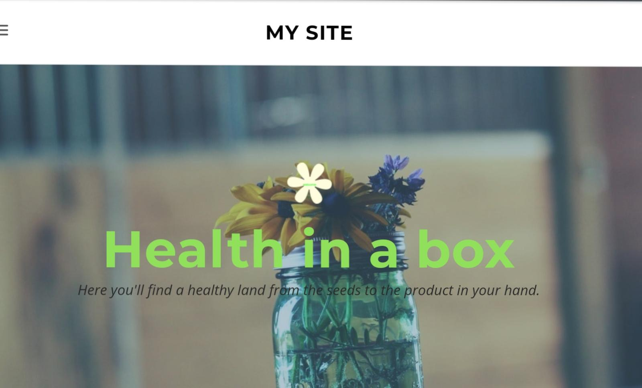
The chosen colours for the website Health in a box represent the emotions that the brand intends to express. There are used also the colour trends that helping to create a website that is new and professional.
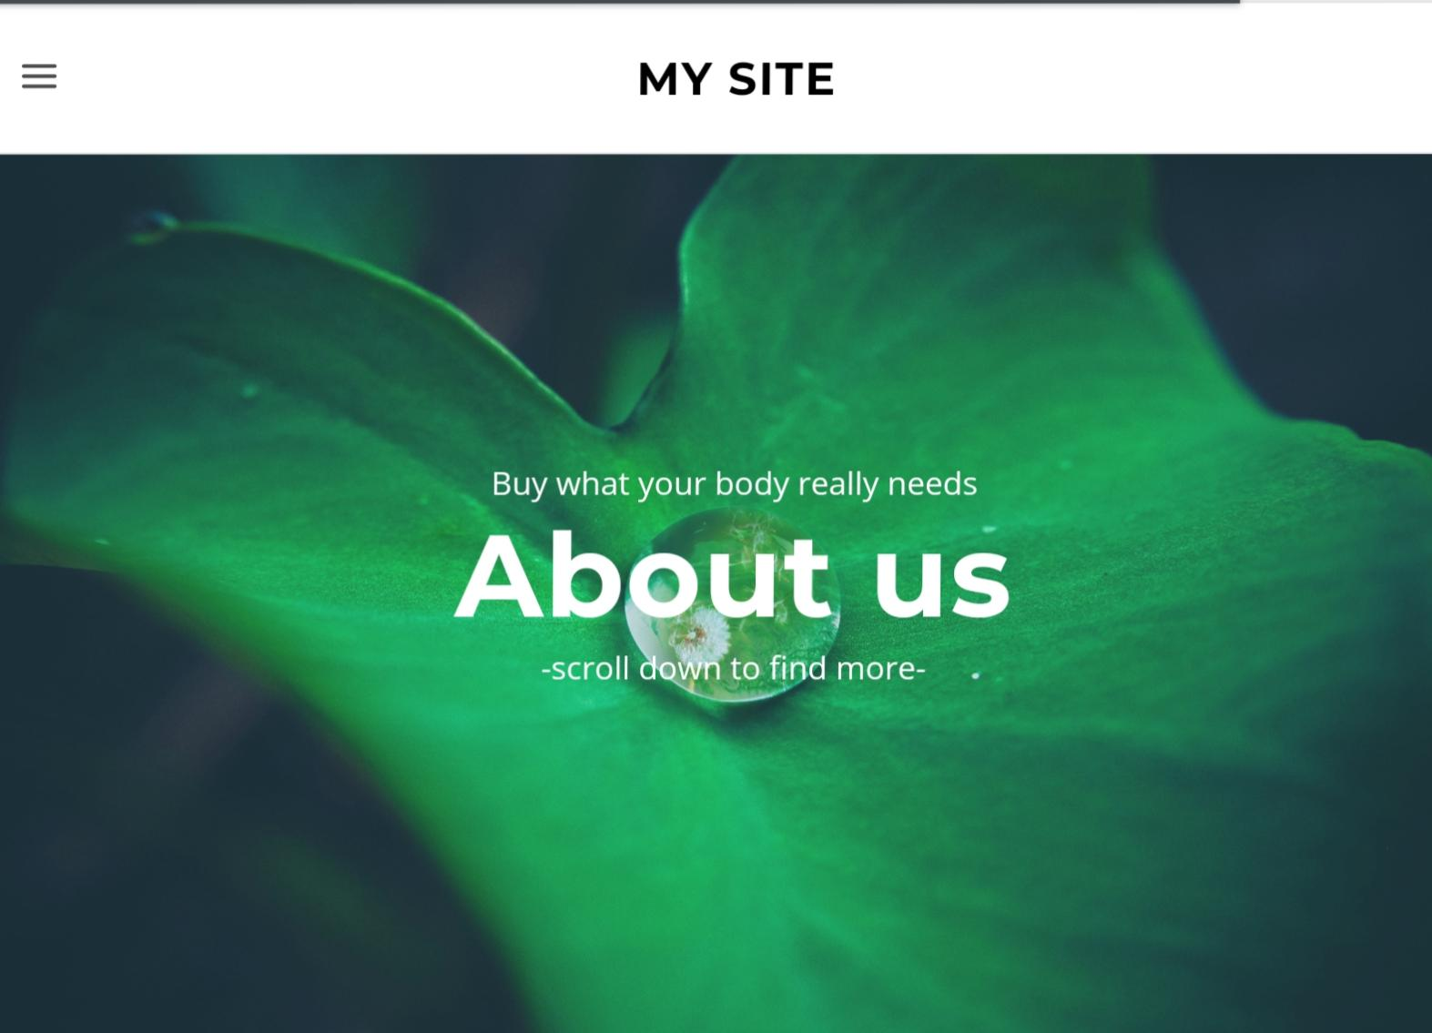

The basic colour chosen for the website is green because this symbolises vitality, energy, life and happiness. Clients should understand that life is important and to use the resources from nature this will be important for their body.

Conclusion

To sum up everything that has been registered this report was created in order to proof the importance of questionnaire and in which way can help increasing the business and create a website. Gathering relevant information on questionnaire company will have the most reliable source for creating the website. With the information obtained will be easy to evidence what clients want and put their needs first. Using a series of key words on the website page will provide a big picture of what company offer and why customers should try their products.
“Companies may perform a website analysis for numerous reasons. For instance, they may want to know how well their website functions or they may need to examine what competitors do with Web pages.” (Kristie Sweet, 2020)

References

Bidhan Acharya “QUESTIONNAIRE DESIGN” June 5, 2010
GCL “5 Reason why primary market research is essential” 16 November 2020
Ionel Alexandru, Petrescu Ligia “Journal of Industrial Design & Engineering Graphics” 2010, Vol. 5, p19-22

Kristie Sweet “How to Write a Website Analysis” 2020
Monideepa Tarafdar, Jie Zhang “Analysis of Critical Website Characteristics: A Cross-Category Study of Successful Websites” pp 14-24, 05 Jan 2016

