2020 Digital Entrepreneurship

Task 1 – Part A

Name: Adam Wright
Student #: 1803749
Recipient: Dr Roisin Mullins
Date: 27th July 2020
Programme: BMMB7002D Digital Entrepreneurship

https://youtu.be/aQHARDhAh_k

2020 Digital Entrepreneurship

Task 1 – Part B

Name: Adam Wright
Student #: 1803749
Recipient: Dr Roisin Mullins
Date: 27th July 2020
Programme: BMMB7002D Digital Entrepreneurship

Contents
1 Executive Summary 5
2 Introduction 6
3 Market 7
3.1 Market Structure in Sensata 7
3.2 Growth of IoT & Smart & Connected Market 8
3.3 Sensata S&C Market in IoT Context 10
4 Organisation Analysis in Context of IoT 10
4.1 PESTLE 10
4.2 SWOT 12
4.3 Selling to the Market 13
5 Conclusion 14
6 Recommendations 14
7 References 15

Table of Figures
Figure 1 - Sensata's Main Markets 6
Figure 2 - Revenue pools for device enablement platforms for IoT (Dahlqvist, et al., 2020) 8
Figure 3 - Sensata S&C vs IoT 9
Figure 4 - SWOT of Sensata 11
Figure 5 - Typical customers in the stack 12
Figure 6 - Selling to the stack 12

Executive Summary
Sensata is breaking into the emerging IoT market (Smart & Connected market). Hardware solutions that Sensata already provides are suitable to start impact the foundation of the IoT stack however Sensata can boost attractiveness of these hardware offering by effectively integrating with mid layer providers to make digital transformation of fleet management and logistics efficiencies more appealing and less cumbersome for parent companies.

Introduction
Sensata Technologies is one of the world’s leading suppliers of sensing, electrical protection, control and power management solutions with operations and business centers in 11 countries. Sensata’s products improve safety, efficiency and comfort for millions of people every day in automotive, appliance, aircraft, industrial, military, heavy vehicle, heating, air-conditioning and ventilation, data, telecommunications, recreational vehicle and marine applications. (Sensata.com, 2019)
Sensata has a rich history and specialisation in making sensors that are mission or safety critical. The company also differentiates by making sensor solutions that other business can not.
As a global supplier, Sensata has a wide array of design centers and manufacturing sites in America, Europe and Asia. This brings many benefits to help negotiate trade regulations in various regions but brings challenges associated with corporate financial structure, global collaboration and more. Due to the diversity of markets served by Sensata, this study will look at the activity and opportunity in the emerging “smart and connected” market, also known as IoT (Internet of Things) in the main stream.

Market

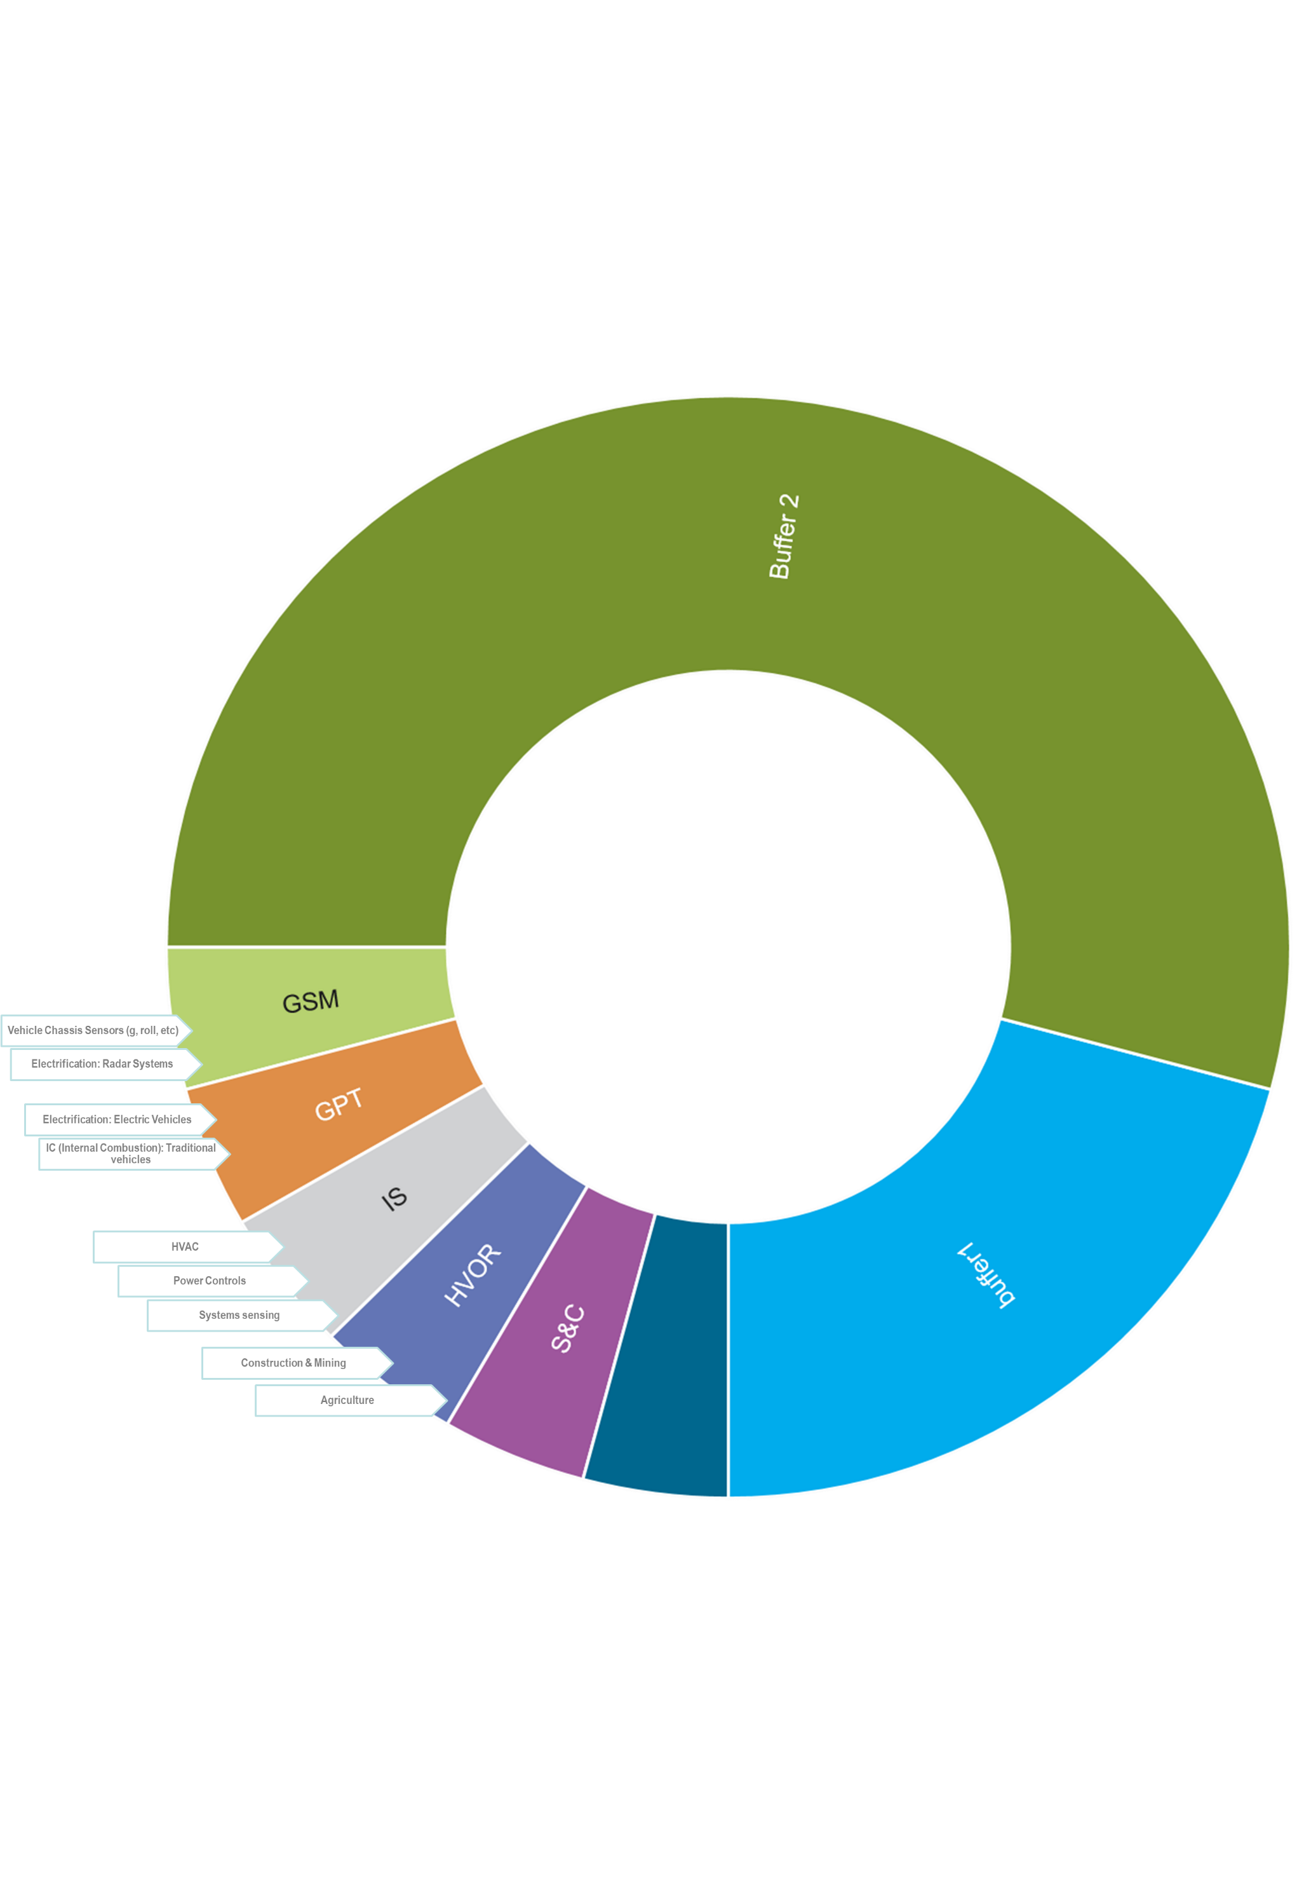


Market Structure in Sensata
Aero
Figure 1 - Sensata's Main Markets

Sensata has a presence in various markets which helps protect it somewhat to market instability. However, the portfolio is weighted heavily in the auto (passenger car vehicle) market for which the GSM (Global Safety & Mobility) and GPT (Global Power Train) segments serve. GSM & GPT make up around 50% of Sensata’s revenue. GPT is seeing significant change of mix within this segment as passenger car technologies migrate from IC (Internal Combustion) to EV (Electric vehicle). GSM is seeing a similar but slightly delayed disruption as vehicles of all kinds get “smarter” and with more autonomy.
IS (Industrial Solutions), HVOR (Heavy vehicle and Off Road), & Aero (aerospace) are all around 14% of the make up. Aero has seen a significant impact in 2020 with $314bn USD (Mazareanu, 2020) estimated loss in global airline annual revenue impacting orders for new aircraft. HVOR is subject mainly to construction but is also tied to logistics / haulage so there has been a swing in the mix.
S&C (Smart and Connected) is an emerging market segment for Sensata and as such, is not as well established as the aforementioned markets. However, due to the nature of the market, it continues to see growth despite challenging economics on 2020. This segment is shared with OEM (Original Equipment Manufacturers) in the Auto industry, HVOR fleets and other fleet services / industries.
This report focussed on the S&C market situation and opportunities as this is where most growth in anticipated.

Growth of IoT & Smart & Connected Market
Internet of Things (IoT) seems poised to cross over into mainstream business use. The number of businesses that use the IoT technologies has increased from 13 percent in 2014 to about 25 percent today. And the worldwide number of IoT-connected devices is projected to increase to 43 billion by 2023, an almost threefold increase from 2018. (Gupta, et al., 2017)
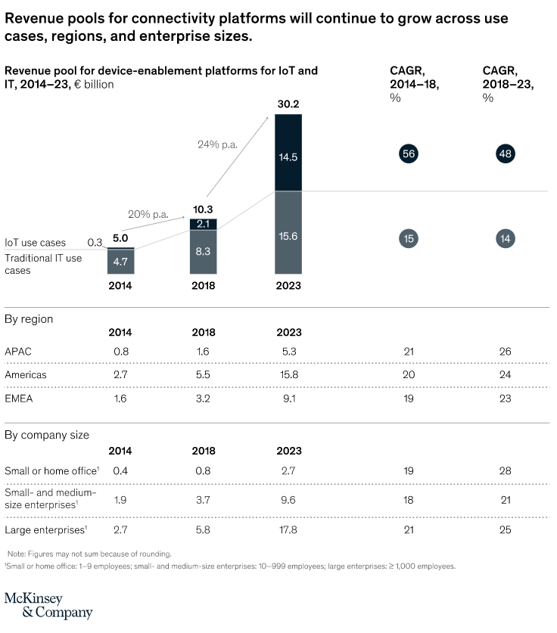
Figure 2 - Revenue pools for device enablement platforms for IoT (Dahlqvist, et al., 2020)
In Figure 2 - Revenue pools for device enablement platforms for IoT (Dahlqvist, et al., 2020) (Dahlqvist, et al., 2020) we can see the growth in IoT potential.

Sensata S&C Market in IoT Context
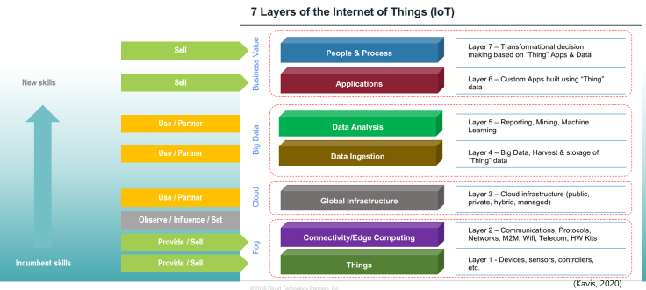
Figure 3 - Sensata S&C vs IoT
In Figure 3 - Sensata S&C vs IoT we can see how the market opportunity for Sensata aligns with the standardised IoT Stack.
Sensata is well positioned to sell into the foundation layers with hardware, sensors and devices. The Cloud & Big Data layers are not familiar to Sensata and will require the development of support services & integrations with key providers, systems and platforms. As we move to the edge of the cloud and into the application layer Sensata has some value to add here again with experience in software and system services. Finally, the ultimate layer of transformation due to insights brings an opportunity for us to consult on the data that we capture within and across solutions.

Organisation Analysis in Context of IoT

PESTLE
- Political
  - Harvesting, hosting and analysing data from around the work will require extra care, not just for regional compliance, but for political sensitivities that may arise form population data within the ownership of a differing nation.
- Economic
  - For Fleets, the leading stakeholder in IoT / S&C development there is a 24.5% CAGR (Reports, 2020) forecasted. This indicates a strong and accelerating uptake for which Sesnata needs to position to ensure market share.
- Social
  - Sensata will migrate from handling engineering data to handling personal data. This increases anxiety potentially for the end user and increase responsibility on the company.
  - Potential for personal or demographic habits and insights to be established and leveraged.
- Technological
  - Standardisation of protocols for communication is key. Sensata should continue to influence and contribute to these as well as adopt them.
  - Additional insights form larger, connected data sets could deliver breakthroughs for Sensata in other development.
- Legal
  - Handling of data and the security there-of will be crucial to protect customers and the business brand.
- Environmental
  - This approach gives Sensata and it’s customers to provide insights in support of optimisation for the environment – especially for fleet and logistics efficiencies.

SWOT
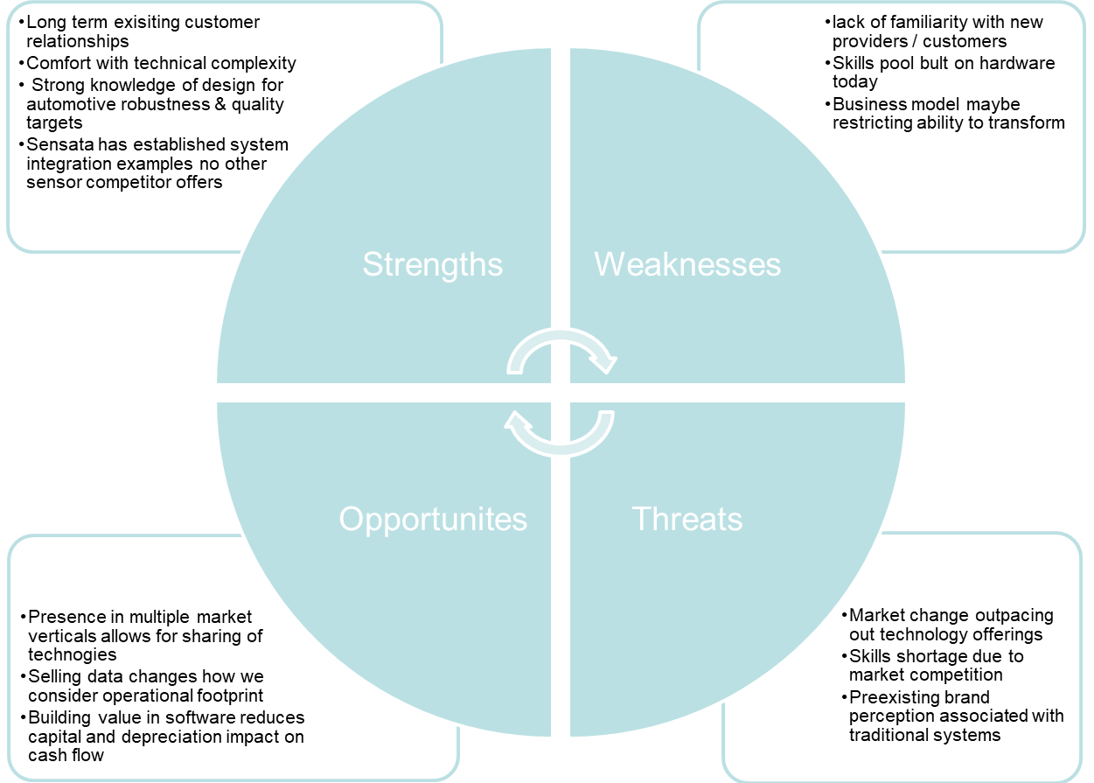
Figure 4 - SWOT of Sensata

Selling to the Market
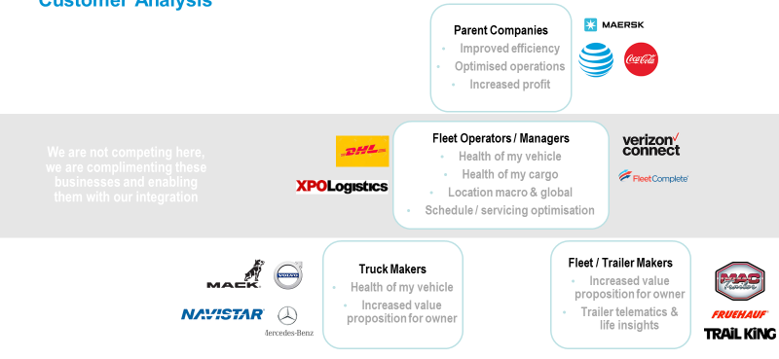
Figure 5 - Typical customers in the stack
The internal market categories for IoT / S&C stacks are quite different in their aim. The lower tier has no reason to add cost for features unless their customer demands it. Generating that demand in and important strategy for Sensata.
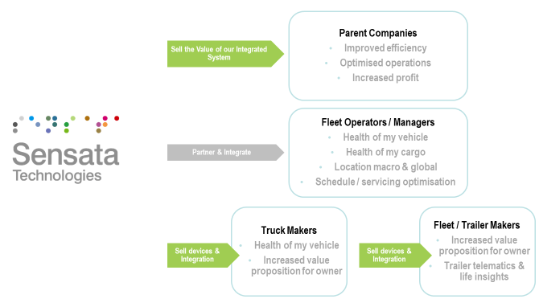
Figure 6 - Selling to the stack
Sensata has opportunity to sell technology and system solutions to both parent companies and vehicle makers. The middle layer of fleet operation and management has some opportunity but that is not where we can directly provide, it is where we must partner.
Having influence, understanding and connections to these 3 layers is important to maximise sales opportunities.

Conclusion
Sensata can readily penetrate the foundation layers of the IoT stack however, the demand for those features must be encouraged by demonstrating to the top of the stack (end users) what insights, and possible value impact they could benefit from. This sale of concept will drive the need for integration and system design down through the stack. Sensata is well positioned with a hardware and system integration solution that can take pain away form the middle tiers in trying to integrate with other component providers.

Recommendations
Sensata should evaluate and trial different sales models to help encourage adoption and maturity of S&C systems. For example: Free hardware, pay for data on demand or Pay for system, subscribe for data and various models in between. This may vary by business, customer and layer and so Sensata needs a more flexible sales model for this market compared to the traditional B2B transactional model employed widely to date.

References
Dahlqvist, F., Patel, M., Rajko, A. & Shulman, J., 2020. Growing Opportunities In The Internet Of Things. [Online]
Available at: www.mckinsey.com/industries/private-equity-and-principal-investors/our-insights/growing-opportunities-in-the-internet-of-things
[Accessed 16 July 2020].
Gupta, A. et al., 2017. Forecast: Internet Of Things — Endpoints And Associated Services, Worldwide, 2017. [Online]
Available at: www.gartner.com/en/documents/3840665/forecast-internet-of-things-endpoints-and-associated-ser
[Accessed 15 July 2020].
Mazareanu, E., 2020. Coronavirus: impact on the aviation industry worldwide - Statistics & Facts. [Online]
Available at: https://www.statista.com/topics/6178/coronavirus-impact-on-the-aviation-industry-worldwide/
[Accessed 24 July 2020].
Reports, V., 2020. Global Fleet Management Market Size Was Valued At USD 7755 Million In 2015 And Is Expected To Reach USD 34629 Million By 2022 Growing At A CAGR Of 24.5%. [Online]
Available at: https://www.prnewswire.com/news-releases/global-fleet-management-market-size-was-valued-at-usd-7755-million-in-2015-and-is-expected-to-reach-usd-34629-million-by-2022-growing-at-a-cagr-of-24-5--valuates-reports-300979832.html
[Accessed 16 July 2020].
Sensata.com, 2019. Sensata Technologies To Introduce New Suite Of Temperature, Pressure And Position Sensors For Aircraft Engines At 2019 Paris Airshow. [Online]
Available at: www.sensata.com/contact/newsroom/sensata-technologies-introduce-new-suite-temperature-pressure-and-position-sensors#:~:text=About%20Sensata%20Technologies,business%20centers%20in%2011%20countries
[Accessed July 2020].

