Name: Banafshe Barzegarsaadi
Student number: 2215168
E-portfolio report
Learning in the Digital Era – BMPL4007/BMPS4009

Table of Contents

Task 1 – Written summary 2
Task 2 – Mind map 3
Task 3 – Presentation 5
Task 4 – Reflection 6
Reference list 7

Task 1 – Written summary

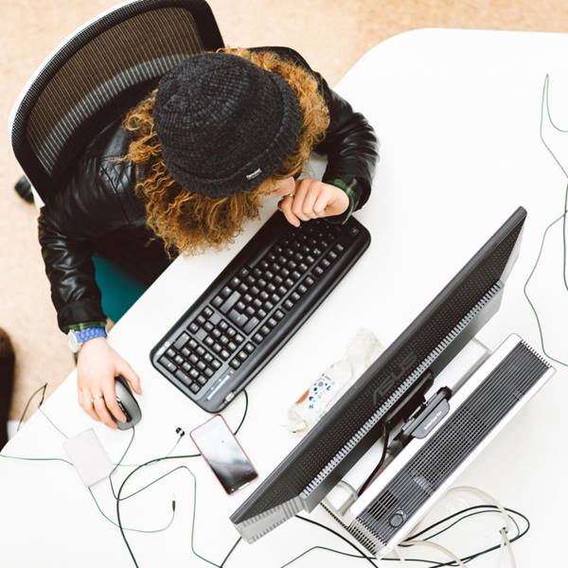
(University of Essex 2022)
Preparing for higher education:
In this task I will focus on the main parts that each student should consider during their academic study. First issue is students can recognise how to study effectively? It is expected that students understand what part of day is more effective and they can focus better on their study with less distraction. Although it’s important to set rest time between the study. Time management is the golden key to success. study place is important, and student must try to delete all attractive items and do not use that place as leisure. (Penn 2019)
Using the effective planning avoid student to fall behind writing and reading and missing deadlines for assignments. One who has not clear and realistic plan will face problems in time management. There is principle named Eisenhower and said, “we have two kinds of problem: urgent and important.” students must understand which problem has priority.
Procrastination means postpone. Student may also avoid working because they are afraid of failing or performing poorly on a task. They intentionally procrastinate to find motivation but under the pressure no one can produce better work. Some want to do everything perfect, and it is a big issue they must try to do as well as they are able. (b. Draper, Z 2022).
In the academic year student expected to use experts research to discuss in their assignments. Referencing provides context for all work and recognises the contributions of others. Students should cite it every time borrow someone else's concept to avoid plagiarism.
Microsoft word and PowerPoint are the two main software students use in their assessment. On the internet all must be aware of hackers and protect their privacy. Antiviruses are useful to stay safe online.
finally understanding what you are asked to do and in which method you are going to assessed is important.

Task 2 – Mind ma

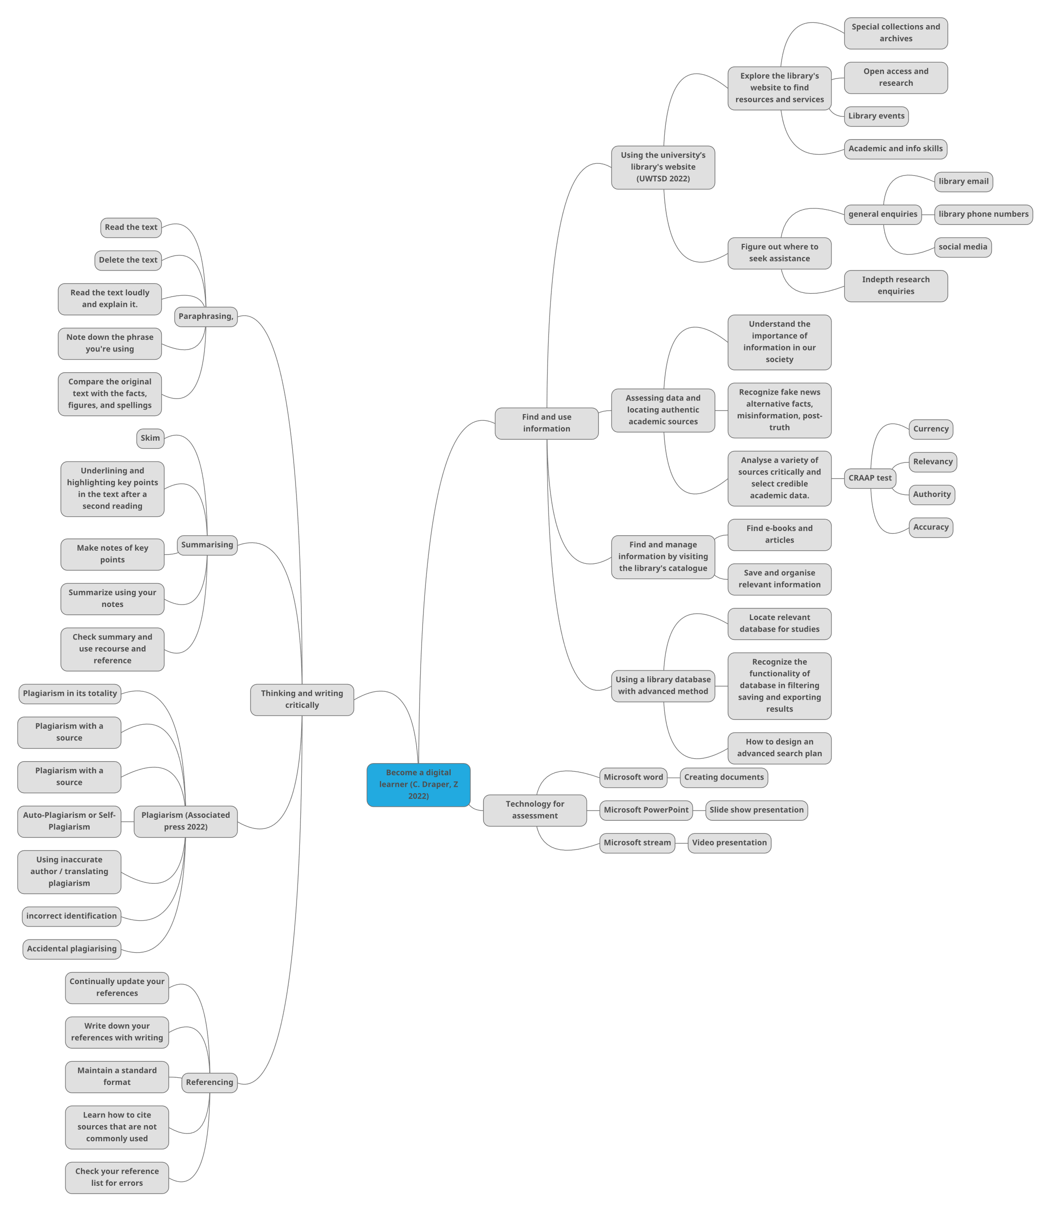

I will attach a pdf of my mind map and online website for easier access. I used mind mup tool.
Available at: https://app.mindmup.com/map/_free/2022/11/f101eb50606d11edbfe72771b7da9e4e.
mirror back up 1: https://drive.google.com/file/d/1hEtinZmN3nN2yA3-UW82cA_7m9qdtTaG/view?usp=drivesdk.
mirror back up2: https://1drv.ms/b/s!Anyva6y95JEIgYUcy2BK96HWff5MoQ.

Task 3 – Presentation
Please follow this link to view my presentation: https://www.youtube.com/watch?v=Ux4Azq32Cpg.

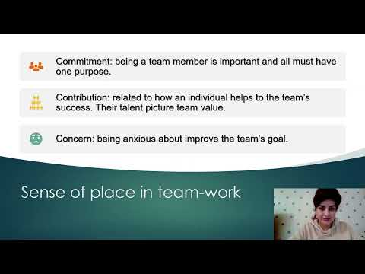

Task 4 – Reflection
What?
Starting university
At the start of the university everything was strange, I was really confused and frightened about course. I was disappointed in myself about the course and got stressed. Other students were trying to get the purpose of the course. I had some information about digital learning, and I thought that was enough, but the issue was the habit of being procrastinated. It was a new method for me on studying. Digital learning is a method of studying that work with lots of tools. (Bolton, G 2014).
So, what?
Getting to grips with online learning and resources.
During the course I had opportunity to get the useful information about the digital learning. Understanding of how to reference and give credit to work give me self-confidence. In the university time I learn how to use tools and software. I was stressed when I hear about new method, and I really didn’t spend enough time to work and learn it. Feeling nervous and shy make the situation worse. My structure for studying was not perfect and I had to change it. Otherwise, I was happy to learn new things and go to the next level of education. (Brookfield, S.D 1995).
Now what?
The process of writing your first assignments.
I realise that I should improve my method of studying and planning. When the assignment released, I must make sure to manage my time and overcome my bad habit of procrastination. This helps me to start my assignments with less stress and have more time on feedback. While writing my first assignment I searched everything on library. Team working and get help from another student makes everything easier. understanding the assignment question and using Microsoft Word and PowerPoint was even enjoyable. I feel comfortable to ask question directly from tutors. I found out how to avoid plagiarism in my assignment. (Queen Mary university).

Reference list

- a. Draper, Z. (2022). unit 2- becoming a team player. Available at: https://moodle.uwtsd.ac.uk/mod/scorm/player.php?a=4569&currentorg=unit_2_topic_2_ORG&scoid=9985&sesskey=3lQWMPSpZk&display=popup&mode=normal. ( accessed 25 November 2022).
- Associated press. (2022). Writer’s essay on why she plagiarized her book removed for plagiarism. Available at: https://www.theguardian.com/education/2022/may/09/jumi-bello-the-leaving-plagiarism-riverhead-books. (Accessed 07 November 2022).
- b. Draper, Z. (2022) Unit 0 - Preparing for higher education. Available at: https://moodle.uwtsd.ac.uk/course/view.php?id=8618. (Accessed: 28 october2022).
- Balkis, M., 2011. Academic efficacy as a mediator and moderator variable in the relationship between academic procrastination and academic achievement. Eurasian Journal of Educational Research, 45(45), pp.1-16. Available at: https://ejer.com.tr/wp-content/uploads/2021/01/ejer.2011.45.1-1.pdf. (Accessed 04 November 2022).
- Baranowsky, A. (2015). How to Create a Wellness Mind Map. Traumatology Institute. Available ate: https://video-alexanderstreet-com.ezproxy.uwtsd.ac.uk/watch/how-to-create-a-wellness-mind-map?utm_campaign=Video&utm_medium=MARC&utm_source=aspresolver. (Accessed 25 October 2022).
- Bolton G (2014) Reflective Practice: Writing and Professional Development. London: Sage.
- Brookfield, S.D. (1995) Becoming a critically reflective teacher. San Francisco: Jossey-Bass Inc.
- Buzan, T, Buzan, B. (2018). Mind Map Mastery: The Complete Guide to Learning and Using the Most Powerful Thinking: The Complete Guide to Learning and Using the Most Powerful Thinking Tool in the Universe Paperback. London: Watkins Publishing Ltd.
- c. Draper, Z. (2022). Unit 1-becoming a digital learner. Available at: https://moodle.uwtsd.ac.uk/course/view.php?id=8618. (Accessed 29 November 2022).
- Penn, P. (2019) The Psychology of Effective Studying, How to Succeed in Your Degree? London: Routledge.
- Psychology Today Staff. (2022). Identity. Available at: https://www.psychologytoday.com/gb/basics/identity. (Accessed 08 November 2022).
- Queen Mary University of London. (2016). Guidance on Reflective Writing. Available at: http://qmplus.qmul.ac.uk/mod/book/view.php?id=257889. (Accessed: 05 November 2022).
- The basic of referencing. (2022). Available at: https://www-citethemrightonline-com.ezproxy.uwtsd.ac.uk/basics-of-referencing. (Accessed 06 November 2022).
- University of Essex. (2022). Preparing for higher education. Available at: https://www.essex.ac.uk/undergraduate/preparing-for-higher-education. (Accessed 07 November 2022).
- UWTSD. (2022). Welcome. Available at: https://www.uwtsd.ac.uk/library/. (Accessed 07 November 2022).

