

Master of Business Administration
International Marketing: Principles and Practices
Module Code: LCMB7026
Individual Report
Pizza Hut International Marketing Strategy
A Comparative Analysis of the United States and India
Student Name: [RUTVIK PATEL]
Student ID: [2505514]
Submission Date: 13 August 2026

Contents
Section 1: International Marketing Report 4
1. Introduction 4
1.1 Company and Market Background 4
1.2 Report Purpose and Scope 4
2. International Market Environment 5
2.1 Comparative PESTEL Analysis 5
2.2 Comparative Hofstede Analysis 7
3. Comparative STP Strategy 9
3.1 Segmentation and Targeting 9
3.2 Comparative Brand Positioning 10
4. International Marketing Mix 11
4.1 Product and Price Strategies 11
4.2 Place and Promotion Strategies 12
4.3 People, Process and Evidence 13
5. Market Entry Strategy 15
5.1 Pizza Hut Entry into India 15
5.2 Entry Strategy Evaluation 15
6. Ethical Marketing Evaluation 16
6.1 Ethical Issues in India 16
6.2 Corporate Response and Judgement 17
7. Strategic Recommendations 17
7.1 Market Adaptation Recommendations 17
7.2 Sustainable Growth Recommendations 18
8. Conclusion 18
Section 2: Reflective Account 19
9. Gibbs Reflective Account 19
9.1 Description 19
9.2 Feelings 19
9.3 Evaluation 19
9.4 Analysis 20
9.5 Conclusion 21
9.6 Personal Action Plan 21
Reference List 22

Section 1: International Marketing Report

1. Introduction

1.1 Company and Market Background
Pizza Hut is one of the popular pizza restaurant chains that started in the USA and has since spread to numerous international markets. It is expected to be part of Yum! Until its ownership change is completed, as announced recently. Brands, which has an international restaurant system of 155 countries and territories. The Pizza Hut has expanded internationally through a franchise-based business model, thereby relying on local market expertise. Pizza Hut is primarily a company serving Chinese people, and India serves as a good host-market comparison for the USA. The markets vary when it comes to income levels, food preferences, and culture and food behaviour. For this reason, it is useful to see how a global restaurant brand can remain the same, while adapting to different local market conditions, by comparing the USA and India (Alonso 2022).

1.2 Report Purpose and Scope
This report will briefly discuss the international marketing strategy of Pizza Hut and will do a comparison between the international marketing strategy of Pizza Hut in India and the United States. Analysis is carried out via PESTEL which looks at the differences in the wider business environment and Hofstede's cultural framework which helps understand how cultural factors may affect customers. It then examines Pizza Hut's segmentation, targeting and positioning (STP) and thereafter the international marketing mix of the 7Ps: Product, Price, Place, Promotion, People, Process and Physical Evidence. The report also analyses Pizza Hut's strategy for entering the Indian market, ethical marketing problem and recommends the strategies for future international expansion of Pizza Hut. The primary point is that global standardisation and local adaptation are not the only options available to Pizza Hut. Rather, international competitiveness must be achieved with a balance in which the brand core is known, and certain marketing activities are tailored to the local economic, cultural and consumer needs (Koshksaray & al. 2023).

2. International Market Environment

2.1 Comparative PESTEL Analysis
PESTEL Factor | United States | India | Critical Marketing Implication for Pizza Hut
Political | The US restaurant sector operates within a mature regulatory environment, with food businesses affected by federal, state and local requirements. | India's food sector is regulated through the Food Safety and Standards Authority of India (FSSAI), which covers areas including licensing, food standards, packaging, advertising and labelling. | Pizza Hut cannot simply transfer US operating practices to India. It must maintain global standards while ensuring that products, communication and restaurant operations meet Indian regulatory requirements.
Economic | Consumers generally have much greater purchasing power. World Bank data show GDP per capita of about US$86,170 in 2024, although this should not be treated as personal income. | India's GDP per capita was about US$2,592 in 2024, showing a major economic difference between the markets. | The gap makes affordability much more important in India. Pizza Hut therefore benefits from value meals, smaller offers and sharing deals rather than copying US prices. Its Indian menu currently includes offers such as 1 Plus 1 and meal deals, providing practical evidence of this adaptation.
Social | Convenience is a major feature of US restaurant consumption. In 2025, nearly three-quarters of restaurant traffic occurred off-premises, while younger consumers were especially active users of takeout and delivery. | India requires stronger adaptation to local tastes and dietary preferences. Pizza Hut's current Indian menu includes Tandoori Paneer, Paneer Makhni Masala, Schezwan dishes and a wide selection of vegetarian pizzas. | Pizza Hut can standardise its core pizza concept, but product execution needs localisation. The Indian menu shows that cultural relevance can be created without removing the global Pizza Hut identity.
Technological | Digital ordering is well established. US restaurant research shows that speed, easy ordering/payment technology and customer service are important for repeat off-premises purchases. | Food-delivery applications and digital interfaces are also important to Indian consumers, with research linking user-friendly app design to satisfaction and continued usage. | Technology creates an opportunity in both markets, so digital convenience can remain relatively standardised. However, Pizza Hut should adapt payment, delivery and platform choices to local customer habits.
Environmental | Restaurants face growing pressure to reduce waste and improve the sustainability of takeaway operations. | India specifically regulates food packaging through FSSAI's Packaging Regulations, creating an additional compliance requirement for restaurant businesses. | Sustainable packaging can support a common global responsibility strategy, but implementation must reflect country-specific regulations and supply conditions.
Legal | FDA rules require covered restaurant chains with 20 or more locations to display calories for standard menu items and make further nutrition information available. | FSSAI regulations cover licensing, advertising and claims, packaging, and labelling and display. Food businesses are also required to display relevant food-safety information at premises. | Legal differences affect menu information, advertising and physical evidence. Compliance should therefore be locally managed rather than completely standardised.

2.2 Comparative Hofstede Analysis
Clearly, India and the United States have very different cultural profiles as seen in figure 1. The most important difference for Pizza Hut is individualism. Generally speaking, the USA is more individualistic and India has more collectivist traits. This implies that US marketing and promotional campaigns could be more naturally focused on personal choice, convenience, personal customisation. The family meal, sharing and group experiences may be more marketable in India. This can be achieved by the Indian menu of Pizza Hut, which includes meal-for-two, four people pizza and x-aif (Xaif 2021).
Figure 1 also shows that power distance is also more in India than in the USA. But this doesn't necessarily mean that all Indian customers are the same. The more useful implication for Pizza Hut is: The service expectations and communications should not simply be replicated from the US market; they must be understood in their local social context.
Figure 1 also suggests variations in terms of the indulgence and long-term orientation measures. The size of these dimensions indicates Pizza Hut should not assume that the same promotional message will evoke the same response in both markets. In India, the value, the sharing of value with the family and the culturally known products can complement the global brand. In the Indian menu, there is ample evidence of localisation, for example, Tandoori Paneer, Paneer Makhni Masala and the pizzas based on Schezwan are all localised menus. The US national menu has categories like pizzas, wings, Melts, Pasta and desserts (Eguriase Caleb Okobia 2023).
Hofstede can therefore provide some general insights into the culture, but should not be used to describe consumers in full. There are also some significant regional variations and some differences in age and lifestyle between India and USA, and critics of Hofstede point out that nation culture cannot be simply quantified as scores. Combining cultural information with empirical evidence from consumers and markets is, therefore, the best option for Pizza Hut. This aligns with a global brand, while allowing for some adaptation in certain areas (Minkov 2013).
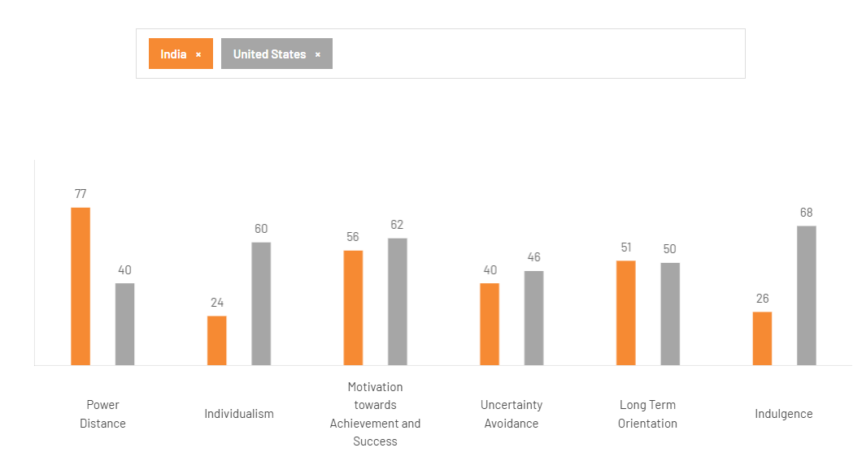
Figure 1: Comparative Cultural Dimensions Across India and America

3. Comparative STP Strategy

3.1 Segmentation and Targeting
Demographic, geographic, psychographic and behavioural segmentation are leveraged by Pizza Hut in both markets, but each segment is more or less significant in each market. In the USA, segments are important such as families, young adults, people who are convenience shoppers or delivery/carryout shoppers. This is good for business since it allows Pizza Hut to cater to individual and group functions. It has, for instance, a category dedicated to “Party of One” in its current U.S. menu alongside pizzas, wings, pasta and other offerings, and its digital menu is heavily focused on delivery and carryout (Alonso 2022).
Targeting in India focuses more on the urban youth, value conscious consumers and customers with local/vegetarian food preferences, families. This is a combination of economic and cultural factors as seen in Figure 2. Pizza Hut India currently offers vegetarian and non-vegetarian combinations, a ‘Hut Treat Meal’ for 4 people, as well as personal deals and shares. The menu also features localised flavours like Paneer Makhni Masala and Fiery Schezwan Veggie, highlighting that segmentation is not just about age and income, but also about dietary and taste preferences (Rathi & al. 2025).
As such, it is evident that there is a distinction in targeting logic in Figure 2. While the former (US targeting) emphasizes convenience and flexible consumption occasions, the latter (Indian targeting) is focused on convenience in conjunction with affordability, family sharing, and local tastes. This reinforces the previous PESTEL analysis and the cultural analysis: there is a lack of uniformity in puchasing power and social consumption, as a whole standardisation of targeting is not feasible. But, a focus on families and younger consumers and digital ordering is also revealing that localisation is not a full-fledged process.
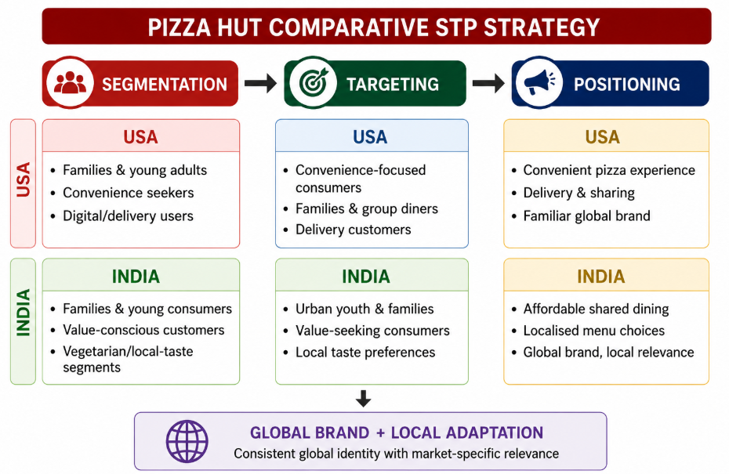
Figure 2: Pizza Hut Comparative Segmentation Targeting Positioning Strategy

3.2 Comparative Brand Positioning
Pizza Hut's positioning is a familiar international pizza brand and value propositions at the market level. In the USA its positioning is increasingly becoming tied up with convenience, choice and value. For instance, the existing Hut Hookup programme has daily offers available on the app and online such as the Personal Pan Pizza offer, which is for personal use. This confirms the USA depiction in Figure 3, that Pizza Hut offers a relatively good branded option (Sekine-Pettite 2018).
Internationally recognized, affordable and relevant, Pizza Hut does it all in India. Current meal deals and promotions include a Buy 1 Get 3 Free offer and the menu is a mix of the world's pizza with Indian flavours and good vegetarian options. This could help a more value driven stance than the US strategy.
Figure 3, however, does not represent actual market share data, but rather a positioning analytical map. Primary consumer perception data would be needed to confirm locations of exact competitors on the map. It has only been useful to the extent that it demonstrates the desired strategic shift between two market positions for Pizza Hut.
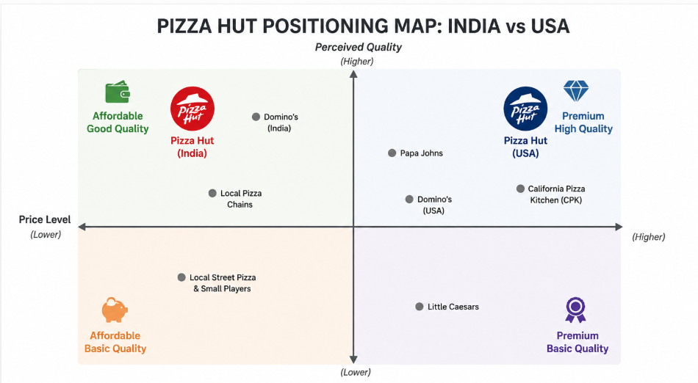
Figure 3: Pizza Hut Positioning Across Indian American Markets

4. International Marketing Mix

4.1 Product and Price Strategies
Pizza hut's product strategy in USA and India is a hybrid product strategy. The core offer has stayed the same with pizza, known branding and eating a meal, but the menu will vary based on local preferences. The national menu in USA features a selection of pizzas, Melts, wings, pasta, sides, desserts and a “Party of One” category. Different crusts and toppings are also available for customers to choose from. In India localisation is much deeper. There are Tandoori Paneer, Kadhai Paneer, Chicken Tikka and Murg Malai Chicken pizzas in addition to popular ones like chicken and fish. Pizza Hut therefore adjusts Indian products to vegetarian tastes and local familiar flavors, instead of having to change Indian people's palates to the full American menu (Sengupta & al. 2012).
Selective adaptation is also shown by Price. Value extends beyond the pizza hut as they have deals in both countries. The nature of value is, however, different. Hut Hookup is currently running a $3 Personal Pan Pizza and promotional wings, and a $10 large, 3-topping pizza is being promoted in the USA. Pizza Hut offers a meal deal in India that includes pizza with sides and a beverage for Rs 399, which is equivalent to Rs 129.93 per person.In India, Pizza Hut offers a pizza deal of Buy 1 and Get 3 Free, which is a pizza with sides and a drink for Rs 399, or Rs 129.93 per person.
This difference is significant since India's purchasing power as discussed previously in PESTEL analysis is lower, which makes the perceived affordability of the product crucial. Bundling can make the total cost of the family or group consumption less "expensive" for the customer, without Pizza Hut having to sell itself exclusively as a low price brand. Generally, Figure 4 is good in presenting product and price as not standardised but not localised either. While the global product category value promise stays the same, the flavours, meal combinations and price promotions are customized to make it more localized.
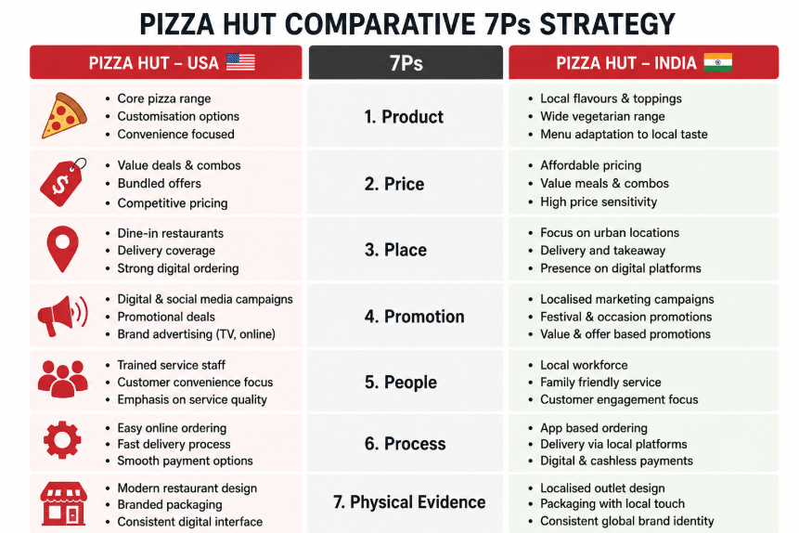
Figure 4: Comparative Pizza Hut Marketing Mix Across Markets

4.2 Place and Promotion Strategies
In both markets, Place has been growing more and more associated with digital convenience. Pizza Hut, in the USA, is a pizza joint that offers both dine-in and take-out, delivery and its online and mobile platforms. The company has even created restaurant formats based on technology on its US site, where the customer can start with carryout or delivery without even visiting the restaurant. A newer restaurant in Plano, Texas, for instance, added some self-service kiosks, pick-up cabinets and a Hut 'N Go drive-through menu. This indicates that the distribution is no longer limited to the location of the restaurant but also the speed and ease with which the customers can access the product (Chotai 2026).
India also integrates restaurants with online ordering and home delivery. Just like in the international market, pizza hut India is also emphasizing doorstep delivery and online offers on its current website, highlighting the significance of digital accessibility in the Indian market. Therefore, Figure 4 is not intended to imply totally new distribution systems. The market is becoming digitally integrated, with the platforms and the customer journey being managed locally (Hasselwander 2024).
The promotion system is similar for the International and local levels. The USA already has a digital promotions initiative in place, consisting of two main digital campaigns: Hut Hookup, which offers discounts paired with online and app orders, and Hut Rewards. The message is powerful in the areas of convenience and person-centred consumption and saving. Indian promotions focus more on 'value combinations' and 'sharing moments'. For instance, a pizza is paired with breadsticks, fries and Pepsi, for which they offer a Buy 1, Get 3 Free deal, to make an entire meal. This is aligned with the more family and group-oriented culture reflected in the cultural analysis.
The strategic distinction then is more on the message and offer than in the giving up of global branding. Pizza Hut maintains its recognizable name and pizza identity in both countries, while adjusting pizza value for consumption. Figure 4 is, as a result, a helpful international strategy: distribution is becoming more digital convenient, promotion more locally adapted (Romaniuk & al. 2007).

4.3 People, Process and Evidence
Humans are at the heart of Pizza Hut, and they cannot be replaced by technology. Restaurants staff members cook, handle dine-in customers, deal with issues and assist with collection and delivery. This relationship becomes apparent in Pizza Hut's newer U.S. Restaurant concept; technology like kiosks and pick-up cabinets are to make ordering easier so team members are able to serve the customer better. Open kitchen also allows customers to watch the employees prepare pizzas. So staff are not standing in isolation from the marketing experience and their speed, behaviour, service quality, effect on the brand promise (Greer 2024).
The process is similarly designed for ease of use. Customers can place orders via the website or app for delivery and pick-up, and Hut Rewards correlates digital ordering with promotion. Newer format in the USA: Self-service kiosks, contactless pick up cabinets and drive-through collection to minimize waiting time. Online orders and delivery services are also offered, with the current website boasting a promise to deliver items to the doors of its customers. The similarity is critical, strategically: Pizza Hut doesn't have to develop entirely new processes just because there are national cultures. In both markets speed and convenience are valued. Local adaptation becomes more critical at the specific level of payments, menus and delivery of the associated common process (Manhas & al. 2024).
Physical proof makes the service more tangible and alleviates the uncertainty of an intangible restaurant experience. Pizza Hut's digital environment is part of this evidence, as shown in figure 5. The Pizza Hut name, a brand recognisable visual identity, and menu presentation leads to brand consistency across markets. Physical restaurants convey additional cues via layout, cleanliness, packaging and food presentation. In the USA, a newer version of Pizza Hut features a new look and feel on the exterior and interior of the restaurant, as well as digital menus, open kitchen areas and the actual preparation of the food. These attributes are a sign of modernity and quality of the product.
It is important to note that the evaluation of people, process, and physical evidence is not done independently. If the service standards are low, a modern restaurant is of little value and if the preparation and delivery are poor, the efficiency of the app is of little value to customers. The 7Ps of Pizza Hut are thus interdependent. Product localisation and value pricing draws the local buyers, accessible channels and promotions are encouraging them to purchase, and people, processes and physical evidence provide promised experience (Xia 2023).
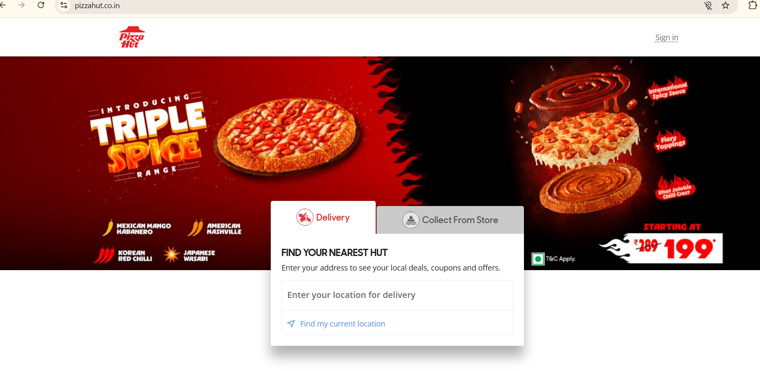
Figure 5: Pizza Hut website

5. Market Entry Strategy

5.1 Pizza Hut Entry into India
Pizza Hut opened its first outlet in India in June 1996 in Bangalore. This is the official date of entry for Pizza Hut's website in India and is also reported by the contemporary media as the first restaurant operating in Bangalore. The market was tough as foreign fast-food chains were competing with local brands and at the time there was an aversion to foreign brands and preference for locally produced foods. It was not just the transfer of the American restaurant model to enter India (DAVID 1996).
Pizza Hut grew their presence in India primarily via a franchise business approach with large local firms over time. Devyani International and Sapphire Foods are significant Pizza Hut franchisee players in India. Their local operating ability gives Pizza Hut insight into where they are located, what people like to eat, the availability of labour, the supply chain and market conditions, while the brand can continue to grow without having to take direct control of every restaurant. The two operators agreed to merge in 2026 and the merger was planned to provide the company with larger scale and operating efficiencies (U.S. Pizza India 2026).
Local adaptation is also possible in this model. Pizza Hut India has local flavours, vegetarian options and value meals, as demonstrated earlier. The entrance is thus a synthesis of the international brand's knowledge and identity and the local operational capabilities. Strategically, it allows Pizza Hut to cut back on its own resources needed to run the business and to be able to meet the demands of a culturally and economically different market.

5.2 Entry Strategy Evaluation
The overall approach for Pizza Hut's expansion in India – which is blending America and Indian skills, adapting to Indian tastes and successfully connecting the dots in its outreach efforts – is illustrated in figure 5. The primary benefit is that it is scalable. Local operators bring in local food knowledge and operational assets and Pizza Hut brings the brand and restaurant system. This can help cut down on direct investment and promote more rapid growth (Ali & Santos 2025).
But there is an important control – resource trade off in the context of a franchise. Pizza Hut also gains a lot of knowledge about the opportunities in the local market, but they have to rely less on them and more on the franchise operators, which means there may be some problems with uniformity of service, profitability, and brand management. Such risks are still applicable – recent studies reveal that the Pizza Hut India operators are seeing sluggish demand, high expenses, and stiff competition (Huang & Lin 2025).
Overall, the strategy was appropriate as Pizza Hut built up the brand and its presence in an intricate foreign market. But this isn't done by simply putting down restaurants; it's done by making sure that the quality of the restaurant, its local relevance and its profitability is there.
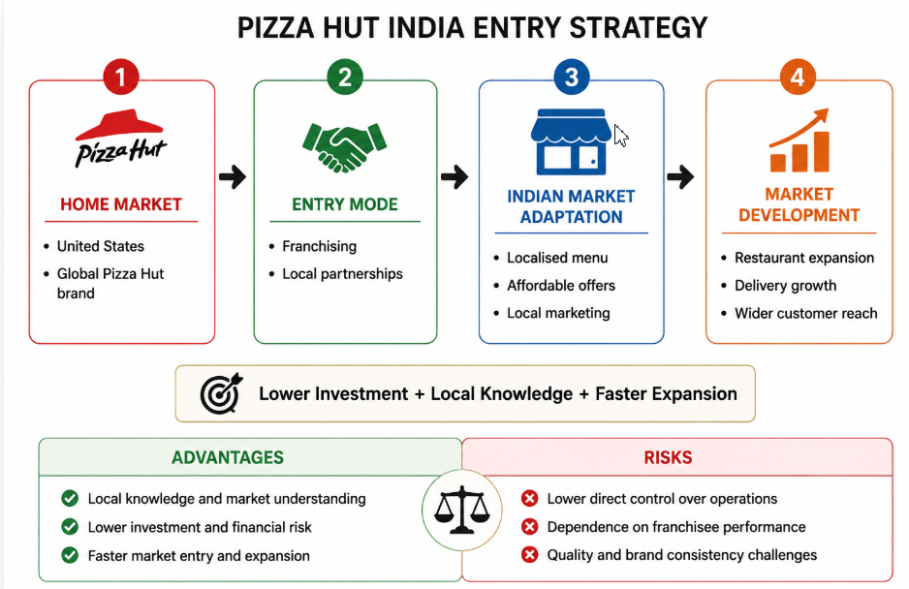
Figure 5: Pizza Hut Indian Market Entry Strategy Framework

6. Ethical Marketing Evaluation

6.1 Ethical Issues in India
Health and responsible fast food marketing is a major ethical dilemma for Pizza Hut in India. The ethical issue isn't the selling of a pizza per se, but the use of promotions and value bundles that can promote the consumption of foods that may have a high calorie, saturated fat, sodium and/or sugar content. This is especially significant when marketing can reach the younger generation and families. In the past, FSSAI has pointed out the role of food marketing on children's food choices and highlighted irresponsible food marketing of foods high in fat, salt and sugar (Tahir & al. 2022).
Responsible marketing for Pizza Hut means more than just adhering to legal requirements. Consumers must be provided sufficient information to enable them to make informed choices. This is particularly crucial in promotions that focus on quantity and value. India already has regulations on advertising and claims for children as part of FSSAI, labelling and display for children specific to schools, and safe food and balanced diets for children specific to the school. Morphologically, Pizza Hut should thus weigh business goals and ethical standards of communicating transparently with the public and its welfare against health impact, instead of promoting the consumption of products without taking into account the health impact (Kumar & Ciddikie 2023).

6.2 Corporate Response and Judgement
Pizza Hut India has a nutrition dedicated resource that enables consumers to make access to nutrition information available regarding its products. This helps to promote transparency and empowers customers to make informed decisions. The advertising guidelines also set out the formal guidelines for food businesses to communicate to consumers when making claims.
But the provision of information does not completely alleviate the ethical issue. Pizza Hut can reinforce its strategy by making the nutrition information more prominent when ordering online, encouraging moderation, and ensuring that value marketing does not negatively impact healthy options. So, its current strategy is a good starting point and more robust responsible marketing would better serve consumers' and families' interests alongside business growth (Kraak & al. 2017).

7. Strategic Recommendations

7.1 Market Adaptation Recommendations
Pizza Hut has to adopt a selective localisation approach in India and cannot simply use the approach which is implemented in the USA. The first is that there needs to be more region specific vegetarian and non-vegetarian flavours available but still maintaining the pizza identity. This would take care of the above cultural and dietary differences without affecting global brand recognition. Secondly, Pizza Hut should strengthen its value pricing strategy, specifically, to have a lower pizza price and a higher family pizza price. This would enable India to be price sensitive and not just low cost. Third, digital promotions need to be targeted by the occasion of consumption. Young customers might be offered individual offers via the app, and families might be offered sharing discounts, or festival offers that are tailored to their culture. The convenience and personalisation and ease of ordering pizza digitally in the USA needs to be paid more attention to by Pizza Hut as these are the bigger segments identified in the analysis (Indian Retailer Bureau 2025).

7.2 Sustainable Growth Recommendations
Pizza Hut's expansion should be connected to the concerns of health, transparency and environmental care. Nutrition information should be more visible and available with online ordering in India, but shouldn't require the customer to look it up elsewhere. The company can also make lighter meals, serve smaller quantities and healthier sides to help balance out meals. This would directly tackle the ethical issues regarding eating fast food and still allow consumers to opt-in. Sustainable Packaging should be expanded where commercially and technically feasible, having clear targets for unnecessary materials and food waste. On a digital level, Pizza Hut should streamline the ordering process, offer personalised suggestions, reward loyalty members and obtain feedback from customers all while maintaining their privacy. These should be based on a standardized global measurement for both markets, and local application. This would send a positive signal regarding the consumer trust, keep Pizza Hut's brand identity intact in foreign countries and make it easier to be relevant to its operations and more competitive in the long term (Goyal & Singh 2007).

8. Conclusion
It is observed from the comparison that exactly the same marketing strategy cannot be adopted by Pizza Hut in the USA and India to operate on an international basis. The market environment and the attitudes and purchasing habits of customers set different expectations. Thus, Pizza Hut's STP and 7Ps are best implemented if they are backed by the local content, prices, promotions and experiences. Its franchise model of development in India was helpful in gaining local insights and aiding in expansion, but also brought along some control and consistency issues. Pizza Hut should maintain its current international approach, which is a blend of global standardization and local adaptation, with the goal of establishing uniformity of those factors that generate their global image and efficiency and only adapting those factors that are of direct importance to value and market relevance to the local customer (Kaufmann & Eroglu 1999).

Section 2: Reflective Account

9. Gibbs Reflective Account

9.1 Description
The first step I took in this assignment was to develop an understanding of the requirements and which of the main international marketing concepts was going to be used. I chose Pizza Hut as the company's product and compared USA to India as the home market is the USA and India is a different cultural and economic environment. Next, the research was split into PESTEL, Hofstede, STP, the 7Ps, market entry and ethical marketing. The information I used was from academic literature, from a government source, from company websites and reliable sources from the industry. I attempted to do some comparisons across countries within the report, rather than looking at them one country at a time. I also gave a few examples as Pizza Hut India's menu and value offers to make the theory of international marketing come alive in the real world scenario (Dana & al. 2022).

9.2 Feelings
To be honest I had a reasonable amount of confidence initially as I was familiar with some fundamental marketing concepts – segmentation, marketing mix etc. But as I looked into the international market, I didn't feel too sure when I knew I would have to make deeper comparisons between two vastly different markets. Initially it was challenging for me to use PESTEL, Hofstede and the 7 Ps without over describing the report. I was also worried about getting reliable information for both countries that would be equal in quality. As my research progressed, my confidence grew as I was starting to see the linkages between the frameworks. When I was working at Pizza Hut, I realized that cultural and economic differences are the reasons behind the different products, prices and promotions used in India versus the USA (Manhas & al. 2024).

9.3 Evaluation
What was helpful was organizing the research into themes prior to the main analysis. This hindered me in gathering data I didn't have any need to gather that has little to do with the task. It was also beneficial to use various evidence types. I used the websites of Pizza Hut to get information on the menu and deals, as well as digital ordering, and the websites of government and academic sources to get information on broader cultural, economic, and regulatory matters (Ahmed & al., 2025).
I did see that I had some weaknesses in my strategy, however. In the beginning I would take the company info for granted and not ask questions. Then I found out that there are pizza hut websites that can give an idea of what pizza hut is currently doing, but they can of course show the company in the best light. So I needed more independent evidence when I was making critical judgements. Hofstede was an additional challenge as cultural scores can give national cultures an overly simplistic image. I learned that I could not make assumptions based on national scores about the behaviors of all Indians or American consumers. Overall, the ability to organise evidence was my strongest skill and the ability to go from description to deeper evaluation my main weakness.

9.4 Analysis
The key lesson was that International marketing is not just the same product, in a different country. PESTEL enabled me to understand the impact of economic, legal, technological and social factors on marketing decisions. For instance, the disparity in purchasing power helped explain India's need to pay special attention to the value and affordability. It was there that I learned to link external forces with real marketing activities, and not consider the external factors as independent ( Shah & Asghar 2023).
Hofstede has helped me to understand about culture and differences in culture with regard to individualism and about power distance and long term orientation. At the same time, however, I acquired a keen awareness of the need to work with cultural frameworks with care. National scores can show general trends but cannot explain any individual consumer. This made me want to put together my cultural theory with some real evidence from the market.
It was especially helpful to compare STP and the 7Ps since it made it easier for me to see how various marketing decisions interact. The decisions about segmentation determine the type of consumers that Pizza Hut reaches, the decisions about product, price, promotion and service determine the type of value Pizza Hut offers those consumers. Standardisation and adaptation were my two choices at the outset. In this research I came to know that both can be used simultaneously in international enterprises. Pizza Hut has the ability to have a global brand but ensure that its products, promotions and marketing messages are localized to fit with local requirements (Shastri 2021).
In my evaluation of sources, my approach became more critical. I learned how to ask the following questions about the information: Who was responsible for the information, why was it published, how recent was it, and did another source back it up. My research, however, was still secondary and so I could only measure secondary data, which meant that I was unable to measure consumer perceptions directly. Understanding this restriction helped me to make better judgements as I was more cautious about making claims which were not fully substantiated by the evidence available.

9.5 Conclusion
I found this assignment to be beneficial for my international marketing understanding and academic research. My greatest lessons were that a good comparison was not just to demonstrate that two countries were different but also to explain why there were differences and what they meant to business decisions. Also, I enhanced my framework understanding and used to join frameworks rather than considering PESTEL, Hofstede, STP and the 7Ps as independent topics. Meanwhile, I identified that I must develop a level of critical scepticism of sources and theories. I would have started academic research sooner and finalize an evidence plan before writing each section if I had to do the report again (Francioni & Martín 2024).

9.6 Personal Action Plan
In future assignments, I will enhance the research process in a few practical ways. First, I will start searching the database earlier and will pay more attention to recent peer reviewed journal articles. I will make a basic evidence record that records the source of the information, the date of the information, the credibility of the information, and the argument that is supported by the information. This is going to make me not rely too much on company sites.
Second, I will develop my critical writing skills in the format evidence, comparison, explanation and judgement. I will present information and ask why it is important and if there is another explanation. I will also set aside dedicated time to research, write and edit rather than spend time writing and editing simultaneously.
Last but not least, I will deepen my understanding of International Consumer Behaviour, Cultural Adaptation and Global Branding. I wish to apply theories to make decisions in the future MBA work, instead of just describing them. Professionally, these skills will assist me in evaluating international markets, evaluate evidence and make balanced recommendations. My goal is to be a more self-reliant researcher, capable of making decisions, informed by credible evidence and through critical thinking (Daniels & al. 2025).

Reference List
Ahmed, S.K., Mohammed, R.A., Nashwan, A.J., Ibrahim, R.H., Abdalla, A.Q., Ameen, B.M.M. & Khidhir, R.M. 2025. Using thematic analysis in qualitative research. Journal of Medicine, Surgery, and Public Health, 6, 6, pp. 100198. URL: https://doi.org/https://doi.org/10.1016/j.glmedi.2025.100198. Accessed: 7 August 2026.
Ali, U.F. & Santos, V. 2025. Glocalization strategies in the food industry. Advances in human resources management and organizational development book series, 1, 1, pp. 237–262. URL: https://doi.org/10.4018/979-8-3373-0149-5.ch012. Accessed: 7 August 2026.
Alonso, T. 2022. Strategy study: How pizza hut reimagined pizza to become the largest pizza chain. URL: https://www.cascade.app/studies/pizza-hut-strategy-study. Accessed: 7 August 2026.
Chotai, N.A. 2026. Dine-in or deliver? Pizza hut’s strategic dilemma in a delivery-driven market. International Journal of Economic Practices and Theories, 2026, pp. 2650–2663. URL: https://ijapt.org/index.php/journal/article/view/446. Accessed: 7 August 2026.
Dana, L.-P., Salamzadeh, A., Mortazavi, S. & Hadizadeh, M. 2022. Investigating the impact of international markets and new digital technologies on business innovation in emerging markets. Sustainability, 14, 2, pp. 983. URL: https://www.mdpi.com/2071-1050/14/2/983. Accessed: 7 August 2026.
Daniels, M., O&#x27;Brien, M.P., Costin, Y. & Slattery, D.M. 2025. Global perspectives, local impact: Facilitating responsible management learning outcomes through international experiential learning. The International Journal of Management Education, 23, 3, pp. 101243. URL: https://doi.org/10.1016/j.ijme.2025.101243. Accessed: 7 August 2026.
DAVID, S. 1996. Pizza hut opens its first outlet in India in Bangalore with police protection. URL: https://www.indiatoday.in/magazine/your-week/story/19960715-pizza-hut-opens-its-first-outlet-in-india-in-bangalore-with-police-protection-833567-1996-07-14. Accessed: 7 August 2026.
Eguriase Caleb Okobia 2023. Customer satisfaction and brand loyalty: Pizza hut case study. The International Journal of Business & Management. URL: https://doi.org/10.24940/theijbm/2023/v11/i9/BM2309-017. Accessed: 7 August 2026.
Francioni, B. & Martín, O.M. 2024. International market, network, and opportunity selection: A systematic review of empirical research, integrative framework, and comprehensive research agenda. Journal of international management, 30, 5, pp. 101174–101174. URL: https://doi.org/10.1016/j.intman.2024.101174.
Goyal, A. & Singh, N.P. 2007. Consumer perception about fast food in India: An exploratory study. British Food Journal, 109, 2, pp. 182–195. URL: https://doi.org/10.1108/00070700710725536.
Greer, D. 2024. Pizza Hut Pilots New Restaurant Design in Plano, Texas. URL: https://pizzatoday.com/news/pizza-hut-pilots-new-restaurant-design-in-plano-texas/148322/. Accessed: 7 August 2026.
Hasselwander, M. 2024. Digital platforms’ growth strategies and the rise of super apps. Heliyon, 10, 5. URL: https://doi.org/10.1016/j.heliyon.2024.e25856.
Huang, C.I. & Lin, L.C. 2025. The trade-off between franchise expansion and organizational stability. URL: https://doi.org/10.2139/ssrn.5334722. Accessed: 7 August 2026.
Indian Retailer Bureau 2025. Pizza Hut India launches refreshed identity and new crust. URL: https://indianretailer.com/news/pizza-hut-india-launches-refreshed-identity-and-new-crust. Accessed: 7 August 2026.
Kaufmann, P.J. & Eroglu, S. 1999. Standardization and adaptation in business format franchising. Journal of Business Venturing, 14, 1, pp. 69–85. URL: https://doi.org/10.1016/s0883-9026(97)00097-9.
Koshksaray, A.A., Quach, S., Trinh, G., Keivani, S.B. & Thaichon, P. 2023. Brand competitiveness antecedents: The interaction effects of marketing and R&D expenditure. Journal of Retailing and Consumer Services, 75, pp. 103532–103532. URL: https://doi.org/10.1016/j.jretconser.2023.103532.
Kraak, V.I., Englund, T., Misyak, S. & Serrano, E.L. 2017. A novel marketing mix and choice architecture framework to nudge restaurant customers toward healthy food environments to reduce obesity in the United States. Obesity Reviews, 18, 8, pp. 852–868. URL: https://doi.org/10.1111/obr.12553.
Kumar, A. & Ciddikie, M.D. 2023. Marketing strategies and challenges for emerging markets. Bharti Publications. URL: https://www.researchgate.net/publication/372915021_Marketing_Strategies_and_Challenges_for_Emerging_Markets. Accessed: 7 August 2026.
Manhas, P.S., Sharma, P. & Quintela, J.A. 2024. Product innovation and customer experience: Catalysts for enhancing satisfaction in quick service restaurants. Tourism and Hospitality, 5, 3, pp. 559–576. URL: https://doi.org/10.3390/tourhosp5030034. Accessed: 7 August 2026.
Minkov, M. 2013. Cross-cultural analysis: The science and art of comparing the world’s modern societies and their cultures. Cross-Cultural Analysis: The Science and Art of Comparing the World’s Modern Societies and Their Cultures. URL: https://doi.org/10.4135/9781483384719.
Rathi, N., Worsley, A. & Bruening, M. 2025. Factors that influence snacking behaviors among urban Indian adolescents – a qualitative inquiry. Frontiers in Nutrition, 12. URL: https://doi.org/10.3389/fnut.2025.1637799.
Romaniuk, J., Sharp, B. & Ehrenberg, A. 2007. Evidence concerning the importance of perceived brand differentiation. Australasian Marketing Journal (AMJ), 15, 2, pp. 42–54. URL: https://doi.org/10.1016/s1441-3582(07)70042-3. Accessed: 7 August 2026.
Sekine-Pettite, C. 2018. Pizza hut global brand positioning launch – caribla franchisee association. URL: https://www.caribla.com/pizza-hut-global-brand-positioning-launch/. Accessed: 7 August 2026.
Sengupta, M., Sengupta, N. & Raghupathi, S. 2012. A case study on pizza hut: Competitors’ envy, consumers’ choice. URL: https://www.sdmimd.ac.in/SDMRCMS/cases/CIM2012/6.pdf. Accessed: 7 August 2026.
Shah, S.S. & Asghar, Z. 2023. Dynamics of social influence on consumption choices: A social network representation. Heliyon, 9, 6. URL: https://doi.org/10.1016/j.heliyon.2023.e17146. Accessed: 7 August 2026.
Shastri, A. 2021. Comprehensive marketing mix of pizza hut - 7 pS | IIDE. URL: https://iide.co/case-studies/marketing-mix-of-pizza-hut/. Accessed: 7 August 2026.
Tahir, N.S., Ahmad, Y., Bustami, M.R., Hamid, S.N.F.A., Zamri, N.E.M.M. & Mulyany, R. 2022. Generation Z’s perception of fast food’s product safety, nutrition, and Health. Environment-Behaviour Proceedings Journal, 7, 20. URL: https://doi.org/10.21834/ebpj.v7i20.3441. Accessed: 7 August 2026.
U.S. Pizza India 2026. Pizza hut franchise in India: Cost & whether you can buy one. U.S. Pizza India. URL: https://uspizza.in/franchise-guide/pizza-hut-franchise-india/. Accessed: 7 August 2026.
Xaif 2021. Exclusive study on marketing strategy of pizza hut: 2023. URL: https://iide.co/blog/pizza-hut-marketing-strategy/. Accessed: 7 August 2026.
Xia, Y. 2023. The 4Ps of marketing and applications in various brands. Journal of Education, Humanities and Social Sciences, 16, 1, pp. 165–170. URL: https://doi.org/https://doi.org/10.54097/ehss.v16i.9601.

