
Assignment 2:
Operating Systems
CertHE Computing Skills for Workplace

Computer Architecture and Operating Systems. ACCA4022_LON
DR. Redhwan Al-Amri (Lecturer)
University of Wales Trinity Saint David
(London Campus)
Student Name: Marwa Jaser
Student Number:2530994
Group: 01
Date: 08/06/2026

Table of Contents
Introduction 1
1. Key functions of general Operating Systems 1
1.1 Process and Processor Management 2
1.2 Memory Management 3
1.3 File System Management 4
1.4 Security and Protection 5
2. Use of Windows OS CLI commands. 6
11
3. Use of Linux OS CLI commands. 16
4. Use of Windows OS scripts. 26
Script 1: System Health Check 26
Script 2: File Backup Manager 28
5. Use of Linux OS scripts. 30
Script 1: Linux System Information 30
Script 2: Linux File Creator 33
Conclusion 35
References 36
Appendices 37
Appendix A – Windows Learning Evidence 37
Appendix B – Linux Learning Evidence 40

Introduction
Most computers need an operating system to help the user work with the hardware and applications. It manages many activities in the background while the user opens files, uses programs, connects to the internet and works with different devices. Without the operating system, these tasks would be much harder to manage.

This report looks at some of the main jobs carried out by an operating system using practical examples from my own computer. I used Windows tools, Windows Command Prompt and Ubuntu to test different commands and system functions. I also created simple Batch and Bash scripts to practise automation. Screenshots are included to show the commands, scripts and results from my practical work.

Key functions of general Operating Systems
For this task, I used Windows to look at different jobs carried out by an operating system. I checked tools such as Task Manager, File Explorer and Windows Security to see how the computer manages processes, memory, files and protection.

Process and Processor Management
Several programs can work at the same time on a computer. Windows controls these running processes and shares the processor between them. When I opened Task Manager, I saw applications such as Microsoft Word, PowerPoint, Spotify and Microsoft Edge, as well as many background processes [1].
Task Manager also showed the CPU, memory, disk and network use for each process. This allowed me to compare the resources being used by different applications. I could also identify programs using more resources and see which background processes were active [1].

Figure 1: Windows Task Manager displaying active applications and background processes
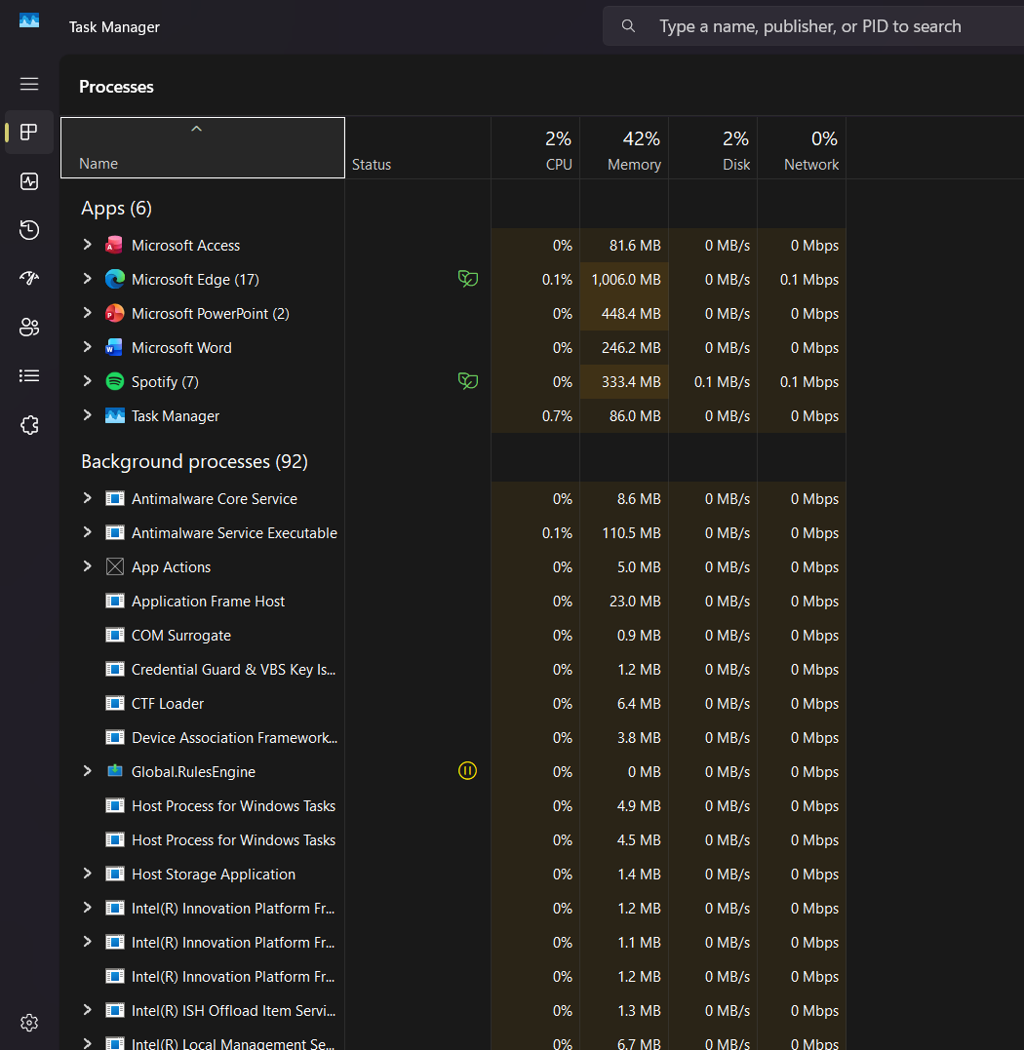

I used the Processes tab to check the programs running on my computer and see their CPU and memory use.

Memory Management

Windows controls how RAM is used by the programs that are open. It provides memory while a program is running and makes that memory available again when it is no longer required [1].
I used the Memory section in Task Manager to check how much RAM was being used and how much was available. The values changed depending on the programs that were open. This helped me see how running several applications can increase memory use [1].

Figure 2: Windows Task Manager showing memory usage
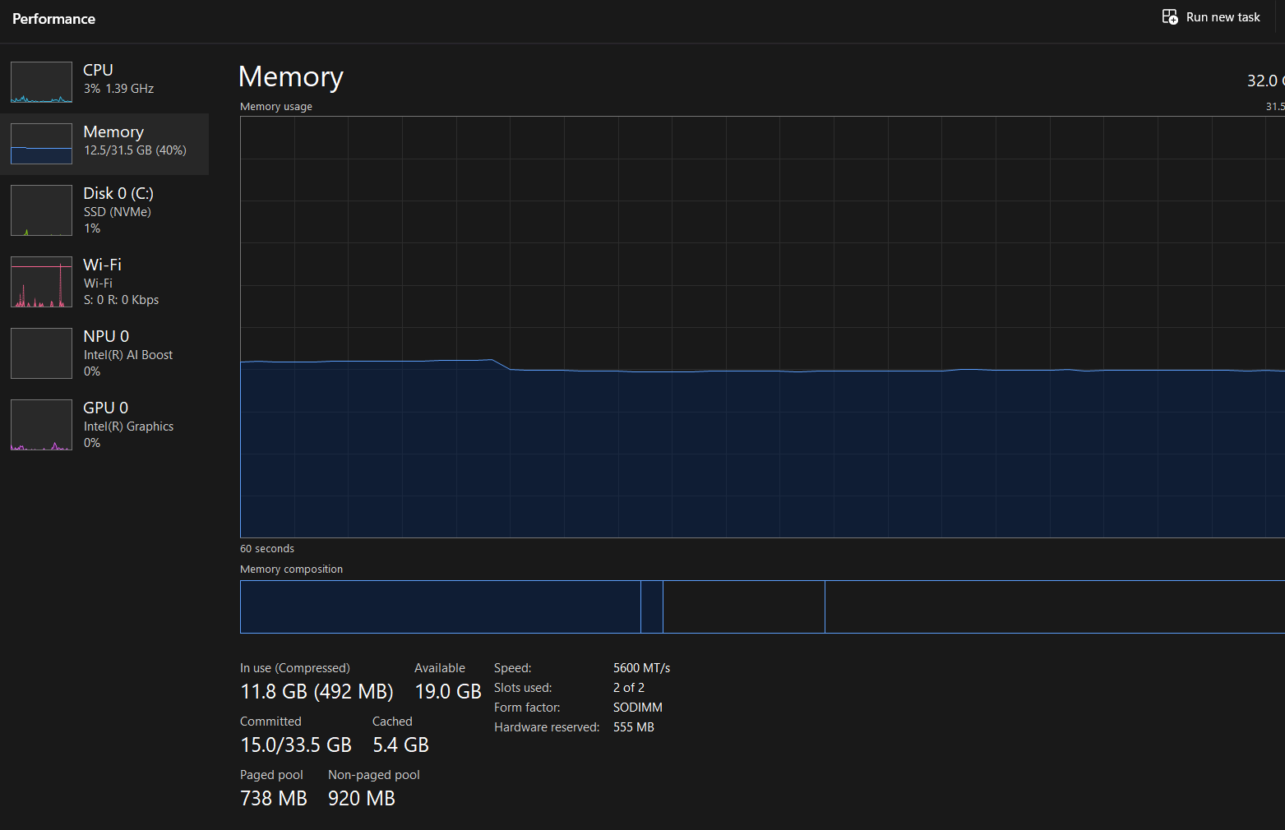
The Memory section shows the RAM currently in use and the amount still available.

File System Management

The operating system helps users manage the files stored on the computer. Files can be placed in folders, opened, copied, moved, renamed or removed when needed [2].
I used File Explorer to view folders such as Documents, Downloads, Desktop and Pictures. I could also see my university work saved in the Documents folder. This helped me check where my files were stored and move between folders easily [2].

Figure 3: Files and folders displayed in the Windows Documents folder
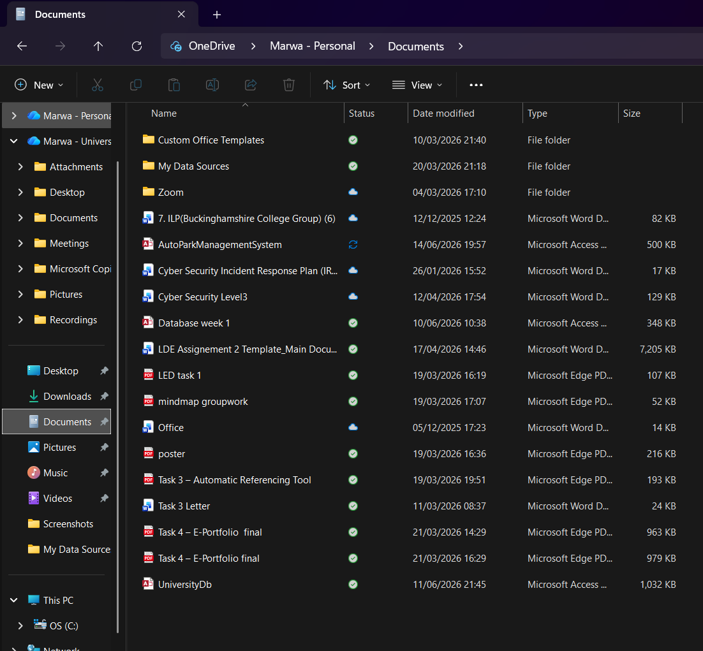
I used the Documents folder to view my files and see how they are stored in different folders.

1.4 Security and Protection

I opened Windows Security and checked the different protection sections. I could see Virus & threat protection, Firewall & network protection, Account protection and App & browser control. This helped me check the security status of my computer and see if Windows reported any problems [3].
Figure 4: Main protection sections shown in Windows Security
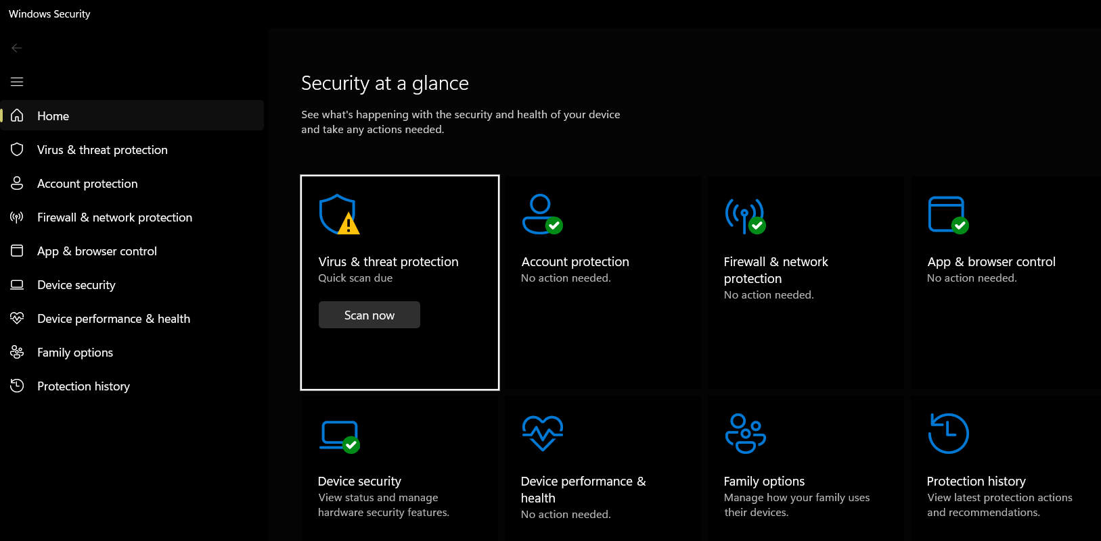
The Windows Security dashboard shows the main areas where security settings can be checked and managed.

Use of Windows OS CLI commands.

I tested different commands using Windows Command Prompt on my computer. I used them to look at system information, processes, files, network details, user accounts and scheduled tasks [4].

- systeminfo: I used the systeminfo command to check basic information about my computer and operating system. The result showed that my computer uses Windows 11 Pro, a 64-bit system and around 32 GB of physical memory. This command displayed the main system details in one place.
Figure 5: The systeminfo command showing Windows and computer information
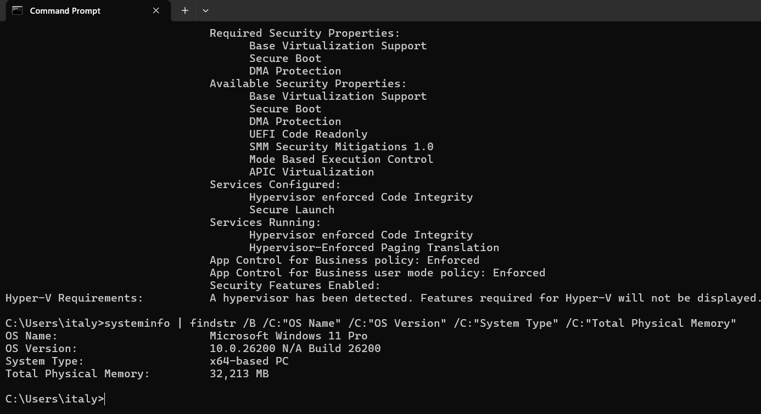
Input
Output

- tasklist: I used the tasklist command in Command Prompt to view the processes running on my computer. The result showed the name of each process, its process ID and the amount of memory it was using. This command gave me a text-based view of running processes without opening Task Manager.
Figure 6: The tasklist command showing running processes in Windows
Input
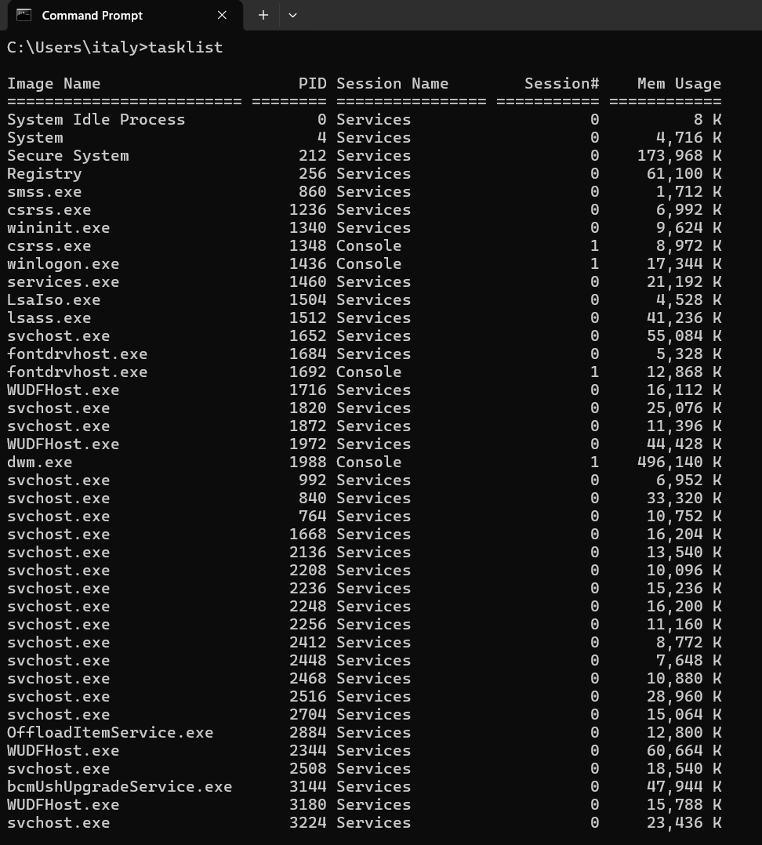
Output

- Ipconfig :I used the ipconfig command to check the network connection on my computer. The result showed the Wi-Fi adapter, IPv4 address, subnet mask and default gateway. It also showed that some other network adapters were disconnected. This command is useful for checking basic network information and finding connection problems.
Figure 7: The ipconfig command showing Windows network information
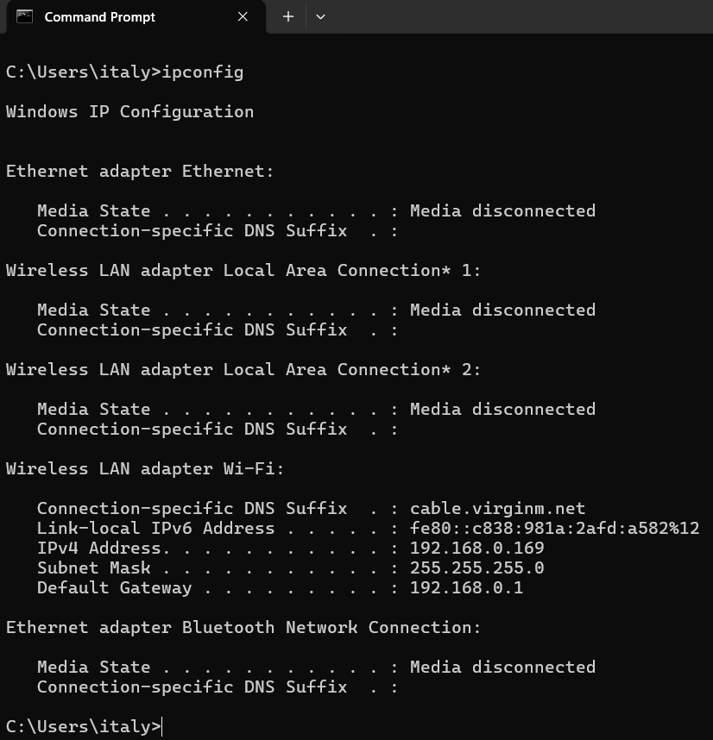
Input
Output
- Dir: I used the dir command to check what was inside the current folder. It showed the folders and files in that location, including Documents, Downloads, Music, OneDrive and Videos. It also displayed the available storage space. I found this useful for checking folder contents without opening File Explorer.
Input
Figure 8: The dir command showing folders in the user directory
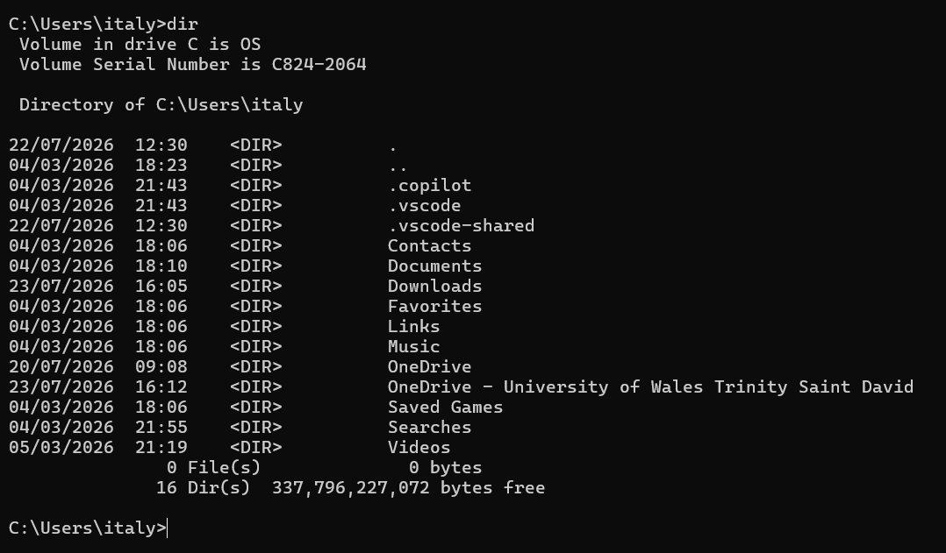

Output
- Ping: I used the ping command to test the network connection. The result showed four replies, with no lost packets and an average response time of 23 milliseconds. This confirmed that the computer was connected to the network and could communicate successfully.
Figure 9: The ping command testing the network connection
Input

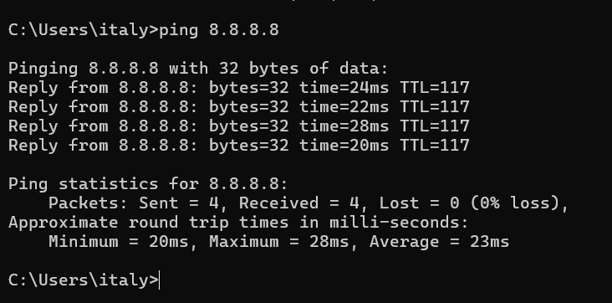
Output

- Taskkill: I used the taskkill command to close Notepad++ from Command Prompt. The /IM option selected the process by its name, while /F forced the program to close. The result confirmed that the process was terminated successfully.
Figure 10: The taskkill command closing a running process in Windows

Input
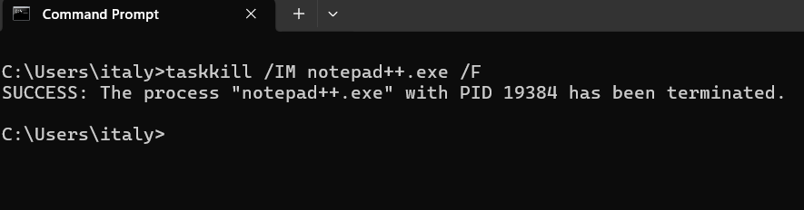
Output
- Whoami: I used the whoami command with the /user option to check the current Windows user account. The result showed my username and the security identifier, known as the SID. Windows uses this identifier to recognise and manage each user account.
Figure 11: The whoami command showing the current Windows user account
Input
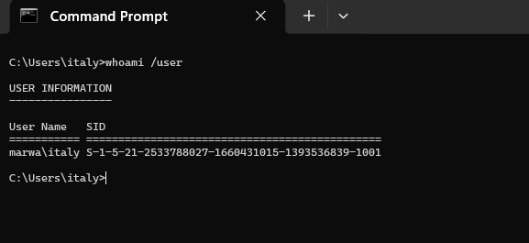
Output

- Net: I used the net user command to check the user accounts on my computer. The result showed my main account and other Windows accounts that are available on the system. This helped me see which user accounts were set up.
Figure 12: Windows user accounts displayed using the net user command
Input
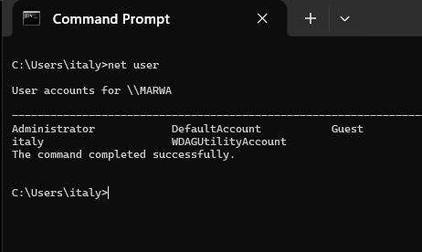
Output

- Schtasks: I used the schtasks command with the /query and /fo TABLE options to check the scheduled tasks on Windows. The result showed the task names, their next run time and their current status. This helped me see which tasks were set to run automatically.

Figure 13: Scheduled Windows tasks displayed using the schtasks command
Input
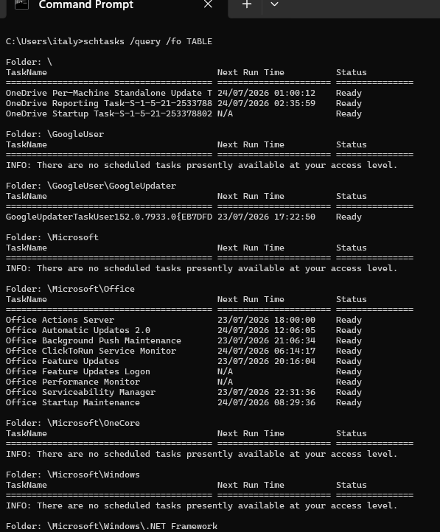
Output

- Mkdir : I used the mkdir command to create a new folder called CLI_Test. The command completed without an error, which showed that the folder was created successfully. This command is useful for creating folders from Command Prompt.
Output: No message was displayed because the command completed successfully.

Figure 14: The mkdir command creating a new folder in Windows

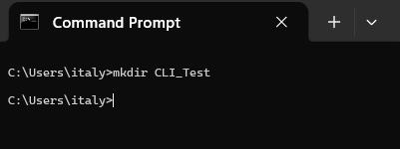
Input

- Echo : I used the echo command to create a text file called test.txt inside the CLI_Test folder. The > symbol sent the written text into the file. This command can create a simple file without opening a text editor.
Output: No message displayed
Figure 15: The echo command creating a text file in Windows

Input
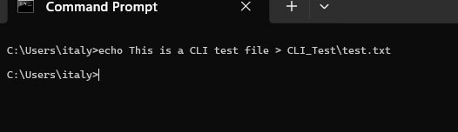

- Copy: I used the copy command to create another version of test.txt. The copied file was saved as test_copy.txt. I used the /Y option so Windows could replace an existing file without asking me again. The result confirmed that the file was copied successfully.

Figure 16: The copy command creating a copy of a text file

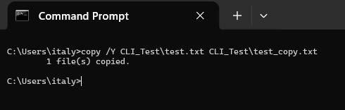
Output
Input

Use of Linux OS CLI commands.
For this task, I used Ubuntu through Windows Subsystem for Linux to test different Linux commands. I used the commands to check system information, running processes, files and folders, network settings, user details and scheduled tasks [5].

- uname: I used the uname command with the -a option to view information about the Linux system. The result showed the Linux version, system name and 64-bit architecture. This command gives basic system information in one line.
Figure 17: The uname command showing Linux system information
Input
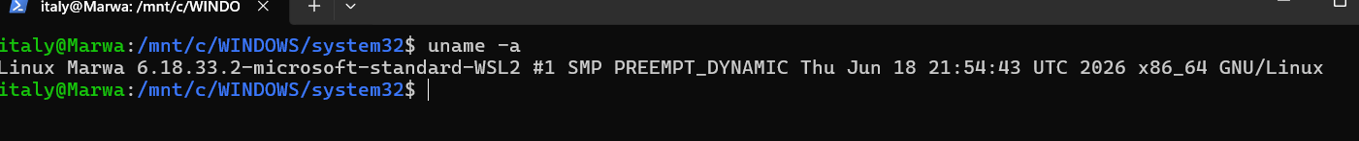
Output

- ps: I used the ps command with the -ef options to view running processes in Linux. I also used head -n 5 to show only the first five results. The output showed the user, process ID and command for each process.
Figure 18: The ps command showing running Linux processes
Input

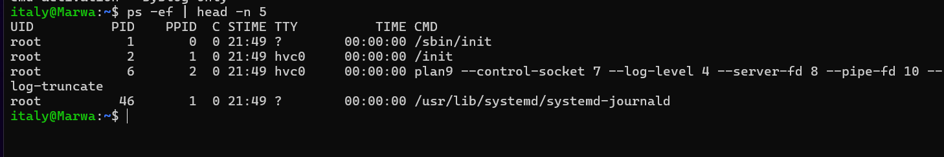
Output
- mkdir: I used the mkdir command with the -v option to create a new folder called Linux_CLI_Test2. The result confirmed that the directory was created successfully. This command is useful for creating folders in Linux.
Figure 19: The mkdir command creating a new Linux directory
Input
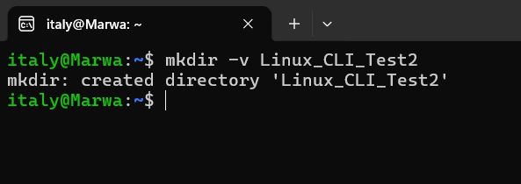
Output

- ls: I used the ls command with the -l and -d options to view details about the Linux_CLI_Test2 folder. The result showed the folder permissions, owner, size and last modified date.
Figure 20: The ls command showing Linux directory details
Input

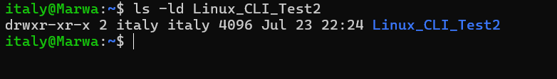
Output

- echo :I used the echo command with tee to create a text file inside the Linux_CLI_Test2 folder. The text was written into a file called test.txt and also displayed in the terminal.
Figure 21: The echo and tee commands creating a Linux text file
Input

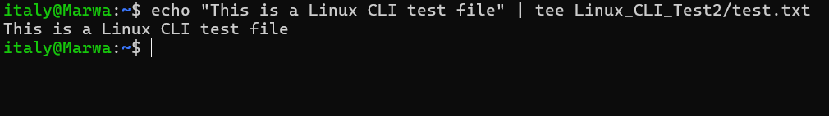
Output

- cp: I used the cp command with the -v option to copy the test.txt file. The new copy was saved as test_copy.txt. The result showed the original file and the new copied file.
Figure 22: The cp command copying a file in Linux
Input

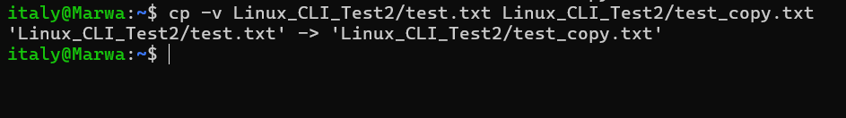
Output
- ping: I used the ping command with the -c 4 option to test the network connection. The command sent four packets and received four replies with no packet loss. This showed that the Linux system was connected to the network.
Figure 23: The ping command testing the Linux network connection
Input
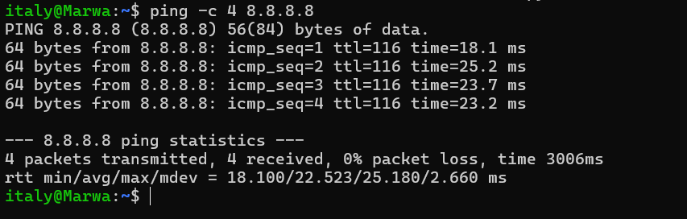
Output

- id: I used the id command with the -u and -n options to check the current Linux user. The result showed the username italy. This command is useful for checking which account is active.
Figure 24: The id command showing the current Linux user
Input
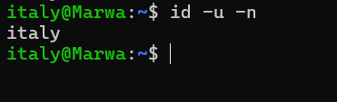
Output

- systemctl: used the systemctl command to view scheduled tasks in Linux. The --all option showed all timers, and head -n 8 limited the result to the first eight lines. The output showed the next run time and the service linked to each timer.
Input
Figure 25: The systemctl command showing scheduled Linux tasks
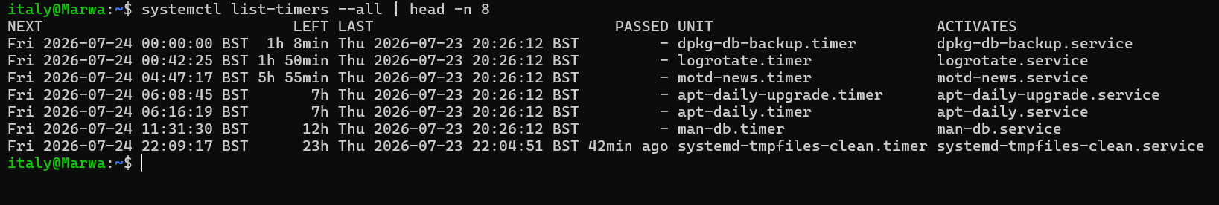
Output

- Ip: I used the ip command with the -brief option to view the Linux network interfaces. The result showed the loopback interface and the active eth0 connection with its IP address. This command gives a short and clear view of the network settings.
Figure 26: The ip command showing Linux network interfaces
Input

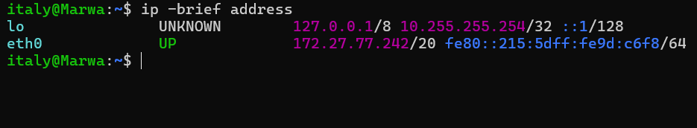
Output

- Top: I used the top command with the -b and -n 1 options to check Linux system activity. The result showed CPU usage, memory usage and some running processes. I also used head -n 8 to keep the output short and clear.
Input
Figure 27: The top command showing Linux system activity
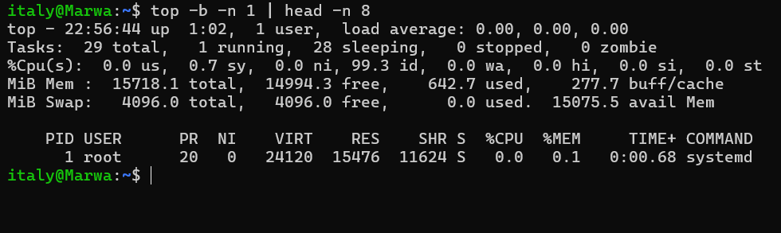
Output

- Mv: I used the mv command with the -v option to rename the copied file. The file name changed from test_copy.txt to test_renamed.txt. The result confirmed that the file was renamed successfully.
Figure 28: The mv command renaming a file in Linux
Input

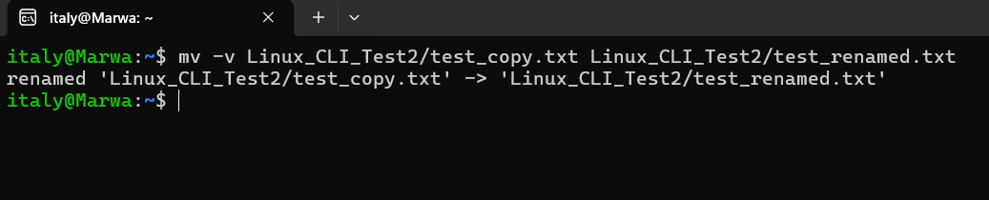
Output

Use of Windows OS scripts.

I made two Batch scripts in Windows to practise automating simple tasks. In the scripts, I used variables, user input, calculations, loops and conditions.

Script 1: System Health Check

I created a Batch script called System Health Check. It asks the user for a name and the number of network tests. It then checks the Windows version, memory, free storage space and network connection.
Figure 29: Batch code for the System Health Check script

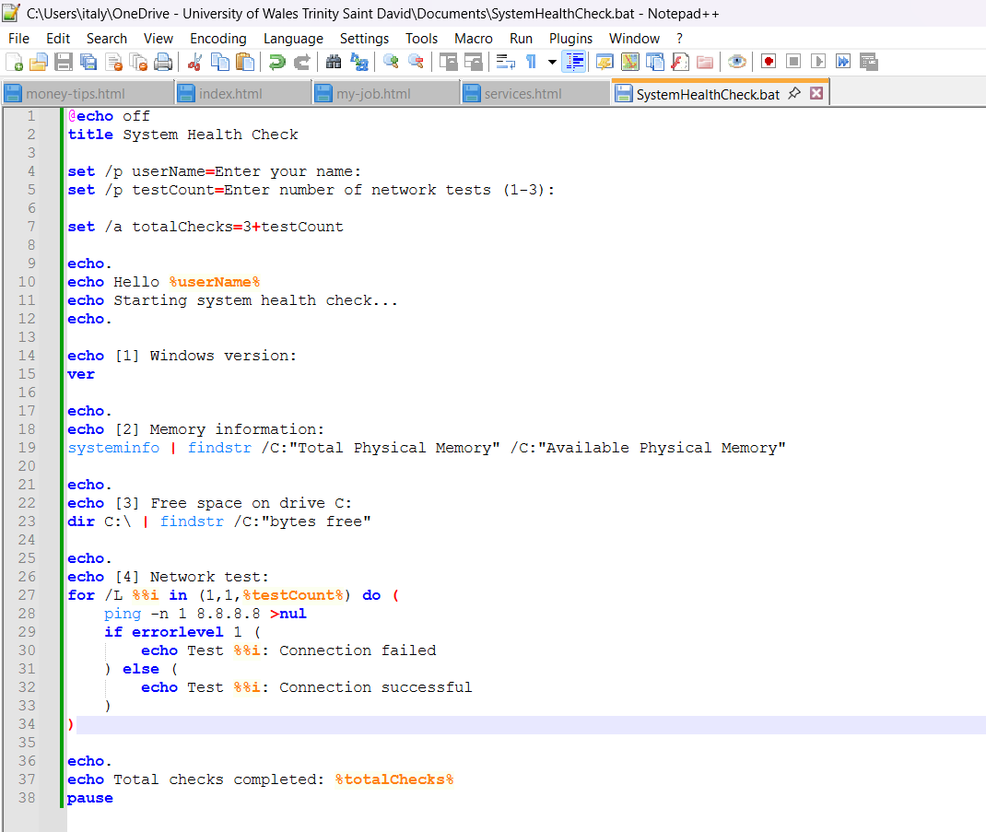

The script ran successfully after I entered my name and selected two network tests. It showed the Windows version, memory information, free storage space and the network test results. Both network tests were successful, and the script calculated that five checks were completed.
Figure 30: Output of the System Health Check Batch script
Input
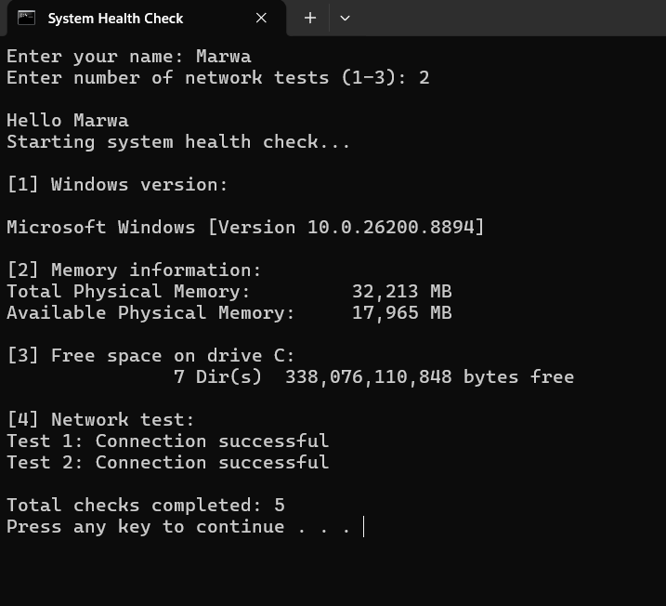
Output

Script 2: File Backup Manager

I created a Batch script called File Backup Manager. It asks the user to enter a name and choose how many files to create. The script creates a backup folder, uses a loop to create the files and shows a message after each file is completed. It also uses a condition to check the number entered and calculates the total number of items created.
Figure 31: Batch code for the File Backup Manager script

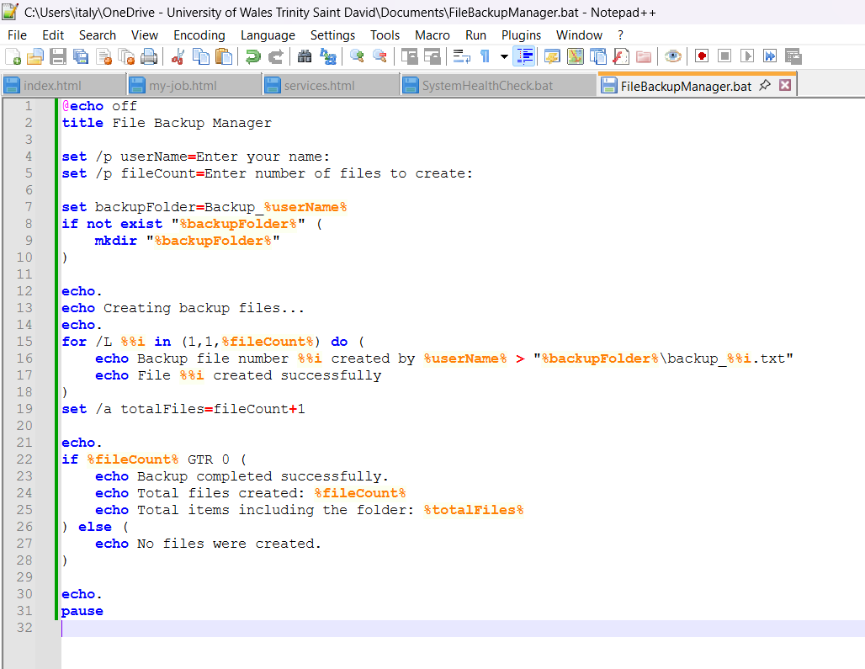

The script ran successfully after I entered my name and selected three files. It created a backup folder and three text files. The script displayed a message after each file was created and calculated that four items were created in total, including the folder.
Figure 32: Output of the File Backup Manager Batch script

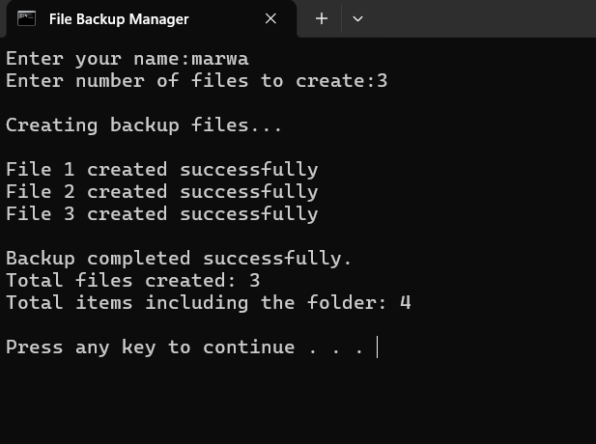
Output
Input

Both Batch scripts worked successfully. They helped me practise using variables, user input, calculations, loops and conditions to automate simple tasks in Windows.

Use of Linux OS scripts.
For this task, I created two Bash scripts in Ubuntu to practise simple Linux automation. The scripts used variables, user input, calculations, loops and conditions to complete basic tasks in the terminal.

Script 1: Linux System Information

I created a Bash script called Linux System Information. It asks the user to enter a name and then shows the Linux version, current user, memory information and storage information. The script also uses a calculation and a condition to display the total number of checks completed.
Figure 33: Bash code for the Linux System Information script
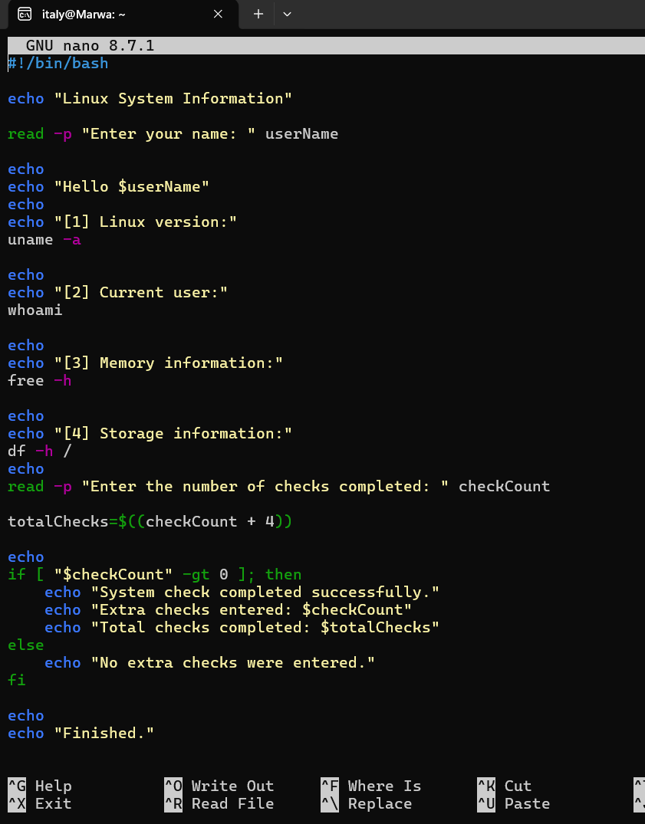

The script ran successfully after I entered my name and selected two additional checks. It displayed the Linux version, current user, memory information and storage information. The script then calculated the total number of checks and confirmed that the system check was completed successfully.
Figure 34: Output of the Linux System Information Bash script

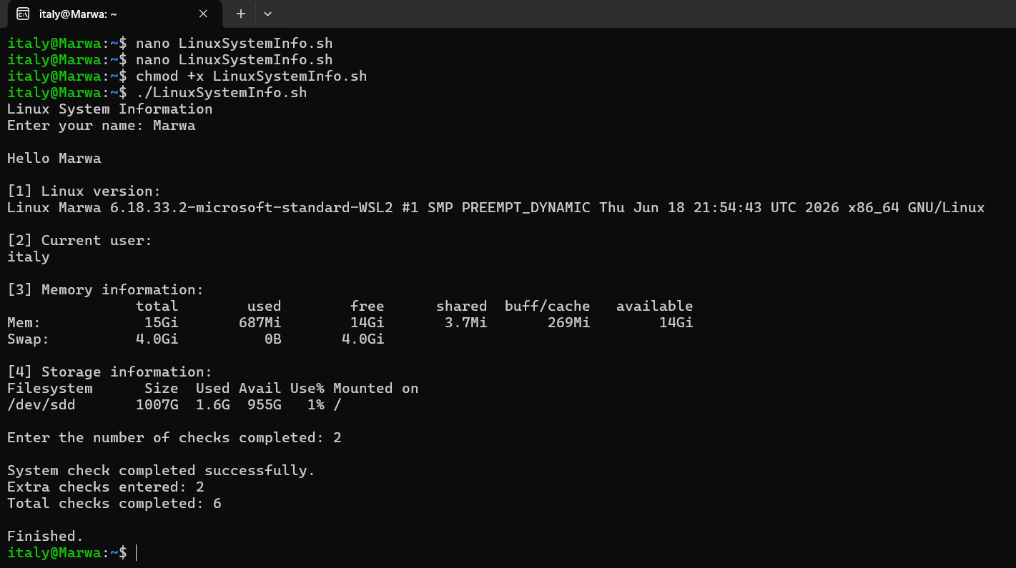
Input
Output
Input
Output

Script 2: Linux File Creator

I made a Bash script called Linux File Creator. The script asks for my name and how many files I want to create. It makes a folder and then uses a loop to create the files one by one. It also checks the number entered and shows the total number of items at the end.
Figure 35: Bash code for the Linux File Creator script
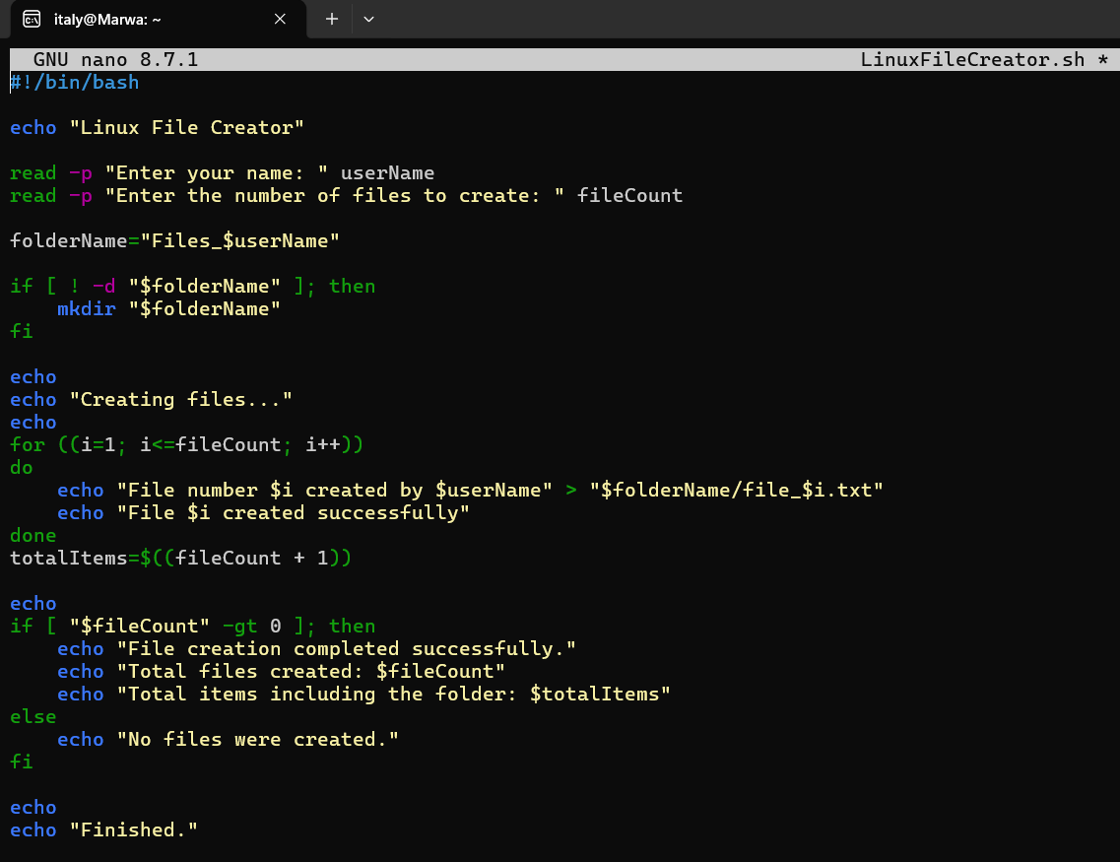

The script ran successfully after I entered my name and selected three files. It created three text files inside a new folder and displayed a message after each file was created. The script also calculated that four items were created in total, including the folder.

Figure 36: Output of the Linux File Creator Bash script

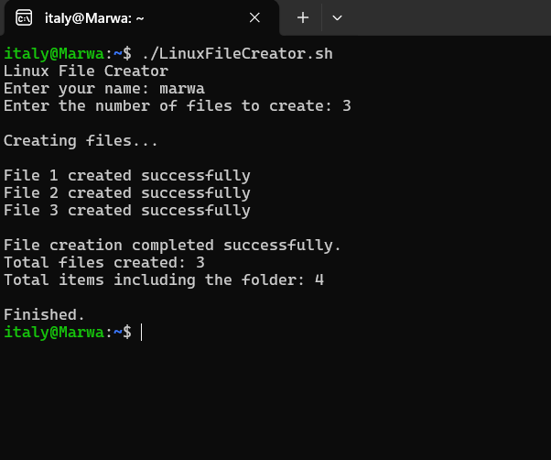
Input
Output
Both Bash scripts worked successfully. They helped me practise using variables, user input, calculations, loops and conditions to complete simple tasks in Linux.

Conclusion
In this report, I learned about the main functions of operating systems and completed practical work using Windows and Linux. I looked at process management, memory management, file management and security. I used tools such as Task Manager, File Explorer and Windows Security to see how these functions can be checked and managed on my computer.
I also used different commands in Windows Command Prompt and Ubuntu. These commands helped me check system information, running processes, network settings, user accounts, files, folders and scheduled tasks. I used commands with options and switches and took screenshots of the commands and their results. At first, some commands were new to me, but after testing them several times, I understood them better.
Another important part of this assignment was creating two Batch scripts in Windows and two Bash scripts in Linux. The scripts used variables, user input, calculations, loops and conditions. They completed simple tasks such as checking system information, testing the network, creating folders and creating files automatically. I also fixed some errors when the scripts did not work correctly. This showed me that small mistakes in the code or file location can stop a script from working.
I also learned how to install and use Ubuntu through Windows Subsystem for Linux. This allowed me to practise Linux commands on my Windows computer without needing another device. Using Windows Command Prompt and the Linux terminal helped me understand the differences between the two command-line environments.
I used Microsoft Learn to review Windows commands, loops and conditions. I also used Ubuntu Tutorials to learn more about the Linux terminal, folders and files. These online resources supported the practical work I completed in the report.
Overall, this assignment improved my understanding of operating systems, command-line tools and simple automation. The practical tasks and screenshots helped me learn because I could see the commands working on my own computer. I now feel more confident using Windows and Linux commands and creating simple scripts.

References

[1] | M. Learn, “Task Manager,” Microsoft, [Online]. Available: https://learn.microsoft.com/en-us/shows/inside/task-manager. [Accessed 14 06 2026].
[2] | M. Support, “Stay protected with the Windows Security app,” Microsoft, [Online]. Available: https://support.microsoft.com/en-us/windows/stay-protected-with-the-windows-security-app-2ae0363d-0ada-c064-8b56-6a39afb6a963. [Accessed 14 06 2026].
[3] | M. support, “File Explorer in Windows,” Microsoft, [Online]. Available: https://support.microsoft.com/en-us/windows/file-explorer-in-windows-ef370130-1cca-9dc5-e0df-2f7416fe1cb1. [Accessed 14 06 2026].
[4] | Microsoft, “Windows Commands,” Microsoft Learn, [Online]. Available: https://learn.microsoft.com/en-us/windows-server/administration/windows-commands/windows-commands. [Accessed 2026 07 20].
[5] | Canonical, “The Linux command line for beginners,” Ubuntu Tutorials, [Online]. Available: https://ubuntu.com/tutorials/command-line-for-beginners#7-the-command-line-and-the-superuser. [Accessed 20 07 2026].

Appendices

Appendix A – Windows Learning Evidence

I used Microsoft Learn to understand Windows commands and Batch scripting. The pages helped me review general Windows commands and learn how loops and conditions are used in Batch files.

The first page gave me a general overview of Windows commands and explained how commands can be used in scripts to automate tasks.
Figure 37: Microsoft Learn page showing Windows Commands

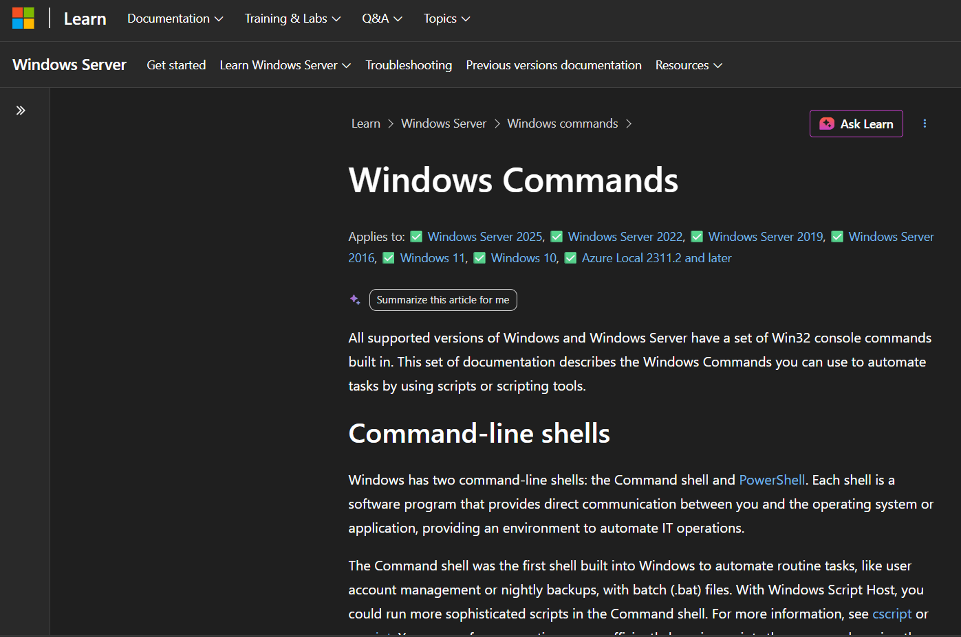

The second page explained the for command. I used this command in my Batch scripts to repeat actions and create several files.
Figure 38: Microsoft Learn page showing the Windows for command

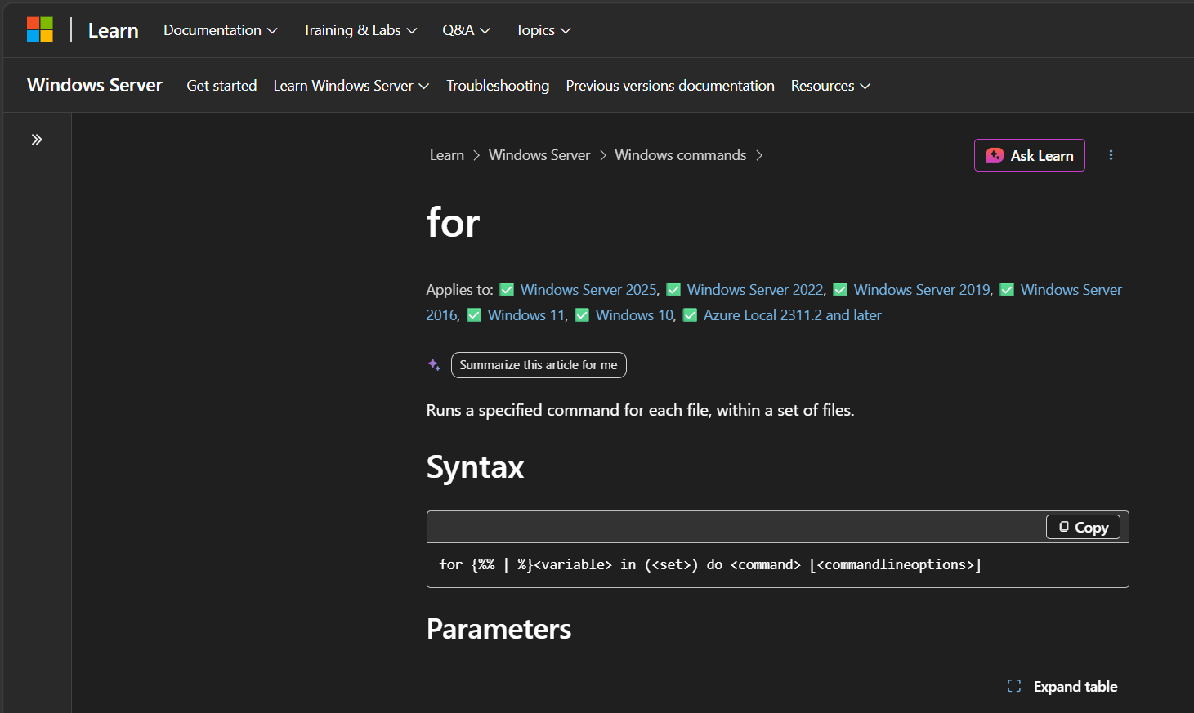

The third page explained the if command. I used this command in my scripts to check conditions and display different results.
Figure 39: Microsoft Learn page showing the Windows if command

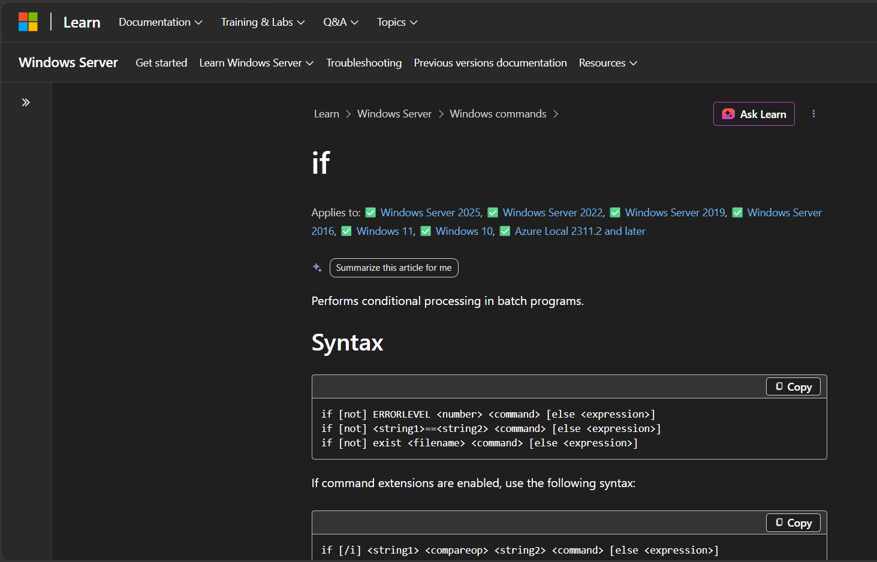

Appendix B – Linux Learning Evidence

I used the Ubuntu Tutorials website to learn more about the Linux command line and Bash scripting. The tutorials helped me understand the Linux terminal, basic commands and file management used in this report.
The Ubuntu tutorial introduced the Linux command line and explained the basic topics needed to start using Linux commands.
Figure 40: Ubuntu Tutorials – The Linux command line for beginners

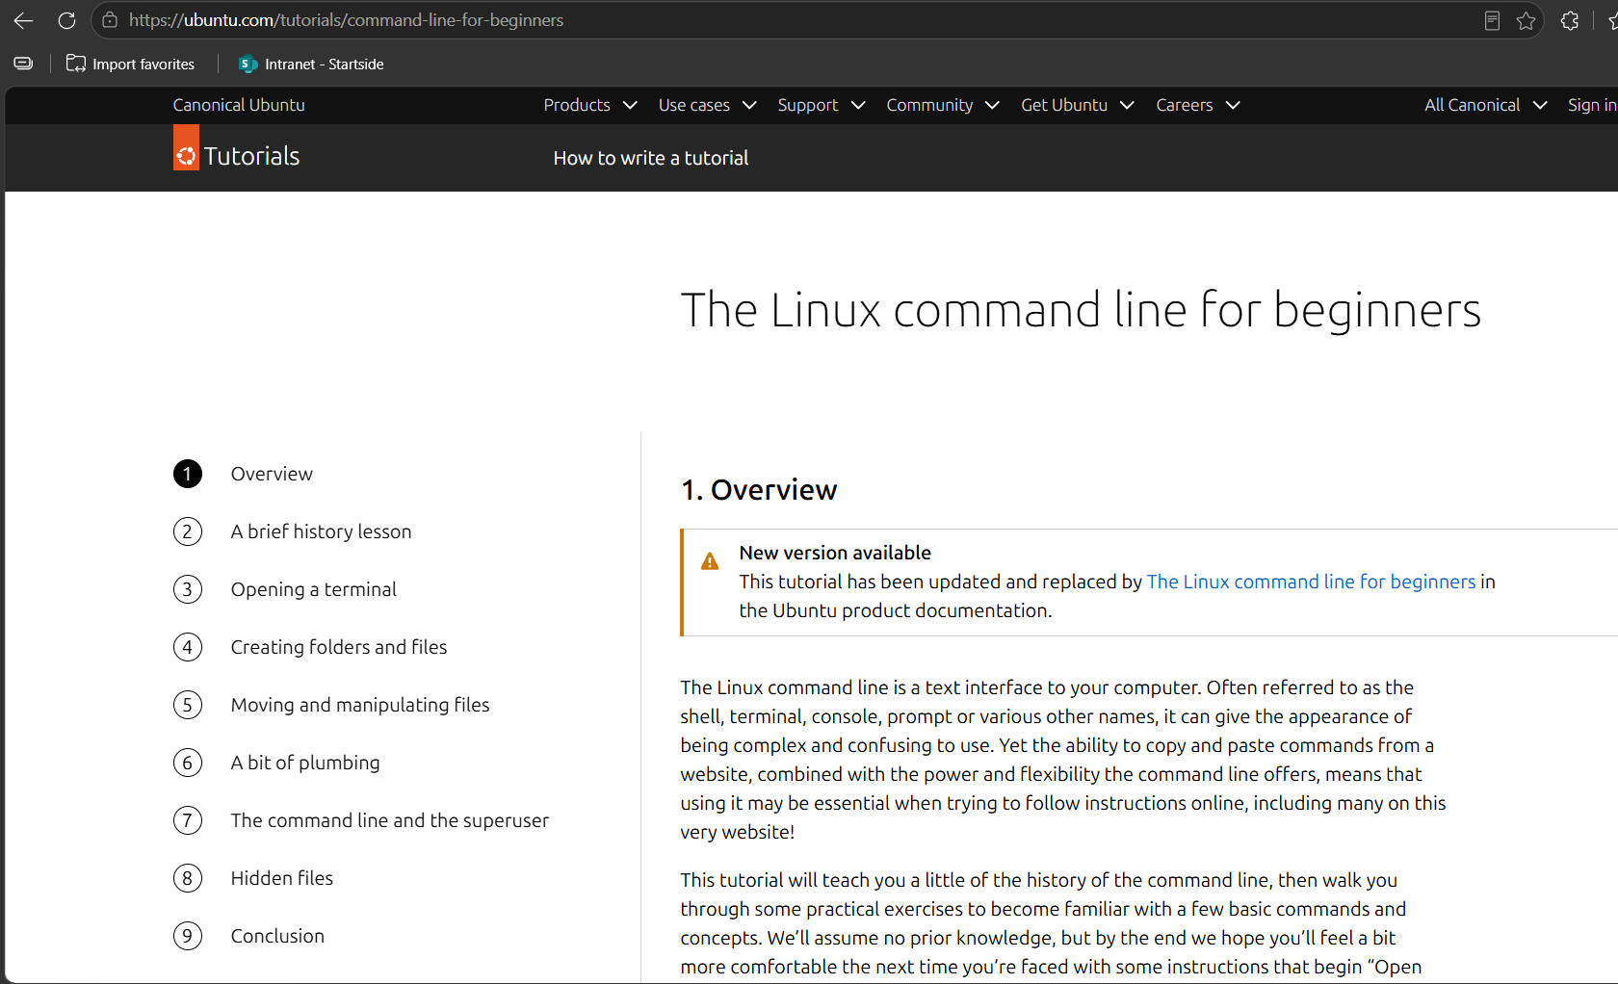

This page explained how to create folders and files in Linux using basic commands such as mkdir. This helped me understand the file creation tasks used in my Bash script.
Figure 41: Ubuntu Tutorials – Creating folders and files

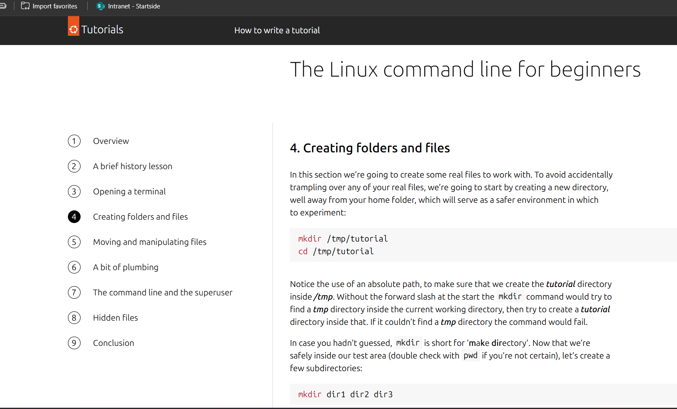

This page explained how to open the Linux terminal before running commands and Bash scripts. This helped me practise the Linux commands used in this assignment.
Figure 42: Ubuntu Tutorials – Opening a terminal



