
1701121

What helps me learn language and mathematics? : An analysis of a child’s learning in mathematics and language with recommendations for ensuring progress.

This essay will critically analyse a child’s perception and progress within mathematics and language over a period of four weeks. The evidence will be used to derive information that will be used to inform future planning and will be used to improve my own approaches to teaching language and mathematics within the Primary School Sector. Tarrant (2013) states that reflection allows for professional development which is crucial for educators and teachers.

To ensure this essay is within the British Educational Research Association (BERA, 2018) guidelines, the pupil and school will remain anonymised and will be referred to as Child A and School A. Child A was explicitly made aware that his participation was not compulsory and he was made aware of his right to withdraw from any further research from the beginning.

The pupil being discussed throughout this essay is a ten year old boy within a year five class, he is an average attaining pupil within a mainstream school in South Wales. The school is a large school and is currently adapting their methods and approaches to teaching for the new curriculum proposed by Donaldson (2015).

In order to collect a range of data, the Mosaic Approach (Clarke and Moss, 2001) was implemented to an extent to collect the evidence for this essay. Interviews, as shown within the appendix, were held with Child A to gain a child’s perspective on learning mathematics and language. Observational notes were also made and completed work was collected from Child A to see how he learned Mathematics and Language. This essay will look into the differing attitudes, skills, knowledge (ASK) and the effects of these upon the way a child learns mathematics and language. Nottingham (2013) argues that when ASK is developed within a learner then they will be more successful within their learning.

Mathematics is arguably one of the most important subjects within education as it allows children to “make sense of the world around them” (Donaldson, 2015: p.49). This is also supported by Ofsted (2012) who state that mathematics in education aims to enable all pupils to develop their conceptual understanding of mathematics, which therefore validates the need to improve standards of teaching the subject within schools.

The skill being developed was to ‘divide 3-digit numbers by a single-digit number’ (Welsh Government [A], 2016: p5), this was a new skill being taught to the class so a lot of whole class interaction and involvement was used to try and convey the method behind developing the skill. This skill was being developed over the course of a week to allow the learners to absorb and remember the methods and approaches to division. Social-constructivist approaches were used at times to allow the learners to consolidate their own learning within the lesson, such as think, pair share. Child A stated that he enjoyed working on a problem with his friend as it allowed him to feel more confident in the answer (Appendix 1). This therefore shows that cooperation and teamwork allow for successful learning within Mathematics as it develops one's confidence. However it can be argued that by allowing students to work within pairs often they are not fully participating within the activity and therefore are not developing their skills. This therefore stresses the need to improve classroom management to ensure all learners are on task when completing group work.

When given the opportunity to work with his partner, Child A enjoyed talking with his partner explaining to him how he got the answers (Appendix 1). This allowed Child A to consolidate his own learning and in turn teach another pupil his methods of obtaining the answers. Child A was able to use his social skills to help other pupils, this type of learning is supported by Hopkins (2007) who stated that teachers should give learners opportunities to talk about what they are doing to consolidate their own understanding, which is supported further by Smith (2010) and Vygotsky (Dolya, 2010). However, Wright (2009) argues that social-constructivism is only effective when the learners are engaging within ‘interactivity’ which enables them to be more active within their learning. This therefore stresses that although it is useful for conversations to occur about the work but a clear guide has to be set out by the teacher to enable effective communication and consolidation of a child’s understanding.

In relation to the ASK model mentioned afore, the attitudes of the learner within mathematics were observed. Child A expressed that he enjoyed learning mathematics because he enjoyed finding the answers to difficult problems and gaining praise from finding the answer (Appendix 1). This enjoyment in the subject can be seen as motivating (Dean, 2001), however when the learning becomes too demanding the learner can become very stressed which leads to a decrease in the memorable information obtained from the work (Pu, 2009). This is supported further by Goleman, as cited in Pound and Lee (2010), who infers that learning requires emotional engagement and motivation with a suitable amount of stress to allow learning to take place effectively. This therefore shows that there is a link between the attitude of the learner and the learning taking place, if there was no motivation within the student then they would be less willing to participate (Liu, Bridgeman and Adler, 2012).

The learner was developing his understanding of dividing three-digit numbers by a single digit number using the bus-stop method (Appendix 3). As this was a new topic for the learner, he was intrigued and motivated to learn, however within the final lesson, he expressed that he was ‘bored’ of doing division and therefore he lost concentration in completing his work (Appendix 1). When asked what he found boring, he stated that he felt that he was not being challenged enough and felt as though he was more than able to complete the tasks (Appendix 1). This shows that in order for the pupil to develop, the work needs to be more challenging to encourage a more fulfilling and challenging environment. Bethune (2018) argues that the stretch zone allows students to come out of their comfort zones and allows them to be within a purposeful and suitably challenging task for the learner. However, it can be argued that the student’s emotions can have an impact of the level of stress to be obtained within that lesson, for example if a learner is having family problems the likelihood of them wanting to participate within learning is very low.

Child A showed traits of having a fixed mindset and often did not ask for help when he required it, this impacted his learning because when he struggled within the division he was afraid of being ‘told off for not understanding’ (Appendix 1). This shows that the learner did not have a growth mindset and this impacted on his learning. Nottingham (2013) argues that in order for a child to develop their own learning then they need to see failure as a positive thing rather than a negative, as it allows the children to learn from their mistakes. Boaler (2016) also supports this view as she believed that children often achieve a lot more when they have a growth mindset. Thus by Child A having a fixed mindset, his learning is heavily affected as he views failure as being wrong whereas if he was encouraged to see it as a stepping stone, he would have a much more positive attitude to learning.

Child A was very knowledgeable with multiplication, this should have allowed him to understand the bus stop method. However, within the first session this connection was not made explicitly clear to Child A due to lack of explanation on behalf of myself. This therefore left him confused within the task as shown within Appendix 3. Haylock (2007) argues that through making connections between previously learned knowledge and new knowledge, understanding becomes more visible to the learner. This therefore implies that in order for the learner to gain understanding the connection needs to be made clear. This theory was implemented within the next session (Appendix 4) where the connection between multiplication and division was explicitly stated to Child A. Once this link was made, the learner explained how he understood the work and how he felt confident in using multiplication to help him when using division (Appendix 1).

Overall, within Mathematics communication within groups allows the learner to consolidate his own learning and allows him to have a deeper understanding. Connections and links from prior knowledge need to be addressed to the learners to allow them to gain understanding of new topics. In addition to this, learners need to be made aware that in order to be a successful learner they must see failure as a positive way of changing their approaches.

This section will analyse the learner’s own approaches to developing language and gaining understanding from content as shown within Appendix 6 and 7. This section has been divided into three subsections to show the continuity of Child A’s language capabilities. Donaldson (2015) and Barnes (2015) argue that language needs to be included within all aspects of the curriculum where deemed acceptable, this is to ensure meaningful experiences take place which encourage further engagement within activities (Pound, 2006). Therefore the analysis of Child A’s language will discuss the learners progress within his classroom experience rather than within a specific Language lesson. This section will be divided into the strands within the English KS2 framework, oracy, reading and writing.

Woolley (2014) argues that oracy is the underpinning skill that pupils need to progress within both reading and writing, this therefore emphasises the need to develop a learners oracy skills before they are asked to complete written work. Child A was a confident individual and enjoyed communicating with his fellow classmates. Although he found talking in front of the class embarrassing to an extent, he felt like he was quite confident when he knew what he was talking about (Appendix 2). Within the experience, Child A was observed giving a classroom presentation about a topic of his own choice. He stated he enjoyed this as it was something he knew a lot about and because he was allowed to decide what to talk about, it allowed more freedom (Appendix 2). The enthusiasm that was portrayed within his voice throughout the presentation showed that he was confident and he was interested in what he was talking about. Child A stated that he would prefer language tasks a lot more if he was given opportunities to decide on what he wanted to learn as he felt this was something he was not given much options within (Appendix 2). Gipps, McCallum and Hargreaves (2000) believe that when a learner has control over their learning they gain independence and they are more willing to learn within lessons. This view is supported further by Donaldson (2015) who states that learners should be encouraged to become independent learners and be given more opportunities to have choice in their learning.

In relation to this, Child A spoke how he enjoyed using ICT within his presentation as it made the learning more enjoyable as it was more visually pleasing (Appendix 2). The Welsh Government (2016) states that learners should be given opportunities to develop their ICT skills within their Language and Mathematics sessions, therefore it is a recommended and effective way of making the learning more enjoyable for children. Estyn’s (2013) case studies prove that there is a clear improvement within Language skills when ICT is used for projects, this therefore shows that a cross-curricular approach is effective and beneficial for learners within language. Barnes (2015) argues that cross-curricular activities allow learners to participate within meaningful tasks to develop multiple skills.

Within an interview Child A explained how he enjoyed reading at home and how he read aloud to his parents for half an hour a day. This therefore shows that his engagement with other literacy allows him to understand meaning behind texts a lot more, it also suggests his fluency and letter recognition would be a lot quicker than a child that does not read as often which would lead to a better understanding and representation of the text. The engagement from the learners parent’s allows the learners to become effective language learners (Wray et. al, 2002), this view is supported further by Hattie (2012) as this active learning at home allows for increased opportunity to develop skills.

Child A completed a comprehension activity which asked questions around an extract read within class (Appendix 6 and 7). Child A discussed how he found it helpful to highlight the key words within the text in order to find the answer to the questions, this therefore shows that the learner was able to scan the work to find key words and highlight where appropriate. The highlighter allowed the learner to isolate these words and then use these to derive meaning from what was being said to answer the questions (Oakhill and Beard, 1999).

When discussing writing with Child A, he often rolled his eyes as he was not interested within the topic at all. I asked him why he did not like writing and he explained how he found it boring and he stated he did not feel confident within his abilities to think creatively (Appendix 2). However he spoke about how he felt comfortable writing when he was given a structure to follow and this helped him plan his thoughts before writing. This form of scaffolding can be supported by various social-constructivist theorists such as Vygotsky (Jordan, Carlile and Stack, 2008) as it allows the learner to gain confidence within the topic before they are eventually given independence to work alone on the work.

Child A’s understanding of writing is to a good level, however the way his work is portrayed within his books could be developed greatly. Within the school, learners are encouraged to write within cursive handwriting, Child A is able to write within cursive handwriting. However, as the handwriting is defined as being a very important aspect within his classroom often spelling, punctuation and grammar are forgotten. The child states that the most important thing about writing is being to understand the writing being written. This therefore impacts the learners views on writing as it shows that he is focusing on his handwriting within lessons rather than focusing on his actual content. From observations the learner struggles to remember the concepts within a sentence such as capital letters and the ability to form a complete sentence.

From the analysis of a learner, I have personally encountered recommendations and methods for my own teaching practice to help develop learners understanding of both mathematics and language. From observations, informal interviews and analysis of Child A’s work, the best fit level of attainment for Child A would be borderline level four and five within mathematics as the learner was able to ‘mentally recall multiplication facts to 10x10’ (Welsh Government[A], 2016: p.13) and was able to use place value to divide whole numbers. However, this analysis of the learner is not an accurate representation of the learners abilities because the study was only carried out for a number of weeks, in order to get the most accurate leveling of the pupil then his progress would need to be analysed over the course of a year.

In order to progress Child A further within Mathematics, more challenging work would need to be provided. For example, within Appendix 4 the learner was given division problems that he was able to work out easily, to progress this further I could adapt the work given by showing realistic problems that would need to be solved using division. Such as a football problem as it would link to his personal life and would engage him within the activity. This would also allow him to use his independent thinking skills to work out how he could use the information within the question to create his own formula to solve the problem. This would then secure him within a level five in terms of constructing and using his own formula (Welsh Government[A], 2016).

An area that needs improvement with the learner would be to develop his understanding of remainders, once this knowledge is secure enough then he could be encouraged to divide using decimals. The development of this knowledge is at the fault of the teacher, within the lesson I focused on developing the learners understanding of how multiplication and division connect. Upon reflection, I should have included a remainder lesson once the connection was understood by the learners, this would have allowed the learners to become competent within dealing with remainders in order to complete the work.

As stated within the essay, the learner expressed his enjoyment for paired and group work. Throughout my PTE little work was done within paired or grouped works, this knowledge that Child A enjoyed the activities and genuinely allowed him to feel more confident within the subject means that I will try to include more group work and activities within my own future teaching practice. Working within groups allows development for communication skills, leadership skills and also allows for development of team working skills which is crucial within adult

Within language Child A lacked confidence and skill within his writing abilities, his spelling in particular this was made apparent within appendix 6. Estyn (2017) highlight that there is a need to improve standards of spelling and grammar amongst schools, in relation to this there is currently a scheme which allows learners to develop their spelling and sounding out of words, known as read, write inc. However, this requires a whole school approach in order to be effective. Therefore, to develop learners spelling within the classroom environment a ‘spelling book’ could be given to every pupil to allow them to have a words bank full of words that they would be unsure of. Granted, the likelihood of a learner remembering the words is not very high, thus incorporating both the spelling book and a weekly spelling test on commonly misspelt words would be beneficial to the class as it would enable them to enhance their spelling abilities. This would be particularly useful for Child A if the word being learned was ‘because’, as shown in appendix 6 he was unable to spell this word correctly. Therefore, if this spelling book was introduced it would allow him to remember the spelling - and he would have constant access to the book during lesson time. This limited ability to spell words accurately shows traits of a writing level three, so if this method was to be adopted by myself then the learner would be able to progress his writing further to develop consistency within spellings.

As mentioned within the analysis, Child A participates on reading at home with his parents. This is reflected in the way he can analyse texts within comprehension as he was able to give reasons and quotations for his answers. To develop Child A’s reading skills further an implication of different texts would need to be provided by the teacher, this would allow him to experience more text types and would therefore encourage him to look at the range of factors that differ between text types. Donaldson (2015: p.50) states that the ‘exposure to literature extends...young people’s understanding of the power of language’ which therefore highlights the need to give learners the experiences of various text types.

Child A was a confident individual and was able to communicate his views with reasons to support, he was also able to communicate for a range of purposes. From observations, Child A shows traits of a borderline level four and five within oracy. In order to develop his oracy skills, he would need to develop expression within his talk to engage the audience. Although he was able to convey his thoughts they were not always explained with expression, therefore an activity that could enable him to develop his expression and in turn develop his reading skills further would be to read plays aloud within class. This would allow him to portray emotion through his words and develop a sense of character when talking. Therefore, within my own pedagogy I would need to enable opportunities for this characterisation to occur. In order to encourage purposeful talk within the class, I would give the learners questions to consider to allow the conversations to have a purpose. For example, within a discussion about an experiment I would place ‘points to consider’ upon the whiteboard and ask the learners to think and discuss with their partners about the questions on the board.

Reference List:

Barnes, J. (2015) Cross-Curricular Learning 3-14. 3rd Ed. London: Sage.

Bethune, A. (2018) Wellbeing in the Primary Classroom.London: Bloomsbury.

Boaler, J. (2016) Mathematical Mindsets. San Francisco: Jossey-Bass.

British Educational Research Association [BERA]. (2018) Ethical Guidelines for Educational Research. Available at: https://www.bera.ac.uk/wp-content/uploads/2018/06/BERA-Ethical-Guidelines-for-Educational-Research_4thEdn_2018.pdf?noredirect=1 (Accessed: 24th March 2019).

Clarke, A. and Moss, P. (2011) Listening to Young Children. London: NBC.

Dean, J. (2001) Organising Learning in the Primary School Classroom. 3rd Ed. London: RoutledgeFalmer.

Dolya, G. (2010) Vygotsky in Action in the Early Years. Oxon: Routledge.

Donaldson, G. (2015) Successful Futures. Crown copyright. Available at: https://gweddill.gov.wales/docs/dcells/publications/150225-successful-futures-en.pdf (Accessed: 25th March 2019).

Estyn. (2013) The impact of ICT on pupils’ learning in primary schools. Available at: https://www.estyn.gov.wales/sites/default/files/documents/The%20impact%20of%20ICT%20on%20pupils%C3%A2%E2%82%AC%E2%84%A2%20learning%20in%20primary%20schools%20-%20July%202013.pdf (Accessed: 1st April 2019).

Estyn. (2017) The Annual Report of Her Majesty’s Chief Inspector of Education and Training in Wales. Available at: https://www.estyn.gov.wales/sites/default/files/documents/Estyn_Annual%20Report_2018_English_Accessible.pdf (Accessed: 1st April 2019).

Gipps, C. McCallum, B. and Hargreaves, E. (2000) What Makes a Good Primary School Teacher? London: RoutledgeFalmer.

Hattie, J. (2012) Visible Learning for Teachers. Oxon: Routledge.

Haylock, D. (2007) Key concepts in Teaching Primary Mathematics. London: SAGE Publications Ltd.

Hopkins, D. (2007) Every school a great school. Maidenhead: Open University Press.

Jordan, A. Carlile, O. and Stack, A. (2008) Approaches to learning. Maidenhead: Open University Press.

Lui, O. Bridgeman, B. and Adler, R. (2012) ‘Measuring Learning Outcomes in Higher Education: Motivation Matters’, Educational Researcher, 41(9), pp. 352-362.
DOI: 10.3102/0013189X12459679.

Nottingham, J. (2013) Encouraging Learning. Oxon: Routledge.

Oakhill, J. and Beard, R. (1999) Reading Development and the Teaching of Reading. Oxford: Blackwell Publishers.

Ofsted. (2012) Mathematics: made to measure. Available at: https://assets.publishing.service.gov.uk/government/uploads/system/uploads/attachment_data/file/417449/Mathematics_made_to_measure_report_summary.pdf (Accessed: 3rd April 2019).

Pound, L. (2006) How Children Learn. London: Practical Pre-School Books.

Pound, L. and Lee, T. (2010) Teaching Mathematics Creatively. Oxon: Routledge.

Pu, Z. (2009) A temporal perspective on stress hormones and memory. Available at: https://dare.uva.nl/search?identifier=64699bf6-f7b8-4f97-97d2-24e97e565709 (Accessed: 1st April 2019).

Smith, J. (2010) Talk, Thinking and Philosophy in the Primary Classroom. Exeter: Learning Matters.

Tarrant, P. (2013) Reflective Practice and Professional Development. London: SAGE Publications Ltd.

Woolley, G. (2014) Developing Literacy in the Primary Classroom. London: SAGE Publications Ltd.

Wray, D. et. al. (2002) Teaching Literacy Effectively in the Primary School. Oxon: Routledge.

Wright, T. (2009) How to be a Brilliant Teacher. Oxon: Routledge.

Welsh Government[A]. (2016) Programme of Study for Mathematics: Key stages 2-4. Available at: https://learning.gov.wales/docs/learningwales/publications/150717-nc-maths-en-v2.pdf (Accessed: 2nd April 2019).

Welsh Government[B]. (2016) Programme of Study for English: Key Stages 2-4. Available at: https://learning.gov.wales/docs/learningwales/publications/150717-nc-english-en-v3.pdf (Accessed: 2nd April 2019).

Appendix 1:

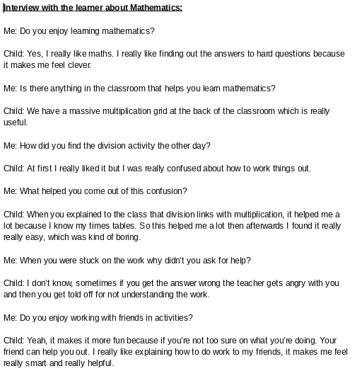

Appendix 2:
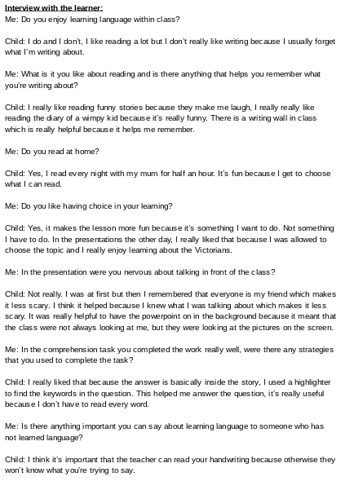

Appendix 3:
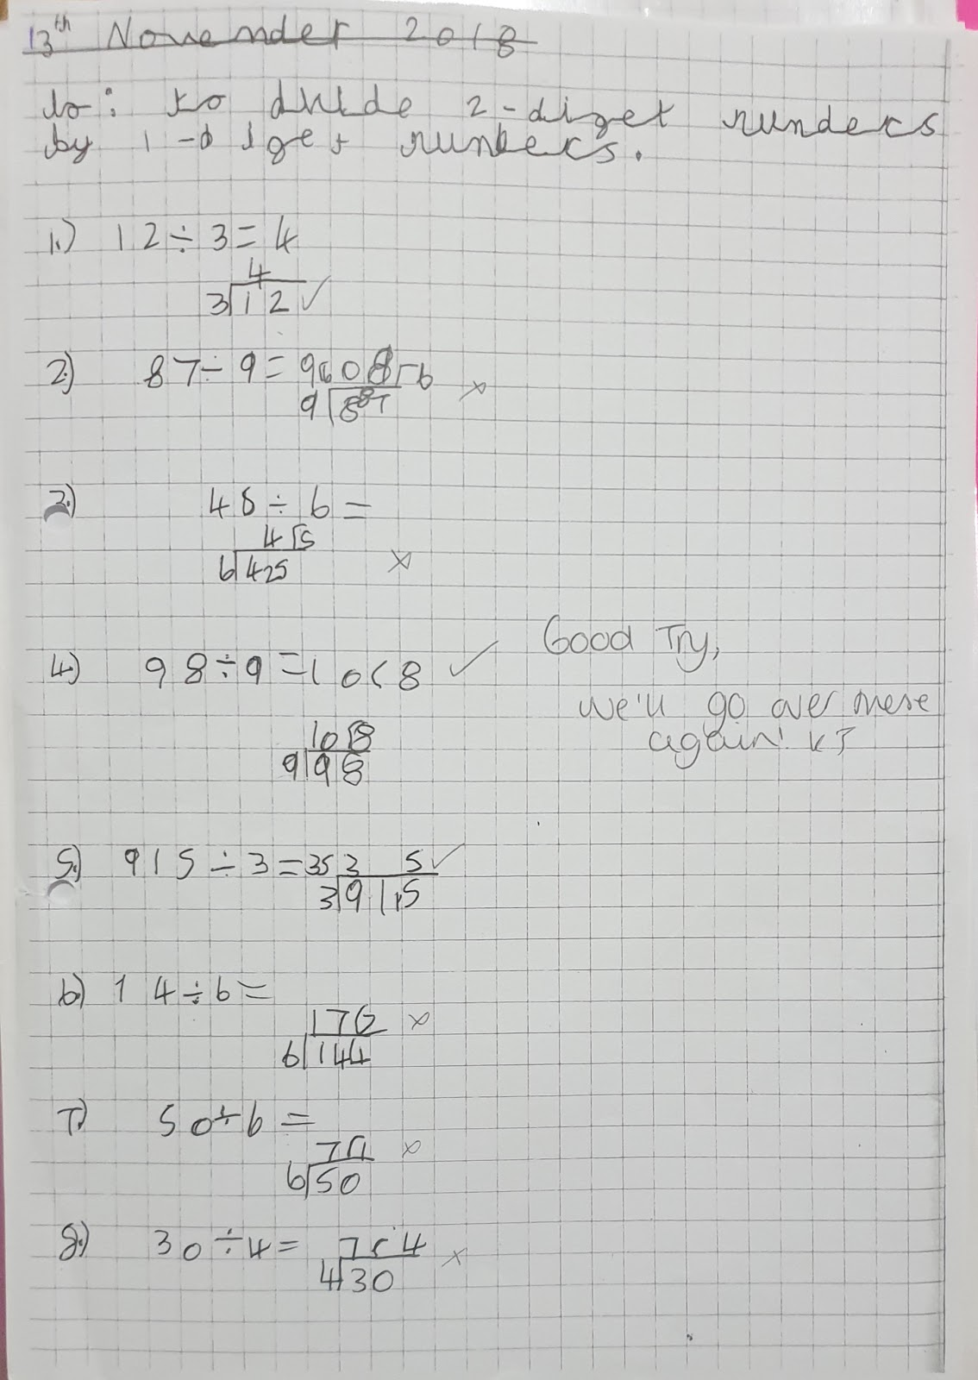

Appendix 4: 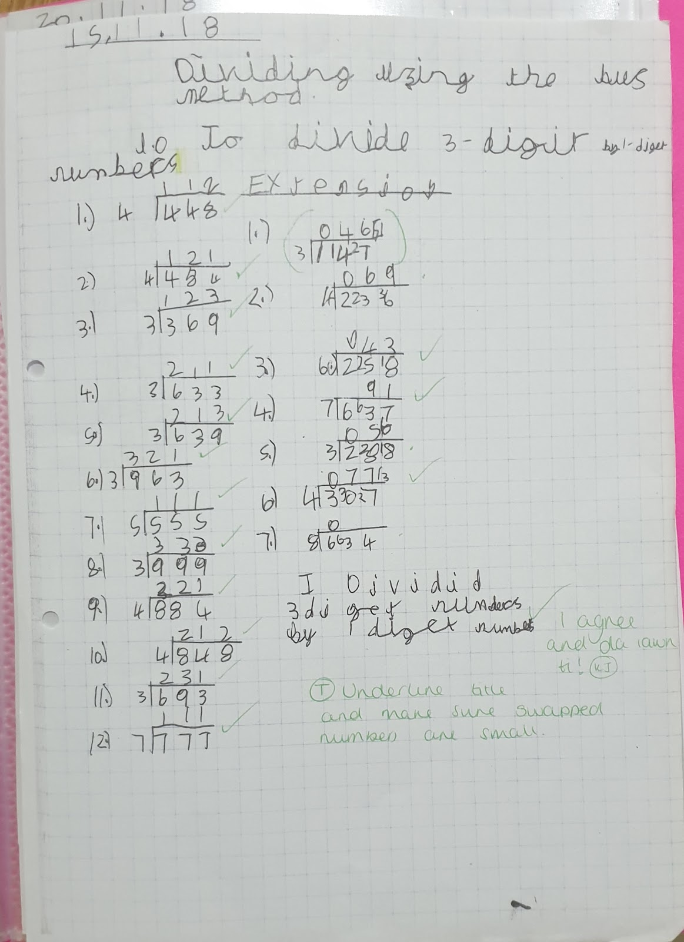

Appendix 5:
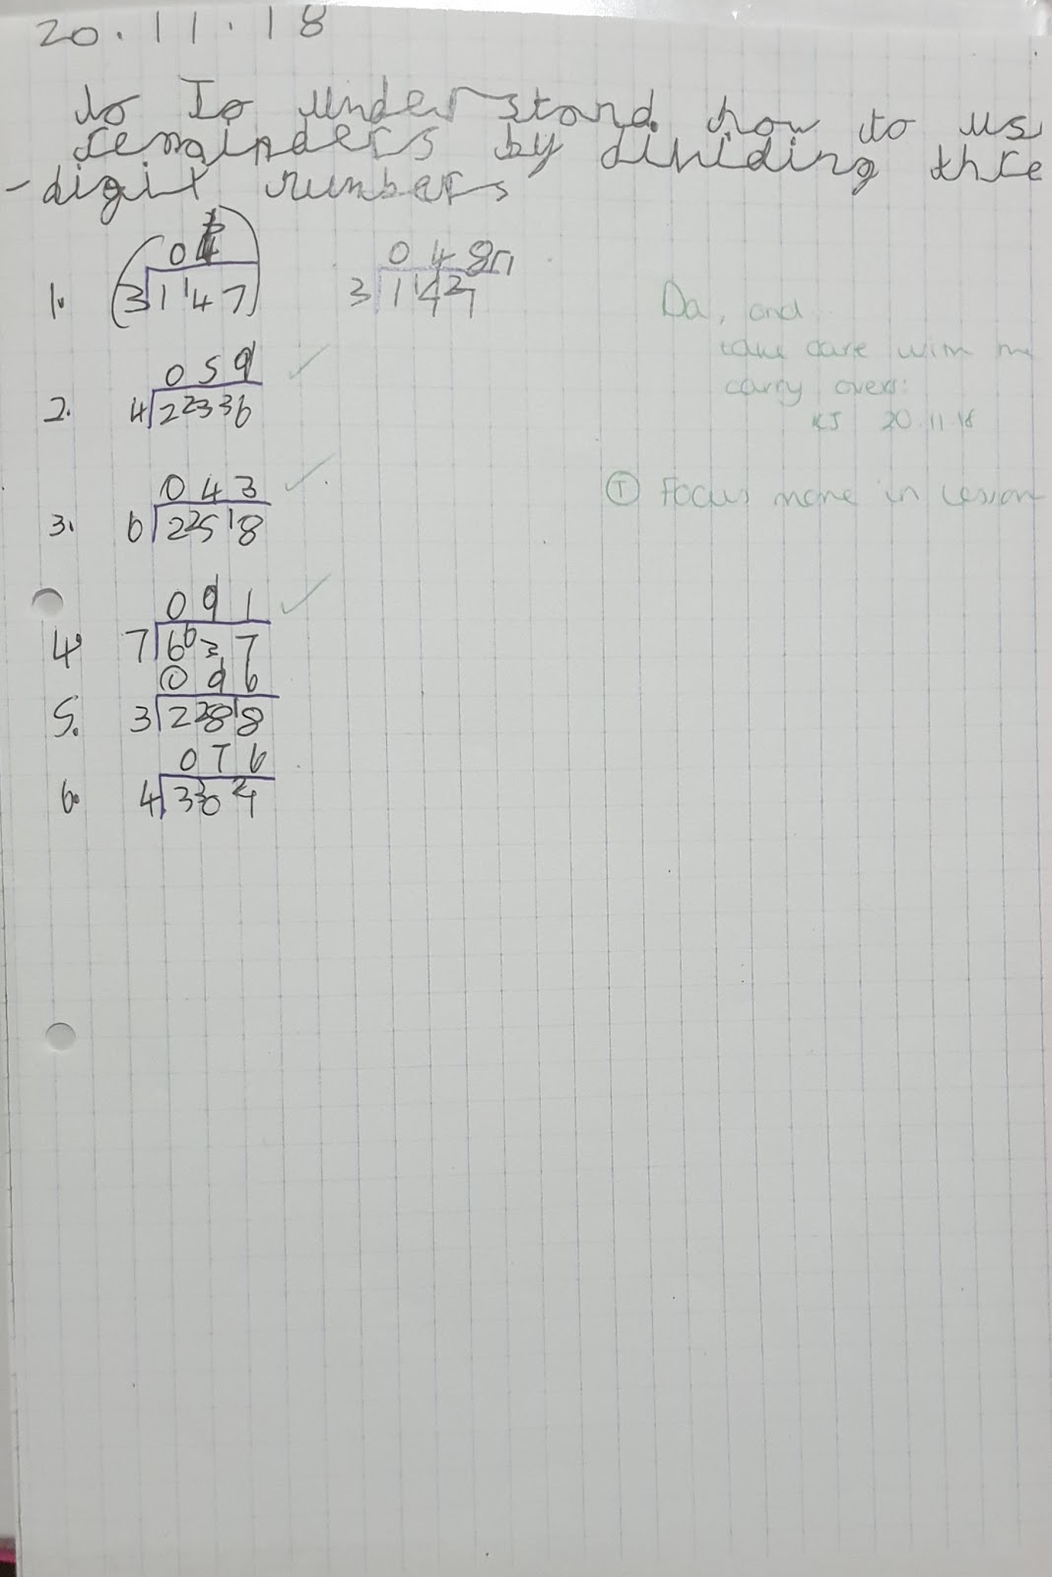

Appendix 6:

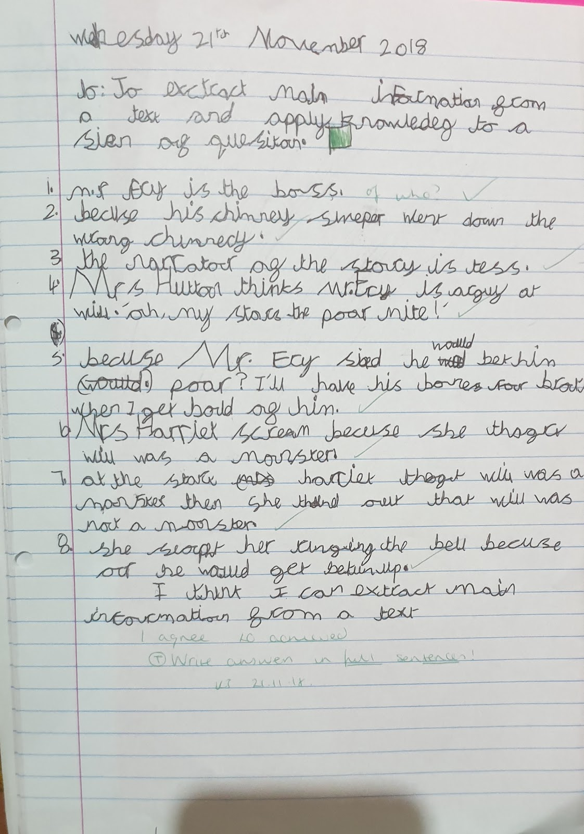

Appendix 7:


