AI Acknowledgement
I confirm that I have not used any AI tools in the research and creation of this assignment. I confirm that I have not presented any AI generated materials as my own work. I confirm I have copies of my drafts, notes, and other resources I used, which I may be asked to provide in evidence

Abstract
The aim of this study was to understand the beliefs people have about the social, emotional and cognitive effects that social exclusion can have on older people, and how we can alleviate the effects. To achieve this, we conducted four interviews, with four separate participants; however, for the purpose of this report only two have been analysed. The results of that analysis indicated that people believe that the main emotional, and cognitive effects are anger, frustration and loneliness, whereas the main social effects are social withdrawal from friends and family, leading to further isolation. Using the conclusions drawn from the data analysis, it has been concluded that the best way to alleviate the negative symptoms of social exclusion is to raise awareness around the issues these people face, either through more exposure to this topic at schools and workplaces, or through more community focused groups, helping to introduce this issue at the ground level.

▪ Introduction
ASD or autism spectrum disorder is one of the most common disorders worldwide, in the United Kingdom alone approximately 1% of its population are diagnosed with ASD (NHS Survey 2023/24) which equates to approximately 700,000 people. Even though it is one of the most prevalent disorders, very little is known about how it effects older people diagnosed with it. Because of this, it is important to understand the potential social, emotional and cognitive effects that social exclusion could have on older ASD people, specifically how the effects could be made better.
Piven et al (2011) conducted research into the effects that the disabilities and needs that people develop as they age have when they interact with the effects of autism spectrum disorder. Specifically, they wanted to focus on how the healthcare and economic systems can help support these people. They specifically stated that an understanding of all the aspects of ASD in older people is needed in order to properly help them, “but studies on ASDs in these individuals are practically nonexistent”.
Roestorf et al (2019) discussed the categorisation of “Aging” ASD people and the meeting of a SIG (special interest group) who focused on the consequences of aging for people with ASD and they discussed frameworks for future studies into this at the International Society for Autism Research (INSAR).
Roestorf specifically focused on the physical and cognitive effects that take place from ages 50 onwards And found that there was deterioration on their quality of life.
This report aims to identify what the beliefs and opinions that people have relating to the cognitive, social and emotional effects, social exclusion can have on older people and what can be done to help better the effects it has.

▪ Method
The there were a total of four participants in this research report, however only two were chosen for analysis and it took place using a semi-structured interview. The participants were all university students, from the same course with ages ranging from 20-40 for this report specifically. Both of the participants were already briefed with the case study.
The data was collected using a series of questions (see appendix), using a semi structured interview format. The data was collected from two participants. The questions themselves were developed initially through key points that needed to be covered; however they were later adapted after a piolet study was completed. This initial piolet study helped identify overlapping topic areas amongst the questions, alongside areas that the questions did not provide enough information on. The questions found in the appendices were finalised before the final interview took place, however if any interesting topic appeared during the interview, prompt questions may have been added which were not originally planned for. The interviews themselves lasted approximately 10-20 minutes with the average being around 14. All of the data was collected on a university laptop specifically through Microsoft teams recordings which were done with the participants consent and awareness that it was recorded.
The questions used are as follows:
- Why do you think people respond to Alan in the way they do?
- How do you think being excluded might make people behave?
- How do think this may affect those with autism emotionally?
- Do you think social exclusion may affect people cognitively, and if so, how?
- Being socially excluded affects us all differently, how do you think social exclusion makes older people with ASD feel?
- How could this effect the ways that older people with ASD think about social situations?
- How do you think being socially excluded might affect the ways that older people with ASD resolve problem and issues on a day-to-day basis?
- Social exclusion affects us all differently; how do you think this could affect the behaviour of older people with ASD?
- What ways do you think society could include older people with autism more?
When analysing this data Braun & Clarke’s (2006) thematic analysis has been used to highlight key information. Braun & Clarke’s thematic analysis uses six different phases to separate and analyse the data included within a transcript.
Stage one is familiarising yourself with the transcript, usually via reading it multiple times through over an extended period of time, making only brief notes, as this stage is about familiarity with the data, not full analysis yet.
Stage two is the beginning of a key, you need to create codes that align with specific ideas, for this data specifically, it could be ideas of isolation or loneliness. The main aim of this stage is to simplify the data to make it more manageable, typically the codes are something that stands out in the data, unexpected points or repeated terms.
Stage three involves searching for linking themes. Themes are groups of codes. As mentioned earlier codes loneliness and isolation could be grouped under the theme of exclusion.
Stage four of Braun & Clarke’s thematic analysis is reviewing the themes to make sure they make sense for the data, focusing specifically on this data, the themes I have found involve sub-themes of a lack of confidence, and motivation which I have categorised as the self-esteem theme. Another series of linked sub-themes are feelings of loneliness and accidental isolation which have been categorised under the theme of Exclusion. Finally, there was repeated discussion around awareness on ASD in both schools and work, and as such the final theme found was Lack of awareness/taught information. The categorising and finalisation of themes is what the fifth stage of thematic analysis is about.
The final stage of thematic analysis is producing finalised data for the report. I believe that Braun & Clarke’s thematic analysis was the correct analysis choice to use, because of its use in analysing these themes in my data.
▪ results section
As mentioned above, Braun and Clarke’s thematic analysis has been used to analyse the transcripts produced by the interviews. When analysing three main themes have been produced, exclusion, Awareness, and self-esteem. For the sake of this report, only two will be discussed. If you wish to view the final theme, it will be listed in the appendix.
Theme 1: Awareness
When discussing the believed effects social exclusion can have on older people, participant (A) mentioned right away that “because there is a lack of understanding of ASD and autism.” (Participant A, page 2, lines 14-15). Immediately the participant (A) mentioned a lack of understanding around the topic, this indicates to me that they believe it is a key issue that exacerbates the social, emotional and biological symptoms. This is because there is minimal research in this area, resulting in very few resources and systems being put into place to help them manage the effects of social exclusion. When prompted with an additional question from the researcher “Should there be more” (in regard to talks from schools and work – Researcher (N), page 2, line 19) the participant (A) states
100%, yeah. I feel as though like with school it can definitely be told a bit more and even say like through sort of like... health institutes, sort of like the NHS, they could provide more information on it. Like anyone could also set up say like interventions or sort of like a like a community thing where people can go if they have like ASD and then maybe like members of the public can help out to get like a better understanding of it, possibly, I would say. (participant A, Page 2, lines 21-25)
This supports the prior idea that there is a belief that there should be more systems in place, to support people who are older, and those with ASD (autism spectrum disorder)
Participant L also gives appears to have similar ideas, “I think there's more education and more understanding needs to happen within workplaces, within communities” (Participant L, Page 12 (doc 2), lines 239-240)
Subtheme 1.1 - confusion for the older people
When discussing with the participants for the interview Researchers N and H both referred to a case study of Alan a 58-yr old man with ASD who's historically relied on a highly structured, routinised life, supported by his parents. However, when Researcher H asks participant (L) about how social exclusion may affect older people in general Participant (L) stated
older people in general tend to have routines, have done things for a long, long time. So … For someone with ASD at an older age to have be excluded from things that they've been involved with for a long, long time will be very confusing for them. It might be harder for them to understand why they are being excluded from these things and the reasoning behind that. (Participant L, Page 7 (doc 2), lines 136-141)
Participant L comments on how long-term exclusion could confuse older people and make it hard to understand why. This reinforces the need for what participant A discussed above. The confusion and lack of understanding could be ameliorated, if more systems were put into place to help these people specifically, and if more people were made aware of the issues in the current system, through “interventions” or places where the public could “help out”, then it would help spread an understanding of the problems they currently face.
Subtheme 1.2 – Reliance
Researcher H prompts participant L to discuss how they feel social exclusion would affect the older people, and participant L mentions how they believe it would affect them emotionally “angry, confused, I think, confused” (Participant L, Page 8 (doc 2) lines 150-151) and also how they believe it would make them more self-reliant.
“They probably become more self-sufficient, where they stop asking people for the help to solve problems. … probably become more self-sufficient, where they stop asking people for the help to solve problems. And if they can't solve the problem, it just won't get solved” (participant L, page 9 (doc 2) lines 191-198)
Whilst self-reliance is not a bad thing, what participant L is discussing is self-reliance, caused by social exclusion, which is not good. The lack of assistance they will have found has caused them to try and solve all the problems themselves, and as they not received any help in a long time, they don’t bother asking anymore. This means that not only do they no longer receive social interactions, which has been proven to help elderly people be less lonely and improve their emotional wellbeing (Lee et al 1987)
Theme 2 - effects of exclusion
Social exclusion is believed to cause many emotional, social and behavioural effects on a person’s life. Both participant A and L state that they believe social exclusion would make older people “angry, confused, I think, confused” (Participant L, Page 8 (doc 2) lines 150-151) and “they may be like stressed or frustrated, have lower self-esteem and confidence” (Participant A, Page 4, lines 62-63). Both participants highlight a belief that social exclusion would affect older people negatively, specifically, making them angry frustrated and confused.
Subtheme 2.1 – loneliness
Participant A suggests multiple times that social exclusion would make the older person lonely. When asked by researcher N how they believe social exclusion may make someone behave, they stated that “it may also introduce a depression and loneliness.” (Participant A, Page 3, lines 43-44). furthermore, when they were asked how they believed social exclusion may affect older people, they stated:
There'll be fewer opportunities to engage in conversations or activities. So they may already have a sense of loneliness and then because of this, like because of the autism, they may also like be even more lonely because they don't have like the urge to talk to people (Participant A, Page 4, lines 70-73)
They believed that the lack of interaction would cause an increase in the older persons loneliness, because they would no longer be interacting with as many people, and in the case of Alan specifically, they may not be interacting with anyone entirely.
Discussion
The aim of this report was to identify, what beliefs people had regarding the social, emotional and cognitive issues older people may have as a result of social exclusion, and what can be done to make the effects better. The results of both used interviews seems to highlight that the main cognitive and emotional effects that people believe happen as a result of social exclusion, is anger, frustration, and confusion, alongside loneliness, because they no longer have as many people to interact with. This is reinforced by both participant A and L separately stating similar responses to the set questions, with participant L talking about “angry, confused, I think, confused” and participant A stating, “they may be like stressed or frustrated”.
Alongside this, both participants highlighted a belief that one of the core ways to improve the negative effects that social exclusion creates, is to raise the public awareness around the issue, and make more ways for the communities to interact with these people, whilst also making new systems to help support these people, this is shown through participant L’s “I think there's more education and more understanding needs to happen within workplaces, within communities” and participant A’s “I feel as though like with school it can definitely be told a bit more and even say like through sort of like... health institutes, sort of like the NHS, they could provide more information on it”.
Whilst this research does suggest ways to improve these effects, the main downsides to using Braun and Clarke’s thematic analysis is that the themes suggested in this research are entirely subjective, other researchers may create different themes from the same data that points to separate conclusions. However, I believe that the themes created have been properly justified through the use of quotes taken straight from the data.
As such, I believe that the results of this report are that people believe that social exclusion effects older people negatively, when referring to the social, emotional and cognitive effects, and that the main way that we can alleviate these effects, is by improving the systems in place, and raising the awareness that people have for social exclusion on older people, and older people with ASD.

▪ Reference list
https://digital.nhs.uk/data-and-information/publications/statistical/adult-psychiatric-morbidity-survey/survey-of-mental-health-and-wellbeing-england-2023-24/autism-spectrum-disorder
Braun, V., & Clarke, V. (2006). Using thematic analysis in psychology. Qualitative Research in Psychology, 3(2), 77–101. https://doi.org/10.1191/1478088706qp063oa
Piven, J., Rabins, P., & Autism‐in‐Older Adults Working Group. (2011). Autism spectrum disorders in older adults: Toward defining a research agenda. Journal of the American Geriatrics Society, 59(11), 2151-2155.
Roestorf, A., Bowler, D. M., Deserno, M. K., Howlin, P., Klinger, L., McConachie, H., ... & Geurts, H. M. (2019). “Older Adults with ASD: The Consequences of Aging.” Insights from a series of special interest group meetings held at the International Society for Autism Research 2016–2017. Research in Autism Spectrum Disorders, 63, 3-12.
Lee, G. R., & Ishii-Kuntz, M. (1987). Social interaction, loneliness, and emotional well-being among the elderly. Research on aging, 9(4), 459-482.
▪ Appendices

Transcript 1
1  2  3  4  5  6  7  8  9  10  11  12  13  14  15  16  17  18  19  20  21  22  23  24  25  26  27  28  29  30  31  32  33  34  35  36  37  38  39  40  41  42  43  44  45  46  47  48  49  50  51  52  53  54  55  56  57  58  59  60  61  62  63  64  65  66  67  68  69  70  71  72  73  74  75  76  77  78  79  80  81  82  83  84  85  86  87  88  89  90  91  92  93  94  95  96  97  98  99  100  101  102  103  104  105  106  107  108  109  110  111  112  113  114  115  116 | Okay, so this is going to be a discussion focusing on Alan. Just a bit of brief information. Alan is a 57, 58 year old man with SD who is historically relied highly on like a structured routine life, which has been supported by his parents.  He's A productive and reliable employee in his day entry role, but he prefers quite repetitive tasks and he really struggles with social interaction. And communication is quite important for his role. So that's been one of the main issues he's found. He finds it difficult to deal with and interpret non-verbal cues, and unspoken social rules, which often leads to anxiety, exhaustion from trying to mimic what other people do. And he has a history of being targeted for mockery. His father is in hospital and he's quite scared he's going to lose his structured life. And obviously he hasn't got, His mother's died earlier, so he's lost a bit on his family, I suppose.  So starting off with questions, first one, what do you think, sorry, why do you think people respond to Alan in the way that they do?  I feel as though people respond to him in the way they do because there is a lack of understanding of ASD and autism.  I feel as though like in schools, it's not talked about enough. And also like later on in life, to say like jobs, like there is never really any acknowledgement of ASD.  Yeah. Do you think that there should be more?  Oh yeah, 100%, yeah. I feel as though like with school it can definitely be told a bit more and even say like through sort of like... health institutes, sort of like the NHS, they could provide more information on it. Like anyone could also set up say like interventions or sort of like a like a community thing where people can go if they have like ASD and then maybe like members of the public can help out to get like a better understanding of it, possibly, I would say  Yeah. What's your opinion on that being almost like a mandatory training to understand sort of information for like a workplace environment specifically? So for a school environment.  What do you mean?  So you mean sort of like... So would you do you... think it should be mandatory or do you think it should be something that's advised but not required?  I would say with school it should definitely be mandatory and that's not even just for like ASD that should be for like any like mental illness or like any like physical illness like that should definitely be talked about more.  But in the workplace, I feel like it could maybe be optional, maybe. Yeah, it should be, yeah, it should be encouraged, but I feel like it should be optional. Like, obviously, it would be beneficial. but you can't exactly force people to do it, I would say.  Yeah. So how do you think being excluded might make people behave?  I would definitely say that there would be like a much less like, they would have much less like motivation. So they may be less inclined to, say, get a job or like seek, say, higher education if they've already been to school or seclude themselves from their friends or family, And it may also introduce a depression and loneliness.  Would you say these behaviours are more positive or negative realistically?  I'm saying the negative. Obviously there's like a thing that people like assume that people with autism are like clever and say no like everything like the top of their head. But I feel like if people don't know that they may sort of like if like say someone was ASD doesn't like, they're not that intelligent. I feel like they may have like... I don't know what sense of like pressure, yeah, and like pressure, yeah, being like down and trying to like meet those expectations, and I feel like that may make them like behave in like a bit more of a like... anxious kind of way to try and get to that like expectation sort of thing.  Yeah. So focusing less on behaviour now, how do you think this may affect those with autism emotionally?  I would say that emotionally they would... I wouldn't say that they would be like... They may still be happy, but I don't think they would be like as happy as someone without autism. I feel like because there is such like not much understanding of it, that they wouldn't be that happy because they may feel that people don't like get them sort of thing. and they may sort of like feel as if they're like misunderstood in conversations, and they may be like stressed or frustrated, have lower self-esteem and confidence. And yeah.  Okay, so it's more, there's less positives than neuronic, even if it doesn't get rid of all of their positive emotions, it's more of a... It heightens the negative ones. Do you think that social exclusion affects people cognitively? And if so, how?  I would say that it does because they would have like reduced confidence affecting decision making. So that could be sort of like deciding whether they want to get a job or what they do if they have that job sort of thing. There'll be fewer opportunities to engage in conversations or activities. So they may already have a sense of loneliness and then because of this, like because of the autism, they may also like be even more lonely because they don't have like the urge to talk to people. They might have slower thinking over time due to lack of engagement as well, I would say. And they would have also, like I said, reduced confidence in social situations, in my opinion.  Do you think the confidence could lead to more social exclusion?  Yeah, 100%. Yeah. So obviously, if they have a lack of confidence, then if they don't already have friends, or even if they do already have friends, they may feel like less inclined to talk to those friends. Or if they don't already have friends, then make new friends and they wouldn't, you know, possibly feel as inclined to make new friends. But also, like I say, occupation wise, I feel like they wouldn't want to go to an interview if they have a lack of confidence. Or if they go to the interview, they might not want to go to the job because, you know, it's a new thing. Like, it might not be brave enough sort of thing. Yeah, yeah  It’s not part of their routine  exactly. Yeah. yeah, 100%.  How do you think this could be, how do you think that this could affect how people with ASD think about social situations, less so how they deal with it, more so how they react to new social situations?  Can you repeat that? Sorry.  No worry. How do you think that this could affect how people with ASD think about social situations? So for example, like meeting a new work group or whatever.  I would say that they would definitely feel anxious and... worried, I would say. Like, I know personally when I have to like go somewhere new, like I overthink it so much. So they may also overthink it. They may sort of like beat themselves up over it and sort of have a sense of like, oh, maybe they're going to think of me this way. Maybe they're not going to like me because of my autism. Like they may class me as like, say, different, for example.  Yeah.  How do you think that being socially excluded might affect the way that older people with ASD resolve problems and issues on a day-to-day basis?  So you mentioned earlier, if it's confidence.  Oh yeah, yeah.  Any other sort of... cognitive aspects that you think might mean like a reasoning, anything like that. Do you think that that would sort of affect their day-to-day situations? So the sort of stuff that we deal with on it?  Yeah, I would say so. So say like, I don't know, food shopping for example, like they may not even want to go out to do that, especially like if they're older, they may like... say, not have children or, you know, their parents may have passed. So they don't have anyone that they can depend on. Like they could be the ones being depended on by, say, grandchildren, if they have any, or even their own children. So I feel like they don't really have anybody to help them. is more them needing to help others when they may not even be able to do that. So I feel like it would be affected in that sense. Or even say like making a doctor's appointment or anything like that, even, I don't know, like finances, like they may feel less comfortable doing it because, like I said, they don't have anybody to rely on possibly due to the age, I would say, I think. Social exclusion affects us all differently.  How do you think the behaviour of older people with ASD can be affected specifically by social exclusion? So behaviour, sort of, do you think they'll be having more positive behaviours, more negative behaviours? If so, what sort of behaviours are we talking?  I feel as if it would be me negative. Like, for example, like older people are more likely to get like dementia, say, for example, so they could already be dealing with autism, then also be dealing with dementia. And then that is just like...  Piled together.  Yeah, like double, you know, like on top of each other. Yeah. So I feel like that would definitely have an effect.  Mhm.  I don't know what else to say.  That's fine. What way do you think society could include older people with autism more and how could they support them?  I definitely think like having more like groups, say sort of like in the community, like I know my grandmother, she'll go to like a knitting group. So even something like that is like beneficial.  and just making them feel seen, even if it's not like dedicated specifically to autism. I feel like just having more groups in general could definitely help, but even better if it is like dedicated to autism, like I feel like that would definitely like Be helpful, um. Or even just like... (END OF SENTENCE)  END OF RECORDING

Transcript 2
Issues copying transcript 2 (screenshots instead of raw text)

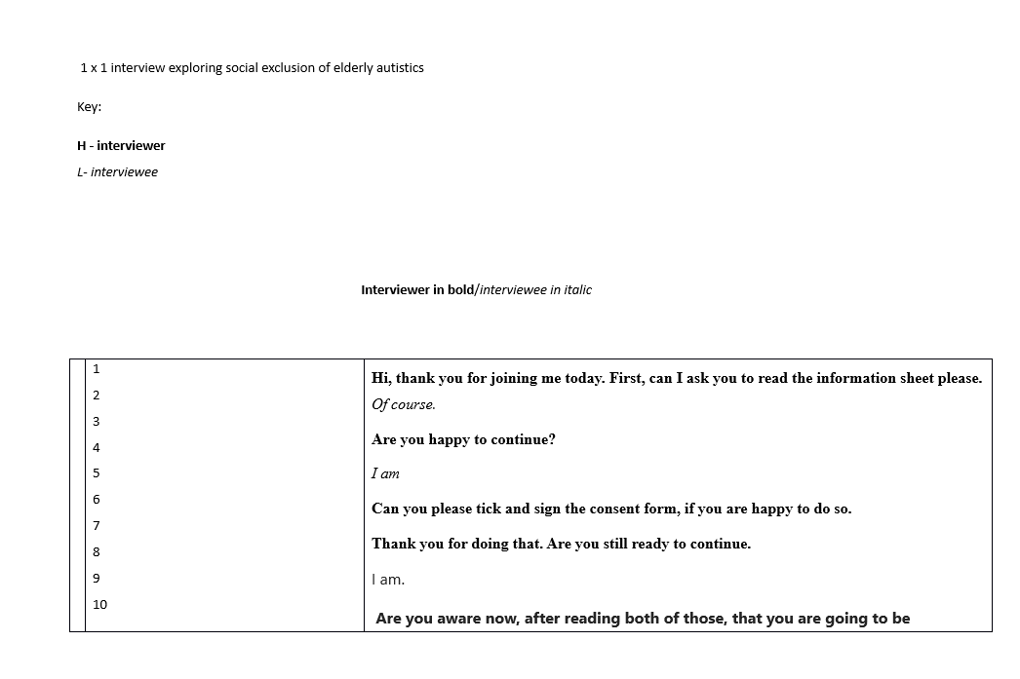

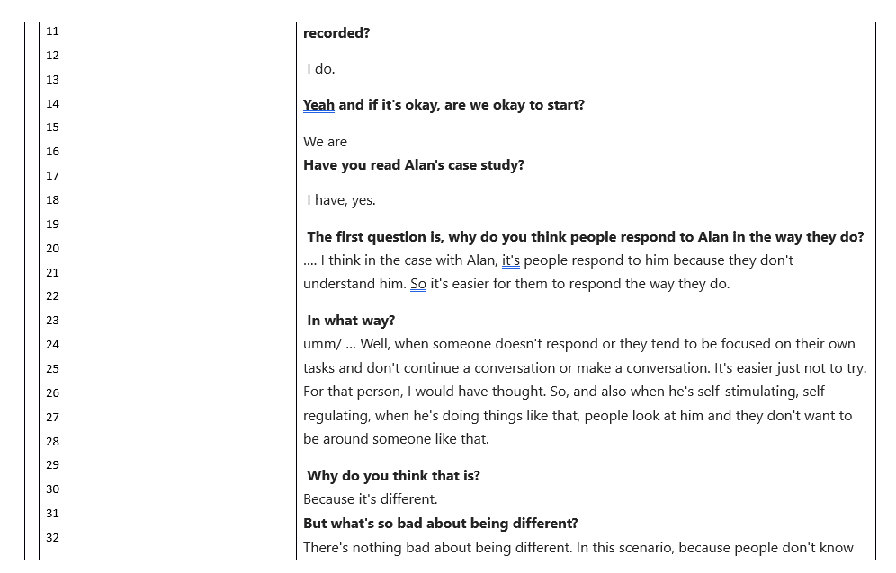

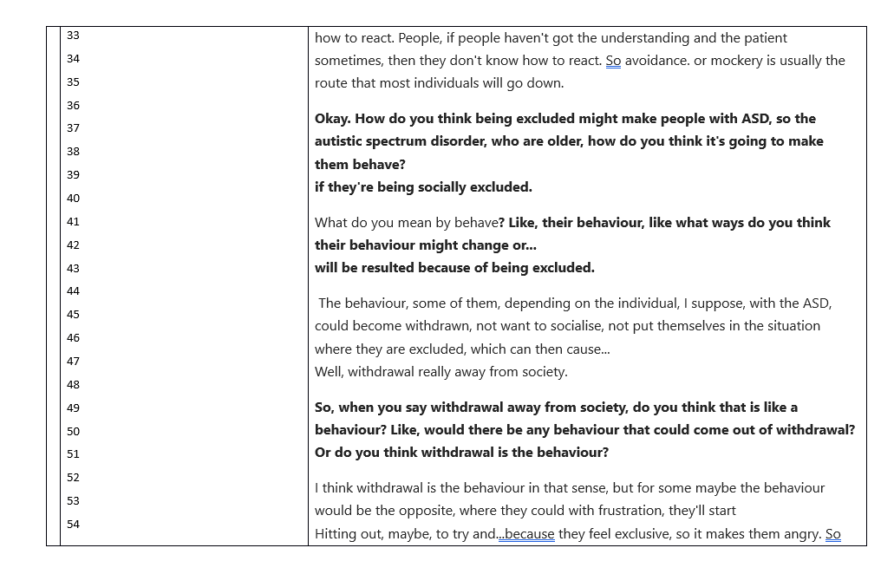

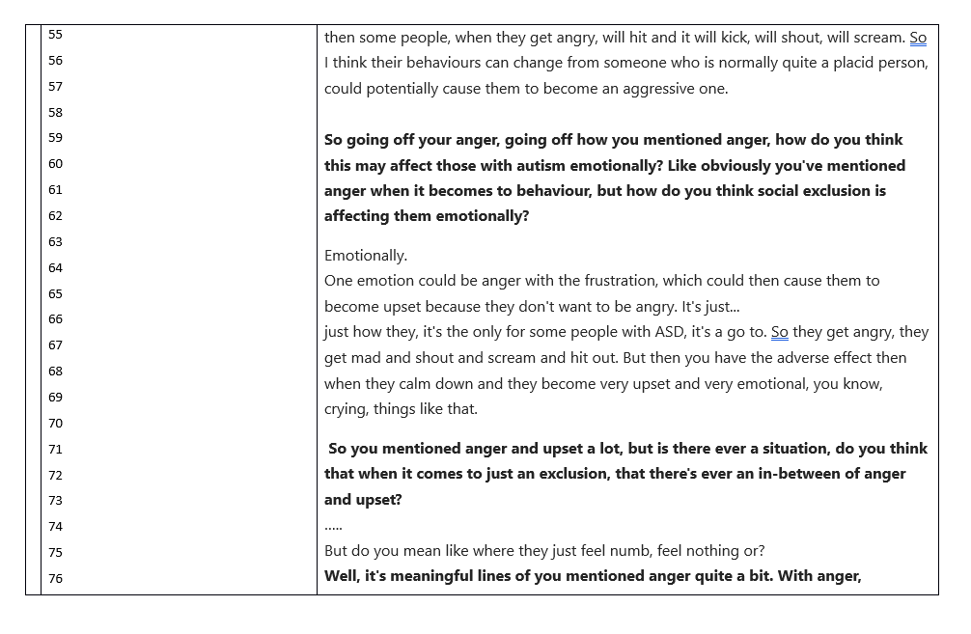

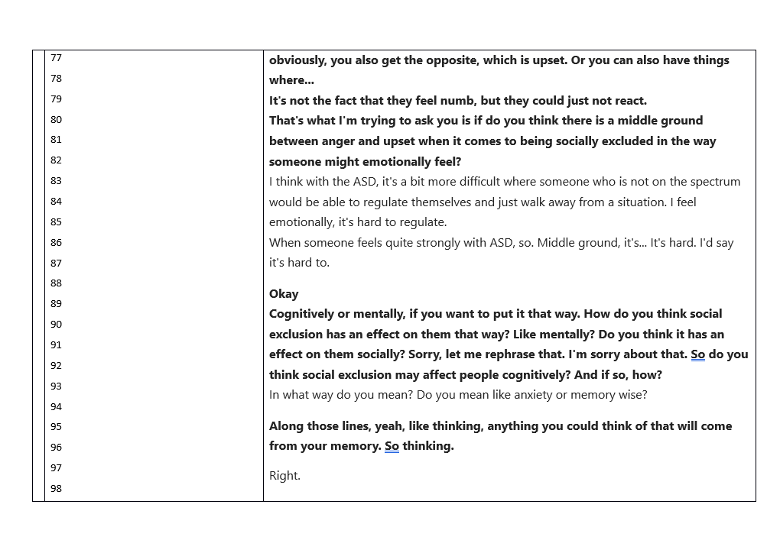

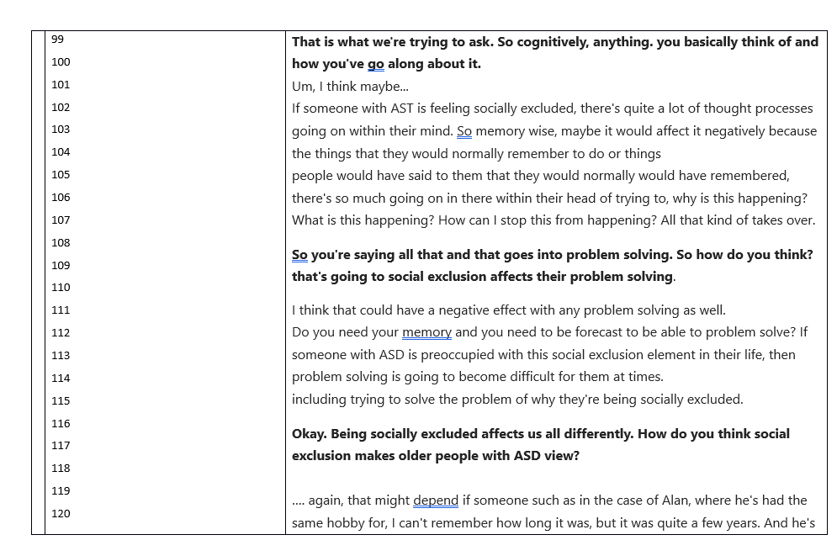

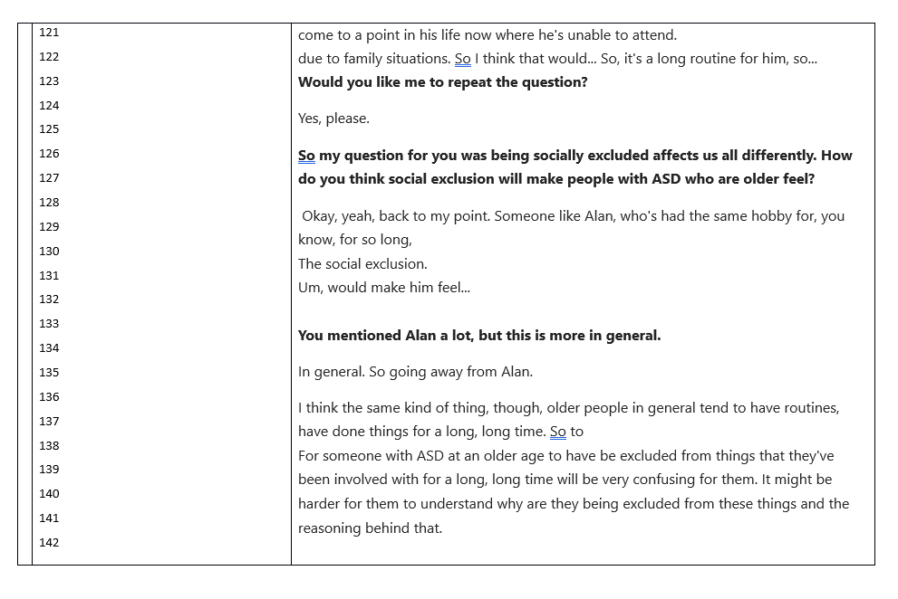

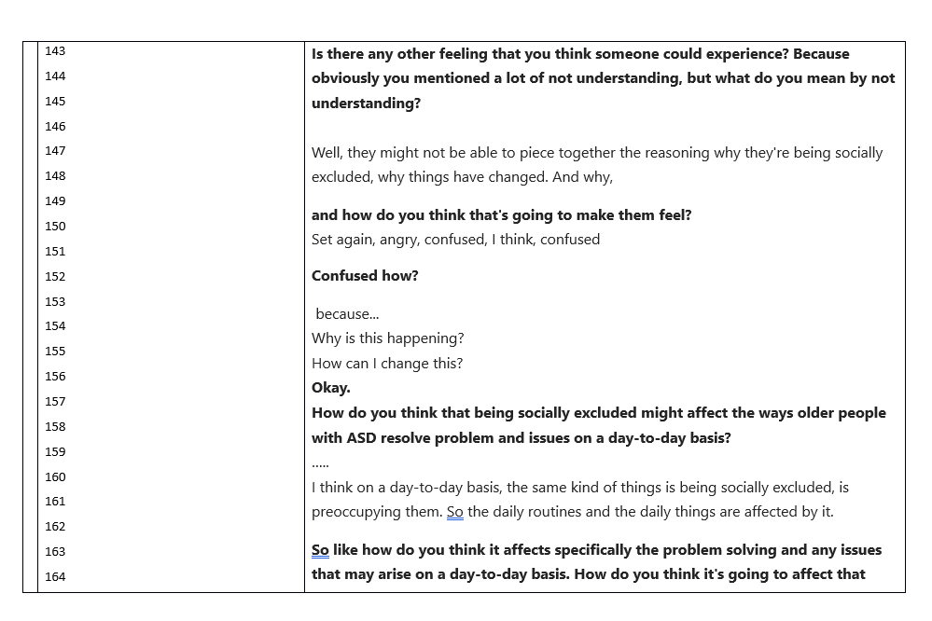

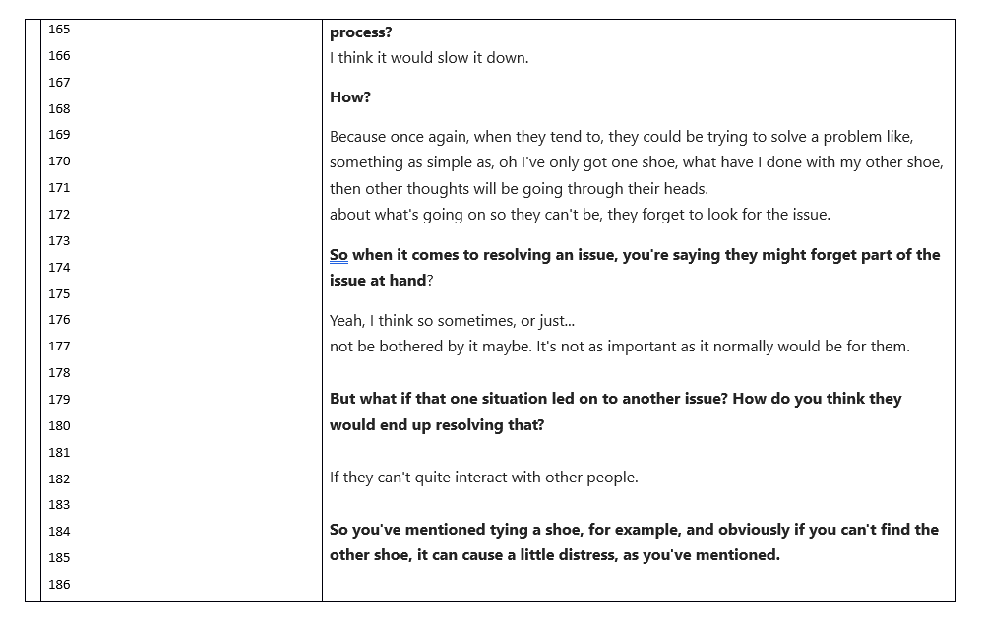

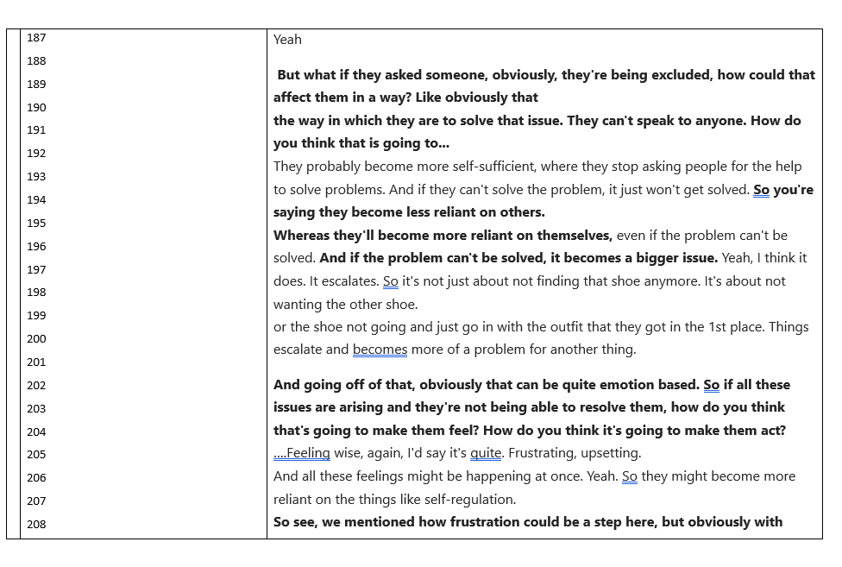

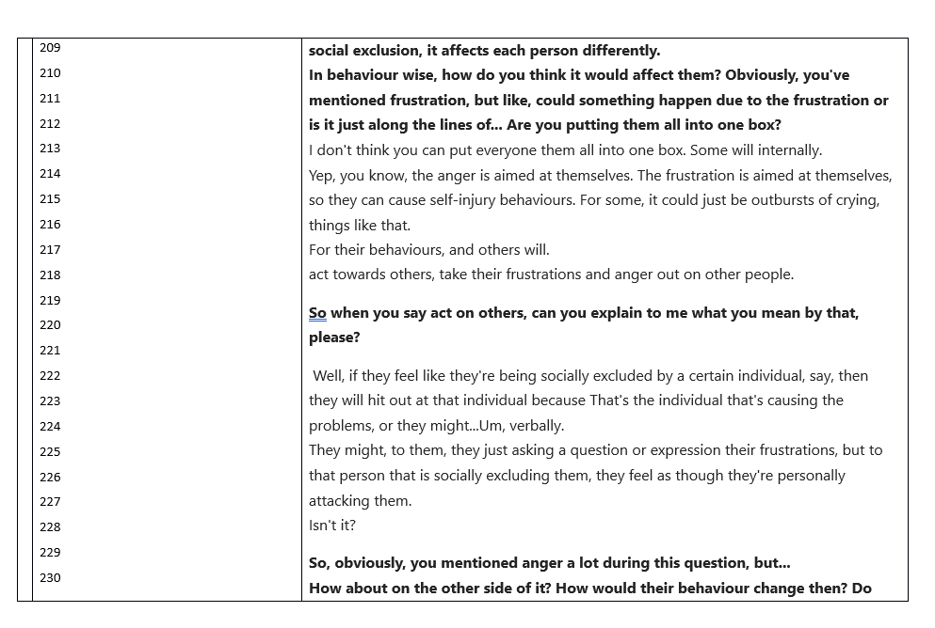

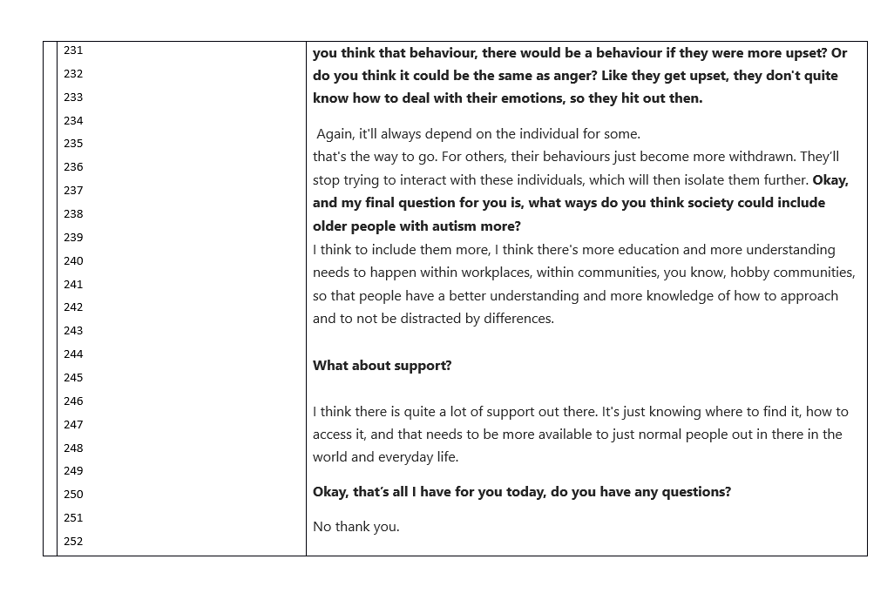

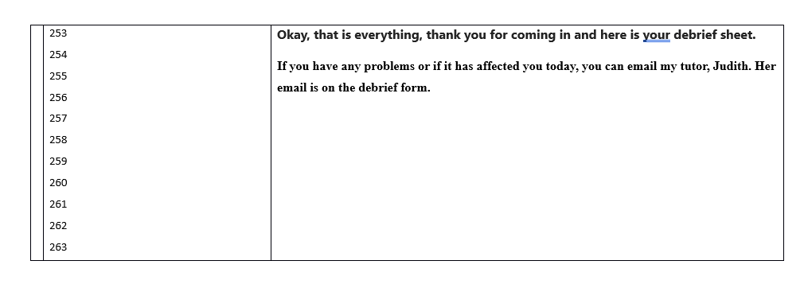

Themes | Sub Themes | Quotes
Exclusion | Loneliness  Isolation | “it may also introduce a depression and loneliness.”  “There'll be fewer opportunities to engage in conversations or activities. So they may already have a sense of loneliness and then because of this, like because of the autism, they may also like be even more lonely because they don't have like the urge to talk to people”  “It might be harder for them to understand why they are being excluded from these things and the reasoning behind that.”  “they would have much less like motivation. So they may be less inclined to, say, get a job or like seek, say, higher education if they've already been to school or seclude themselves from their friends or family”  “So they may already have a sense of loneliness and then because of this, like because of the autism, they may also like be even more lonely because they don't have like the urge to talk to people”  “older people in general tend to have routines, have done things for a long, long time. So … For someone with ASD at an older age to have be excluded from things that they've been involved with for a long, long time will be very confusing for them. It might be harder for them to understand why they are being excluded from these things and the reasoning behind that.”
Self-Esteem | Motivation  Lack of Confidence | “Sense of like pressure, yeah, and like pressure, yeah, being like down and trying to like meet those expectations”  “I feel like because there is such like not much understanding of it, that they wouldn't be that happy because they may feel that people don't like get them”  “Lower self-esteem and confidence”  “Reduced confidence affecting decision making”
Awareness | Should there be more Awareness  How should it be made easier to be aware | “Because there is a lack of understanding of ASD and autism”  “I would say with school it should definitely be mandatory and that's not even just for like ASD that should be for like any like mental illness or like any like physical illness like that should definitely be talked about more.”  I feel as though like with school it can definitely be told a bit more “  “health institutes, sort of like the NHS, they could provide more information on it.”  “like a community thing where people can go if they have like ASD and then maybe like members of the public can help out to get like a better understanding of it”

Questions
Bearing Alan in mind: Cognitive, emotional and behavioural?
- Why do you think people respond to Alan in the way they do?
- How do you think being excluded might make people behave?
- How do think this may affect those with autism emotionally?
- Do you think social exclusion may affect people cognitively, and if so, how?
- Being socially excluded affects us all differently, how do you think social exclusion makes older people with ASD feel?
- How could this effect the ways that older people with ASD think about social situations?
- How do you think being socially excluded might affect the ways that older people with ASD resolve problem and issues on a day-to-day basis?
- Social exclusion affects us all differently; how do you think this could affect the behaviour of older people with ASD?
- What ways do you think society could include older people with autism more?

Demographic Form
Demographics

Gender
- Male | - Female | - Non/Binary | - Other

Age
- 18-25 | - 26– 33 | - 34 - 40 | - 41- 49 | - 50+

Information Sheet
Centre for Psychology and Counselling

SA1 Campus

Swansea



Study Information Sheet

This document provides key information regarding the study and provides details about what will be expected of you as a participant. Therefore, please read this information carefully before providing consent to take part.

The purpose of this study is to explore the beliefs and opinions that students have regarding the cognitive, emotional, and social effects of social exclusion on older people. The aim of the study is to determine how negative effects might be improved

During this study you will be asked to do the following:

Take part in an interview in the psychology laboratory which take place in room (211)

At the end of the interview, you will be provided with the study debrief.

If you have any questions or concerns about this study, please contact the researchers available:
Hannah-lee Rhodes (1901657@student.uwtsd.ac.uk)
Kayleigh Jones (2404358@student.uwtsd.ac.uk)
Kavan Graham (2500328@student.uwtsd.ac.uk)
Noah Finney (2405255@student.uwtsd.ac.uk)

If you are happy to take part in this study, please click the button below to direct you to the consent form for the study.

If you feel you want to leave the study, you can do so at any time notifying the researcher if you are taking part in this study in the Psychology labs. Once the study has ended you will be asked if you want your audio recording to be saved as part of the study. If you agree then your data will be anonymised and therefore untraceable to later delete.

Consent Form

Study Consent Form
I understand that this research is being carried out to collect data for a group of 2nd year Psychology students for a research report. I understand that taking part in this study will involve a 1 to 1 interview and responses will be recorded through a voice recorder.
This study will take approximately 15-20 minutes to complete.
I understand that participation in this study is voluntary and I am free to withdraw my participation at any time during or before the end of the study without giving a reason and without penalty.
I understand that once I complete the study, I will not be able to withdraw my data, as it will be anonymized and the researcher will be unable to trace my data back to me.
I am aware that if I have any questions or concerns about the study, I can contact the research supervisor, Judith Marshall, at any time before, during or after the study on judith.marshall@uwtsd.ac.uk.
You can download a copy of this consent form by clicking here: Consent Form
Please tick all boxes below to confirm your consent into participating in this study:
¨ I am 18 years of age or over
¨ I understand I can withdraw at any time without penalty by closing the browser
¨ I understand my data will be held confidentially and my identity will remain anonymous
¨ I understand all the above information on this consent form
¨ I consent to taking part in this study

Debrief Form

Study Debrief Sheet
How do undergraduate students perceive the risk of social exclusion for older people with autism, and how do they think negative effects might be improved?

This study has been conducted to explore how undergraduate students perceive the risk of social exclusion on older people with autism; additionally, we also aimed to explore how they believe the negative effects of social exclusion may be improved.
As a reminder, your data will only be used for this research, and it will not be traceable to you; the data submitted will remain confidential and will be anonymous for your safety.
If you wish to withdraw all your data from this study, then you must tell the researcher now.
If you have any queries or concerns about taking part in this study, please email the following researchers;
Hannah- Lee Rhodes (1901657@student.uwtsd.ac.uk),
Kayleigh Jones (2404358@student.uwtsd.ac.uk),
Kavan Graham (2500328@student.uwtsd.ac.uk),
Noah Finney (2405255@student.uwtsd.ac.uk), or the academic supervisor, Judith Marshall (judith.marshall@uwtsd.ac.uk)
If you feel that your participation has caused any distress, there is a range of support available on the MyTSD app; alternatively, you can fill out the request form for support or for additional Wellbeing Support by scanning the QR code.
Thank you for taking part in this study and for your contribution to our data.
University of Wales Trinity Saint David
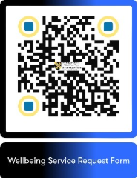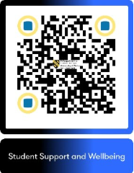BSc Psychology
BSc Psychology and Counselling
BSC Psychology and Criminology

Ethics form
APPLICATION FOR ETHICAL APPROVAL

In order for research to result in benefit and minimise risk of harm, it must be conducted ethically. A researcher may not be covered by the University’s insurance if ethical approval has not been obtained prior to commencement.

The University follows the OECD Frascati manual definition of research activity: “creative work undertaken on a systematic basis in order to increase the stock of knowledge, including knowledge of man, culture and society, and the use of this stock of knowledge to devise new applications”. As such this covers activities undertaken by members of staff, postgraduate research students, and both taught postgraduate and undergraduate students working on dissertations/projects.
The individual undertaking the research activity is known as the “principal researcher”.
Ethical approval is not required for routine audits, performance reviews, quality assurance studies, testing within normal educational requirements, and literary or artistic criticism.
Please read the notes for guidance before completing ALL sections of the form.

This form must be completed and approved prior to undertaking any research activity. Please see Checklist for details of process for different categories of application.

SECTION A: About You (Principal Researcher)
1 | Full Name: |  | Hannah-Lee Rhodes
2 | Tick all boxes that apply: |  | Member of staff: | ☐ | Honorary research fellow: | ☐
 | Undergraduate Student | ​​☒​ | Taught Postgraduate Student | ​​☐​ | Postgraduate Research Student | ​​☐​

3 | Institute/Academic Discipline/Centre: | Institute of Education and Humanities: Psychology and Counselling
4 | Campus: | Swansea IQ Campus
5 | E-mail address: | Hannah-lee Rhodes (1901657@student.uwtsd.ac.uk)  Kayleigh Jones (2404358@student.uwtsd.ac.uk)  Kavan Graham (2500328@student.uwtsd.ac.uk)  Noah Finney (2405255@student.uwtsd.ac.uk)
6 | Contact Telephone Number: | N/A
 | For students:
7 | Student Number: | Hannah-lee Rhodes (1901657),  Kayleigh Jones (2404358),  Kavan Graham (2500328),  Noah Finney (2405255)
8 | Programme of Study: | BSc Psychology / BSc Psychology and Counselling / BSc Psychology and Criminology
9 | Director of Studies/Supervisor: | Dr Judith Marshall

SECTION B: Approval for Research Activity
1 | Has the research activity received approval in principle?  (please check the Guidance Notes as to the appropriate approval process for different levels of research by different categories of individual) |  | YES | ​​☒​ | NO | ​​☐​
 |  |  |  |  | Date
2 | If Yes, please indicate source of approval (and date where known): Approval in principle must be obtained from the relevant source prior to seeking ethical approval | Research Degrees Committee |  | ​​☐​
2 |  | Institute Research Committee |  | ​​☐​
2 |  | Other (write in)  Module lead;  Dr Judith Marshall |  | ​​☒​ | 05/01/2026

SECTION C: Internal and External Ethical Guidance Materials
 | Please list the core ethical guidance documents that have been referred to during the completion of this form (including any discipline-specific codes of research ethics, location-specific codes of research ethics, and also any specific ethical guidance relating to the proposed methodology). Please tick to confirm that your research proposal adheres to these codes and guidelines. You may add rows to this table if needed.
1 | UWTSD Research Ethics & Integrity Code of Practice | ​​☒​
2 | UWTSD Research Data Management Policy | ​​☒​
3 | BPS Code of Ethics and Conduct | ​​☒​
4 | BPS Code of Human Research Ethics | ​​☒​

SECTION D: External Collaborative Research Activity
If there are external collaborators then you should gain consent from the contact persons to share their personal data with the university. If there are no external collaborators then leave this section blank and continue to section E.
1 | Institution | N/A
2 | Contact person name
3 | Contact person e-mail address
4 | Is your research externally funded? |  | YES | ​​☐​ | NO |  | ​​☐​
5 | Are you in receipt of a KESS scholarship? |  | YES | ​​☐​ | NO |  | ​​☐​
6 | Are you specifically employed to undertake this research in either a paid or voluntary capacity? | Voluntary | YES | ​​☐​ | NO | ​​☐​
7 |  | Employed | YES | ​​☐​ | NO | ​​☐​
8 | Is the research being undertaken within an existing UWTSD Athrofa Professional Learning Partnership (APLP)? | If YES then the permission question below does not need to be answered. | YES | ​​☐​ | NO |  | ​​☐​
9 | Has permission to undertake the research has been provided by the partner organisation? | (If YES attach copy)  If NO the application cannot continue | YES | ​​☐​ | NO |  | ​​☐​

Where research activity is carried out in collaboration with an external organisation
10 | Does this organisation have its own ethics approval system? | YES | ​​☐​ | NO | ​​☒​
 | If Yes, please attach a copy of any final approval (or interim approval) from the organisation (this may be a copy of an email if appropriate).

SECTION E: Details of Research Activity
1 | Indicative title: | Qualitative Report: Students’ beliefs and opinions relating to potential cognitive, emotional and social effects of social exclusion on older people, and how negative effects might be improved.
2 | Proposed start date: | 26/01/26 | Proposed end date: | 29/04/27
Introduction to the Research
Social inclusion is widely recognised as an important factor in emotional well-being and quality of life. However, autistic people, particularly in later adulthood, often experience ongoing social exclusion due to misunderstanding, stigma, and a lack of inclusive community environments. While much existing research focuses on autistic children or younger adults, relatively little attention has been paid to how autism is perceived in older age or to how social exclusion may affect this group. Understanding public perceptions is important because these views influence attitudes, behaviour, and community responses.

Purpose of the Research Activity
The purpose of this research is to explore how undergraduate university students perceive the risk of social exclusion for older people with autism and how they believe the negative effects of exclusion might be reduced within communities.

Proposed Research Question
How do undergraduate students perceive the risk of social exclusion for older people with autism, and how do they think negative effects might be improved?
Aims of the Research Activity
The aim of this study is to gain insight into university students’ understanding of social exclusion in older autistic adults and to explore their ideas about improving inclusion and well-being at a community level.

Objectives of the Research Activity
The objectives are to:
Explore students’ perceptions of social exclusion in older autistic adults
Identify perceived emotional and social impacts of exclusion
Examine students’ views on how communities could become more inclusive

Existing Research and Contribution
Previous research indicates that autistic adults experience higher levels of loneliness and social isolation across the lifespan, often with negative emotional consequences. However, there is limited research examining how non-autistic individuals, particularly students in psychology-related fields, understand these issues. This study will add to existing knowledge by highlighting current perceptions among future practitioners and professionals. By identifying gaps, assumptions, or areas of awareness, the research addresses an important issue in promoting social inclusion and improving community responses to older autistic adults.

3 | Purpose of Research Activity  The purpose of this research activity is to explore how undergraduate university students perceive the risk of social exclusion experienced by older people living with autism, and to understand how they believe the negative effects of such exclusion might be reduced within communities. By examining students’ views, the research aims to gain insight into levels of awareness, understanding, and attitudes toward autism in later adulthood. This information can help identify gaps in knowledge and highlight areas where greater education or community-based inclusion efforts may be needed. The study does not focus on clinical interventions but instead seeks to contribute to a broader understanding of social inclusion and the role of community attitudes in shaping the well-being of older autistic adults.  Cognitive – regarding people with autism in the older generation, social exclusion can affect their cognitive development. For example, they may experience cognative decline and inadequate cognitive functions such as critical processing (Baumeister, 2002). Social exclusion for older people with autism has also been linked to the development of cognitive issues such as dementia and communication issues. A lack of support from friends and family can impact their cognitive abilities and amplify the decay of these processes that already happen with ageing (Yarar 2021).  Research was done into the experiences that people over 50 who possess autism spectrum disorder (ASD) to understand their lived experiences. Hickey et al (2017) conducted semi structured interviews with 13 participants who were over 50 with ASD, asking questions about their social support, and their experiences after their diagnosis. As these participants were diagnosed later into their lives, it prompted what Hickey called, a “life review”. They looked back on the events of their lives and found overlapping categories for each persons lived experiences. They all blamed ASD in relation to any of the negative events in their lives, any loneliness, isolation inability to understand social situations, and a lack of connection to others, were all attributed to them developing ASD. Hickey then compared it to data found with younger people with ASD and found that they also had similar lived experiences. The final takeaway that they developed was that there needs to be a greater support for people with ASD so that they feel supported and understood, failure to do so could lead to the development of depression and increased social isolation. This would lead to the symptoms Baumeister (2002) and Yarar (2021) found.  This research is supported by French et Al's (2026) study on the lives of people with later diagnosis of Autism and ADHD. Their study also included 13 participants with 5 having ASD, 5 having ADHD and 3 having both. The results of their semi structured interview boiled down to three points. Later diagnoses of ASD can leave to many negative cognitive impacts, however, having a late diagnosis is not always negative. It relies on having good relationships, strong support and making sure they don't believe that it's a label or a burden. If all these criteria are met, then many of the negative cognitive impacts can be mitigated. This further reinforces the need for social support for those with ASD to make sure they don’t feel lost or isolated.  Emotional - Social exclusion can have profound and cumulative emotional consequences across the lifespan for individuals with autism spectrum disorder (ASD), with effects that are often intensified in later adulthood. For a 58-year-old autistic man, long-standing experiences of exclusion may reflect decades of social misunderstanding, stigma, and limited opportunities for reciprocal connection. Autistic adults consistently report higher levels of loneliness, emotional isolation, and feeling misunderstood compared to neurotypical peers, experiences that frequently begin in childhood and persist into later life (Müller et al., 2008; Howlin & Moss, 2012).  Emotionally, chronic social exclusion is associated with persistent feelings of sadness, low self-worth, and emotional fatigue. Repeated experiences of rejection or social failure can erode confidence and contribute to a sense of invisibility or non-belonging. In later adulthood, these emotional burdens may be compounded by age-related transitions such as retirement, bereavement, or reduced social networks, increasing vulnerability to depression and anxiety (Happé & Charlton, 2012). Over time, many autistic men may adopt emotional withdrawal as a protective coping strategy—not due to lack of desire for connection, but to reduce the pain associated with repeated social exclusion.  Loneliness and social isolation are also linked to heightened emotional stress and reduced emotional resilience. In the general population, chronic loneliness is associated with dysregulated stress responses and increased mortality risk, effects that may be amplified in autistic individuals who face additional barriers to emotional expression and mental health support (Holt-Lunstad et al., 2015). Limited access to meaningful social roles can further reinforce feelings of purposelessness and emotional disconnection in later life.  Importantly, these emotional consequences are not intrinsic to autism itself but arise from social and structural exclusion. Research highlights that autistic adults experience improved emotional wellbeing when they feel accepted, valued, and able to participate authentically in social contexts (Milton & Sims, 2016). Addressing social exclusion in older autistic men is therefore essential for promoting emotional health, dignity, and quality of life across the lifespan.  Social – The older autistic generation has experienced a high level of social exclusion due to social stigma and a lack of community support that should have been provided for them at a young age. Due to society’s beliefs of what the norm should be, the elderly generation have suffered from incorrect ideology on autism and how to support those who are autistic. Additionally, this has caused a lack of support due to severe masking from a young age, hiding their true personalities to conform to the standards that were expected of those times, leading to exhaustion and loneliness from a lack of authentic relationships with their peers.  Research has shown that “autistic people are also more likely to experience bullying, social exclusion and interpersonal victimisation” (Williams, 2025), with the article continuing that “for autistic adults without co-occurring learning disabilities, the leading cause of early death was found to be suicide in one large Swedish population study” showing the difficulties that older autistics have. Due to the camouflaging and masking, many also feel misunderstood or excluded due to communication issues or social behaviour that may not let them fit in with others, which in turn, causes them to feel unaccepted and isolated (Marsh, 2024). As well as this, according to one article, many studies on autism and ageing are based on children and young adults and rarely ever feature elderly or middle-aged participants, which shows a clear limitation in autism research and a lack of understanding of those experiences from those over the age of +30 (Leroux, 2025), with Stewart et al. (2024) adding that autistic women weare recorded as being lonelier than the men, the men showed an increase in social isolation and loneliness as they aged.  Roestorf et al. (2019) states that “some individuals may be unable to take part in research because of limited verbal or cognitive ability”, showing another limitation, as well as a need for more information on how autism affects the older generation and how, as the new generation grows, society can help them feel accepted and safe within their own community.  Provide a Reference section  Cognitive Refs -  Zıvralı Yarar, E., Howlin, P., Charlton, R., & Happé, F. (2021). Age-Related Effects on Social Cognition in Adults with Autism Spectrum Disorder: A Possible Protective Effect on Theory of Mind. Autism research: official journal of the International Society for Autism Research, 14(5), 911–920.  Baumeister, R. F., Twenge, J. M., & Nuss, C. K. (2002). Effects of social exclusion on cognitive processes: anticipated aloneness reduces intelligent thought. Journal of personality and social psychology, 83(4), 817.  Hickey, A., Crabtree, J., & Stott, J. (2018). ‘Suddenly the first fifty years of my life made sense’: Experiences of older people with autism. Autism, 22(3), 357-367.  French, B., & Cassidy, S. (2026). “Going through life on hard mode”—the experience of late diagnosis of autism and/or ADHD: a qualitative study. Autism in Adulthood, 8(1), 127-136.  Emotional Refs -  Happé, F., & Charlton, R. A. (2012). Aging in Autism Spectrum Disorders: A Mini-Review. Gerontology (Basel), 58(1), 70–78. https://doi.org/10.1159/000329720  Holt-Lunstad, J., Smith, T. B., Baker, M., Harris, T., & Stephenson, D. (2015). Loneliness and Social Isolation as Risk Factors for Mortality: A Meta-Analytic Review. Perspectives on Psychological Science, 10(2), 227–237. https://doi.org/10.1177/1745691614568352  Howlin, P., & Moss, P. (2012). Adults with Autism Spectrum Disorders. Canadian Journal of Psychiatry, 57(5), 275–283. https://doi.org/10.1177/070674371205700502  Milton, D., & Sims, T. (2016). How is a sense of well-being and belonging constructed in the accounts of autistic adults? Disability & Society, 31(4), 520–534.  https://doi.org/10.1080/09687599.2016.1186529  Müller, E., Schuler, A., & Yates, G. B. (2008). Social challenges and supports from the perspective of individuals with Asperger syndrome and other autism spectrum disabilities. Autism : The  International Journal of Research and Practice, 12(2), 173–190.  https://doi.org/10.1177/1362361307086664  Social Refs –  Leroux, M.-P. (2025, August 5). Where Are the Autistic Elders? Exploring Aging and Autism. Socially Spicy. https://www.sociallyspicy.com/post/where-are-the-autistic-elders-exploring-aging-and-autism  Marsh, E. (2024, November 21). Friendship, Loneliness and Belonging in Autistic People - Reframing Autism. Reframing Autism. https://reframingautism.org.au/friendship-loneliness-and-belonging-in-autistic-people/  Roestorf, A., Bowler, D. M., Deserno, M. K., Howlin, P., Klinger, L., McConachie, H., Parr, J. R., Powell, P., Van Heijst, B. F. C., & Geurts, H. M. (2019). “Older Adults with ASD: The Consequences of Aging.” Insights from a series of special interest group meetings held at the International Society for Autism Research 2016–2017. Research in Autism Spectrum Disorders, 63, 3–12. https://doi.org/10.1016/j.rasd.2018.08.007  Stewart, G. R., Luedecke, E., Mandy, W., Charlton, R. A., & Happé, F. (2024). Experiences of social isolation and loneliness in middle-aged and older autistic adults. Neurodiversity, 2. https://doi.org/10.1177/27546330241245529  Williams, G. (2025, September 12). Making it to older age against the odds | NDTi. NDTi. https://www.ndti.org.uk/resource/making-it-to-older-age-against-the-odds/  (this box should expand as you type)
4 | Research Question  How do undergraduate students perceive the risk of social exclusion on older people with autism, and how do they think negative effects might be improved?  Research shows that undergraduate students see the exclusion of older people with autism as having a ‘double stigma’ due to ableism and agism. History has shown that the older generation severely lacked the diagnosis of autism, as it was seen as shameful for someone to be seen as different and not the norm, as society deemed normal. Instead of help and assistance given to the children in need, they were instead hidden away, some to asylums that were dedicated to their care, and other care facilities used their lack of knowledge to abuse and experiment on the children.  Students see that the older generation was severely lacking in care and having the right facilities to help those deemed as abnormal, and the services that were provided were increasing in those growing up and falling into poverty, and a feeling of loneliness, which in turn, has caused them to grow up with more difficulties, such as camouflaging to hide their disability, leading to social withdrawal.  One way to improve this negative effect is to educate a new generational mentor scheme, one that understands the needs of the older generation with autism and how to meet their requirements. Including the elderly autistic patients within training may also be beneficial as it allows the students to learn how to understand both children and older patients who have autism. Having a more inclusive space may also allow elderly autistic people to feel included and accepted within their community and allow them to understand that the stereotype and shame they were subjected to as children is not tolerated within the new generation.  (this box should expand as you type)
5 | Aims of Research Activity  The aims of this research activity are to explore undergraduate students’ perceptions of social exclusion experienced by older people living with autism and to examine how students believe the emotional and social consequences of this exclusion could be reduced within communities. The study aims to develop a clearer understanding of how future professionals in psychology and counselling conceptualise social exclusion in later adulthood and to identify common themes in their views regarding inclusion, support, and community responsibility.  (this box should expand as you type)
6 | Objectives of Research Activity  The objective of this research activity is to gather qualitative data from undergraduate psychology and counselling students to examine their understanding of social exclusion in older people living with autism, the perceived emotional and social impacts of this exclusion, and their views on how these negative effects might be improved through community-based approaches.
Proposed methods (maximum 600 words)
Methods
Study Design
This research will adopt a qualitative study design to explore undergraduate students’ perceptions of the risks of social exclusion for older autistic adults and how negative effects might be improved within communities. A qualitative approach is appropriate for capturing subjective views, meanings, and interpretations expressed by participants in their own words.

Method to Be Used
The study will employ semi-structured interviews, with data analysed using thematic analysis. Semi-structured interviews allow flexibility while ensuring that key topics relevant to the research question are consistently addressed across participants.

Group and Individual Activities
All data will be collected through individual interviews. No group-based data collection methods (e.g., focus groups) will be used. Conducting interviews individually is intended to allow participants to speak openly and reflectively without influence from peers.

Participants
Participants will be Level 5 undergraduate students enrolled in Psychology and Counselling programmes at UWTSD. Participants will be recruited using convenience sampling methods, such as university email invitations or course announcements. Inclusion criteria will be enrolment at Level 5 and being aged 18 years or over. Participation will be voluntary.

Materials
The following materials will be required:
- Participant Information Sheet
- Informed Consent Form
- Semi-structured interview guide

- Debrief Form
- Audio recording device or secure online recording software (e.g., encrypted video-conferencing platform)
- Secure data storage (password-protected files)
Example Interview Questions
The interview guide will include open-ended questions such as:
- “How do you think social exclusion affects older people living with autism?”
- “What emotional or psychological impacts do you think long-term social exclusion might have?”
- “In your view, are older autistic adults at particular risk of being excluded socially?”
- “What factors do you think contribute to social exclusion for older people with autism?”
- “What changes within communities might help reduce social exclusion for older autistic adults?”
Follow-up prompts may be used to encourage clarification or elaboration.
Procedure for Data Collection
Following ethical approval, participants will be provided with an information sheet outlining the study aims, procedures, and their rights. Written informed consent will be obtained prior to participation. Interviews will be scheduled at a mutually convenient time and will last approximately 15 minutes.
Interviews may be conducted in person or online, depending on participant preference and availability. At the start of each interview, participants will be reminded of their right to withdraw at any time and to decline to answer any question. Interviews will be audio-recorded with participant consent. No identifying information will be included in the recordings.
Following the interview, participants will be debriefed and provided with researcher contact details and information about student support services, should the discussion raise any concerns or discomfort.

Method of Analysis
Interview recordings will be transcribed verbatim. Data will be analysed using thematic analysis, following a systematic process of familiarisation with the data, generation of initial codes, identification of themes, review of themes, and definition and naming of final themes. Analysis will focus on patterns in how participants conceptualise social exclusion, perceived risks for older autistic adults, and suggested community-based improvements.
All data will be anonymised prior to analysis, and pseudonyms will be used in transcripts and reporting.

Location of Research Activity
Research activity will take place either:
- At the University of Wales Trinity Saint David, In the psychology labs, IQ Building, Swansea Campus
- Online, using a secure video-conferencing platform approved by the university
All data storage and analysis will be conducted on password-protected university or personal devices in accordance with data protection and ethical guidelines.

Research activity outside of the UK
If research activity will take place overseas, you are responsible for ensuring that local ethical considerations are complied with and that the relevant permissions are sought. Specify any local guidelines (e.g. from local professional associations/learned societies/universities) that exist and whether these involve any ethical stipulations beyond those usual in the UK (provide details of any licenses or permissions required). Also specify whether there are any specific ethical issues raised by the local context in which the research activity is taking place, for example, cultural and/or legal sensitivities or vulnerabilities of participants. If you live in the country where you will do the research, then please state this.
9 | N/A  (this box should expand as you type)

10 | Use of documentation not in the public domain: Are any documents NOT publicly available? | NO | ​​☒​
10 |  | YES | ​​☐​
11 | If Yes, please provide details here of how you will gain access to specific documentation that is not in the public domain and that this is in accordance with the current data protection law of the country in question and that of England and Wales.  (this box should expand as you type)

 | Does your research relate to one or more of the seven aims of the Well-being of Future Generations (Wales) Act 2015? | YES | NO
12 | A prosperous Wales | ​​☐​ | ​​☒​
13 | A resilient Wales | ​​☐​ | ​​☒​
14 | A healthier Wales | ​​☒​ | ​​☐​
15 | A more equal Wales | ​​☒​ | ​​☐​
16 | A Wales of cohesive communities | ​​☒​ | ​​☐​
17 | A Wales of vibrant culture and thriving Welsh language | ​​☐​ | ​​☒​
18 | A globally responsible Wales | ​​☐​ | ​​☒​
19 | If YES to any of the above, please give details:
The proposed research will provide information relating to attitudes towards climate change. As such the resulting report should allow for commentary and proposals relating to health, equality, and the cohesiveness of society within Wales that links to wider global responsibility.

(this box should expand as you type)

SECTION F: Scope of Research Activity
 | Will the research activity include: | YES | NO
1 | Use of a questionnaire or similar research instrument? | ​​☐​ | ​​☒​
2 | Use of interviews? | ​​☒​ | ​​☐​
3 | Use of focus groups? | ​​☐​ | ​​☒​
4 | Use of participant diaries? | ​​☐​ | ​​☒​
5 | Use of video or audio recording? | ​​☒​ | ​​☐​
6 | Use of computer-generated log files? | ​​☐​ | ​​☒​
7 | Participant observation with their knowledge? | ​​☐​ | ​​☒​
8 | Participant observation without their knowledge? | ​​☐​ | ​​☒​
9 | Access to personal or confidential information without the participants’ specific consent? | ​​☐​ | ​​☒​
10 | Administration of any questions, test stimuli, presentation that may be experienced as physically, mentally or emotionally harmful / offensive? | ​​☐​ | ​​☒​
11 | Performance of any acts which may cause embarrassment or affect self-esteem? | ​​☐​ | ​​☒​
12 | Investigation of participants involved in illegal activities? | ​​☐​ | ​​☒​
13 | Use of procedures that involve deception? | ​​☐​ | ​​☒​
14 | Administration of any substance, agent or placebo? | ​​☐​ | ​​☒​
15 | Working with live vertebrate animals? | ​​☐​ | ​​☒​
16 | Procedures that may have a negative impact on the environment? | ​​☐​ | ​​☒​
17 | Other primary data collection methods. Please indicate the type of data collection method(s) below. | ​​☐​ | ​​☒​
 | Details of any other primary data collection method:  (this box should expand as you type) | ​​☐​ | ​​☒​
If NO to every question, then the research activity is (ethically) low risk and may be exempt from some of the following sections (please refer to Guidance Notes).

If YES to any question, then no research activity should be undertaken until full ethical approval has been obtained.

SECTION G: Intended Participants
If there are no participants then do not complete this section, but go directly to section H.

 | Who are the intended participants: | YES | NO
1 | Students or staff at the University? | ​​☒​ | ​​☐​
2 | Adults (over the age of 18 and competent to give consent)? | ​​☐​ | ​​☒​
3 | Vulnerable adults? | ​​☐​ | ​​☒​
4 | Children and Young People under the age of 18? (Consent from Parent, Carer or Guardian will be required) | ​​☐​ | ​​☒​
5 | Prisoners? | ​​☐​ | ​​☒​
6 | Young offenders? | ​​☐​ | ​​☒​
7 | Those who could be considered to have a particularly dependent relationship with the investigator or a gatekeeper? | ​​☐​ | ​​☒​
8 | People engaged in illegal activities? | ​​☐​ | ​​☒​
9 | Others. Please indicate the participants below, and specifically any group who may be unable to give consent. | ​​☐​ | ​​☒​
 | Details of any other participant groups:  (this box should expand as you type) | ​​☐​ | ​​☒​

Participant numbers and source
Provide an estimate of the expected number of participants. How will you identify participants and how will they be recruited?
10 | How many participants are expected? | 3-4 participants for a module-based group research project.  Students will analyse 2 transcripts each  (this box should expand as you type)
11 | Who will the participants be? | Level five students within the Developmental Psychology and Individual Differences Module.  (this box should expand as you type)
12 | How will you identify the participants? | Students enrolled on the Developmental Psychology and Individual Differences Module will all take part as both researchers and participants.  (this box should expand as you type)

 | Information for participants: | YES | NO | N/A
13 | Will you describe the main research procedures to participants in advance, so that they are informed about what to expect? | ​​☒​ | ​​☐​ | ​​☐​
14 | Will you tell participants that their participation is voluntary? | ​​☒​ | ​​☐​ | ​​☐​
15 | Will you obtain written consent for participation? | ​​☒​ | ​​☐​ | ​​☐​
16 | Will you explain to participants that refusal to participate in the research will not affect their treatment or education (if relevant)? | ​​☒​ | ​​☐​ | ​​☐​
17 | If the research is observational, will you ask participants for their consent to being observed? | ​​☐​ | ​​☐​ | ​​☒​
18 | Will you tell participants that they may withdraw from the research at any time and for any reason? | ​​☒​ | ​​☐​ | ​​☐​
19 | With questionnaires, will you give participants the option of omitting questions they do not want to answer? | ​​☒​ | ​​☐​ | ​​☐​
20 | Will you tell participants that their data will be treated with full confidentiality and that, if published, it will not be identifiable as theirs? | ​​☒​ | ​​☐​ | ​​☐​
21 | Will you debrief participants at the end of their participation, in a way appropriate to the type of research undertaken? | ​​☒​ | ​​☐​ | ​​☐​
22 | If NO to any of above questions, please give an explanation
 | (this box should expand as you type)

 | Information for participants: | YES | NO | N/A
24 | Will participants be paid? | ​​☐​ | ​​☒​ | ​​☐​
25 | Is specialist electrical or other equipment to be used with participants? | ​​☐​ | ​​☒​ | ​​☐​
26 | Are there any financial or other interests to the investigator or University arising from this study? | ​​☐​ | ​​☒​ | ​​☐​
27 | Will the research activity involve deliberately misleading participants in any way, or the partial or full concealment of the specific study aims? | ​​☐​ | ​​☒​ | ​​☐​
28 | If YES to any question, please provide full details
 | (this box should expand as you type)

SECTION H: Anticipated Risks

Outline any anticipated risks that may adversely affect any of the participants, the researchers and/or the University, and the steps that will be taken to address them.

If you have completed a full risk assessment (for example as required by a laboratory, or external research collaborator) you may append that to this form.
1 | Full risk assessment completed and appended? |  | Yes | ​​☐​
1 |  |  | No | ​​☒​
2 | Risks to participants  For example: sector-specific health & safety, emotional distress, financial disclosure, physical harm, transfer of personal data, sensitive organisational information
 | - Emotional discomfort or distress  Participants may experience mild emotional discomfort when discussing topics such as social exclusion, loneliness, discrimination, or ageing. These topics may prompt reflection on personal experiences or beliefs, which could be unsettling for some individuals.  - Unanticipated personal reflection  Some participants may recognize parallels between the research topic and their own experiences of exclusion, neurodivergence, or marginalisation, leading to unexpected emotional responses.  - Discomfort expressing opinions  Participants may feel uneasy articulating their views on autism, aging, or social exclusion due to concerns about being perceived as insensitive, uninformed, or socially unacceptable.  - Fear of judgement or evaluation  Despite reassurance, participants may worry that their responses will be judged by the researcher, particularly if their views differ from perceived social norms or academic expectations.  - Confidentiality concerns  In qualitative research (e.g., interviews or focus groups), participants may be concerned about whether their views can be traced back to them, especially if discussing personal beliefs or experiences.  - Cognitive fatigue  Reflective qualitative questioning may cause mild fatigue or concentration difficulties, particularly during longer interviews or discussions. | - Informed consent  Participants will be provided with a detailed information sheet outlining the purpose of the study, the nature of participation, potential risks, and their rights. Written informed consent will be obtained prior to participation, in accordance with the British Psychological Society’s Code of Human Research Ethics (BPS, 2021).  - Right to withdraw without penalty  Participants will be informed that participation is entirely voluntary and that they may withdraw from the study at any time without providing a reason and without negative consequences. This aligns with the BPS principle of Respect for the Autonomy and Dignity of Persons (BPS, 2021).  - Minimising psychological distress  Interview questions will be non-leading, open-ended, and phrased sensitively to reduce the likelihood of distress. Participants will not be required to disclose personal experiences. This reflects the BPS guidance on avoiding harm and minimising risk (BPS, 2021).  - Participant control during data collection  Participants will be reminded that they may decline to answer any question or pause the interview at any point. This helps maintain participant comfort and agency, consistent with BPS ethical standards regarding participant welfare.  - Confidentiality and anonymity  All data will be anonymised using pseudonyms, and any identifying information will be removed from transcripts. Data will be stored securely in accordance with BPS guidance on confidentiality and data protection, as well as GDPR requirements.  - Safe handling of sensitive topics  The researcher will adopt a neutral, non-judgmental stance during data collection to reduce participant anxiety about expressing opinions. This approach aligns with the BPS emphasis on integrity and respect in research relationships.  - Debriefing procedures  Participants will receive a debrief sheet after participation, summarising the study’s aims and providing contact details for the researcher. Where appropriate, participants will also be signposted to university wellbeing or support services, in line with BPS recommendations on post-participation care.  - Focus group safeguards (if applicable)  If focus groups are used, participants will be reminded to respect the confidentiality of others’ contributions. While confidentiality cannot be fully guaranteed in group settings, this limitation will be clearly communicated beforehand, following BPS ethical guidance.  - Researcher competence and supervision  The researcher will conduct the study under appropriate academic supervision and within their level of training and competence, consistent with BPS guidance on researcher responsibility and accountability.
3 | If research activity may include sensitive, embarrassing or upsetting topics (e.g. sexual activity, drug use) or issues likely to disclose information requiring further action (e.g. criminal activity), give details of the procedures to deal with these issues, including any support/advice (e.g. helpline numbers) to be offered to participants. Note that where applicable, consent procedures should make it clear that if something potentially or actually illegal is discovered in the course of a project, it may need to be disclosed to the proper authorities
N/A

(this box should expand as you type)
4 | Risks to the investigator  For example: personal health & safety, physical harm, emotional distress, risk of accusation of harm/impropriety, conflict of interest
- Emotional impact
Engaging repeatedly with discussions about social exclusion, loneliness, and marginalisation may have an emotional impact on the investigator, particularly if the researcher has personal or professional interest in the topic.
- Emotional labour and fatigue
Conducting and transcribing qualitative interviews can be emotionally and cognitively demanding, potentially leading to fatigue, stress, or reduced well-being over time.
- Managing participant distress
Although the study does not involve vulnerable participants, some interviewees may become emotionally affected during discussion. Responding appropriately without providing therapeutic support may place pressure on the investigator.
- Role boundary challenges
As the investigator is a psychology or counselling student, participants may assume a supportive or advisory role. Managing professional boundaries may present a challenge.
- Time and workload pressure
Scheduling, conducting, transcribing, and analysing interviews within academic deadlines may increase stress levels.
- Data protection responsibility
The investigator is responsible for securely handling sensitive qualitative data. Errors in data management could lead to ethical or academic consequences.
- Reputational or academic risk
Failure to adhere to ethical guidelines, confidentiality requirements, or methodological standards could impact academic standing or project approval.

5 | University/institutional risks  For example: adverse publicity, financial loss, data protection
1. Ethical Risks
- Participant distress or harm: Discussions about social exclusion can trigger emotional distress for participants, particularly older adults with autism who may have experienced trauma or isolation. The university is responsible for ensuring participants are protected.
- Informed consent issues: Ensuring participants fully understand the study, its purpose, and their rights can be challenging, especially if communication differences exist. Missteps could constitute ethical violations.
- Power dynamics: If students are conducting the interviews, there’s a risk of unintentional coercion, miscommunication, or bias, which could be seen as ethical lapses.

2. Legal / Regulatory Risks
- Data protection and privacy breaches: Collecting, storing, and processing sensitive personal data about adults with autism requires compliance with laws like GDPR (in the EU/UK) or institutional policies on data handling.
- Mandatory reporting obligations: If participants disclose abuse, neglect, or serious mental health risks, the institution may have a legal obligation to act. Mishandling such disclosures could lead to liability.
- Consent capacity: If participants have varying cognitive abilities, the university may be legally accountable for ensuring valid consent is obtained, or for involving guardians where necessary.

3. Reputational Risks
- Negative public perception: If the study is perceived as exploitative, insensitive, or poorly conducted, it could damage the university’s reputation for ethical research.
- Participant complaints: Poor handling of interviews, confidentiality, or follow-up could lead to formal complaints, which may escalate to regulatory bodies or media scrutiny.

4. Operational / Research Risks
- Student training and competence: Inexperienced interviewers may inadvertently bias responses, misinterpret data, or mishandle sensitive topics, which could compromise research integrity.
- Data quality and reliability: Poorly conducted interviews can lead to low-quality or unusable data, which could impact the credibility of publications or reports linked to the institution.
- Resource liability: If participants require follow-up support (e.g., counselling due to distress during interviews), the university may need to provide resources.

6 | Environmental risks  For example: accidental spillage of pollutants, damage to local ecosystems
 | Risk to the environment:  N/A  (this box should expand as you type) | How you will mitigate the risk to environment:  (this box should expand as you type)

 | Disclosure and Barring Service
 | If the research activity involves children or vulnerable adults, a Disclosure and Barring Service (DBS) certificate must be obtained before any contact with such participants. | YES | NO | N/A
7 | Does your research require you to hold a current DBS Certificate? | ​​☐​ | ​​☒​ | ​​☐​
8 | If YES, please give the certificate number. If the certificate number is not available please write “Pending”; in this case any ethical approval will be subject to providing the appropriate certificate number.

SECTION I: Feedback, Consent and Confidentiality

1 | Feedback  What de-briefing and feedback will be provided to participants, how will this be done and when?
Participants will receive a debrief sheet after participation, summarising the study’s aims and providing contact details for the researcher and their research supervisor. Where appropriate, participants will also be signposted to university wellbeing or support services, in line with BPS recommendations on post-participation care.

(this box should expand as you type)
2 | Informed consent  Describe the arrangements to inform potential participants, before providing consent, of what is involved in participating. Describe the arrangements for participants to provide full consent before data collection begins. If gaining consent in this way is inappropriate, explain how consent will be obtained and recorded in accordance with prevailing data protection legislation.
Participants will be provided with a detailed information sheet outlining the purpose of the study, the nature of participation, potential risks, and their rights. Written informed consent will be obtained prior to participation, in accordance with the British Psychological Society’s Code of Human Research Ethics (BPS, 2021).

(this box should expand as you type)
3 | Confidentiality / Anonymity  Set out how anonymity of participants and confidentiality will be ensured in any outputs. If anonymity is not being offered, explain why this is the case.
All data will be anonymised using pseudonyms, and any identifying information will be removed from transcripts. Data will be stored securely in accordance with BPS guidance on confidentiality and data protection

(this box should expand as you type)

SECTION J: Data Protection and Storage

 | Does the research activity involve personal data (as defined by the General Data Protection Regulation 2016 “GDPR” and the Data Protection Act 2018 “DPA”)? | YES | NO
1 | “Personal data” means any information relating to an identified or identifiable natural person (‘data subject’). An identifiable natural person is one who can be identified, directly or indirectly, in particular by reference to an identifier such as a name, an identification number, location data, an online identifier or to one or more factors specific to the physical, physiological, genetic, mental, economic, cultural or social identity of that natural person. Any video or audio recordings of participants is considered to be personal data. | ​​☒​ | ☐
 | If YES, provide a description of the data and explain why this data needs to be collected:
2 | Age and gender data will be collected. These are basic data elements and could inform the analysis.  (this box should expand as you type)
 | Does it involve special category data (as defined by the GDPR)? | YES | NO
3 | “Special category data” means sensitive personal data consisting of information as to the data subjects’ –  (a) racial or ethnic origin,  (b) political opinions,  (c ) religious beliefs or other beliefs of a similar nature,  (d) membership of a trade union (within the meaning of the Trade Union and Labour Relations (Consolidation) Act 1992),  (e) physical or mental health or condition,  (f) sexual life,  (g) genetics,  (h) biometric data (as used for ID purposes), | ​​☒​ | ☐
 | If YES, provide a description of the special category data and explain why this data needs to be collected:
4 | Students are required to explore participants’ beliefs and opinions of issues around issues relating to social exclusion as part of the research study. No questions regarding special category data will be asked. However, it is recognised that aspects such as religious beliefs or political opinions could be offered by the participant voluntarily.  (this box should expand as you type)

 | Will data from the research activity (collected data, drafts of the thesis, or materials for publication) be stored in any of the following ways? | YES | NO
5 | Manual files (i.e. in paper form)? | ​​☒​ | ​​☐​
6 | University computers? | ​​☐​ | ​​☒​
7 | Private company computers? | ​​☐​ | ​​☒​
8 | Home or other personal computers? | ​​☐​ | ​​☒​
9 | Laptop computers/ CDs/ Portable disk-drives/ memory sticks? | ​​☒​ | ​​☐​
10 | “Cloud” storage or websites? | ​​☒​ | ​​☐​
11 | Other – specify: | ​​☐​ | ​​☒​
12 | For all stored data, explain the measures in place to ensure the security of the data collected, data confidentiality, including details of backup procedures, password protection, encryption, anonymisation and pseudonymisation:
Students will be allocated a specific and unique number that is assigned to them; this ensures that their data is safe and secure within their ID used for this study.

(this box should expand as you type)

 | Data Protection
 | Will the research activity involve any of the following activities: | YES | NO
13 | Electronic transfer of data in any form? | ​​☒​ | ​​☐​
14 | Sharing of data with others at the University outside of the immediate research team? | ​​☐​ | ​​☒​
15 | Sharing of data with other organisations? | ​​☐​ | ​​☒​
16 | Export of data outside the UK or importing of data from outside the UK? | ​​☐​ | ​​☒​
17 | Use of personal addresses, postcodes, faxes, emails or telephone numbers? | ​​☐​ | ​​☒​
18 | Publication of data that might allow identification of individuals? | ​​☐​ | ​​☒​
19 | Use of data management system? | ​​☐​ | ​​☒​
20 | Data archiving? | ​​☐​ | ​​☒​
21 | If YES to any question, please provide full details, explaining how this will be conducted in accordance with the GDPR and Data Protection Act (2018) (and any international equivalents, where appropriate):
Uploading of audio recordings to the student’s OneDrive account.

(this box should expand as you type)
22 | List all who will have access to the data generated by the research activity:
Dr Judith Marshall

Names of students within each group

Hannah-Lee Rhodes
Kayleigh Jones
Kavan Graham
Noah Finney

(this box should expand as you type)
23 | List who will have control of, and act as custodian(s) for, data generated by the research activity:
Names of students in group
Hannah-Lee Rhodes
Kayleigh Jones
Kavan Graham
Noah Finney

Accessible by Dr Judith Marshall

(this box should expand as you type)
24 | Give details of data storage arrangements, including security measures in place to protect the data, where data will be stored, how long for, and in what form. Will data be archived – if so how and if not why not.
Raw data will not be stored in tandem with the agreement that after the data has been collected and analysed, it will be deleted when the study is fully complete and only the analysed data will remain.

(this box should expand as you type)
25 | Please indicate if your data will be stored in the UWTSD Research Data Repository (see https://researchdata.uwtsd.ac.uk/ ). If so please explain. (Most relevant to academic staff)
No, this is data collected for a taught module that will not meet thresholds for publication and so will not be stored in the university repository.

(this box should expand as you type)
26 | Confirm that you have read the UWTSD guidance on data management (see https://www.uwtsd.ac.uk/library/research-data-management/) | YES | ​​☒​
27 | Confirm that you are aware that you need to keep all data until after your research has completed or the end of your funding | YES | ​​☒​

SECTION K: Declaration
The information which I have provided is correct and complete to the best of my knowledge. I have attempted to identify any risks and issues related to the research activity and acknowledge my obligations and the rights of the participants.

In submitting this application, I hereby confirm that I undertake to ensure that the above-named research activity will meet the University’s Research Ethics and Integrity Code of Practice which is published on the website: https://www.uwtsd.ac.uk/research/research-ethics/
1 | Signature of applicant: | Names of students in the research group  Hannah-Lee Rhodes  Kayleigh Jones  Kavan Graham  Noah Finney | Date:

For STUDENT Submissions:
2 | Director of Studies/Supervisor: | Dr Judith Marshall | Date:
3 | Signature: |  | Date:

For STAFF Submissions:
4 | Academic Director/ Assistant Dean: |  | Date:
5 | Signature: |  | Date:

Checklist: Please complete the checklist below to ensure that you have completed the form according to the guidelines and attached any required documentation:
​​☒​ | I have read the guidance notes supplied before completing the form.
​​☒​ | I have completed ALL RELEVANT sections of the form in full.
​​☒​ | I confirm that the research activity has received approval in principle
​​☐​ | I have attached a copy of final/interim approval from external organisation (where appropriate)
​​☐​ | I have attached a full risk assessment (where appropriate) ONLY TICK IF YOU HAVE ATTACHED A FULL RISK ASSESSMENT
​​☒​ | I understand that it is my responsibility to ensure that the above named research activity will meet the University’s Research Ethics and Integrity Code of Practice.
​​☒​ | I understand that before commencing data collection all documents aimed at respondents (including information sheets, consent forms, questionnaires, interview schedules etc.) must be confirmed by the DoS/Supervisor, module tutor or Academic Director.

RESEARCH STUDENTS AND STAFF ONLY
All communications relating to this application during its processing must be in writing and emailed to pgresearch@uwtsd.ac.uk , with the title ‘Ethical Approval’ followed by your name.
You will be informed of the outcome of your claim by email; therefore it is important that you check your University and personal email accounts regularly.
STUDENTS ON UNDERGRADUATE OR TAUGHT MASTERS PROGRAMMES should submit this form (and receive the outcome) via systems explained to you by the supervisor/module leader.

This form is available electronically from the Academic Office web pages: https://www.uwtsd.ac.uk/academic-office/appendices-and-forms/

