DS 1 Template

My Screenshots/Photos
- Please add 4–6 screenshots or photos of your digital life.
- You can use your phone or laptop.
- For each screenshot, write one or two sentences explaining what it shows.

Screenshot/Photo 1
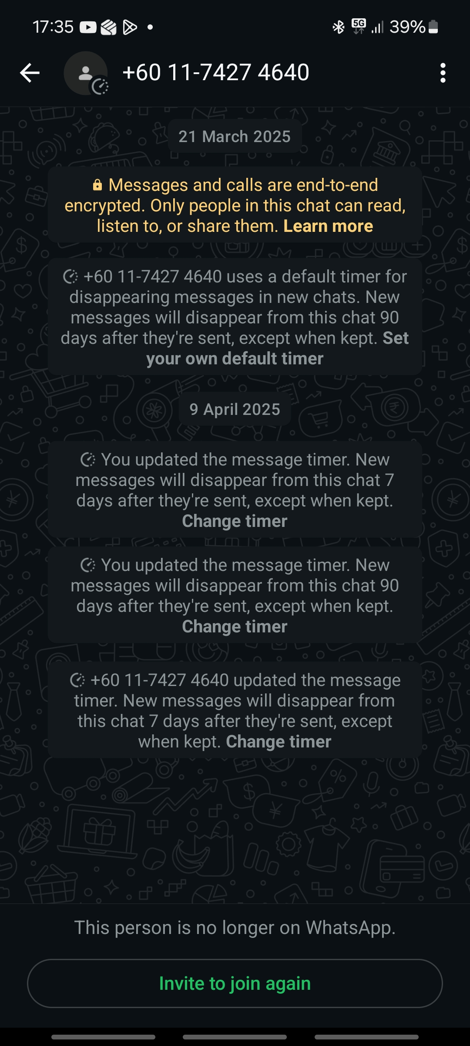
This is WhatsApp

Screenshot/Photo 2

This is Barclays Banking app
Screenshot/Photo 3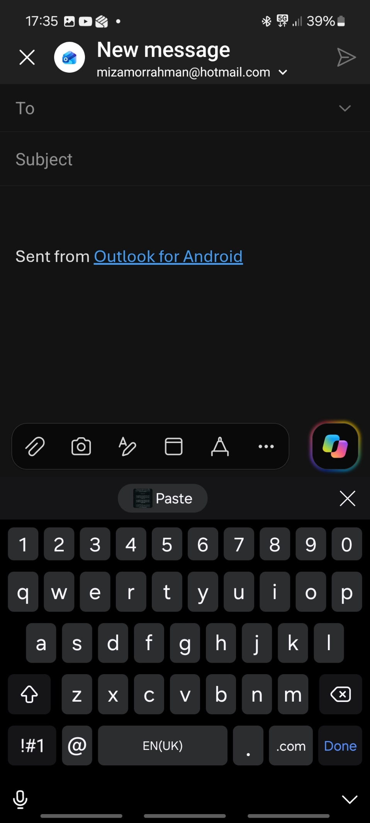
This is Outlook
This is Google 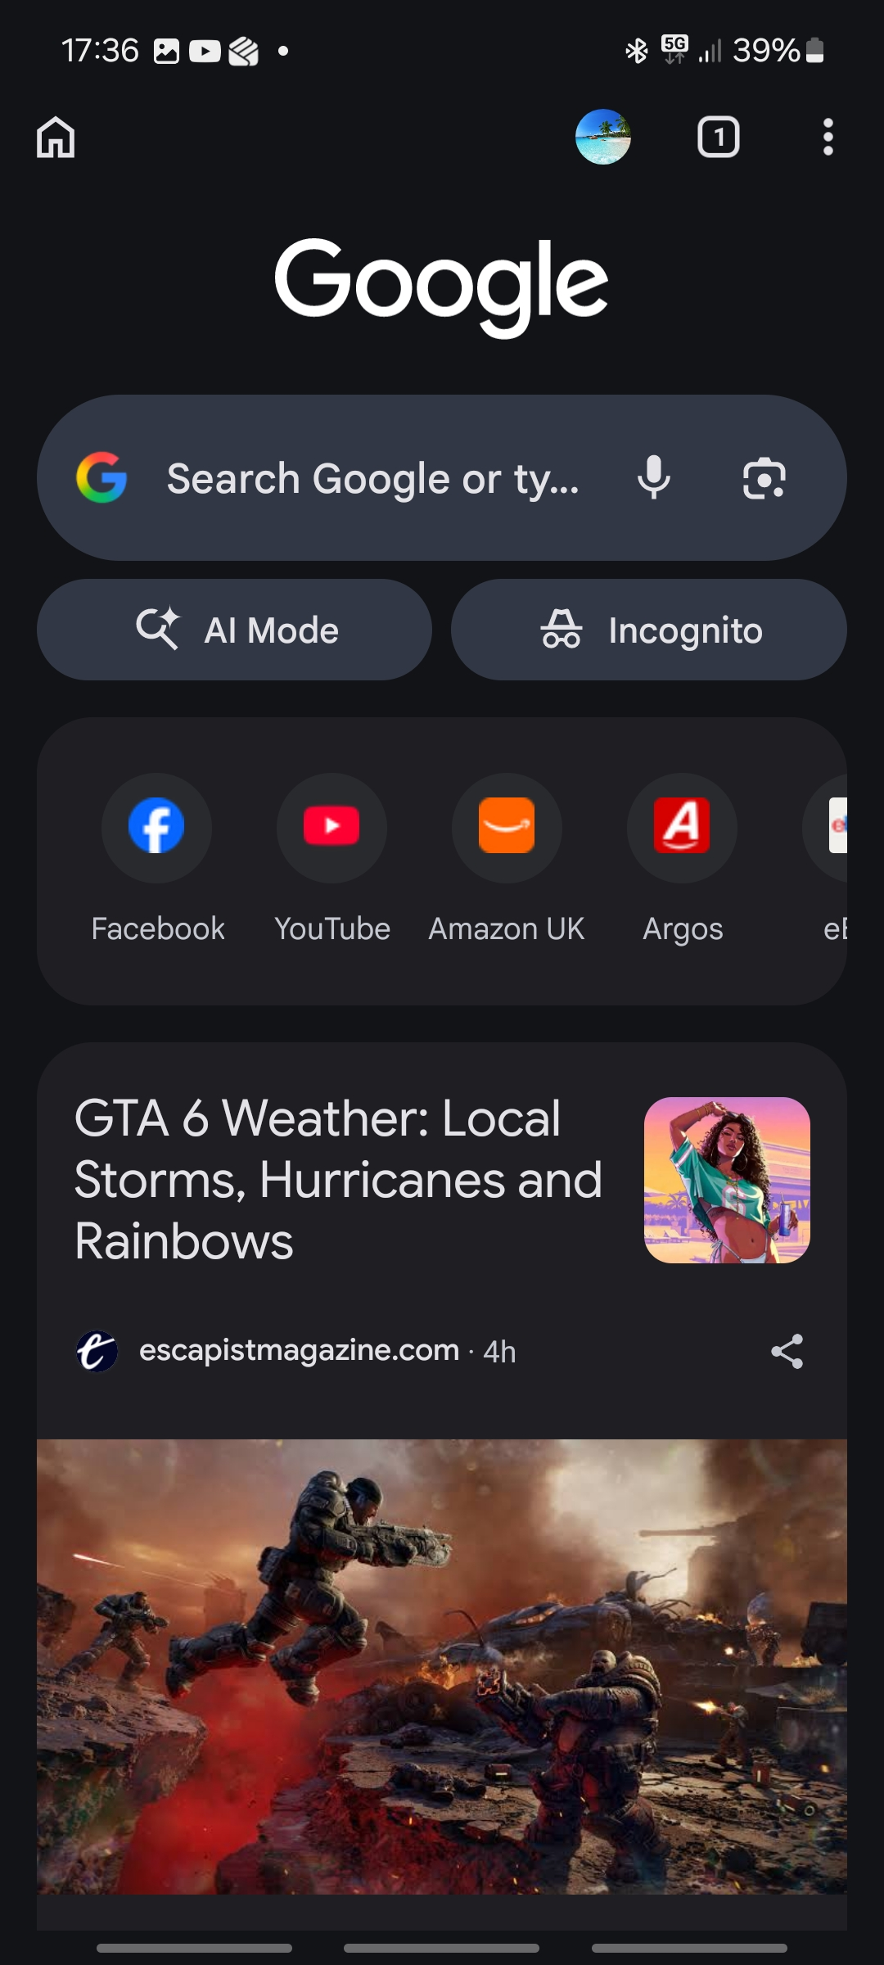

Screenshot/Photo 5

Screenshot/Photo 6

My Short Reflection
- Write 5–8 simple sentences about your digital life.
- You can use the sentence starters below if helpful.
I use WhatsApp to stay connected with family and friends. I feel confident in using this app because it's reliable and messages are sent instantly. I can improve by using voice notes more to save time.
I use Google Chrome to do online shopping and web searching. I feel confident in using this app because it warns me if a website is not safe to open or give personal details. I can improve by bookmarking more to save time searching again.
I use Outlook to check my emails from my GP university or work. I feel confident using this app because it is formal and safe. I can improve by using the focused inbox option to reduce junk mail.
I use Barclays to do online banking. I feel confident using this app because i can manage my finances and it is secure. I can improve by linking my card to Google Pay to make shopping easier.

Sentence starters
- I use digital tools to …
- I feel confident when I …
- I want to improve …
- I often use these tools: …
- I sometimes feel nervous about …
- I hope this module will help me …
- Digital skills are important for me because …
You can write more if you want.

