FIRST CINPRESSIONS
https://wordpress.com/view/firstcinpressions.wordpress.com

Title card
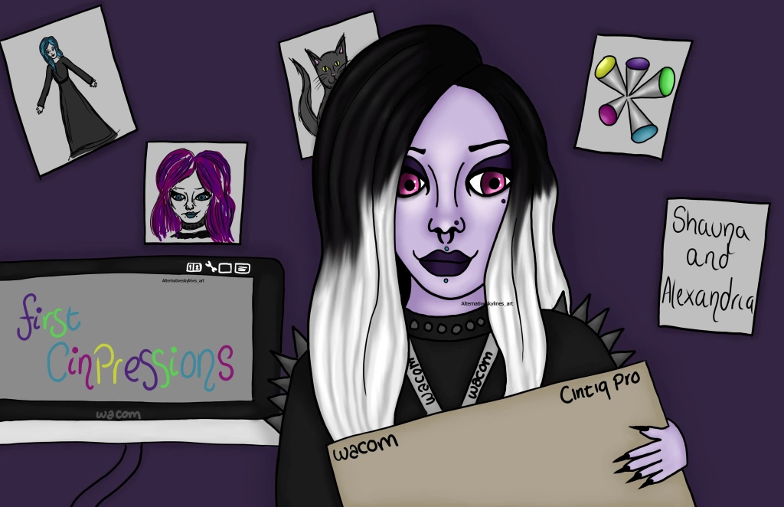
This is the title card for the animation. Shauna and Alexandria are the two characters, Shauna is the character in the tittle card.

Movie poster
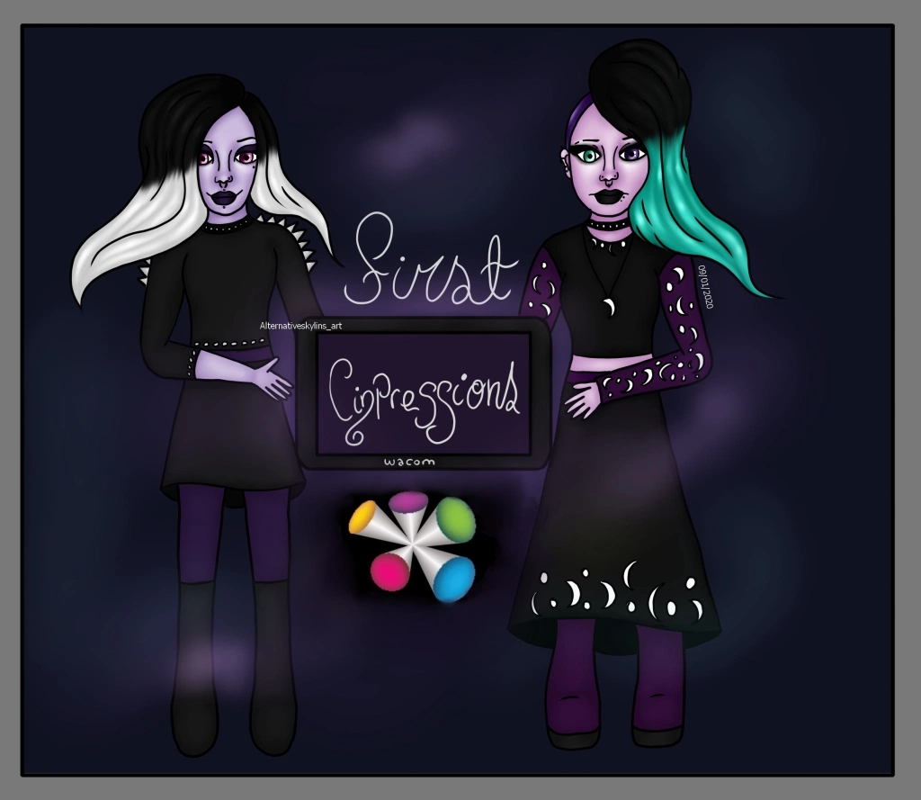
The movie poster for the animation featuring the two characters, Shauna and Alexandria.

Wacom reposted the animatic
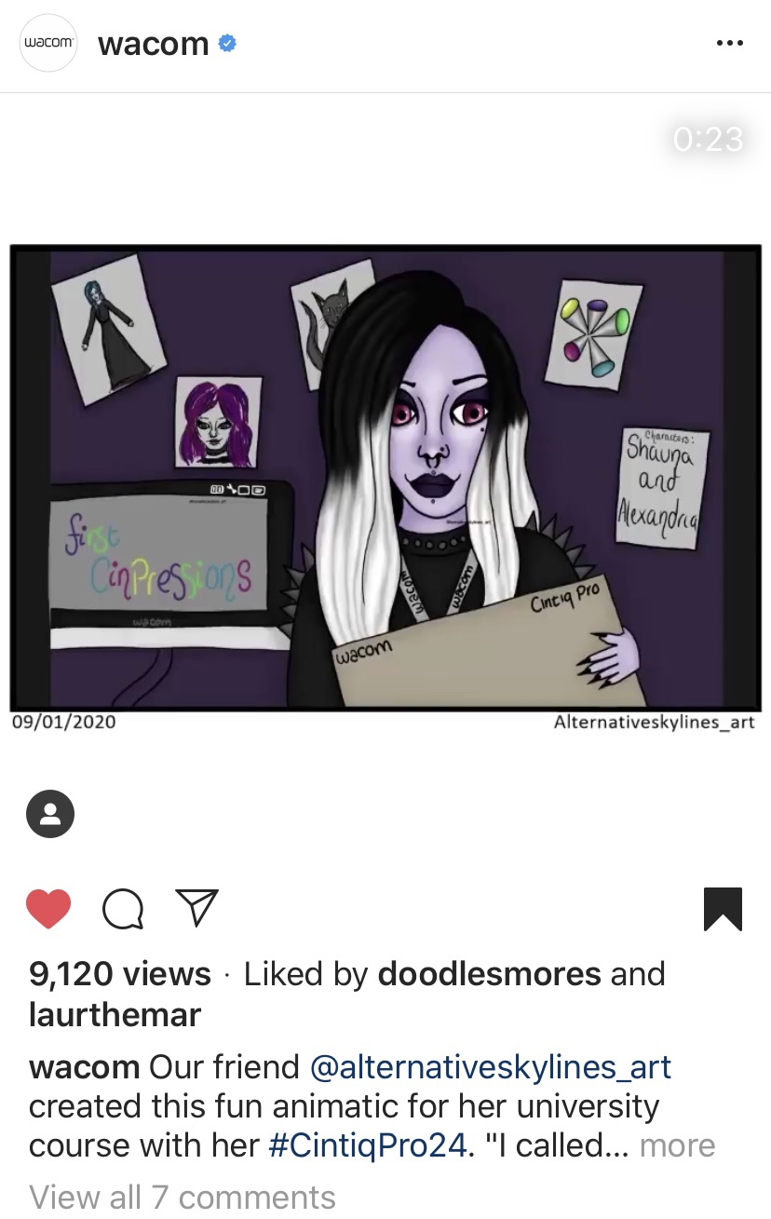
Wacom reposted the 2D animatic on the 20/01/2020. This was a very happy day 🙂

Pen designs
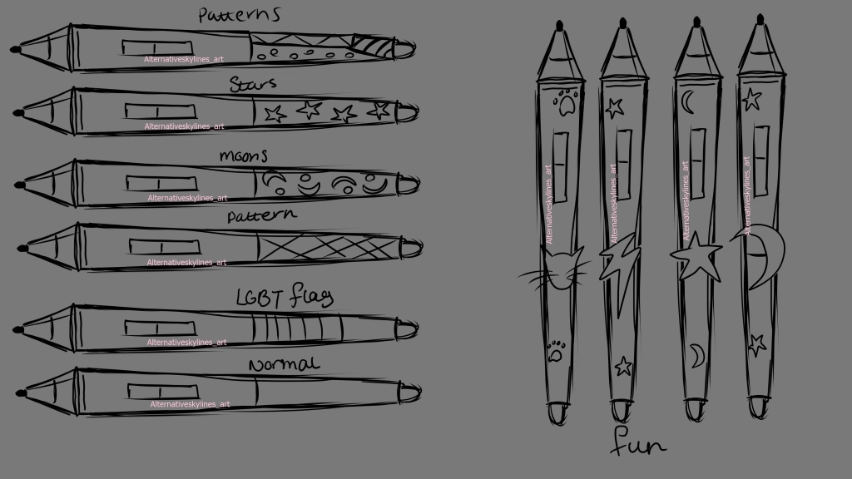
A few patterns and fun designs for the Wacom Pro Pen 2. I wanted to try out different ideas because I wanted to make something unique for my characters

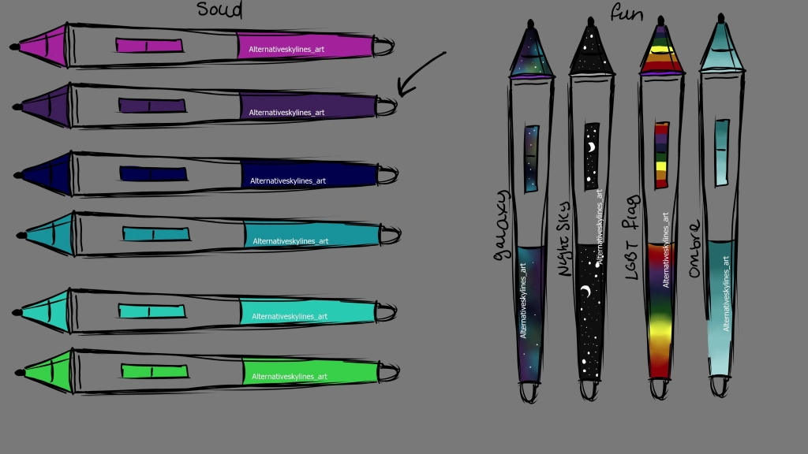
I chose the normal design for the Pro Pen 2 but I still wanted to change the colour. So I varied it by a range of solid colours, galaxy, night sky, LGBT pride flag and ombré

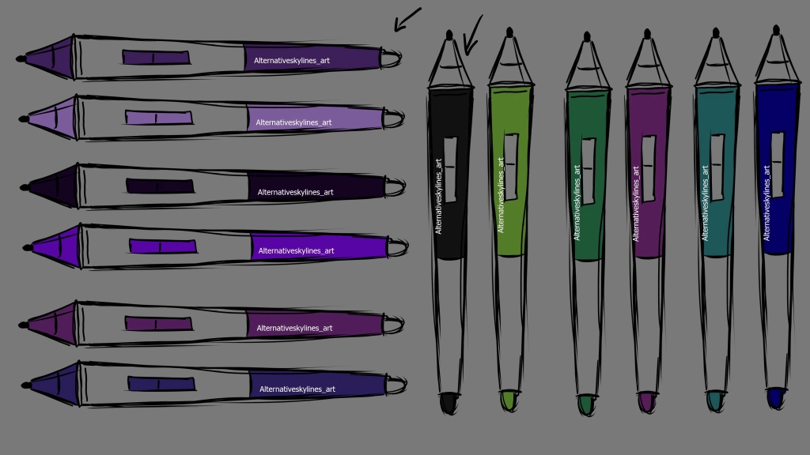
I chose the purple design but wanted to vary it further so I changed it for each by adjusting the light, saturation and hue. I also wanted to vary the grip too so I gave myself a few colour options before going for the standard black grip that all pro pens have.

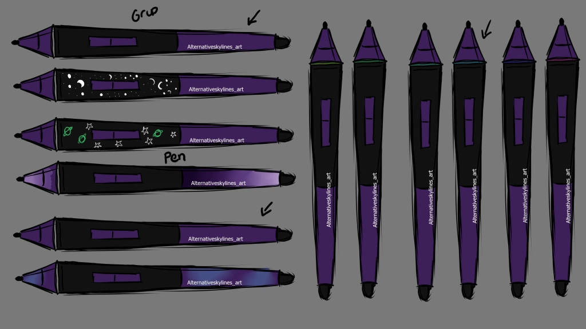
I varied the grip with a few pattern design however still chose the original as I felt it worked best. I also varied the pen itself but also went for the plain purple there too keeping in mind that I will have to 3D Model this. I finally then chose from a few different colours for the ring on the pen.

Logo
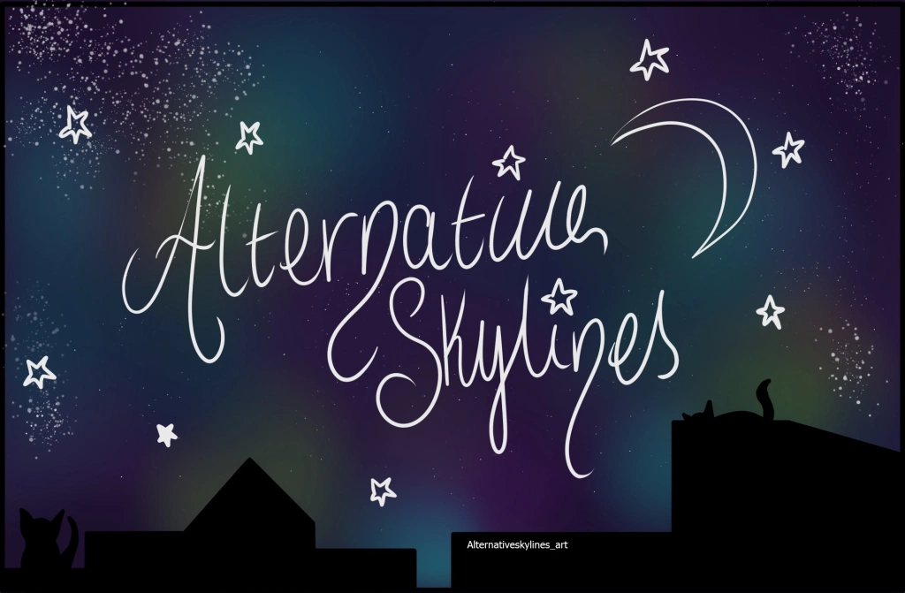
Main logo for all of my future work
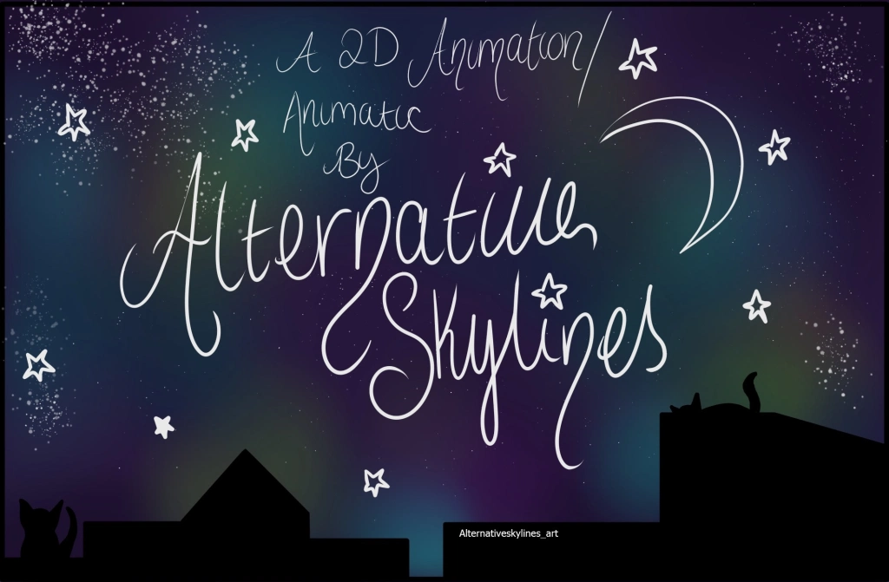
Logo for 2D animations and animatics
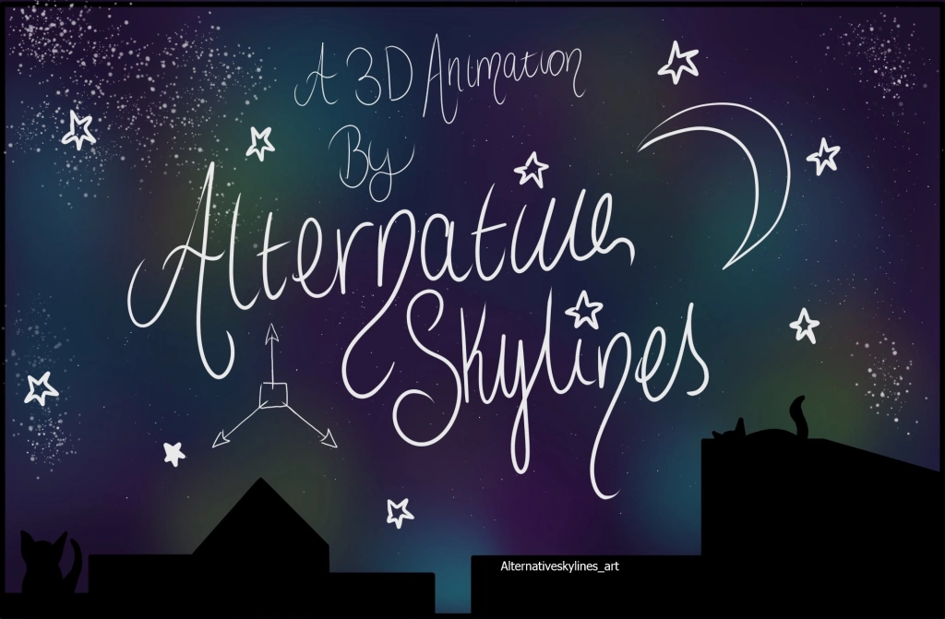
Logo for 3D animations

Shauna and Alexandria design
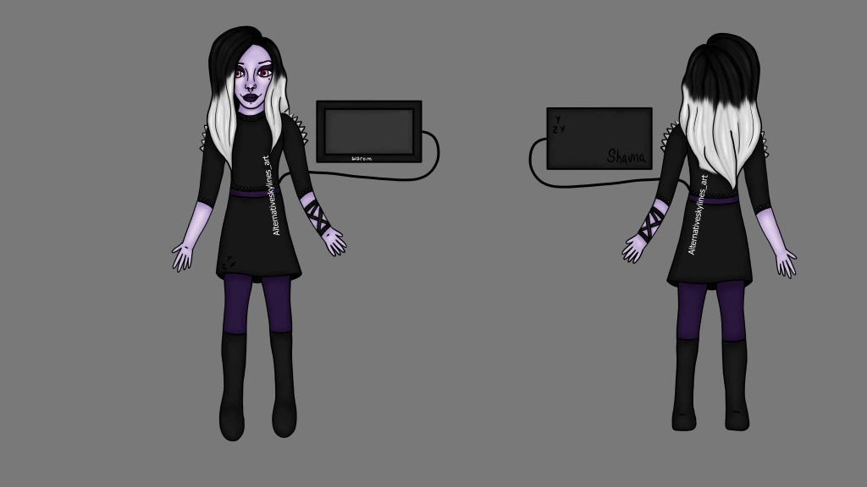
Shauna’s design. This is a redraw I did in November as the original from June needed improving.
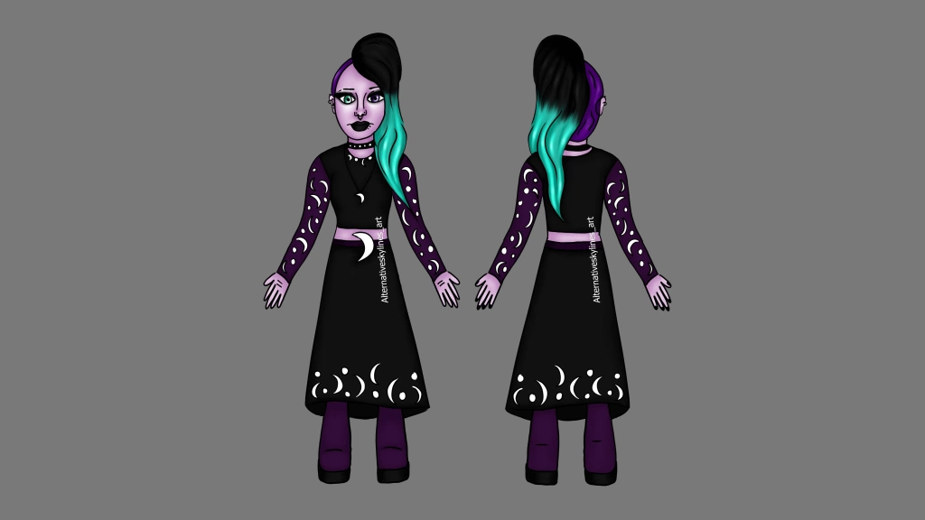
Alexandria’s design. Made in January

Mice and Wacom pens
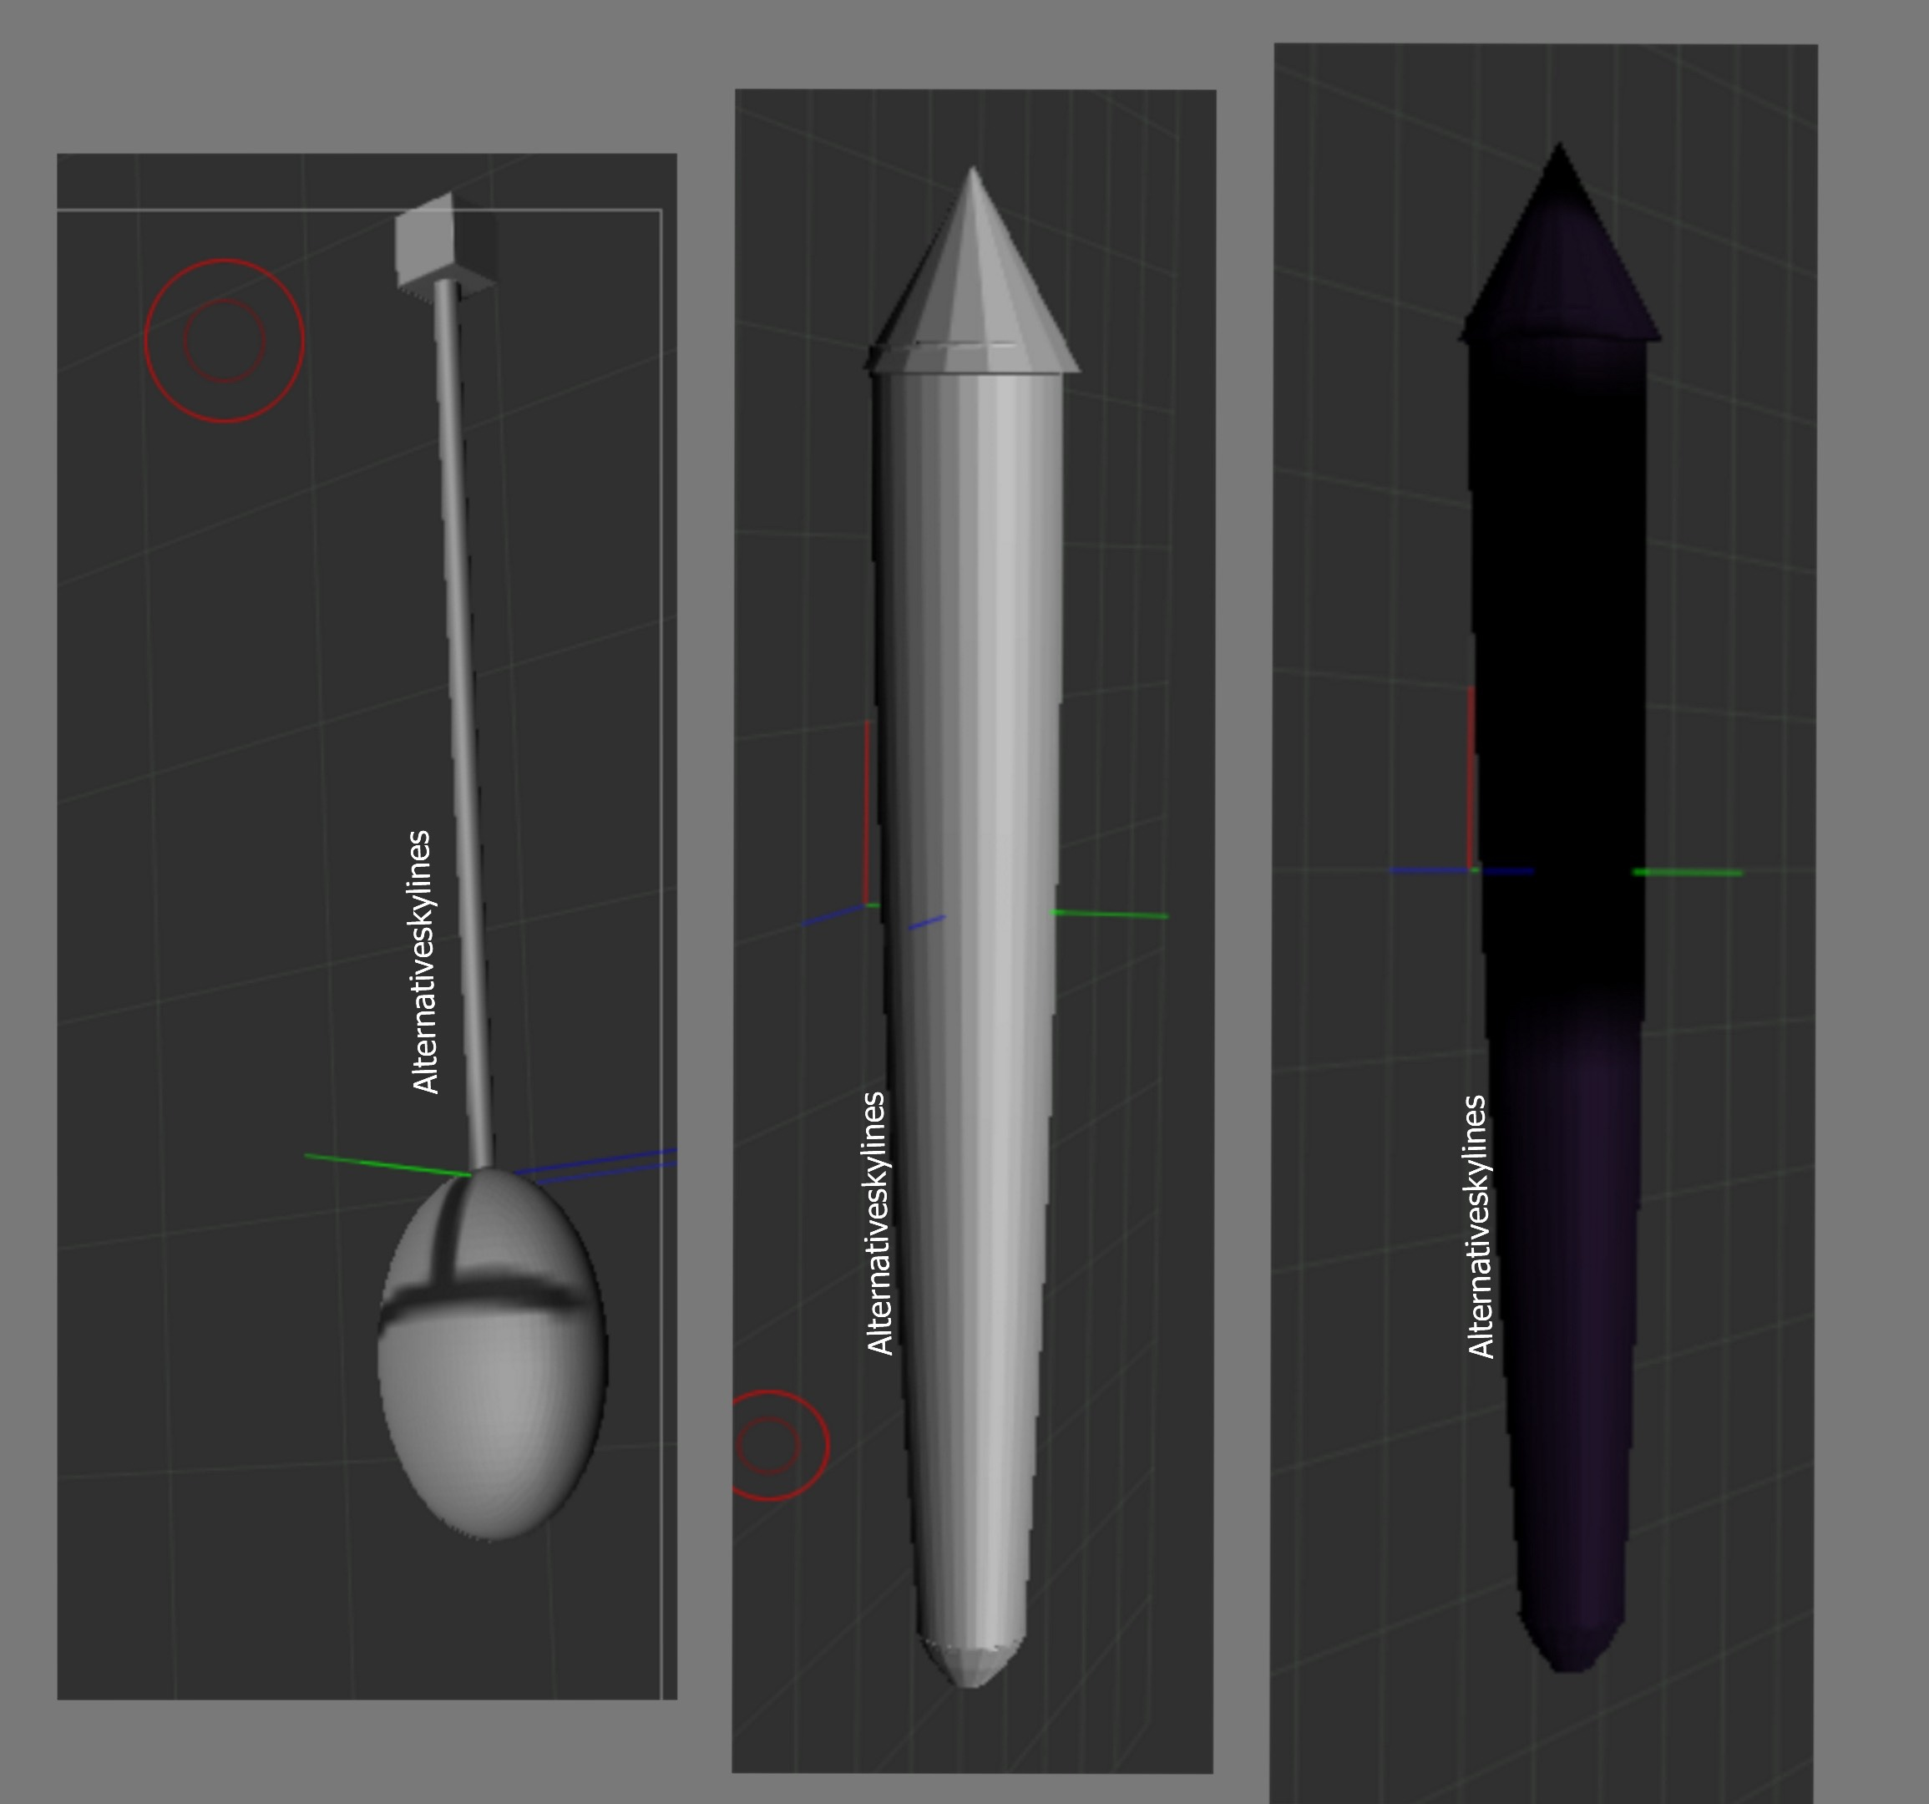
The first image on the left is the mouse, made with a sphere, cylinder and cube in zbrush and then poly painted.
The middle image is the Wacom pen before poly paint. I tapered the cylinder for it to look like a Wacom pen. I need to practice more to get this perfect
The final image is the Wacom pen poly painted to the chosen colours from the original design variations I did.

The Cintiq
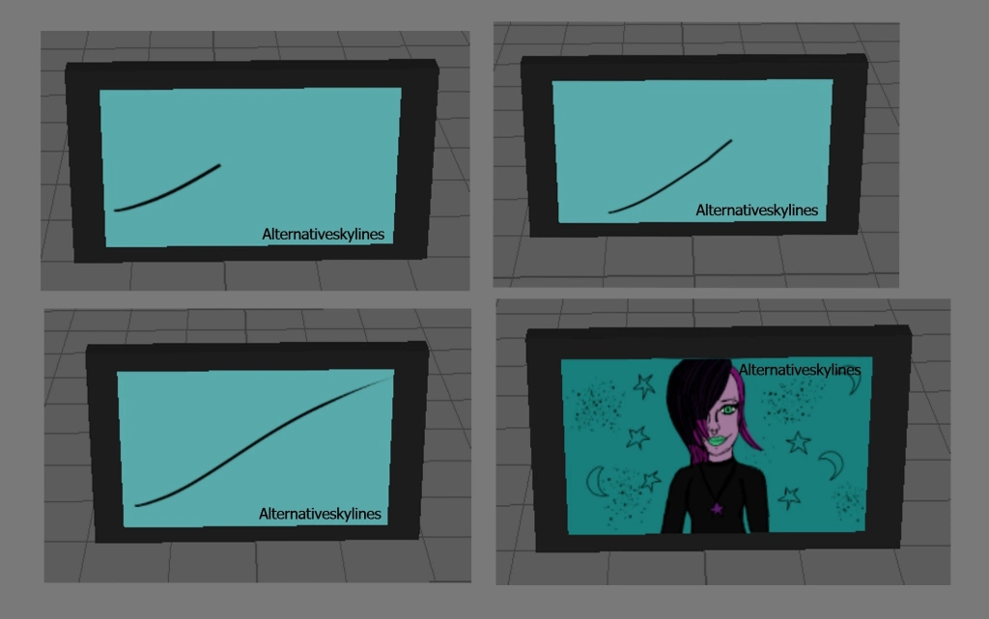
I made a Cintiq and then duplicated it 4 times so I could have different textures on it.
The first 3 textures are of the first line Alexandria makes on the Cintiq and the final one is of the character she makes 6 months later

Environment
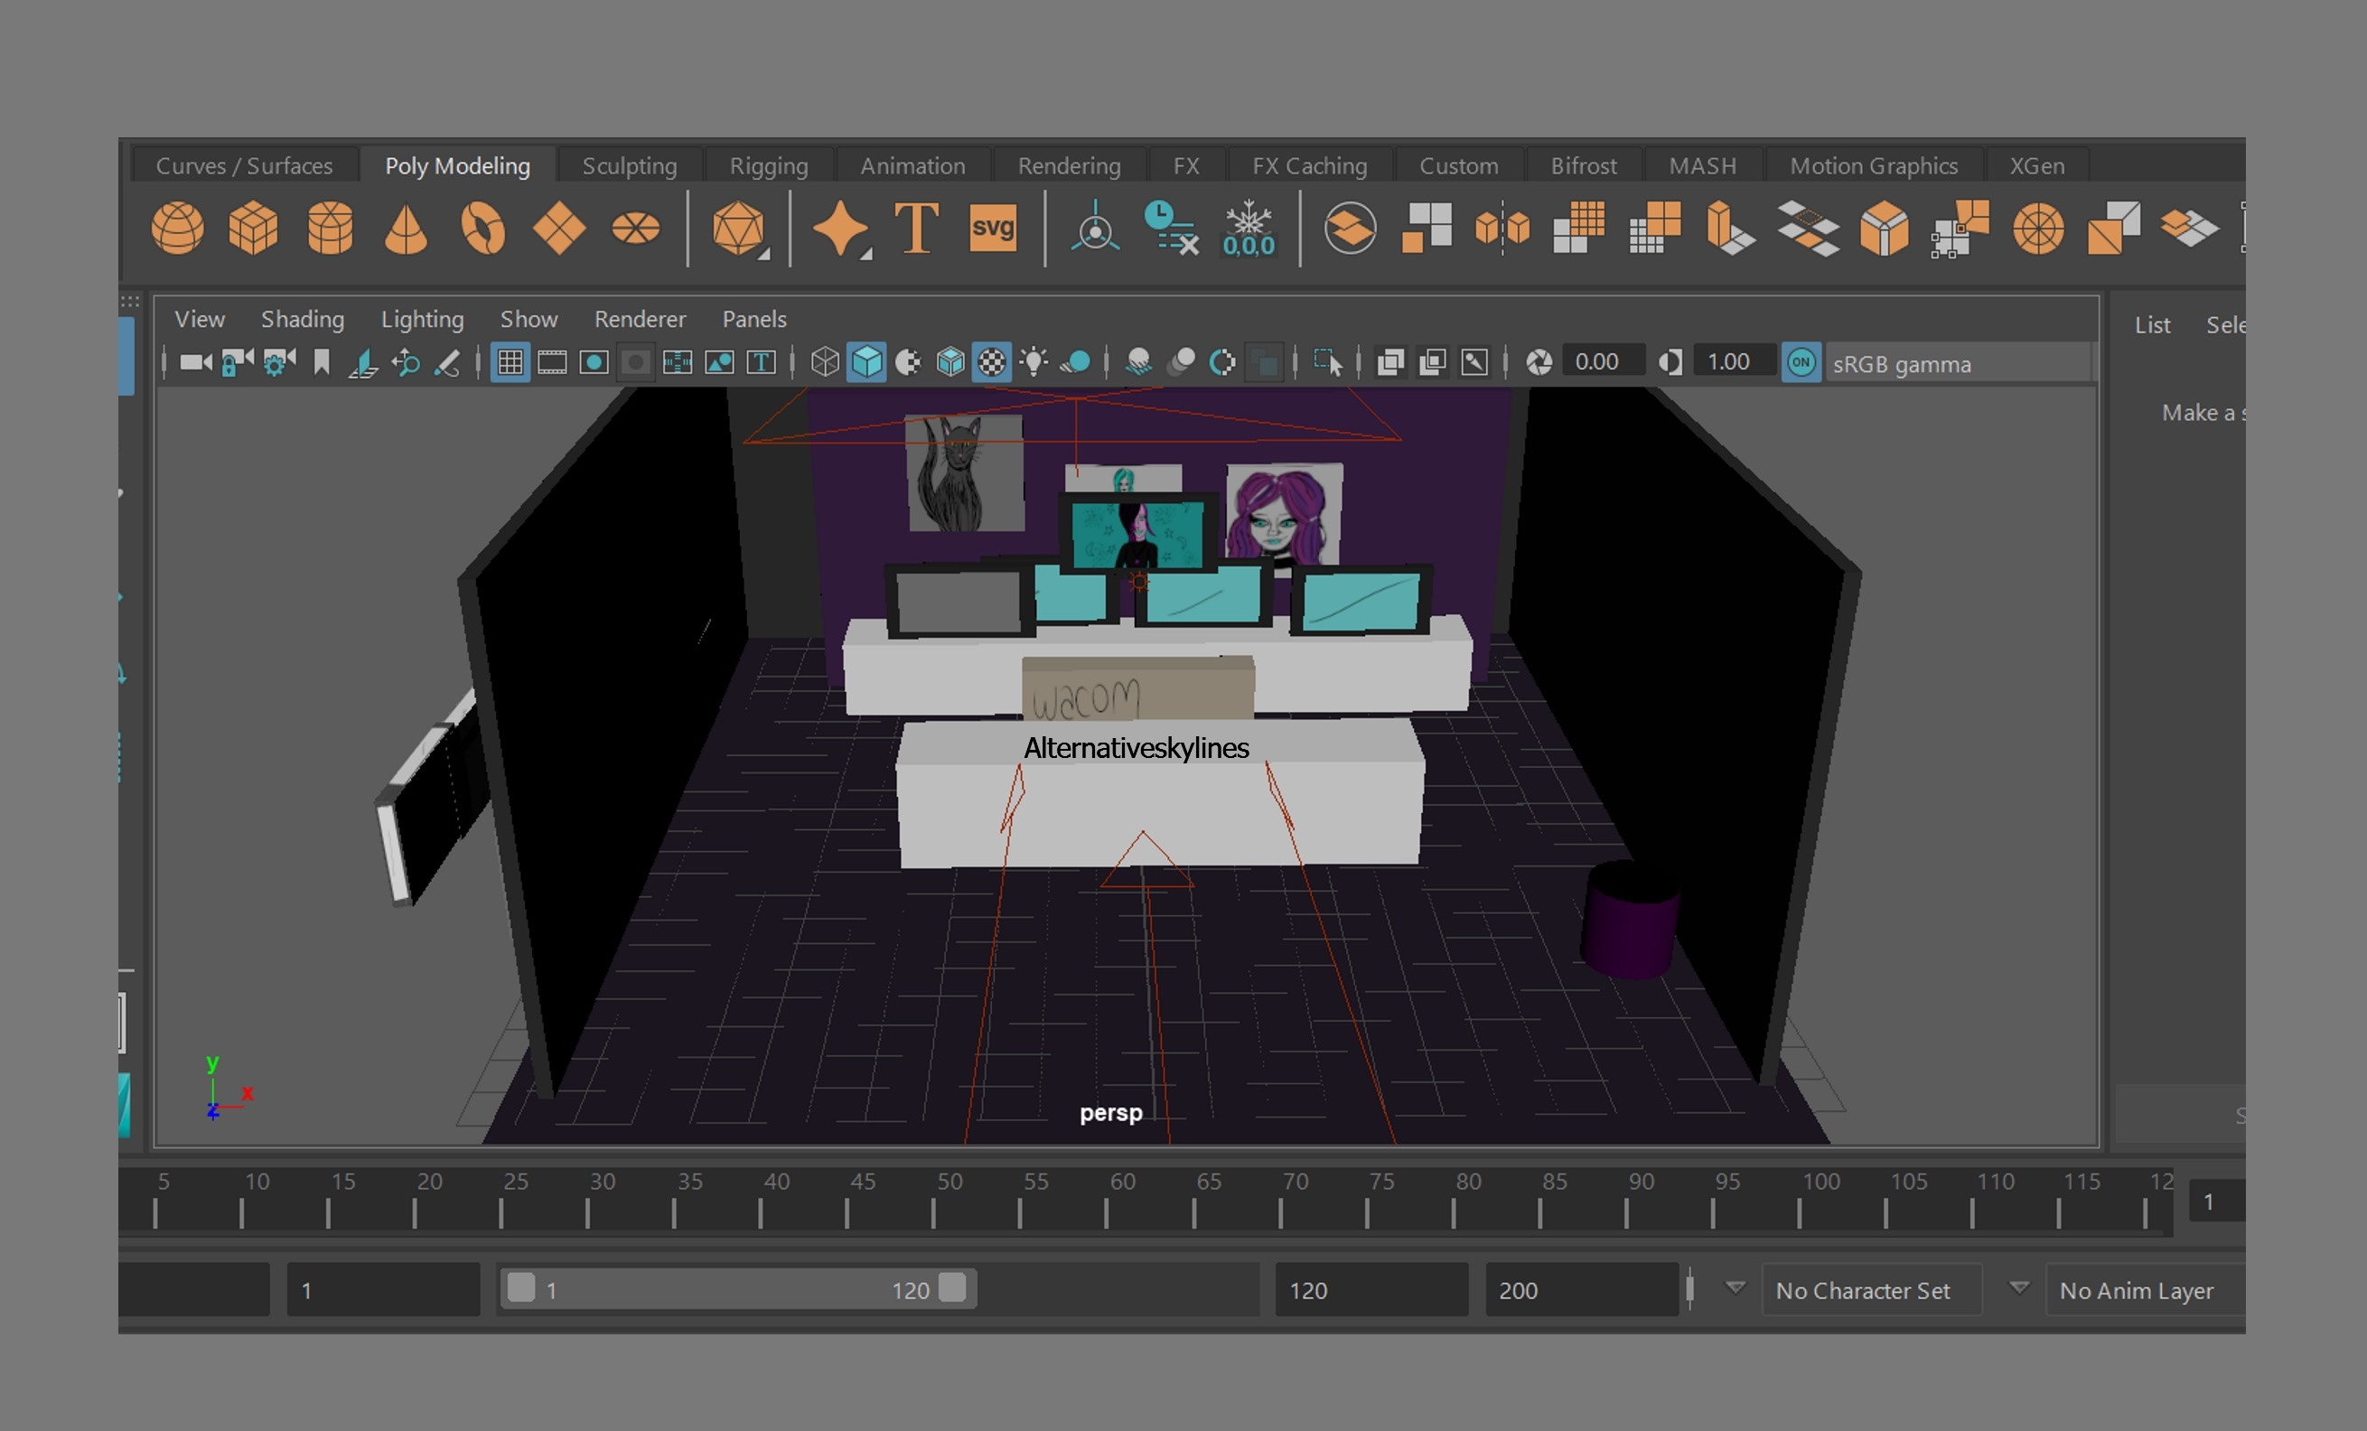
The environment is still messy at the moment but I have just imported everything into it ready for animation. This is based off Shauna’a filming room as she is a 3D artist and Wacom ambassador.

Mouse animation
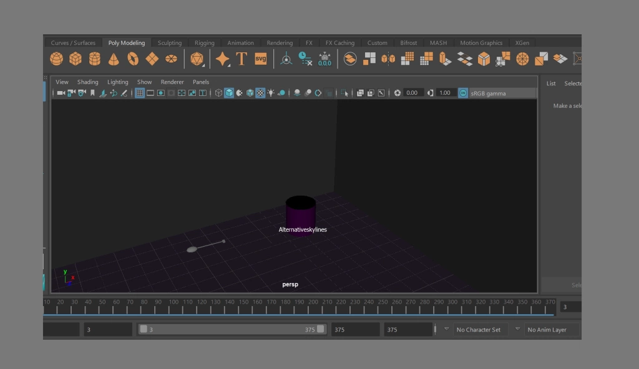
I put the bin and the mouse in a separate scene just to allow more room. I have already put in key frames for the mouse going into the bin. The one thing I changed from the original is that Shauna now doesn’t kick the mouse.

Base model
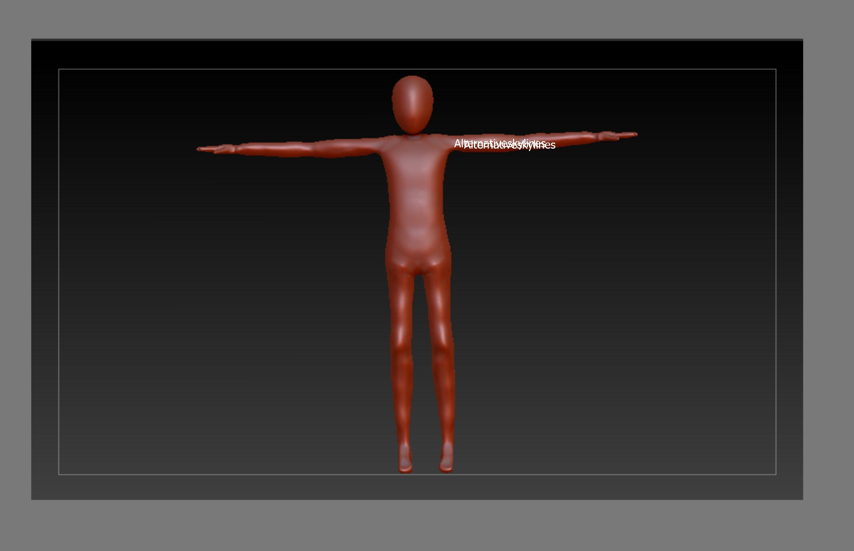
This is a base model from a character I modelled last year. After a few failed attempts, I decided to use my character from last year as a base to build on top. This is because I liked the proportions.

Alexandria model
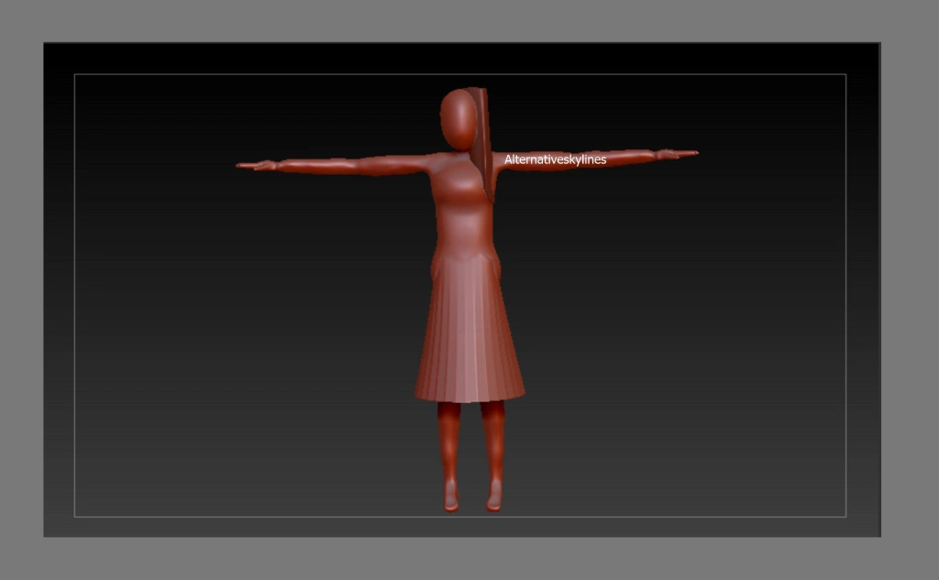
Start of the base model. At this point I had added in the skirt and some of the hair. for the skirt I appended in a cylinder and then used the deformer to make it fit to the body and then the taper to make it look more like her dress in the original design. The hair was added in by appending a sphere for the top of the head and then a cylinder, I changed the shape of this using the deformer tool again. I was originally having trouble getting everything to blend together naturally but I found out the dynamesh tool was to be used for that.
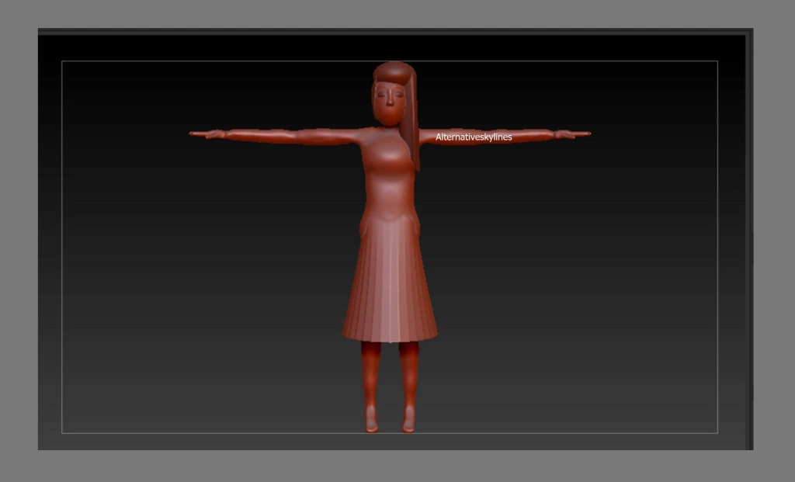
The final base model. All hair added and the eyes and nose. For the eyes and nose I used the same techniques as what I used for the clothing and hair. I used the applicable shapes such as a cylinder for the nose and spheres for the eyes. I then went on to use the clay, clay build-up and standard brush for the details on the face including the creation of the lips.
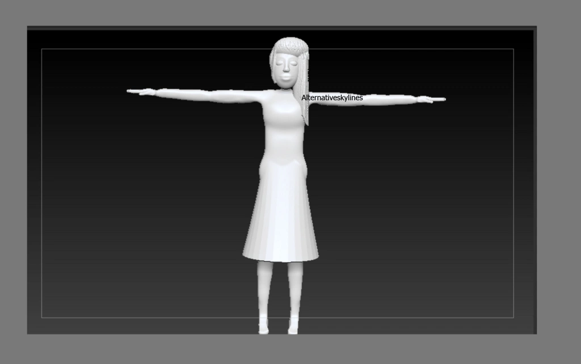
At this point I changed the character to one of the skin shaders so poly paint works better as I found on the other shader when I was adding the colour it was faded
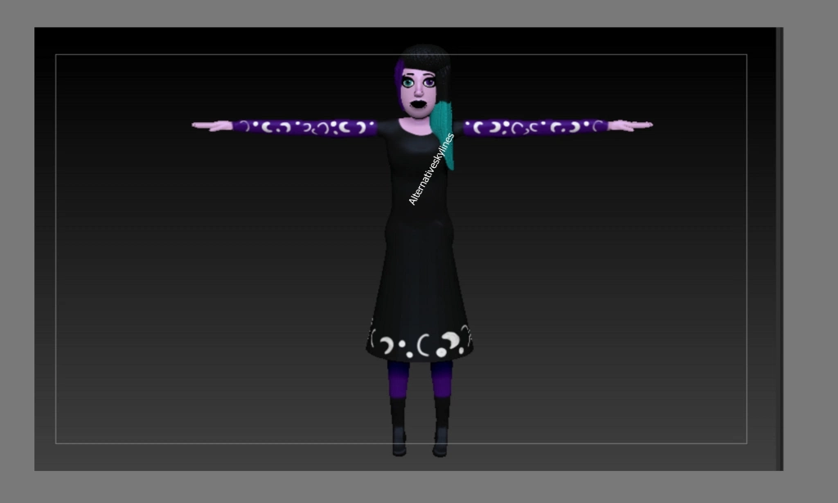
The final Alexandria. Fully textured with poly paint and ready for the animation.

Shauna model
Base model. Some hair and clothing added.
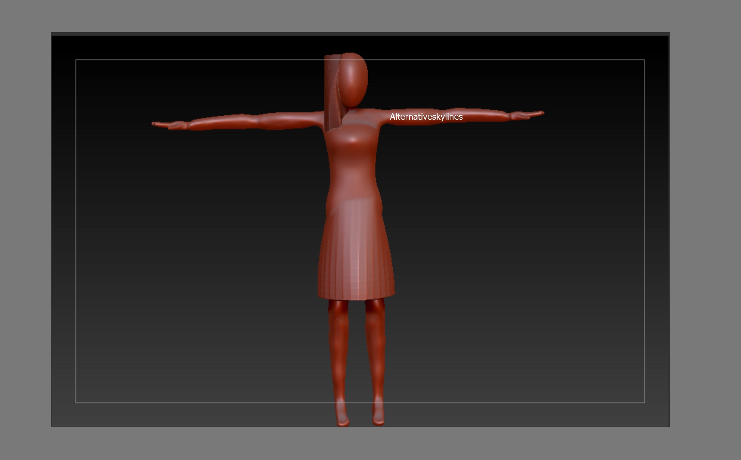
Finished base model before details. All of the hair, spikes and face blocked out. I used the same techniques for Shauna as I did Alexandria. Although I feel like Alexandria’s face was a lot more successful however Shuana’s hair was more successful. For the spikes I merged them all together on one side and then duplicated them so I could have them exactly the same on the other side.
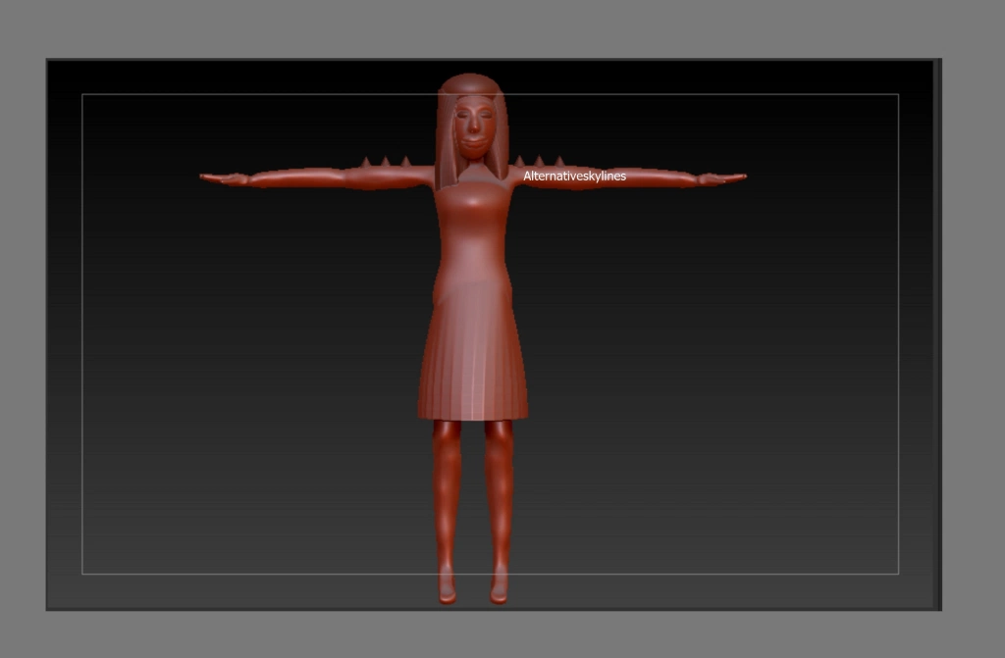

I really struggled with the lips on Shauna so they are a bit big. I added an alpha to the hair to make it appear more like hair.
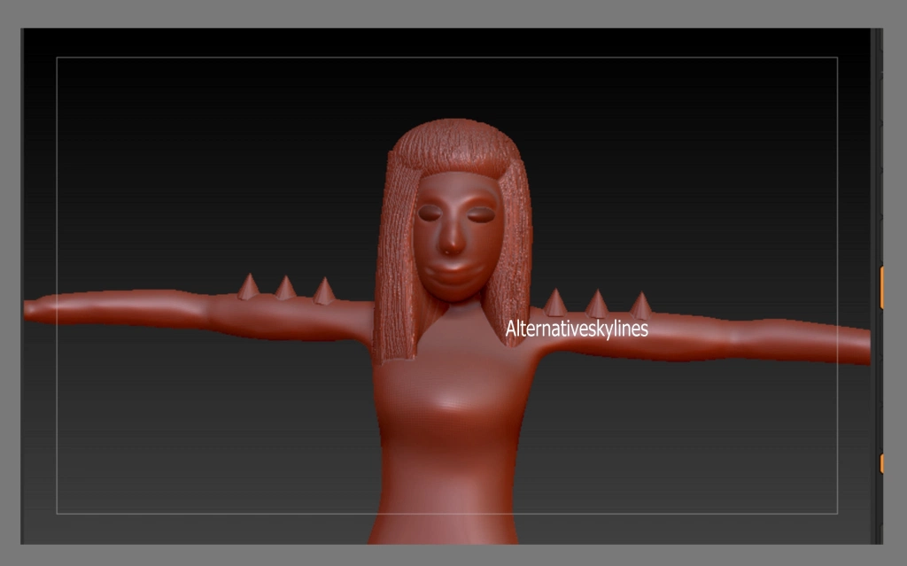

Final Shauna. Fully textured using poly paint.
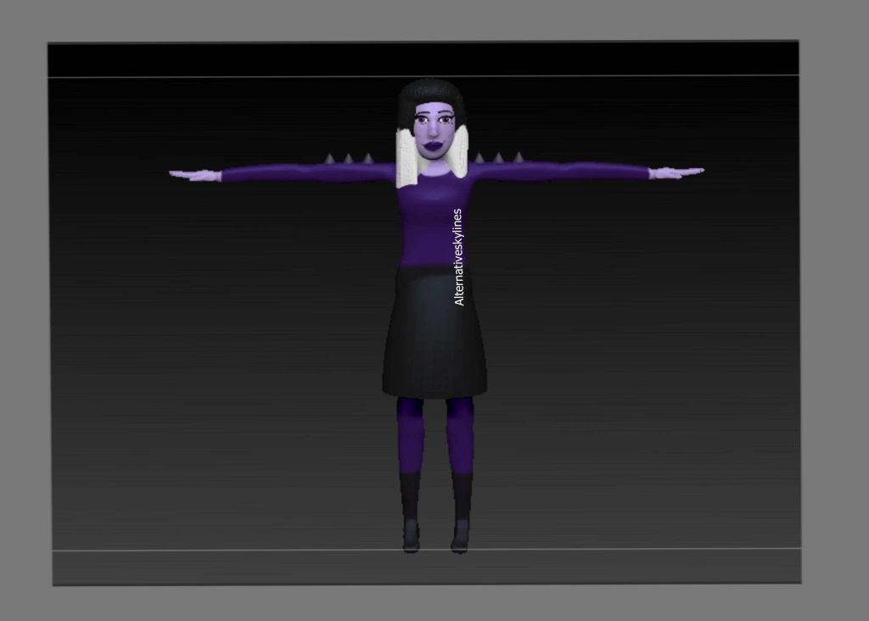
Rigged characters
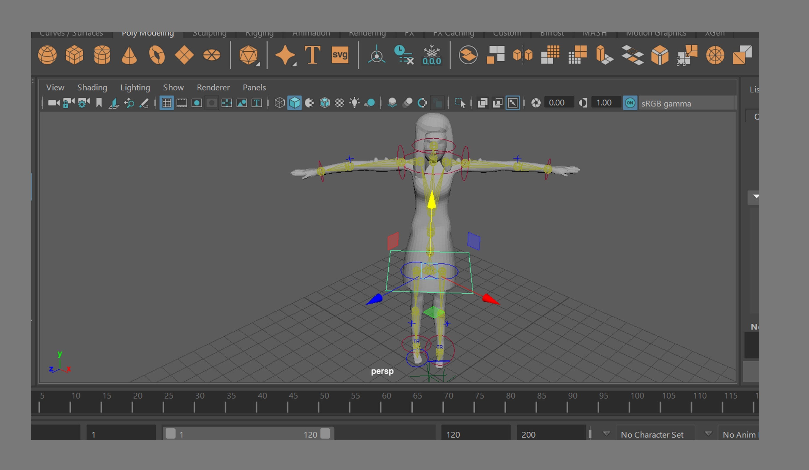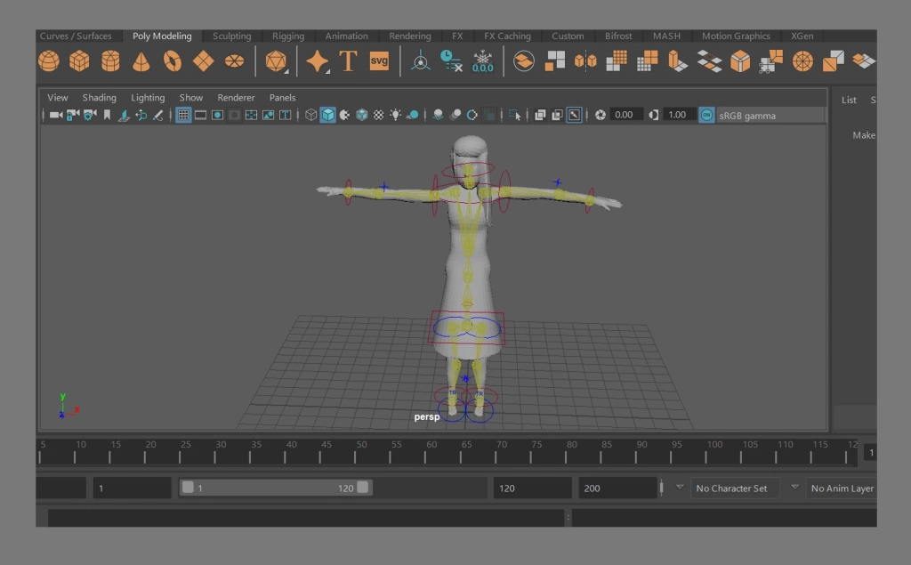
I had to reduce the polygons a large amount so I could add the characters into maya as they where taking too long originally. I did this using z re mesher which meant I also lost the textures (colour) I had on the characters.

I then rigged them with the quick rig in maya and I didn’t even have to fix the paint weights which saved time.

Undo scene
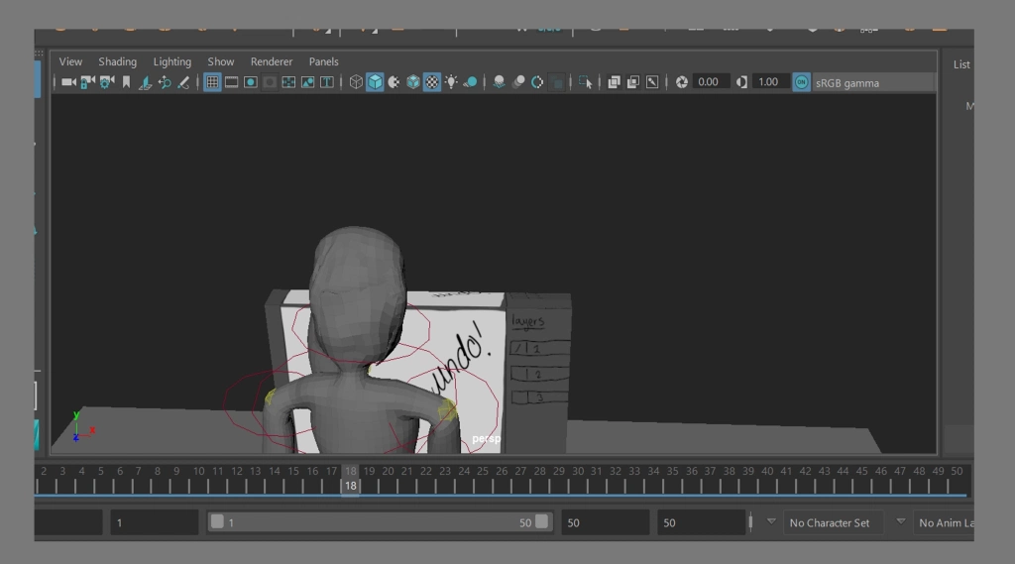
I didn’t add any animation to this scene as it just shows Alexandria from behind. I still wanted it to count as part of the time in the animation so I playblasted it out to last 2 seconds

Mouse scene version two
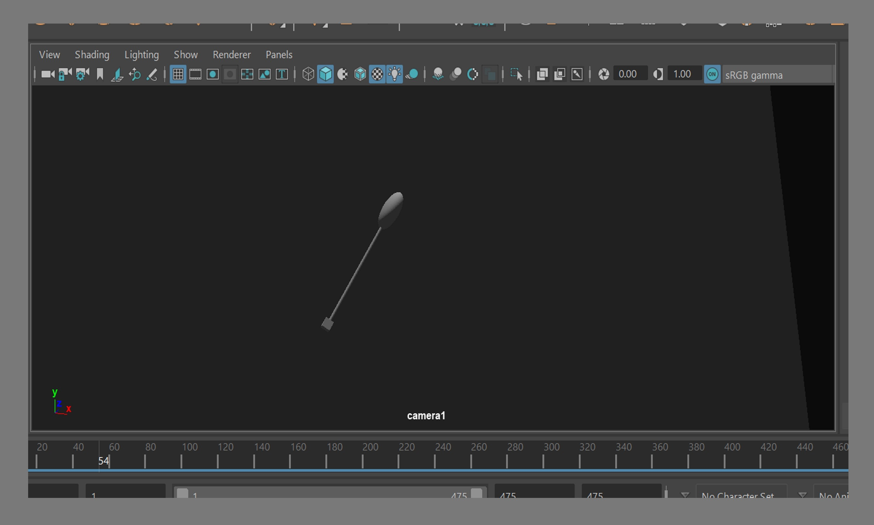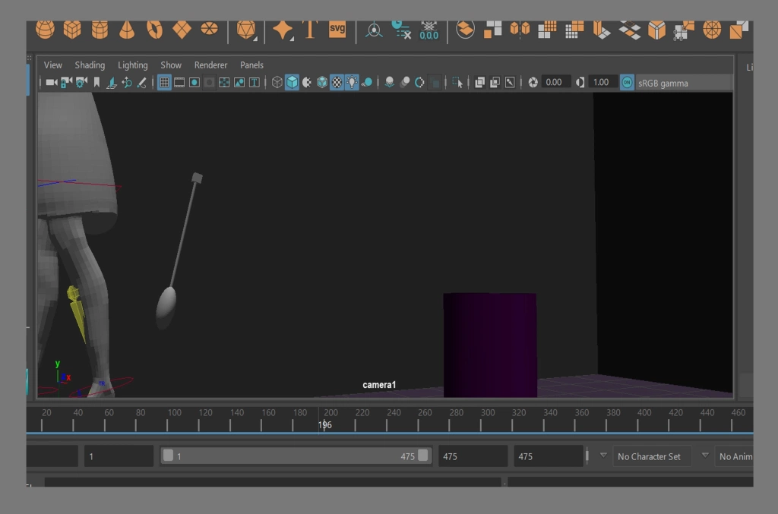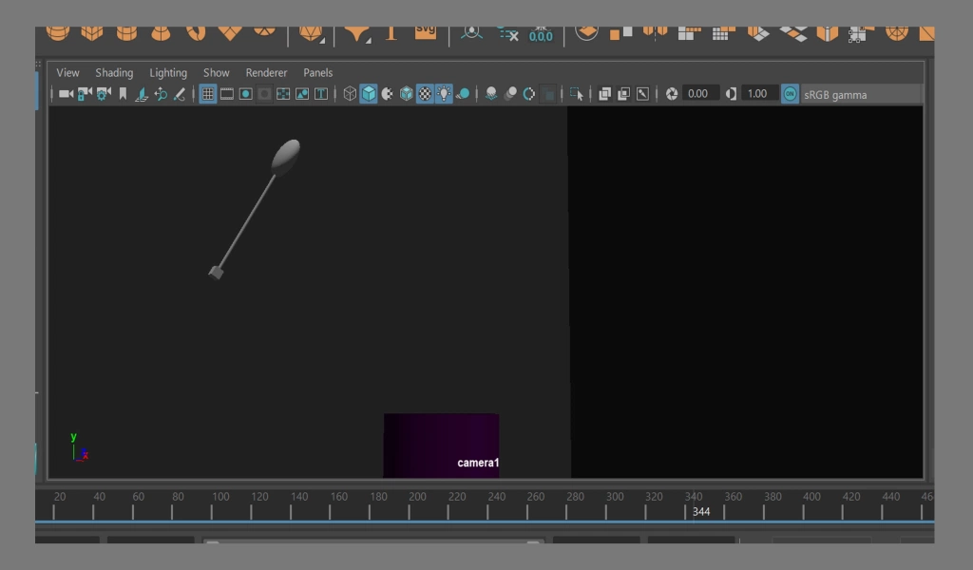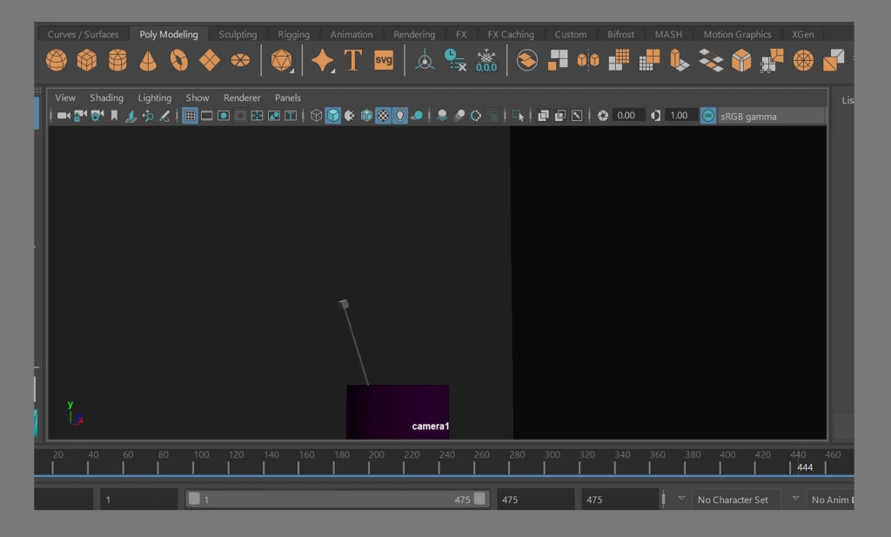I re animated the mouse scene as it was way too fast and also didn’t look right. I added in Shauna so I could do the drop kick like in the animatic.

I did start off animating this in stepped and when I changed it back to spline it was exactly the same as animating it in spline first time around (I feel like I might have done something wrong but can not work it out) so from this time on I animated in spline.

When I did animate in stepped I used the graph editor to change this. The reason why an animation should be animated in stepped first and then changed over to spline later is because maya isn’t the best at “inbetweening”

For the mouse scene I did stick to the original animatic as much as I could. I feel like this was the most accurate scene of them all. This was actually the first scene I animated as it was going to be the longest and I wanted to get it over with first so then I could work out how long I wanted the other scenes to be to fit into the 45 second timeframe limit
In this scene, which I wished I did in the other scenes too, I played around with the lighting to give it more shadows and I felt it worked very well. I Used a spotlight to give the shading and then also used an ambient light to brighten it up as it was appearing too dark with just the one light.

Mouse scene camera
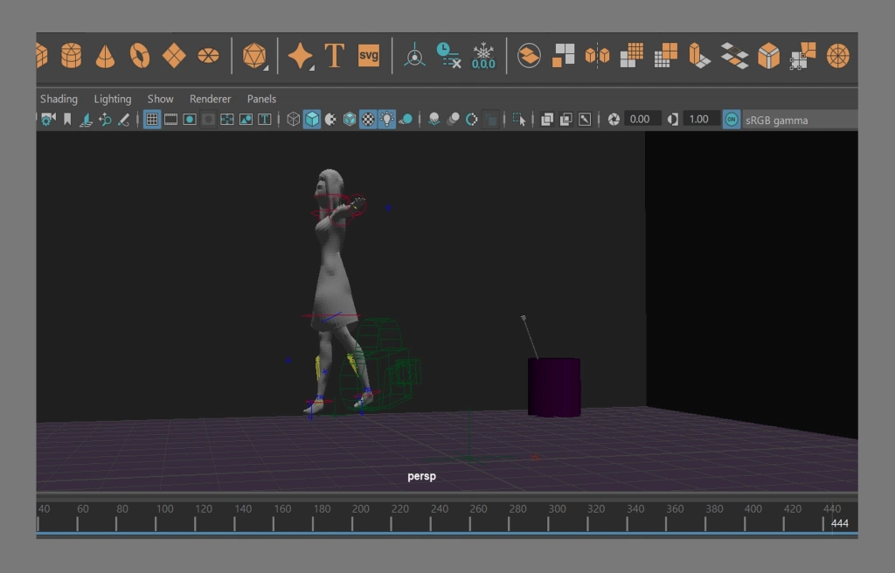Because I only wanted certain objects in the shot at certain times I created a camera for this scene. Although I wasn’t too sure on how to animate cameras I still wanted to make an attempt

I animated the camera to move with the mouse instead of staying in one position. This also meant I could have Shauna only in the scene for the one particular time where she kicks the mouse and then the camera could follow the mouse off to the bin.

This also meant it made the shot a lot more interesting as there was more than character and prop animation.

Angry scene
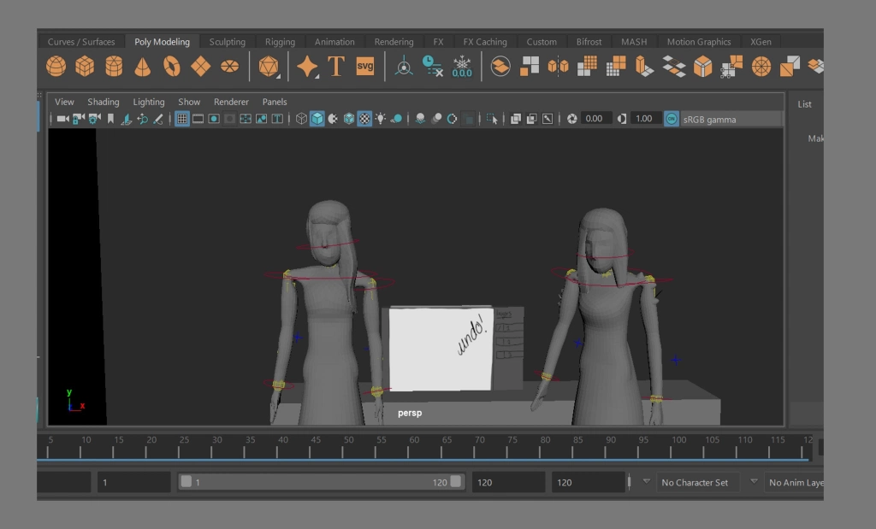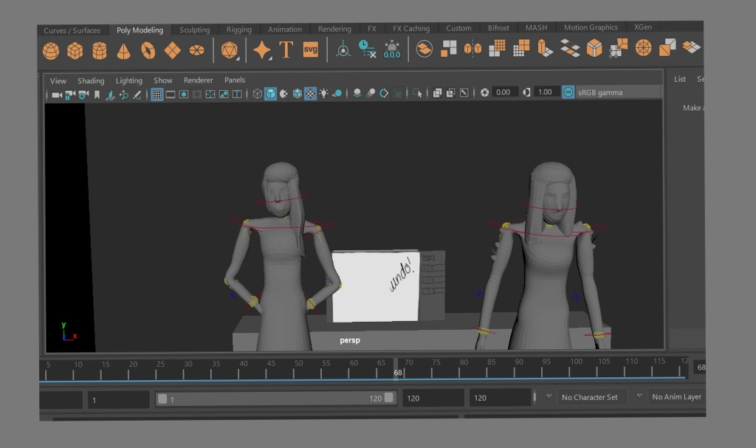This is the scene that comes straight after the mouse scene.
Alexandria shows her anger and Shauna walks off to the “filming room” where she has the surprise Cintiq.
Shauna’s walking as her legs where off screen I didn’t move them however as I moved her forward I added a bounce too to give an illusion she is walking.
I did not add a camera to this scene as there wasn’t much movement.
I did end up moving this environment next to the main environment because it then gave me more room to animate this scene.

Main scene part 1
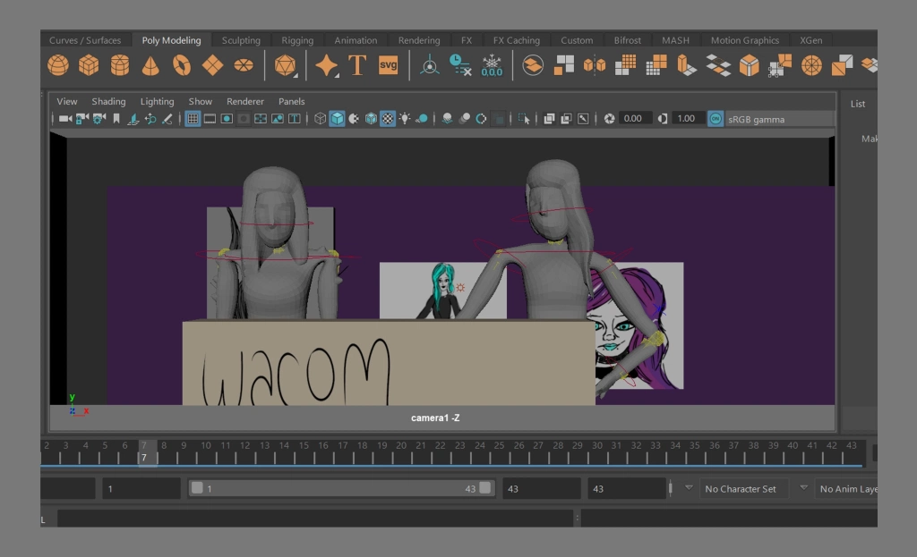This is the scene where Alexandria sees the big Wacom box and is no longer angry. 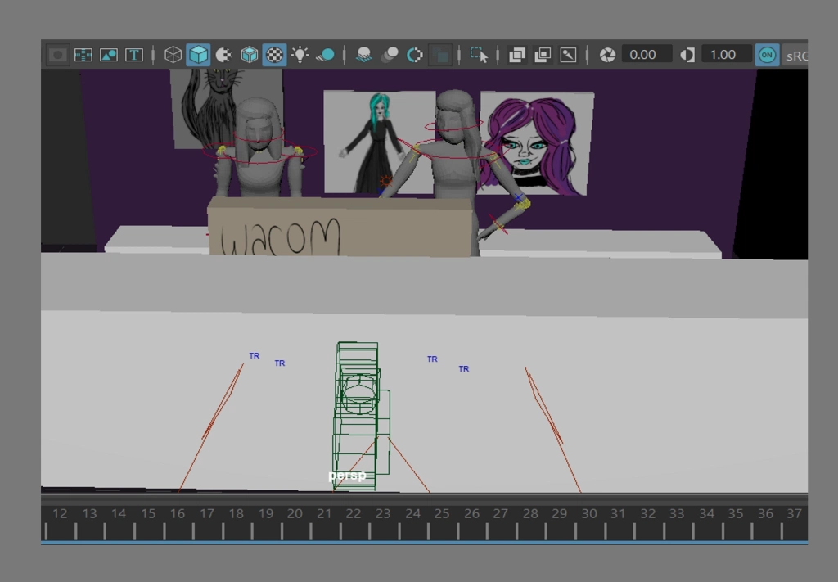I did use a camera for this scene because I was going to be using it in part 2 and 3 of the main scene and it was also added so I could get the correct angle I wanted in this scene. I did use a camera for this scene because I was going to be using it in part 2 and 3 of the main scene and it was also added so I could get the correct angle I wanted in this scene.
I ended up making this environment a lot more tidy and put certain props off screen for the time they was not in use.

Main scene part 2
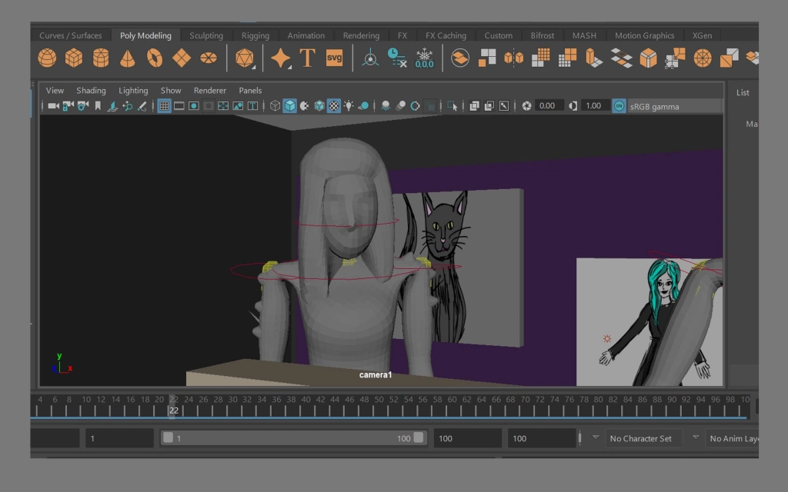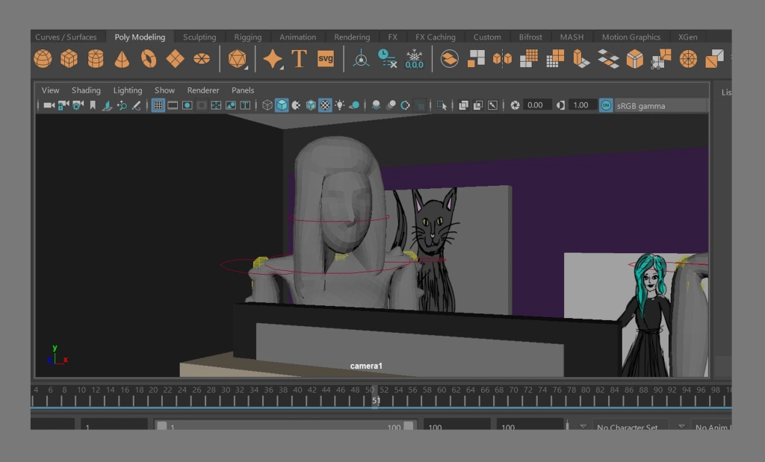
This is the scene where she gets the Cintiq out of the box. I had to move the camera for each scene to hide the things that where off screen to make sure this scene focuses on Shauna talking the cintiq out of the box

Main scene part 3
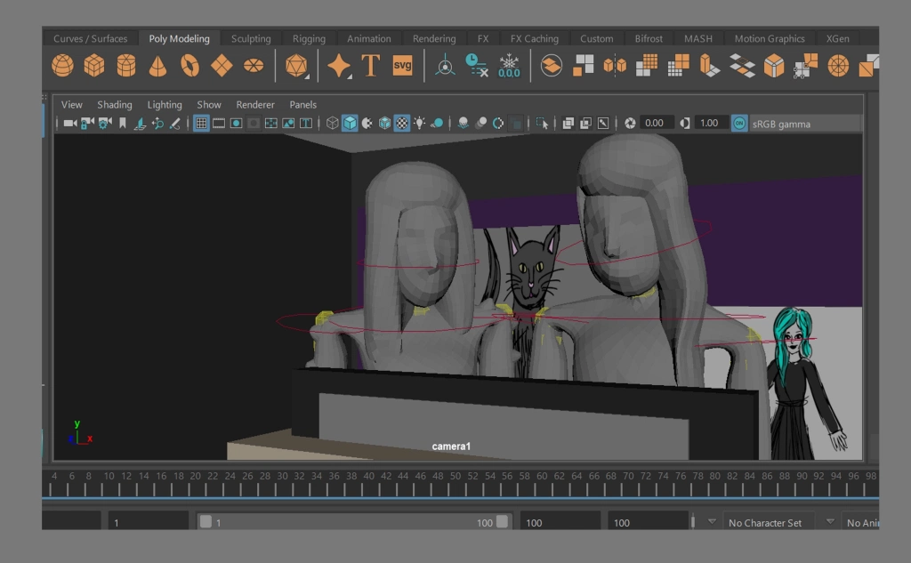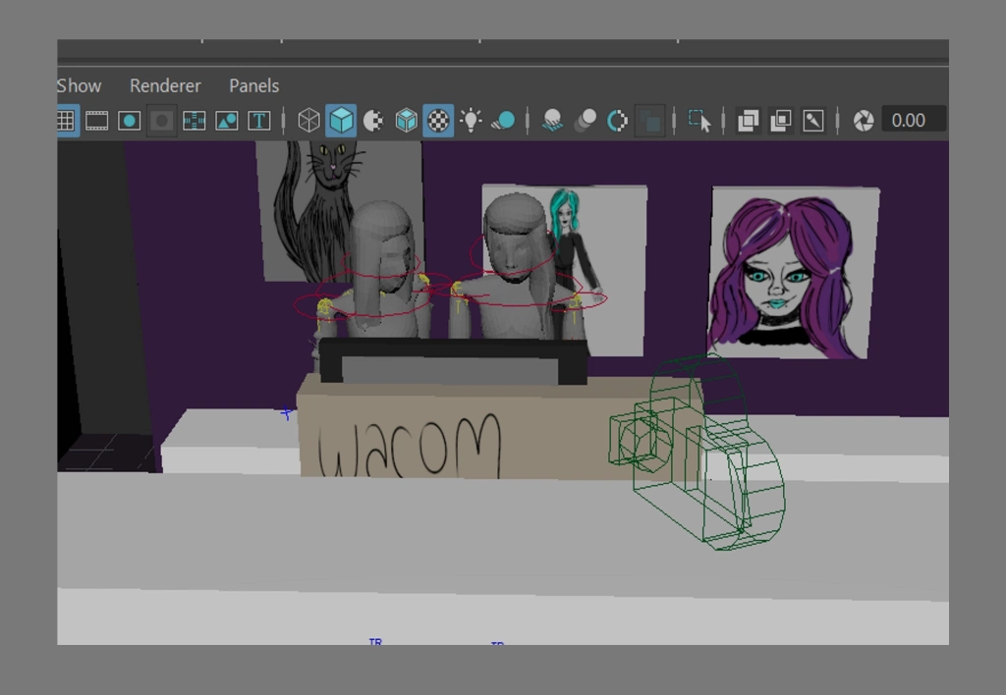
This is where Alexandria goes over to Shauna to look at the Cintiq. This is the final part before Alexandria is on her own with the device.

Shauna drawing
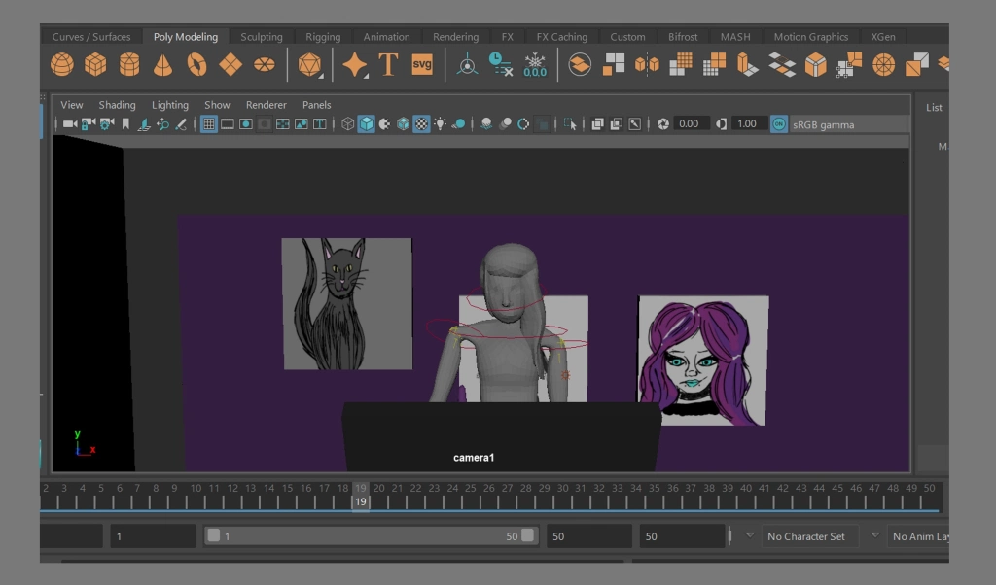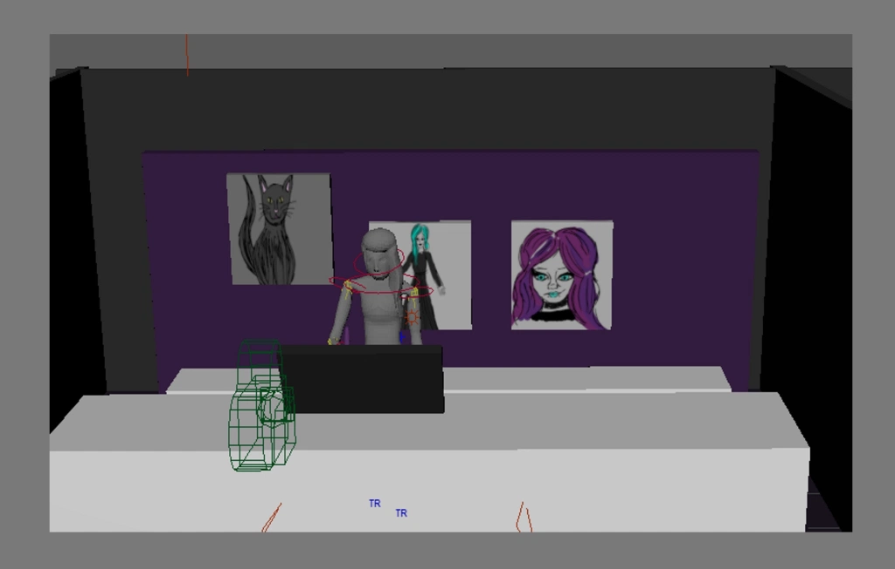This is the scene where Alexandria is drawing for the first time. In the animatic you have a view from behind however because I couldn’t have the pen stroke appear on the screen I faced the camera towards Alexandria instead and moved her arm with the pen to look like she’s making that first line.

Ending part 1
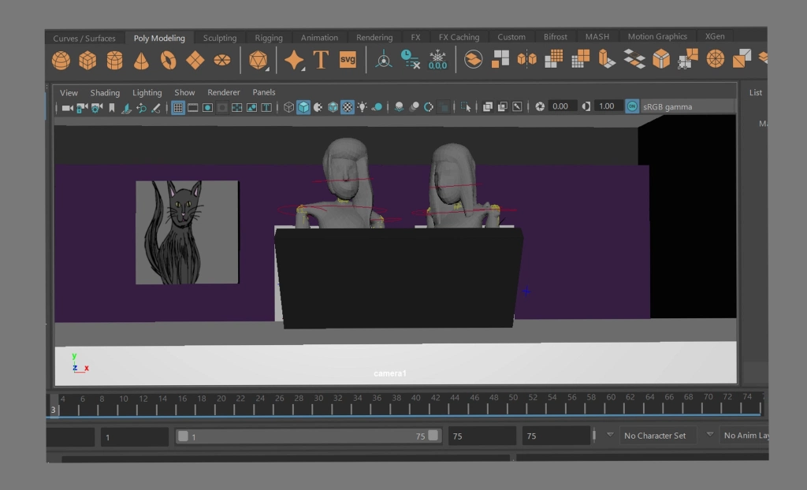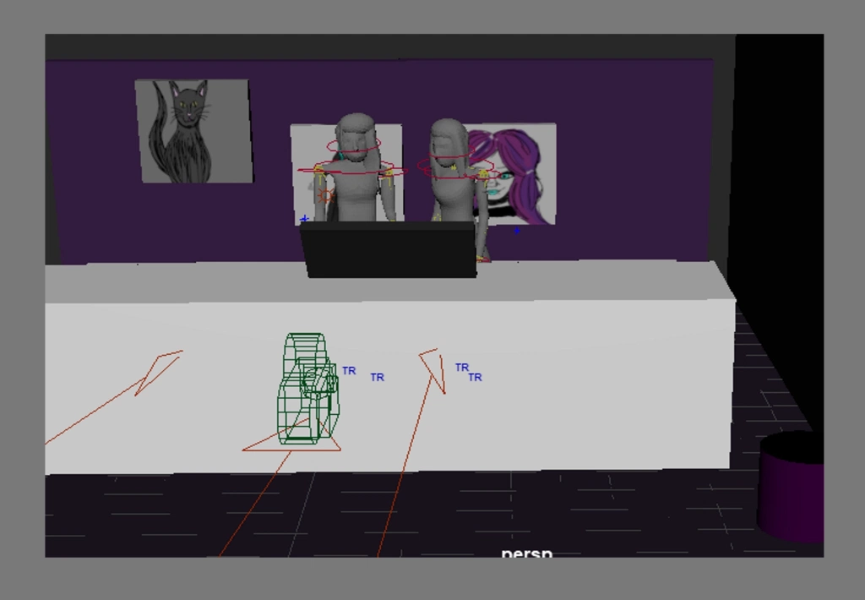This is the final scene where Shauna comes back in (offscreen) and looks at the drawing and then looks at Alexandria. This is after the 6 months later in the animatic (which I didn’t get chance to add to the 3D version as it was text and wasn’t too sure how to add text)

I kept the camera in the same place as it didn’t need to be moved at this point as I wanted it facing them.

Final scene part 2
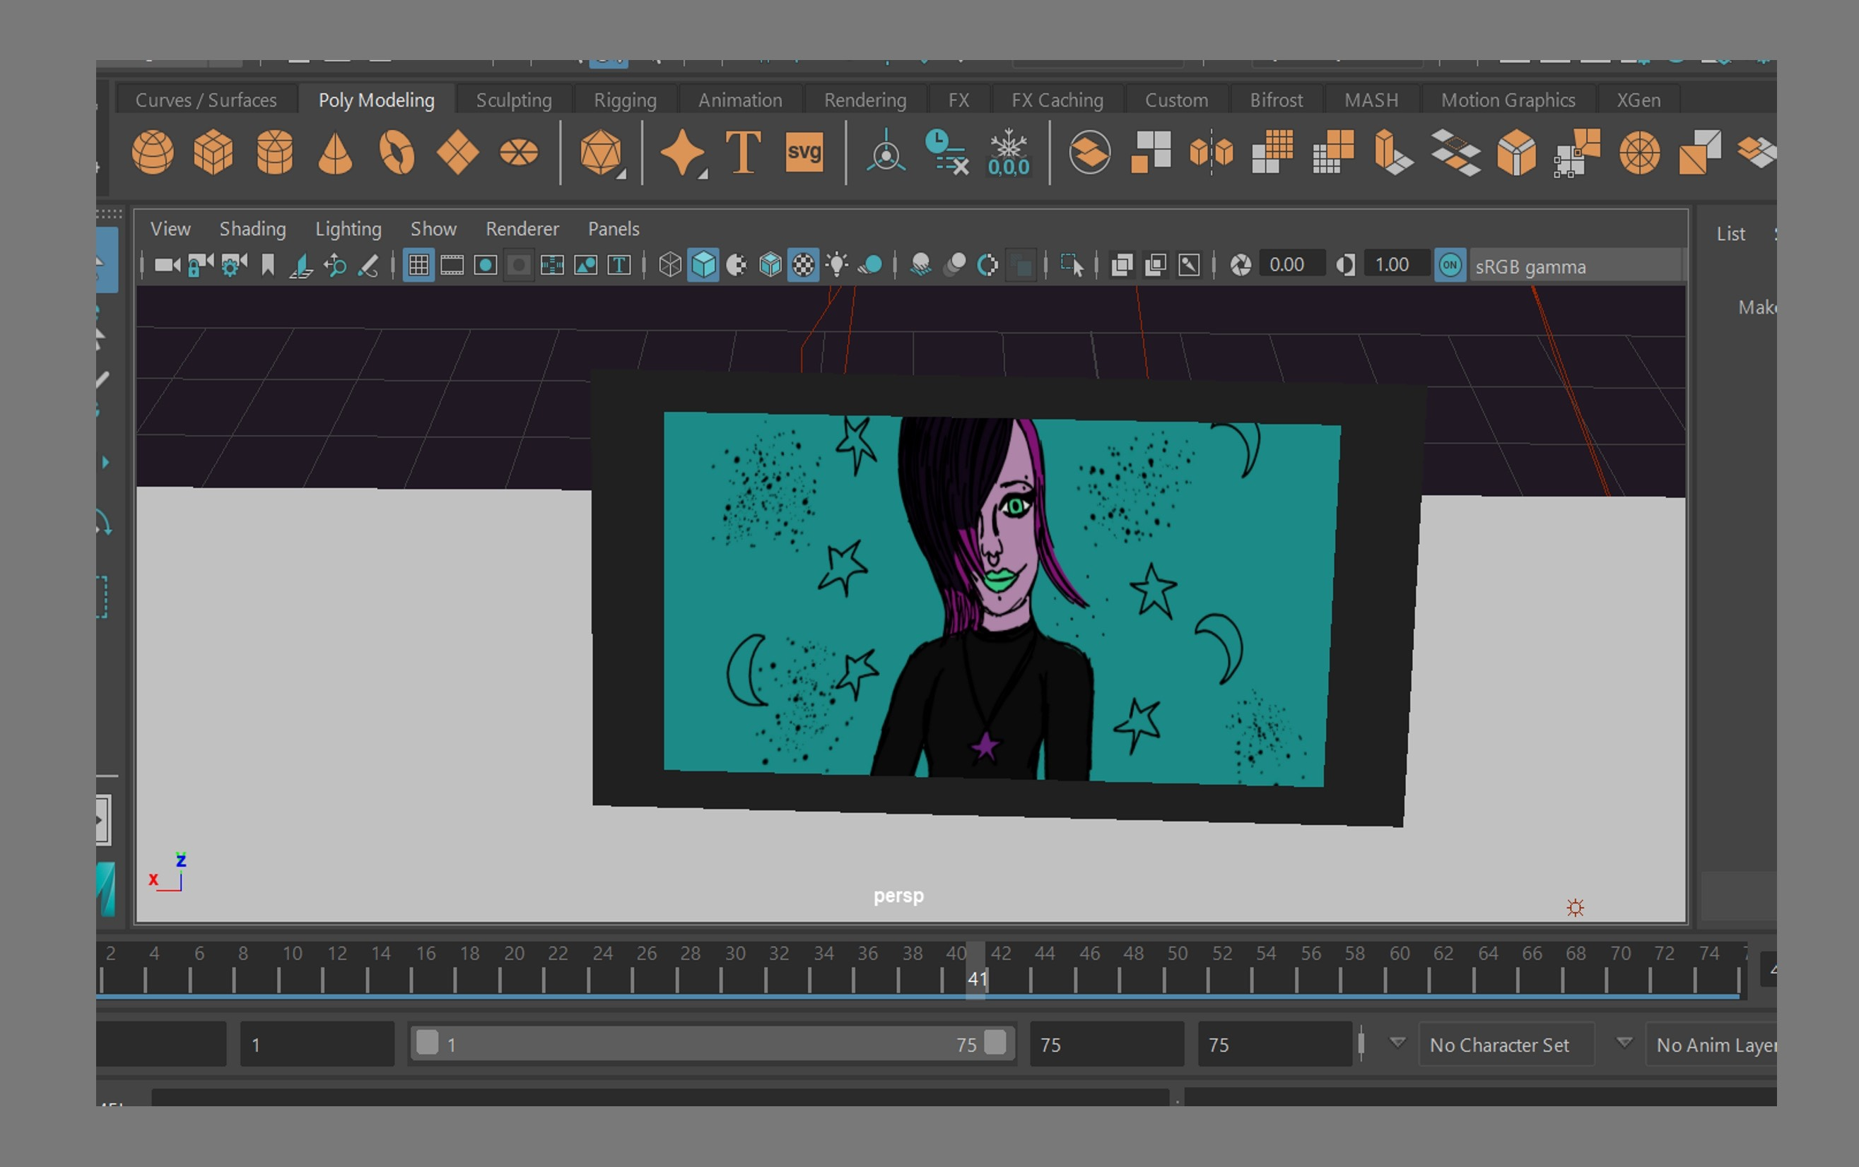This is the same image that appears on the cintiq as in the animatic. I redrew it to look a bit neater and then added it as a texture
I didn’t use a camera for this as there was no movement.
This would be the final scene before my logo and also wacom’s logo in the sequence.

Reflection
Overall I feel happy with the final animation considering the current situation.
I feel that if this was done when life was normal this could have come out a lot better than it did however I am very happy with how I tried to adapt and still managed to come out with what I did, I feel like I achieved and learnt a lot.

Unfortunately, my characters where low resolution and had no textures (colour) which I am sad about however I tried my best with getting them into maya at least so I could animate them. I also couldn’t render out as I didn’t know much about this but I did play blast the scenes so I did have a sequence for each scene and I didn’t have a full put together sequence as I didn’t have premiere to put it together, these are all things I can be well prepared for in my final project and this is where I mainly want to improve on.
Although it didn’t turn out the way I 100% wanted it I am still very happy with a few things. I managed to animate my own characters for the first time which was something I had a lot of problems with in the first year. Thanks to quick rig I didn’t have to stress about rigging the characters from scratch and there was also another bonus because I didn’t have to fix the paint weights and I also had fun with all of that though I do want to learn how to rig from scratch as sometimes I might not be so lucky with quick rig every time, I feel like my character models are improving with the anatomy and structure and I also had fun with that and I got to experiment with different things that will help me in the future. The main thing is the animation got the point across and never lost the story which I feel is a major achievement and I’m happy I did it. Despite the whole situation and struggling myself with adjustment due to the last minute massive changes in my life I am still happy that I managed to get this done and that’s what really matters to me and I can still see a massive improvement vs last year.

