DS 1 Template

My laptop
- .
- laptop.
- For each screenshot, write one or two sentences explaining what it shows.

laptop
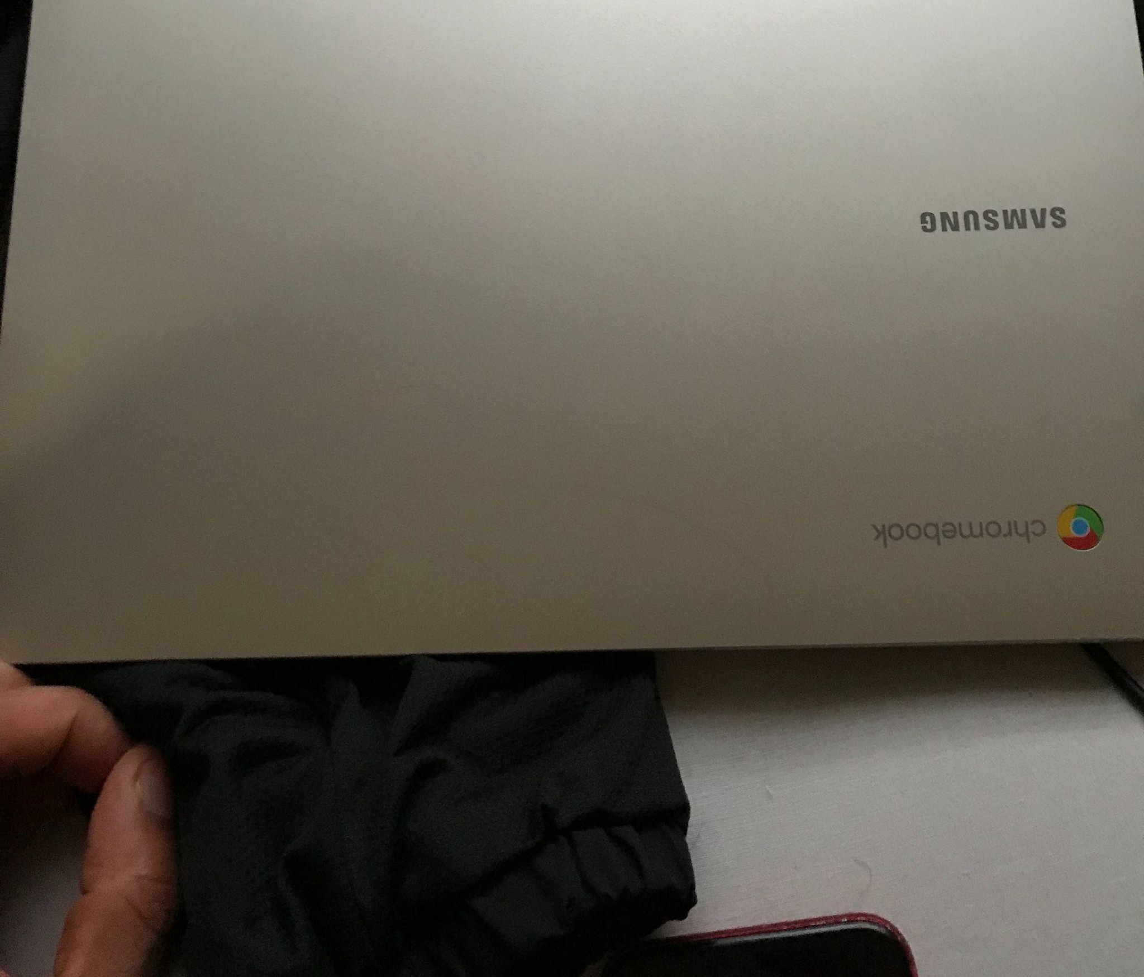
laptiop can used for work plus whatch tv play games plus it keeps you entartained can used help with your day plus mange your work

moblie phone
[Insert Photo/Screenshot below] 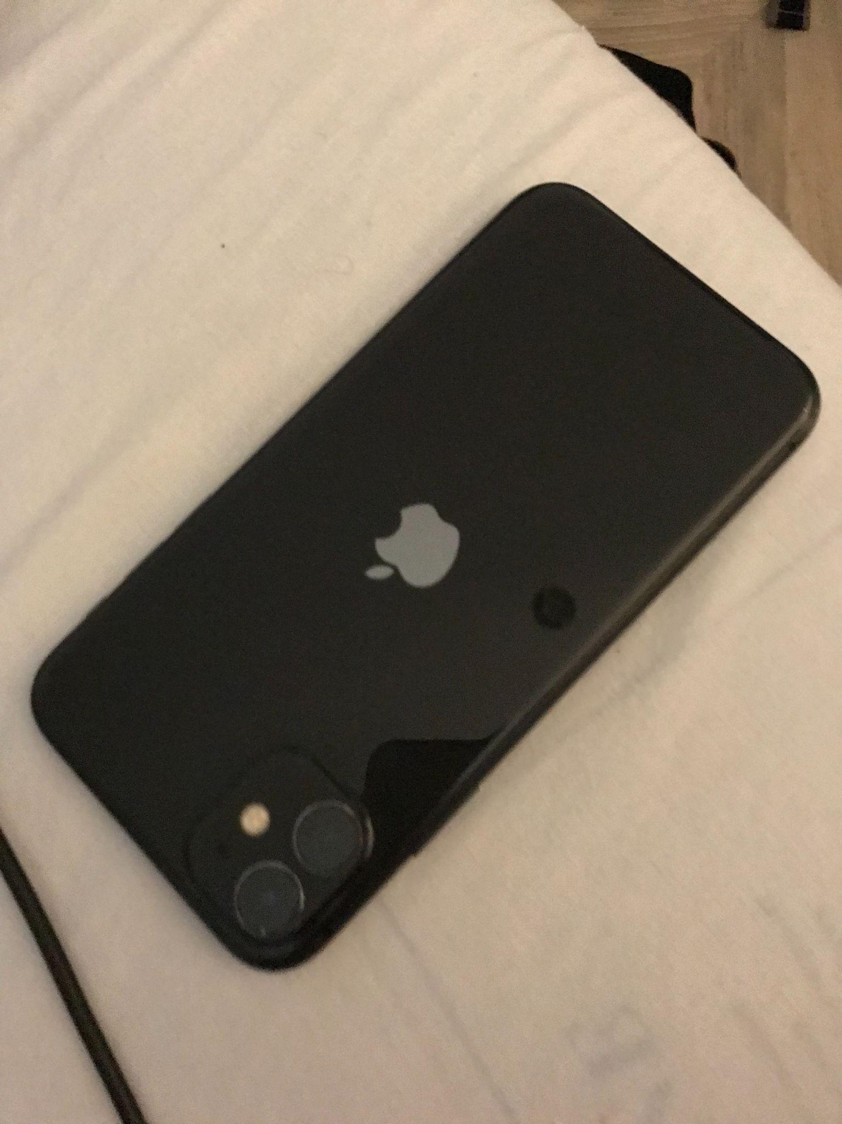
this moblie needed for everyday life takeing pictures, keepin contat with family paying for items and use the maps to be guied to places eg food plsces doctors etc

oyster card tapping point
this is used for travel if you dont or csant make it to buy a ticket can tap at staion can use you phone aswell and betterv then sa ticket as can get lost or wet 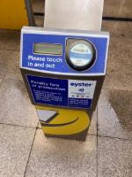

smart tv

[Insert Photo/Screenshot below]
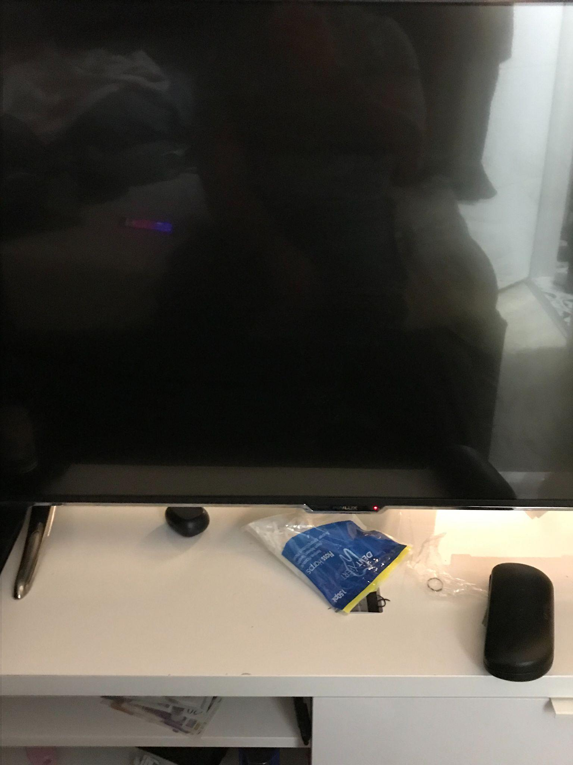this is how i wharch the news catch up on tv shows record shows play muisic videos plus use usb yto whatch flims and go online to use apps eg face book

Screenshot/Photo 5
[Insert Photo/Screenshot below]

[Write what this shows of your digital life]

Screenshot/Photo 6
[Insert Photo/Screenshot below]
[Write what this shows of your digital life]

My Short Reflection
- Write 5–8 simple sentences about your digital life.
- You can use the sentence starters below if helpful.

Sentence starters
- I use digital tools to …
- I feel confident when I …
- I want to improve …
- I often use these tools: …
- I sometimes feel nervous about …
- I hope this module will help me …
- Digital skills are important for me because …
You can write more if you want.

Submission Checklist
Before you submit, please check:
​​​ ☐ I added 4–6 screenshots
☐ I wrote short sentences for each screenshot
☐ I wrote my short reflection
☐ My work is my own
☐ My file opens correctly
​​☐ My file opens correctly

