Business Plan for
Seafood Shack

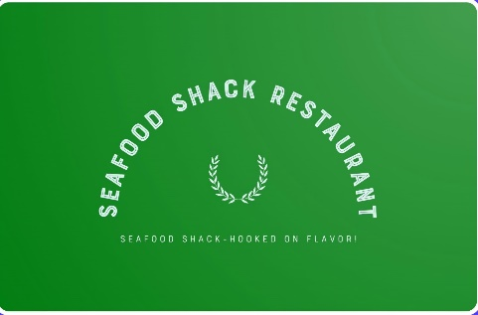

Produced By:

GROUP MEMBERS:
Student Name | Student No.
Farhad Chowdhury | 2233893
Vasile Pitirici | 2213442
Mohammed Miah | 2118790
Kamrul khan | 2230751

Dated: __06/06/2024____________

Module Name: Entrepreneurship
Module Code: BMIH5001
Lecturer Name: Charlotte Joyner_____________

CONTENTS

 |  |  |  | PAGE
1. | Executive Summary |  |  | 2
2. | The Business Idea |  |  | 3
3. | The Team |  |  | 5
4. | Market Research |  |  | 8
5. | Marketing Plan |  |  | 10
6. | Key Resources |  |  | 11
7. | Finances & Start-Up Support |  |  | 13
APPENDICES:
Appendix A |  |  | SWOT Analysis | 16
Appendix B |  |  | PEST Analysis | 17
Appendix C |  |  | Copy of Pitch Supporting Material | 18
Reference List |  |  |  | 28

1. EXECUTIVE SUMMARY

The Business plan is on a restaurant which will be located in London, the UK. It will offer a variety of seafood items to the different customer segments. The name of the restaurant is Seafood Shack. It will have an expenditure of £297,500 in the first year. The total income will be 410,000. Hence, the business will have a net profit of £112,500. The business will also address the sustainability aspects to meet the customer preferences for healthy and sustainable foods. It will use both digital and traditional marketing channels to raise awareness and create a strong position in London.
2. THE BUSINESS IDEA

2.1 The Product/Service
Company Name: Seafood Shack
Location: London, the UK
Industry: Food and Beverage
Business Activities: It is a casual dining restaurant that offers a variety of seafood options to seafood lovers and health-conscious people in London. The business manages sustainable sources for its seafood by creating partnerships with local fishermen and suppliers.
Product/Service: The restaurant offers a diverse menu of seafood. The customers can find fresh fish, shellfish, and speciality dishes prepared from local ingredients.
Features and Benefits:
Sustainability: The restaurant will integrate sustainability into its business operations. The sourcing of ingredients should be from the suppliers who promote sustainability.
Freshness: The quality of the seafood will be high as the fresh fish will be purchased daily.
Local Sourcing: The local fisheries will be chosen for making a partnership.
Value Proposition: Seafood Shack offers the freshest and most sustainable seafood that provides a unique experience to the guests (Barringer and Ireland, 2018).

2.2 SWOT Analysis Summary
The SWOT Analysis has been performed below:
Strengths:
- Key location in London
- Sustainability and ethical practices
- High quality foods and services (Gurel, 2017).
Weaknesses:
- Higher initial costs
- Intense Competition
Opportunities:
- Growing demand for healthy and sustainable foods
- High growth potential (Restaurantonline.co.uk, 2022).
Threats:
- Economic downturns (BBC, 2023).
- Regulatory changes
Strategies for Risk Reduction are provided below:
- The restaurant should diversify its menu and include different cuisines so that it can attract customers from different market segments (Burns, 2016).
- A compliance team will be formed that will continuously monitor the changes in regulations.
- The restaurant will optimise its costs by streamlining the processes and the supply chain. Hence it can offer the foods at competitive prices during economic challenges (Barringer and Ireland, 2018).
3. THE TEAM

3.1 Key Personnel

Name and Company Position: Muhammed -Head chef
Skills and Experience: Cook, working as a chief for few years on a restaurant.

Role and Responsibilities: cook chief - His role and responsibilities as a food truck chef, or cook chief, is the culinary mastermind responsible for menu creation, kitchen operations, staff management, food preparation, safety compliance, inventory control, and staying abreast of industry trends to ensure a delightful and efficient dining experience on wheels.

Name and Company Position: Vasile Salesman
Skills and Experience: bartender, worked few years on a pub as a barista.

Role and Responsibilities: interacting directly with customers, taking their orders, and providing them with the prepared food and getting the payments for the foods, drinks etc.

Name and Company Position: Kamrul Manager
Skills and Experience: Procurement Manager, worked for a food company as a manager.

Role and Responsibilities: His purchasing manager's role encompasses developing purchasing strategies, monitoring key metrics, negotiating terms, collaborating with stakeholders, forecasting market trends, mitigating risks, managing supplier relationships, overseeing budgets, and ensuring efficient inventory management to align procurement activities with the company's objectives.

Name and Company Position: Farhad
Skills and Experience: Accountant, worked 3 years as doing accounting for a food business.

Role and Responsibilities: An accountant who maintains financial records, ensure tax compliance, manage costs and inventory, and oversee cash flow.

3.2 Skills Gaps & Key Partners

3.2.1 Additional Staff Requirements (Roles and Responsibilities):
- Specialist: For sustainable seafood sourcing, a specialist needs to be recruited.
- Sustainability Coordinator: The coordinator ensures that sustainability practices such as renewable energy usage, and waste management stick to the business operations.
- Digital Marketing Manager: The management will be responsible for increasing the online presence of the restaurant (Ciapponi, 2023).

3.2.2 Training and Development:
- Customer Service Excellence: Training and development opportunities should be offered to the employees on customer service for enhanced services.
- Food Safety and Hygiene: Staff should be trained on safety standards (Choi and Rajagopal, 2013).
- Leadership Management: The management needs training in leadership management so that it can effectively direct and manage the team to achieve the organisational goals and objectives (Torrington and Hall, 2020).

3.2.3 Outsourced Support / Key Partners:
- Accounting Services: The restaurant will streamline its operations by using Cogneesol's services. They support the financial management and accounting aspects of the restaurant (Cogneesol, 2024).
- IT and Systems Integration: Menzies can help to integrate IT systems in the restaurant (Menzies, 2024).
- Legal Support: A local law firm in London can be chosen for getting legal support.
4. MARKET RESEARCH

4.1 Market Information, Trends and External Factors
The UK seafood market is growing at a significant rate. The seafood industry in the UK had a 7% growth in 2022. The UK exported to 117 countries around the world of 454,000 tonnes of seafood which was worth £1.7 billion in the same year (Seafish, 2024). The estimated consumer expenditure was £4.33 billion in that year which shows the growing demand for seafood in the UK (Statista, 2024). This market information suggests that Seafood Shack has immense potential in the UK market to grow and succeed in the long run.
The UK market has a growing trend for sustainable and healthy food consumption. Consumers prefer sustainable foods and healthy lifestyles which align with the Seafood Shack's commitment to sustainability (Alae-Carew et al., 2021). After the COVID-19 pandemic, the seafood market in the UK has been volatile. The reason for the volatility can be identified as the rising inflation. As a result, the import volume declined significantly. Although the volume of imports declined, the value of the seafood increased by 1.3% within 12 months in 2020 (Seafish, 2023).
PEST Analysis Findings:
Political Factors: Brexit affected the UK's trade with other EU countries and the influx of international tourists (RSE, 2023). These can reduce the demand side of the restaurant.
Economic Factors: The rising cost of living and inflation have changed consumer purchasing behaviour (BBC, 2023).
Social Factors: The ageing population in the UK, those between 50 to 75 years old, are the biggest fish consumers (Statista, 2024). The restaurant can target the customer segment to achieve a greater market share.
Technological Factors: The advancement in green technology and other technologies in the UK can enhance restaurant operations.
Strategies to Overcome External Challenges:
- The restaurant will ensure that its supply chain is diversified so that the disruption caused by the economic or political issues is addressed (Burns, 2016).
- Making the pricing flexible, the business can overcome the economic challenges and drop in seafood demand. The purchasing power of the people and economic conditions can be considered to adjust the prices.

4.2 Customer Profiles
- The Health-Conscious Professional: This particular market segment has a high interest in healthy living, wellness, and fitness. Usually, they are aged between 30 to 50 years old. They like to pay a premium for healthy and sustainable foods. They may choose Seafood Shack because the restaurant will provide fresh and quality fish and uphold sustainability practices (Gazdecki et al., 2021).
- The Culinary Enthusiast: The customer segment has immense interest in trying new foods and experiencing exceptional hospitality. Their age ranges between 25 and 45. Most of the time they share their experiences on social media platforms. They will be attracted by the restaurant's diverse menu offerings and exceptional culinary experience.
- The Eco-Friendly Family: The families with young children are the target customer segment. They have an interest in outdoor activities and dining. They explore the casual environment for family dining (Gazdecki et al., 2021). Because the restaurant ensures sustainability practices, they might prefer the business for their dining in.

4.3 Competitor Profiles
- Spagó Mediterranean & Seafood Restaurant
This restaurant offers seafood that has a Mediterranean twist while Seafood Shack will resonate with the traditional and modern British seafood (Spagolytham, 2024). The strength of the competitor is its high quality food offering. Its weakness is the mix of customer reviews. Seafood Shack can outperform the competitor by its USP which is high quality food, guest experience, and commitment to sustainability.
- Drum and Monkey - Harrogate
It is a fine dining restaurant that offers seafood while Seafood Shack will choose a casual dining strategy (DrumandMonkey, 2024). The competitor has a strong brand reputation in the market. However, it fails to attract a large customer segment because of its premium pricing strategy. Seafood Shack can outperform the competitor by offering high quality seafood at an affordable price.
- Cargo Seafood
The company offers other dishes such as vegetarian options and steaks along with seafood while Seafood Shack will offer only the seafood items (Cargoseafood, 2024). It has a reputation for its exceptional services. But its wide range of dishes may dilute its seafood offerings. To outperform the competitor, Seafood Shack may introduce a unique and specialised seafood menu.

5. MARKETING PLAN
5.1 Price
The pricing strategy is crucial to attract the target customers. Seafood Shack will make its prices relevant to the competition. To do so, it will conduct a comprehensive market research to assess the competitor's prices. Then the prices will be determined. A value-based pricing strategy will be implemented. Because the restaurant will offer high-quality and unique seafood and exceptional dining experience to the guests. Based on their perceived value for the restaurant, the prices will be determined (Williams, 2021). Moreover, it will also have bundle pricing for different meal deals.
5.2 Product
The food will be prepared from fresh ingredients and fish with locally sourced spices. Using sustainable packaging, the foods will be delivered to the customers. For branding, it will use a shellfish in a clear visualisation. The interior and tableware of the restaurant will reflect modern equipment and sustainability practices. For the colour scheme, shades of blue and green might be appropriate.
5.3 Placement
The restaurant will be located at the key areas in London. It may participate in various pop-up events such as food festivals in different locations (Williams, 2021). For online sales, it will use its website and food delivery platforms such as Deliveroo, Just Eat, and Uber Eats.
5.4 Promotion
To raise awareness about the restaurant among the target customers and increase brand visibility, the business will use both digital and traditional marketing. The following digital marketing channels will be used:
- Search Engine Optimization (SEO): SEO can increase organic traffic by improving the key searches. The key words such as sustainable seafood and dining experience can be focused to improve the website ranking (Chaffey and Ellis-Chadwick, 2019).
- Social Media Marketing: Different social media sites such as Facebook, Twitter, and Instagram will be used to share interactive content as it will enhance the customer engagement and reach a large number of people.
- Influencer Partnership: Partnerships with the social media influencers will be formed as the parasocial relationship between influencers and followers might increase the number of customers (Yuan, Kim and Kim, 2016).
- Traditional Advertising: For traditional advertising, flyers and print media can be used as they are appropriate for targeted marketing in London.
The restaurant will maintain a good relationship with the customers by offering feedback and working on their feedback. It will also offer a loyalty programme for the repeated customers who will get special deals and discounts.
6. KEY RESOURCES

6.1 Premises

The requirements for physical space are discussed below:
- Production: To prepare the seafood, the restaurant needs a fully equipped kitchen. Enough space with cold storage, dry storage, and dishwshing stations must be present to ensure that high quality seafood is served and it is prepared from fresh ingredients.
- Sales: The dining area of the restaurant should accommodate 50 people at the same time and it will have a separate bar seating (Williams, 2021).
- Administrative Office: A small office will be established where all the managerial work should be performed.
- Ideal Location: The restaurant will be located at the high traffic area that is close to any cultural attraction.
- Rent: London West End's rent can exceed £2000 per square foot annually. If the restaurant size is 1500 square feet, the total rent can be £150,000 annually in other less expensive areas (Sam, 2022).
- Rates: There are significantly high rates in central London.

6.2 Equipment

The following equipment and tools are required for the business:
- Commercial Refrigerator: Seafood will be kept at the optimal temperature to ensure its freshness and quality. Adexa Direct offers such a refrigerator (Adexa Direct, 2024).
- Cooking Equipment: Ovens, grills, fryers, and other essential equipment can be purchased from Catering Appliance Superstore (Catering Appliance, 2024). The equipment is used to prepare the seafood.
- Furniture: Table, chair, bar tools, and other furniture can be purchased from Adexa Direct.
- Serving Ware: Plates, bowls, utensils, and glasswares are needed to serve the guests. ChefsWarehouse sells these items (Chefswarehouse, 2022).
Costs:
- For medium set-up, the cost of Kitchen equipment will be around £60,000.
- The estimated cost for furniture and decorations is £35,000.

6.3 Key Suppliers

The restaurant will make partnerships with the following businesses:
- For the supply of fresh seafood, the restaurant will form a partnership with Direct Seafood company. The costs for purchasing the products are negotiable.
- Partnership with Catering Appliance Superstore can be developed for the supply of equipment. Initial cost may exceed £60,000.
- For the supply of packaging, eco-friendly companies like Eco Packaging Solutions can be chosen (Burns, 2016).
7. FINANCES AND START-UP SUPPORT

EXPENDITURE | Year 1  £
Company Registration | 100
Rent/Rates | 150,000
Staff Wages | 27,000
Telephone (mobile) | 200
Broadband | 700
Utilities | 13,000
Marketing and materials | 5,000
Insurance | 2,000
Capital Expenditure/Equipment | 95,000
Training & Development | 2,000
Accounting/Legal | 500
Outside Services | 1000
Office Consumables | 1000
Total Expenditure | £ 297,500

INCOME | Year 1  £
Sales A | 100,000
Sales B | 100,000
Sales C | 60,000
Capital Introduced | 100,000
Funding | 50,000
Total Income | £ 410,000

YEAR ONE PROFIT/LOSS | £
Total Income | 410,000
Total Expenditure | 297,500
Profit/Loss | £112,500

7.1 Financial Summary
The restaurant business will have different sources for expenditures. Some of the key expenditures are forecasted for the year 1 based on the market dynamics and economic conditions. A significant portion of expenditure will incur at the annual rent. However, the income side of the restaurant has created three sources for revenue generation and they are sale of food, bar services, and catering services. Moreover, the entrepreneurs will provide 100,000 in capital and other 50,000 will be managed from funding. The total income is higher than the total expenditure. Hence, the business will be profitable in the first year (Williams, 2021).
APPENDICES

Appendix A – SWOT Analysis

Strengths:
- The location is the biggest strength for the business. The restaurant will be established in the key location in London. It will provide greater access to the different customer segments.
- The company will ensure ethical and sustainability practices in its operations. It can enhance the brand reputation and attract customers who prefer sustainability.
- By providing high quality food and maintain greater standard, it will create a distinctive position in the market (Gurel, 2017).
Weaknesses:
- To establish a sustainable restaurant is challenging because it will require a substantial amount of resources for the initial investment. The investment in sustainable technologies and materials will increase the expenditure.
- The target market is highly competitive because there exist already established players. It will be difficult for the startup to create a position.
Opportunities:
- The increasing demand for sustainable and healthy products in the UK can create new opportunities for the business to grow and succeed.
- The restaurant can expand other region of the UK. However, expansion decision might be relevant for long term success (Restaurantonline.co.uk, 2022).
Threats:
- The UK has encountered severe economic challenges after the COVID-19 pandemic. The increasing inflation rate can reduce the demand side of the business (BBC, 2023).
- Any type of regulatory changes can affect the overall business activities. In such circumstances, the restaurant might face reputational stake and financial losses.

Appendix B – PEST Analysis

Political Factors: The UK has a stable political climate that is suitable for startups. The relationship with other international community is also positive which facilitate the import and export activities. However, the recent Brexit has created complexities in the UK's trade agreement with other EU countries (RSE, 2023). The import of materials for the restaurant can be time consuming and may require more paperwork.
Economic Factors: The UK has faced economic challenges in recent years due to the COVID-19 pandemic. The inflation rate increased to a record high and so the cost of living rose (BBC, 2023). It affected the purchasing power of the UK consumers.
Social Factors: The UK has diversified people from different backgrounds. These people have different tastes and preferences. The ageing population shows the greatest demand for fish consumption (Statista , 2024). Fish consumption is less popular among the young generation. Moreover, the cultural diversity can also play a crucial role in creating demand for fish items.
Technological Factors: The UK is a technologically advanced country. It is the leader in the tech industry. The restaurant business can adopt the latest technologies to streamline its operations. Moreover, it can also adopt green technologies to support its sustainability practices.

Appendix C – Copy of Pitch Supporting Material
Slide 1
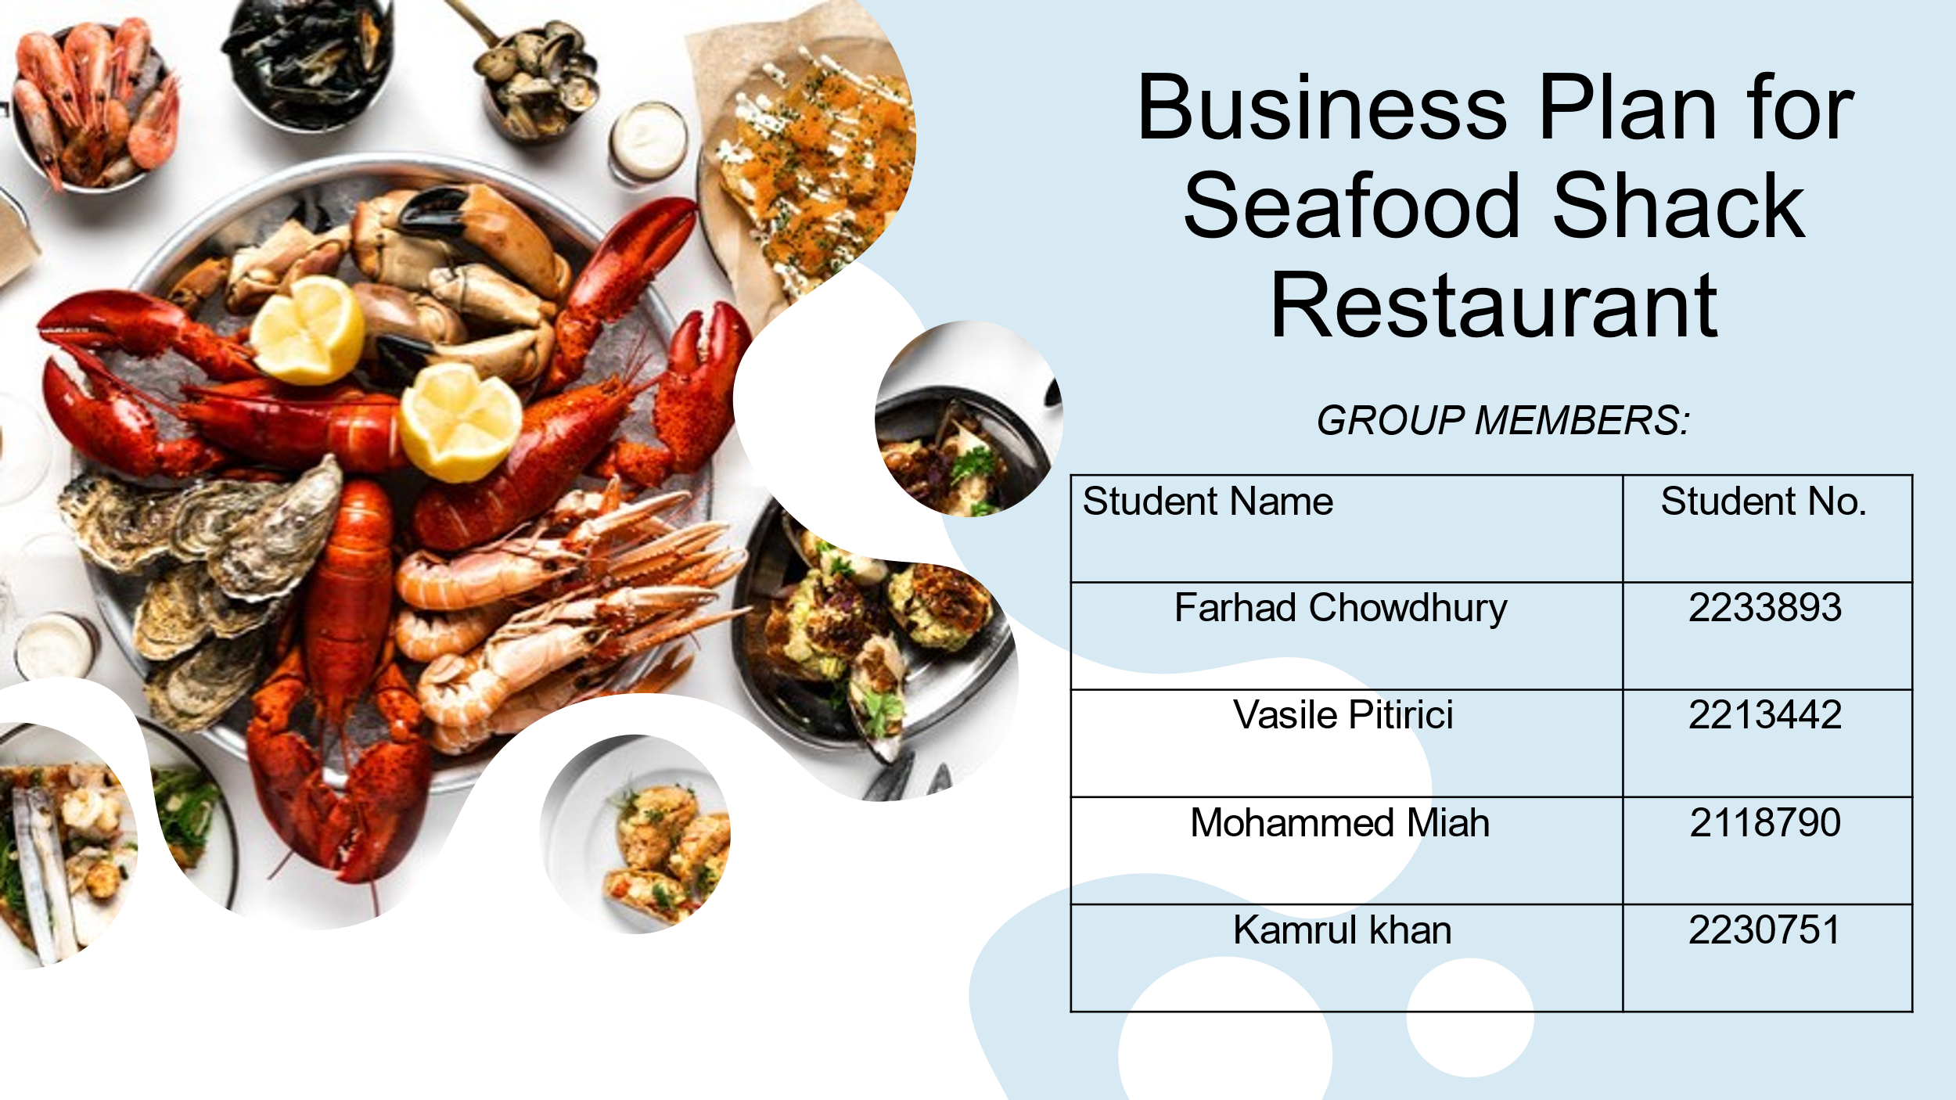
Slide 2


Slide 3
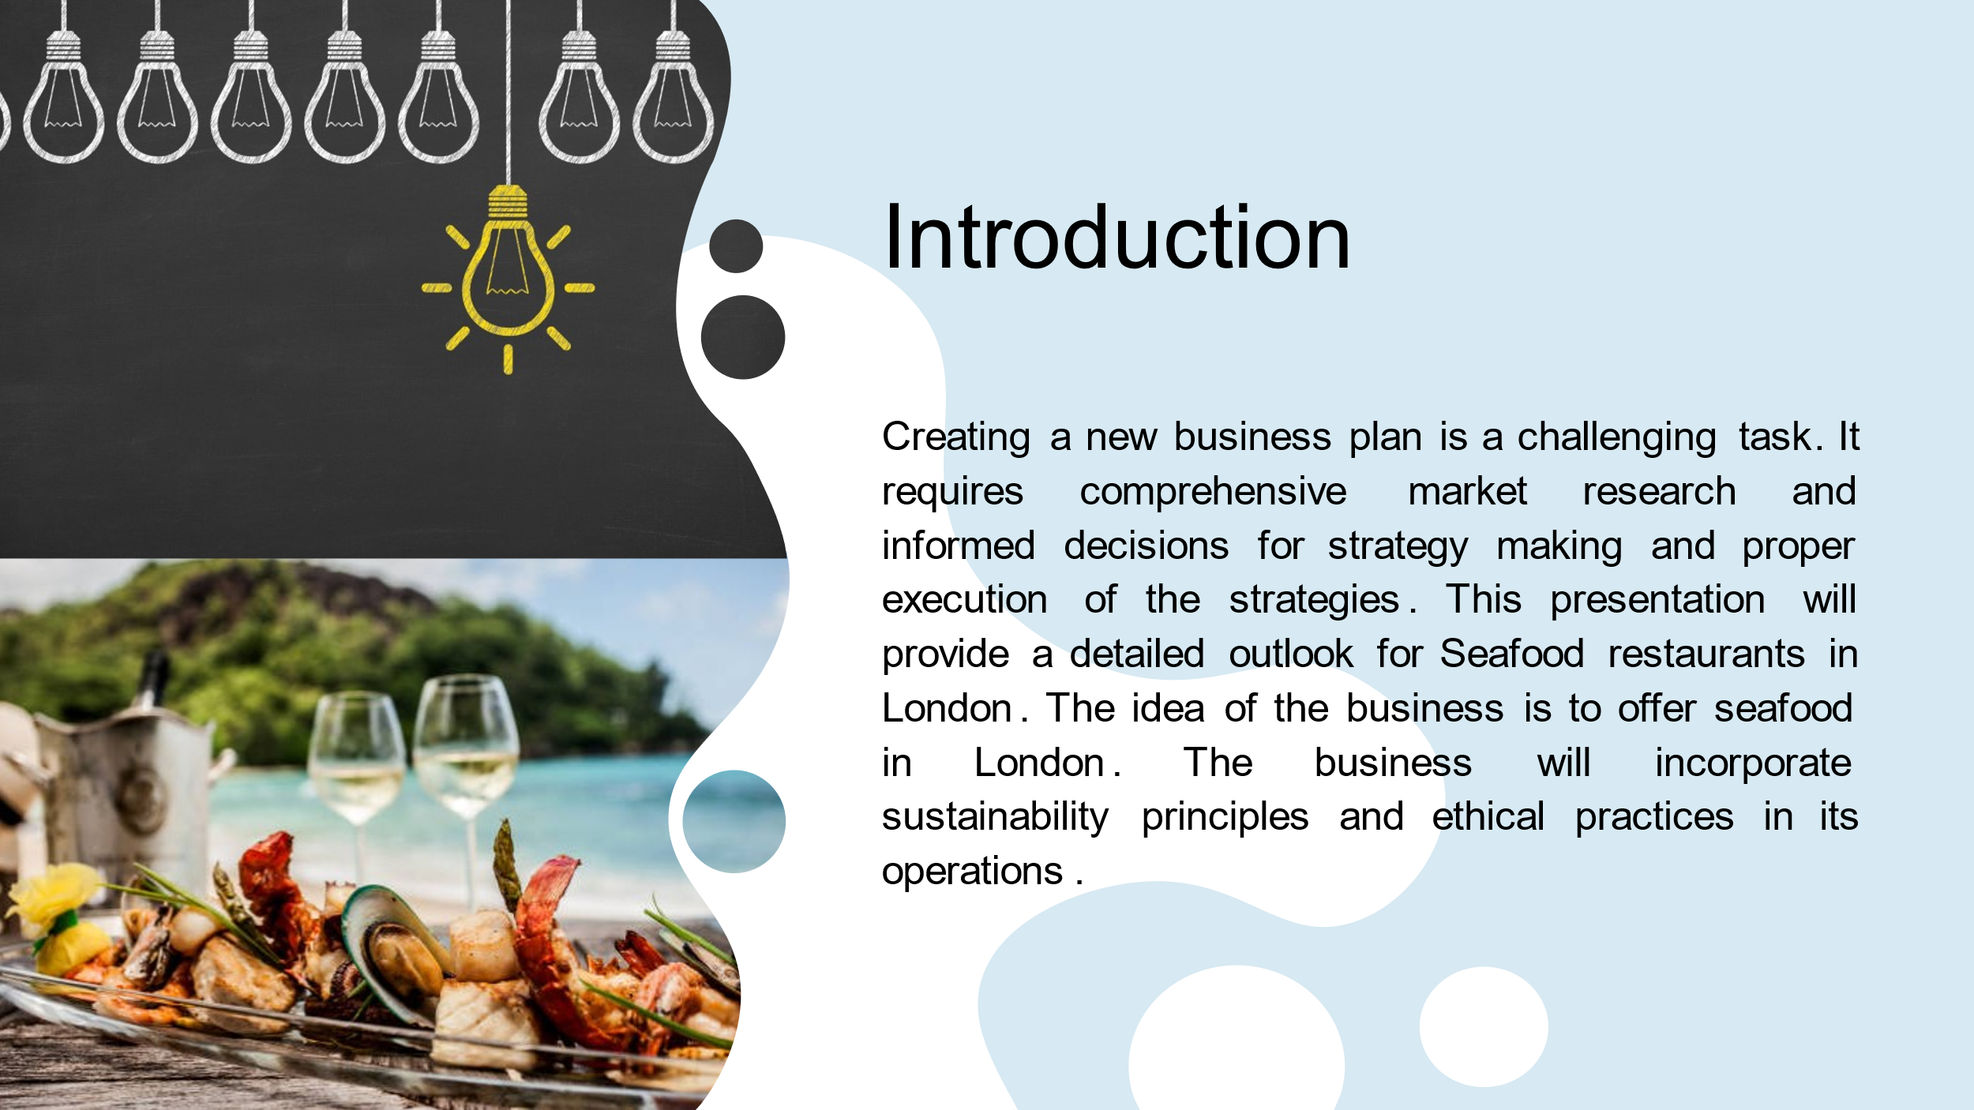
Slide 4
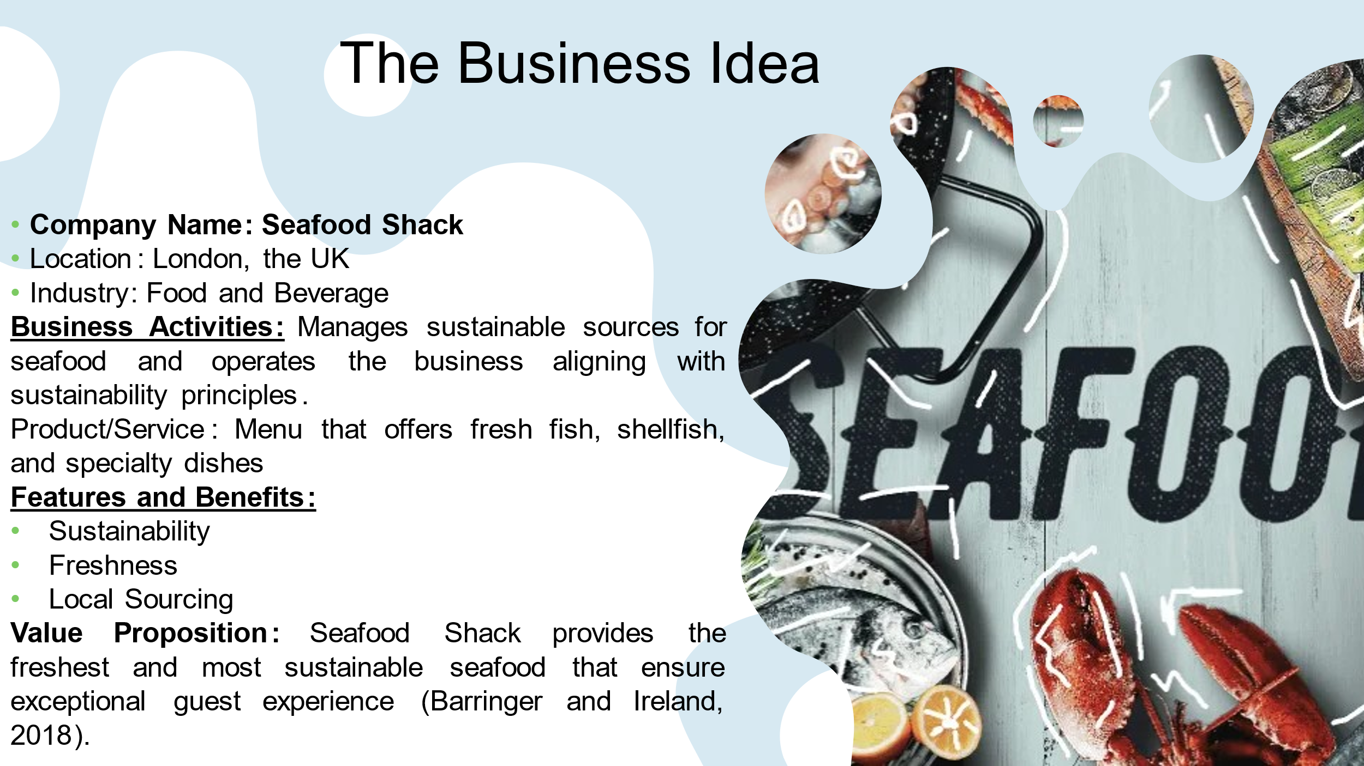

Slide 5
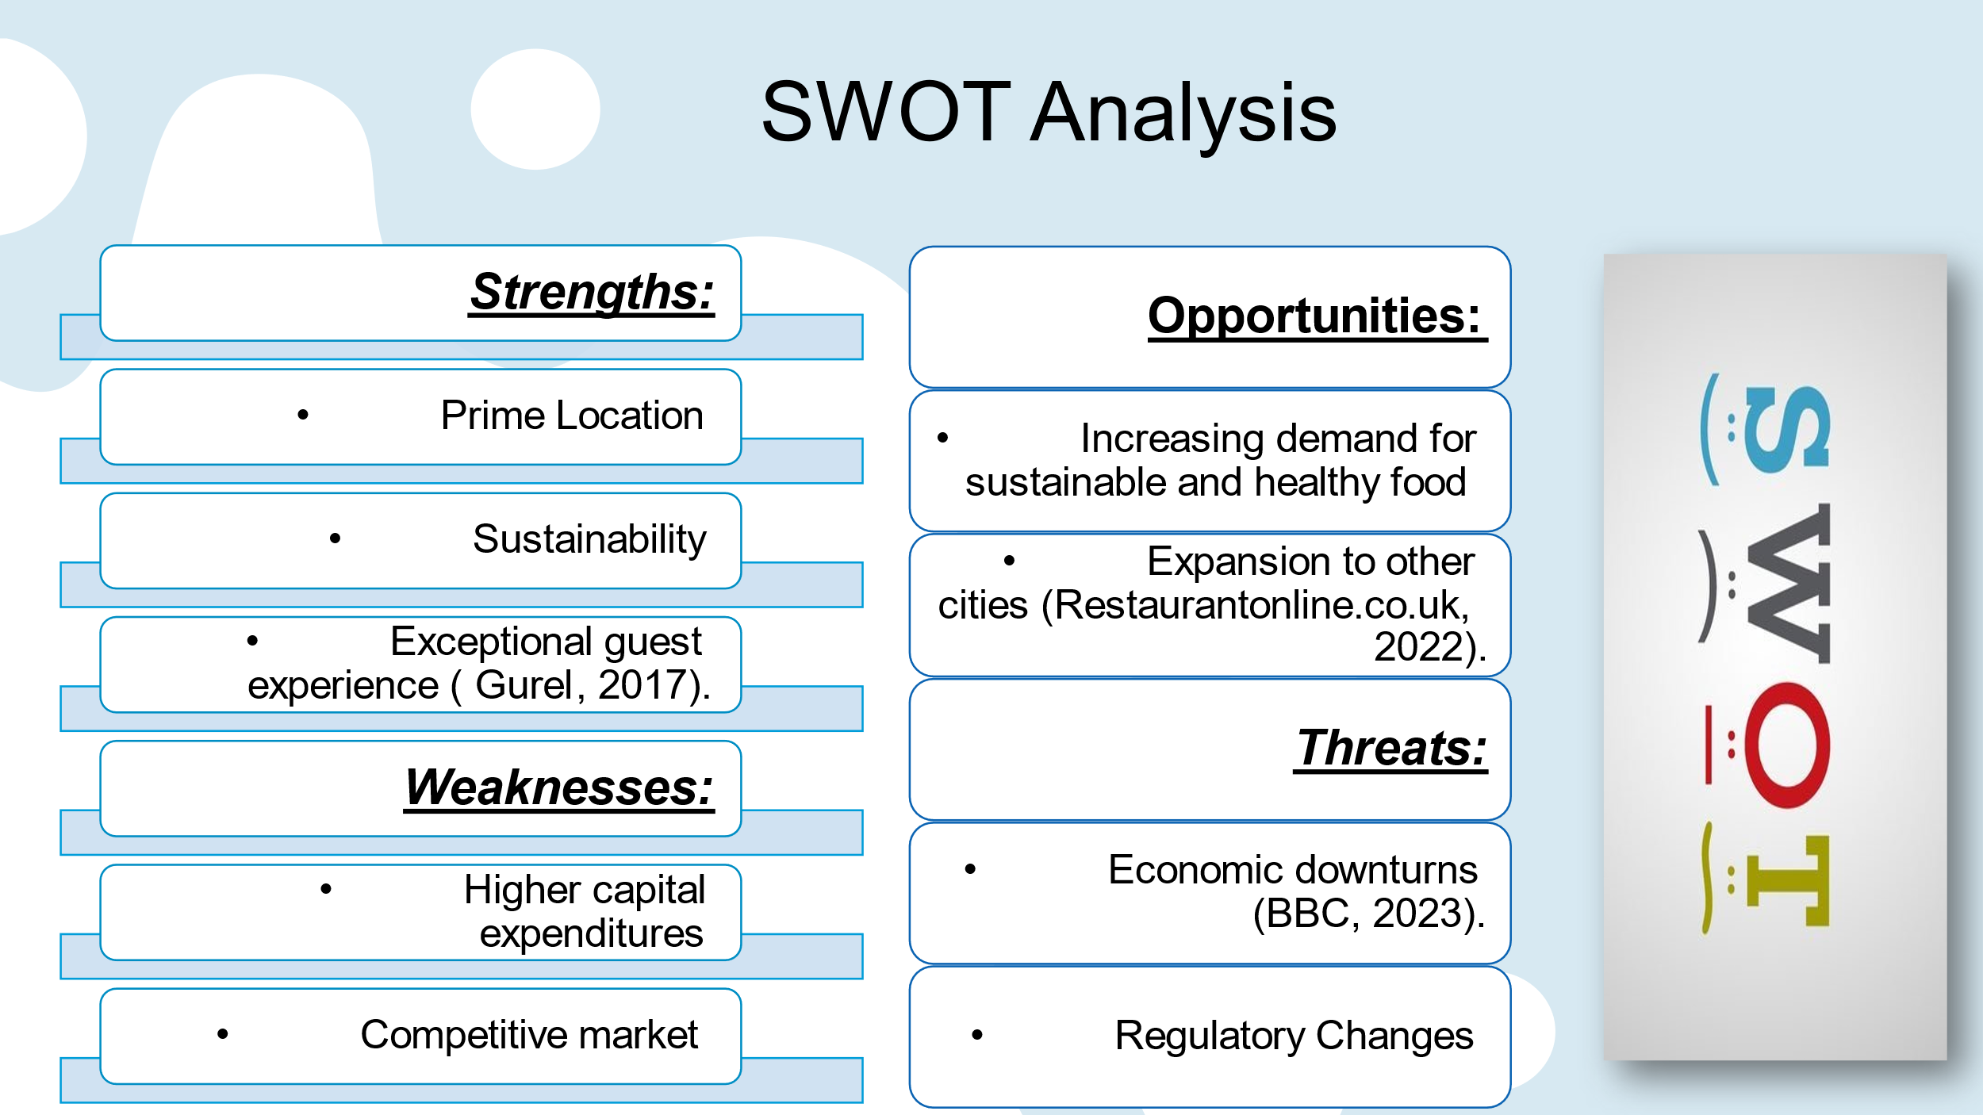
Slide 6
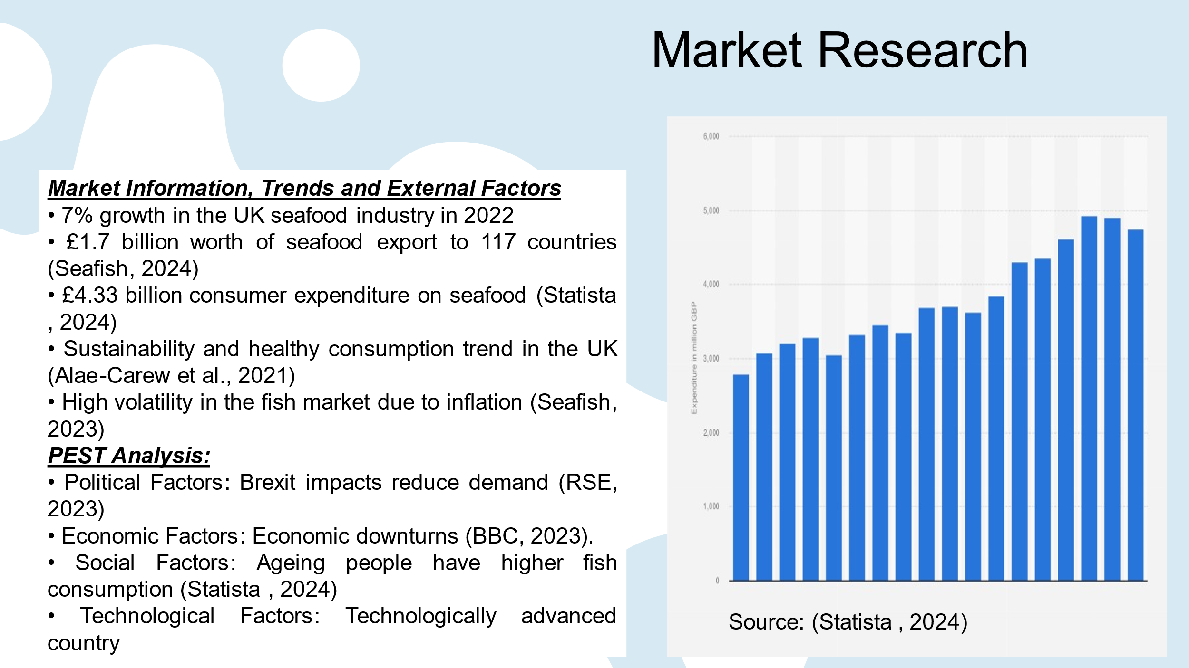
Slide 7
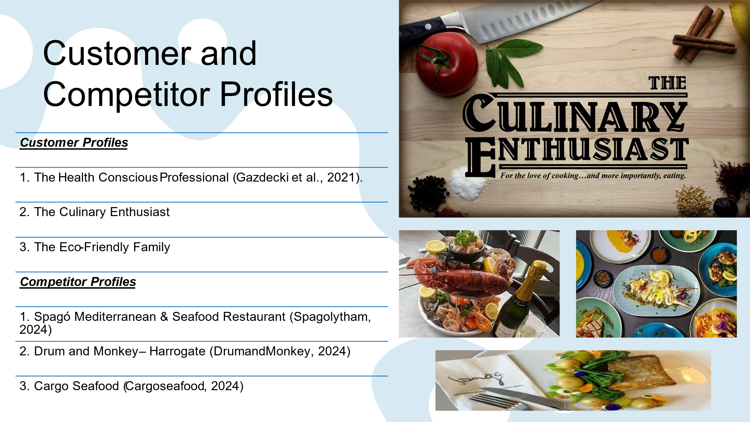
Slide 8
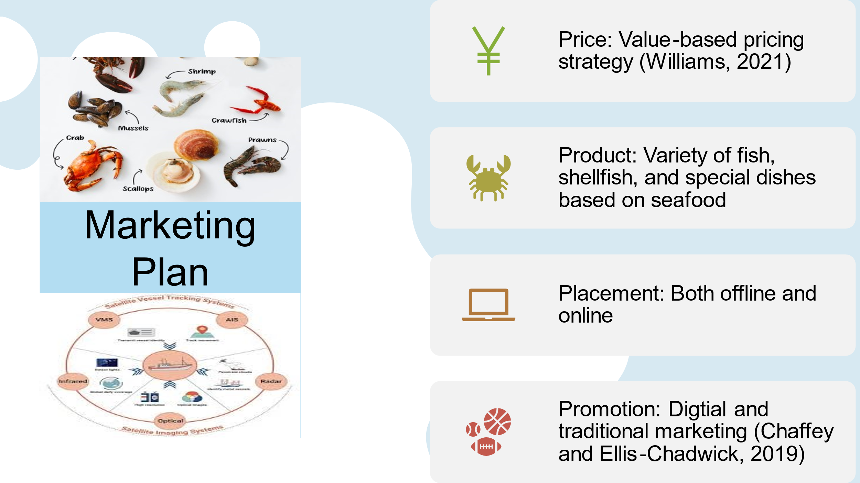

Slide 9
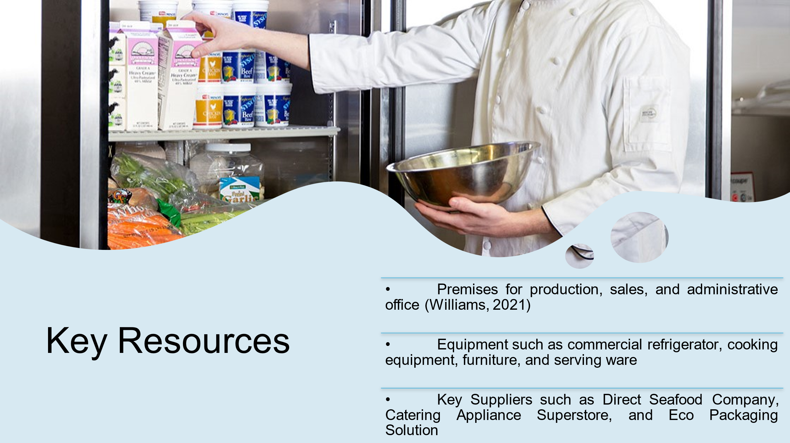
Slide 10
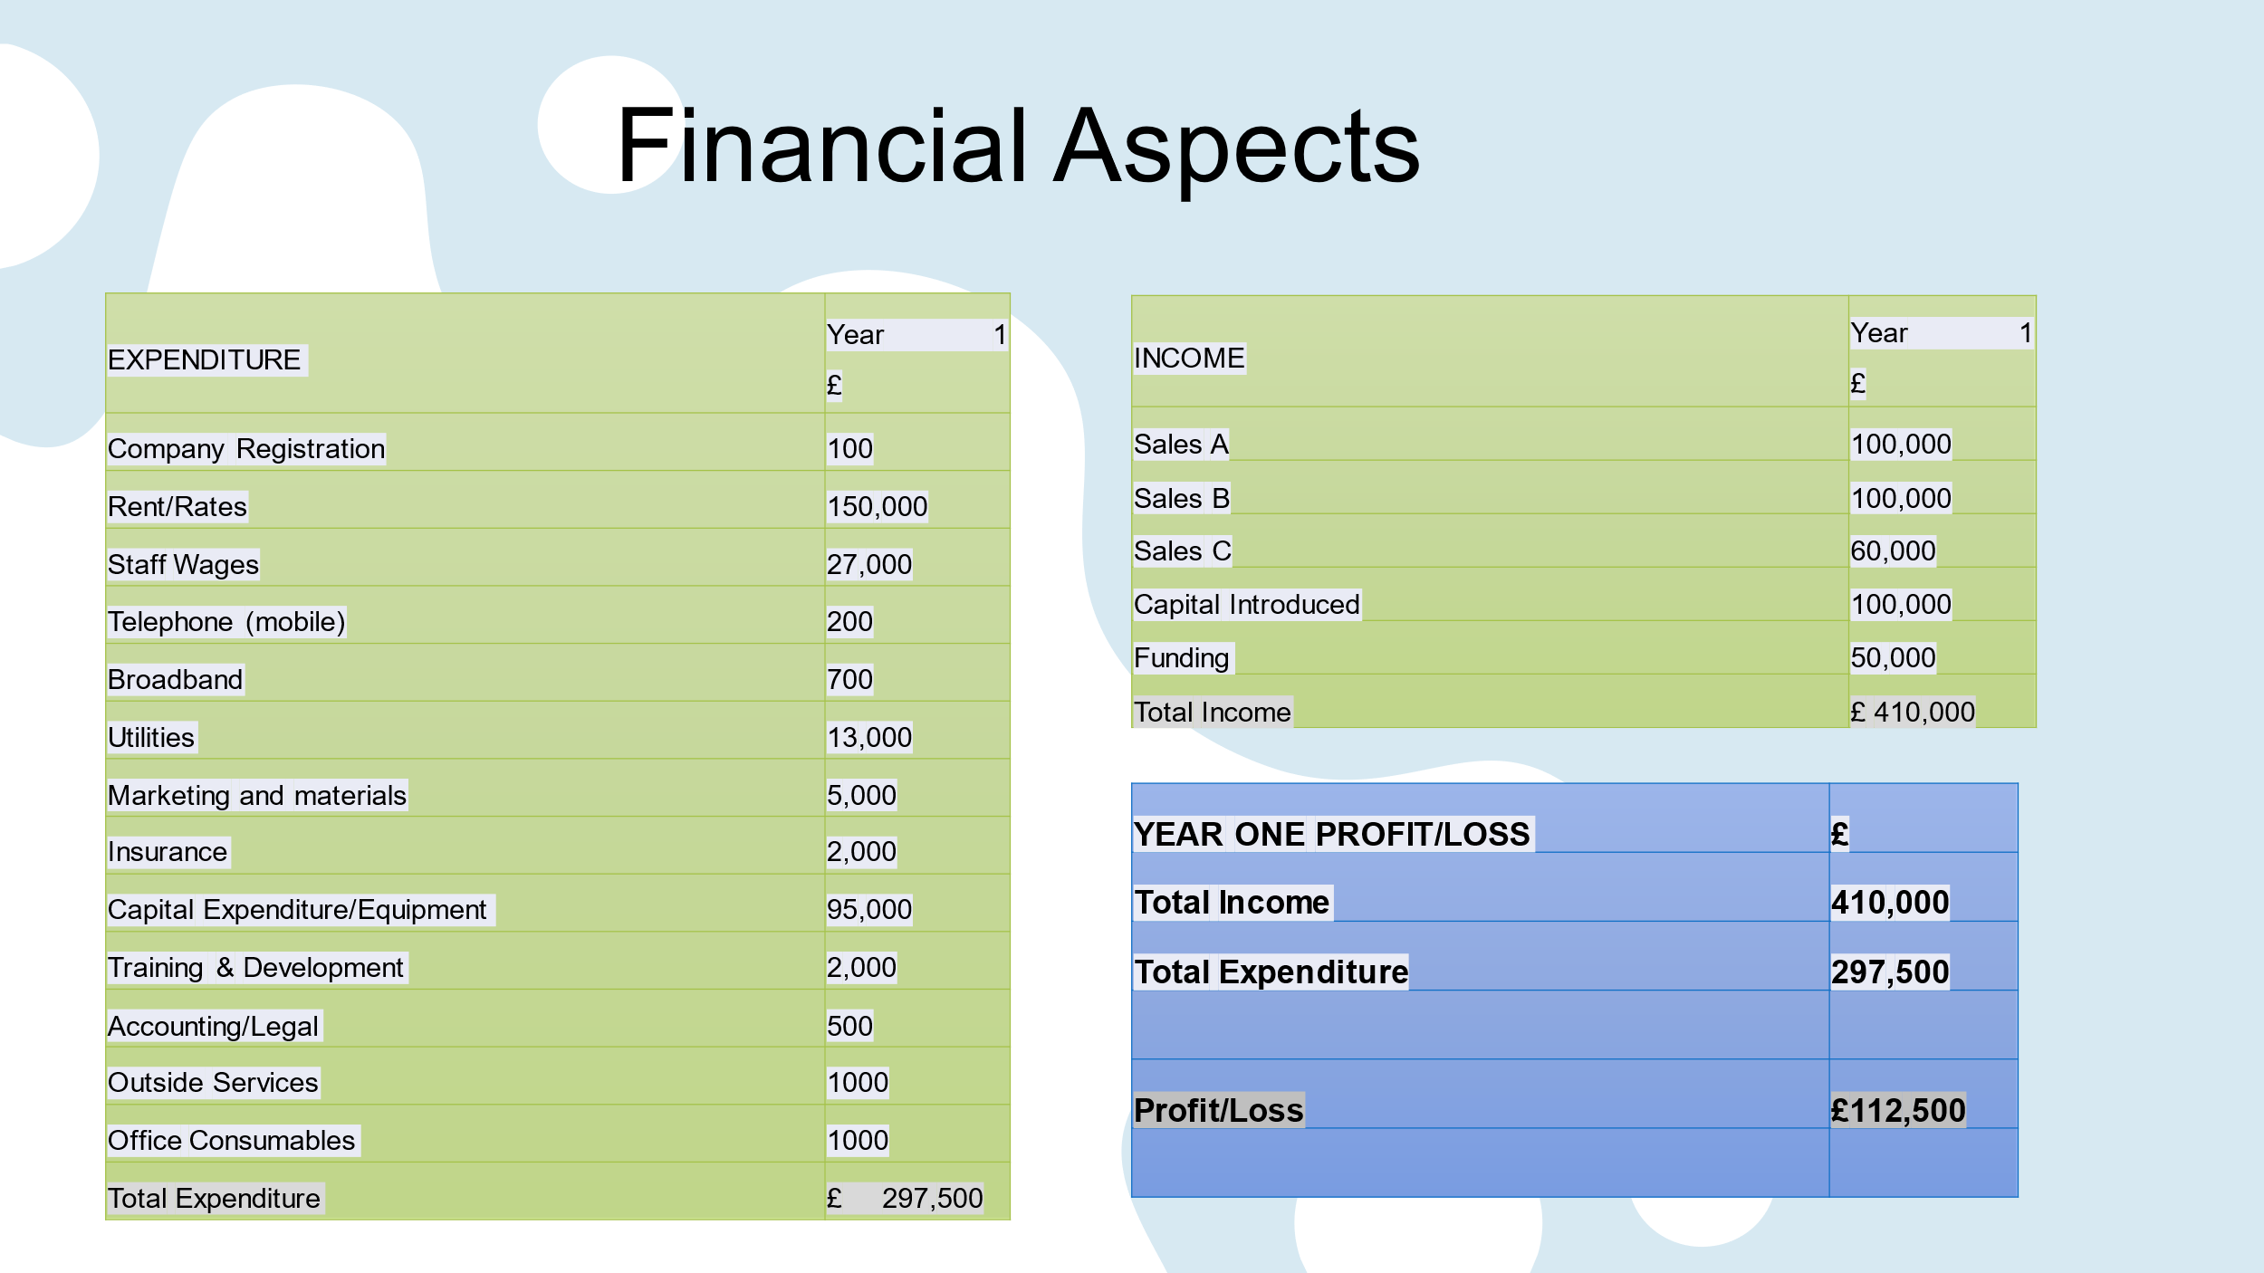

Slide 11
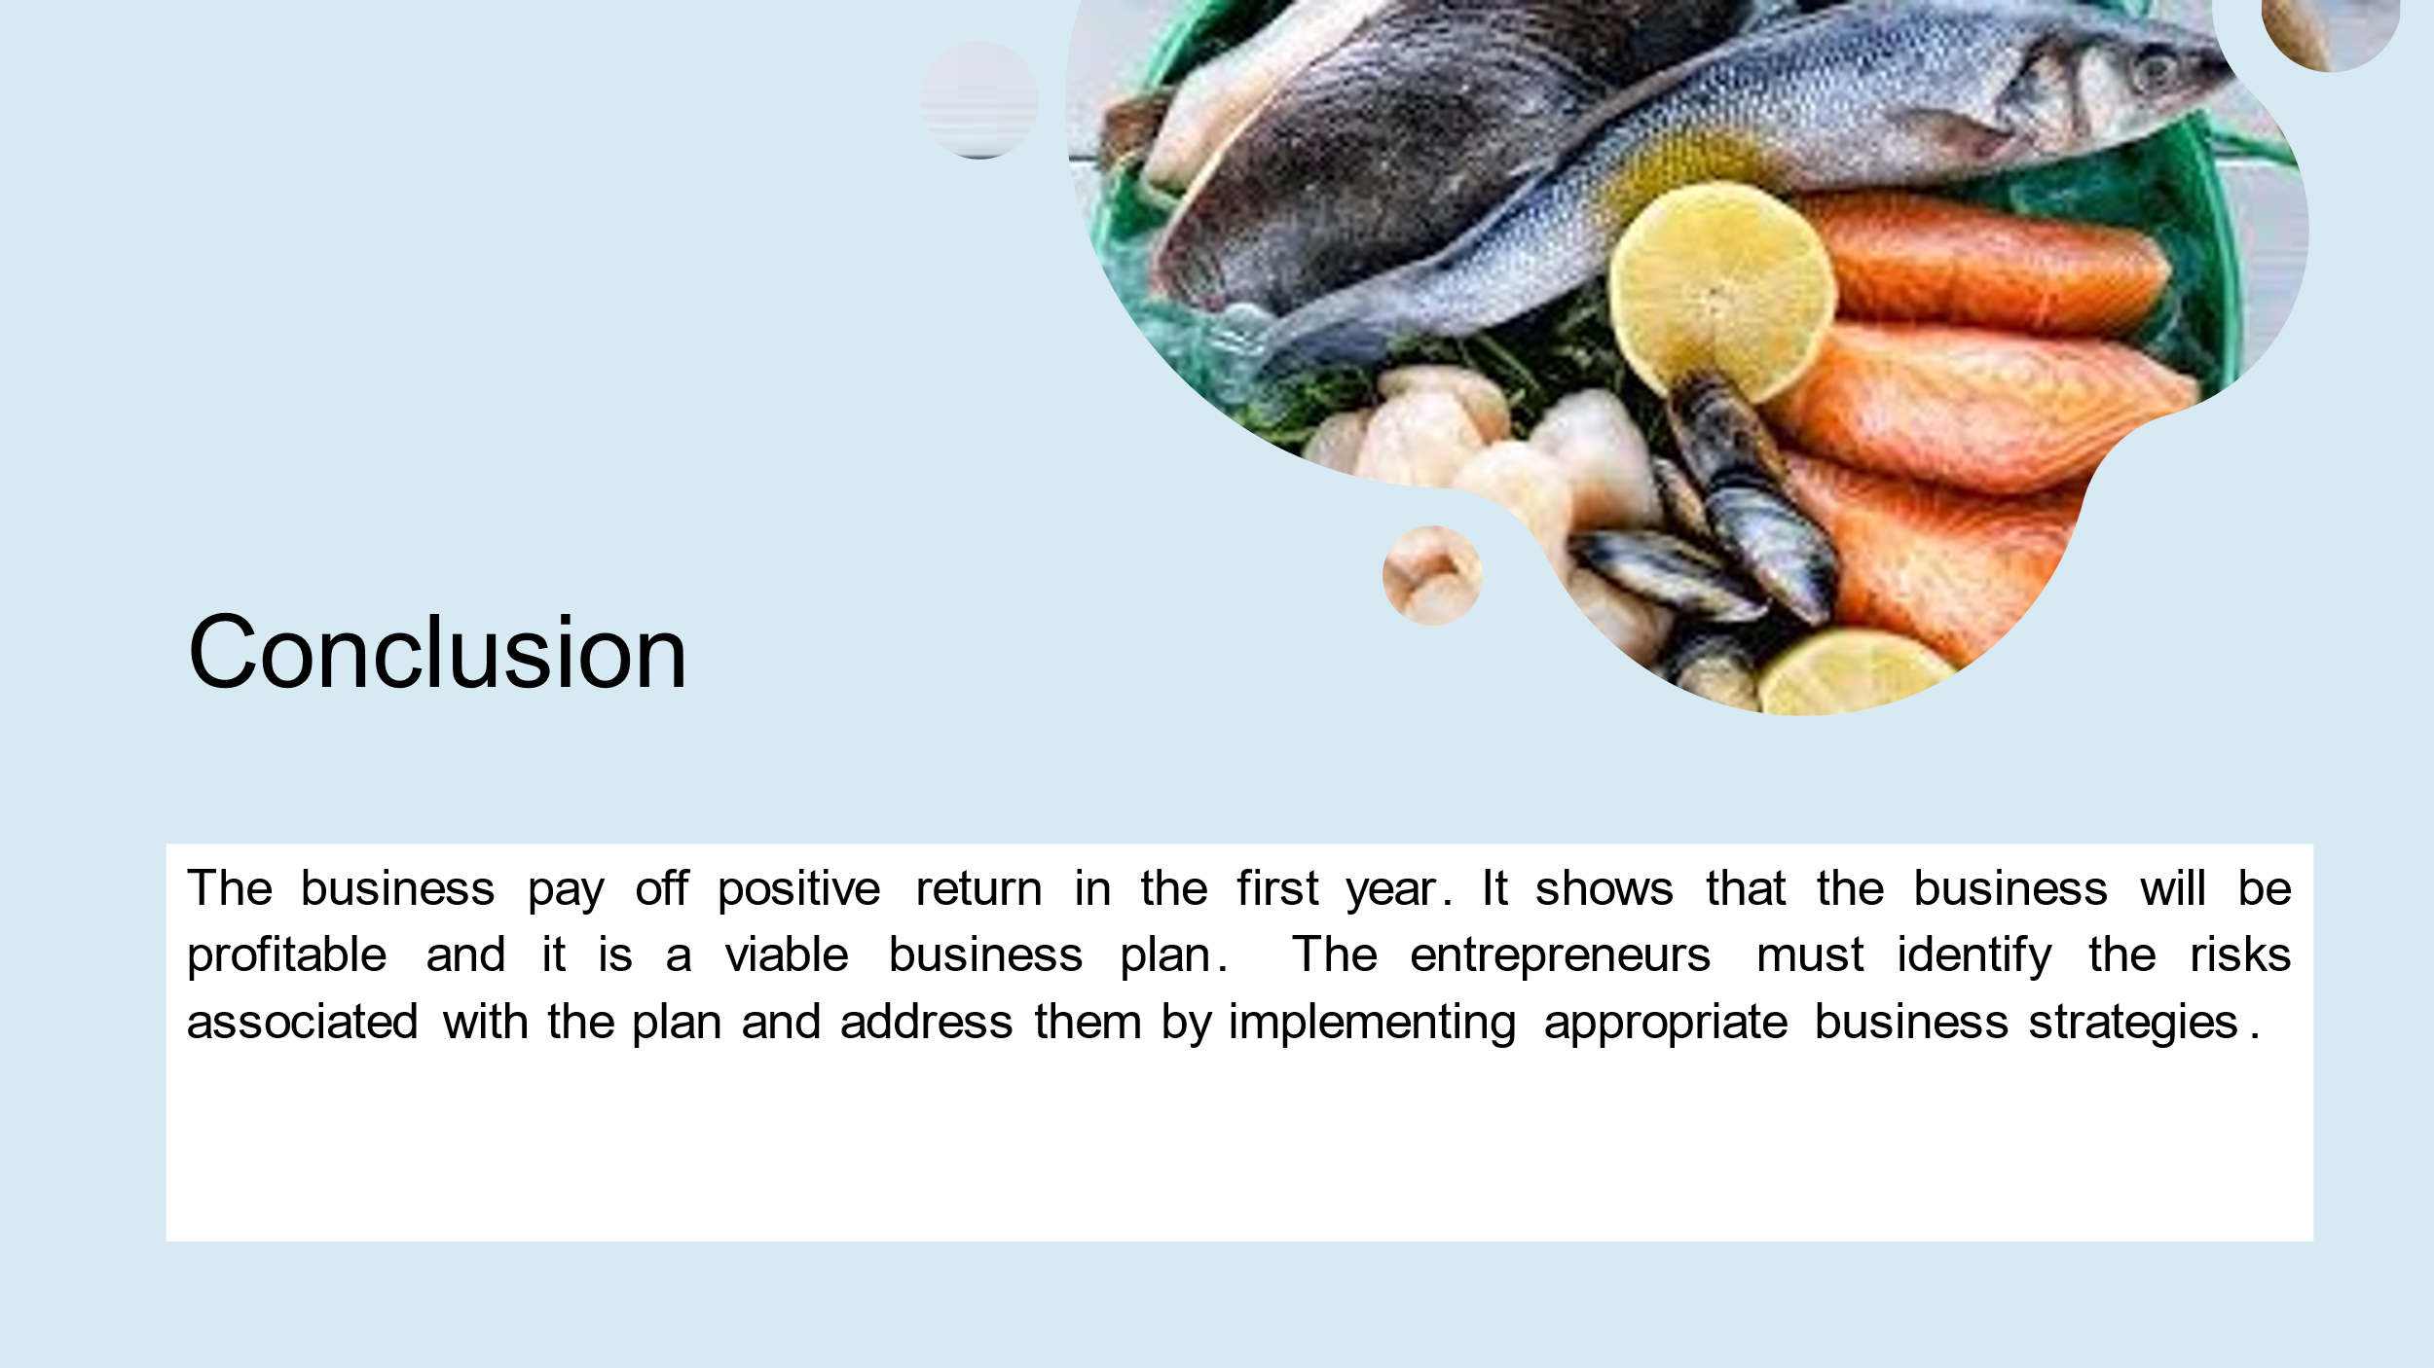
Slide 12
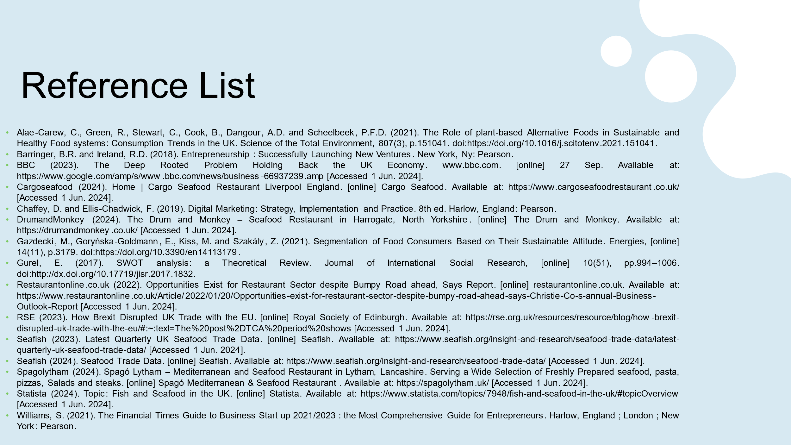

REFERENCE LIST:
Adexa Direct (2024) Adexa Direct. [online] Adexa Direct. Available at: https://adexa.co.uk/ [Accessed 1 Jun. 2024].
Alae-Carew, C., Green, R., Stewart, C., Cook, B., Dangour, A.D. and Scheelbeek, P.F.D. (2021) The Role of plant-based Alternative Foods in Sustainable and Healthy Food systems: Consumption Trends in the UK. Science of the Total Environment, 807(3), p.151041. doi:https://doi.org/10.1016/j.scitotenv.2021.151041.
Barringer, B.R. and Ireland, R.D. (2018) Entrepreneurship : Successfully Launching New Ventures. New York, Ny: Pearson.
BBC (2023) The Deep Rooted Problem Holding Back the UK Economy. www.bbc.com. [online] 27 Sep. Available at: https://www.google.com/amp/s/www.bbc.com/news/business-66937239.amp [Accessed 1 Jun. 2024].
Burns, P. (2016) Entrepreneurship and Small Business : start-up, Growth and Maturity. 5th ed. Basingstoke (Gb): Palgrave Macmillan Education, Cop.
Cargoseafood (2024) Home | Cargo Seafood Restaurant Liverpool England. [online] Cargo Seafood. Available at: https://www.cargoseafoodrestaurant.co.uk/ [Accessed 1 Jun. 2024].
Catering Appliance (2024) Commercial Catering Equipment UK. [online] Catering Appliance Superstore. Available at: https://www.catering-appliance.com/ [Accessed 1 Jun. 2024].
Chaffey, D. and Ellis-Chadwick, F. (2019) Digital Marketing: Strategy, Implementation and Practice. 8th ed. Harlow, England: Pearson.
Chefswarehouse (2022) Chefswarehouse . [online] Chefswarehouse.com. Available at: https://www.chefswarehouse.com/ [Accessed 1 Jun. 2024].
Choi, J.H. and Rajagopal, L. (2013) Food Allergy knowledge, attitudes, practices, and Training of Foodservice Workers at a University Foodservice Operation in the Midwestern United States. Food Control, 31(2), pp.474–481. doi:https://doi.org/10.1016/j.foodcont.2012.10.023.
Ciapponi, D. (2023) The Skills Gap in the Hospitality Industry. [online] hospitalityinsights.ehl.edu. Available at: https://hospitalityinsights.ehl.edu/skills-gap-hospitality-industry [Accessed 1 Jun. 2024].
Cogneesol (2024) Digital Transformation & Business Process Management Services. [online] www.cogneesol.com. Available at: https://www.cogneesol.com/ [Accessed 1 Jun. 2024].
DrumandMonkey (2024) The Drum and Monkey - Seafood Restaurant in Harrogate, North Yorkshire. [online] The Drum and Monkey. Available at: https://drumandmonkey.co.uk/ [Accessed 1 Jun. 2024].
Gazdecki, M., Goryńska-Goldmann, E., Kiss, M. and Szakály, Z. (2021) Segmentation of Food Consumers Based on Their Sustainable Attitude. Energies, [online] 14(11), p.3179. doi:https://doi.org/10.3390/en14113179.
Gurel, E. (2017) SWOT analysis: a Theoretical Review. Journal of International Social Research, [online] 10(51), pp.994–1006. doi:http://dx.doi.org/10.17719/jisr.2017.1832.
Menzies (2024) Home - Menzies Distribution. [online] Menzies Distribution. Available at: https://www.menziesdistribution.com/ [Accessed 1 Jun. 2024].
Restaurantonline.co.uk (2022) Opportunities Exist for Restaurant Sector despite Bumpy Road ahead, Says Report. [online] restaurantonline.co.uk. Available at: https://www.restaurantonline.co.uk/Article/2022/01/20/Opportunities-exist-for-restaurant-sector-despite-bumpy-road-ahead-says-Christie-Co-s-annual-Business-Outlook-Report [Accessed 1 Jun. 2024].
RSE (2023) How Brexit Disrupted UK Trade with the EU. [online] Royal Society of Edinburgh. Available at: https://rse.org.uk/resources/resource/blog/how-brexit-disrupted-uk-trade-with-the-eu/#:~:text=The%20post%2DTCA%20period%20shows [Accessed 1 Jun. 2024].
Sam (2022) How Much Does It Cost to Open a Restaurant in the UK? – Calculator. [online] Calculator.co.uk. Available at: https://www.calculator.co.uk/2022/03/how-much-does-it-cost-to-open-a-restaurant-in-the-uk/ [Accessed 1 Jun. 2024].
Seafish (2023) Latest Quarterly UK Seafood Trade Data. [online] Seafish. Available at: https://www.seafish.org/insight-and-research/seafood-trade-data/latest-quarterly-uk-seafood-trade-data/ [Accessed 1 Jun. 2024].
Seafish (2024) Seafood Trade Data. [online] Seafish. Available at: https://www.seafish.org/insight-and-research/seafood-trade-data/ [Accessed 1 Jun. 2024].
Spagolytham (2024) Spagó Lytham – Mediterranean and Seafood Restaurant in Lytham, Lancashire. Serving a Wide Selection of Freshly Prepared seafood, pasta, pizzas, Salads and steaks. [online] Spagó Mediterranean & Seafood Restaurant . Available at: https://spagolytham.uk/ [Accessed 1 Jun. 2024].
Statista (2024) Topic: Fish and Seafood in the UK. [online] Statista. Available at: https://www.statista.com/topics/7948/fish-and-seafood-in-the-uk/#topicOverview [Accessed 1 Jun. 2024].
Torrington, D. and Hall, L. (2020) Human Resource Management. 11th ed. Harlow, U.K.: Pearson Education Limited.
Williams, S. (2021) The Financial Times Guide to Business Start up 2021/2023 : the Most Comprehensive Guide for Entrepreneurs. Harlow, England ; London ; New York: Pearson.
Yuan, C.L., Kim, J. and Kim, S.J. (2016) Parasocial Relationship Effects on Customer Equity in the Social Media Context. Journal of Business Research, 69(9), pp.3795–3803.

