
Skills for the Workplace
Module Assignment Submission
Student Name: | Pavlin Grancharov
Student Number: | 1806469
Module No: | BMSK4003
Module Title: | DIGITAL SKILLS AND RESEARCH METHODS
Lecturer: | Balendran Kandasamy

Table of contents
Introduction 3
Part 1: 3
Part 2 9
Part 3 10
Reference List 12

Introduction
Technology in the business has been a growing necessity, as the years have been going day-by-day; the world of business has been leaning more and more towards the technology, making the business impossible for separating these two from each other. Innovation breeds the business; moreover, since, the technology paves the approach for the same, it might be gathered here that the business needs the technology for being sustained. The role of the technology in the business has caused the tremendous growth in commerce and trade; the concepts including models regarding the business have been revolutionized as the results of introducing the technology. It is due to that the technology has given a better and new approach over how for going about with the business; technology has also offered a bit faster, more efficient and more convenient way of performing the business transactions (Beckett, 2015).
In the context of this assignment, it is important to focus two different technologies offered by two different providers, one is the smart phones and another is web-conferencing; however, two different companies are iPhone & Samsung and for web-conferencing, Timeviewer& Skype are used.

Part 1:
Evaluating the modern technologies
Smart phones: The Smart-phones have been getting more well-equipped and compact with each passing day. Smart-Phones have become the strong tools, whenever, it comes to the business that as a result makes the business executives smarter. However, it has become a challenge for keeping the track regarding all the latest gadgets.
- Web conferencing: Web-conferencing also offers various opportunities for hosting or attending the business-meetings using the internet service and computer. Most of the small, large and medium companies have used the web-conferencing for conducting the internal-meetings with the employees, who are not present physically in a single location.
1 Technology =>2 providers
- Smart phones
Describing the technology offered by two providers
Either an individual or an entire business, both rely over smart phones for connecting with their family, friends, employees, stakeholders, business-partners and many others and stay informed about the current events. However, it further seems as the only time they use smart phones for working whenever they check their emails, this could be seen for the individuals, who use smart-phones for being connected with their friends and families. In today’s world of business, the technology used in the smart-phone has advanced to such point, where, the business-executives can get the substantial amount of the work that is done with just their thumbs; hence, () have stated that smart-phones can also now access their work-documents, taking the professional-grade photos, moreover, even translate the signs, which are in various languages.
.
Advantages and disadvantages
The smart-phones have become a vital piece of the business equipment for most of the business owners along with their staffs too. According to Chen and Ann(2016), smart-phones offer substantial advantages; hence, using these phones within the workplace is both advantageous and challenging as well.
Advantages
Smart-phones allow a smooth communication even in the remote areas, as a business-executive, he/she know that the business is such that can happen anywhere, which means that the deals and transactions of business could be done even outside of the office.
However, in the context of real-life, as per a study, around 10% of the entire time spent by the people over the smart-phones is utilized while opening the browsers for surfing the internet. In addition, with the smart-phones, the people, especially youth of today’s generation have an easy access to the information.
In the field of business, the smart-phones, in today, have bigger memory-capacity, along with the largest storage, the users can also easily store the files specifically those, which are significant for the businesses. In addition, aside from the same, the files such as the music along with the photos can also be stored right after downloading or even after sharing through the Bluetooth (Tredinnick, 2018).
Disadvantages
Disruption of workflow: Business being always-on communication as a source of work and personal related calls may disturb the workflow of employees that decrease their productivity
Territories: If an individual expects users for different reasons unrelated to the work, the devices have become into mind that he/she might need the tri-band handsets if travelling to the NA.
Security and distractions are the two major factors for which the smart-phones are considered as a disadvantageous tool especially for the young generation. According to Campbell-Kellyet al. (2015), smart-phones are the distracters that potentially decrease the productivity at students/workers study/work and keep the consumers off-task respectively.
Comparing iPhone and Samsung (iPhone XS and Samsung S₉)
IPhone (Apple XS) | Samsung (S9)
iPhone XS model of Apple has resolutions of 2,436*1,125 or 458 ppi | The S9 model of Samsung comes out ahead on the perspective of resolution with 2,960*1440 or 570 ppi (pixels per inch)
Phones of Apple have larger screen with long-life battery,  For instance, iPhone XS has the newest processor as A12 Bionic that features a six-core CPU | Models of this company usually being the second option because of its battery-life; however, its S₉ somewhere, matches with the iPhone XS in relation to size
Size of the screen, for example, iPhone XS-Max is about 6.5 inches, can have a huge effect over most of the aspects of these phones. | Galaxy S₉ does not offer significantly faster performance as compared to iPhone XS; however, S₉ is powered by its eight-core Qualcomm Snapdragon 845 and 4GB of RAM
iPhone XS includes such camera notch cutout at the top of the phone’s screen | This model of Samsung does not have same feature as Apple has

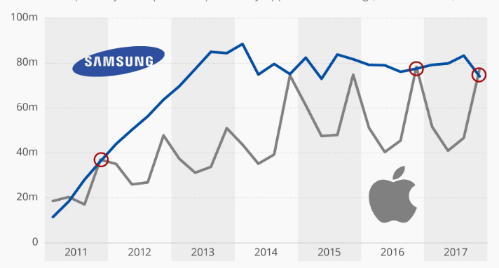
Figure 1: Popularity of Samsung over Apple
(Source: Songet al. 2016)

Samsung is better than iPhone, however, sizes are at a very rare case are comparable, hence, the models offered by Samsung takes an advantage of having large screen, via multitasking, in such way that the Applemodels do not (Chen and Ann, 2016). Hence, while comparing these two with respect to size, Samsung wins the race. In terms of Camera, again, the devices of Samsung continue for holding their own, however, iPhone is on its improvement stages (Dolata, 2017).
2. Web Conferencing
a) Skype: Conferencing through Skype for the business servers allow its users for meeting and holding the conferences online through using their Skype-Id for the business-clients despite of each getting together inside the same room. Hence, meeting the participants can further connect to the meeting with their Skype-id for the clients associated with their business for having the full video and audio experiences, or dialing into a conference using the phone. Hence, according to Yoonet al. (2015), conferences can also support the instant-messaging, desktop, interactive white-boards and application sharing.
b) Team-viewer: All-in one approach of team-viewer ensures the users that they have each & everything, which they need for having both such as the effective communication along with collaborative working within a single convenient package. Whether, the users are working from their homes, or wishing for collaborating with their colleagues abroad, and then the same software offers its users the fully integrated solutions for online conference for video and audio communication.
Advantages, disadvantages and recommendations
Advantages
- It saves time and money, for instance, the days of spending the hours on planes or trains for getting to a business-meeting are long gone.
- It increases the productivity, for example, in real-life practices, scheduling and pre-planning a business-meeting can take a lot time, hence, web-conferencing can act as an effective and efficient way via which the productivity can be increased through reducing the time-spent before the scheduled meeting, the valuable time that can also be spent by working on other significant things (Hahnet al. 2016)
Disadvantages
- Not every web-conference is free; web-conferencing can clearly reduce the costs, which are associated with the business-travel, hence, it is not always completely free of charges
- Web-conferencing can be less-personal as compared to face-to-face meeting: for instance only by sitting in front of the screen over webcam to an individual cannot have a same personal touch, which sitting around the table with all in person can.
Team-viewer | Skype
It is a remote support, online-meetings and remote-access based management software | It is a telecommunications-software, which offers video-chat along with voice-calls from the mobile-devices, computers and the tablets
It is designed for keeping the people and the devices connecteted, allowing the users for accessing their official-PC from roads, video-conferences across their towns, along with share the screen for the remote supporting from the different side across the world | It is used by the freelancers, multinational enterprises and start-ups based organizations as such
As Team-viewer is a multiplatform along with multi-language solution, hence, it offers the users a flexibility for running on the broad-spectrum regarding the operating systems and devices in over 30 languages (Jainet al. 2016) | Skype further facilitates the multi-channel collaboration and communication in any workplace

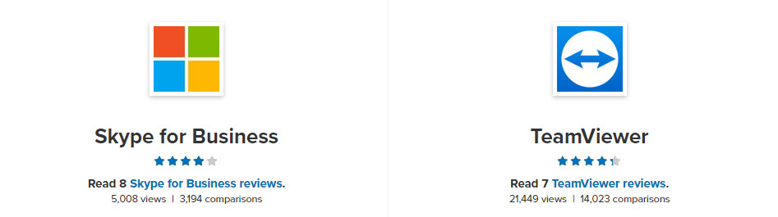
Figure 2: Popularity of Team-viewer over Skype
(Source: Yoonet al. 2015)
While comparing these two technologies used for web-conferencing, Team-viewer is found to be better than Skype; it is due to that team-viewer offers large number of facilities as compared to Skype, for example, integrating checking of monitor and device management and many others. Furthermore, the best part of Team-viewer is that the same technology offers a platform for 30 different language users; hence, noany communication barrier needsto be faced by the users (Muehlsteinet al. 2017).

Part 2
Social media
FACEBOOK as a tool for the business especially for marketing purpose
Facebook continues for being the reigning camp regarding the social-media sites; furthermore, this application has also become of the significant and top platforms of social-media nowadays, moreover, there are a large number of advantages with Facebook. According to Chandelet al. (2017), one fact, which is known by each owner is that the marketing strategies regarding the business can have the huge effects over their growth along with success. Thus, it is essential for the business-owners for promoting their services if the owners wish for drawing in the customers.Here, Facebook can further be extremely useful, while having the business page on Facebook, is similar to owning the website, hence, there are few key benefits, which only Facebook can offer:
This marketing-strategy is of low-cost: Any business can also sign-up over Facebook for free-of-cost along with for the small start-up business, it is really found to be useful and they do not have the money as yet for paying for the website
Facebook can further be utilized for sharing the information regarding the business; hence, it is very easy for creating the business-page over the social network. Hence, people need to enter useful information associated with the business. For instances, the product-details, history and the purpose need to be provided over the page, moreover, the same will draw the users of Facebook.
This social-network can also allow the business for communicating with the existing including the prospective clients, moreover, Facebook offers customers-support, which is also easier via Facebook (Gilbert, 2016). In addition, the awareness amongst the users can be raised with the help of the likes of Facebook.

Part 3
Evidence of my own online preference
Facebook profile - https://www.facebook.com/pavlin.grancharov
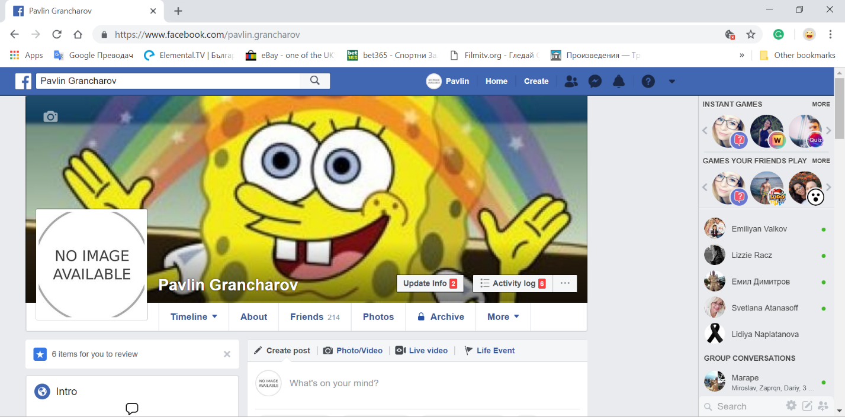

Linkedin Profile - https://www.linkedin.com/in/pavlin-grancharov-439219175/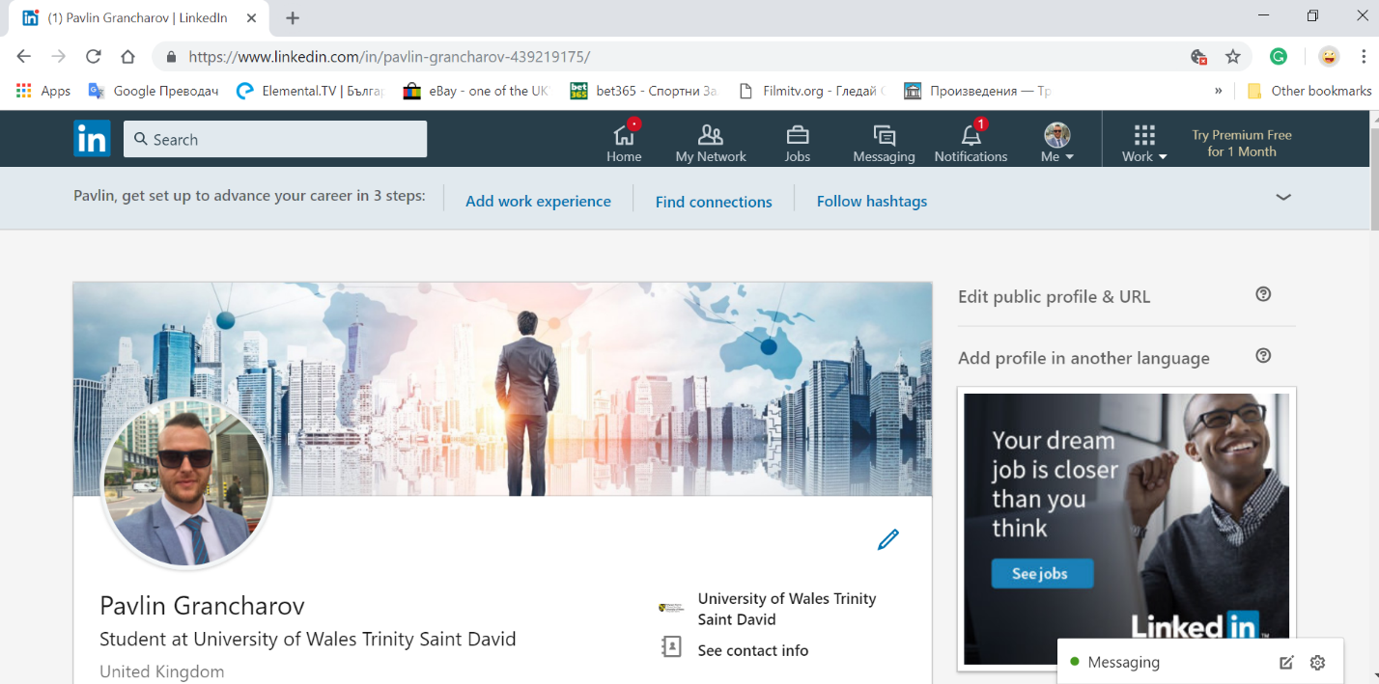
Tweeter Profile - https://twitter.com/PGrancharov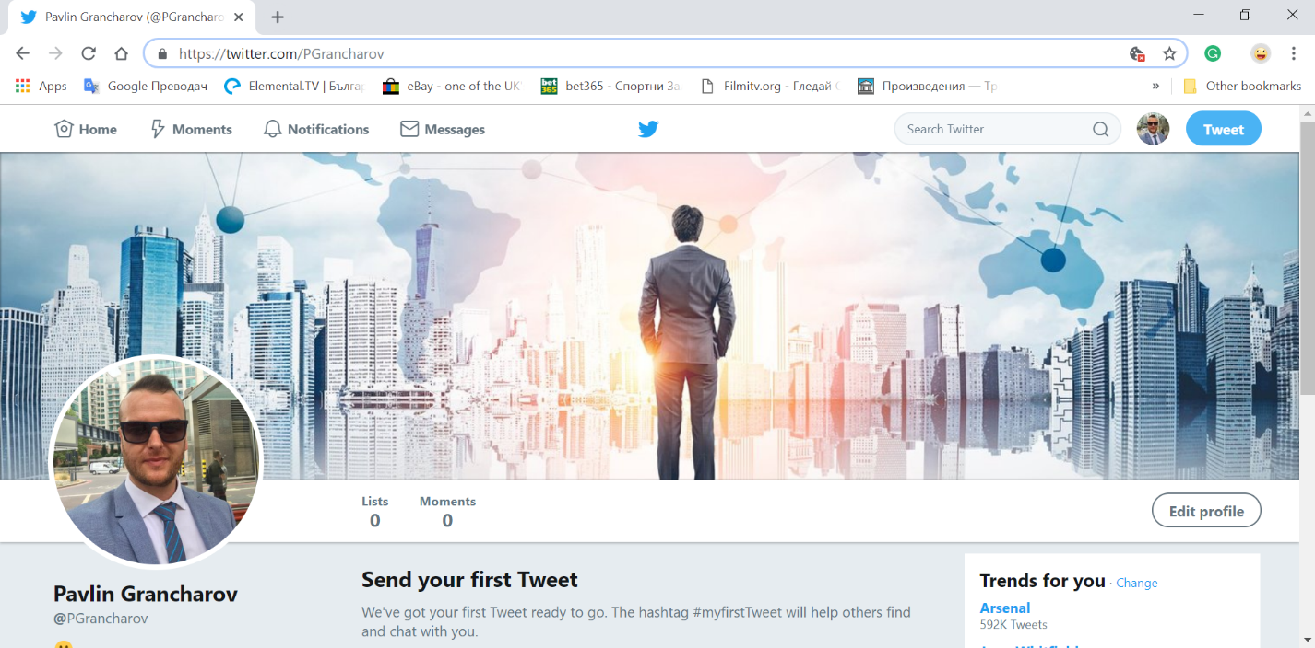

Reference List
Beckett, P., 2015. The business risks of using smartphones. Network Security, 2015(11), pp.16-17.
Campbell-Kelly, M., Garcia-Swartz, D., Lam, R. and Yang, Y., 2015. Economic and business perspectives on smartphones as multi-sided platforms. Telecommunications Policy, 39(8), pp.717-734.
Chandel, A., Sethi, A. and Mishra, P., 2017. A Comparative Study of Facebook Marketing Practices of Selected Theme Based Restaurants in India. Indian Journal of Marketing, 47(12), pp.51-63.
Chen, C.M. and Ann, B.Y., 2016. Efficiencies vs. importance-performance analysis for the leading smartphone brands of Apple, Samsung and HTC. Total Quality Management & Business Excellence, 27(3-4), pp.227-249.
Dolata, U., 2017. Apple, Amazon, Google, Facebook, Microsoft: Market concentration-competition-innovation strategies (No. 2017-01). StuttgarterBeiträgezurOrganisations-und Innovationsforschung, SOI Discussion Paper.
Gilbert, L.L., 2016. 'Friends','fans', and foes: Identity performance through responses to Facebook brand marketing(Doctoral dissertation, University of East Anglia).
Hahn, T., Rahman, H.U., Segall, R., Heim, C., Brunson, R., Sharma, A., Aslam, M., Lara-Rodriguez, A., Islam, M.S., Gupta, N. and Embry, C.S., 2016, October. Remote access programs to better integrate individuals with disabilities. In Proceedings of the 18th International ACM SIGACCESS Conference on Computers and Accessibility (pp. 245-250). ACM.
Jain, K., Himmatramka, A., Bhandary, A., D’silva, A. and Barge, D., 2016. Synchronized Development Using WebRTC Real-Time Collaboration in WebRTC. International Journal of Engineering Science, 6(4).
Muehlstein, J., Zion, Y., Bahumi, M., Kirshenboim, I., Dubin, R., Dvir, A. and Pele, O., 2017, January. Analyzing HTTPS encrypted traffic to identify user's operating system, browser and application. In Consumer Communications & Networking Conference (CCNC), 2017 14th IEEE Annual (pp. 1-6). IEEE.
Tredinnick, L., 2018. Virtual realities in the business world. Business Information Review, 35(1), pp.39-42.
Yoon, S.H., Park, J.S. and Kim, M.S., 2015. Behavior signature for fine-grained traffic identification. Appl. Math, 9(2L), pp.523-534.

