
Effective Team working and Communication
[Document subtitle]

July 13, 2018
University of Wales Trinity Saint David

Husna Kowser
ID: 1709537

Executive Summary

This study deals with the significance of communication and their related theories and models in association with effectiveness of teamwork. This study revolves around a case scenario of Local Council where employees faced tremendous problems and workload due to communication gap. This study also highlights about the strategies implemented in working of the organisation. Additionally, relevant recommendations are also provided for the study.

Table of Contents
Executive Summary 1
Terms of Reference 3
Procedure 4
Introduction 5
Findings 6
Conclusion 16
Recommendations 17
Reference 18
Acknowledgements 20

Terms of Reference

Effective Team Working and Communication report was requested by Melanie Squire on May 2018. The purpose of the report is to understand meaning of communication and the connection related to theories and models with effectiveness of teamwork. The report will be submitted by 13th June 2018.

Procedure

This procedure is secondary research through accessing Books, websites and journals.

Introduction

Communication is considered to be an integral part of an organisation. Flexibility in communication avoids misunderstanding of information that are transported. In context of an organisation, communication plays an essential role in enhancing effectiveness and collaboration of a team. This study deals with identifying issues that are associated with communication and discussing about significance of these issues on teamwork. Additionally, various theories and models are elaborated in alignment with communication and their effect on teamwork. In fact, importance of communication cycle, communication methods, and effect of types of communication on a team is also stated here. Appropriate recommendations are stated based on findings derived from the study.

Findings

Communication
Effective communication is essential for better performance of the employees of a concerned organisation. As conclude by (Banovic 2016), communication aids as foundation of every business. Communication must be clear and flexible so that every employee of an organisation gets a clear perception of information provided by top-level management of the particular organisation. Communication is efficient in building morality and motivates team to perform at their level best (Brewster 2017).
Communication issues
There are different barriers to communication that hurdles the pathway of success of an organisation.
- Employee turnover: Employee turnover is considered to be a result of poor management. In relevance to the case study, it is found that in Local Council, there was a huge employee turnover due to misconception of information conveyed. The new procedures were not known to the employees that led to employee absence.
- Poor performance: As observed by (Cardon and Marshall 2015), communication gap results in poor performance of employees. In accordance to the case study, it is found that due to employee turnover, there were various new employees in the Local Council. The existing employees were not comfortable with the new employees that resulted in lack of discussion and poor performance.
- No two-way communication: In the Local Council, it is found that the manager of the organisation held occasional face to face communication and one-way communication led to complaining of team members of the council. Due to lack of two-way communication, employees were not able to perform properly.
- Lack of trust: In accordance to the case scenario, the existing employees were not able to trust on new employees that resulted in awkwardness and communication gap among the employees.
- Improper induction: In relevance to case scenario, it is found that the new employees of Local Council were not provided with proper training session that in turn resulted in communication gap among the employees.
- Quality issues: In accordance to (Carlson et al. 2017), the employees were not able to give their best effort in preparing the reports. The reports were poorly made and employees were inactive in their approach.
Communication issues can develop in any particular situation inside an organisation. As conclude by (Condoluci et al. 2015), lack of flexibility in communication results in misinterpretation of information conveyed to the employees. In relevance to the case study it has been found that there was a poor performance of the department. Additionally, various issues were faced by the department such as employee turnover and absence. There was a communication gap that created diluted mistakes and messages.

Impact of communication issues on teamwork
The issues of communication lay an adverse effect on the working of the organisation. There are several issues faced in Local Council are stated below:
- Employee absenteeism: Employees being not present at their workplace is referred to as absenteeism of employees. In relation to the case study, it is found that employees of Local Council were not willing to work further at their place. The work anxiety of the Council was not according to the comfortability of the employees.
- Improper training: Training is considered to be an essential part for an employee. Training sessions help every employee to develop their skills and talents for enhancing their working. The new employees were not provided with proper training, this resulted in improper working of the new employees (McLeskey et al. 2017).
- Communication gap: During the meetings held, the managers did not take initiatives to resolve the doubts of the employees arise. The existing employees were not bothered in sharing their doubts further. This created a communication gap among the managers and their employees.
- One-way communication: as opined by (Jia et al. 2014), the managers occasionally held fact-to-face communication and a one-way communication took place. In this way, the employees were unable to share their ideologies with their managers. This restricted the better growth of the organisation. The employees suffered with ultimate stress and workload.
- Service issues: The employees faced ultimate pressure and due to communication gap. The employees were unable to produce their best. This resulted in poor preparation of reports. The employees were not able to prepare appropriate work and meet the organisational goals.
- Misinterpretation: At times, there were new procedures introduced in Local Council. The employees were not able to have a clear perspective of the rules and regulations. The procedures were like surprises to the employees. The employees were distant from the management and a gap was being created.
- Employee shortage: Poor management results in employee shortage. The employees were not feeling at comfort in the working apprehension of the Local Council. This resulted in employee turnover.
- Poor interpersonal relationships: According to (Sander et al. 2015), the doubts of the employees were not resolved by the head of the council. The employees were not able to share their ideologies with the management. These gaps resulted in poor interpersonal relationship.
- Rate of turnover: Poor management of Local Council resulted in higher rate of employee turnover. The working anxiety was not in harmony to the employees that bound the employees to quit the organisation.
- Workload: The employees were in stress and extreme workload. As the new employees were not given proper training sessions, this laid great pressure on the existing employees (Shaw et al. 2014).

Shannon-Weaver Model of Communication
The major objective of these models is to signal transmission from the source to the destination through a transmitter by a channel. The Shannon-Weaver Model consists of 7 main elements. Those are under laid:

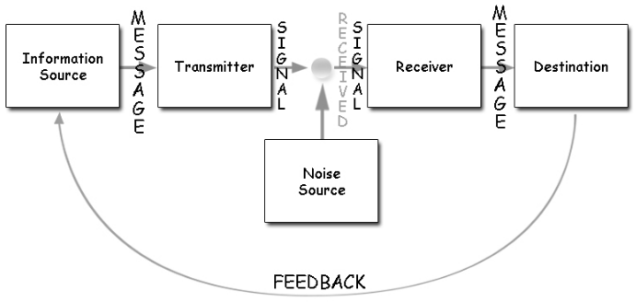
Figure 1: Shannon-Weaver Model of Communication
(Source: Rogers et al. 2017)

- Information source: A desired message is chosen by the sender that can be mixture of image or sound.
- Transmitter: Message is changed to signals with the help of transmitter.
- Channel: Channel can be referred to the path from where the message passes from transmitter to receiver.
- Receiver: Receiver can also be stated as translator who reverses the transmitter to change the signal back to message (Rogers et al. 2017)
- Destination: It is the place where the message reaches.
- Noise: Noise is the physical barrier to the message. It is responsible for the distortion made in transmission.
- Feedback: feedback is the information or reaction of the receiver in context of the message received.
In relevance to the case study, it is found that head of the organisation held occasional face to face communication with the employees and managers. The communication was a one-way communication that did not centre the employees and thus this objected the members.

Berlo’s Model of Communication
Berlo’s Model of Communication highlights the emotional aspects of the message. This model functions on the SMCR Model:

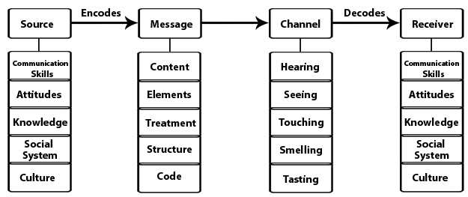
Figure 2: Berlo’s Model of Communication
(Source: Jackson 2015)

- S-Source: Source can be also stated as sender of the message. The sender sends the message with the help of attitude, communication skills, knowledge, culture and social system.
- M-Message: Messaging is also called encoding. In this process, the message encompasses of element, content, structure, code and treatment.
- C-Channel: Channel is the medium through which message is transferred to the receiver. Channel involves seeing, hearing, smelling, touching and tasting (Jackson 2015)
- R-Receiver: The process can be also stated as decoding.
In accordance to the case scenario, the employees had innovative ideas but they were not able to express due to the communication gap among the employees and the manager. The employees did not implement those ideologies into their working and thus resulted in poor performance.

Communication cycle

Communication Cycle is a linear model of communication. This cycle represents a systematic relationship among sender, message, channel and the receiver (Jauhari and Bharwani 2017).

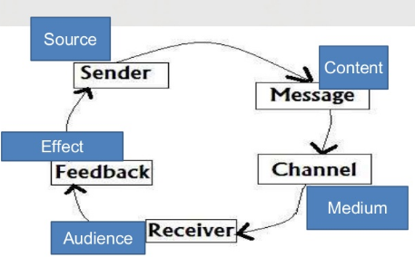
Figure 3: Communication Cycle
(Source: Jauhari and Bharwani 2017)

In association to the case study, it is found that the employees were not comfortable in sharing their ideologies with head of the Local Council due to one-way communication. This resulted in poor preparation of the reports.

Tuckman Theory
Tuckman theory consists of 4 different stages:

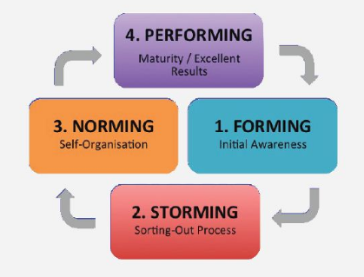
Figure 4: Tuckman Theory of Communication
(Source: Jeejeebhoy 2018)

Forming- This stage creates a dependency on leaders for direction and guidance. Leaders must prepare an agenda for answering the questions of the employees.
Storming- In this stage, employees must focus on their goals and avoid personal and emotional distractions.
Norming- Decisions can be allocated to members within a group. Commitments made must be strong and united. The team members must engage themselves in social activities (Jeejeebhoy 2018).
Performing- This stage pressures on looking each other and share their tasks and duties. The team members are free to assistance from the leader with interpersonal and personal development.
In relation to the case scenario, it is found that the employees did not have the faculty to share their ideas for the betterment of working of the organisation.
By implementing Tuckman’s theory in an organisation, teamwork can be enhanced. Collaboration in teamwork is additionally essential for the better working of the organisation.

Verbal and Written communication

Communication is a two-way process that results in effectiveness of teamwork. Verbal and written communication also lays a great significance on the working of an organisation. There is different significance of verbal and written communication. Those are follows:
- Confidence: Verbal communication improves and develops confidence among every concerned individual. In relevance to the case study, it is found that the employees lacked confidence as they were not able to express their views (Weller et al. 2014).
- Interpretation: Interpretation refers to appropriate communication of information. In Local Council, it is found that interpretation of information was not done appropriately. Additionally, it is found that the new procedures were not explained to the employees properly.
- Professionalism: In accordance to (Wittenberg et al. 2016), there must be a proper profession working apprehension in order to increase efficiency of the employees. In relation to case study, it is found that there was lack of professional environment of working.
- Clarity: There must be clarity in information that is conveyed to the employees. The management must take initiatives to clarify information conveyed to the employees.

Figure 5: Verbal and Written communication
(Source: Created by Husna Kowser)

Schramm’s Model of Communication, 1954
Schramm’s Model of Communication, 1954 includes different components. Those components are stated below:
- Sender: Sender is the person who takes the initiatives to send message.
- Encoder: Encoder is the person who converts the message into signals or codes.
- Decoder: Decoder is the person who converts the message into understandable language.
- Interpreter: Interpreter analyses the messages. Interpreter can also be stated as receivers.
- Receiver: Receiver receives the message and analyses it.
- Message: Message is the data or information sent by the sender (Yeomans and FitzPatrick 2017).
- Feedback: Feedback is the response of the receiver received after getting the message.
- Medium: Medium or channel is the way through which message is sent.
In reference to the case study, it is found that the employees were suffering from communication gap in Local Council. There must be implementation of these relevant models for enhancing the working of the organisation.

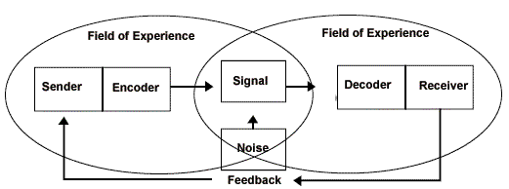
Figure 6: Schramm’s Model of Communication
(Source: Yeomans and FitzPatrick 2017)

Conclusion

It can be concluded that communication is an integral part of an organisation in improving teamwork. There must be flexibility in communication avoids misconception of information that are conveyed. This study catered an idea about the issues that are associated with communication and their significance, it is also specified in relation to the models and theories. A detailed idea about Shannon-Weaver Model, Berlo’s Model of communication, Tuckman theory of communication and communication cycle is obtained.

Recommendations

It can be recommended from the above study that the management of the Local Council must take relevant measures in order to develop their working strategies and provide job satisfaction to their employees. The managers of the Local Council are required to overcome their faults and provide proper training to the new employees so that they are able to provide their best at the workplace. The management of the organisation must take initiatives to implement the above explored theories for improving teamwork and increase their efficiency.

Reference

Banovic, S. (2016), ‘Cultivating support through effective communication between a medical team and a cancer patient: Case report’, Medicinski časopis, 50:2, pp.72-76.
Brewster, C. (2017), ‘The integration of human resource management and corporate strategy In Policy and practice in European human resource management’, 13:7. pp. 22-35 (Second Edition) Abingdon:Routledge
Cardon, P.W. and Marshall, B. (2015), ‘The hype and reality of social media use for work collaboration and team communication’, International Journal of Business Communication, 52:3, pp. 273-293
Carlson, J.R., Carlson, D.S., Hunter, E.M., Vaughn, R.L. and George, J.F. (2017), ‘Virtual team effectiveness: Investigating the moderating role of experience with computer-mediated communication on the impact of team cohesion and openness’, In Remote Work and Collaboration: Breakthroughs in Research and Practice, 77:5, pp 687-706
Condoluci, M., Dohler, M., Araniti, G., Molinaro, A. and Zheng, K. (2015), ‘Toward 5G densenets: architectural advances for effective machine-type communications over femtocells’, IEEE Communications Magazine, 53:1, pp. 134-141
Jackson, D., (2015), ‘Employability skill development in work-integrated learning: Barriers and best practice’, Studies in Higher Education, 40:2, pp. 350-367
Jauhari, V. and Bharwani, S. (2017), ‘An exploratory study of competencies required to cocreate memorable customer experiences in the hospitality industry’, In Hospitality Marketing and Consumer Behavior, 12:2, pp. 159-185
Jeejeebhoy, K.N. (2018), ‘Organization of the Nutritional Support Team’, In Total parenteral nutrition in the hospital and at home, 25:5, pp. 1-4 (fourth Edition) London: CRC Press.
Jia, L., Shaw, J.D., Tsui, A.S. and Park, T.Y. (2014), ‘A social–structural perspective on employee–organization relationships and team creativity’, Academy of Management Journal, 57:3, pp. 869-891
McLeskey, J.L., Rosenberg, M.S. and Westling, D.L. (2017), ‘Inclusion: Effective practices for all students, Pearson 45:12, pp. 12-20
Rogers, E.M. and Valente, T.W. (2017), ‘A history of information theory in communication research’, In Between communication and information, 45:11, pp. 35-56 (Third Edition) Abingdon:Routledge
Sander, P.C., Van Doorn, R.R., Van Der Pal, J. and Zijlstra, F.R. (2015), ‘Team adaptation to an unforeseen system failure: Limits of the potential aids of shared knowledge and standardized communication’, European Journal of Work and Organizational Psychology, 24:5, pp. 796-811
Shaw, D.J., Davidson, J.E., Smilde, R.I., Sondoozi, T. and Agan, D. (2014), ‘Multidisciplinary team training to enhance family communication in the ICU’, Critical care medicine, 42:2, pp. 265-271
Weller, J., Boyd, M. and Cumin, D. (2014), ‘Teams, tribes and patient safety: overcoming barriers to effective teamwork in healthcare’, Postgraduate medical journal, 23:5, pp. 12-14
Wittenberg, E., Ferrell, B., Goldsmith, J., Ragan, S.L. and Paice, J. (2016), ‘Assessment of a statewide palliative care team training course: COMFORT Communication for Palliative Care Teams’, Journal of palliative medicine, 19:7, pp. 746-752
Yeomans, L. and FitzPatrick, L. (2017), ‘Internal communication’, 33:22, pp. 45-48

Acknowledgements

I take the pleasure to complete this entire assignment in association with my teachers, friends and family members. It has been a wonderful opportunity to supply to all surveys that has been conducted. I also show my earnest concern to thank all librarians allowing me to access all information.

