

Name: Shreyaben Radhey Patel
Student ID: 2242222
Module: Strategic Management
Module Code: LCMB7003
Lecturer: Dr. Jaya Gopalkrishnan
Submission Date: 03/01/2024

Table of Contents
Introduction 3
Vision 3
Mission 4
Objectives 4
Internal and External environmental audit 6
External Environment Analysis: PESTLE analysis 6
Internal Environmental Analysis: Porter’s 5 Forces 8
Industry Attractiveness and Market Strategies 10
Strategic options available for Leicester Kitchen Square to achieve Sustainable Competitive Advantage using Porter’s Generic Strategy 12
Critical Analysis 13
BCG Matrix 13
Ansoff Matrix 14
VRIO analysis 16
SWOT 17
Value Chain Analysis 18
Evaluation 20
Ways to implement and execute the strategy 20
Strategy 20
Structure 21
Systems 22
Critical Analysis 23
KPI as monitoring tool to monitor the Strategy 24
Critical Evaluation of Green Strategy, Sustainability, and CSR activities that can be undertaken 24
Green Strategy 24
Sustainability and CSR activities 25
Conclusion 26
References 27

Introduction
In the dynamic and competitive landscape of today's business world, strategic planning is not just beneficial but it is essential for any organization seeking sustainable success and growth. Strategic planning serves as a roadmap, guiding a business through the complexities and uncertainties of the market, and ensuring that every step taken aligns with its overarching goals and vision. The essence of strategic planning lies in its ability to provide a long-term perspective, helping businesses navigate through short-term challenges while keeping their long-term objectives in focus (Rêgo et al., 2021). This forward-looking approach is crucial for staying ahead of market trends, adapting to changing consumer demands and identifying new opportunities for growth and innovation. Strategic planning is not just about setting goals and defining actions and it's about creating a cohesive, adaptable, and efficient approach to business that ensures long-term success and resilience in an ever-changing world.
Moreover, strategic planning is instrumental in resource optimization. It enables businesses to allocate their resources be they financial, human, or technological in a manner that maximizes efficiency and effectiveness. By setting clear priorities and objectives, companies can avoid wasteful expenditures and focus their efforts where they will have the most impact. In a rapidly evolving business environment, strategic planning also provides a framework for flexibility and adaptability. It allows organizations to quickly respond to unexpected changes, such as shifts in the economy, new competitors, or technological advancements, minimizing risks and capitalizing on emerging opportunities (Rêgo et al., 2021). Furthermore, strategic planning fosters a sense of direction and purpose within the organization. It aligns the efforts of all team members towards common goals, enhancing collaboration, and driving collective progress.

Vision
The vision of Leicester Kitchen Square is to become a symbol of culinary brilliance and innovation in the United Kingdom. Not only does the restaurant want to provide an outstanding dining experience, but it also wants to be known as an innovator in environmentally and socially responsible cuisine (leicestersquare.london, 2022). With an eye on building a chain of restaurants recognized for their dedication to quality, authenticity, and remarkable culinary experiences, its mission goes beyond the walls of its current location to impact the fine dining culture across the United Kingdom.

Figure 1: Leicester Kitchen Square

Mission
Leicester Kitchen Square’s mission is to offer an unparalleled fine dining experience that combines traditional flavors with contemporary culinary techniques. The restaurant is committed to sourcing the finest ingredients, fostering relationships with local farmers and suppliers, and prioritizing sustainability in every aspect of its operations (leicestersquare.london, 2022). It aims to provide exceptional service in an ambiance that reflects both sophistication and warmth, making each dining experience memorable. Emphasizing continuous innovation in its menu offerings, the restaurant seeks to continuously surprise and delight its patrons.

Objectives
- The goal is to open multiple Leicester Kitchen Squares in big UK cities in the next five years, with an emphasis on areas with a strong reputation for foodie culture and appreciation.
- The goal of their strategic marketing, public relations, and involvement in culinary events and contests is to raise awareness of their brand and solidify their position as the UK's premier fine dining establishment.
- In order to lessen our impact on the environment and promote sustainable practices, the restaurant aims to use 75% locally sourced foods in all of its menu items.
- To maintain a high level of customer satisfaction by always going above and beyond to make each guest's dining experience special (leicestersquare.london, 2022).
- In order to keep things interesting and fresh for their customers, they have decided to implement biannual menu overhauls that use seasonal ingredients and current culinary trends.
- To create an all-encompassing curriculum for staff training that emphasizes sustainable methods, top-notch customer service, and culinary arts and maintain a yearly employee retention rate of at least 85%.
- Following expansion, attain a minimum yearly revenue growth rate of 10% while keeping quality and service at an all-time high and guaranteeing profitability.
- To participate in community-based projects and form alliances in service of sustainable agriculture, food literacy, and local food programs.
- In order to improve the restaurant's online presence, they will be updating their website, engaging with social media, and launching an online reservation and feedback system.
- Creating a client loyalty program that recognizes regulars and compensates them for their business is their top priority.
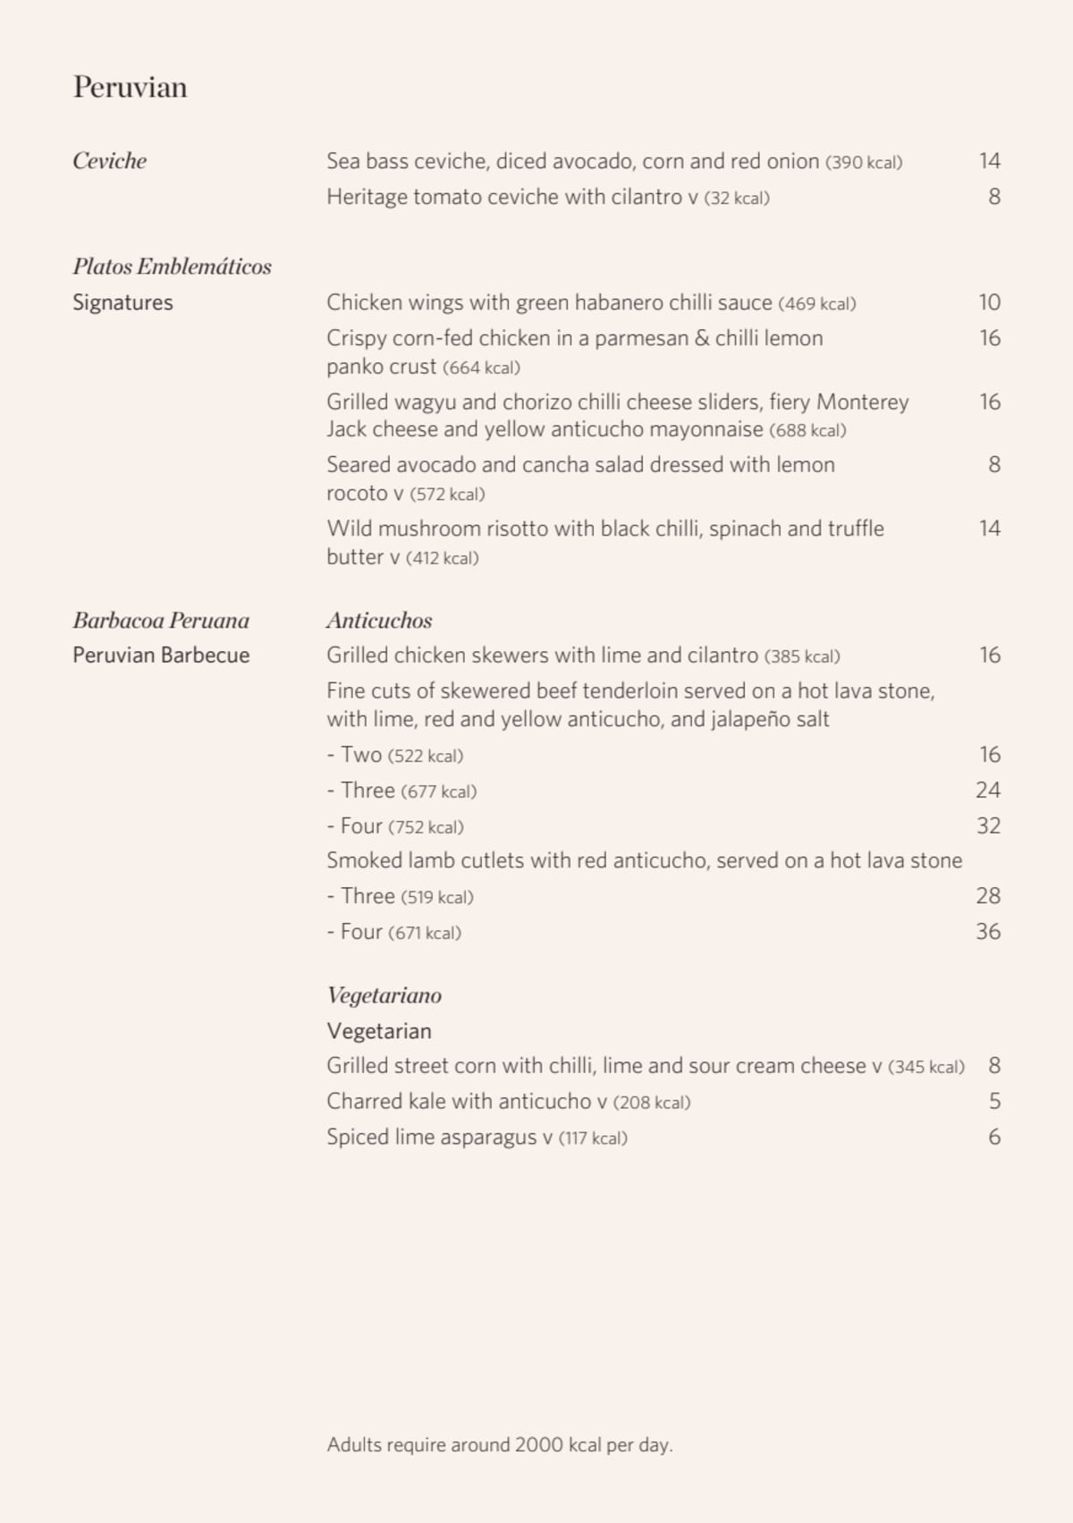
Figure 2: Menu of Leicester Kitchen Square’s
Source: (leicestersquare.london, 2022)

Internal and External environmental audit

External Environment Analysis: PESTLE analysis
Political Factors
- Government Policies: Regulations concerning food safety, hygiene, and health are crucial for Leicester Kitchen Square. Compliance with these regulations is essential.
- Trade Policies: Brexit implications, such as changes in import tariffs, can affect the cost of imported ingredients.
- Local Zoning Laws: Expansion plans may be influenced by zoning laws in different UK cities, impacting location choices (Juutila, 2019).
Economic Factors
- Economic Trends: The UK’s economic health influences consumer spending. Economic downturns may lead to reduced spending on luxury dining.
- Currency Fluctuations: As a business that may import ingredients, currency stability is vital for cost management (Juutila, 2019).
- Employment Rates: Higher employment rates can increase disposable income levels, potentially boosting restaurant patronage.
Social Factors
- Changing Consumer Preferences: Trends in dietary preferences, such as veganism or organic foods, can impact menu offerings.
- Cultural Diversity: The UK’s diverse population may call for a diverse culinary offering, catering to a range of tastes (Cumbo, 2023).
- Lifestyle Trends: Increasing focus on experiences over material goods can benefit fine dining establishments as consumers seek unique dining experiences.
Technological Factors
- Online Presence and E-Commerce: Leveraging technology for reservations, delivery services, or online marketing is crucial.
- Food Technology Trends: Innovations in cooking techniques and food presentation can enhance the dining experience.
- Data Analytics: Utilizing customer data for personalized marketing and improving customer service.
Legal Factors
- Employment Laws: Adherence to fair labor practices, including wages, working conditions, and equal opportunities, is essential.
- Food and Beverage Regulations: Compliance with food labeling, alcohol licenses, and health and safety standards.
- Data Protection Laws: Adherence to GDPR for customer data collected through digital channels.
Environmental Factors
- Sustainable Sourcing: Focus on locally sourced, sustainable ingredients can appeal to environmentally conscious consumers.
- Waste Management: Implementing effective waste management strategies, including recycling and reducing food waste (Arturo ARREDONDO-PÉREZ et al., 2022).
- Energy Consumption: Using energy-efficient appliances and practices to minimize the environmental footprint.
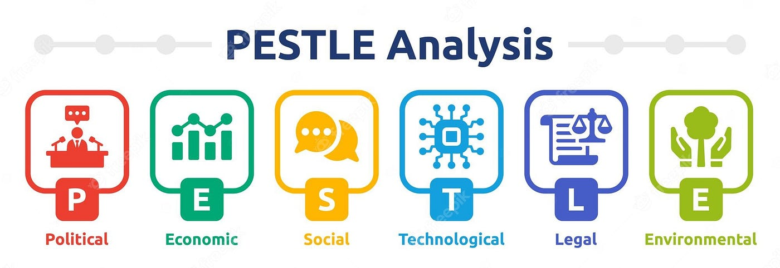
Figure 3: PESTLE analysis
Source: (Mukherjee, 2023)
The PESTLE analysis reveals a wide variety of elements that will impact the growth and strategic planning of Leicester Kitchen Square. Following government laws and adjusting to changes in trade policy are crucial from a political standpoint. In terms of money, the eatery has to deal with the UK economy, which means adjusting to things like customer purchasing habits and currency changes. To be socially responsible, it has to keep an eye on cultural diversity and changing customer tastes so that it can reach a wide demographic with its food and advertising. If Leicester Kitchen Square wants to be technologically ahead of the competition and increase consumer involvement, it should embrace digital tools and culinary advances. The restaurant is legally obligated to adhere strictly to regulations on data privacy, food safety, and employment. From an ecological perspective, dedication to sustainable sourcing and operations may lessen its ecological footprint and win over eco-conscious customers. Leicester Kitchen Square must skillfully navigate these PESTLE variables if it wants to grow in the UK's high-end restaurant industry. To thrive and expand in the competitive restaurant industry, the establishment must be nimble, creative, and legally compliant.

Internal Environmental Analysis: Porter’s 5 Forces
Threat of New Entrants
The fine dining sector in the UK presents a moderate to high barrier to entry. While the initial investment in setting up a fine dining establishment can be significant, covering aspects like location, interior decor, and hiring skilled staff, the biggest challenge lies in building a brand reputation and customer base. New entrants must compete with established names and overcome customer loyalty to existing brands (Duan, 2022). The uniqueness of Leicester Kitchen Square’s culinary offerings and dining experience can act as a barrier against new competitors.
Bargaining Power of Suppliers
The bargaining power of suppliers in the fine dining industry varies for exclusive or unique ingredients, suppliers may hold more power, especially if there are few alternative sources. Leicester Kitchen Square’s emphasis on quality and potentially rare ingredients could increase supplier bargaining power. However, for more common ingredients, the restaurant may have multiple supplier options, reducing supplier power (Duan, 2022). Building strong relationships with local suppliers could be a strategic move to mitigate this power.
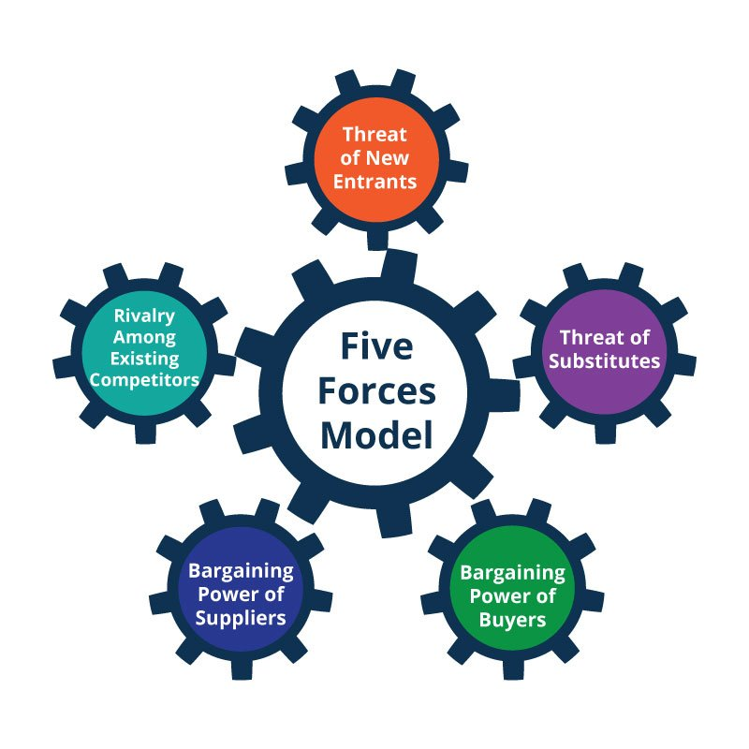
Figure 4: Porter’s Five Forces
Source: (Stanke, 2022)
Bargaining Power of Buyers
In the fine dining segment, the bargaining power of buyers is typically moderate. While customers are willing to pay premium prices for a high-quality dining experience, their expectations in terms of food quality, ambiance, and service are correspondingly high (Silvano, 2022). In an era where online reviews can significantly influence reputation, customer satisfaction becomes crucial. Leicester Kitchen Square needs to consistently meet and exceed customer expectations to maintain its market position.

Figure 5: Restaurant Usage in UK
Source: (statista.com, 2021)
Threat of Substitutes
The threat of substitutes in the fine dining industry is high. Alternatives such as casual dining, fast food, food delivery services, and even home cooking provide customers with a range of options. The restaurant needs to differentiate itself by offering a unique dining experience, exceptional service, and a menu that can’t be easily replicated elsewhere. Special events, chef’s specials, and culinary workshops can add value beyond just dining, reducing the threat of substitutes.
Rivalry Among Existing Competitors
Competition in the fine dining sector in cities like London is intense. Competitors not only include other fine dining restaurants but also casual dining places that offer high-quality food. Leicester Kitchen Square must differentiate itself through its culinary offerings, ambiance, and customer service (Silvano, 2022). A focus on unique culinary experiences, leveraging the chef’s expertise and creativity, and maintaining high standards of service can help in standing out in a crowded market.

Industry Attractiveness and Market Strategies
Market Strategies
Differentiation through Culinary Excellence: Leicester Kitchen Square can capitalize on the trend of experiential dining. Offering a unique culinary experience that combines traditional techniques with modern gastronomy can set the restaurant apart. This includes special tasting menus, chef's table experiences, and themed dining evenings.
Emphasizing Local and Sustainable Ingredients: With rising consumer awareness about sustainability, focusing on locally sourced and ethically produced ingredients can be a significant differentiator. This approach not only supports local farmers and suppliers but also appeals to environmentally conscious consumers.
Leveraging Digital Platforms for Marketing: To reach a broader audience, especially among younger demographics, effective use of digital marketing is essential. This includes a strong social media presence, influencer collaborations, and engaging digital content that showcases the restaurant’s offerings and dining experience.
Building Partnerships and Collaborations: Collaborating with renowned chefs, local artisans, and food and wine connoisseurs for special events or limited-time menus can attract food enthusiasts and create buzz around the restaurant.
Personalized and Exceptional Service: In the fine dining sector, service is as important as the food. Training staff to provide personalized, attentive, and knowledgeable service can enhance the overall dining experience, encouraging repeat visits and positive word-of-mouth.
Expanding into New Markets: For expansion, Leicester Kitchen Square should identify locations where the demand for fine dining is underserved. Market research to understand local tastes and preferences will be crucial for successful entry into new markets.
Membership and Loyalty Programs: Implementing a loyalty program can encourage repeat business. Exclusive offers, early access to special events, and personalized experiences can foster a loyal customer base.
Industry Attractiveness
Due to the dynamic nature of the market and the ever-changing preferences of customers, the fine dining sector in the United Kingdom continues to be appealing. The industry provides a wealth of potential for expansion, particularly for businesses that are at the forefront of innovation and are able to adjust to changing customer demands. However, it is also a highly competitive environment that necessitates maintaining a high level of progress and having a profound comprehension of the expectations of customers. It is possible for Leicester Kitchen Square to achieve sustainable development and a strong market position by capitalizing on its strengths in culinary innovation and customer experience, while also adapting to the changing digital environment and trends in sustainability.
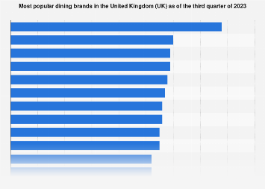
Figure 6: Popular dining brands
Source: (statista.com, 2021)

Strategic options available for Leicester Kitchen Square to achieve Sustainable Competitive Advantage using Porter’s Generic Strategy
Leicester Kitchen Square, in pursuit of a sustainable competitive advantage, can evaluate its strategic options through Porter's Generic Strategies framework, which outlines three potential paths: Cost Leadership, Differentiation, and Focus.
Cost Leadership: This strategy involves becoming the low-cost producer in the industry (Ouma and Oloko, 2017). For Leicester Kitchen Square, this would mean optimizing operations to reduce costs, potentially appealing to a broader market with affordable pricing. However, this approach risks reducing quality and may not align with the restaurant’s brand image or target market.
Differentiation: This strategy focuses on offering unique products or services. Leicester Kitchen Square could implement this by offering a distinctive menu, exceptional customer service, or a unique dining experience that sets it apart from competitors (econposts.com, 2021). Differentiation aligns well with creating a strong brand identity and can justify premium pricing.
Focus Strategy: This involves focusing on a specific market segment and Leicester Kitchen Square might choose to cater to a niche market, like specializing in a particular cuisine or dietary preference (e.g., vegan, organic).
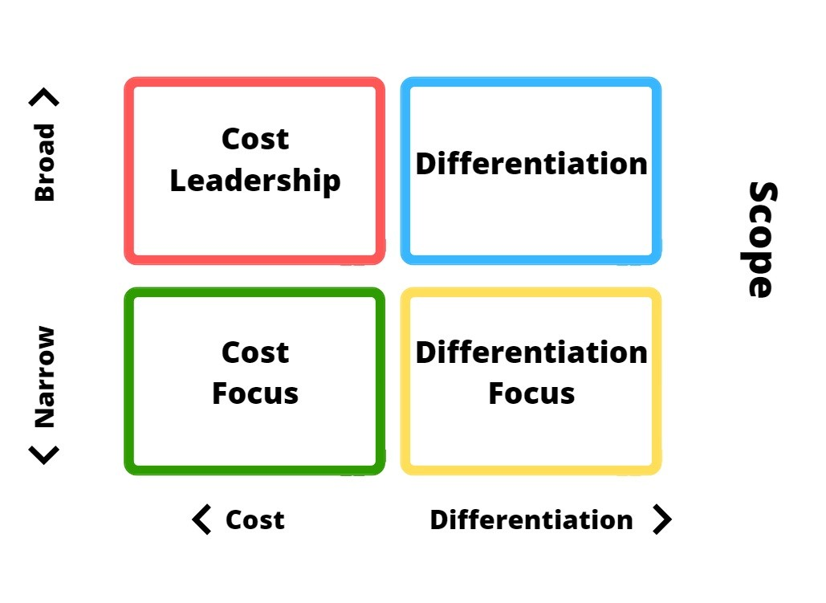
Figure 7: Porter’s Generic Strategy
Source: (econposts.com, 2021)

Critical Analysis

BCG Matrix
Stars (High Growth, High Market Share):
As of right now, it is possible that Leicester Kitchen Square does not have a 'Star' component since it is a single-location establishment. On the other hand, its one-of-a-kind eating experience and the possibility of growth might make its future locations in big cities "Stars," particularly if they soon become popular and seize a substantial portion of the market in those regions (Barachnea et al., 2022).
Question Marks (High Growth, Low Market Share):
There is a possibility that this category includes new business endeavors or expansions into new geographical places. Although these places have great market potential, there are also concerns associated with them since Leicester Kitchen Square has a relatively modest market presence in those areas at the moment (Barachnea et al., 2022). These new expansions have the potential to get closer to the 'Stars' category with the assistance of strategic marketing and one-of-a-kind culinary experiences.
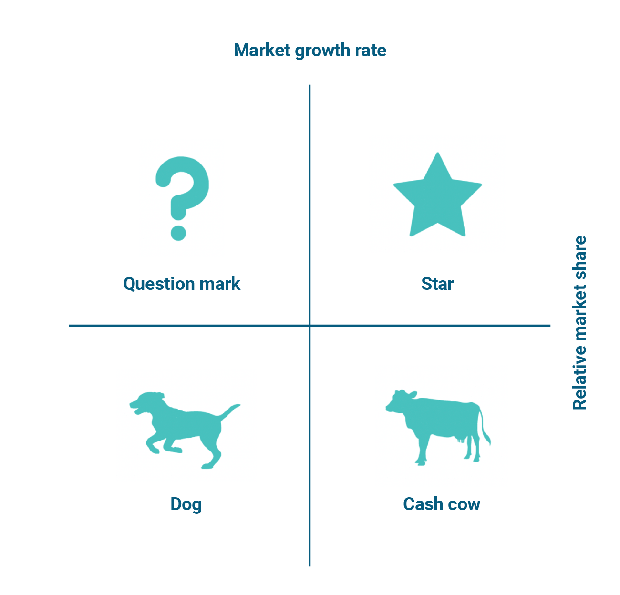
Figure 8: BCG Matrix
Source: (ogsmsoftware.com, 2022)
Cash Cows (Low Growth, High Market Share):
The current location of Leicester Kitchen Square in London has the potential to be referred to as a "Cash Cow" if it continues to maintain a substantial client base and maintains a dominant position in a certain segment of the fine dining market. The income generated by this sector is often consistent, and there is no need for significant investment (Barachnea et al., 2022).
Dogs (Low Growth, Low Market Share):
There is a possibility that some characteristics of the company, such as certain products on the menu or services that are generally less well-liked, are included in this category. There is a possibility that certain regions may need to be reevaluated or eliminated in order to better efficiently distribute resources (Barachnea et al., 2022).

Ansoff Matrix
Market Penetration (Existing Markets, Existing Products):
Increasing the market share of Leicester Kitchen Square in London is the objective of this plan. Increasing marketing efforts, increasing customer loyalty programs, and providing unique eating experiences are all potential strategies that might be used in order to attract a greater number of consumers. The objective is to get the most possible income from the current market (Shishan et al., 2021).
Product Development (Existing Markets, New Products):
In an effort to attract existing consumers, Leicester Kitchen Square can consider introducing new products to the menu or offering limited-time culinary experiences. To do this, it may be necessary to experiment with novel approaches to cooking or to incorporate rising trends in the culinary world. In order to achieve the goal of growing sales, the idea is to provide the current consumer base with something completely fresh and intriguing.
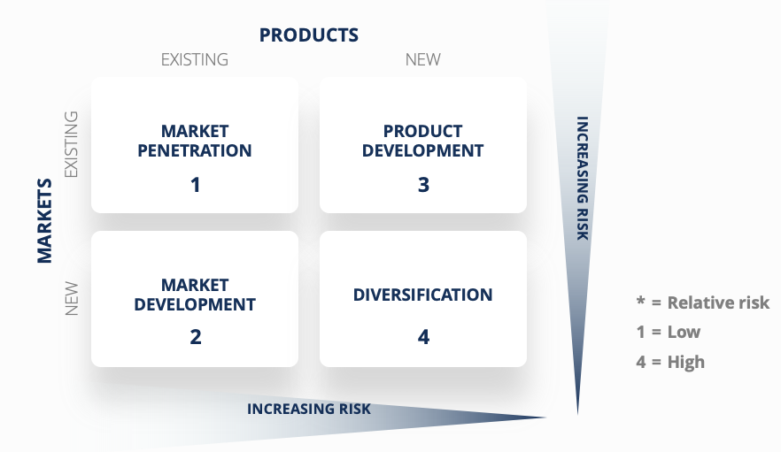
Figure 9: Ansoff Matrix
Source: (Peterdy, 2020)
Market Development (New Markets, Existing Products):
Expansion into new geographic areas within the UK represents this strategy. Leicester Kitchen Square could open new locations in other major cities, targeting customers who are looking for unique fine dining experiences. Market research would be crucial to understand regional preferences and ensure successful entry into new markets (Shishan et al., 2021).
Diversification (New Markets, New Products):
This could involve Leicester Kitchen Square venturing into entirely new business areas, such as launching a line of gourmet products or starting a culinary school. This strategy is the riskiest, as it involves both new products and new markets, but it could also open up significant new revenue streams.

VRIO analysis
Value
A one-of-a-kind value proposition is provided by Leicester Kitchen Square in the form of its remarkable culinary experiences, which combine unconventional recipes with ingredients of the highest possible quality. The company's capacity to provide a dining experience that is unique and unforgettable adds a considerable amount of value to the services it provides, which has the potential to bring in new consumers and keep existing ones (Yoon et al., 2020).
Rarity
There is a possibility that the restaurant's particular recipes, cooking methods, or even a trademark dish might be regarded as uncommon if they are exclusive to Leicester Kitchen Square and are not often seen in other fine dining restaurants (Bruin, 2016). Due to its rarity, a competitive advantage may be created by providing them with something that they cannot get somewhere else.
Imitability
If the culinary skills, recipes, or entire eating experience at Leicester Kitchen Square are difficult to mimic owing to the intricacy of the dish, the competence of the chef, or the unique ingredients used, then this provides a barrier to imitation (Bruin, 2016). As a result of this inimitability, its competitive position is strengthened, since it would be difficult for rivals to readily reproduce its success.
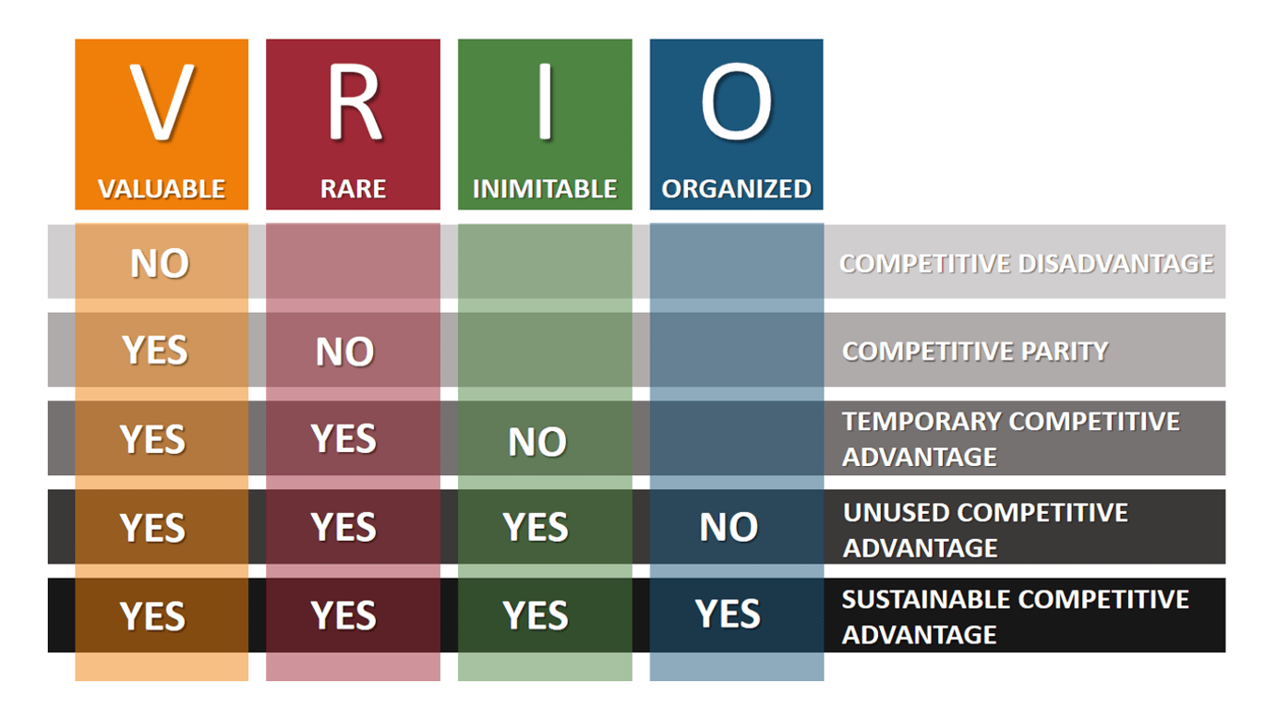
Figure 10: VRIO Framework
Source: (Bruin, 2016)
Organization
It is determined if Leicester Kitchen Square is structured in a manner that maximizes the use of its resources (Bruin, 2016). Effective marketing, efficient operations, high-quality service, and strong leadership are all included in this, and in the event that Leicester Kitchen Square is well-organized, it will be able to make the most of its resources, which are expensive, uncommon, and unrepeatable.

SWOT
Strengths
- Culinary Expertise: Leicester Kitchen Square boasts a high level of culinary skill, offering innovative and high-quality dishes that set it apart.
- Strong Brand Reputation: The restaurant has established a strong reputation in London for fine dining excellence, attracting both locals and tourists (Shaw, 2017).
- Location: Situated in London, the restaurant benefits from a high-traffic location, appealing to diverse clients.
Weaknesses
- Limited Reach: Currently confined to one location, its reach is limited compared to chains or restaurants with multiple outlets.
- High Operating Costs: Fine dining establishments face high operating costs due to premium ingredients, skilled staff, and upscale ambiance maintenance.
- Vulnerability to Economic Fluctuations: As a luxury service, it can be sensitive to economic downturns, where consumers may cut back on non-essential spending (Shaw, 2017).

Figure 11: SWOT analysis
Source: (Shaw, 2017)
Opportunities
- Expansion: Potential to expand into other UK cities, tapping into new markets.
- Diversifying Offerings: Opportunity to diversify its menu or add services like private events, cooking classes, or a gourmet line of products.
- Leveraging Digital Marketing: Utilizing digital platforms for marketing and customer engagement can broaden its customer base (Shaw, 2017).
Threats
- Competition: Intense competition in the fine dining sector, especially in London.
- Changing Consumer Preferences: Rapid shifts in consumer tastes and dietary preferences can impact demand.
- Economic Instability: Economic downturns can lead to reduced consumer spending on luxury dining experiences (Shaw, 2017).

Value Chain Analysis
Inbound Logistics
Leicester Kitchen Square’s excellence begins with sourcing high-quality, fresh ingredients. Establishing strong relationships with suppliers, prioritizing locally sourced and sustainable products, and efficient inventory management are critical.
Operations
The core operation involves the preparation and presentation of gourmet dishes. This includes innovative menu design, culinary expertise, maintaining high standards of food safety, and efficient kitchen management. The ambiance and décor of the restaurant also play a significant role in enhancing the dining experience (Yoon et al., 2020).
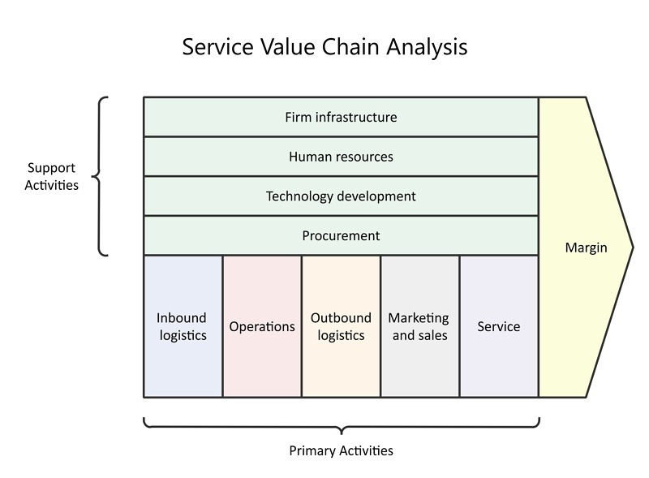
Figure 13: Value Chain Analysis
Source: (Yoon et al., 2020)
Outbound Logistics
While outbound logistics traditionally involve distribution, for Leicester Kitchen Square, it translates to serving the food to customers and potentially offering catering services. Ensuring the timely and elegant presentation of dishes is vital.
Marketing and Sales
The restaurant’s reputation is bolstered through effective marketing. This includes digital marketing, word-of-mouth promotion, partnerships with food critics and influencers, and maintaining a strong online presence with engaging content.
Service
Exceptional customer service is paramount in fine dining. Personalized attention, knowledge about the menu, and a warm, welcoming environment contribute significantly to customer satisfaction and repeat business.
Support Activities
- Procurement: Strategic procurement ensures quality and cost-efficiency.
- Technology Development: Leveraging technology for reservation systems, customer relationship management, and efficient kitchen operations.
- Human Resource Management: Recruiting skilled chefs and trained staff, and investing in their continuous training and development.
- Infrastructure: Efficient management, financial control, legal compliance, and safety standards.

Evaluation
A Differentiation Strategy is the way to go for Leicester Kitchen Square if they want to stay ahead of the competition. One way to set yourself apart from the competition is to provide exceptional, one-of-a-kind dining experiences. Leicester Kitchen Square may build a solid customer by showcasing creative menu items, outstanding service, and a one-of-a-kind meal setting. The restaurant may stand out in the upscale dining industry even more by using sustainable and locally sourced foods. In addition to bolstering the restaurant's standing as a premier dining spot, this strategy is in line with modern customer preferences towards sustainability and authenticity.

Ways to implement and execute the strategy
Those who work in the fine dining industry, which is defined by its focus on great quality, one-of-a-kind culinary experiences, and superb service, do so in an environment that is characterized by tremendous levels of competition. It is necessary to take a close look at the establishment's strategy, structure, and systems when analyzing a fine dining establishment like Leicester Kitchen Square. It is also important to take into consideration the ways in which these components interact with one another in order to provide a sustained competitive advantage.

Strategy
The strategy of Leicester Kitchen Square, which puts a focus on one-of-a-kind dining experiences, outstanding service, and luxurious design, is based on differentiation, which is at the core of the approach. Customers who frequent restaurants that specialize in fine dining want more than just a meal as they want an experience that is personal and memorable, which is exactly in line with this approach. The restaurant caters to a clientele that is environmentally concerned and loves good dining while also supporting local farmers by providing them with inventive food that is crafted with fresh, locally sourced products. Its growth-oriented mindset is also on show in its objective of extending out to other sites in the United Kingdom, where it intends to duplicate its success while maintaining the same degree of exclusivity and high standards as its first location established. There is a possible drawback associated with a differentiation approach in the premium restaurant market, and that is the expensive cost of maintaining first-rate quality and service. The prospective client base might be reduced as a result of this. On the other hand, by adopting this strategy, Leicester Kitchen Square is able to not only charge premium pricing but also fulfill the highly anticipated requirements of its target customers.

Structure
There is a considerable probability that Leicester Kitchen Square will have a hierarchical organizational structure yet, the company places a significant focus on cooperation and collaboration, which is vital in a high-pressure culinary atmosphere. The kitchen is often overseen by an executive chef, who is responsible for overseeing the operations of sous chefs, line cooks, and other members of the kitchen crew. Sommeliers, waiters, and hosts are all members of the front of the house, which is overseen by the management of the restaurant itself. To promote creativity and innovation in the kitchen while preserving efficiency and providing great service, this structure has to be sufficiently adaptable or flexible (F.Dieffenbacher, 2023). One of the most important aspects of this structure is communication, and there must exist channels of communication that are both clear and effective between the crew in the kitchen and the staff in the dining room to guarantee that the client experience is uninterrupted. To facilitate this, regular team meetings, staff training, and a culture that encourages open feedback are all possible.
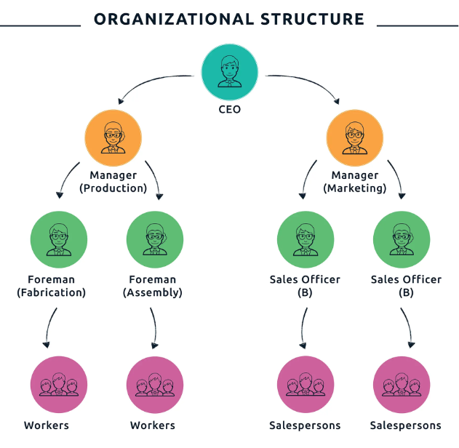
Figure 14: Organizational Structure
Source: (F.Dieffenbacher, 2023)

Systems
Leicester Kitchen Square’s systems include all processes and technologies that support its operations. Key systems include:
- Supply Chain Management: For a fine dining restaurant, having a reliable supply chain for high-quality ingredients is vital. This includes relationships with local farmers, artisans, and suppliers, and systems for inventory management to ensure freshness and minimize waste.
- Reservation and Table Management Systems: To manage customer flow and enhance the dining experience, sophisticated reservation systems are essential. These systems not only handle bookings but also manage customer preferences and history, which can be used to personalize the service.
- Customer Relationship Management (CRM): A CRM system helps in collecting and analyzing customer data, useful for marketing and improving customer service. Tailored marketing initiatives, like personalized emails about new menu items or events, can enhance customer engagement.
- Financial Systems: To monitor the restaurant's financial health and provide input for strategic decision-making, it is essential to have robust financial systems that include budgeting, accounting, and financial reporting.
- Employee Management Systems: These systems are responsible for overseeing staff development, payroll, and scheduling. Due to the high rate of employee turnover in the hospitality business, emphasizing the training and development of staff members may be a differentiator.

Critical Analysis
The approach that Leicester Kitchen Square employs to differentiate itself in the fine dining industry is an excellent one since it is in line with the expectations of a customer who is looking for exclusivity and better quality. The restaurant is in a position to experience growth in a certain market segment thanks to this approach, which also emphasizes expansion. On the other hand, this strategy requires a continuous dedication to providing excellent service to customers and achieving culinary perfection, which in turn necessitates a substantial investment in both people and material resources. The restaurant's approach is supported by its hierarchical but collaborative structure, which encourages creative thinking in the kitchen while also guaranteeing that operations are carried out efficiently. Nevertheless, it may be difficult to strike a balance between innovation and efficiency, particularly during times of high demand or while expanding into new places.
The systems that the restaurant uses, in particular its emphasis on customer relationship management and supply chain management, are strengths that support the differentiation approach that it employs. The reputation of the Leicester Kitchen Square brand may be improved if the company places a higher priority on incorporating personalization into its customer connections and incorporating sustainability into its supply chain. The difficulty of administering these systems, on the other hand, rises with growth, which calls for more robust procedures and perhaps more sophisticated technological solutions. The strategy, structure, and processes that Leicester Kitchen Square employs are perfectly in line with the requirements that are placed on the fine dining industry. The restaurant, on the other hand, will confront difficulties in maintaining its standards of quality and exclusivity as it continues to grow over the years. The most important thing will be to modify its strategy, structure, and procedures to efficiently manage development while still maintaining the distinctive eating experience that gives its brand its identity.

KPI as monitoring tool to monitor the Strategy
To monitor the strategy of Leicester Kitchen Square effectively, Key Performance Indicators (KPIs) can be employed as a robust monitoring tool.
Customer Satisfaction Score (CSAT): This KPI measures customer satisfaction with the dining experience. Regular surveys can be used to gauge customer feedback, aiming for a consistent improvement in scores (Fraser and Wu, 2016).
Average Revenue per Customer: Monitoring the average spend per customer helps in assessing the effectiveness of menu pricing strategies and promotional activities (Mun and Jang, 2018).
Table Turnover Rate: This indicates how quickly tables are being filled and vacated. A higher rate suggests efficient service and good demand, crucial for profitability.
Online Engagement Metrics: For digital marketing strategies, monitoring website traffic, social media engagement, and online reviews are essential. These metrics reflect the brand's online presence and reputation.
Supply Chain Efficiency: Track the time and cost involved in sourcing ingredients to ensure efficient operations and cost control.
Employee Turnover and Satisfaction: Employee satisfaction levels are critical for service quality. Lower turnover rates can indicate a healthy work environment, which directly impacts customer service quality.

Critical Evaluation of Green Strategy, Sustainability, and CSR activities that can be undertaken

Green Strategy
A strong Green Strategy may help Leicester Kitchen Square, a gourmet dining establishment, improve its sustainability efforts and win more eco-conscious customers. From food sourcing to trash management, this plan should cover it all for the restaurant. The restaurant might start by making it a point to use seasonal and locally sourced foods wherever possible. In addition to bolstering the local economy, forming partnerships with nearby farmers and suppliers helps cut down on transportation-related carbon emissions. In addition to being in line with environmentally conscious methods, prioritizing organic and ethically sourced components guarantees high-quality products. It is possible to drastically cut down on energy use in the kitchen by switching to more energy-efficient equipment and methods (Hussain et al., 2022). All equipment must be well-maintained and in top working order, and energy-efficient appliances like refrigerators and ovens must be used.

Sustainability and CSR activities

Sustainability Initiatives
Sourcing Ethically and Locally: A fundamental aspect of sustainability is the sourcing of ingredients. Leicester Kitchen Square can build relationships with local farmers and producers to source organic and ethically-produced ingredients, reducing the carbon footprint associated with long-distance transportation and supporting the local economy (Hussain et al., 2022).
Energy Efficiency and Waste Reduction: Implementing energy-efficient practices in the kitchen and dining area, such as using LED lighting and energy-efficient appliances, can significantly reduce energy consumption. Additionally, the restaurant can adopt comprehensive waste management strategies, focusing on reducing food waste, composting, and recycling.
Water Conservation: Installing water-saving fixtures and adopting practices that reduce water usage can have a substantial impact on conserving this vital resource.

CSR Activities
Community Engagement and Support: Leicester Kitchen Square can engage in community activities, such as hosting charity events or culinary workshops, and support local initiatives that promote food education and sustainability. Collaborating with community gardens or local schools to educate on nutrition and sustainable food practices can have a lasting impact.
Employee Welfare and Development: Prioritizing employee welfare by offering fair wages, conducive working conditions, and opportunities for professional development is a crucial aspect of CSR. Investing in staff training, especially in areas of sustainability and customer service, can enhance the overall quality of service while empowering employees.
Promoting Sustainable Dining: The restaurant can play a pivotal role in promoting sustainable dining practices. This could involve educational initiatives for customers about the importance of sustainable and ethical food choices and how these contribute to environmental conservation.
Charitable Contributions and Partnerships: Leicester Kitchen Square could establish partnerships with local charities, particularly those focusing on food security and sustainability. Donating a portion of profits to these causes or organizing fundraising events can bolster community relationships and reflect the restaurant's commitment to social responsibility.

Conclusion
Leicester Kitchen Square can stand out in the competitive fine dining industry by incorporating sustainability and corporate social responsibility (CSR) into its business practices. This helps the company run more ethically and responsibly. A win-win scenario may be achieved for the company and its stakeholders via these initiatives, which can boost consumer loyalty, improve brand image, and have a good influence on the community and environment.

References
Arturo ARREDONDO-PÉREZ, C., María MOREJÓN-SÁNCHEZ, J., ELISEO-DANTÉS, H. and Iván HUERTA-RAMÍREZ, A., 2022. Market research for the development of a business model: tacos restaurant. Journal of Business Development Strategies, 8(22).
Barachnea, R.S., Fulache, Y.M., Palo, J.M. and Cada, L., 2022. Strategic Management Plan for Hamburger Restaurant (THM–Caloocan, Philippines).
Bruin, L. d., 2016. VRIO: From Firm Resources to Competitive Advantage. [Online]
Available at: https://www.business-to-you.com/vrio-from-firm-resources-to-competitive-advantage/
Cumbo, C.L., 2023. Strategies for Sustaining Small Family Restaurant Businesses (Doctoral dissertation, Walden University).
Duan, H., 2022. Five Forces Model Analysis of Enterprise Strategic Management——Take Haidilao Hotpot Catering Company as an Example. World, 1(1).
econposts.com, 2021. Michael Porter’s 4 Generic Strategies. [Online]
Available at: https://www.econposts.com/business-management/generic-strategies/
F.Dieffenbacher, S., 2023. Organizational Structure Vital Role in Shaping Business Innovation. [Online]
Available at: https://digitalleadership.com/blog/organizational-structure/
Fraser, M.W. and Wu, S., 2016. Measures of consumer satisfaction in social welfare and behavioral health: A systematic review. Research on Social Work Practice, 26(7), pp.762-776.
Hussain, Y., Abbass, K., Usman, M., Rehan, M. and Asif, M., 2022. Exploring the mediating role of environmental strategy, green innovations, and transformational leadership: the impact of corporate social responsibility on environmental performance. Environmental science and pollution research, 29(51), pp.76864-76880.
Juutila, J., 2019. Global restaurant chains entering the Finnish market: Hypothetical Case: Chipotle Mexican Grill.
leicestersquare.london, 2022. Leicester Square Kitchen. [Online]
Available at: https://leicestersquare.london/locations/leicester-square-kitchen
Mukherjee, A., 2023. PESTLE Analysis. [Online]
Available at: https://medium.com/@anirbanmukherjee1311/pestle-analysis-c6b822164d4
Mun, S.G. and Jang, S.S., 2018. Restaurant operating expenses and their effects on profitability enhancement. International Journal of Hospitality Management, 71, pp.68-76.
ogsmsoftware.com, 2022. Preparing for your strategic plan: BCG matrix. [Online]
Available at: https://ogsmsoftware.com/bcg-matrix-explained/
Ouma, G. and Oloko, M., 2017. THE RELATIONSHIP BETWEEN PORTER’S GENERIC STRATEGIES AND COMPETITIVE ADVANTAGE A CASE STUDY OF BUS COMPANIES PLYING THE KISUMU-NAIROBI ROUTE, KENYA.
Peterdy, K., 2020. Ansoff Matrix. [Online]
Available at: https://corporatefinanceinstitute.com/resources/management/ansoff-matrix/
Rêgo, B.S., Jayantilal, S., Ferreira, J.J. and Carayannis, E.G., 2021. Digital transformation and strategic management: A systematic review of the literature. Journal of the Knowledge Economy, pp.1-28.
Shaw, J., 2017. How to Complete a Personal SWOT Analysis. [Online]
Available at: https://medium.com/thrive-global/how-to-complete-a-personal-swot-analysis-2f8769aebd5e
Shishan, F., Mahshi, R., Al Kurdi, B., Alotoum, F.J. and Alshurideh, M.T., 2021. Does the past affect the future? An analysis of consumers’ dining intentions towards green restaurants in the UK. Sustainability, 14(1), p.276.
Silvano, M.D.C.L.F., 2022. Sustainability management in fine dining restaurants (Doctoral dissertation).
Stanke, B., 2022. Porter’s Five Forces: Navigating Competitive Markets. [Online]
Available at: https://www.bobstanke.com/blog/porters-five-forces-competitive-markets
statista.com, 2021. Number of people visiting restaurants in Great Britain from 2018 to 2020, by frequency of use. [Online]
Available at: https://www.statista.com/statistics/586195/restaurant-usage-in-the-uk-frequency/
Yoon, B., Chung, Y. and Jun, K., 2020. Restaurant industry practices to promote healthy sustainable eating: A content analysis of restaurant websites using the value chain approach. Sustainability, 12(17), p.7127.

