A Report into The Effectiveness of the Current Structure of NHS Wales

  - Management Organisation
  - M4X01966
  - Lecturer: Tania Davies

Elsa Rehn
1802880

Abstract
In this report will reflect on the findings from exploring the current structure of the National Health Service (NHS) in Wales by mentioning the pros and cons of the hierarchical structure that is used and how it effects the NHS. This was found by using statistics and guides from different publications and reports connected to the National Health Service along with a picture of the structure in a simple format. It will also be discussing how the 6.3 billion pound funding for the NHS in Wales is allocated within the seven health boards as well as a description of the seven health boards and where they are situated as well as the three NHS trusts.

Contents Page

Abstract ..……………………………………………………………………2

Introduction …………………………………………………………………4-5

Information / Statistics / Guides ……………………………………………5-6

Evaluation of Current Structure …………………………………………….6-8

Conclusion ………………………………………………………………….8-9

Recommendations …………………………………………………………..9

Reference list ………………………………………………………………..10-11

Introduction to Report

Health in Wales (2019) states that The National Health Service (NHS) Wales is publicly funded health and medical care service. The NHS provides healthcare to more than three million people in the country and their key principle is to ensure that good healthcare is available to all people regardless of their wealth and with this eliminate as much inequalities as possible (Health in Wales, 2019). The NHS Wales aims to achieve this by providing a number of services, these range from treatments for coughs and colds, emergency treatment as well as open heart surgery all the way to end of life care.

Health in Wales (2019) mentions the structure as well as mentioning that the NHS Wales replaced seven trusts and 22 local health boards and put in seven new health boards instead during 2009 these have a goal to plan, develop and provide different healthcare treatments in their local health board area. The three NHS Wales trusts provide care to everyone and work to ensure that this happens even with the increase in population. They also work on providing care for those who are unable to leave their homes. The new health boards built a new structure the constantly changing NHS Wales. The trusts and local health boards are all connected to four care sectors that provide ambulance, GP surgeries and specialist services.

Information / Statistics / Guides

The Welsh Government are responsible for the financial funding’s for the NHS in Wales. The Welsh Government has a revenue budget of £15 billion. £7.3 billion which is about 49% of the budget is invested each year and goes towards the Health and Wellbeing along with Social Services according to the Welsh Government (2019) and GP One (2019). The Welsh Government invests around £6.5 billion straight into the delivery of services. The National Health Service is allocated around 7.3 billion pounds every year. This is to be allocated into each local health board. Looking at the seven health boards their populations and locations differ somewhat, this can affect the way the National Health Service along with the Welsh Government allocate the money. The set budget for each health board it thoroughly examined by the help of each health board to discuss what care and treatment is needed in each location as well as the population, age and other services. This is all glanced over by the Welsh Government and the NHS to determine the correct amount.

The seven health boards are as shown in the picture and according to Health in Wales (2019):
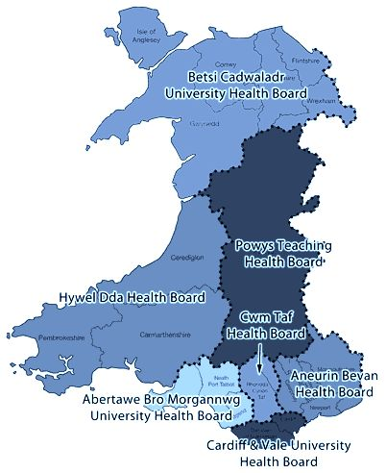
- Abertawe Bro Morgannwg University Health Board, the counties apart of this health board are: Swansea, Neath Port Talbot and Bridgend (NHS Wales University Health Board 2019).
- Aneurin Bevan Health Board, which covers Blaenau Gwent, Caerphilly, Monmouthshire, Newport, Torfaen and South Powys (NHS Wales University Health Board 2019).
- Betsi Cadwaladr University Health Board, which covers Anglesey, Gwynedd, Conwy, Denbighshire, Flintshire, and Wrexham (NHS Wales University Health Board 2019).
- Cardiff & Vale University Health Board, this board covers the Vale of Glamorgan and Cardiff (NHS Wales University Health Board 2019).
- Cwm Taf Morgannwg Health Board, this board covers Bridgend, Merthyr Tydfil and Rhondda Cynon Ta (NHS Wales University Health Board 2019).
- Hywel Dda University Health Board. Carmarthenshire, Ceredigion and Pembrokeshire are covered in this area (NHS Wales University Health Board 2019).
- Powys Teaching Health Board, this covers quarter of Wales (NHS Wales University Health Board 2019).
Each of these health boards, depending on their location, population and age requirements have different requirements for different medical treatments and services (Health in Wales, 2019).

It is mentioned by the NHS Wales University Health Board (2019) that the largest population within these seven health boards lay in the Betsi Cadwaladr with around 700 000 people based in this area. The health board with the least amount of people living there are Powys with a population of less than 150 000. When looking at the former allocated budget for 2018 Betsi Cadwaladr received 1.3 billion pounds whilst Powys received 300 million (NHS Wales University Health Board 2019). The difference in population shows a difference in the budget however more factors help decide the budget, factors such as age and medical and care services.

Evaluation of Current Structure
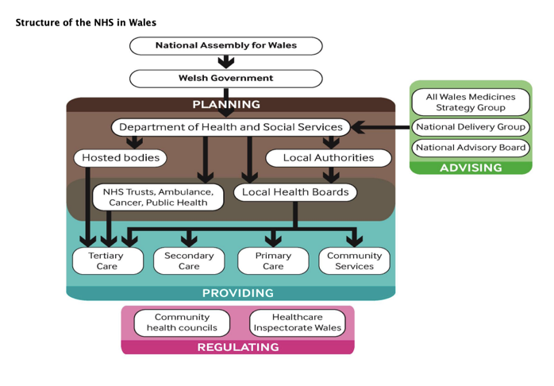
The general structure for NHS in Wales is based off a hierarchy structure which, according to Hierarchy Structure (2019) is a technique used to bring values and categories together. This sorts them into higher and lower categories and is used to help with a wide variety of systems. When organising the company, it is important to have everything in order therefore having a manager with responsibilities at the top which gets passed down. For this hierarchical structure there is a picture, taken of the structure from a report by the National Assembly for Wales (2015) giving an easy incite on how the NHS is organised. When looking at the hierarchy structure and how the NHS uses it there is a clear idea of who is in charge. It is an organised structure where the National Assembly and the Welsh government have the highest authority over the health boards, the trusts and the care units in Wales. This is positive due to the National Assembly for Wales having the most knowledge and statistics on Wales as a whole which in turn helps the Welsh Government decide on the financial side for the National Health Service in Wales, how much should go where and why.

The National Assembly’s role for Wales is to represent everyone and make sure that the Welsh Government are accountable stated by the National Assembly for Wales (2019). The Welsh Government is therefore below the National Assembly for Wales (National Assembly for Wales 2015). The Welsh Government (2017) states that they are responsible for the Welsh Education System, the funding for the NHS, Health in Wales, health policies, the economy and environment and many more important matters.

Further down the structure is the planning section this begins with the Department of Health and Social Services (National Assembly for Wales 2015). The Department of Health and Social Services discusses with the Welsh Government on policies and strategies in the form of legislations and by the use of funding for the NHS in regard the health and social care in Wales suggests Health in Wales (2019). Along the side the structure is the advising stage, this is part of the Department of Health and Social Services. In this branch the Medicine Strategy Group, National Advisory Board and the National Delivery Group are there to provide their services. The Department of Health and Social Services splits into four different sections when moving down the structure. These are the Hosted Bodies, Local authorities as well as the seven Local Health Boards and the three Trusts (National Assembly for Wales 2015). The hosted bodies being senior executives, board members and other authorities. The Local authorities when mentioning the Department of Health and Social Services is in charge of discussing policies and deciding on what type of services need to be delivered or moved. This is discussed with the Health Boards. The Department of Health and Social Services is also connected to the seven Local Health Boards as well as the three NHS Trusts. The Local Health Boards as mentioned previously are:
- Abertawe Bro Morgannwg University Health Board
- Aneurin Bevan Health Board
- Betsi Cadwaladr University Health Board
- Cardiff & Vale University Health Board
- Cwm Taf Morgannwg Health Board
- Hywel Dda University Health Board
- Powys Teaching Health Board

These Health Boards are responsible for planning, developing, designing and securing the delivery of care along with specialist services throughout their local communities in Wales advised by the GP One (2019).

The three NHS trusts focus on the whole of Wales and provide national support along with specialist care services. These trusts are:
- Welsh Ambulance Service NHS Trust
- Velindre NHS Trust
- Public Health Wales

Below the seven Health Boards and the three Trusts you have the four care units. These are in the providing section and arrange the care needed. These four are:
- Primary Care, which is provided by GPs, Surgeries in Wales and Health Centres.
- Secondary Care, this care is delivered through Hospital and Ambulance services.
- Tertiary Care is the unit that treats illnesses such as cancer and is provided at Hospitals.
- Community Care provides local services and delivers to patients who stay at home.

All of this builds the National Health Service in Wales according to the National Assembly for Wales (2015). The NHS in Wales structure is mainly about the seven local health boards along with the three trusts. These are what keep the NHS functioning by looking after the welsh population.

The structure is well organised and clear. It gives each section their own tasks and responsibilities as well as combined goals to reach together. This is beneficial for the whole structure as it keeps the communication going through all sections to prevent mistakes.

Even though the structure aims to make communication easy between departments it can appear difficult when certain responsibilities need to be discussed. Depending on the number of managers in each department, miscommunication and disagreements between managers over important matters could end up in patients suffering. This is where the National Health Service can suffer when using the hierarchical structure. The hierarchical structure is restricting in regard to long-term planning and this can be caused by over worked leaders who would rather focus on their own department than the whole organisation according to Org Chart (2019) and Bianca, A. (2019). They also mention that the lower you sit in the hierarchical structure the less your ideas will be voiced and listened to which is important not to let happen within hospital and nursing settings.

Conclusion

This report has looked at how the National Health Service in Wales organises its finances through the Welsh Government, its aim and goals along with its structure being the hierarchical structure and how it has a positive and negative side that effects the NHS. It looked at the seven local health boards in regard to their role in the NHS structure as well as what parts of Wales they cover. While mentioning the health boards the report also mentioned the three NHS trusts.

It highlighted that concerns in the hierarchical structure can be issues with communication as there are many managers that could be advising different concepts making it hard to come to a reasonable decision. This can in turn cause ill treatment in patients which could turn into fatalities due to miscommunication in prescription dosages. The report therefore found that there can be many changes made to ensure that the NHS in Wales has a bigger chance of achieving its goals to provide good healthcare to everyone. Ideas on this will be mentioned in the recommendation section below.

Recommendations

To conclude this report, here are some ideas to help the NHS in Wales as it is evident that they have to make improvements in order to obtain and reach its goals. These recommendations below are there to help make hospitals more efficient time wise along with saving or redirecting money to more worthy causes. The ideas are:
- Making public announcements through internet or TV commercials, posters and other campaigns to show that minimising unnecessary hospital visits can save lives. Something that could help prevent long waits could be to put in a queue ticket machine where options are "Critical, Semi-Critical, Need Prescription" so those who are in critical conditions can be seen quickly as they are the highest priority.
- Redirect the money spending’s on unnecessary treatments or services to the nurses to ensure that they get an acceptable pay to minimise strikes. Money could be taken for example from those who miss their booked appointments.
- Due to most hospitals lacking in beds it could be advised to discharge most patients in the early morning to make a smoother turn over for the day when other patients need to be admitted.

Reference List:
Bianca, A. (2019) Pros & Cons of a Hierarchical Organizational Structure. Available at: https://smallbusiness.chron.com/pros-cons-hierarchical-organizational-structure-24276.html [Accessed 30 04 2019]
GP One (2019) Structure. Available at: http://www.gpone.wales.nhs.uk/nhs-wales-structure [Accessed 10 04 2019]
Health in Wales (2019) NHS Wales – About us. Available at: http://www.wales.nhs.uk/nhswalesaboutus [Accessed 16 04 2019]
Health in Wales (2019) Structure. Available at: http://www.wales.nhs.uk/nhswalesaboutus/structure [Accessed 16 04 2019]
Hierarchy Structure (2019) What is an Example of a Hierarchy? Available at: https://www.hierarchystructure.com/what-is-an-example-of-a-hierarchy/ [Accessed 16 04 2019]
National Assembly for Wales (2015) Research Paper, the organisation of the NHS in the UK: comparing structures in the four countries. Available at: http://www.assembly.wales/research%20documents/15-020%20-%20the%20organisation%20of%20the%20nhs%20in%20the%20uk%20comparing%20structures%20in%20the%20four%20countries/15-020.pdf [Accessed 12 04 2019]
National Assembly for Wales (2019) What is the role of the Assembly? Available at: https://www.assembly.wales/en/abthome/role-of-assembly-how-it-works/what-is-the-role-of-the-assembly/Pages/what-is-the-role-of-the-assembly.aspx [Accessed 20 04 2019]
NHS Wales University Health Board. (2019) Abertawe Bro Morgannwg University Health Board. Available at: http://www.wales.nhs.uk/sitesplus/863/page/66187 [Accessed 16 04 2019]
NHS Wales University Health Board. (2019) Aneurin Bevan University Health Board. Available at: http://www.wales.nhs.uk/sitesplus/866/page/40762 [Accessed 16 04 2019]
NHS Wales University Health Board. (2019) Betsi Cadwaladr University Health Board. Available at: http://www.wales.nhs.uk/sitesplus/861/page/84723 [Accessed 16 04 2019]
NHS Wales University Health Board. (2019) Cardiff and Vale University Health Board. Available at: http://www.cardiffandvaleuhb.wales.nhs.uk/freedom-of-information-guide-class-one [Accessed 16 04 2019]
NHS Wales University Health Board. (2019) Cwm Taf Morgannwg Health Board. Available at: https://cwmtaf.wales/we-are-cwm-tafmorgannwg/ [Accessed 16 04 2019]
NHS Wales University Health Board. (2019) Hywel Dda University Health Board. Available at: http://www.wales.nhs.uk/sitesplus/862/page/40317 [Accessed 16 04 2019]
NHS Wales University Health Board. (2019) Powys Teaching Health Board. Available at: http://www.powysthb.wales.nhs.uk/about-us [Accessed 16 04 2019]
Org Chart (2019) Advantages and Disadvantages of Hierarchical Organisational Structure. Available at: http://www.orgcharting.com/advantages-disadvantages-hierarchical-organisational-structure/ [Accessed 28 04 2019]
Welsh Government (2017) What our role is. Available at: https://gov.wales/what-our-role [Accessed 12 04 2019]

