Principles of Health and Social Care

Done by: Mutiat Shobajo

Student Number: 1910057
Professor’s Name: Ade
Module Title: Principles of Health and social
Module Code: BMHP5002_LON
Institution: University of Wales Trinity Saint David
Location of Institution: London
Date: May 7, 2021

Table of Contents
Introduction 3
Discussion 3
Theories that Govern Person-Centered Care 4
Ethics that govern policies and practices in the health social care sector 5
Benefits of Person-Centered Care 5
Limitations of Person-Centered Care 5
Application of Person-Centered Care to Dementia 6
Recommendations 6
Conclusion 7
References 8
Appendix 10

Introduction
Person-centered care then is handling a patient who is receiving medication and treatment with respect and dignity by making them part of decision-making on their health status and improvement (Arakelian et al., 2017). It keeps the rights of the patients safe and practiced. Patients can make decisions about their treatment and ask relevant questions (Kadri et al., 2018). Person-centered care has enhanced communication between the patient and service care provider, enhancing the patient's ability to care for himself. The patient also knows in detail his health status and is free share his health issue. To enhance the healthcare process, the healthcare organization puts methods and support for getting healthcare providers. For example, dementia is a condition of poor memorizing ability, and its patients deserve proper treatment to heal from the disease. The patients need love, comfort, and recognition by the service providers. They are often involved in making decisions on what can make them happy and satisfied. They can be applied in deciding what to cook for them. They need to have an identity that gives their history and proper attention from the care providers. Age UK, a health organization, offers care services to dementia patients by seeking methods to keep the patients safe (Fisher et al., 2018). Over 850,000 people live with dementia in the UK (Dowson, 2020). They are taken care of by carrying home visits to socialize effectively with them and help them exercise their wishes. For activities to better their conditions, the Age UK organization provides free transport services to them. This paper discusses person-centered care and its practices, UK handling of dementia patients, analysis of person-centered care, theories and ethics governing person-centered care, its benefits and limitations, its application in dealing with dementia, and recommendations to improving person-centered care for dementia.

Discussion
Person-centered care involves treating a patient with respect and a lot of care in the process of their treatment. The healthcare providers take into consideration the needs of the patients, lifestyle, and preferences. Patients are thoroughly involved in medical research, commissioning, training, and education (Wolf et al., 2017). According to Hippocrates, it is better to know one's disease status than knowing the sort of disease. Unlike in the past, hospitals provide complete information on a patient's condition, offer excellent care to them and make sure information reaches them. Person-centered care, therefore, gives the patients a high rank just like any other healthcare provider. In taking care of patients, the healthcare provider has to know the strongholds of the patients, exercising their abilities.
Regarding them as patients who only need treatment entirely is not advised. Instead, they should be trained on how to take care of themselves. If the healthcare provider assumes the ability of a patient to provide some health care practices, there will be no room for the patient to practice his abilities. Their abilities need to be recognized and supported to improve daily. The government is investing the patient's suitable funds in the NHS to provide a broad knowledge of how to deal with certain diseases like dementia. Excellent results are often experienced when healthcare providers commit fully with a passion to their work, involve patients in making their decisions. According to UK Supreme Court, patients should be given full attention and asked about their knowledge of their disease treatment. It applies majorly to patients with long-term conditions. Advices to patients is nowadays terminated by collecting opinions from both the clinician and the patient.
Even though person-centered care is important for handling and treating patients, multimorbidity conditions need too much attention that has often prevented its prevalence (Vetrano et al., 2018). The best treatment for such situations has got a low probability of quickly accessing it. Multi-morbidity has got lower chances of the patient getting healed. Healthcare organizations consider eight dimensions that include the needs of the patients, background information, provision of emotional support and physical comfort, and coordination of care considering transition. The provision of person-centered care to patients encourages clinical professionals to work effectively and improve the results of a specific medical condition of its patients. To a more extent, person-centered care involves co-creation, which involves deep interaction between the patients and healthcare professionals. Patients with chronic illness have got declined socialization but the better physical condition of the patients. Person-centered care is often used to lower the gaps that are for aged care practices. People living with dementia have reduced stigma and low self-esteem due to the use of person-centered points.

Theories that Govern Person-Centered Care
For person-centered care to be effective and convenient, some theories have to be put into place to give guidelines. The approaches include; first, the healthcare provider should treat the patients of dementia as ordinary individuals, asking them what treatment pattern they need and what they could like to be addressed by the Organization. The clinician should not underestimate the decisions made by the patient. If a patient is not well conversant with his health status, a severe explanation should be given by the healthcare professional present. Trust should be built between the patient and the service provider to enable the patient to be free of asking relevant questions. They will also gain confidence by correctly answering their medical questions. The patient must be included when planning for the treatment process, and both the clinician and the patient should be able to communicate effectively without misunderstanding. Clinical supervision should be based on the agenda of the patient. The clinician should not be dictated towards making a treatment decision. He should allow views from the dementia patient. Nobody, either patient or clinician, should be left behind when making a final decision. The plan should then be documented. Their conversation should be very formal with colleagues. Clinicians who are eligible for providing care to people with dementia must have read the directives and origin for treatment. They must consider ethical rules of practice while at work. The clinicians should be highly interactive with the patients to get very detailed information from them. The language to be used must be that which the patient is most comfortable with (Buckley et al., 2018).

Ethics that govern policies and practices in the health social care sector
Just as in any other sector, ethics need to be followed to the latter to be constructive when caring for a patient with dementia. The ethics consider the cultural background of the patients, their individual preferences, family status, lifestyle, and values. The patients are needed to help in planning for treatment. The appropriate involving surrogate gives those with poor decision-making skills special attention. Ethics help to resolve issues due to misunderstanding between the patient and the clinician or between the clinicians. In enhancing the following of ethics, physicians are beneficial in promoting discussions between the patient and the healthcare provider. They give better options to be followed. They are trusted with their techniques created. The capacity of decision-making by the patient is dependent on his state. The patients also have got the right to refuse treatment. They can choose the type of treatment they want. Their cultural practices have to be favored. They are mostly treated as partners of the healthcare organization. They should not be perceived as being of patients only but also viewed as problem solvers (Forslind et al., 2018). For example, some medical professionals assume the patient's capabilities cannot make any change in the treatment process. The patients also have the chance to view the treatment process and correct where necessary.

Benefits of Person-Centered Care
Person-centered care has dramatically helped in the process of caring for those with dementia. Improved outcomes have been realized. The Age UK organization has registered a lower visit rate for those with dementia. It has also aided in creating fast recovery, and the use of healthcare organization facilities has reduced since patients can take care of themselves right from home. Patients have got intense satisfaction from their trusted clinicians (Ballard et al., 2018). There has therefore been an improvement in health outcomes. Patients become satisfied if only their desires and opinions are followed, and therefore have no doubt with their healthcare providers. If people with dementia are treated with a lot of care and their views considered, they will automatically recognize the hood reputation of the Organization. They can even advise other people with the same dementia condition to visit the healthcare organization. For example, there was a deep relation of the Organization's reputation to the facilities availed for treatment in Spain. All its patients viewed the hospital as a perfect place to be when sick. Their services had limited mistakes that could destroy their reputation. Person-centered care also has a significant impact in creating job satisfaction for healthcare professionals. They get morale when the patients cooperate in making treatment decisions. Some have grown a passion for helping the patients with a positive response. Person-centered care is a program that can easily be used to increase the quality of care provided to those with dementia. Health care is also made accessible since the knowledge of treatment is passed to its patients who can help other people with the same conditions. The patients' needs, rights, and preferences are well taken care of.

Limitations of Person-Centered Care
As much as person-centered care is considered adequate, it experiences some challenges like rejection by the patient's family members. They perceive the activities launched may not be very effective and can cause harm to the patients. One may also have experienced problems before in adopting the program. He, therefore, fears falling into a trap again (Naldemirci et al., 2016).
Application of Person-Centered Care to Dementia
Dementia is a condition where one tends to forget quickly hence poor memory records (Clarkson et al., 2017). They need the attention of their healthcare providers to get well. Criteria have been created to keep them safe. They are engaged in activities that help to improve their memory function. Those with dementia deserve an environment with such actions and that with loving and considerate healthcare workers. They need to socialize with people who can understand their situation. Music is essential for their healing. It stays in their memory and improves their memory. In the UK, facilities have been created to support entirely those with dementia. They are engaged in questions that help to jog their minds. At times, they are involved in cooking, which is enough to make them believe in the love offered to them. Those who do home care services are taught the best practices to sustain the patients. Since those with dementia may even forget their environment and the operations created for their care, there need to be individuals to keep them safe. The home needed to be designed such that it supports the patient. Daily routines need to be almost the same to help them remember easily. They are often engaged in decision-making by asking them what to do at a particular time, what to eat and how to make a delicacy. They need proper lighting at home to avoid accidents while moving (Midtbust., 2018). The environment should be able to absorb any source of noise to prevent discomfort in their ears. There is a need to do regular ear check-ups and support the damaged ones by giving hearing aids. Any form of obstacles needs to be removed from their walking paths. Person-centered care is applied in caring for those with dementia through treating them with love, respect, and maintenance. Also, they are engaged in decision-making. The type of furniture available for them should be bright, contrasting the dull wall color. They are also made comfortable by giving them unique items like phones and clocks. They should be engaged in outside visits to get exposure to a new environment.

Recommendations
To improve the person-centered care for people with dementia, one needs to internalize the cause of distress to the individual. It may not be easy, but one can achieve it by creating a good rapport with the patient, asking him simple questions that may lead to a conclusion of the course of distress. Also, there is a need to consider their feelings with great attention (Choudhary et al., 2017). One may feel like not taking the meal prepared for dinner; therefore, preparing his choice will make him happy, hence improving his situation. They are always in need of regular hugs. This is after reading their body language and identifying the next step of action they are to take. For future policies and practices, patients should access their EHR data and their status notes. In this way, they will get updated and engage in activities that can improve their condition. The hospital environment should be favorable, considering facilities like furniture. A practice of random questions should be developed to keep them active. Their families should also maintain close contact with the caregivers to bring out excellent results (Lawton et al., 2017).

Conclusion
In conclusion, person-centered care is an effective way of improving the medical condition of a person. It makes one grow trust in the healthcare providers and feel secure. The hospitals that have adopted person-centered care have a good reputation, and they have different regular visits due to the quality of services. The healthcare providers get motivated and even wish to continue giving care to this other patient. They are satisfied with their occupations. Dementia is characterized by insufficient memory. People with dementia feel loved and respected when they are engaged in decision-making for their treatment. Organizations that provide person-centered care for dementia should have facilities that support the operations of those with dementia. Furniture and the environment should be very relevant to them. This offers quality services. There should be trained healthcare professionals to take care of those with dementia. They should be engaged in social activities that also improve their conditions. To enhance one's condition, there is a need to identify the course of distress. They also need to be given access to their daily status by showing them their EHR records. A practice of random questions to the healthcare organization should also adopt them to improve their memory. Person-centered care I'd be, therefore, very relevant to people with dementia.

References

Arakelian, E., Swenne, C. L., Lindberg, S., Rudolfsson, G., &amp; von Vogelsang, A.-C. (2017). The meaning of person-centered care in the perioperative nursing context is an integrative review from the patient's perspective. Journal of Clinical Nursing, 26(17-18), 25272544. https://doi.org/10.1111/jocn.13639
Ballard, C. et al., 2018. Impact of person-centered care training and person-centered activities on quality of life, agitation, and antipsychotic use in people with dementia living in nursing homes: A cluster-randomized controlled trial. PLOS Medicine, 15(2).
Buckley, C., McCormack, B. &amp; Ryan, A., 2018. Working in storied way-Narrative-based approaches to person-centered care and practice development in older adult residential care settings. Journal of Clinical Nursing, 27(5-6).
Choudhary, D., Bhattacharyya, S. &amp; Bose, S., 2017. Efficacy and Safety of Ashwagandha (Withania somnifera (L.) Dunal) Root Extract in Improving Memory and Cognitive Functions. Journal of Dietary Supplements, 14(6), pp.599612.
Clarkson, P. et al., 2017. A Systematic Review of the Economic Evidence for Home Support Interventions in Dementia. Value in Health, 20(8), pp.11981209.
Dowson, E.R.M., 2020. Expanding access to group singing for people with dementia: implications of music therapy skill-sharing for research and practice. Expanding access to group singing for people with dementia: implications of music therapy skill-sharing for research and practice - Nottingham ePrints. Available at: http://eprints.nottingham.ac.uk/60507/ [Accessed May 12, 2021].
Fisher, L.H. et al., 2018. Building design for people with dementia: a case study of a UK cares home. Facilities, 36(7/8), pp.349368.
Forslind, K. et al., 2018. Person-centered care in nurse-led outpatient rheumatology clinics: Conceptualization and initial development of a measurement instrument. Musculoskeletal Care, 16(2), pp.287295.
Kadri, A. et al., 2018. Care workers, the unacknowledged persons in person-centered care: A secondary qualitative analysis of UK care home staff interviews. PLOS ONE, 13(7).
Lawton, R. et al., 2017. Can patient involvement improve patient safety? A cluster randomized control trial of the Patient Reporting and Action for a Safe Environment (PRASE) intervention. BMJ Quality &amp; Safety, 26(8), pp.622631.
Midtbust, M.H. et al., 2018. Perceived barriers and facilitators in providing palliative care for people with severe dementia: the healthcare professionals' experiences. BMC Health Services Research, 18(1).
Naldemirci, Ö., et al., 2016. Tenacious assumptions of person-centered care? Exploring tensions and variations in practice. Health: An Interdisciplinary Journal for the Social Study of Health, Illness, and Medicine, 22(1), pp.5471.
Snowdon, D.A., Leggat, S.G. &amp; Taylor, N.F., 2017. Does clinical supervision of healthcare professionals improve the effectiveness of care and patient experience? A systematic review. BMC Health Services Research, 17(1).
Swall, A., Hammar, L.M. &amp; Gransjön Craftman, Å., 2020. Like a bridge over troubled water  a qualitative study of professional caregiver singing and music as a way to enable person-centered care for persons with dementia. International Journal of Qualitative Studies on Health and Well-being, 15(1), p.1735092.
Vetrano, D.L. et al., 2018. Frailty and Multimorbidity: A Systematic Review and Meta-analysis. The Journals of Gerontology: Series A, 74(5), pp.659666.
Wolf, A. et al., 2017. The realities of partnership in person-centered care: a qualitative interview study with patients and professionals. BMJ Open, 7(7).

Appendix
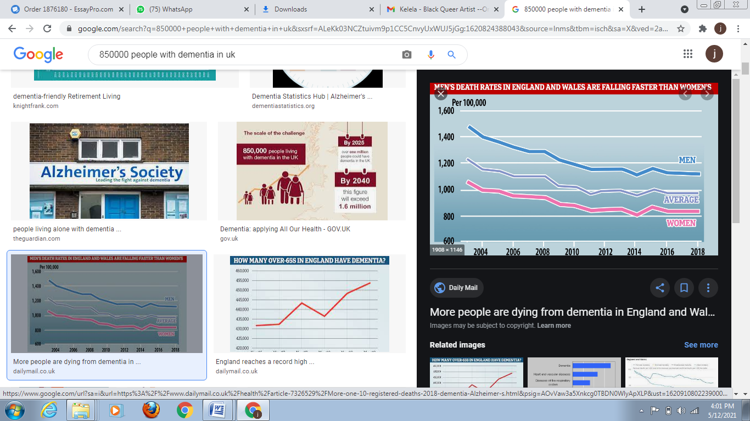
Figure 1: A graph showing the prevalence of dementia in the UK

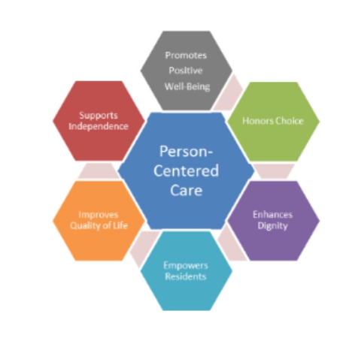

Figure 2: Benefits of person-centered care

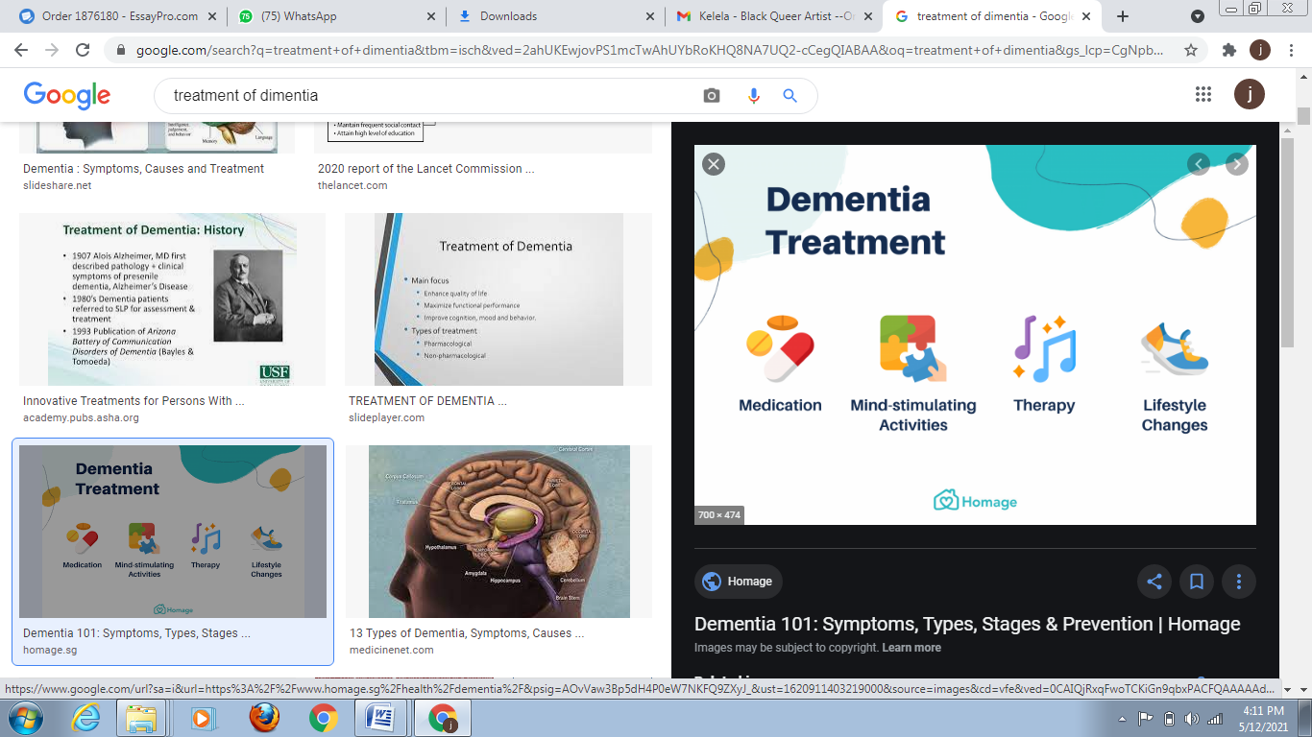
Figure 3: Person-centered care for dementia

