Geo-Visualisation and the Application of GIS
M3XCP5 - Geographical Information Systems
Josh Lapham - 182500

Contents
Task 1 2
Origins of GIS & Cartographic Representation 2
Fundamentals as a Visual Information System 4
Emergence of GIS 5
FlightRader24 5
What the World Would Look Like if All the Ice Melted 5
Trendsmap 6
Relations with Socio-Demographic Data 7
Task 2 8
Microsoft Access 8
QGIS 10
Task 3 12
Visual and Non-Visual Database Solutions 12
Microsoft Access 12
QGIS 12
Conclusion 12
How can GIS be used for healthcare informatics analysis? 13
Bibliography 14

Task 1

Origins of GIS & Cartographic Representation
The first breakthrough with cartographic representation was discovered by Dr. John Snow within 1854. Dr Snow took a particular interest at the time on how many people within his local town were being diagnosed with cholera, and he wanted to discover the potential cause of this deadly disease and prevent it from spreading. It is mentioned by K Tuthill [1] that Dr. Snow wrote “As soon as I became acquainted with the situation and extent of this irruption of cholera, I suspected some contamination of the water of the much-frequented street-pump in Broad Street.”
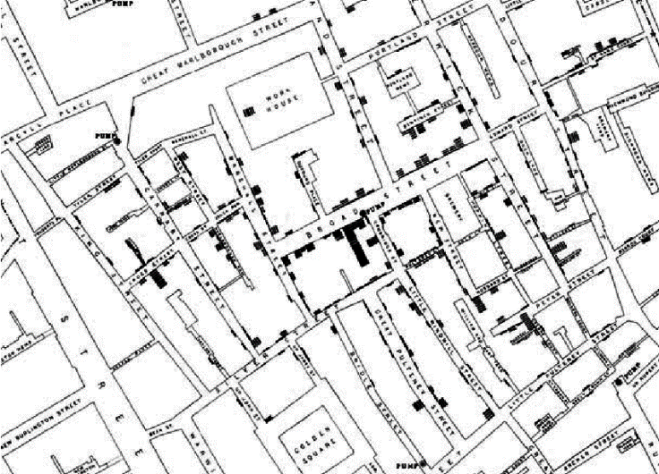
Image taken from Research Gate [2]

In order for Dr. Snow to convince the other Doctors and Scientists about his theory, he decided to plot the data that he had gathered on a map of Broad Street and the surrounding neighbourhood. This would be able to give him a cartographic representation of that the outbreaks of cholera within the area, and that they can all be correlated with the fact that they all use the same pump for water. From the evidence of the relationship between the pump and the disease, similar maps would be reproduced within several different cities all across the UK such as Birmingham, Leicester, Exeter and Hull. This shows the substantial impact of the use cartographic representation being implemented, as it would then save thousands of lives across the UK with the indication of a cholera outbreak. [3] [4]

The preliminary usage of GIS started to be within the 1960’s, and this is because of the advancement with computers as they were becoming more comfortable and powerful with the vast amounts of data being collected. One of the first organisations to use GIS was developed by the Canadian Government, and they created the Canada Geographic Information System (CGIS). This system was used then to manage and analyse the “Canada Land Inventory Data” [5].

At the start of the 1970’s cartographic paper based maps would start to be plotted on a GIS, and therefore it would be digitally stored on the computers. Before a vast majority of maps would have been added to a GIS, meaning that users had the ability to view all different varieties of maps visually on the computer. [6] [7]
The next stage of advancements with GIS came between the 1980’s to the mid 1990’s. D Mark et al [8] states that “GIS also has had a major influence on the discipline of Geography in the 1980s and 1990s, variously seen as a critical factor in reviving academic geography or an unhealthy influence that distorts the discipline.” This shows that there was GIS had grown, and has now got a great significance in relation to not only the use for organisations, but mostly for a new stream of academic research. The most influential GIS within that era was ArcInfo, and this was the first release of a desktop product that could be used by any user who purchased the licence. It then allowed them the same amount of control and flexibility from the programs that were used by larger institutes. [9] [10]

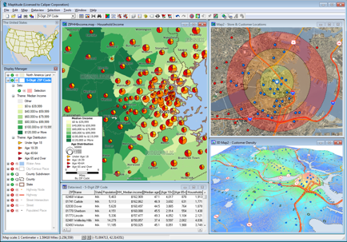
In modern day, the majority of decisions that are made by all organisations would of have had the inclusion of some sort of GIS (Graphical Information System). Goodchild [6] explains that “GIS are computer applications concerned with the manipulation of geographic information, and today these software packages are capable of the representation, analysis, and visualization of virtually any form of information about the distribution of features and phenomena on the surface of the Earth.” What he is trying to say is that a GIS is an application that specialises in taking ordinary information within a database, and transform it into a visual representation.

Image taken from Caliper [11]

Fundamentals as a Visual Information System
It can be said that a map with data plotted on it can be its very own visual information system. Taken from the University of New York, AK Deaking [12] says that “GIS is very much dependent on visualization for its effectiveness.” Without a graphic map displays and related spatial analysis that GIS offers, there would be little to distinguish GIS from other information systems.

Looking at the fundamentals of the visual perception with relation to the use of GIS, D Fairbairn [13] mentions in his paper that “perceptual deficiencies, such as colour deficiencies, may lead to the need to consider alternative representations.” This means that although there may be a big focus with making the map look appealing with the use of a range of colours, an alternative black and white map will needed to cater for those who struggle with the understanding of diverse colours.

With regards to the cartographic visualisation, B Jiang [14] states that “Cartographers make much of the importance of psychological aspects of cartographic visualisation as it is an act of cognition. It is a human ability to develop mental representations that allow us to identify patterns and create to impose order.” What this shows us is that there is more of a psychological characteristic, when it comes to the understanding of maps. It has been made aware that it comes naturally for people to easily identify any patterns certainly in terms of maps, whereas this wouldn’t be as possible if it were to be displayed within a table. To support what B Jiang mentioned about the cartographic visualisation D Fairbairn [12] also states within his paper “We recognize patterns and obtain insights from graphical representations in a ‘non-serial’ way. There is a connection, therefore, between the real world and its iconic representation in map and more schematic forms – an inherent.”

Emergence of GIS
This part of the report will be looking at the emergence of GIS, and how it is used in various applications, and also how it works together with the end users perception of its use.

FlightRader24
https://www.flightradar24.com/

‘FlightRadar24’ is a flight tracking service that will provide the users with real-time information about thousands of aircraft around the globe. The type of system that is being used for this tracking service is called an ADS-B (Automatic Dependant Surveillance – Broadcast) Network. The unique factor with this type of system us that the information that is being gathered is obtained by using the satellite navigation, which therefore tracks the aircraft. The information that can be obtained on the aircraft can range from its airspeed, current altitude and also its exact global position using the latitude and longitude values. This information will then automatically be updated, and displayed on the website. [15] [16]
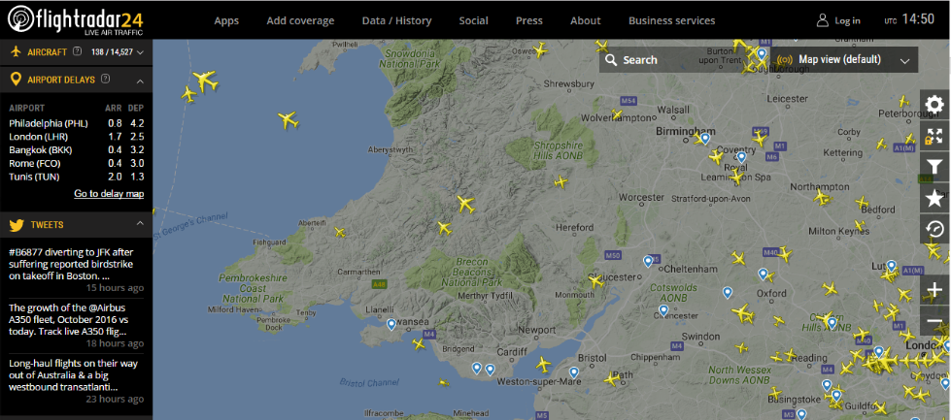

Showing all of the current aircrafts that are in flight [15]

Taken directly from the ‘FlightRadar24’ website, they claim that they have upwards of 1.5 million users today. This is clear to me the significance of this type of GIS, not only for personal use but also for business use. As an example, for the end-user they will be able to use this information on the website to track a flights estimated landing time, and from this they will be able to plan a suitable pick-up time. If the flight is to be delayed or cancelled, this information will be visible for them also.

What the World Would Look Like if All the Ice Melted
https://www.nationalgeographic.com/magazine/2013/09/rising-seas-ice-melt-new-shoreline-maps/
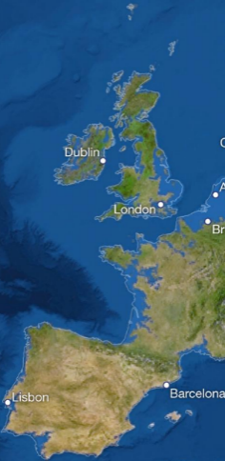
National Geographic created a GIS application where it would display what the world would look like “If we keep burning fossil fuels indefinitely, global warming will eventually melt all the ice at the poles and on mountaintops, raising sea level by 216 feet.” As global warming is becoming more of a concern every year, this application will allow people to be able to visualise the potential impact that could originate from it. Potentially, as people will be able to see what exactly the world will look like within the future, it may make them take more consideration on the environment and participate more in preventing this from happening. [17]

Trendsmap
https://www.trendsmap.com/
Trendsmap lets you scan through the latest trends around the world, on the social media platform of Twitter. This website allows you to see trends from any time within the last 7 days, and filter just for words, hashtags or users. You can click on a trend to see the top related tweets, images and videos being shared in that city, and see where that trend is being discussed most around the world. It also allows you to see the top trends for each city and country, and filter by the last 2, 8 or 24 hours. [18]
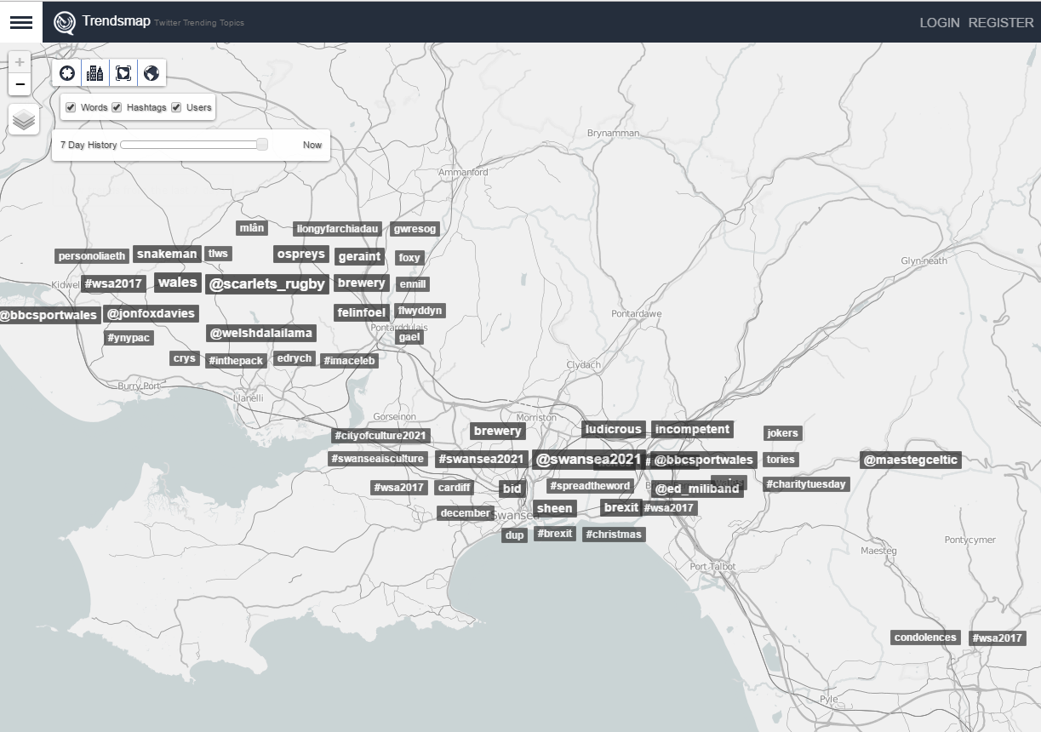
Showing all of the current trends within the Swansea Area [18]

This type of GIS application will be useful in many different ways, and also for a range of different societies. What makes this application so distinctive to any other social media service, is that the data that is gathered and displayed onto the website will be collected using a complex programming algorithm. This will search through all of the ‘tweets’ and Twitter users, and combine all of the data collected and then map it all together with the location of the different users.

Relations with Socio-Demographic Data
To understand what is meant by socio-demographic data, it needs to be split into two different sections, the first one being the sociological data and the second one being the demographic data. Sociological characteristics are more unbiased qualities, such as potential involvement within a group, household status, personal interests, and social assemblies. Demographic characteristics can be often referred to as age, sex, home address and marital position. Joining these two different types of data together, socio-demographic data will be produced provide a broader range of information on a certain individual. [19] [20]

An example of how this could be used, is that a selection of people could be investigated such as people over the age of 40, and who are interested in street running, and this would be an example of a socio-demographic group. G Andrienko [21] from London City University stated that “Interaction with a thematic value-by-area map, such as a representation of election results combined with socio-demographic data, may draw attention to hidden patterns that were not evident in spatial representations of the data.”
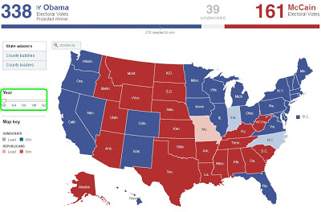

Showing election results in USA from 2008 [22]

Using the scenario that G Andrienko, the image above shows the final election results that was taken from the 2008 President Election within the USA. From this image it is clear that there is a pattern with the more central states voting for one candidate, whereas the external states are more favourable for the other candidate. With this correlation of the data that has been identified, researches can then take a plan of action and start to look at the Socio-Demographic Data of the different states to see if they can identify a purpose for this phenomenon. The benefit from displaying it within a map is that it can quickly display the clear information, and that from this quick and decisive decisions can be made. [23]

Task 2

Microsoft Access
Microsoft Access could be used to build a SDSS (Spatial Decision Support Systems) with its range of functions and features, to aid the local health board’s analysis. In my example below I first had to obtain the required data that I would be later analysing. This data was retrieved from the Health Maps Wales and also Stats Wales.
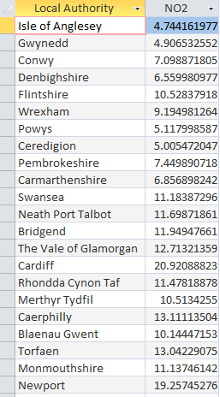
Once the data has been successfully imported into Access and placed into its corresponding tables, it is then ready to be queried. In the example shown, I used a query to extract the relevant data from the air quality table so that it would only represent the data on N02, and none of the other elements.
Once the relevant data has been extracted with the use of a query, it is then ready to be placed in a form of a report. There are many different types of reports that can be created within Access, and they suit all different types of situations for example you can create reports in displays such as tables, and a range of different graphs.
The use of graphs in general provide quick and decisive decisions, as the trends/ patterns of certain data can be identifiable. Whereas, if the data were to be presented in a table style report, then certain types of trends/patterns will not be as visible.
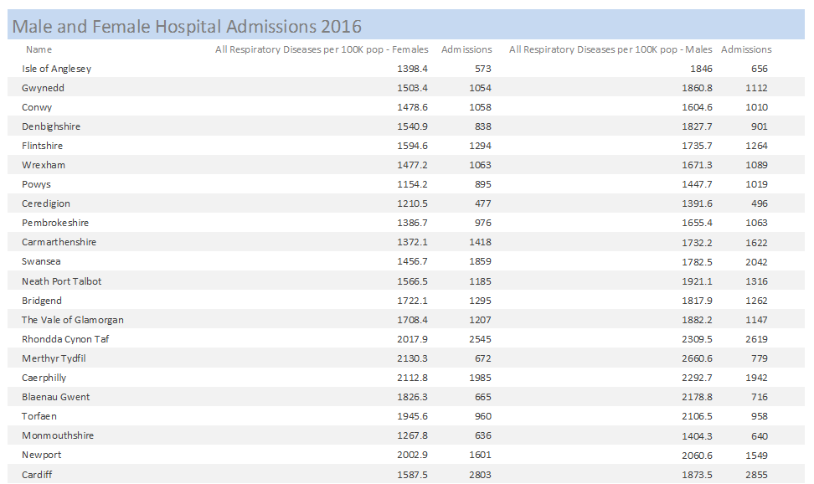
Here is a report that was created using the data from Health Maps Wales, showing the amount of hospital admissions there were in relation to respiratory occurrences. The reason for me choosing this type of report was because of the vast amount of data that was retrieved, and it would be too much data to display on a map.
To see if there was any link between the admissions of respiratory related incidents and the air quality of the local authorities, I needed to produce another report on the N02 levels. Below is the final report of the N02 levels, and it is clear to see that the 2 major cities in Wales have the uppermost indicators of N02 levels.
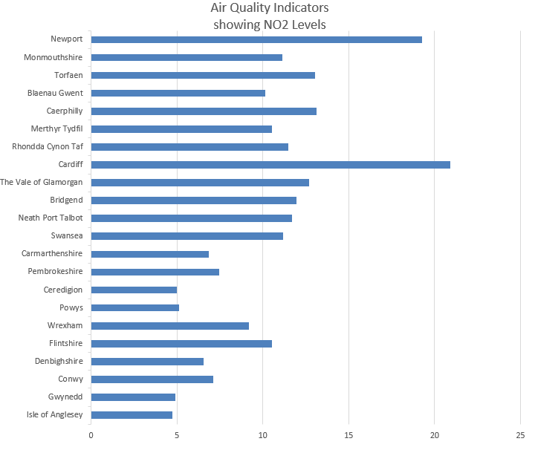

To summarise my findings I needed to bring together the two different reports that I created, and try to identify if there was a potential connection between the Hospital Admissions and the Air Quality. I found that the best report that would be suitable to find a pattern/trend with this link, would be the use of a graph.

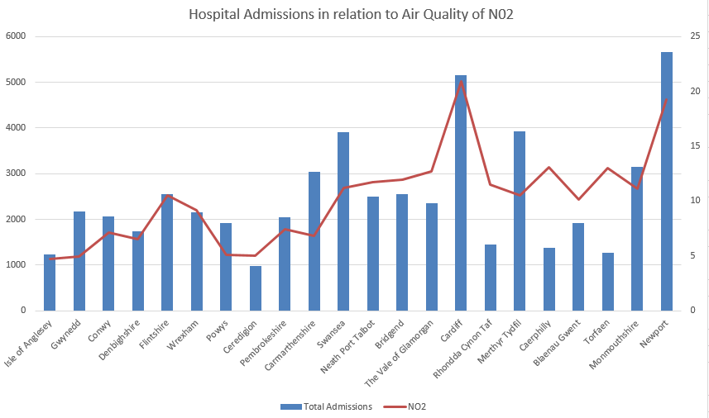

QGIS
In order for me to fairly demonstrate how QGIS could be used to build a SDSS to aid the local health board’s analysis, against the use with Access I decided to use the same queries for both. The purpose for this is because they are going to both have the same data, although they will be presented contrarily.

The first map that I created within QGIS was to display the respiratory related hospital admissions for all of the LA’s (Local Authorities) within Wales. From this map, you can indicate that a vast majority of the hospital admissions are coming from the South East region of Wales.
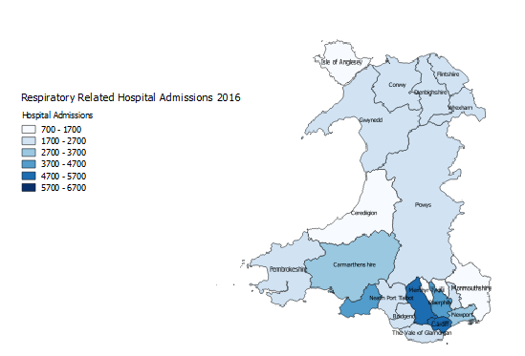
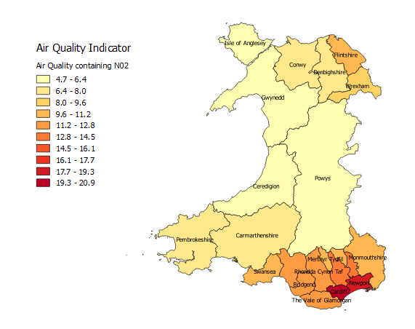
The second map that I created within QGIS was to display the quality of the air for all of the Local Authorities within Wales. From this map, you can see that a similar to the hospital admissions that the majority of LA’s of the South East region are showing high data concentrated areas.

To try and justify and see if there is some form of relationship between the two different maps, another one was created to display both sets of data. As there is a congregation of LA’s with high readings of poor air quality within the South East of Wales, I decided to clip this section of the map and enlarge it to make this information more visable.

From the screenshot below, there are some hotspots on the map when the air quality is parallel with the hospital admissions, thus meaning that there could be an argument that these 2 could be interrelated with each other. However, as the majority of the Local Authorities are not adjacent enough with the two variables, it could be said that there is a direct relationship between them.
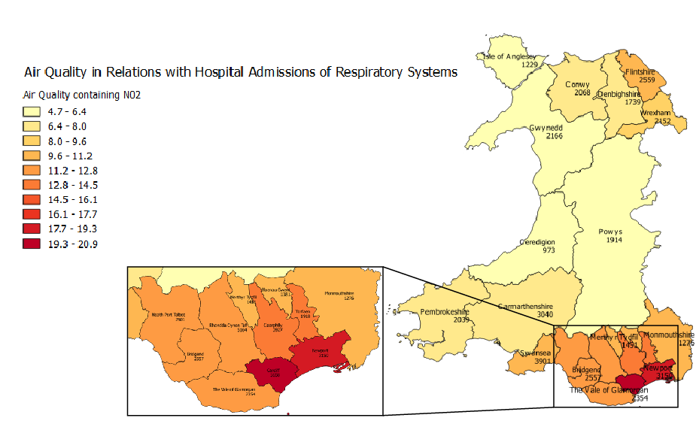

Task 3
To bring this report to a close, I will be comparing and contrasting the visual and non-visual database solutions that I have previously created in Task 2. Furthermore, I will be discussing how a GIS could be utilised for healthcare informatics analysis.

Visual and Non-Visual Database Solutions

Microsoft Access
This is one of the Non-Visual database solutions that is currently available, and is the one that I used within my research. This is an information management application that helps users store information for reporting and also analysis. It helps users analyse large amounts of data, and manages the related data competently. The advantage of using this type of package as a database solution, is that it is simple and straightforward to create queries on the data. It gives you the option of creating a query yourself, or you can use its built-in wizard where you select the fields and the criteria for them. I found that when I was using Access, the presentation of the reports could be vastly improved. It wasn’t easy to control, and it felt as if it was very incomplete compared to other database applications.

QGIS
QGIS is an open source GIS, and it is what I used to develop the Visual Database to support the recognition of trends/patterns in hospital admissions. The benefit that I found when using QGIS was its ability to improve the communication between the data that is collected, and how it is presented to the end-users. As I was able to visualise on a map the output of the data, I found it easier to explain how the data could be dependant one where it is based on a map. For example, it was clear to me that on a maps certain areas were more dynamic with the amount of data, than the other areas. A function that I was impressed with within QGIS, was the ability to colour in the maps depending on the data related to it. This would allow me to be able to see on the map, what places had a higher statistics than others just by looking at the shade of the colour. The advantage of this is that it will be quick and clear to see the information on the map, and from this a possibility of patterns/trends could be identified.

Conclusion
After looking at some of the advantages and disadvantages of the two different types of database solutions, it is hard to justify which package is the most suitable as it depends on the scenario. The ideal situation when undertaking this sort of project again, would be to use some of the elements of Access and then use that to implement it into QGIS. I found that the query features that are available within Access can quickly select the required data that is needed, but the reports that were to be produced were not up to a good enough standard. However, the visual reports that are created within QGIS really help with the understanding of the data, and theoretically locate any potential patterns/trends.

How can GIS be used for healthcare informatics analysis?
As the advancement of GIS is becoming more involved with everyday life, is there a potential way that it can be used for the purpose of supporting the analysis for healthcare organisations. Taken from a study by E Fradelos et al [24], they stated that “We can say with absolute certainty that GIS’s are important tools in relation to the investigation of health sciences and they have many applications. These systems enable health-related information to be displayed.” It is clear that with the current power of GIS, it can be used more proficiently to identify more obscure but frequent patterns with regards to healthcare.

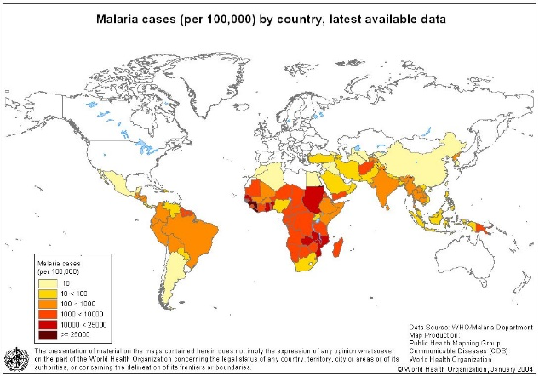
J Nhavoto [25] from the National Institutes of Health mentioned that “Disease surveillance is a field where GIS technology has been much used. GIS for disease surveillance is an epidemiological practice that monitors the spread of disease in order to establish patterns of progression.” When these types of GIS systems are already in place, it can show the significance in the amount of impact it can have on the world as it can potentially save lives with the suitable data that is receives. Looking at the example screenshot of a malaria outbreak, it shows that GIS a powerful set of tools for disease surveillance, predicting potential disease outbreaks, and targeting intervention programs.
Example of GIS Epidemiology for Malaria

With regards to the UK, G Higgs [26] suggested an extended part for GIS in the NHS, and made it clear that GIS applications relating to health fall into two comprehensive categories, epidemiological and health care delivery. “Epidemiological work concerned with the nature of variations in health outcomes and possible reasons for observed patterns. Health care delivery with consideration of the effective organization and configuration of services and the consequences for health care utilization and accessibility.” Inside a healthcare system such as NHS, the use of GIS offers many opportunities for health planning that is strategic and complete, and that incorporates local health needs. [27]

Bibliography

[1] | K. Tuthill, “John Snow and the Broad Street Pump,” UCLA Department of Epidemiology, [Online]. Available: http://www.ph.ucla.edu/epi/snow/snowcricketarticle.html. [Accessed 28 November 2017].
[2] | “John Snow’s famous map of the 1854 Broad Street,” [Online]. Available: https://www.researchgate.net/. [Accessed 28 November 2017].
[3] | J. Snow, “On the Mode of Communication of Cholera,” London, 1855.
[4] | T. Koch, “The Map as Intent: Variations on the Theme of John Snow,” University of British Columbia, Vancouver, 2004.
[5] | J. T. Coppock, “The History of GIS,” [Online]. Available: https://www.geos.ed.ac.uk/~gisteac/ilw/generic_resources/books_and_papers/Thx1ARTICLE.pdf. [Accessed 29 November 2017].
[6] | M. F. Goodchild, “Cartography: GIS and Cartography (Relationship Between),” [Online]. Available: http://www.geog.ucsb.edu/~good/papers/474B.pdf. [Accessed 21 November 2017].
[7] | J. S. Aber, “Brief History of Maps and Cartography,” 2008. [Online]. Available: http://academic.emporia.edu/aberjame/map/h_map/h_map.htm. [Accessed 28 November 2017].
[8] | N. C. A. F. P. M. J. P. David Mark, “The GIS History Project,” June 1997. [Online]. Available: http://www.ncgia.buffalo.edu/ncgia/gishist/bar_harbor.html. [Accessed 1 December 2017].
[9] | C. T. Alexander von Lunen, History and GIS, Springer & Business Media, 2012.
[10] | I. N. Gregory, “A place in history: A guide to using GIS in historical research,” Oxbow, Oxford, 2005.
[11] | “Caliper,” [Online]. Available: https://www.caliper.com/Graphics/Maptitude_Mapping_Software_Screen.png.
[12] | A. Deaking, “EVOLUTION OF GEOGRAPHIC INFORMATION AND VISUALIZATION SYSTEMS,” [Online]. Available: https://www.eolss.net/Sample-Chapters/C09/E6-38A-06-01.pdf. [Accessed 5 December 2017].
[13] | D. Fairbairn, “Representation and its relationship with cartographic visualization,” Cartography and Geographic Information Science.
[14] | B. Jiang, “Cartographic Visualization,” December 1996. [Online]. Available: http://fromto.hig.se/~BJG/cartography1.PDF. [Accessed 5 December 2017].
[15] | Flight Radar 24, 2017. [Online]. Available: https://www.flightradar24.com/. [Accessed 07 November 2017].
[16] | O. J. o. t. E. Union, “Performance and the interoperability of surveillance for the signle European Sky,” 22 November 2011. [Online]. Available: http://eur-lex.europa.eu/LexUriServ/LexUriServ.do?uri=OJ:L:2011:305:0035:0052:EN:PDF. [Accessed 08 November 2017].
[17] | “Sea Level Rise & Global Warming,” Union of Concerned Scientists, 2014. [Online]. Available: http://www.ucsusa.org/sealevelrise. [Accessed 5 December 2017].
[18] | “Trendsmap: Twitter Trending Topics,” [Online]. Available: https://www.trendsmap.com/.
[19] | E. Breeze, “The Socio-Demographic characterisics of the ELSA population,” 2005. [Online]. Available: https://www.ifs.org.uk/elsa/report06/ch2.pdf. [Accessed 4 December 2017].
[20] | R. W. J. P. Emee Vida Estacio, “Examining socio-demographic factors,” 2016. [Online]. Available: https://www.keele.ac.uk/media/keeleuniversity/facnatsci/schpsych/staffdocs/estacio/Digital%20health%20literacy%20EE%20RW%20JP%20FINAL.pdf. [Accessed 4 December 2017].
[21] | G. Andrienko, “Geovisualization of Dynamics, Movement and Change,” London City University, London, 2008.
[22] | “GIS @ Highered,” [Online]. Available: http://gisatvassar.blogspot.co.uk/2008/11/election-is-over-take-look-at-maps.html.
[23] | P. Norman, “Georefencing socio-demographic information,” 2016. [Online]. Available: http://eprints.whiterose.ac.uk/100333/1/Georeferencing-PN-28-05-2016.pdf. [Accessed 4 December 2017].
[24] | I. P. D. M. C. K. Evangelos Fradelos, “Health Based Geographic Information Systems and their Applications,” December 2014. [Online]. Available: https://www.ncbi.nlm.nih.gov/pmc/articles/PMC4315644/. [Accessed 4 December 2017].
[25] | J. Nhavoto, “Mobile Technologies and Geographic Information Systems to Improve Health Care Systems,” PMC, June 2014. [Online]. Available: https://www.ncbi.nlm.nih.gov/pmc/articles/PMC4114429/. [Accessed 4 December 2017].
[26] | M. G. G Higgs, “Is there a role for GIS in the 'new NHS'?,” Health and Place, 2001.
[27] | J. F. S. W. Cindy Gotz, “Geographic Information Systems In Health Organisations,” California State University, California.
[28] | “Image - The Canada Land Inventory,” [Online]. Available: http://www.geostrategis.com/p_mapm1.html.
[29] | “Introduction to Queries,” Microsoft, [Online]. Available: https://support.office.com/en-gb/article/Introduction-to-queries-d85e4893-0ed7-4118-8297-785a01357516.

