Student Expense Tracker for Better Budget Management
Aaron Miles
2404521
L5 – Change makers: Creativity and Value Creation

Table of Contents
Introduction 1
Task 1 – Practical Development / Implementation 2
Task 2 – Enterprise & Innovation 3
Task 3 – Project Feedback & Reflection 4
Conclusion 5
Weekly Project Progress Form 1 5
Weekly Project Progress Form 2 6
Weekly Project Progress Form 3 7
Weekly Project Progress Form 4 7
References 8

Introduction

The Student Expense Tracker app was created to enable university students to track expenditures and cultivate positive budgeting practices via an online tool. Because students find it challenging to balance the books due to increasing expenses and a lack of budget management abilities, this web-based tool was created to allow users to keep track of all of their daily transactions, as well as see how close their monthly budget is to completion. [1]
HTML, CSS, and JavaScript are the technologies that were utilized in the creation of this application. [1] HTML was used to build out the app, CSS was used to improve the look and feel and make it responsive, and JavaScript was used to create a more dynamic experience by including things like math and live updates of the transaction data. It will examine the project implementation, the end users feedback, enterprise ideas, and the skills I gained from completing the project.

Task 1 – Practical Development / Implementation

Q1: Initial feedback

Feedback was sought from five users through questionnaires and chat conversations. They were provided with the prototype of the application and the initial idea of the application.

Participant Feedback
Student 1: The dashboard is very user-friendly.

Student 2: More categories should be included.

Student 3: Suggested using warning messages.

Student 4: More responsive design required.

Student 5: Suggested for permanent data storage

It was suggested that users liked the application because the dashboard is easy to use and the cards in the dashboard are colour coded. Users also suggested that the application could store information permanently; more categories should be added, and it should be responsive to the device it is being viewed on. As a result of the feedback received, a responsive design was implemented, and warnings were added to inform the user of budget limits. [2] Several additional categories were added to the expense form.
Q2: Implementation
The application was built using HTML, CSS, and JavaScript. HTML and CSS The expense form, dashboard cards, transaction table and budget status was created using HTML. The visual appeal of the application was improved using CSS by adding colours, padding, responsive design, and CSS grid. The cards are colour coded with green meaning balance, blue representing monthly budget and red for spending. Media queries were used to improve the application’s responsiveness, so it looks good on a smaller screen. [3] JavaScript The application’s functionality is implemented using JavaScript. [2] The calculateSpent() function returns the total value of all expenses. The updateUI() function updates the display on the dashboard including the balance, spending total, budget warning text, and the progress bar. The renderTransactions() function renders all transactions to the table. The addExpense() function allows the user to add an expense which is then calculated and displayed on the dashboard immediately. The development of the application included several problems. Initially, the calculation of spending on the budget card was not updating. This was rectified by adding a call to the updateUI() function at the end of the addExpense() function. The response design of the application was problematic due to some elements being cut off at certain zoom levels. This was rectified by using media queries and using a flexible CSS grid. Additionally, there were problems with adding non-numeric expenses to the application; this was fixed by using the isNaN() function to check that only numeric characters were added. [5]
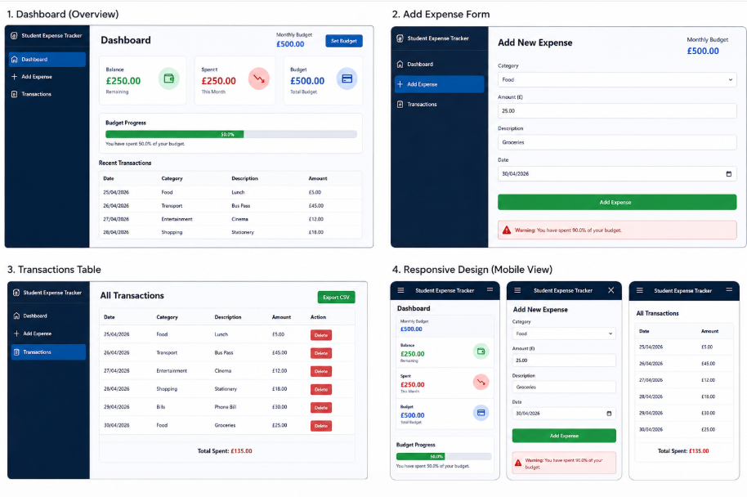

Task 2 – Enterprise & Innovation

Q1: Start-up Information
The start-up's name would be BudgetWise Technologies, and the business type chosen would be a private limited company (Ltd). This structure would provide support for business growth and would provide protection for the owners in the form of limited liability. A start-up strategy could be developed to assist students with their finances using affordable online resources. Potential sources of funding include government grants, angel investors, and crowdfunding. The business model for the start-up would generate income through the premium version of the app, university partnerships, and ads. [6]
Q2: PEST Analysis
Politically The business will need to follow data protection laws such as the General Data Protection Regulation. [7] Economic Rising cost of living will create a need for the app. Social Increasing use of technology by students to control their finances. Technological Apps will be designed to work effectively through modern web technologies on most devices. Legal / Ethical The user's financial data will need to be secure and private, and there should also be ethical issues addressed in how user information is handled.

Task 3 – Project Feedback & Reflection

Q1: Feedback from implementation
I have gathered extra feedback post-implementation:
Participant: Student 1, Feedback: Application was very easy to use
Participant: Student 2, Feedback: Would like financial charts
Participant: Student 3, Feedback: Would like to be able to edit and delete existing records
Participant: Student 4, Feedback: Would like to be able to log in before using application

Most participants were very impressed with the easy interface and budget tracking features of the application. Features mentioned for future development were inclusion of charts, adding local storage capability and user login functionality.
Q2: Reflection on the project
I made use of a weekly schedule to manage the development of the project as it was a great way to keep myself on track and reminded me to stay on schedule. It allowed me to plan my time effectively while keeping my development on track. A challenge I came across was having to complete the practical implementation, test it and complete the report all in the allotted time. If I was to redo the project, I would allocate more time to complete certain features which I would have liked to be implemented. I would have liked to develop local storage and graphical data representation for the application.
Q3: Reflection on skills development
The project helped to develop technical skills such as creating websites using HTML, CSS and JavaScript. [8] It also helped with skills such as coding and testing websites. My ability to create websites that are suitable for a large selection of device sizes and resolution (responsive design) was also improved.
The project also helped to develop my communication skills as I was able to communicate the progress and outcome of my project to a group of people. I was able to keep on schedule with the project, thus developing my project management skills. My problem-solving skills were challenged and consequently improved.
Q4: Reflection on positive social impact
This project would have a positive social impact as it will benefit students to have a simple tool to help them keep their finances organized, and in turn help them improve their budgeting habits. It could potentially reduce financial stress within young people by increasing their level of awareness towards personal finance management and financial literacy.

Conclusion
The Student Expense Tracker project showcased the process of creating a fully functional and responsive expense tracking application using HTML, CSS, and JavaScript. [9] With the help of this app, users would be able to add expenses, keep track of how much they spent, and compare that with their budget.

This project contributed towards the development of my skills in front-end development, problem solving, project management, and critical reflection. This project could be further developed to have an option for the data to be saved permanently, to add a chart which plots the expenses over time, and to develop a mobile version of the application.

Weekly Project Progress Form 1

Date: 16/03/2026 – 23/03/2026

Progress
Research budgeting tools and student money management issues.
Defined the scope and features of the Student Expense Tracker.
Started the wireframe and app framework design.
Setup HTML, CSS and JS project files.
To do
Draft the HTML skeleton.
Style the dashboard using CSS.
Outline the JavaScript logic.

Next review date: 23/03/2026

Weekly Project Progress Form 2

Date: 23/03/2026 – 30/03/2026

Progress

Wrote HTML structure.
Made dashboard cards and transaction table.
Wrote CSS and responsive styles.
Write the JavaScript logic for calculation.
To do
Finish JavaScript functions.
Add transaction dynamic updates.
Test responsiveness further.

Next review date: 30/03/2026

Weekly Project Progress Form 3

Date: 20/04/2026 – 27/04/2026

Progress
Built functions calculateSpent() and updateUI().
Built transaction rendering and validation logic.
Built progress bar budget functionality.
Fixed an overflow bug with the progress bar.
To do
Test calculations.
Enhance transaction display formatting.
Obtain user feedback.

Next review date: 27/04/2026

Weekly Project Progress Form 4

Date: 27/04/2026 – 04/05/2026

Progress
Finished testing and troubleshooting.
Got final student feedback.
Improved responsiveness and readability.
Identify future improvements and limitations.
To do
Finalize the project report.
Include screenshots and appendices.
Ready for submission.

Next review date: 04/05/2026

References

[1] | P. Barry, "Head First Programming," O’Reilly Media, 2009.
[2] | J. Duckett, "HTML and CSS: Design and Build Websites," WIley, 2011.
[3] | I. Sommerville, "Software Engineering," Pearson, 2015.
[4] | N. Patel, "Responsive Web Design Principles," Web Design Journal, vol. 12, pp. 45-52, 2023.
[5] | D. Flanagan, "JavaScript: The Definitive Guide.," O’Reilly Media, 202.
[6] | M. D. Network, "JavaScript Guide," MDN Web Docs, 2026.
[7] | E. Ries, "The Lean Startup," Crown Business, 2011.
[8] | E. Union, "General Data Protection Regulation," GDPR Information Portal, 2026.
[9] | W3Schools, "HTML Tutorial," W3Schools, 2026.
[10] | J. Duckett, "JavaScript and JQuery," Wiley, 2014.

