

Human Resource Management
R E P O R T

Student: Gordana Trpchevska Lecturer: Mary March
Student number: 1818667

LONDON, January 2020
Report about Hanoi Hat Company

As an outsourcing Human Resource Company we made detail review and research of the reward strategy, and concluded that should be only benefit for the employees in Hanoi Hat Company. During the preparation of our strategy we have made detail research about culture, sociological behaviour, economy, customs and employment situation in South Korea.
According to the current situation, the employees in Hanoi Hat are paid by piece based. At this moment, the Company are employed in a contract with an international company which is changing the products they require often. Being paid for the products they make, the employees cannot make a good enough salary as they are training. That is the reason why, we would like to introduce a new scheme of payment which would be hourly based. The current minimum wage is 8,350 South Korean won which is approximately 5,43 British Pound Sterling. With the aim to motivate the employees, we would like to suggest paying more than current salaries to the Hanoi Hat Company’s employees.
We also strongly believe that the company should pay for the employees training and development, in order to become more successful and improved in their day to day tasks. To stimulate the workers to achieve higher production we are going to offer yearly Bonus. If the company prospers, the employees are going to be entitled to a bonus, depending on the company’s profit.
Another incentive to stay would be providing the workers with additional health care package, which would be covering 20% of the employees Co-Payment. ‘’The co-payment is the portion of the health care service cost which patients should pay for the medical service when they visit a hospital. ‘’

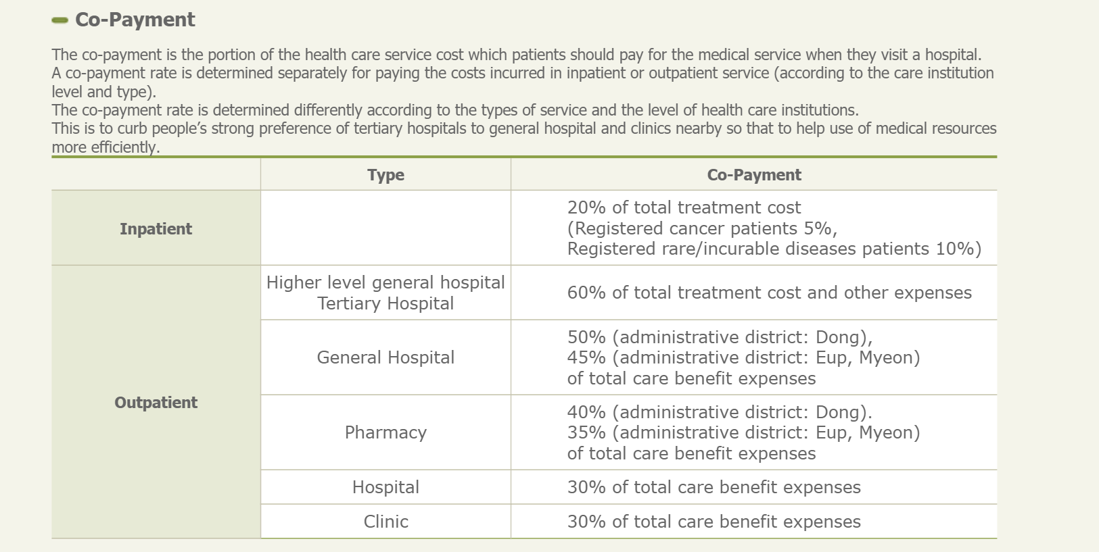
(System, 2019)

We would like to introduce a new sick leave policy as well. Even if a worker Is not suffering from an occupational injury or disease, we would offer 5 sick paid days off – annually.
According to section 60 of the labour Standards Act (LSA): For every 3 years or more continuously worked, an employee is entitled to 1 extra day leave on every 2 years. The regular annual leave they are entitled to is 15 days. We believe that apart from these 15 days, which every company should provide by law, we could offer an additional 10.
(ACT, 2012)
Benefits:
Considering our new reward strategy, we expect that the employee turnover will reduce. The motivated and higher skilled workforce is going to be more productive which will lead the company to a new level. We consider the vested interest, not in monetary terms, so if the employees are investing their time and effort, they will expect the company to grow and consequently to pay them more.

