Is archaeology political?
By Lillian Mary York
2317170

Context
What is archaeology?
Politics
Is archaeology political?
Controversy in archaeology
Conclusion
What is archaeology?

Archaeology as a whole, is the research of material to study the past of humans and their lifestyle. This then helps us to understand why they did what they did. Diane Boudreau, et al (2023) was a useful tool of information.

Archaeologists use these material artefacts to learn about the past, which then in turn, can then be used to better the future. Especially when archaeologists are researching about global warming, and waste disposal. (Bates, 2010, p.31)

Archaeologists can use all different types of materials to learn about how people lived. Diane Boudreau, et al (2023) was a useful tool of information.
This helps us to gasp an insight on the conditions on human life from different centuries, as 99.9% of human life has no written documentation. (Bates, 2010, p.31)

Not only this, but many of the medieval monks did not approve of Greek literature meaning that 95% of this literature did not actually get through the Middle Ages.
As so much written works never made it through certain periods of time, artefacts are extremely important and valuable to archaeologists. (Bates, 2010, p.23)

Archaeology is a useful tool when learning about the past of humans. This is because archaeology enables us to challenge the history books, which were written by biased men, and helps us to uncover the truth of the world. Not only does it help us to challenge history books, it also, tells us about people who would not have any documentation written on them. This would be people, such as, the poor, enslaved and the common people. We are able to use artefacts to figure out the story of the world and where we came from. (Bates, 2010, p.31)

Archaeology was formed out of antiquarian as well as social evolutionary studies during the late nineteenth century. Throughout the years archaeology has gone through many changes.
Such as, by the middle of the twentieth century its methodological and theoretical basis was developed by a man called Gordon Childe. (Bates, 2010, p.31)

Politics

When people mention politics, they often are referring to different types of people, and different opinions. Professor Christina Boswell (2020) was a helpful source of information.
Mostly anything someone does is considered political. And archaeology is highly controversial when it comes to the matter.

Decades ago, politics was mostly viewed about the distribution of money and power. But recently that has been shaken by ideological views, focusing on the values, culture/identity, and lifestyle of a country. Professor Christina Boswell (2020)

Politics shape everybody’s day to day life. People of power from the past have shaped everyone’s sense of being and why we do what we do. (Quentin Drew, 2023)
When we look at politics, it has so much dimension. From street signs to the structure of people's life.
Everything which people do every day is shaped by politics. Every job is shaped by politics.
(Quentin Drew, 2023)

Is archaeology political?

Overall, yes archaeology is very political.
If we take a look at Saartjie Baartman, for example.
This young woman was born in the year c.1789, then captured in 1810 and died in 1815. (Quentin Drew, 2023)

Saartjie Baartman was born to the eastern Cape subgroup, of the Khoisan people which was the Griqua tribe. (Quentin Drew, 2023)

Saartjie Baartman was originally kept by the french authorities after being captured by the Dutch colonists, at the young age of 20. Sadly, Baartman was taken into captivity for her exotic looks, while the rest of her tribe were slaughtered by the colonists. Baartman died only 5 years after being taken into captivity, which can only suggest to us the extent of the horrific circumstances Baartman was subjected to. (Quentin Drew, 2023)
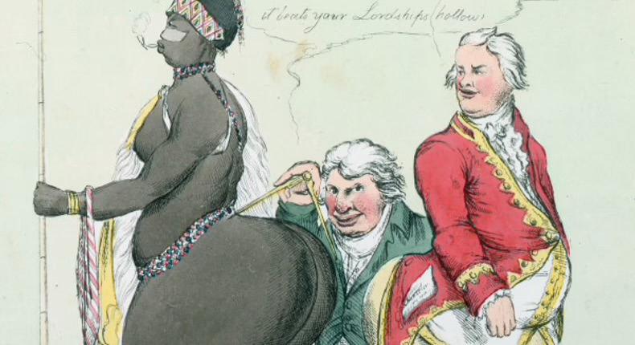
SA History (no date)
Being of Khoisan decent, Baartman’s physical appearance was extremely different to the women of European decent. The European people were extremely fascinated by the largeness and shape of Baartman’s buttocks. The European people were so mesmerised by Baartman’s body that they would put her on freak show displays to the public around the streets of Northern Europe. If this wasn’t humiliating enough, Baartman was even taken as entertainment to dinner parties, where she would be thoroughly examined and exposed to the guests.
Throughout the years Baartman was sold on to many different owners, who would all abuse her in many different devastating ways. The last few years of Baarman’s life was sadly, spent in prostitution. (Quentin Drew, 2023)
After Baartman’s death in 1815, her corpse was sold.
Morticians were the recipients of her corpse. This was because they were extremely interested in the origins of the different races. Baartman’s skeleton was then taken for studying, her skin was stuffed and put on display. Not only was Baartman not able to rest, but she was also always viewed as an object and even her genitalia were put into jars to be examined. (Quentin Drew, 2023)

As the fascination of Baartman’s body was still increasingly clear even after her death, it even changed the fashion standards of European women in the mid nineteenth century, right up to the end of the century.
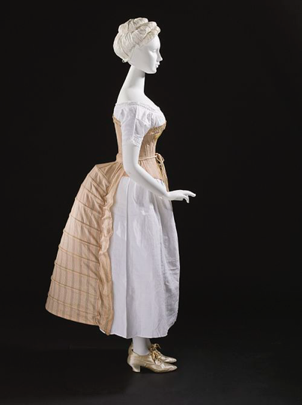
It became a standard for European women to wear a bustle under their skirts. This was to add fullness to the shape of a woman’s body. Which would create a more exotic shape to the European women. (Quentin Drew, 2023)

Los Angeles County Museum of Art (no date)

Baartman was on display going right up until the 1930’s, possibly even up into the 1950’s.
It was not until the 1950’s the Louth came to the decision that Baartman should be viewed by appointment only and should be taken out the view of the public.
Even in the 1950’s Baartman was not able to rest, as she was put into the basement for storage. (Quentin Drew, 2023)

For decades, Baartman was held in storage. Now, if we take a look at South Africa in the 1980’s there was a massive political unrest. And during the final part of the apartheid, Nelson Mandela was changing South Africa and breaking it from its past. Apart of Mandela’s plan to bring South Africa back into in a functioning society, was to build its historical roots back up. (Quentin Drew, 2023)
It came to the South African governments mind, that a massive part of their history and cultural heritage was sitting in a museum in France. Not just any museum, but one of the most known museums in the world. (Quentin Drew, 2023)

At first the Louth denied that they had Baartman’s Corpse. After a lot of back-and-forth discussions, finally the Louth decided in the year 2000, that they would return Baartman’s corpse. Instead, the Louth now have a statue to honour Baartman. (Quentin Drew, 2023)

Baartman did not have her funeral until the year 2002. This was because the whole of her tripe was wiped out by the colonists, so there was nobody to claim her corpse.
In the end, multiple ethnic groups within South Africa claimed her, and in the end one group did win the court case and were able to finally bury her by the Gamtoos River Valley. UNESCO (no date) was a useful source of information. (Quentin Drew, 2023)

Baartman’s funeral was attended by many important figures, such as Thabo Mbeki. (Quentin Drew, 2023)

Not only was Baartman ripped away from her tribe and taken to a European country to be a part of a freak show. Nearly 200 years later when she was finally laid to rest, again she had her identity ripped away from her again and was given the identity of South African. (Quentin Drew, 2023)

Baartman is vied as an icon for many women who face sexual and racial discrimination and abuse today. BBC News Africa (2015) was a great source of information.

The argument is, why are archaeologists allowed to keep the remains of human bodies and the disposition in museums. Surely, we should let people rest, and respect people's identities and cultures.

Controversy in archaeology

Archaeologists face issues every day when going about their business. And this is due to people's political opinions and beliefs.

Archaeology can be seen as being highly controversial. A good example of this is the Baartman story which I mentioned earlier.

Archaeological discoveries are often extremely important to help understand the past of human societies and lifestyles. Not only does it help us to understand about human past, but it also helps us to learn about the present and future. Owen Janus (2022) was a useful source of information.

If archaeology is so valuable in discovering our past, why is it controversial?
Well, this is because people’s identities are being taken away. Not only are people’s identities being taken away, but people also have the argument of what gives these archaeologists the right to be spending large amounts of time and money, disturbing the environment and communities, when there are people within that community who cannot even afford to live? (Quentin Drew, 2023)

If we have a look at the indigenous communities, they treasure their heritage and ancestors, they also hold all of it extremely close to them. Their ancestry makes up their identities. (Quentin Drew, 2023)
As the ancestry is vital for these indigenous communities to thrive and grow, they have very valid concerns about the remains of their ancestors. This includes the concerns which they have about the studies and research anthropologists and archaeologists carry out on their ancestors. (Quentin Drew, 2023)

For the indigenous people, each piece of clothing and accessory will tell a story. This story could be about their lives or the lives of their ancestors which came before them. (Quentin Drew, 2023)

When archaeologists are carrying out research of artefacts from indigenous groups, have they taken the time to understand and interpret the importance of this artefacts and the cultural significance this object may hold on to certain communities. And why it needs to be returned back to the ancestors of the communities it was taken from? Or are archaeologists simply looking at it like it is something which they are able to carry out what ever research they believe will help them complete their research the most efficiently and fasted. And then have it sit in a museum in a foreign country for decades, while the rightful heir of this artefact could be missing an important treasure to do with their culture and heritage? (Quentin Drew, 2023)

A lot of people take pride in their community and the history of where they live. Not only do these archaeological sites and discoveries mean a great deal to people personally, but it also brings a high amount of tourism to certain communities. Which means that local shops and businesses are often able to attract tourists to their businesses which would create a high revenue profit from tourism. (Quentin Drew, 2023)

If archeologists come along and take advantage of these small communities and take away these certain archaeological finds, what would this mean for the local community and their income?

Why should people’s identities and culture be snatched away from then and be taken into a museum or a site miles away from where it was originally located in. Surely the local people should have an input on what should happen to the archaeological object, and what they believe the best outcome would be for them as a community and their historical background. (Quentin Drew, 2023)

Conclusion

How will counties and communities come together, to come up with a solution about which archaeological artefacts belong to who?

There is a great example of how countries come together and determine a solution for artefacts which have been stolen. And this is England and Scotland with The Stone of Destiny.
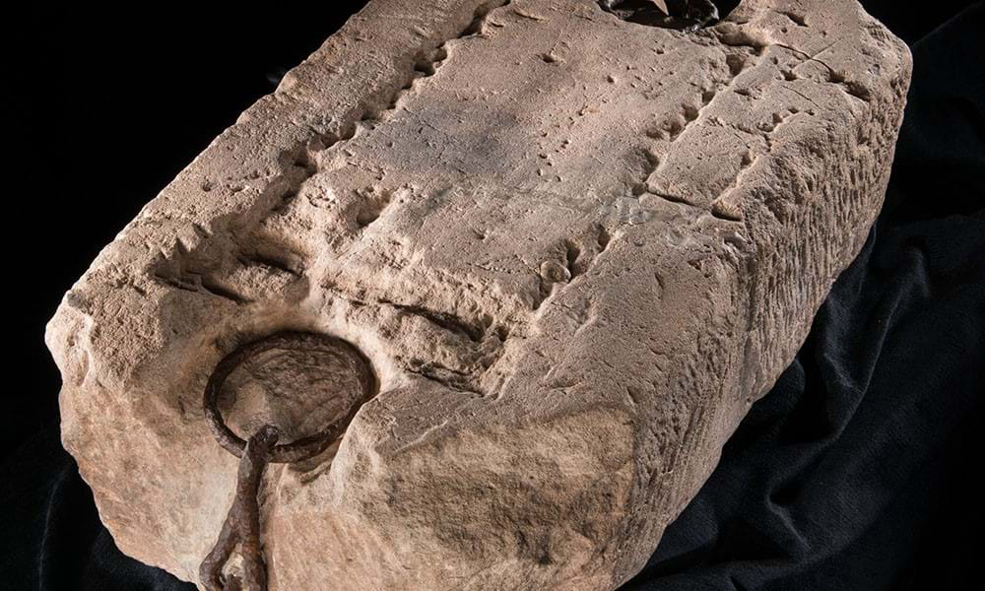
The Stone of Destiny is an ancient stone, which was used to coronate the king by the Scottish monarchy. Edinburgh Castle (no date) was a helpful use of information.
Edinburgh castle (no date)

During the year 1296, the King of England (king Edward I) stole this ancient stone from the Scottish monarchy, and since then it had been held at the Westminster Abbey, to coronate the kings and queens of England. Edinburgh Castle (no date) was a useful bit information.

It was not until 1996 this ancient stone was finally returned back to Scotland, after many years of the Scotts protesting to get this very important artefact back to their country. Edinburgh Castle (no date) was a helpful section of information.

Both countries came up with a solution of who gets to own the Stone of Destiny. And this solution was that the stone will reside in Scotland and will only ever leave the country to come to England for a coronation. Edinburgh Castle (no date) was a useful bit information.

Could this be the way forward for communities and countries to move forward on the ownership of artefacts?
I believe it could be, and I believe that this is the most significant decision which allows countries and communities involved to unite and bring everybody together, to better the future.

References

Diane Boudreau, Melissa McDaniel, Erin Sprout, Andrew Turgeon (2023) Archaeology Available at: https://education.nationalgeographic.org/resource/archaeology/
(Accessed 10th November 2023)

Jonathan Bate. (2010) The public value of the humanities. London: Bloomsbury Publishing Plc

Professor Christina Boswell FBA (2020) What is politics? Available at: https://www.thebritishacademy.ac.uk/blog/what-is-politics/
(Accessed 10th November 2023)

BBC News Africa (2015) South Africa anger after Sarah Baartman’s grave defaced. Available at: https://www.bbc.co.uk/news/world-africa-32499070
(Accessed 13th November 2023)

UNESCO (no date) Saartjie Baartman Memorial. Available at: https://www.cipdh.gob.ar/memorias-situadas/en/lugar-de-memoria/memorial-saartjie-baartman/#:~:text=Sarah%20Baartman%27s%20grave%20is%20located,by%20a%20metal%20fence%20structure.
(Accessed 10th November 2023)

Edinburgh Castle (no date) The Stone of Destiny. Available at: https://www.edinburghcastle.scot/see-and-do/highlights/the-stone-of-destiny
(Accessed 13th November 2023)

Quentin Drew (2023) introduction to archaeology lecture. Archaeology and politics. People and place. 9th November.

SA History (no date) A caricature of Sarah Baartman’s derogation. Available at: https://www.pulse.ng/lifestyle/who-is-sarah-baartman/s9hcds0
(Accessed 13th November 2023)

Los Angeles County Museum of Art (no date) Bustle, lady’s undergarment, England, c.1885. Available at: https://en.wikipedia.org/wiki/Bustle
(Accessed 13th November 2023)

Owen Janus (2022) what is archaeology? Available at: https://www.livescience.com/44448-what-is-archaeology.html
(Accessed 10th November 2023)

