University of Wales Trinity Saint David



BMSW5001
How Individuals’ beliefs, attitudes and values impact on workplace behaviour.
Lecturer: Chijoke Uba
Samina Zia
1709440

Table of Contents
How Individuals’ beliefs, attitudes and values impact on workplace behaviour. 3
Introduction: 3
Critically assess your own belief and value system and how these may affect your professional character. 3
Critically analyse the impact of organisational beliefs and core values on workplace behaviour using a well-known organisation as a case study. 4
Examine the given management theory. 6
Max Weber Bureaucracy Theory 6
Principles of the Bureaucratic Theory 7
Authority Hierarchy 7
Formal Rules and Regulations 8
Division of Labour 8
Career Orientation 8
Impersonality 8
Formal Selection Process 8
Advantages 8
Specialisation or Expertise: 9
Skill-Based Recruitment 9
Predictability 9
Equality 9
Structure 9
System-Based Record Keeping 9
Rationality 9
Disadvantages 10
One Way Communication 10
Exploitation of Power 10
Wastage of Effort, Time and Money 10
A Delay in Business Decision Making 10
Hinders Innovation and Creativity 10
Inflexible and Rigid Methods 10
Using relevant critical thinking models, evaluate the modern-day relevance and weaknesses of the management theory 11
Using an appropriate critical thinking model, develop an argument for / against the notion that the economic environment of a nation affects resident businesses. 11
Appendix: 13
Reference: 16

How Individuals’ beliefs, attitudes and values impact on workplace behaviour.

Introduction:

it is normal to develop individual values, beliefs and attitudes throughout our lives. We do this through our family, friends and community as well as personal life practises and experiences. These can change as we grow more in experience and see the world through our point of view and judge people on a range of basis. Although, beliefs, values and attitudes are the basis for relationships at workplace, however, it is vital that we do not force our own ideas on others and be organised to accept professional ethics in the society as well as the workplace.
Beliefs are ideas that people believe in to be true without any factual evidence. This can be on the basis of their own experiences or cultural/religious customs. To prove this to be true they seek evidence for the beliefs and evaluate according to their own desire.…. while Values are principles, standards and qualities that form through our belief and behaviour (Smith and O’Sullivan, 2012). Beliefs and value shape the individual’s attitudes towards their personal and professional character. This, in turn, largely drive their behaviour. It is important, therefore, to understand how individual beliefs, attitude, etc. The aim of this report is to analyse from different perspectives how individuals’ beliefs impact positively/negatively on their professional character. This report has 5 sections. Following the introduction, the report will critically look at how an individual’s own beliefs and values affect their professional character. Detailed research will be done to evaluate a wide range of evidence. This will then take the report on to the second section, which looks at the organisational beliefs and core values and their impact on the individual working there. It will also look at the individual adjusting their personal values to ensure professional achievements and facing difficulties due to their stubborn attitudes of mixing personal beliefs/values with the professional ones.

Critically assess your own belief and value system and how these may affect your professional character.

In this task I will talk about my personal beliefs and values, and how they Impact on my professional character.

I am a Muslim and strongly believe in Islamic teachings as a way of life. These beliefs strengthen my basic belief in oneness of God, life after death and heaven and hell, as mentioned in the verses in Qur’an, Of the good that they do nothing will be rejected of them; for Allah knoweth well those that do right. Those who reject faith – neither their possessions nor their (numerous) progeny will avail them aught against Allah: they will be companions of the fire, dwelling therein forever, Qur'an 3:115-3:116.

These beliefs have given me strong moral and ethical values, which help me to become a better individual as I look forward to the rewards that are promised by Allah and stay away from negatives as I want to avoid being punished. The teachings helped me to become kind and humble human being. My values also play a strong and positive role in building my attitudes in, both personal and professional character. I have learnt that although my beliefs and values are strong for me, they’re not however, for everyone else. People quickly jump to conclusions based on what they infer by jus viewing. I wear a long gown, called Hijab as my religious requirement, but there are many organisations who will judge me on my appearance rather than my knowledge and experiences. For example, as a qualified learner Support, I worked in a school where I was not originally told of any requirements relating to any dress code. After working for three days I was told not to come in as I did not fit in for the job. This made me feel terrible. However, it also helped me to understand that people mostly infer in making judgements by individuals’ appearance, rather than trying to understand the person’s intellect. Unfortunately, instances of discrimination are not limited to the example that I have given, Weller (2006) also agrees, discussing the multiple dimension of islamophobia in the United Kingdom.
This has not stopped me from practicing my religion. In fact, it has empowered and encouraged me to understand the teachings of Qur’an, to help me develop my personality according to Islamic values and help me to believe that Islam is the way of life and by following this I feel not only successful and at peace, but also feel that I have succeeded in pleasing my creator also. Since Islam is the way of life, my religion plays a powerful and positive role in developing and strengthening my personal and professional character.

Critically analyse the impact of organisational beliefs and core values on workplace behaviour using a well-known organisation as a case study.

For this task I have chosen a school as an organisation where I have worked as a learner support for a year. Since it’s a church of England school, their golden rule is: Treat others the way you want to be treated. (Welcome | St John's C of E Primary School, 2020).
The school mission statement aims to empower every child to reach their full potential while in a safe learning environment. This does not get impacted by the child’s capability, financial or communal circumstances. The school management helps develop and improve community organisation and help develop teacher parent communicational bridge to overcome any hurdle between children’s learning and development. Every individual is respected for societal, mystical, religious and educational multiplicity. Management provides support for parents who are facing difficulties in bringing up children while providing the best educational and social development. The school believes in zero tolerance on partiality and favouritism. School encourages young people to become self-confident, inquisitive, self-determining intellectuals to make a constructive contribution towards their community by looking beyond themselves.
Although this is a powerful statement. However, the staff achievements and students’ success depends on how well the management delivers. This becomes even more difficult when management starts bringing in their personal beliefs and attitudes into their professional character when making decisions. This results in a negative impact on the staff due to poor decisions made by the management and results in poor performance of both, staff and the students. The best way to achieve success is by having a thoughtful discussion with the whole school community regarding what is expected from them and what they could expect in return by the school management and leadership. This procedure must include school admins, teachers, students, parents, and community members who have had a long experience of being involved in schools to shape and secure the school’s future.
There is, however, another example from my workplace at a different school where I have experienced a variety of mixed experiences through my one year of work at the school. It was a Church of England school and gave me very respected and valuable work experience. Their Beliefs and values where very similar to mine and this helped me to perform better and learn better skills throughout my work. However, there was a time where I had to deal with very challenging behaviour by the staff due to my appearance and dressing. School’s main vision is that everyone is different, equal and grow together, unfortunately, my experience was pretty much different to begin with. When I started working at the school my manager did not used to speak to me much. In fact, he would even avoid eye contact with me for the first few months, which I failed to understand the reason for. I assumed from his very unprofessional behaviour that he has made a judgement about my character by just my physical appearance rather than monitoring my performance. It was only after attending an assembly session at the church with the children, that I noticed how he changed his behaviour onwards. He had a positive body language and became more approachable. He also had a professional smile that would make me feel comfortable to be approached by him or be able to approach him for any tasks or guidance. That is what helped me realise that not all the values and visions are followed by the most responsible professionals at the places of work. Such incidents are also reported by many others including (Carrington, 1999) to introduce inclusion as a different culture in schools.
It is true that everyone has their own values, beliefs and attitudes, it is important that we respect and accept other peoples’ values even if they are different from ours. We must also understand that we cannot get others to change their personal beliefs for us just as we cannot change our own for them. When such practice is ignored, issues can arise that result in misunderstandings and disappointments. If such issues are not dealt with accordingly, they can result in further misunderstanding and disappointments at workplace. This is where shared values play a crucial role. By understanding the common goals, we can achieve workplace success and deliver best performance by working hard. Honesty also helps bring discipline and brings out a more positive approach to workplace performance. Collective ideals and principles are often the bases of workplace relationships, so when values are not shared, they open doors for conflict.
When there is a change needed within the school environment, it must be done in line with the values of organisation while keeping in mind those who will be affected by it. If the values are accepted clearly by the employees, then that will bring most positive and successful change and will give staff the assurance to overcome and problem and resolve it quickly and most effectively, (Luthans, 2002).

Examine the given management theory.

Max Weber Bureaucracy Theory

In this part of the report Max Weber’s Bureaucracy theory is examined.
Max Weber, born 1864 died 1920, was a German political economist and sociologist. He had come forwards with the concept of bureaucracy within the management of businesses. (C,2019)
The bureaucratic management theory, which was introduced by Max Weber, has stated that to manage a specific organization efficiently, there was an essential point to have a clear line of discipline. This would include procedures, regulations, the right rules and regulations for the control of each individual business operation. The term bureaucracy is often referred to as the possession of authority over a set of activities or individuals through influence, authority or knowledge. This bureaucratic management theory is focused on two main standards. The first one being the development of a hierarchical system within the business and the second one being the clear definition of clear methods, regulations, rules and procedures to complete main organisation transactions and operations. In my setting,
Weber had the belief that there could only be 3 types of power within a business. Those were traditional, legal-rational and charismatic.
In the traditional power, the staffs/employees are considered as the servants and are dependent on their leader. Also stating that these so called ‘servants’ are blindly following rules and regulations provided to them by their leader in charge.
In legal-rational power, the employees are simply obliged to follow a specific set of principles. In other words, the workers either need to abide by the naturally applicable laws or the legal rules. He did not want people to behave in a family-based environment. Where the head of family is in charge. This according to him did not work well for organizational based business.
Within charismatic power, because of the personalities of the managers, the workers tend to be more motivated to perform their tasks allocated to them. This charisma may fade due to reasons such as the managers resignation, demise etc.
With these reasons, Weber had established this bureaucratic theory. He mainly accentuated on a rather formal business structure. Where a proper hierarchy was maintained, he focused on forming a clear and consice six set of principles.

Principles of the Bureaucratic Theory

Majorly, governmental organisations adopted Max Weber’s Bureaucratic Theory. He laid out the following six principles when it comes to effectively and efficiently managing a business. Those are the hierarchy of authority, formal rules and regulations, division of labour, career orientation, impersonality and formal selection process.

Authority Hierarchy

Weber had proposed that there should be a system-based hierarchy within a business. This would define the position allocated to each employee from the highest to the lowest. In a system like this, the employees would be aware of who they must report to, whosever orders they would need to survey, and what are the various roles of each different individual in the organisation.

Formal Rules and Regulations

According to Weber, within a business there must be a pure, laid out set of principles, rules and regulations and procedures within written form. My setting has policies and procedures in place which are followed by everyone working within the school setting irrespective of whatever position they hold. These are monitored on regular basis and any required changes are added according to the National Curricular and Local Education guidelines.
He also focused on how people complete their work and suggested that it should be assorted into smaller tasks set to each person who’s fit for the job. In other words, the one who is most capable of fulfilling the task. This doesn’t only improve the work proficiency but also makes sure of a proper, even allocation of job responsibilities. This also helps minimise workplace conflicts.

Career Orientation
Another rather vital principle is that the supervision of a business should motivate the employees to build and maintain a long-term career within the organisation they are employed at by providing performance-based incentives and security to them.

Impersonality
Within a business, this principle understands how the impersonal relation which can develop between employees can lead to preference etc. Max Weber stated that the applying of managerial/administrative decisions should be independent and impartial of such relations. The decisions made must be based on balanced grounds rather than impersonal or emotional influence.

Formal Selection Process
Max Weber indicated a belief that the employees within a business should be enlisted based on their technical skills and expertise rather than a ‘first come first serve’ base. Also, the promotions should be based on the efforts, this doesn’t only lead to an increase in productivity but add to the employee’s satisfaction and growth.

Advantages
This theory, introduced by Max Weber has been greatly applied within the 1900s era by the ethics of businesses, political associations and governmental organisations. The benefits of using this theory shall further be explained in detail.
There are various advantages of using the bureaucracy theory which are listed as follows: specialisation or expertise, a skill-based recruitment process, predictability, equality, the right structure, a system-based record keeping and rationality. (Rothschild-Whitt,1979). Some of these are easily used within my setting to help keep everything organised. However, not all of the Weber’s theory can be applied in today’s day to day profession.

Specialisation or Expertise:
Within bureaucracy management, the work allocated is separated amongst the personnel according to their expertise, skills and capabilities. This results in a clear job speciality within the organisation.

Skill-Based Recruitment
This advantage focuses on how the worker are recruited by those who match their expertise and skills that are mandatory for the position to make sure that the correct employee is placed at the right position outlined in the job.

Predictability
When a system-based hierarchy is set in place, specifically defined rules and regulations to perform the complex tasks within the business, various actions in comparable situations often become foreseeable for the hierarchy of management.

Equality
This advantage ensures that the management have an unbiased approach towards the personnel and makes sure a reasonable judgement is placed at the time of any issue of problem within the business.

Structure
A system-based organisational structure can be created through this bureaucracy theory where the regulations, rules, procedures etc. are pre-defined.

System-Based Record Keeping
This advantage often focuses on a used system-based recording to record all the organisations operations and transactions in documents. This gives other employees the ability to use them in the future as well as keep the record of every operation.

Rationality
As mentioned above, the recording of operations within the business insights rationality, e.g. enclosing the laws, rules, regulations and procedures for the future which is constructed on the involvement.

Disadvantages
When bureaucratic management is mentioned, there are various downsides of adopting such a theory to run any business. There is a list of shortcomings which can further be elaborated upon. They are listed as, one-way communication, exploitation of power, wastage of efforts, time and money, a delay in business decision making, hinders innovation and creativity and inflexible and rigid methods.

One Way Communication
Max Weber’s theory mainly emphasises on the passing of information e.g. orders, rules, regulations, tasks from the highest to the lowest in management. Nevertheless, feedback which concerns operational matters and other proposals are not to be taken from the employees within the organisation.

Exploitation of Power
Within a bureaucracy, managers tend to have a higher authority over the workers which may be misused by them to dominate their subordinates or meet their interests.

Wastage of Effort, Time and Money
This disadvantage tends to involve the recording of all the business operations and transactions to produce the necessary documents which require a vast amount of effort, time and money of the staffs.

A Delay in Business Decision Making
The highest level of management in the business keeps the decision-making authority between itself. Therefore, the lower level managers are obliged to rely on their superiors even within the case of a situation demanding immediate action or an emergency.

Hinders Innovation and Creativity
In this disadvantage, the supervisor tends to control the movement of the employees which eventually confines the subordinates/employees to apply innovation and creativity to their allocated work.

Inflexible and Rigid Methods
This theory does not interest any change or amendments within the management system. This makes this method quite inflexible.
There has been a severe criticism following Weber’s theory of bureaucracy.

Using relevant critical thinking models, evaluate the modern-day relevance and weaknesses of the management theory

This theory, introduced by Max Weber, is mainly fixed in monitoring something with the use of authority or power. With this reason it is usually taken as an adverse concept by many individuals. This concept is not negative due to the fact this theory initiates the development of a proper hierarchy within the organisation. Due to this, the authority or power is distributed amongst the workers conferring to their position within the organisation.
Every business transactions and operations are methodically noted down. The employees all follow the rules and regulations stated. Moreover, in the more present scenario, it is rather a struggle to have a pure bureaucratic management system within the business. Still, this fact cannot be ignored that many large-scale organisations rely on exhibiting at least some features of bureaucracy to function effectively. (Mullins, 2005). An example of it can be seen in the supervision of political, civil departments and governmental organisations.

Using an appropriate critical thinking model, develop an argument for / against the notion that the economic environment of a nation affects resident businesses.

This statement claims that economic environment of a nation affects resident businesses. I believe this statement to be true. This is because the natural environment has an important role to play in support of economic activity within the organisation. This is through provision of basic inputs such as, resources, raw materials, goods and services. My chosen organisation is a school. any impact on economic has a direct impact on school environment. The school can be used as a broader economic system where external issue impacts internal performance and vice versa. The schools across country and world are facing a dilemma of Coronavirus at the moment. This has resulted in schools being closed. Staff and students are facing a loss on their learning and educational development.
According to Ghemawat, the economic system in different countries tend to differ in various ways due to the systems placed within that country. This means that the closer the country is to its neighbouring country, the similar their systems would be.
We can look at a PESTLE analysis as a critical thinking model to help understand better.
Political: with schools being closed, it creates a risk for schools to fail in delivering the best for their pupils.
Economic: reduced economy means less funding available for the establishment and result in negative impact on schools as well as the local community. This has both, short term and long-term impacts on the environment as well as the community.
Social: schools play a positive role in building social relationships in society. By keeping everyone informed about the latest news and changes within and out of education the schools play highly valued role.
Technological: by the use of latest technology, the schools are prepared to keep pupils, parents and staff up to date with the latest information relating to the education.
Legislative:
Environmental: School closure due to coronavirus has had immense impact on people’s mental as well as physical health. Although this has been done for public safety. Students performance is affected and can lead children to perform less and not able to achieve to their full potential. This can result on less productivity on a long term towards the country’s economy.
There is not enough information to create an argument against the notion, however, there are possible positives and negatives that can be looked at.

Conclusion
In this report I have analysed how an individual’s beliefs, attitudes and values impact upon the workplace behaviour. This report has also analysed the impact of the organisational beliefs and core values on the workplace behaviour through the use of a well-known organisation in the form of a case study. I have also explained in depth ‘Max Weber’s Bureaucracy Theory’ including every principle, authority, labour, career orientation, formal selection process etc. and how it can be an advantage and disadvantage for a business including prime reasons and examples. I have also included my own belief and value system as to how this would affect my own professional character. This report has also thoroughly used a relevant critical thinking model and evaluated the modern-day relevance and weakness of using this specific management theory. I have also developed a relevant argument for this notion with the reason that the economic environment of a nation affecting resident businesses. Due to a lack of information an argument against such a reason was unable to be created throughout this report.

Appendix:

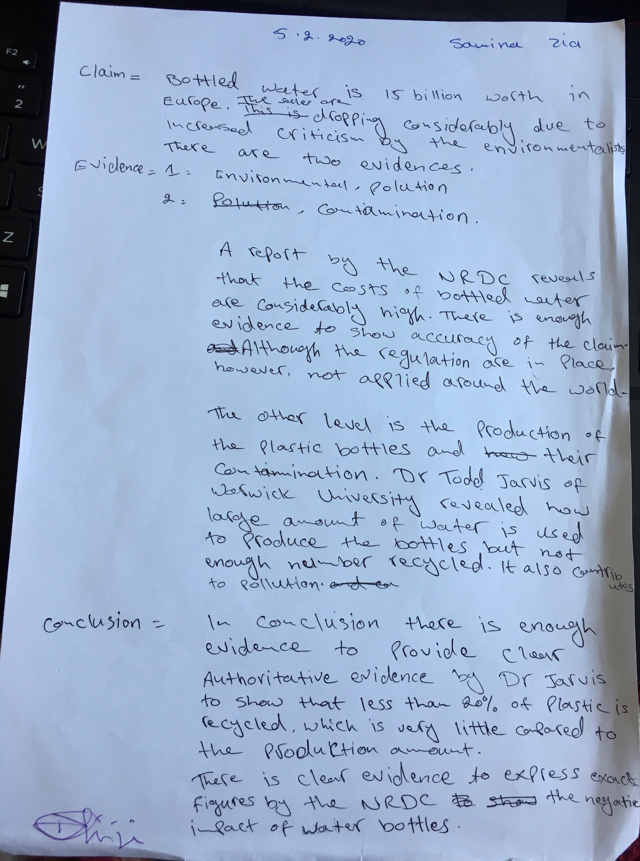



Reference:
C, P., 2019. Max Weber Bureaucracy Theory - Definition, Advantages, Disadvantages - The Investors Book. [online] The Investors Book. Available at: https://theinvestorsbook.com/max-webers-bureaucracy-theory.html [Accessed 8th March 2020].
Carrington, S., 1999. Inclusion needs a different school culture. International journal of inclusive education, 3(3), pp.257-268.
Chatfield, T., 2018. Critical Thinking. Los Angeles [etc.]: SAGE.
Cpss.neasc.org. 2020. [online] Available at: https://cpss.neasc.org/sites/cpss.neasc.org/files/Downloads_pdf/Guide%20to%20Developing%20Core%20Values.pdf [Accessed 28th February 2020].
Ghemawat, P., 2012. The ABCDs of Leadership 3.0. In Leadership Development in a Global World (pp. 62-89). Palgrave Macmillan, London.
Greenfield, T.B., 1973. Organizations as social inventions: Rethinking assumptions about change. The Journal of Applied Behavioral Science, 9(5), pp.551-574.
Irwin, B. and Seasons, M., 2012. School closure decision-making processes: Problems and prospects. Canadian Journal of Urban Research, 21(2), pp.45-67.
Kim, H.C., Kwon, J.W., Zhou, Z. and Heo, J.H., 2019. Does National Distance Affect Different Industries in Different Ways? A Test of the Ghemawat CAGE Model. Journal of Korea Trade, 23(7), pp.13-33.
Luthans, F., 2002. Positive organizational behavior: Developing and managing psychological strengths. Academy of Management Perspectives, 16(1), pp.57-72.
Mullins, L., 2005. Management And Organisational Behaviour By Laurie J. Mullins. 7th ED. Harlow: Pearson Education Limited.
Mutlu, K., 1996. Examining religious beliefs among university students in Ankara. British Journal of Sociology, pp.353-359.
Rothschild-Whitt, J., 1979. The collectivist organization: An alternative to rational-bureaucratic models. American Sociological Review, pp.509-527.
Smith, A.M. and O'Sullivan, T., 2012. Environmentally responsible behaviour in the workplace: An internal social marketing approach. Journal of Marketing Management, 28(3-4), pp.469-493.
St-johns-pri.bham.sch.uk. 2020. Welcome | St John's C Of E Primary School. [online] Available at: https://www.st-johns-pri.bham.sch.uk/welcome/ [Accessed 25th February 2020].
Weller, P., 2006. Addressing religious discrimination and Islamophobia: Muslims and liberal democracies. The case of the United Kingdom. Journal of Islamic Studies, 17(3), pp.295-325.

