

ASSESMENT 1

MARIA GHEORGHE
2243301
DATA HANDLING & BUSINESS INTELLIGENCE
LCBB5000
LECTURER MD SADEQUE IMAM SHAIKH

TABLE OF CONTENT

INTRODUCTION
- What is business intelligence
- Overview of the report
MAIN BODY
- Business intelligence trends in retail industry
- Big data analytics in retail
- Methods in handling data
CONCLUSION
REFERENCES

INTRODUCTION
All organizations need to monitor the business environment and adapt to constant changes to keep developing their performances. To succeed in the business world, is important to gather as much information as possible to adapt effectively and efficiently to the needs of society. “Business intelligence is a broad set of information technology solutions that includes tools for gathering, analysing, and reporting information” (Maheshwari, 2015), to help in the decision-making process in any industry. As stated in Microsoft Power Platform (2024), business intelligence tools can be used by companies through self-service BI platforms, like shared dashboards, artificial intelligence, data visualization. The report outlines the impact of the current trends in Business intelligence in the retail industry. There have been four revolutions in the industrial history. Starting with the invention of the steam engine, to innovative electronics, computers, and in present days, using the internet as a revolutionary force in business, with a major impact on humanity. The retail industry adapted to these changes, using the benefits of the business intelligence (BI) and its tools.
MAIN BODY
In a highly competitive business environment, the retail industry needs to adapt to market changing needs. Organizations use information to acknowledge the customers tastes, needs, and private opinions, to be able to deliver value and maintain performance. “Business intelligence enables organizations to become smarter, work smarter, and make better decisions through the use of information” (Larson and Chang, 2016). Retail companies use business intelligence tools to take advantage of every opportunity, turning data into insights in retail industry to identify trends and patterns, and make better decisions regarding marketing, pricing, inventory, research and development, performance, management and more. There is a complex process involving collecting internal, external and personal data from data warehouse, applying data mining techniques, tools and platforms to identify the relevant information for the respective market, and help the management making decisions in a easy and logical manners, find solutions for various probable issues, and improve performance. There are various business intelligence tools that retailers use to build marketing strategies by analysing data available in databases, such as Cloud Computing, SaaS ( Software as a Service), NLP (Natural Language Processing), Big data Analytical, Data literacy and data-driven cultures, self-service BI drive data discovery, data governance, AI (Artificial Intelligence) and more. Most organizations collect market data, usually in massive volumes, from websites, business transactions, social media, and other sources which provide real-time information. All the information on the internet, a combination between cloud storage, social media, and mobile devices accesses, provide an overview on any situation leading to innovative solutions, new perspectives, new images of the real world. For example, as Maheswari (2015) states, Google can predict the spread of a virus or disease by searching real time events over the globe related to the symptoms or respective features of the disease. Nowadays every enterprise, small or not, has access to information though mobile devices, computers, and similar gadgets. It is important though how all the information is used in competitive advantage. Using business intelligence, with specific skills and tools, retailers can collect, store, analyse and apply these substantial amounts of data in the business structure and business strategies to improve performance.

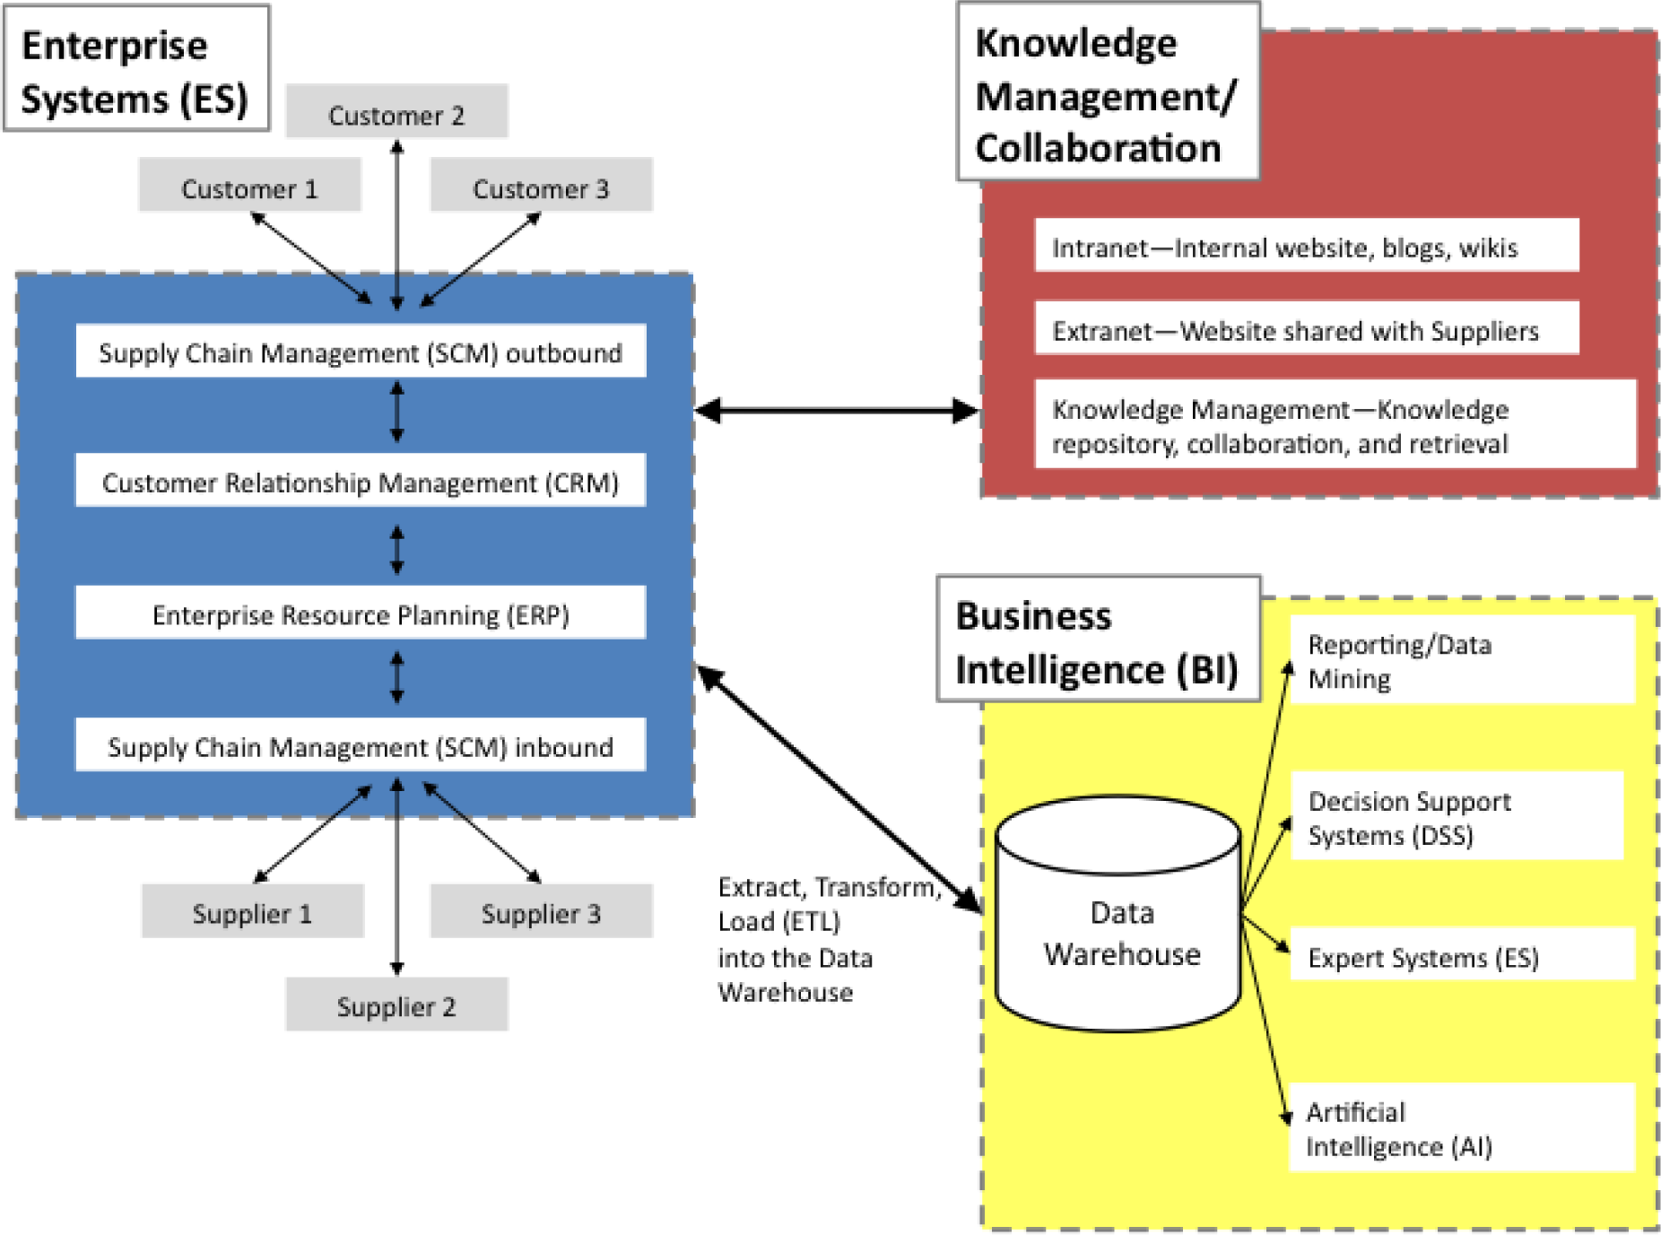
This Photo by Unknown Author is licensed under CC BY-SA-NC
Big data, “the next frontier for innovation, competition and productivity” (Manyika, 2011) is described by these main attributes: volume, variety, velocity, and veracity (Aktas and Meng, 2017); volume as in the vast amount of data available in data warehouses and data marts, which organize the data in better insights, variety due to various sources of information, velocity for the speed of delivery and data generation, and veracity, related to the uncertainty of data. In retail, the amount of information available to research, including all the data stored that customers share through gadgets and apps, give the advantage of knowledge regarding people’s needs and tastes, that businesses use to satisfy in the best ways favourable in competitive advantage. Generating and recording information has become part of daily life. Shopping, social media, location, research history on websites, they all provide hints of lifestyle that retailers use and analyse to achieve customers satisfaction and loyalty. It is important for organization to develop big data strategies to help in decision making processes regarding improvements in customer service relationships and development of new products or services. Therefore, business intelligence experts are necessary to transform data into dashboard reports, ensuring data security, implement data governance, validating accuracy and quality through big data testing methods, providing solutions for better decision making by identifying opportunities through trends and patterns in the industry.
In present time, the world is witnessing the advanced digitalization of the industry, where with the integration of business intelligence tools, such as Internet of Things, or Artificial Intelligence, or smart gadgets enables the rapid flow of information between channels while providing customised services to customers (Loh Li Har, et al., 2022). Retailers can predict trends, provide quality customer experience, optimize their services, and their businesses, through data-driven strategies, collecting and analysing operational data, all with major benefits in the decision making process, some of them are: customer behaviour understanding, improved inventory management, improved supply chain management, more effective marketing, predictive analytics, cost reduction and more.
The organizations develop by satisfying the customers with quality, low costs, in a convenient and timely manner (Maheshwari, 2015).BI enables Customer Behaviour Understanding, by analysing demographic data and behavioural data. The information can be used to target a specific target segment by sending personalized marketing messages (Integrio Systems, 2024).
By tracking inventory from manufactures to the sale point, Inventory Management assures the delivery of the products and services in satisfactory time and at the correct location. Retailers need to have an accurate view of the inventory through omnichannel digital tracking systems, to improve efficiency and customer satisfaction.
Implementing BI tools in Inventory Management has a positive effect on Supply Chain Management, as it provides a large view of orders, stock, and supply chain data, therefore optimise merchandize planning. By leading Predictive Analytics, analysing data from historical sales and market trends, retailers can predict what to stock for future orders.
BI helps retailer avoids unnecessary expenses, by pinpointing processes that are wasting time, are resource-intensive, or have too many errors, leading to Cost Reduction benefit and allowing to allocate the capital in a more efficient manner (Integrio Systems, 2024). The companies can become cost-efficient by gaining more revenue, meeting customers requests, improve productivity and anticipate marketing trends.

CONCLUSION
Retail business intelligence empowers companies to strengthen their organization, and become more competitive, by analysing and understanding customers’ needs and wants, achieving customer satisfaction, increasing profitability. Big data analytics help predict actionable insights, improve performance and competitiveness. As stated by YU Y. L. and Teoh A. P. (2020), business intelligence provides faster access to information and data-driven tools for data analytics, improving business performance, identifying opportunities and threats in the industrial market, improving relationships with stakeholders, like customers, suppliers, employees, community, contributing to human capital development. Business intelligence is a crucial tool in current business environment, with a major impact in knowledge and innovation.

REFERENCES
Aktas, E., & Meng, Y. (2017). An Exploration of Big Data Practices in Retail Sector. Logistics, 1(2), 12. Available at: https://www.mdpi.com/245358 (accessed:15.11.2024)
Integrio Systems (2024), Retail Business Intelligence: How to Implement It, Available athttps://www.integrio.net/retail-business-intelligence, (accessed:16.11.2024)
Larson, D. and Chang, V. (2016), ‘A review and future direction of agile, business intelligence, analytics and data science’, International Journal of Information Management, 36 (5), pp.700-710
Loh Li Har, et al. (2022), Revolution of Retail Industry: From Perspective of Retail 1.0 to 4.0, Procedia Computer Science, 200, 1615-1625. Available at: https://www.sciencedirect.com (accessed: 16.11.2024)
Manyika, J. et al. (2011), Big data: The next frontier for innovation, competition and productivity, McKinsey Global Institute. Available at: https://www.mckinsey,com/mgi (accessed:16.11.2024)
Maheshwari, A. (2015) Business Intelligence and Data Mining. New York, Business Expert Press. Available at: https://research-ebsco-com.ezproxy.uwtsd.ac.uk/linkprocessor/plink?id=41524f74-61fe-3fd2-9a24-4d633f143c20 (Accessed: 16.11.2024).
Microsoft (2024), What is Business Intelligence / Microsoft Power BI, Available at: htpps://www.microsoft.com/en-us/power-platform/products/power-bi/topics/business-intelligence/what-is-business-inteligence (Accessed: 16.11.2024)
YU, Y.L. and TEOH, A.P. (2020), Realizing the strategic impact of business intelligence utilization. Strategic Direction, 36(4), pp. 7-9.

