Supporting pupil progress: a detailed analysis of one child’s holistic development, with justification for the next steps in learning.

Introduction

This assignment will look at the holistic development of an individual pupil within a school context and the different support required to develop the pupil further during their time in school. It will look specifically at Literacy development, Mathematical development, Well-being, Physical development and the development of the Welsh language.

The school that Pupil X is located in, is a relatively large school, with a two-form entry which holds 443 pupils aged from 3 years old to 11 years old (My Local School, 2019). It’s situated in the town centre where 8.2% of families are from an English as an additional language background which is just above the national average in Wales and is 4 times the levels in the local authority. In 2018, the average percentage of pupils on free school meals was 15%, which is below national and local authority average. The class that will be discussed is Year 6 (ten to eleven-year-old) made up of 53 pupils (My Local School, 2019).

The learner that will be followed is an English as an Additional Language (EAL) pupil. This individual came to the school at the start of the year, where they had little to no English. This pupil was chosen because the individual struggles with English as a language, however they are More Able and Talented (MAT) in Maths. Hence identifying different strategies to help develop literacy and linguistic skills as well as challenging their mathematical knowledge.

Data collection

The method in which the data will be collected will follow the Mosaic approach (Clark and Moss, 2011). The Mosaic model is where the child has an input into what they believe is important in their learning. This will give an insight to the researcher about what is important to the child and to listen to their voice about their perspective on how they learn. This form of research is closely linked to theorist Laing (2014) as they believe that child’s voice, whereby their thoughts and perspectives on learning scenarios are important (Alexander, 2010). There are a number of methods to collecting data that the Mosaic approach use, which will be used in this research. Such methods include; observations, photographs, discussion with pupil and annotated sample of work (Clark and Moss, 2011). Through this form of research, it limits the amount of quantitative data and focuses on the qualitive data. Through this, it gives an insight into the thought and opinions from the observer and from this research it may give us an understanding as to how the quantitative data came about.

Observing the pupil whilst they’re undergoing certain actions can give us a lot of information about them (Cooke, 2016). By observing them in a natural environment, it gives us an insight into how the pupils react naturally and in a realistic, genuine way (Welsh Government, 2013). Having said this, if the pupils are aware that they are being watched, some may put on an act resulting in the validity of the data collected being lost (Morse, 1991). However, if the pupils are unaware that they are being watched, then ethical issues will arise (British Educational Research Association (BERA), 2011). Therefore, the pupil will be told that they’re being observed among others as well.

Another method used in the Mosaic approach is where the children take photographs of certain areas / resources that hold a significant importance to them, to help them learn the best possible way. Photos can have a significant importance in collecting data as it gives context without needing words (Clarkand Moss, 2011). If a pupil has difficulty in verbal expression, they can take photos to help themselves explain what’s important to them to help them learn. The downside may be that the pupils may take photos of random objects, which will deter from what actually helps them. Therefore, direct instructions need to be given throughout and continuous reminders for them to link back to what’s most important to them.

Another method in which I will use to gain information about Pupil X is having a discussion with the child (Clark and Moss, 2011). This allows me to gain the point of view of the participant by asking specific-questions. However, this form of data collection does have limitations, as the pupil may want to give an answer that they feel is “correct” and not putting their own point of view across (McTighe and Wiggins, 2013). Therefore, when undergoing the child-conferencing, questions must be impartial and not mis-leading by leading with open-ended questions.

When looking and analysing the collected data, it will follow Nottingham’s (2013) ASK model. This will allow the observer to reflect holistically on the learning of Pupil X, such as their attitude towards learning, their skills and their knowledge on certain subjects. They can then acknowledge that these attributes have an important role in the learning of the participant.

When participating in child research there are ethical issues that need to be discussed and adhered to. Throughout this assignment, the confidentiality of the school and Pupil X will be maintained, to keep the trust between participant and observer, which in turn may then develop further information. As a specific pupil will be followed the anonymity of the pupil cannot be kept, however their identity will remain undisclosed. To ensure that all conditions were adhered to, guidelines from the British Education Research Association (BERA) (2011) will be followed as well as the guidelines set by University under the Ethics and Integrity Code of Practice (UWTSD, 2017). From following these guidelines, it was ensured that consent has been given from the school, from the parents / guardians of Pupil X and most importantly from the pupil themselves (see appendix 1). It was also ensured that if they wish to withdraw at any moment, they are more than welcome to.

Analysis of learner

During the recent weeks, Pupil X has been observed during various lessons, observed on how they react to different scenarios, how they interact with others as well as their attitudes towards learning. The five areas in which will be discussed is Literacy, Mathematics, their Wellbeing, Physical development and Welsh language.

Literacy development:

Pupil X came to the school at the start of the academic year, and they are from an English as an Additional Language family. It is seen from the observation over the past few weeks, that Pupil X’s confidence is low when speaking English. Their preferred method of communication is non-verbal such as nodding, shaking the head or the shrugging of the shoulders when asked questions (see appendix 2). Analysing this, this is probably due to the fact that they’re vocabulary in the language is very limited, resulting in their confidence being low when speaking in front of an audience.

When doing the tour, Pupil X took a photo of the ‘Rainbow room’, which helps them learn English (see appendix 3). However, this had to be prompted from the pupil as they had not chosen a particular area that helped them with their language skills. This room allows pupils from an EAL background to have separate sessions, to help with their literacy skills. However, since being there, Pupil X said that they’ve only attended a few sessions, this may be due to it being run by an external company and funding is limited for this group.

Although having limited knowledge in the English Language, Pupil X’s has an excellent attitude towards learning with great resilience to keep going when faced with a challenging task. When asked to complete a difficult task of writing a newspaper article, Pupil X struggled to find the vocabulary to have an appropriate title (see appendix 4). However, it was shown that they would not finish until their work was at a standard to which they were happy with. As seen in Appendix 5, Pupil X has not written much in the time allocated, however, as Bell Foundation (2017) states that EAL pupils will need extra time to think of appropriate vocabulary. They were determined to find an alliteration for the title proving to have a good resilience. Therefore, Pupil X has the appropriate skills and the attitude towards their learning, however, the attribute that is lacking, is their knowledge on the English Language.

Mathematical development:

Pupil X’s main focus and favourite lesson in school is Maths. As they are a MAT pupil, they enjoy and thrive during Maths lessons. It was observed, during the national tests, Pupil X was laughing and smiling throughout the reasoning and procedural tests, only asking for help to read the questions. When asked to give a tour around what helps them learn, the first area in which the pupil had the biggest interest and thinks helps their learning, is the Mathematical area. They showed the different resources available to them, in which helped them complete mathematical challenges (see appendix 6). They also chose the “Maths Challenge Box”, this box provides mathematical challenges to pupils once they’ve finished their work. Pupil X had great satisfaction in showing that they chose from “Box A” which is tasks aimed at Year 7 / 8 pupils. From this, it was seen that Pupil X had pride in their work as they tried very hard to complete the tasks set for the pupils and they strive to better themselves each time.

One of the reasons as to why the mathematical knowledge of Pupil X is so vast may be due to the fact that prior to attending the school, they were previously in a country. This Country is well known for being in the top 5 best countries for mathematics according to OECD (2015), which is likely to have benefited this individual. Alternatively, a factor that may have a significant impact, would be the fact that mathematics is continuous and consistent throughout the world, whereas language would have an impact on the pupil as the structure of language is different in every Country (Centre for Global Education, 2019).

Linking this to the ASK model (Nottinghams, 2013), Pupil X’s has excellent knowledge and skills in Mathematics which results in a better attitude towards the subject. However, due to the nature of school hours, the observer had limited time to observe Pupil X in their learning of Mathematics, therefore the observer relies heavily on the input made by the teacher. From this, it may have an effect on the validity of the research as every individual has a different outlook on different scenarios.

Wellbeing:

When asked about a “best friend” Child X did not mention a particular name, nor could they mention a group of children (see appendix 7). A number of factors could have been the effect of this, indicatively Child X has only attended the school since the start of the school year, implying it is hard for them to create strong friendship bonds when pupils are in their last year in Primary School, having already built up relationships since attendance at primary school. It was witnessed during an observation session during break, when Pupil X stayed with a group of boys playing football (see appendix 8). During this interaction, Pupil X found it difficult to express themselves to the others and somewhat sat back to watch. This links to the comment earlier in the literacy development. From analysing these interactions with other pupils, it was then seen that Pupil X’s main struggles are with the language barrier, which in turn has an impact on their social skills.

As Bukowski, Newcomb and Hartup (1996) state, individuals need friendship to strive in their learning as when they will feel wanted and they have a sense of belonging to the school, their attitude towards learning gets better. Therefore, not only does it have an impact on their social skills, but it is also needed for their self-esteem. This links to Bronfenbrenner’s theory (Gray and MacBlain, 2012) where the individual’s development is built and shaped from their surroundings which include their peers and friends. From having that lack of connection with others, the individual development will be hindered. Maslow Hierarchy somewhat agrees with Bronfenbrenner’s theory. Maslow (Noltemeyer, 2012) states that at the bottom of the phycological needs, pupils need to have the sense of belonging and love. Without this trait, pupils will not be able to progress onto esteem and self-actualisation needs. Thus meaning, although Pupil X has the bottom two layers to the Maslow Hierarchy need, Pupil X fails to complete the next layer which results in them not reaching their full-potential in their academic and social development.

Welsh Development:

When asked what they thought about the Welsh lessons, Pupil X thought that the lessons can be fun, however they found it difficult as they already have to learn one language from the start let alone another language, especially as its Year 6 and they begin to use more complex sentences instead of simple phrases and sentences (see appendix 9). However, from observing body language when discussing Welsh, it was observed that the body language of Pupil X was reserved, therefore it is thought that Pupil X’s response to the question was to please the observer instead of giving their own opinion.

During one of the Welsh sessions which was an introduction to the theme “gwyliau”, to stimulate and encourage pupil participation, it was decided to help their vocabulary by playing games (see appendix 10). However, as stated before in the literacy development, Pupil X has difficulty with the knowledge of language which affects their confidence. In this scenario Pupil X has little to no knowledge on the Welsh Language and little skill, which has a major influence on the attitude towards their learning. During this session, Pupil X sat back and allowed their partner to do most of their work. This is a huge change into their normal attitude towards learning. As the pupil is well out of their depth with the knowledge of the lesson, they seem to think as it is slightly ‘pointless’ to attempt to learn a language when they are so far behind. Therefore, the resilience and desire to succeed has been impacted, due to the Pupil X’s subject knowledge.

This research has a counter argument against Angelis (2007) theory which states from acquiring another language, it becomes easier to obtain and acquire as it is easier to distinguish between the different language patterns. However, as Pupil X has not got a good comprehension of the English Language, they find that acquiring the Welsh Language much more difficult.

The limitations to this however lie with limited time has been spent observing the pupil during this subject, it is hard to see whether their attitude changes during the different scenarios as it was more of a verbal lesson. If however, we take into consideration the pupils body language when discussing the subject, then it is likely that they will find the subject difficult.

Physical Development:

Pupil X agreed that they enjoyed sports. They are stronger at individual sports rather than team sports as they find difficulty in communicating with their peers (see appendix 11). When asked if they wish to participate in a cricket match, Pupil X agreed to go. However, once realising that it is a team game, they withdrew themselves. When asked about this, Pupil X shrugged their shoulders. A possible likelihood from this is that they will find the communication part of the task difficult.

During the last week, pupils visited a residential area and participated in a variety of activities. From the observation, at the start of the week, pupil X struggles or felt uncomfortable to socialise with other pupils again choosing to interact by body language. However, as the days progressed where the enthusiasm still went on, Pupil X started to become more vocal in expressing themselves, even started to build friendship with 3 pupils who they shared a room with (see appendix 12). These pupils were also MAT in Mathematics. They had good co-ordination skills and enjoyed taking risks in the residential activity centre. Once again, when they had good skills and knowledge of the subject, their attitudes change and they have a stronger desire to succeed. It was evident as the time went on, Pupil X grew in confidence and was eager to take part in all activities. Laing (2014) states that pupils learn best when they find something that they’re interested in. By having this stimulus, it provided a curiosity to the pupil as they had never heard of some of the activities beforehand such as “quad bikes” or “tobogganing”. The pupil listened well to the instructions made by the instructors and persevered when they spoke Welsh. From previous observations, Welsh is a subject that Pupil X find difficult, however, with some encouragement from the instructors, Pupil X started to use simple Welsh language.

When asked about the different activities, Pupil X explained that tobogganing was their favourite as it went “really fast” and “scary” but they also described it as fun as they got to “crash into friends” (see appendix 13). This was the first time that Pupil X mentioned friends since being in the school. As stated earlier, since being in the residential area, Pupil X became friendly with the members in his dorm. They bonded during the activities as well as during their free time.

Pictures of Pupil X and their friends were taken, however due to ethical issues (BERA, 2011), they will not be disclosed within this assignment to maintain the confidentiality of the participant.

Next steps

From these observations it is clear that the main barrier for Pupil X in each subject is language. Once this has been overcome, Pupil X will grow in confidence and it will be easier for them to communicate and express themselves to others.

Literacy Development (inclusion of Welsh):

As seen throughout the observations, the main focus for development for the pupil is their language skills. In order for them to succeed, they should be provided with extra language session to help develop their vocabulary and grammar to help their sentence structure. From looking at Pupil X’s work, where they lack the most confidence is oracy skills as well as tenses. By providing an hour slot every week, where the lesson is specifically aimed to help develop a certain area that needs to be improved. Training can be provided by the Minority Ethnic Achievement Service (MEAS) (Carmarthenshire County Council, 2018) to the Teaching Assistant to help them to target a specific area to help Pupil X with their learning.

During everyday sessions in school, it’s almost impossible to find extra time in order for interventions to occur without the pupils missing out on opportunities. After some thought, it was unadvisable to take Pupil X out during lunch / break as this time of socialising with peers is important for them to develop confidence and practise their social skills, therefore it was decided when Welsh is being taught to the class Pupil X can be taken out to focus specifically on their needs.

From looking at Pupil X’s work, where they lack the most confidence is oracy skills and well as tenses. By providing an hour slot every week, the lesson is specifically aimed to help develop a certain area for Pupil X that needs improving. Training can be provided by the MEAS to the Teaching Assistant to help them to target a specific area to help Pupil X with their learning.

Pupil X does not seem to be benefiting from participating in the Welsh Language session as the challenge is too high for them. To provide extra support for their second language (English), they can have a “catch-up” session with the Teaching Assistant provided in the class. The drawbacks to this however are that the pupil will miss out on the Welsh session all together. This will increase the gap between the attainment of the Welsh language of the class and Pupil X. It cannot go without mentioning of the importance of the Welsh language in today’s education in Wales, with the emphasis on the new curriculum being placed within school by 2021 and the Welsh Government put such an important emphasis for Welsh to be used throughout the school (Welsh Government, 2019).

However, as there’s already a huge gap between the knowledge of the Welsh language between Pupil X and the class, the lessons itself are not benefitting the pupil. It does not mean to say that Pupil X will miss out on all Welsh altogether. Instead of pursuing the education where the challenge is too high for the capability of pupil X, little steps need to be made to build up to this point. To ensure that the Welsh language will not be pushed to one side, and ensure that it will still benefit Pupil X, mini welsh session or “sesiwn drillio” can be placed in every morning. Mini-sessions every day will benefit Pupil X and the teacher can focus on the development of each child, therefore they will be able to challenge the more able in the class as well as challenging Pupil X’s which is suitable for their ability. Mini-sessions like these has been proved to be effective, so long as it is continuous and happen daily. Cohen and Squire (1980) states that, repetition in lessons embeds the knowledge, and ensure long term memory. It is also a good indicator for Assessment for Learning strategies, as it is continuous teachers are more likely to identify the areas in which the children are struggling with.

Although taking pupil X out of Welsh sessions and having a negative effect on their Welsh knowledge. It is more important to have a sound understanding of one language rather than a misconception with one language and little or no ability in the other.

Mathematical Development:

The intervention set into place for their mathematical development is to create an enrichment group solely for More Able and Talented groups for maths. In the school, every class from Year 1 to Year 6 has an opportunity to participate in different activities every Friday afternoon, this slot is called Enrichment. By organising a group to challenge the more able and talented pupils in maths can have many benefits. The benefits of this is that it doesn’t necessarily have to focus on one pupil, therefore it will benefit a group of pupils who are more and talented in Maths. It allows the teacher to focus solely for the more able pupils, challenging them with a higher thinking skills. This provides an opportunity for MAT pupils to be challenged at an appropriate level every week.

However, the downside is within the enrichment groups where it caters from Year 1 up to Year 6. With such an age range there would be no benefit to this scenario as the more able groups will have a huge capability gap. Though theorists such as Vygotsky suggest that scaffolding can benefit the higher attaining pupils as they have a better understanding, however in this case, it needs to be challenging for all pupils (Nordlof, 2014). Therefore, to ensure that all pupils are having that challenge, a rota can be made to allow MAT pupils in every year the opportunity to better their Maths, such as Year 5/6 one week and 3/4 another. Another option we to consider is the fact that pupils may not wish to attend Maths group as they don’t have a particular keenness or curiosity to further their Mathematical knowledge. This has been thought through and taking into consideration the attitude that pupil X has towards Mathematics, it was decided that they would probably consider taking up the group.

As stated earlier, Pupil X started to build a friendship with other MAT pupils in the residential which provided an opportunity to socialise with others alike this group, being beneficial to develop social skills as well as enhancing their academic skills.

Wellbeing (including physical education):

As pupil X struggles with socialising due to the language barrier, I think it is essential for Pupil X to be provided with as many opportunities to allow them to socialise with others, without feeling pressured to do so. As stated earlier, how Bronfenbrenner (Gray and MacBlain, 2012) and Maslow (Noltemeyer, 2012) emphasise the importance of friendship and the feeling of being wanted within their close friendship groups. The strategy putting forward for Pupil X is a buddy system. Year 5 and 6 will be put into pairs and assigned a “mastery” in their strong specific subject, in Pupil X’s case either Maths or Physical Education. They will then have the task of supporting small groups of children in the Foundation Phase, with the area in which they need support with. As this is a whole school approach, consent must be given from the headteacher. This will support Pupil X as they are socialising and having to use language to help and support others whilst also having confidence to teach something that they are aware that they’re good at. Pupils will work in pairs to support each other. The drawbacks however to this is that teachers must be aware of what the pupils are teaching if a pupil has a misconception, it may hinder their learning rather than support (Williams, 2003). This form of intervention will support pupil X in their socialising and the development of their language as well as encouraging them to take some responsibility and feel as though they are worthy of passing on information giving them the feeling of being wanted.

Theorist such as Vygotsky emphasise the importance of socialising as pupils will be able to learn from one and other (Nordlof, 2014). By socialising with others, Pupil X’s peers are able to model the appropriate language when having a conversation, which allows Pupil X to have the opportunity to surround themselves with different vocabulary and different sentence structures. Vygotsky’s other theory is scaffolding. Pupil X will play the role as a teacher, therefore supporting and scaffolding the lower ability pupils, but not only will they be securing their knowledge on the subject, they will also be able to immerse themselves in the English Language (Vygotsky, 1962).

This also links to one of the areas that Donaldson proposed in his report Successful Futures about the development of the Welsh curriculum (Donaldson, 2015). He states that child need good collaboration to help them move forward in their learning. Therefore, by providing opportunities for pupils to work and help each other, it puts them into good stead for the future of the curriculum.

The residential allowed Pupil X to become more confident in expressing themselves. By providing different stimulating opportunities such as the different activities available at the residential may benefit Pupil X as they were curious with the different activities. The drawback to this however, is that these activities will not be able facilitate on the school ground due to funding, space and health and safety rules. However, ensuring the continuing of stimulating team sports (such as football, cricket, rugby, etc) or team working activities (active problem solving tasks) are provided throughout the school will help Pupil X become more confident in speaking and expressing themselves.

However, as stated before, Pupil X did not want to attend a cricket group due to the language barrier. Though the more often they participate in situations or group exercises, the more accustom they become, hence they will become more relaxed during team building exercises. However, this does take out the curiosity element towards their attitude in learning, a main component when attending the residential. To ensure the continuum of their curiosity, it’s important to allow different opportunities for pupils to participate in, however for pupil X, it is critical to keep the same language structure, throughout their education.

Conclusions

From this research, it is seen that the main barrier to the development of Pupil X is their language. Once this barrier is overcome, the pupil will be seen to make enhanced progress in their learning. They have a good attitude towards learning, which helps them succeed in challenging tasks set for them. By focusing on the development of the pupils literacy skills, it should have a domino effect for the development of the other subjects. Most strategies chosen are cost efficient and will benefit more than just one individual. However, as with all strategies, there are limitations, such as the possibility of missing out on a certain area but benefiting another.

Reference:

Alexander, R. (ed) (2010) Children, Their World, Their Education: The Report of the Cambridge Primary Review. London: Routledge.

Ambridge, B., & Lieven, E.V.M. (2011). Language Acquisition: Contrasting theoretical approaches. Cambridge: Cambridge University Press.

Angelis, G. (2007) Third of Additional Language Acquisition. London: Cornwell Press LTD.

Bell Foundation. (2017). Classroom support strategies: Working with EAL learners in secondary settings. Available at: https://www.bell-foundation.org.uk/wp-content/uploads/2017/09/Classroom-Support-Strategies-Secondary.pdf [accessed on: 20th May 2019].

British Educational Research Association (BERA) (2011) Ethical guidelines for educational research. Available at: https://www.bera.ac.uk/researchers-resources/publications/ethical-guidelines-for-educational-research-2011 [Accessed: 21 April. 2019].

Bukowski, W., Newcomb, A. and Hartup, W. (1996) The Company they keep. UK: Cambridge university press.

Carmarthenshire County Council. (2018). Minority Ethnic Achievement Service (MEAS). Procedure and Practice handbook. Available at: https://www.carmarthenshire.gov.wales/home/council-services/education-schools/support-for-learners/#.XO-gLC_MzGI [Accessed on: 20th May].

Centre for Global Education. (2019) Understanding the World Through Maths. Available at: https://asiasociety.org/education/understanding-world-through-math [Accessed on: 26th of May]

Chomsky, N. (1965). Aspects of the Theory of Syntax. MIT Press.

Clark, A., Moss, P. (2011) Listening to young children: The Mosaic Approach. London: NCB.

Cohen, N. J., and Squire, L. R. (1980). Preserved learning and retention of pattern analyzing skill in amnesia: Dissociation of knowing how and knowing that. Science, 210, 207–209.

Cooke, E. (2016) The importance of observation. Available at: http://www.theguardian.com/lifeandstyle/2012/jan/15/pay-attention-people-faces [Accessed: 1 March 2019].

Donaldson, G. (2015) Successful Futures: Independent Review of Curriculum and Assessment Arrangements in Wales Crown Copyright, available at: http://gov.wales/topics/educationandskills/schoolshome/curriculum-for-wales- curriculum-for-life/why-we-are-changing/successful-futures/?lang=en [Accessed on 21st May 2019].

Gray, C. and MacBlain, S. (2012) Learning theories in childhood. London: Sage.

Laing, S. J. (2014) ‘Enabling Young Children’s Participation in Decision Making’, SSSC News, June edn. Available from: http://ssscnews.uk.com/2015/05/04/enabling-young-childrens- participation-decision-making/

McTighe, J. and Wiggins, G. (2013) Essential Questions: Opening Doors to Student Understanding

Morse, J. (1991) Qualitative Nursing Research: A Contemporary Dialogue. London: Sage

My Local School (2019) Model Church School in Wales. Available at: http://mylocalschool.wales.gov.uk/School/6693322?lang=en (accessed on: 27th April 2019).

Noltemeyer, A. (2012). The relationship among deficiency needs and growth needs: An empirical investigation of Maslow's theory. Children & Youth Services Review,34(9), 1862-1868.

Nordlof, John. (2014). Vygotsky, Scaffolding, and the Role of Theory in Writing Center Work. (Vol. 34).

Nottingham, J. (2013) Challenging learning. Theory, effective practice and lesson ideas to create optimal learning in the classroom. New York: Routledge.

OECD (2015) PISA results 2015. Results in focus. Available at: https://www.oecd.org/pisa/pisa-2015-results-in-focus.pdf [Accessed on 25th May].
UWTSD (2017). Research Ethics & Integrity Code of Practice. [online] UWTSD. Available at: https://www.uwtsd.ac.uk/media/uwtsd-website/content-assets/documents/research/research-ethics-integrity-code-practice.pdf [Accessed 10 May. 2019].

Vygotsky, L. S. (1962). Thought and language. Cambridge MA: MIT Press.
Welsh Government (2019) Welsh Language strategy and Plans. Available at: https://gov.wales/welsh-language-strategy-and-plans [Accessed on: 22nd May].

Welsh Government, (2013) Classroom observation. Available at: http://learning.gov.wales/docs/learningwales/publications/131219-classroom-observation-guidance-en.pdf [Accessed on: 20rd of April. 2019].

Williams, J. (Ed.) (2003).The knowledge Quartet. Proceedings of the British Society for Research into Learning Mathematics. University of Cambridge. 23(3).

Appendix:

Appendix 1:
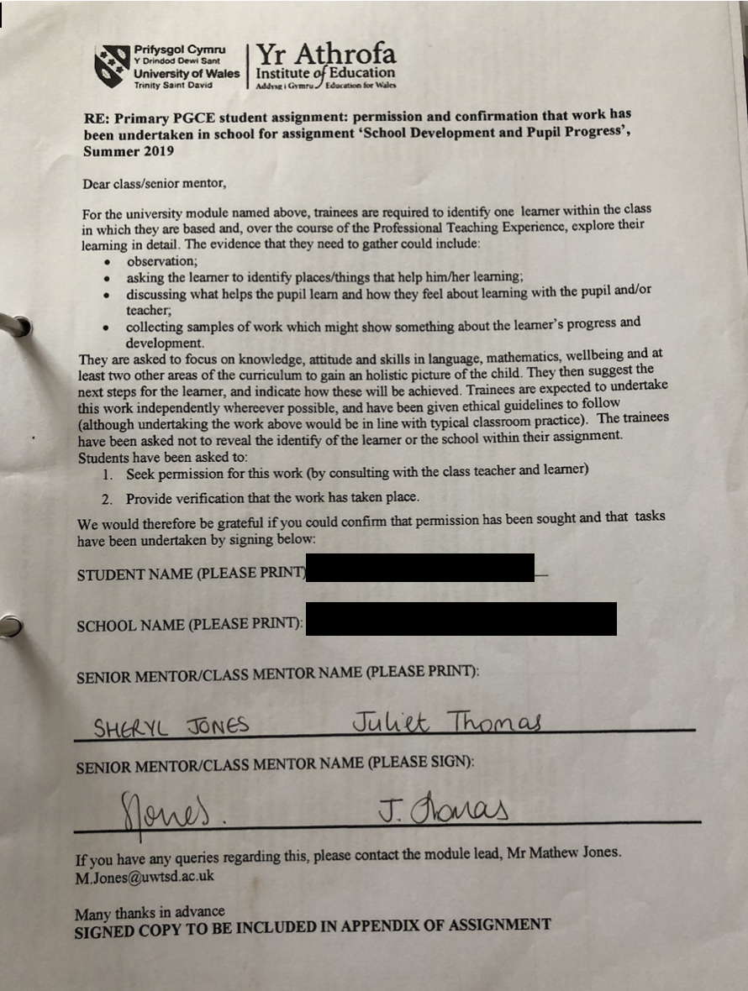

Appendix 2:

Interview:

What do you think about school?

Nods *Thinks* Yes, I like it.

What do you enjoy most?

Umm it got to be Maths.

Can you show me what helps you with maths?

*walks over to the mathematic corner, shows resources (calculator, fraction sheets, place value cards etc*

Do you use any of these in maths?

Nods and points at calculator

What helps you with English?

*Looks around* Shrugs shoulder.

Can you think of anywhere around the school? Outside maybe? Another class?

Umm … maybe rainbow room.

Can you show me? What you do there?

Nods. Umm I don’t know.

Appendix 3:

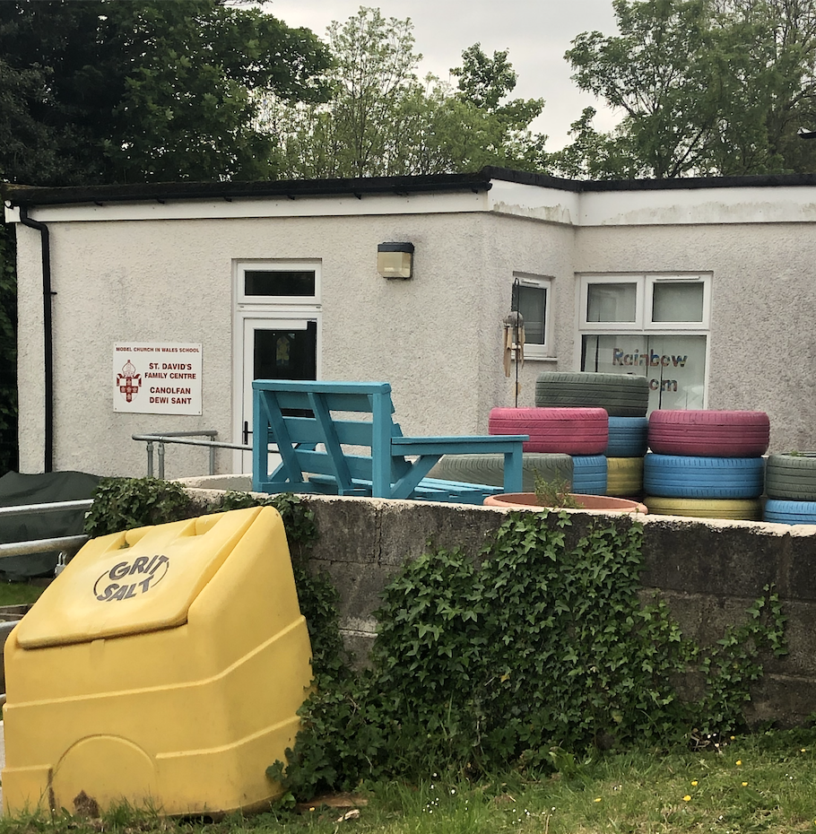

Appendix 4:
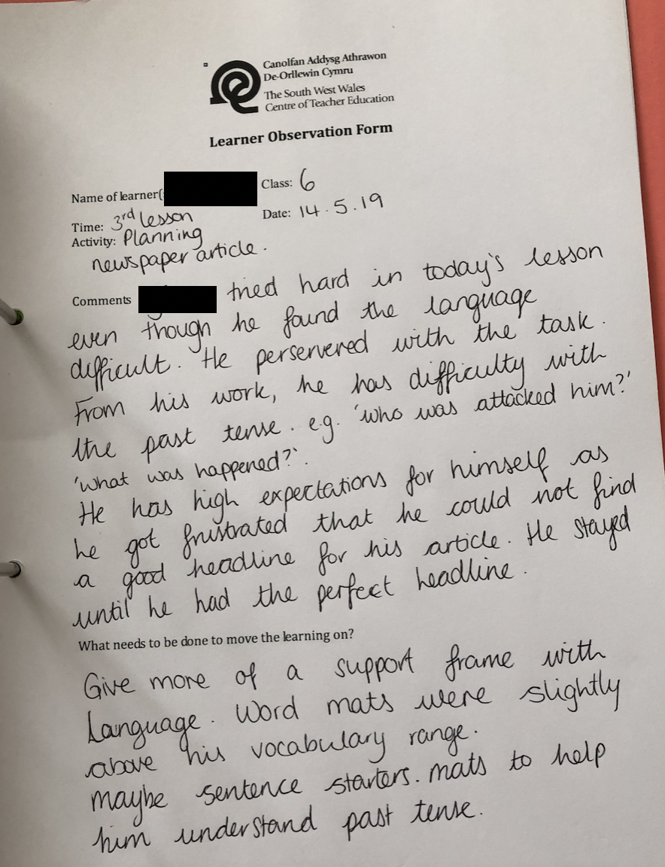

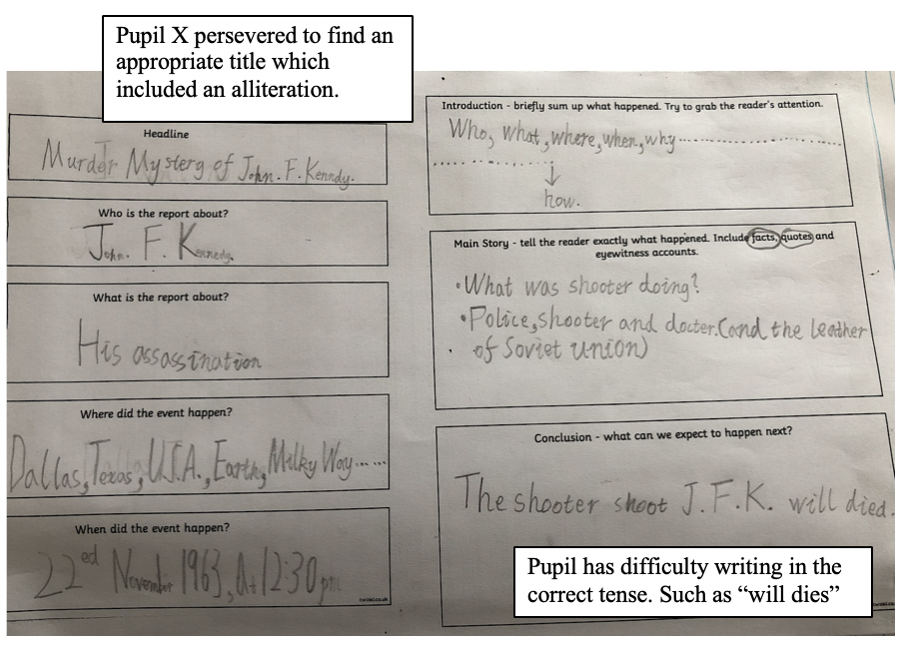

Appendix 5:

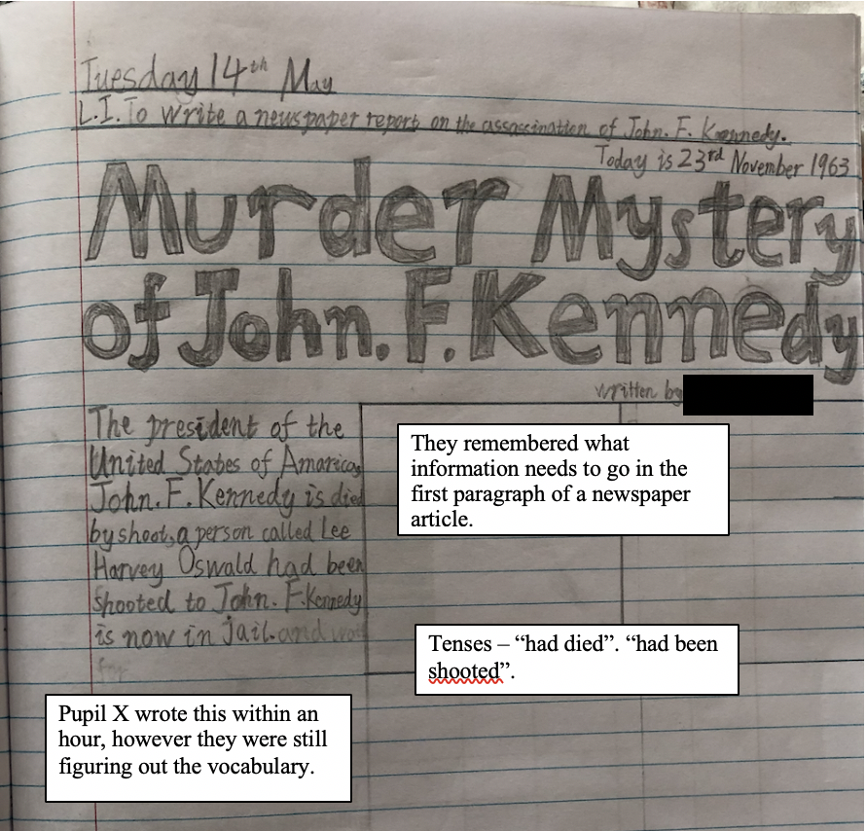

Appendix 6:
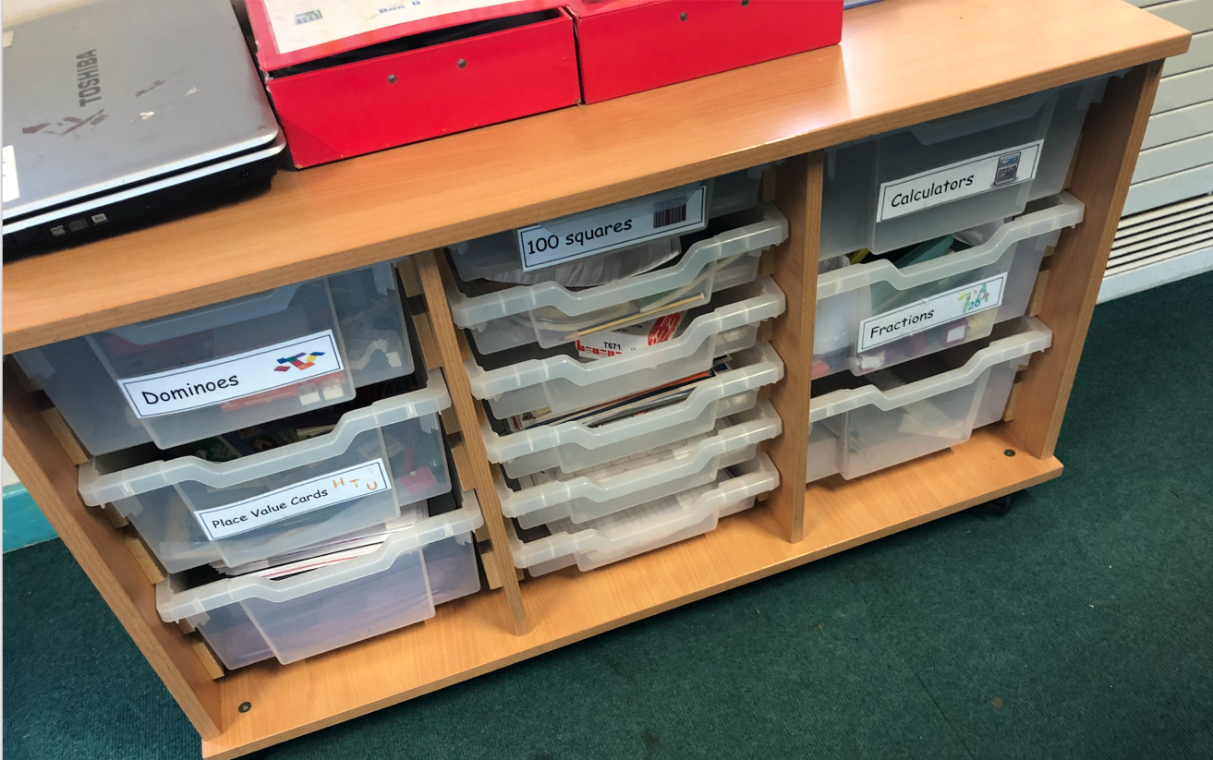

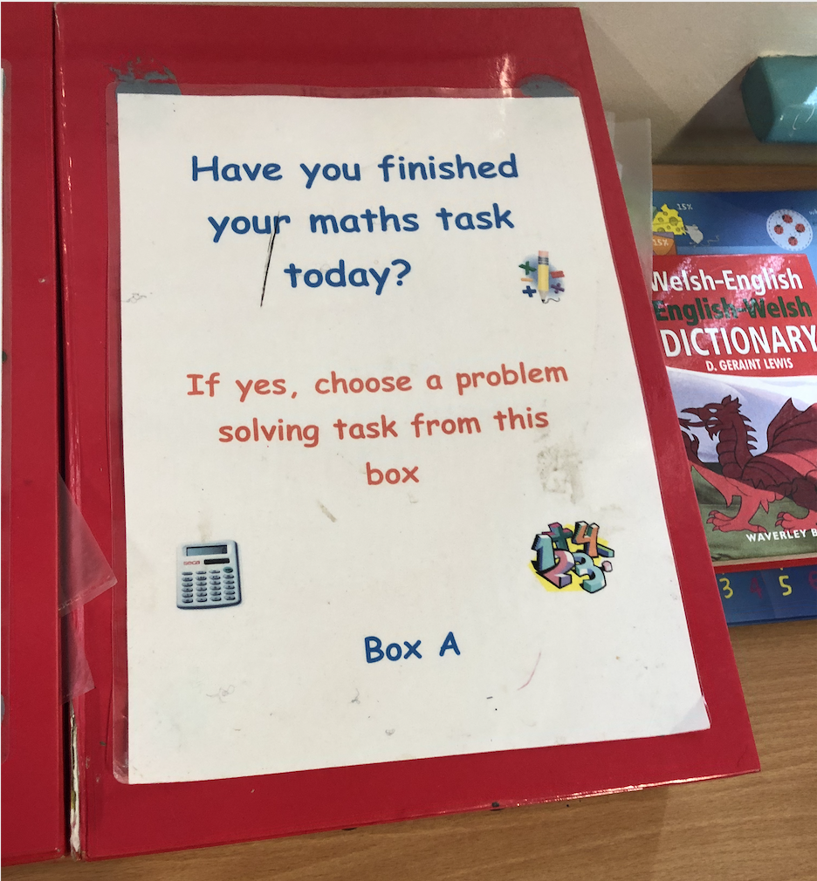

Appendix 7:

Interview:

Who’s your closest friend in school?

Thinks shrugs shoulder

Do you have a group of friends you normally hang around with?

Thinks again. Shrugs shoulder and then shakes head

Interview:

I see you found Welsh a struggle today, what do you think about Welsh lessons?

Umm it’s ok. *looks in another direction*

Do you play games in Welsh?

Nods. It’s fun. *in an off the shoulder*

Appendix 8:

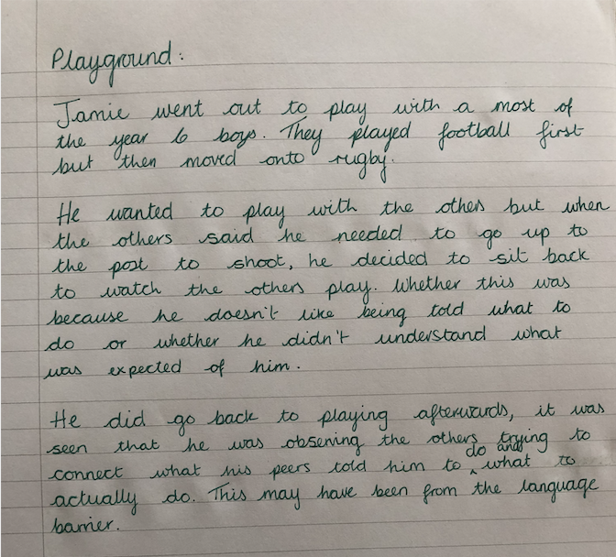

Appendix 9:

Interview:

Who’s your closest friend in school?

Thinks shrugs shoulder

Do you have a group of friends you normally hang around with?

Thinks again. Shrugs shoulder and then shakes head

Interview:

I see you found Welsh a struggle today, what do you think about Welsh lessons?

Umm it’s ok. *looks in another direction*

Do you play games in Welsh?

Nods. It’s fun. *in an off the shoulder*

Appendix 10:

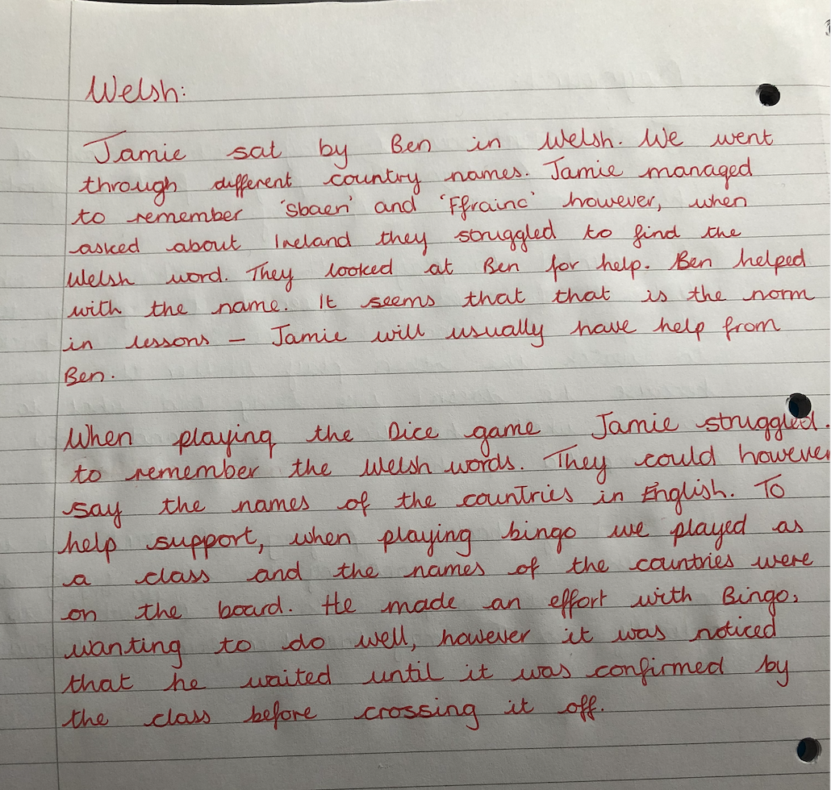

Appendix 11:

Interview:

Do you enjoy sports?

*nods*

What’s your favourite?

*Thinks* shrugs shoulders

Do you prefer team sports or single sports?

Looks confused.

Do you prefer to play with friends, something like football? Or would you rather sprint or do hurdles?

Umm … I like both. It’s hard to know what to do with friends sometimes. Maybe both.

Appendix 12:

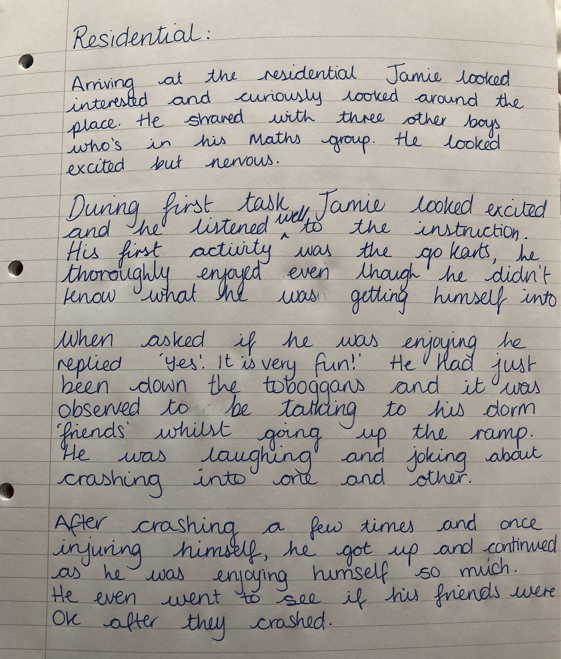

Appendix 13:

Interview:

What did you think about Llangrannog?

*nods* yes! It was good.

What did you enjoy most?

All! Mostly tobogganning. *big smile on their face*

Why?

We went really fast and it was fun. Scary crashing into friends. *laughing* Aadi went into wall and then I went over him. Its funny.

