

Student name: Andrei George Teodorescu

Student ID number:2325440

Programme: Certificate of Higher Education in Employability Skills

Module: Digital Skills for Personal and Professional Growth

Lecturer: Philippa Fitzgerald

Module code: BMSW4008
Date: 07/03/2025

Table of Contents
1 Task 1 Questionnaire Analysis 3
1.1 Design of Questionnaire 3
1.2 Questionnaire Circulation 5
1.3 Questionnaire Analysis 10
2 Task 2 14
2.1 Analysis of Questionnaire Data 14
2.2 Website 15
2.3 Marketing Materials 19
2.4 Segmentation 20
2.5 SEO 21
3 Task 3 22
3.1 Spreadsheet 22
3.2 Essay 22
3.2.1 Introduction 22
3.2.2 Importance of Excel in the digital era 22
3.2.3 Conclusion 23
4 Task 4 25
5 References 28

Task 1 Questionnaire Analysis
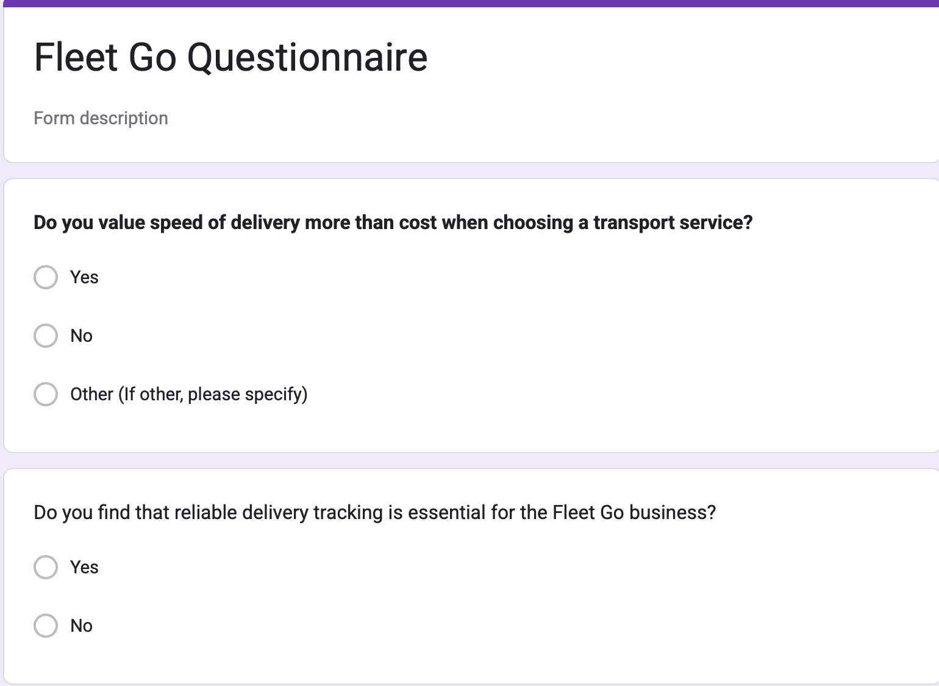
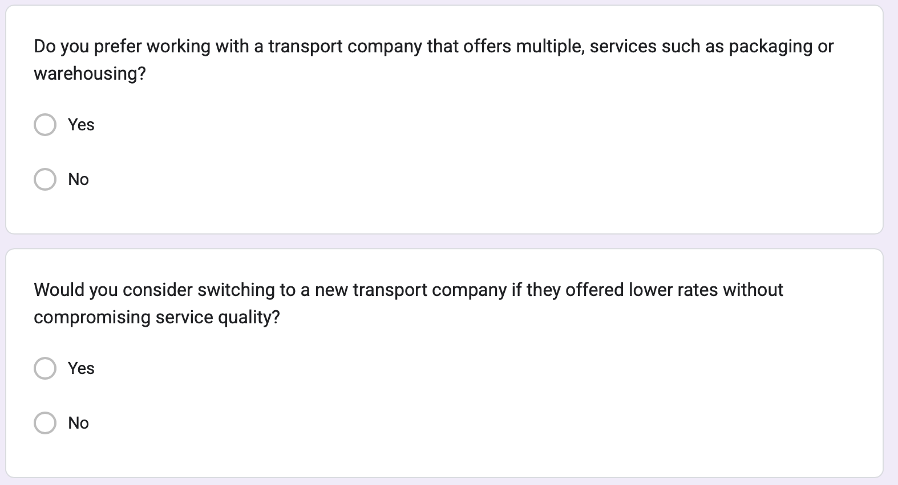

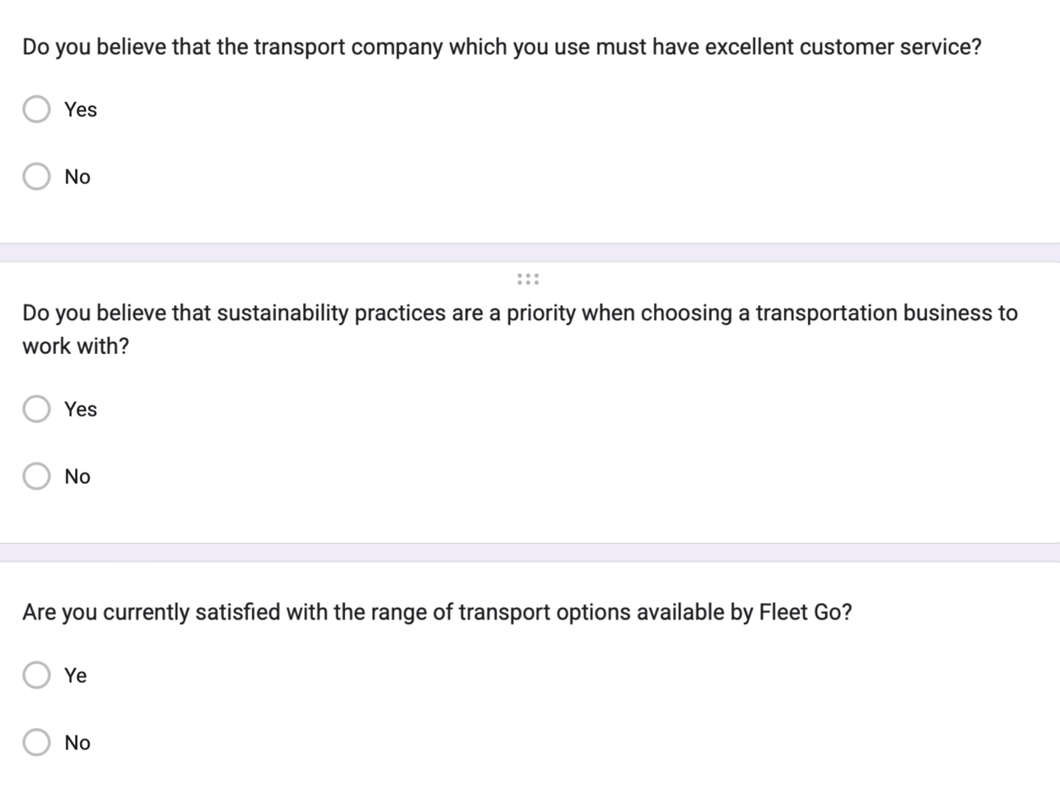
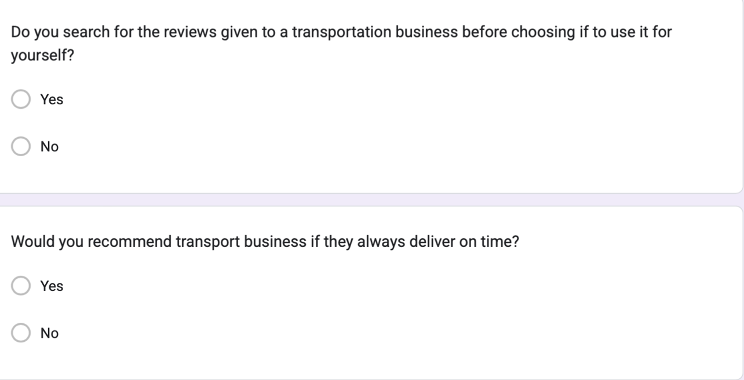

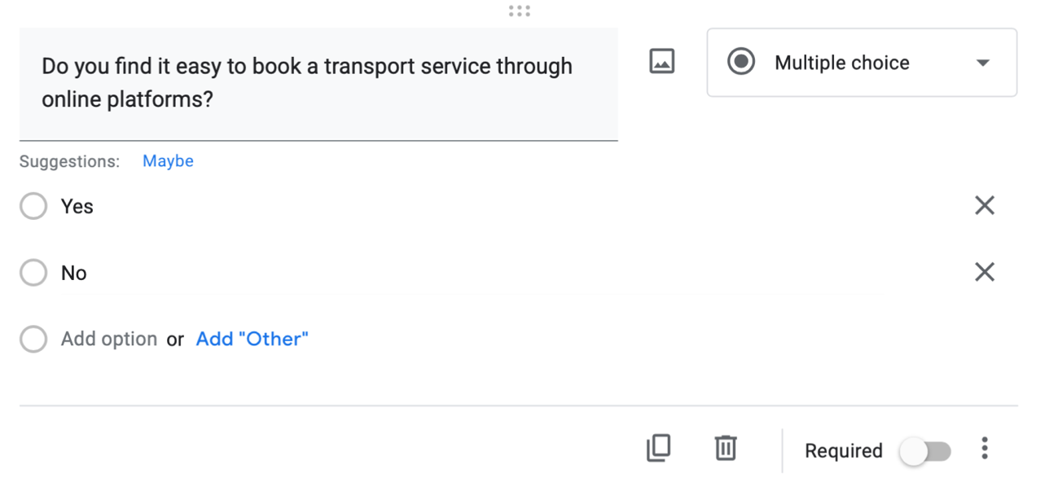

From the above-mentioned questions, the three most important questions, as these questions help us shape the best ways to structure our business and learn what potential customers would prefer from us in order to stay loyal to our services, and their analysis are as follows:

Question: Do you find that reliable delivery tracking is essential for the Fleet Go business?
From this insight, FleetGo needs to either adopt or enhance tracking technology so that customers have up-to-date information on their delivery (Vickerman, 2021). Apart from increasing customer confidence this also reduces the number of questions customers have to ask regarding the status of deliveries. Providing the mentioned feature might help FleetGo stand out in the market and attract those companies that deal with valuable or perishable products. It also might cut internal operation costs and improve customer satisfaction by investing in technology to ensure tracking reliability (Mehmood, 2021). As tracking is classified as highly important, FleetGo should always emphasize this as its strength in promoting the company's services and receiving clients' appreciation for efficient logistics. This would mean targeting organizations that would want to do business with transport service providers that are freed from corruption, and bureaucracy, and whose performance can be easily monitored, something that would put FleetGo at a vantage point in the transport sector.
Question: Would you consider switching to a new transportation company if they offered lower rates without compromising service quality?

The aspect of price is always vital when it comes to the transport industry, but price has to be provided along with service. The price is vital because it gives a competitive advantage over the competitors and a well-calculated price automatically gives the business higher profitability. This indicates that although customers are sensitive, they are also equally concerned with features such as reliability of services (Sarkar et al., 2021). For FleetGo, it raises the question of how to adopt competitive price strategies and at the same time provide proper service quality. The company should ultimately utilize ' subtle' pricing strategies that will appeal to all classes of its customers; for example, offering cheaper prices for bulk customers or customers in certain classes giving them a certain number of services. But the careful focus should be put on attaining high service quality that includes on-time delivery and pick up services, the safety of the goods, and impressive customer care services to customers (Gordon et al., 2020). Further, about the knowledge gained, FleetGo could consider focusing on businesses that may be displeased with the current suppliers’ price models. Leaning more toward affordability without having to compromise on service delivery, FleetGo can also target low-price-sensitive customers. This could be a major selling point whenever it is promoting its services, particularly to small and medium scale enterprises that are engaged in numerous processes that could be made cheaper by adopting this service (Diao et al., 2021).
Question 3: Do you believe that sustainability practices are a priority when choosing a transportation business to work with?
The approach to the solution of many business issues is gradually shifting to take into consideration such a concept as sustainability. This shows that firms are conscious of the environment every time they choose their logistics providers (Bocken and Short, 2021). This insight is helpful to FleetGo since it shows that there is potential interest in green methods of operating logistics services. Probably offering services that employ low-emission automobiles or “adopting environmentally friendly technologies” (jark, 2025) could attract green clients. It would also go any length in assisting FleetGo to thrive in a competitive market, and at the same time bring the company in line with the current trends in the international market (Diao et al., 2021). Sustainability integration into the business model can also improve FleetGo's brand image. Emphasizing 'green' initiatives in marketing communication will interest organizations that follow CSR initiatives as business values (Zhao et al., 2020). In addition, there is an opportunity for FleetGo to extend cooperation with companies that are interested in the transition to more eco-friendly supply chain services and products, thus increasing its customer base in industries where such problems are considered to be of paramount importance (Kelly et al., 2020).

Task 2
The questionnaire results offer relevant data through which FleetGo can modify its website and marketing products considerably. From the data, it will be able to ascertain main themes that will assist in increasing the appeal and efficiency of the brand within the transport sector. The questionnaire findings showed that 36% of clients consider reliable delivery tracking important with 15% strongly believing that it is crucial for their business. This doubles the need for FleetGo to ensure the tracking system on its website is efficient and effective (Usak et al., 2020). Adding real-time tracking as one of the aspects not only conforms to the customer demands but also strengthens the organization’s integrity to its clients. Clients should be able to track their delivery, and a ‘’Track Your Delivery’’ button should appear on the homepage. This could be accompanied by a visual lobby of delivery time and alerts which adds to the efficiency and transparency of operations of FleetGo (Kuberkar and Singhal, 2020). Again the findings reveal that respondents view good customer service as a crucial element of transport service provider. As much as 70% of respondents either agree or strongly agree that customer service is important in customer satisfaction and customer loyalty. Advertisements, like brochures and social media promo, should reach out to the company's customers and stress how much FleetGo cares for them. Reliability and responsiveness may be shown using the testimonials submitted by contented clients (Cheng et al., 2021). Also, having the ‘Contact Us’ tab with phone support, e-mail, and live chat availability will help to ensure potential clients that help if needed is available.

The first question analysed brought a response from some of the respondents who showed a willingness to switch to a new transport company for lower rates while maintaining quality. The insights reveal a need for affordable options, thus requiring FleetGo to employ reasonable pricing models without necessarily reducing service delivery. The mission of FleetGo is to deliver efficient, reliable, and sustainable HGV transport solutions for a diverse range of general goods. To our mind, the positioning of FleetGo needs the creation of a transparent pricing page on the site where all potential clients can see the offered services' categories and their price tags (Dayarian and Savelsbergh, 2020). This could be followed immediately by features such as offers or discounts for those who are using it for the first time. Emphasizing the fact that, despite being fairly priced, it, may attract potential clients such as SMEs, which are “small to medium enterprises” (world bank group team, 2019) which are more likely to remain sensitive to price fluctuations (Hidayat, 2021). Sustainability practices, it is established that beneficiaries are keen on sustainability practices when choosing a transport provider. The present drift in business toward environmental sustainability is therefore a chance that FleetGo could leverage to break the market in logistics. Therefore, FleetGo should incorporate the insight of having environmental responsibility into all, its marketing initiatives. This could include how low-emission vehicles will be used, carbon offset, and other measures of sustainability in logistics (Uzir et al., 2021). The idea is that the website can contain a separate section that indicates the company's sustainable activities so that the customer knows that the respective brand is environmentally friendly.

Website:


Figure 1; Logo of FleetGo

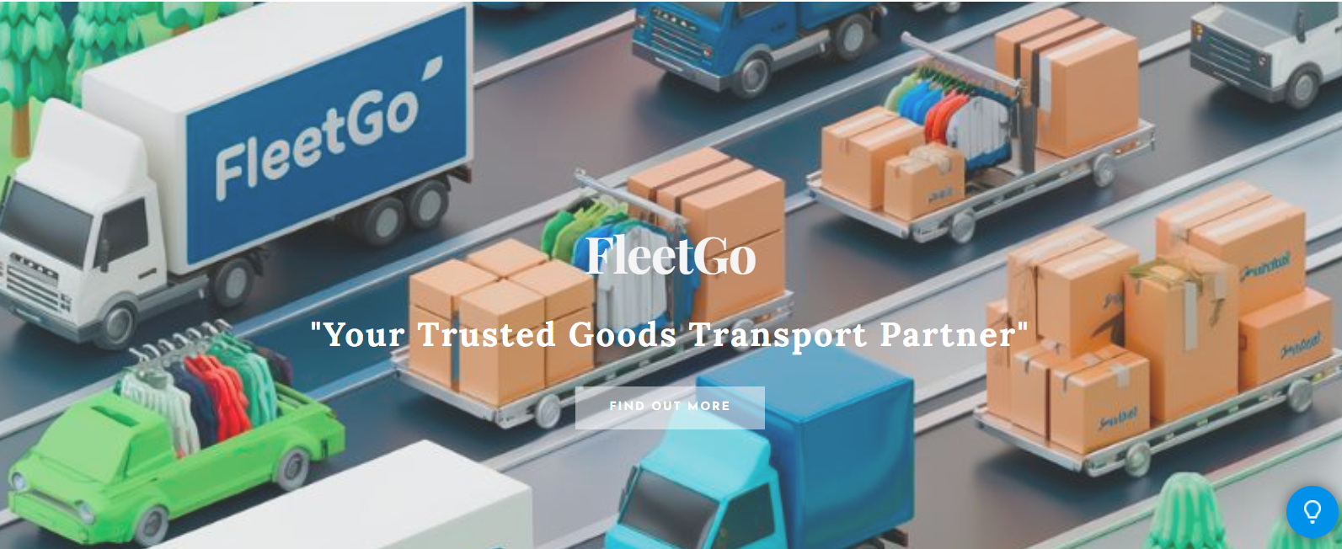
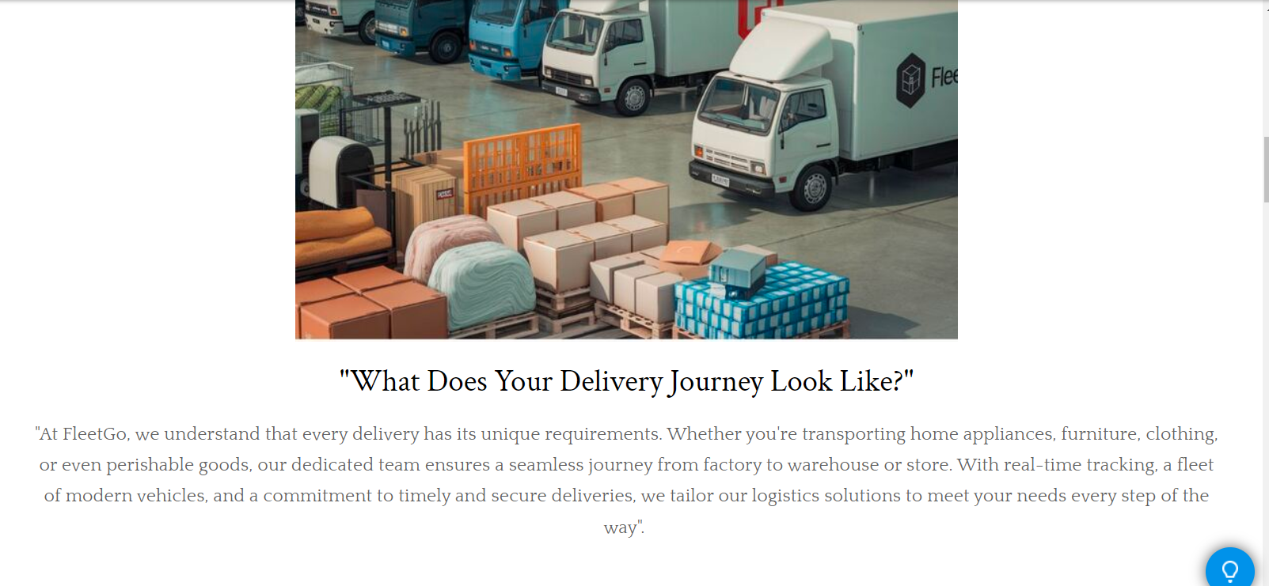

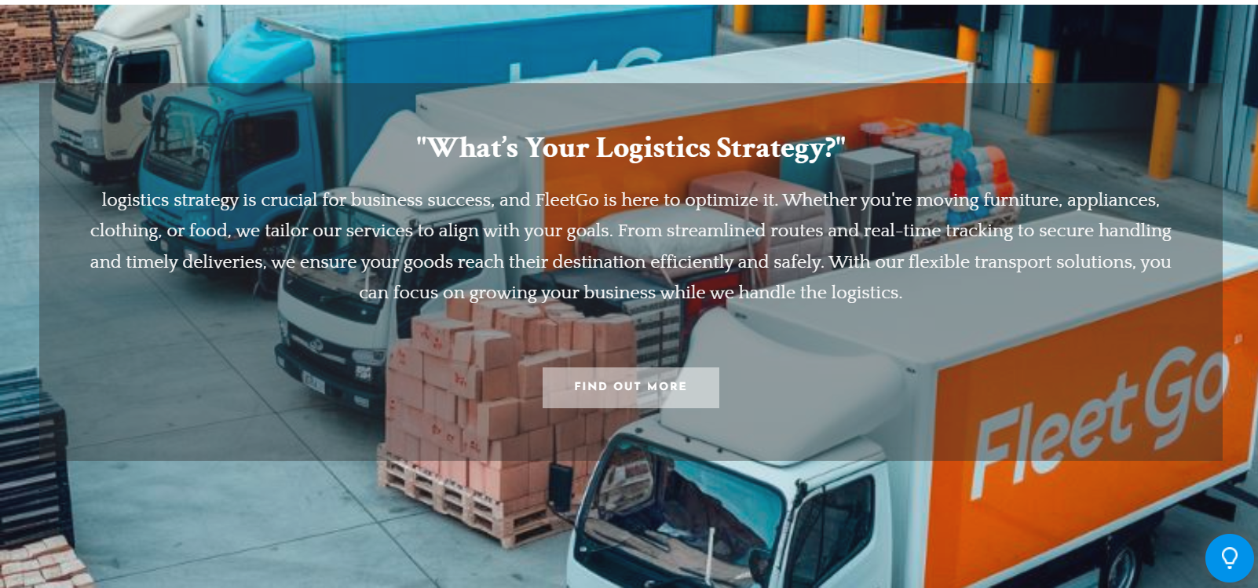

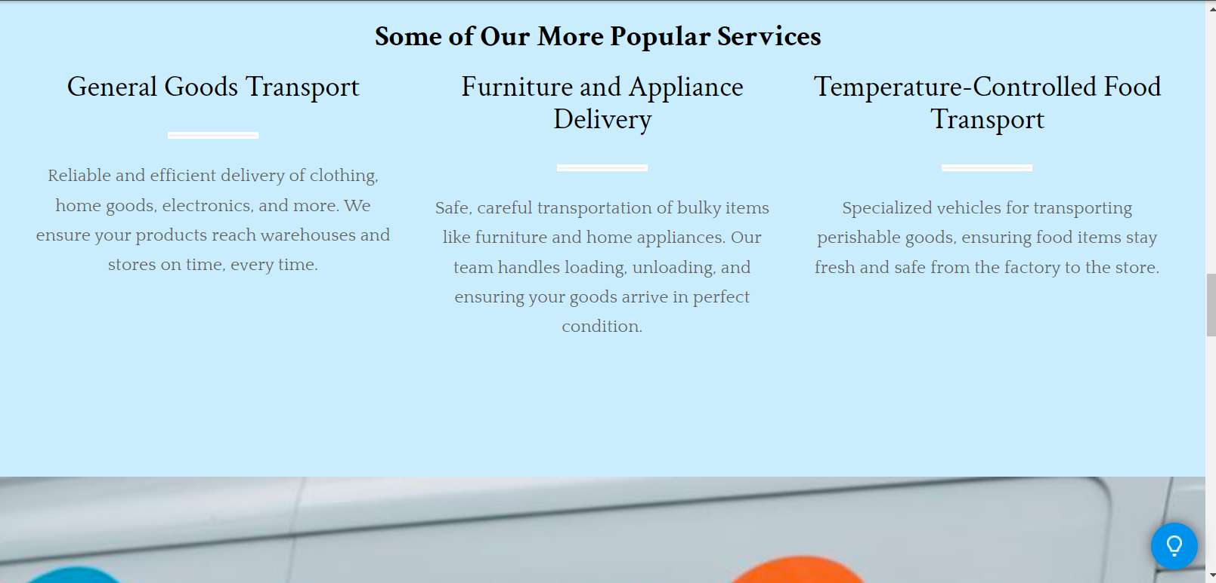

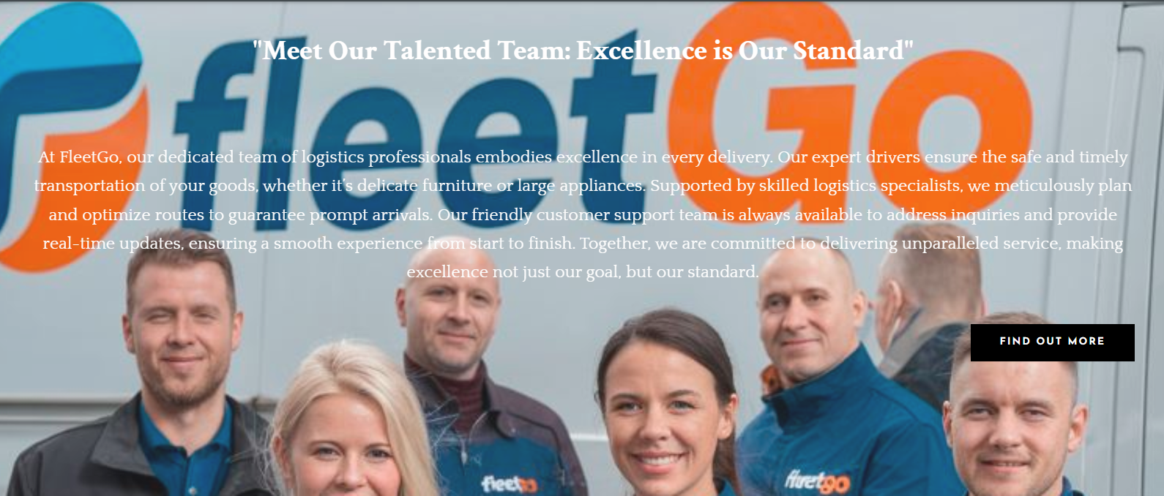

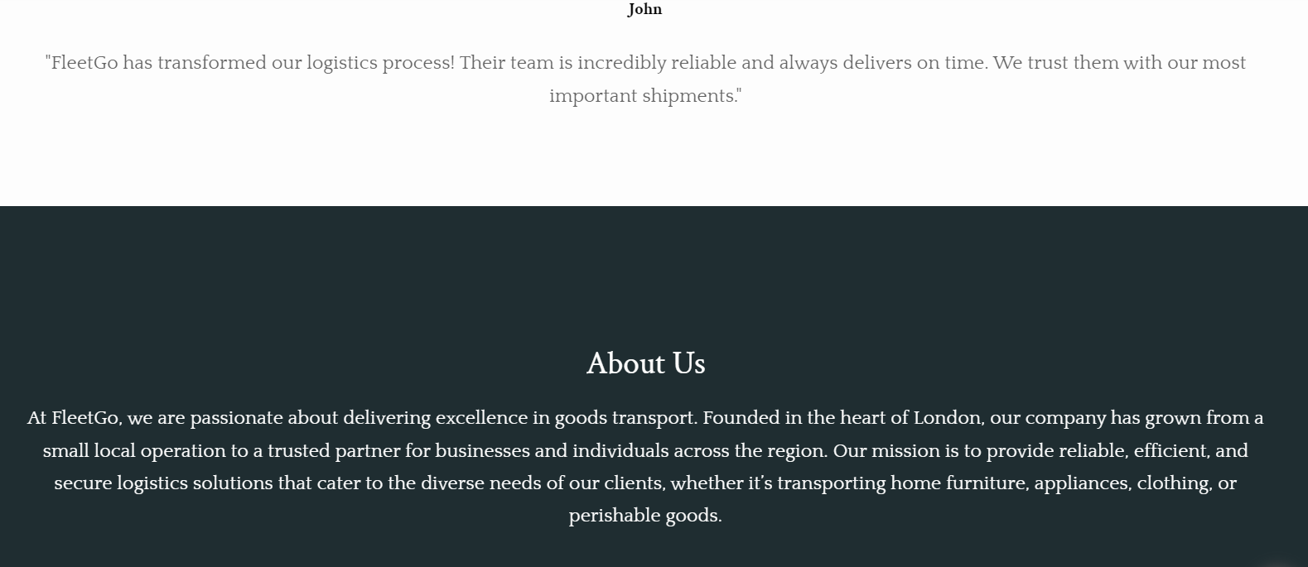

Marketing materials:
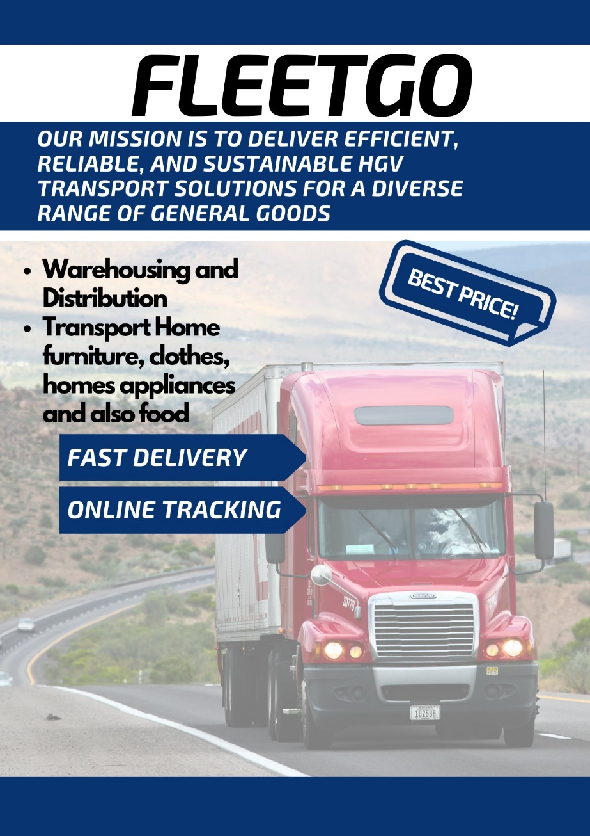

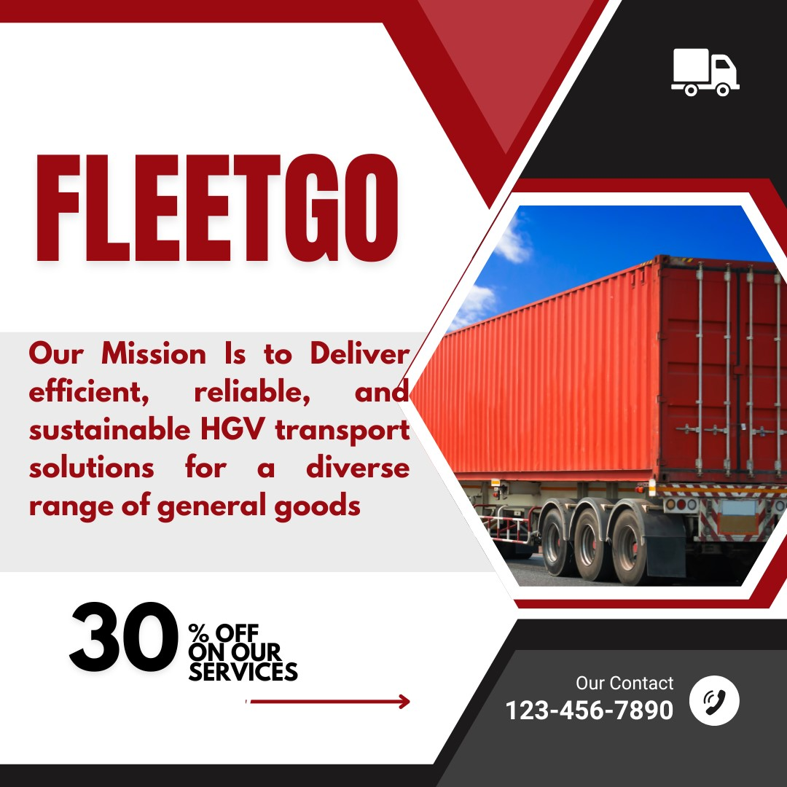

Segmentation Types | Description
Demographic | Targeting small and medium-sized enterprises (SMEs) across various industries, focusing on business owners aged 30-55 who prioritize reliable logistics solutions.
Psychographic | Focusing on businesses that value sustainability and corporate social responsibility, seeking eco-friendly transport options and innovative logistics solutions (Cheng et al., 2021).
Geographic | Looking to cater to businesses located in urban areas, particularly those in regions with high demand for efficient goods transport services, such as major cities and industrial hubs.
Behavioral | Engaging companies that frequently require transport services, particularly those that utilize online booking systems and prioritize real-time tracking for their shipments (Hidayat, 2021).

SEO, which stands for “search engine optimization”, (crain, 2023) commonly refers to the optimization of websites as a way of increasing their ranking when users search for specific items on the web. SEO is the process of enhancing the visibility of a site on the internet by making changes to the site, which are not paid advertisements (Schulthei and Lewandowski, 2021). Some of the techniques of SEO include keyword placement, use of Meta tags, and making the site user friendly while off-SEO techniques include backlinking from other reputable sites.

Keyword Integration: Found from the developed questionnaire, the following key terms have been integrated into the website content, titles, and Meta tags: reliable delivery tracking, affordable goods transport, and sustainable logistics solutions.
Content Structure: The website had a nice heading and subheading system which made it easy for the search engine to crawl the content of the site. They result in good user satisfaction and an ability to retain them, which in - turn influences the SEO rankings.
Mobile Optimization: Considering that people of the target group are active internet users, the website was made responsive, loading rapidly, and being optimized for use on any technology.
High-Quality Visuals: Due to services-related images and videos used in the websites, alt tags were written with related keywords and this has enhanced the SEO results (Lewandowski et al., 2021).
Such strategies create strong recognition of FleetGo when such customers are searching for transport services on the internet.

Task 3
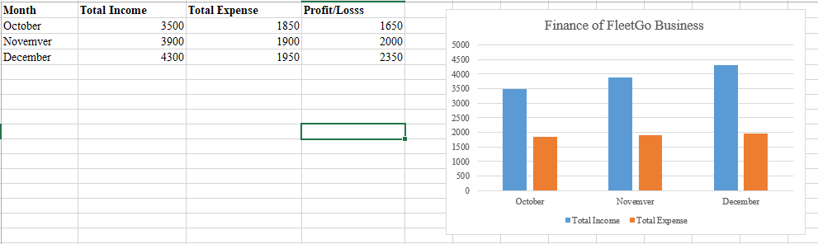

In the ever-changing business world today where more and more business is being done online, data has become one of the most lucrative commodities to businesses regardless of industry type. Due to this, there is an increased rate of data produced daily, and organizations need to capture this information and then analyse it for the benefit of decision-making for competitiveness. Microsoft Excel, a program that has been widely used in business for many years, remains one of the tools leading this data revolution (Avanzas and Kaski, 2021). It is fully compatible, flexible, fast, and equipped with functional capabilities that enable a user to work on large volumes of data, solve intricate problems and visualize information.

Excel is the ability to handle large amounts of data effectively and this remains one of its biggest strengths. Companies produce and accumulate information within different departments’ numbers of sales, customers’ information, performance indicators, stocks, etc. This information can readily be entered in an Excel format and used to analyze it in one guide. Using options like filter, sort, and conditional formatting options, a user can easily analyze information. For instance, monthly sales data is available in the Sales Funnel, thus a sales team is capable of making decisions regarding the performance of that business over a given period (Briones et al., 2020). Excel is another tool that minimizes the time and errors in data management since it is automated Data in Excel is easily analyzed as it contains features in facilitate powerful calculations in business models that include; financial modeling, and business forecasting (Briones et al., 2020). One of the benefits of financial forecasting is that business organizations can predict future revenues, expenditures, and profits within any timeframe. One can be able to use functions like SUM and AVERAGE as well as statements like IF to make automatic calculations of data. For example, a startup may use a cash flow forecasting template which serves the purpose of micro-financial management wherein it anticipates its future needs for acquiring financial resources for investment and operations. It is used and very important when evaluating new projects or prospects for investment (Power et al., 2021). Moreover, the realism capability to develop a ‘what if’ condition creates a capacity for assessing the effects of various aspects in the strategic execution of business.
Moreover, the other benefits of using Excel are Analytical Capacity; Data Modelling and Visualization. These help analyse and organize information as well as “perform practical operations” (tuttle, 2023) to help be more time efficient. The software has features, which include charting systems, where users can graph and chart their results making it easier for them to understand large chunks of information. Graphic presentations like bar charts, line charts, and pie charts are more advantageous in preparing and delivering presentations and reports where each stakeholder can afford to understand the overall view of the business at a glance (Martin et al., 2020). For instance, the marketing team may use Excel to visually present campaign metrics to support compelling presentations to the executive team. In addition to the conversion of data analysis into visual formats, Excel makes it easier to tell the story and present the results to other team members, and even the intended audience, successfully creating a common understanding of the subject being analysed (Diamant, 2024).

Lastly, it is unique that Microsoft Excel continues to be at the forefront of program utilities as companies transforming to digital age employees search for ways to gain and retain competitive advantage. The capacity to acknowledge large amounts of data fast enables organizations to gather useful information and segment it by departments. Some of the software's key activities include using tools like financial modeling and forecasting to enable the business organisms to predict likely revenues, expenditures, and investments in the future. Moreover, due to the spectrum of data visualization tools included in Excel, it is possible to convey information promptly and clearly to other interested parties so that they can easily understand the data. Through the conversion of data into graphs and charts with clear labels, Excel takes data presentation an extra step forward in terms of narrative, thereby creating a common ground for the team to understand the data and make decisions based on it. Due to this, Excel's capabilities and flexibility will always be crucial in the pursuit of success in delivering data-driven solutions for businesses. Overall, Excel not only makes things easier with handling the data but also helps an organization in managing effectively the conditions of a rapidly evolving business environment.

Task 4

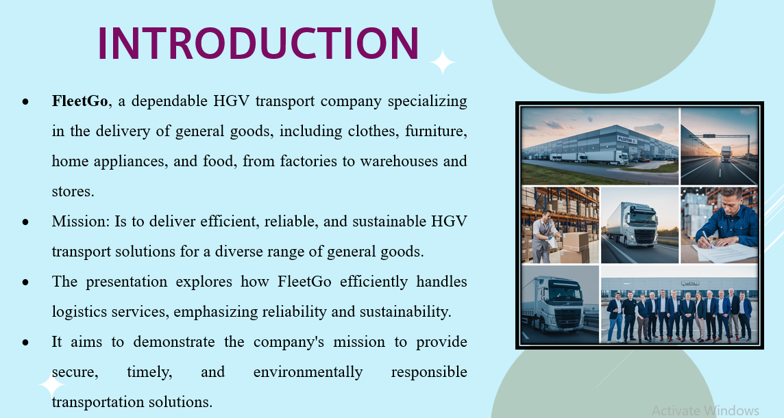
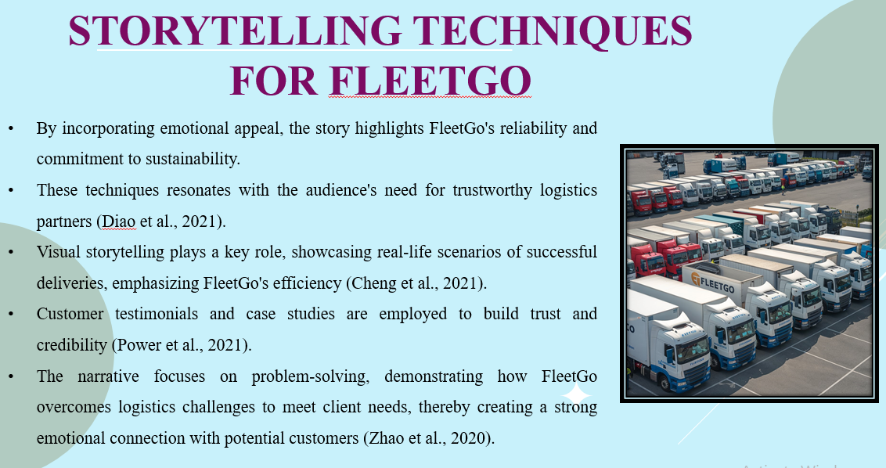

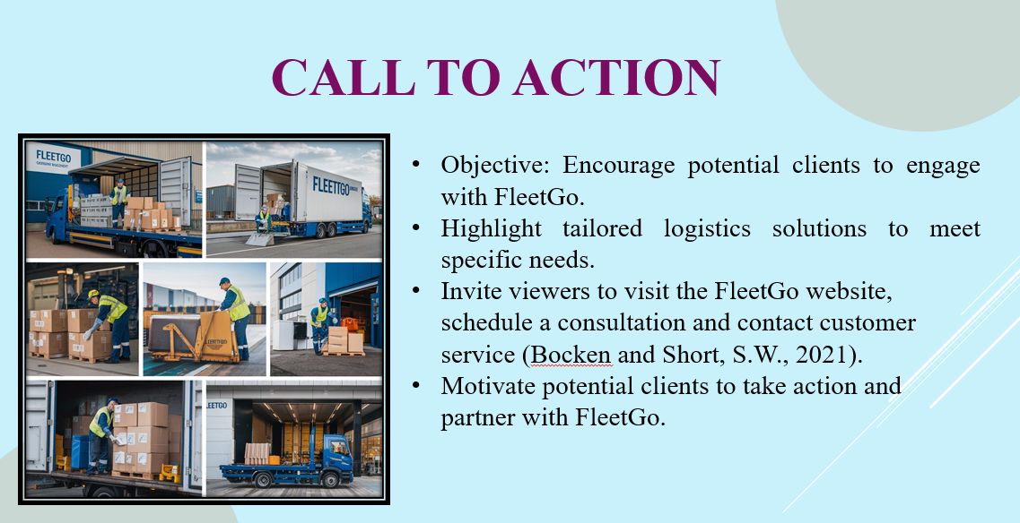

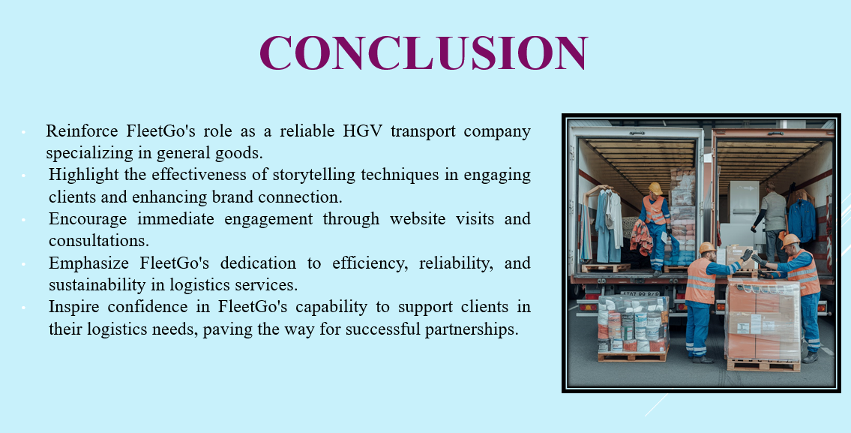
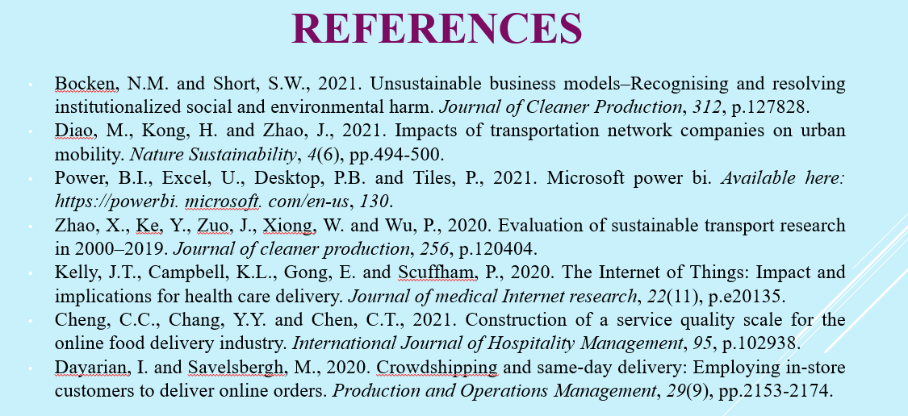

References

Bibliography
crain, G., 2023. SEO: What It Is And Why It’s Important. [Online]
Available at: https://www.forbes.com/councils/forbesagencycouncil/2023/02/07/seo-what-it-is-and-why-its-important/
[Accessed 28 02 2025].
jark, d., 2025. What Is Green Tech? How It Works, Types, Adoption, and Examples. [Online]
Available at: https://www.investopedia.com/terms/g/green_tech.asp
[Accessed 28 02 2025].
tuttle, l., 2023. Features of Excel to Use in Data Analysis. [Online]
Available at: https://www.wgu.edu/blog/features-excel-use-data-analysis2308.html
[Accessed 01 03 2025].
world bank group team, 2019. Small and Medium Enterprises (SMEs) Finance. [Online]
Available at: https://www.worldbank.org/en/topic/smefinance
[Accessed 28 02 2025].

glesias, J., Morales, G. and Escola, J.M., 2020. Application of the microsoft excel solver tool in the optimization of distillation sequences problems. Computer Applications in Engineering Education, 28(2), pp.304-313.
Cheng, C.C., Chang, Y.Y. and Chen, C.T., 2021. Construction of a service quality scale for the online food delivery industry. International Journal of Hospitality Management, 95, p.102938.
Dayarian, I. and Savelsbergh, M., 2020. Crowdshipping and same‐day delivery: Employing in‐store customers to deliver online orders. Production and Operations Management, 29(9), pp.2153-2174.
Diamant, A., 2024. Introducing prescriptive and predictive analytics to MBA students with Microsoft Excel. INFORMS Transactions on Education, 24(2), pp.152-174.
Diao, M., Kong, H. and Zhao, J., 2021. Impacts of transportation network companies on urban mobility. Nature Sustainability, 4(6), pp.494-500.
Gordon, A.L., Goodman, C., Achterberg, W., Barker, R.O., Burns, E., Hanratty, B., Martin, F.C., Meyer, J., O’Neill, D., Schols, J. and Spilsbury, K., 2020. Commentary: COVID in care homes—challenges and dilemmas in healthcare delivery. Age and Aging, 49(5), pp.701-705.
Hidayat, C.W., 2021. The Influence Of Mix Marketing On Decisions For Use Of Online Transportation Towards Global Competition. International Journal of Science, Technology & Management, 2(4), pp.1154-1163.
Kelly, J.T., Campbell, K.L., Gong, E. and Scuffham, P., 2020. The Internet of Things: Impact and implications for health care delivery. Journal of medical Internet research, 22(11), p.e20135.
Kuberkar, S. and Singhal, T.K., 2020. Factors influencing adoption intention of AI powered chatbot for public transport services within a smart city. International Journal of Emerging Technologies in Learning, 11(3), pp.948-958.
Lewandowski, D., Sünkler, S. and Yagci, N., 2021, June. The influence of search engine optimization on Google's results: A multi-dimensional approach for detecting SEO. In Proceedings of the 13th ACM Web Science Conference 2021 (pp. 12-20).
Martin, E.M., Myers, K. and Brickman, K., 2020. Self-preservation in the workplace: The importance of well-being for social work practitioners and field supervisors. Social Work, 65(1), pp.74-81.
Mehmood, T., 2021. Do information technology competencies and fleet management practices lead to effective service delivery? Empirical evidence from the e-commerce industry. International Journal of Technology, Innovation and Management (IJTIM), 1(2), pp.14-41.
Power, B.I., Excel, U., Desktop, P.B. and Tiles, P., 2021. Microsoft power bi. Available here: https://powerbi. microsoft. com/en-us, 130.
Sarkar, B., Sarkar, M., Ganguly, B. and Cárdenas-Barrón, L.E., 2021. Combined effects of carbon emission and production quality improvement for fixed lifetime products in a sustainable supply chain management. International Journal of Production Economics, 231, p.107867.
Schultheiß, S. and Lewandowski, D., 2021. “Outside the industry, nobody knows what we do” SEO as seen by search engine optimizers and content providers. Journal of Documentation, 77(2), pp.542-557.
Usak, M., Kubiatko, M., Shabbir, M.S., Viktorovna Dudnik, O., Jermsittiparsert, K. and Rajabion, L., 2020. Health care service delivery based on the Internet of things: A systematic and comprehensive study. International Journal of Communication Systems, 33(2), p.e4179.
Uzir, M.U.H., Al Halbusi, H., Thurasamy, R., Hock, R.L.T., Aljaberi, M.A., Hasan, N. and Hamid, M., 2021. The effects of service quality, perceived value and trust in-home delivery service personnel on customer satisfaction: Evidence from a developing country. Journal of Retailing and Consumer Services, 63, p.102721.
Vickerman, R., 2021. Will Covid-19 put the public back in public transport? A UK perspective. Transport policy, 103, pp.95-102.
Zhao, X., Ke, Y., Zuo, J., Xiong, W. and Wu, P., 2020. Evaluation of sustainable transport research in 2000–2019. Journal of cleaner production, 256, p.120404.
Avanzas, P. and Kaski, J.C., 2021. The EXCEL Trial. European Cardiology Review, 16.
Bocken, N.M. and Short, S.W., 2021. Unsustainable business models–Recognising and resolving institutionalized social and environmental harm. Journal of Cleaner Production, 312, p.127828.
Briones, L., Morales, V., Iglesias, J., Morales, G. and Escola, J.M., 2020. Application of the microsoft excel solver tool in the optimization of distillation sequences problems. Computer Applications in Engineering Education, 28(2), pp.304-313.
Briones, L., Morales, V., I

