University of Wales Trinity Saint Davids – Swansea

The future of hospitality and is it profitable to be green?

Sustainable Hospitality and Tourism Management BMIH5006
Tutor – Kathryn Roberts

Belu Teodor Catalin (216226)

Table of Contents

Introduction……………………………………………………………………..…3
- John Elkington Triple Bottom Line Theory………………………..…….4
  - Triple Bottom Line Reporting……………………..……5
  - Sustainability as Consumer Driver……………..……..6
  - Greenwashing……………………………………..………7
- Tourism impact on destinations………………………………….………..8
2.1 Butler touristic area life cycle model…………………………………8
2.2. Dixey’s irridex ……………………………………………………..…9
3. Recommendations………………………………………………………..…9

Conclusions……………………………………………………………………….10

References…………………………………………………………………………11

Appendix A…………………………………………………………………………15
Appendix B…………………………………………………………………………15

Introduction

Milton Friedman's groundbreaking essay "The Social Responsibility of Business is to Increase Its Profits" has split the opinions ever since it was first published in the New York Times Magazine more than fifty years ago. His provocative argument ushered in a new period in American economic history where "Greed is Good" and financial gain stood in for company goals. "There is one and only one social responsibility of business to use its resources and engage in activities designed to increase its profits," was Friedman's unequivocal position (Borruso et al, 2020). Friedman's critics are typically divided between those who think businesses have a bigger "social responsibility" and those who think businesses should only focus on making profits and leave other social objectives to politics (Tepper, 2020). However, it's likely that both sides would concur that during this time, the world has grown more complex and that businesses now have to balance an increasing number of competing priorities and CSR become these days essential in all organisations and sectors. There are several reasons for this growing interest in alternatives to traditional business management, including the fact that it is out of date because it only considers economic returns and calls for the adoption of other models that have a less detrimental effect on the environment and society. Concerns about topics like food security, industrial pollution, climate change, and the depletion of natural resources, among many others, have grown in the public and government consciousness as a result of this process and as a result, it is becoming increasingly typical to see investors gauging the social and environmental risks associated with investments, governments formulating policies and defining more stringent regulations, and customers demanding goods and services from socially conscious businesses (Borger and Costa, 2022).

- John Elkington Triple Bottom Line Theory

The triple bottom line theory was developed by John Elkington and was meant to provoke more thought about capitalism and its future rather than just be used as an accounting tool. In total contrast with Milton Friedman’s theory, the triple bottom line expands the scope of traditional business success metrics by incorporating an organization's contributions to environmental health, social well-being, and a just economy (University of Wisconsin, 2022). Elkington's definition aimed to incorporate an integrated approach that prioritises economic prosperity, social development, and environmental quality in business operations, surpassing previous interpretations of sustainable development and corporate social responsibility (Amos et al., 2016, p.92). The theory suggests that organisations should prioritise long-term social, environmental, and economic effects over short-term financial goals. The "three P's" theory, as it is commonly known, is based on the understanding that people, the planet, and prosperity are all interconnected (Figure 1.1.).

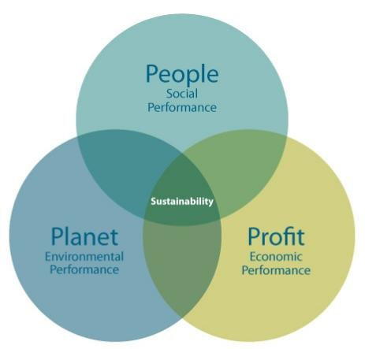
Figure 1.1.

And any initiative connected to one will also impact the others, as systems thinking is the foundation of sustainability. The environment is the base of everything, creates the structure for society and the economy is a bye product of society (Figure 1.2.). Sustainability is an attribute of the whole system and organisations must be accountable to their stakeholders in order to be sustainable. The triple button line currently acts as the benchmark for every hospitality establishment or travel destination (Csikósová et al., 2020, p. 765). Tourism and hospitality service providers have recognised the advantages of developing and implementing sustainable practices, which can act as a decisive factor in customer preference and booking when other factors, like cost and quality, are equal ( Lim, 2016).

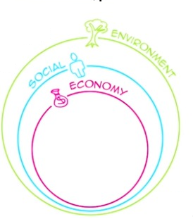

Figure 1.2.

  - Triple Bottom Line Reporting

An approach to sustainable development can be defined as one that is both workable and reduces activities that pose a risk to the environment. By creating jobs, advancing infrastructure, and preserving cultural heritage, the sector has been contributing to the social, cultural, and economic environments in a number of ways but in order to meet the demands of tourists, this industry has also had unfavourable effects, such as environmental degradation, unethical labour practises, and an increase in the rate of prostitution (Fatma et at, 2018). In business accounting, triple bottom line reporting is a technique used to increase stakeholders' understanding of the organisation.
In addition to the traditional financial components, it reveals the company's impact on the environment, giving all parties involved a better understanding of the company and enabling them to fortify their relationships with other stakeholders, both internal and external. TBL reporting is predicated on internal company guiding principles or external standards and guidelines from organisations like the GRI, the World Business Council for Sustainable Development (WBCSD), and the International Standards Organisation (ISO) (Medrado and Jackson, 2016).
All the big organisations in the hospitality and tourism industries decided to adopt CSR initiatives and sustainable practices and report every year about the progress they are making into more sustainable activity. The basis of corporate social responsibility (CSR) lies in the connection businesses build with society, understanding that society has expectations of them regarding their actions and output (Martín de Castro and González-Masip, 2020, p.3). CSR activities include business conduct related to social and environmental issues that go above and beyond what is required by law or regulation in the relevant market or economy (Chen et al., 2018).

  - Sustainability as Consumer Driver

There is a growing trend in the hospitality industry among guests to choose accommodations that minimise their environmental impact and this has placed pressure on hotel operators to adopt eco-friendly practices that meet guest expectations. Customers who have a strong sense of connection to the environment tend to be more proactive in adopting environmentally friendly consuming habits ( Han, 2021, p.1023). Hotels have had to adapt their tourist amenities and services as the market has grown and changed because customers are increasingly choosing to buy products and services that support green initiatives and work to minimise negative environmental impacts as a result of growing awareness of the effects of climate change.
In order to better understand how 489 air travellers felt about environmentally friendly hotels, Virginia Polytechnic Institute and State University conducted an empirical study. Of the respondents, only 3% felt negative about these establishments, and 70% said they would rather stay at an environmentally friendly hotel than a regular one (Hashish et al. 2022).
Analysing consumer attitude towards CSR worldwide (Appendix B), statistics show that in 2022, 3% of respondents said that corporations were not doing enough to combat climate change. Simultaneously, half of those surveyed felt that businesses could have done more to address issues like energy scarcity and economic inequality. By contrast, just 9% of global consumers felt that companies are going too far when it comes to providing reliable information ( Dencheva, 2023).

  - Greenwashing

Businesses have used green marketing techniques to highlight their environmental efforts in an effort to gain a competitive edge and win over environmentally sensitive customers. Green consumers frequently have anti-corporate biases and mistrust advertising, making it difficult to gain confidence in the legitimacy of green marketing (Szabo and Webster, 2021, p .724). Companies may make exaggerated claims about being environmentally conscious, but these claims may not always be supported by their actions. Greenwashing is a tactic used to promote nonsensical solutions to the climate crisis, diverting attention away from and postponing real, credible action, by tricking the public into believing that a company or other entity is protecting the environment more than it actually is (United Nations, no data).

- Tourism impact on destinations

It is commonly recognised that tourism significantly influences the economic growth of tourist destinations and brings about social, environmental, and economic changes in the places it visits. According to World Travel and Tourism Council, the travel and tourism sector contributed with 7.6% to the global GDP (Appendix A), offering 22 million new jobs in 2022 (World Travel and Tourism Council, 2023). The competitiveness of a destination in the global market is crucial to its success but maintaining that competitive edge and being resilient in the face of unanticipated circumstances are also necessary for long-term success.

2.1 Butler touristic area life cycle model

The development of destinations, and especially accommodations, has been intimately correlated with the evolution of tourism. Butler's model (Figure 1.) serves as a graphic metaphor for how destinations change over time and has been acknowledged as one of the fundamental ideas of tourism (McKercher and Wong, 2021, p. 2).

Figure 1
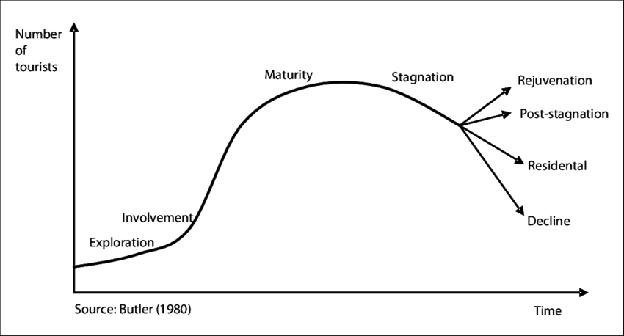

According to the destination life-cycle model, demand should first outpace supply in developing destinations (Paunovic et al., 2020). Like any other product, whether it be physical or service-based, destinations have a life cycle and eventually reach saturation over the years following their initial and subsequent discoveries (Karammustafa and Yilmaz, 2020, p.440). A destination either enters a decline stage after reaching a certain saturation point, or it rejuvenates itself by not only protecting its traditional markets but also seeking out new ones by developing new products and attractions (Cooper, 2021, p. 61).

2.2. Dixey’s irridex

The hosts' perspectives on tourism vary depending on the destination's stage of development. Nevertheless, a number of indicators of host population dissatisfaction usually emerge as soon as the critical threshold is crossed and the economic effects stop being favourable (Zaidan and Kovacs, 2017, p. 295). According to Dixey’s irridex there are four phases of host attitudes: euphoria, apathy, annoyance, and antagonism (Fan, et al., 2019). Linked to the life cycle model hosts are euphoric at the exploration and involvement stage, apathetic at the development stage, annoyed at the consolidation stage and they feel antagonism to stagnation or decline (Roberts, 2023).

- Recommendations

The future lies in sustainable tourism and hospitality, so it's critical that businesses and local governments recognise the negative effects and work to mitigate them. Corporate social responsibility is today must for all organisations and transparency regarding sustainable policies and programs is recommended and will help gain customers' trust and confidence.
It is recommended that tourism strategic planning be done rationally as this will support the preservation of the environment and help maintain the high standard of quality that is necessary for community-based tourism programmes to succeed. Mass tourism has indeed economic advantages but also negatively impact the destination life cycle so is recommended that organisation try to move from mass tourism to alternative tourism which is more sustainable and has a minimal negative effect on the environment and local culture.
Educating the guests and training employees regarding environmental problems, promoting sustainability inside the organisation, and implementing regulation and taxation are recommended in all tourism organisations and destinations.

Conclusions

CSR is defined by the triple line, so it extends the responsibility of the organization beyond the economic sphere. A company's ability to manage socially responsible operations in a methodical manner, detect potential dangers and opportunities, and maintain the correct long-term business venture are all made possible by CSR reports, which can also help make a company more competitive. Organisations informs its clients and consumers about the design process of the product in a transparent manner using a CSR report. Thus, clients are knowledgeable about the effects that purchasing the good or using the service will have on society and the environment. CSR and sustainability are these day a strong consumer driver and a good marketing tool for organisations, generating not just a positive impact but also increase revenue.

References:

Amos, A.O, Uniamikogbo, E. and Atu, G. (2016). Sustainability and triple bottom line: An overview of two interrelated concepts. Igbinedion University Journal of Accounting, 2(16), 88-126.

Available at: https://www.researchgate.net/profile/Emmanuel-Uniamikogbo/publication/322367106_SUSTAINABILITY_AND_TRIPLE_BOTTOM_LINE_AN_OVERVIEW_OF_TWO_INTERRELATED_CONCEPTS/links/5a563e3eaca272bb6963e2f0/SUSTAINABILITY-AND-TRIPLE-BOTTOM-LINE-AN-OVERVIEW-OF-TWO-INTERRELATED-CONCEPTS.pdf (accessed: 02.11.2023)

Borger, F. G, and Costa, A. P, P (2022) Corporate Social Responsibility and Sustainability in Corporate Strategy: Brazilian Cases Studies. Corporate Social Responsibility. IntechOpen. Available at: http://dx.doi.org/10.5772/intechopen.94414 (accessed: 03.11.2023)

Borruso et al (2020) ᾽From there to here: 50 years of thinking on the social responsibility of a business᾽. McKinsey & Company, 11th Sept. Available at: https: www.mckinsey.com/featured-insights/corporate-purpose/from-there-to-here-50-years-of-thinking-on-the-social-responsibility-of-business (accessed: 02.11.2023)

Chen, Y.-C., Hung, M., & Wang, Y. (2018). The effect of mandatory CSR disclosure on firm profitability and social externalities: Evidence from China. Journal of Accounting & Economics, 65(1), 169–190. https://doi.org/10.1016/j.jacceco.2017.11.009 (accessed: 02.11.2023)

Cooper, C. (2021) Essentials of tourism. Third edition. London: SAGE.

Csikósová, A., Janošková, M. and Čulková, K. (2020) ‘Providing of tourism organizations sustainability through Tripple Bottom Line approach’, Entrepreneurship and Sustainability Issues, 8(2), pp. 764–776. Available at: https://doi.org/10.9770/jesi.2020.8.2(46).

Dencheva, V. (2023) ᾽Consumer attitudes towards corporate social responsibility (CSR) worldwide as of November 2022, by type of societal issue᾽. Statista, 22 March. Available at: https://www.statista.com/statistics/1372794/consumer-attitudes-corporate-social-responsibility-worldwide/ (accessed: 01.11.2023)

Fatma, M., Khan, I. and Rahman, Z. (2018) ‘CSR and consumer behavioral responses: the role of customer-company identification’, Asia Pacific journal of marketing and logistics, 30(2), pp. 460–477. Available at: https://doi.org/10.1108/APJML-01-2017-0017 (accessed: 01.11.2023).

Han, H. (2021). Consumer behaviour and environmental sustainability in tourism and hospitality: A review of theories, concepts, and latest research. Journal of Sustainable Tourism, 29(7), 1021-1042. Available at: https://doi.org/10.1080/09669582.2021.1903019 (accessed: 03.11.2023)

Karamustafa, K. U. R. T. U. L. U. Ş., & YILMAZ, M. (2020). Destination Life Cycle: A Conceptual Approach Based on the Turkish Experience. Journal of Tourism & Gastronomy Studies, 8(Special Issue 4), 439-451. Available at: https:// (accessed: 02.11.2023)

Lim, W. M. (2016). Creativity and sustainability in hospitality and tourism. Tourism Management Perspectives, 18, 161-167. Available at: https:// //doi.org/10.1016/j.tmp.2016.02.001 (accessed: 01.11.2023)

Hashish, M.E.-S. et al. (2022) ‘The Nexus between Green Perceived Quality, Green Satisfaction, Green Trust, and Customers’ Green Behavioral Intentions in Eco-Friendly Hotels: A Structural Equation Modeling Approach’, International journal of environmental research and public health, 19(23), pp. 16195-. Available at: https://doi.org/10.3390/ijerph192316195(accessed: 01.11.2023)

McKercher, B., & Wong, I. A. (2021). Do destinations have multiple lifecycles?. Tourism Management, 83, 104232. Available at: https://doi.org/10.1016/j.tourman.2020.104232 (accessed: 03.11.2022)

Medrado, L. and Jackson, L.A. (2016) ‘Corporate nonfinancial disclosures: An illuminating look at the corporate social responsibility and sustainability reporting practices of hospitality and tourism firms’, Tourism, and hospitality research, 16(2), pp. 116–132. Available at: https://doi.org/10.1177/1467358415600210.

Martín de Castro, G. and González-Masip, J.J. (eds) (2020) Knowledge management for corporate social responsibility. Hershey, Pennsylvania: IGI Global. Available at: https://doi.org/10.4018/978-1-7998-4833-2 (accessed: 30.10.2023)

Paunović, I., Dressler, M., Mamula Nikolić, T., & Popović Pantić, S. (2020). Developing a competitive and sustainable destination of the future: Clusters and predictors of successful national-level destination governance across destination life-cycle. Sustainability, 12(10), 4066. Available at: https://doi.org/10.3390/su12104066 (accessed: 02.11.2023)

Roberts, K. (2023) 'Destination Management – Butler and Doxey'. Sustainable Hospitality and Tourism Management - Week 5 Course. Available at: https:// moodle.uwtsd.ac.uk/course/view.php?id=7502&section=7 ( accessed: 03.11.2023).

Szabo, S. and Webster, J. (2021) ‘Perceived Greenwashing: The Effects of Green Marketing on Environmental and Product Perceptions’, Journal of business ethics, 171(4), pp. 719–739. Available at: https://doi.org/10.1007/s10551-020-04461-0. (accessed: 01.11.2023)

Tepper, T. (2020) ᾽Milton Friedman on The Social Responsibility of Business, 50 Years Later᾽, Forbes Advisor, 16th Sept. Available at: https:// www.forbes.com/advisor/investing/milton-friedman-social-responsibility-of-business/ (accessed: 03.11.2023)

University of Wisconsin (2022) ᾽Triple button line᾽. 9th Dec. Available at: https:// uwex.wisconsin.edu/stories-news/triple-bottom-line/#:~:text=Triple%20bottom%20line%20theory%20expands,people%2C%20planet%2C%20and%20prosperity (accessed: 30.10.2023)

United Nation (no data) Greenwashing- the deceptive tactics behind environmental claims. Available at: https:// www.un.org/en/climatechange/science/climate-issues/greenwashing#:~:text=By%20misleading%20the%20public%20to,delay%20concrete%20and%20credible%20action (accessed:01.11.2023)

Zaidan, E., & Kovacs, J. F. (2017). Resident attitudes towards tourists and tourism growth: A case study from the Middle East, Dubai in United Arab Emirates. European Journal of Sustainable Development, 6(1), 291-291. Available at: https://doi.org/10.14207/ejsd.2017.v6n1p291 (accessed: 03.11.2023)

World Travel and Tourism Council (2023) ᾽Economic Impact Research᾽. Available at: https:// wttc.org/research/economic-impact (accessed: 30.10.2023)

Appendix A
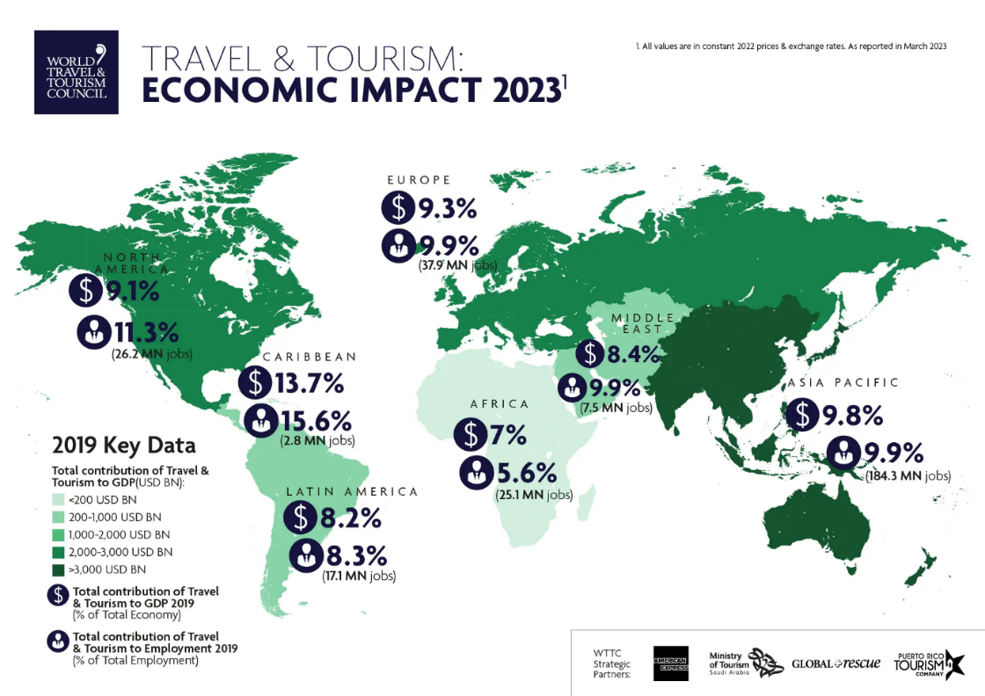

Appendix B


