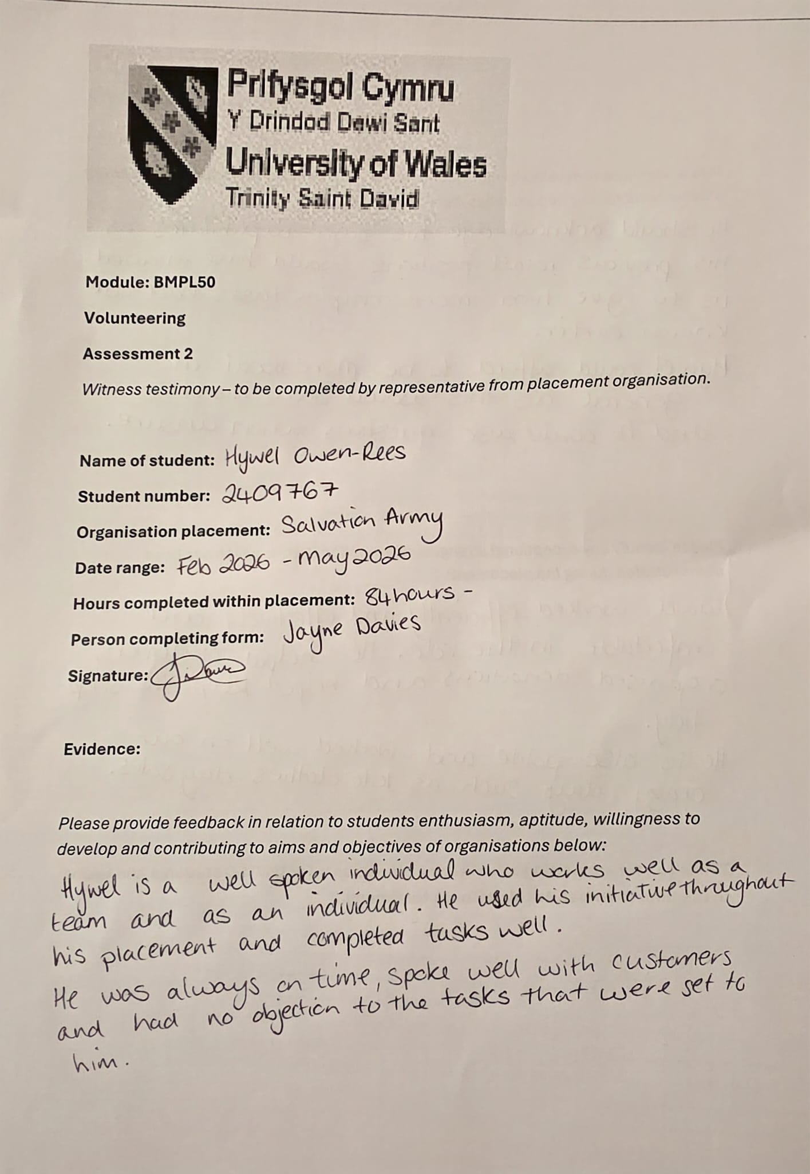
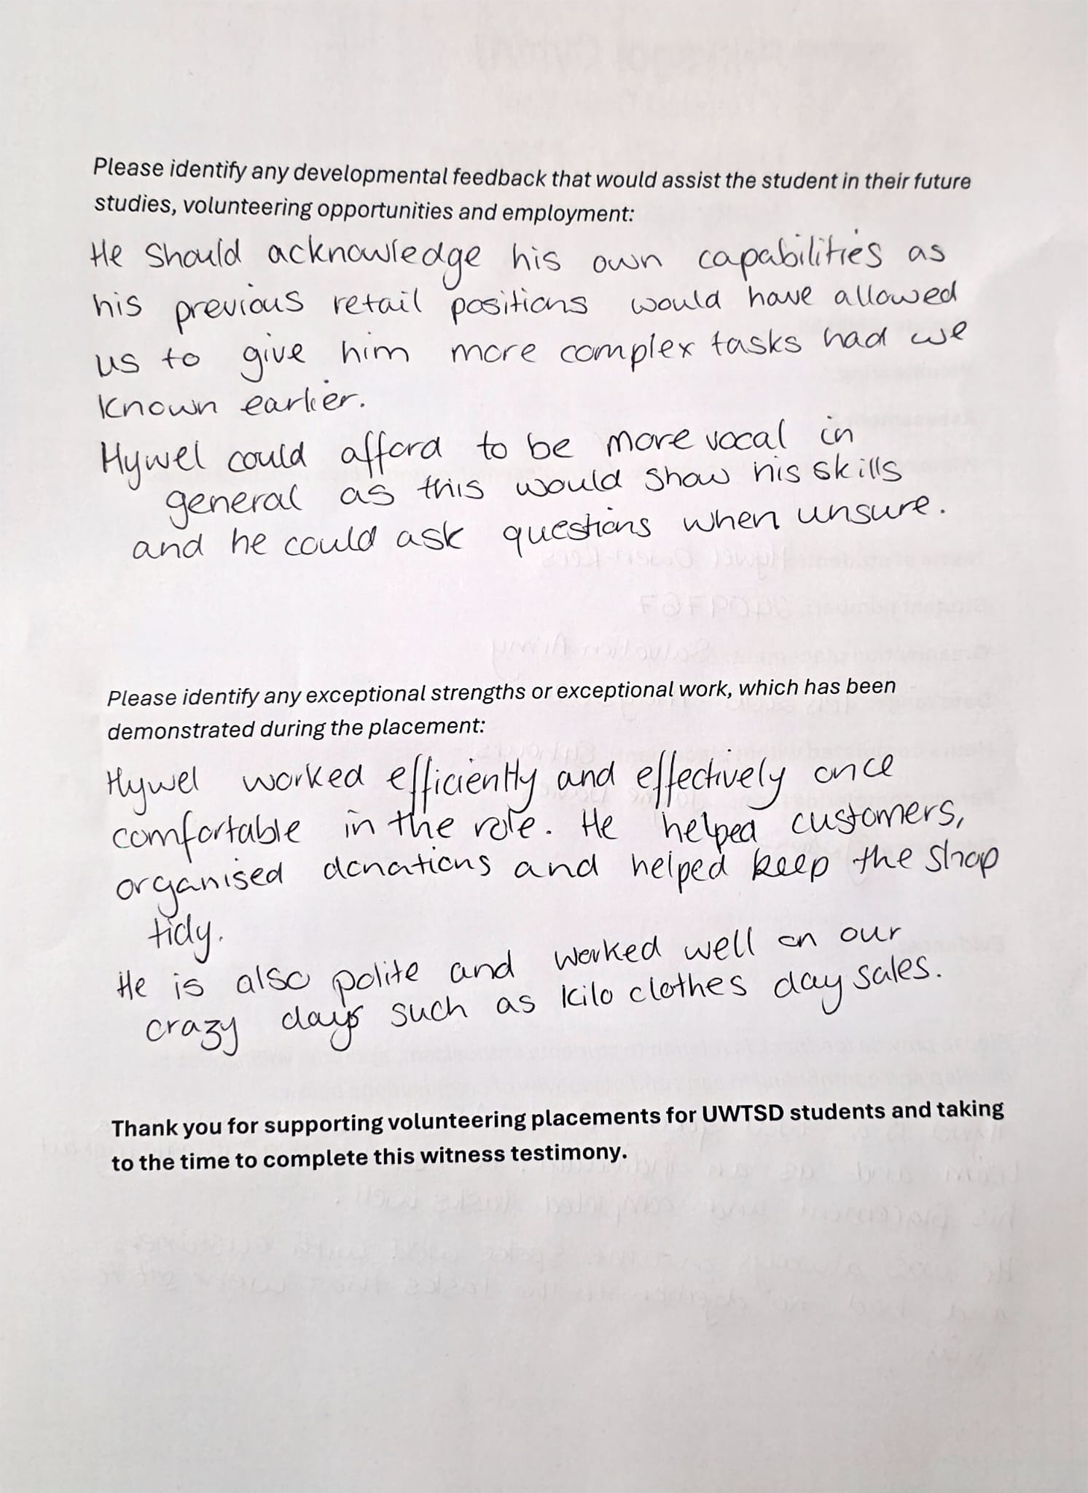
A.I Acknowledgments.

I confirm that I have not used any AI tools in the research and creation of this

Assignment. I confirm that I have not presented any AI generated materials as my own

Work. I confirm I have copies of my drafts, notes, and other resources I used, which I

May be asked to provide in evidence.

