
MODULE: Databases and Application Development
MODULE CODE: ACCA5026
NAME: SAMUEL KWANEA DUAH
STUDENT NO: 2328690
DATE: 2ND APRIL, 20026



TABLE OF CONTENTS
Introduction------------------------------------------------- 1
Database Design------------------------------------------- 2
Constraints
Database Implementation----------------------------- 3
Procedures
Triggers
Stored Procedure and Transactional Scenario -------- 4

Performance Tuning Enhancement ---------------------- 5
Conclusion and Reflection --------------------------------- 6
References ------------------------------------------------------ 7

Introduction
GreenLeaf Organics is entering a pivotal stage in its growth as it transitions from a traditional retail model to a fully integrated online platform. As a UK-based company committed to sustainability, organic living, and environmentally responsible products, this expansion aligns naturally with its mission to make healthy, eco-friendly choices more accessible. The increasing demand for certified organic produce, biodegradable household goods, and ethical personal care items has created the need for a digital infrastructure that can support both operational efficiency and an engaging customer experience.
To achieve this, GreenLeaf Organics requires a robust relational database capable of managing a diverse product catalogue, multiple certified suppliers, and a growing customer base. The new system must support essential functions such as inventory tracking, supplier management, order processing, and customer engagement through reviews and personalised interactions. A scalable database solution will not only streamline internal processes but also ensure that customers can browse, purchase, and evaluate products with ease and confidence.
By investing in a well-designed database foundation, GreenLeaf Organics positions itself to enhance transparency, improve supply chain reliability, and strengthen customer trust. This digital transformation will enable the company to maintain its sustainability values while expanding its reach and operational capabilities.
Database Design
Database design [1] is the systematic process of planning, structuring, and organizing data to create an efficient, accurate, and secure database system
Product
Key attributes
ProductID(PK)
Name
Price
Description
SupplierID(FK)
Relationships
Each product is supplied by one supplier.
Each product can appear in many order items.
Each product can have many customer reviews
Supplier
Key attributes
SupplierID (PK)
SupplierName
ContactName
Email
Phone
Relationships
A supplier provides many products.
A supplier may have multiple certifications
Customer
Key attributes
CustomerID (PK)
FirstName
LastName
Email
Phone
Relationships
A customer can place many orders.
A customer can write many reviews.
Order
Key attributes
OrderID (PK)
CustomerID (FK)
OrderDate
TotalAmount
PaymentStatus
Relationships
An order contains many order items.
An order belongs to one customer
Category
Key attributes
CategoryID (PK)
CategoryName
Description
Relationships
A category contains many products.
Review
Customer feedback on products.
Key attributes
ReviewID (PK)
ProductID (FK)
CustomerID (FK)
ReviewText
ReviewDate
Relationships
A review is written by one customer (Many-to-One).
A review is about one product (Many-to-One).

Product
Product_id(PK)
Poduct_first_last_name
Product_price
Product_description
Product_supplier_id(FK)
Supplier
Supplier_id (PK)
Supplier_first_last_name
Contact_name
Contact_email
Contact_phone
Customer
Customer_id (PK)
Customer_first_name
Customer_last-name
Customer_email
Customer_phone
Order
Order_id(PK)
Customer_id(FK)
Order_date
Total_amount
Payment_status
Order_name
Category
Category_id (PK)
Category_name
Category_description
Review
Review_id (PK)
Product_id (FK)
Customer_id(FK)
Review_text
Review_date

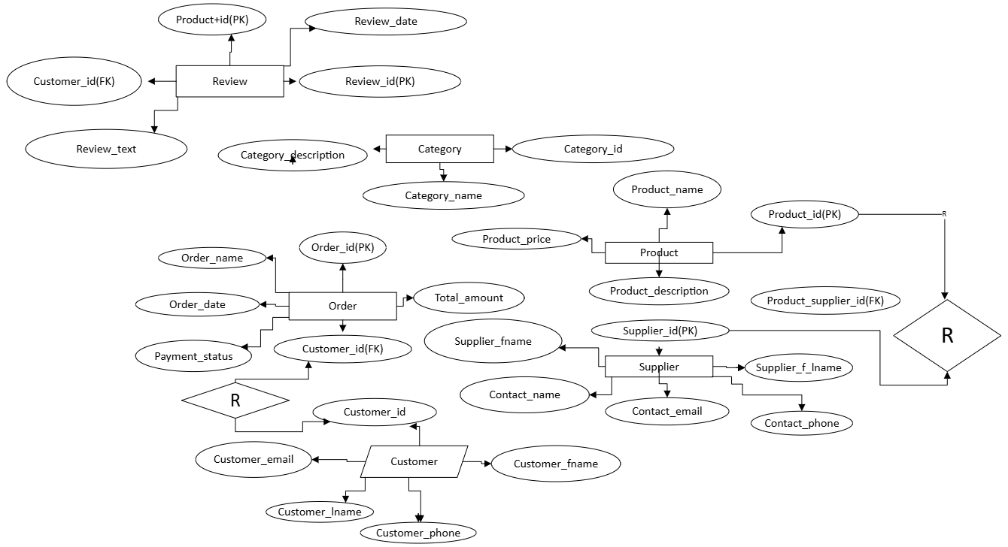
Figure 1 ERD DIAGRAM

The database for GreenLeaf Organics is designed using a fully normalized relational structure to ensure data integrity, reduce redundancy, and support the company’s long-term scalability. Normalization up to Third Normal Form (3NF) ensures that each piece of information is stored only once and in the most appropriate place. For example, customer addresses are separated into their own table so that a customer can maintain multiple shipping or billing addresses without duplicating customer data. Similarly, product information is divided into product-level details and variant-level details, preventing repeated descriptions for each SKU and allowing GreenLeaf to offer multiple sizes or packaging options for the same product.
Relationships between entities are structured to reflect real-world interactions within an e-commerce environment. Customers can place many orders, and each order can contain multiple items, so a one-to-many relationship exists between Customer and Order, and another between Order and OrderItem. Order items store the price and tax at the time of purchase, ensuring that historical financial data remains accurate even if product prices change later. Payments and shipments are also linked to orders in a one-to-many fashion, allowing for partial payments, retries, or split shipments when items are fulfilled from different locations.
Products are organized into categories to support browsing and filtering on the online platform. Each product can have multiple variants, such as different weights or packaging types, which are stored in a separate ProductVariant entity. This separation avoids redundancy and supports flexible catalog management. Inventory is tracked at the variant level, and optionally by warehouse or location, enabling GreenLeaf to maintain accurate stock levels and manage replenishment efficiently.
Supplier management is a key requirement for GreenLeaf, especially given their commitment to sustainability and certified organic sourcing. Suppliers and certifications form a many-to-many relationship, implemented through a junction table that records certification details such as issue and expiry dates. This structure allows GreenLeaf to verify and track supplier compliance over time. Another many-to-many relationship exists between suppliers and product variants, since a single variant may be sourced from multiple suppliers and each supplier may offer many variants. This design supports multi-sourcing strategies, cost comparisons, and supply chain resilience.
Customer engagement is supported through a Review entity, which links customers to the products they review. Reviews are associated with the product rather than the variant, since customers typically evaluate the overall product experience. This relationship structure allows GreenLeaf to display aggregated ratings and feedback on product pages while maintaining moderation controls through attributes such as approval status.
Overall, the design choices in this ERD reflect a balance between normalization, flexibility, and real-world business logic. By structuring the data into well-defined entities with clear relationships, the system becomes easier to maintain, more scalable as the product catalog and supplier network grow, and more reliable for supporting GreenLeaf Organics’ mission of delivering sustainable, high-quality organic products through a robust online platform.
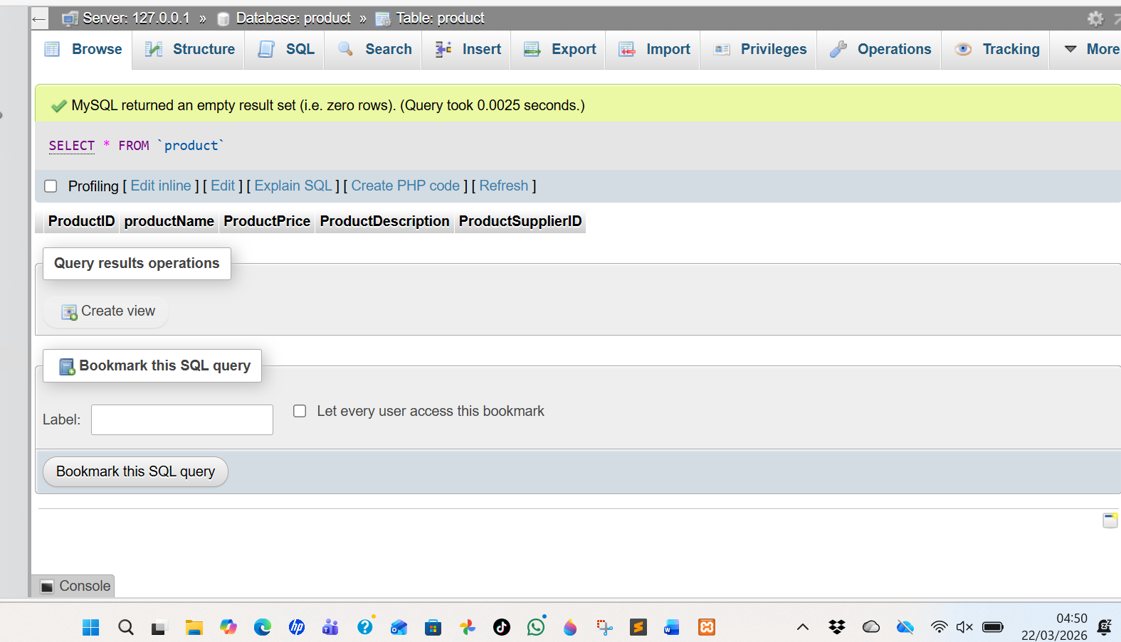
Figure 2 SQL PRODUCT

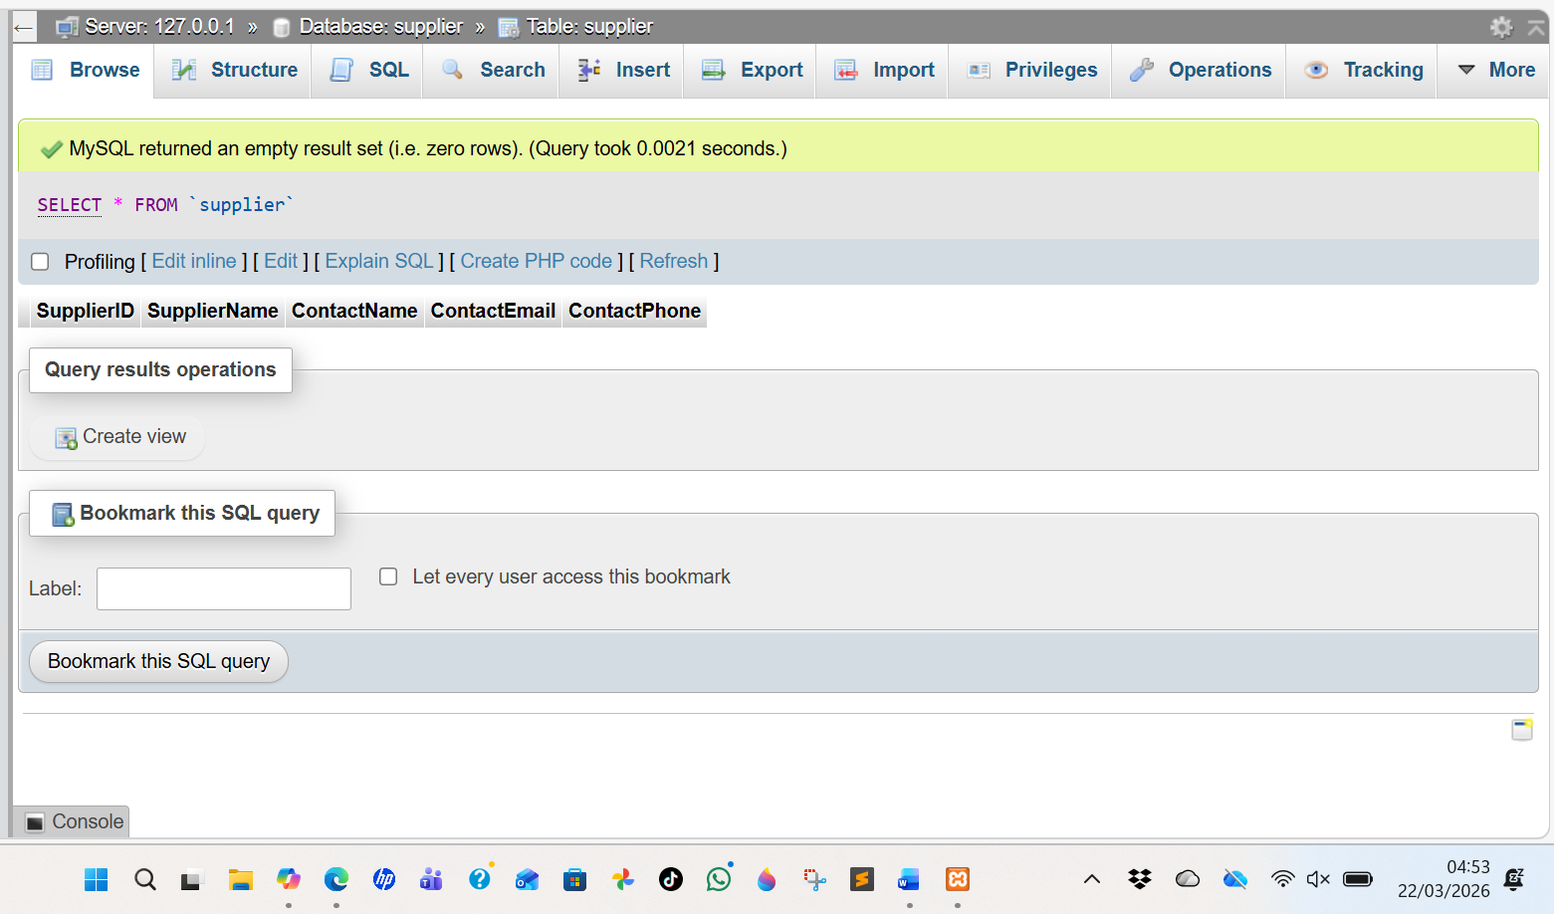
Figure 3 SQL SUPPLIER
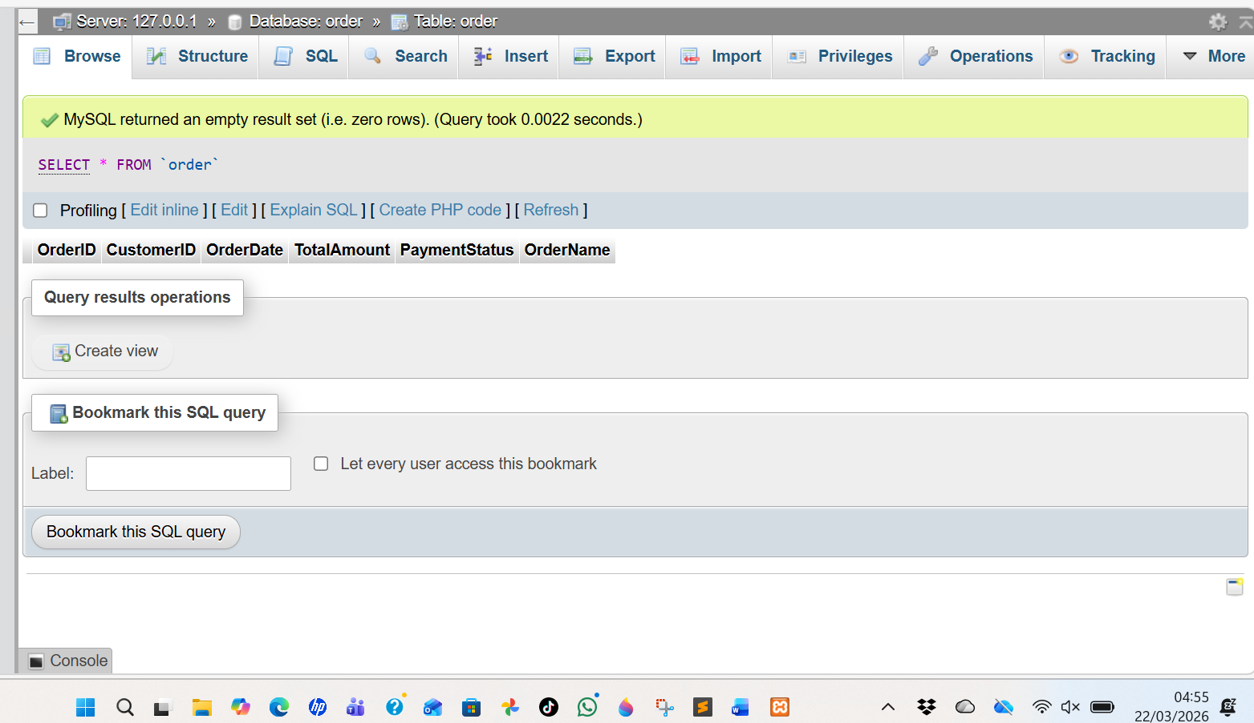
Figure 4 SQL ORDER
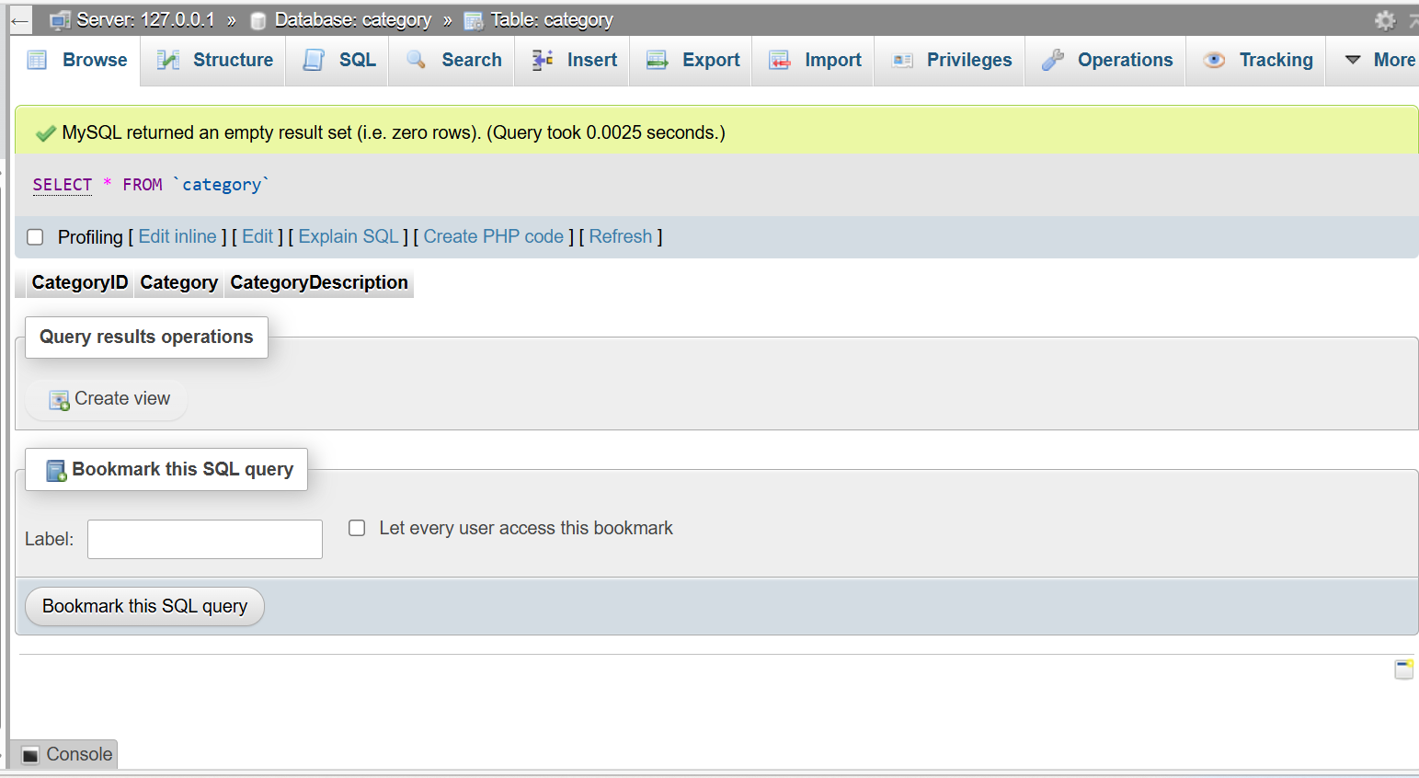
Figure 5 SQL CATEGORY

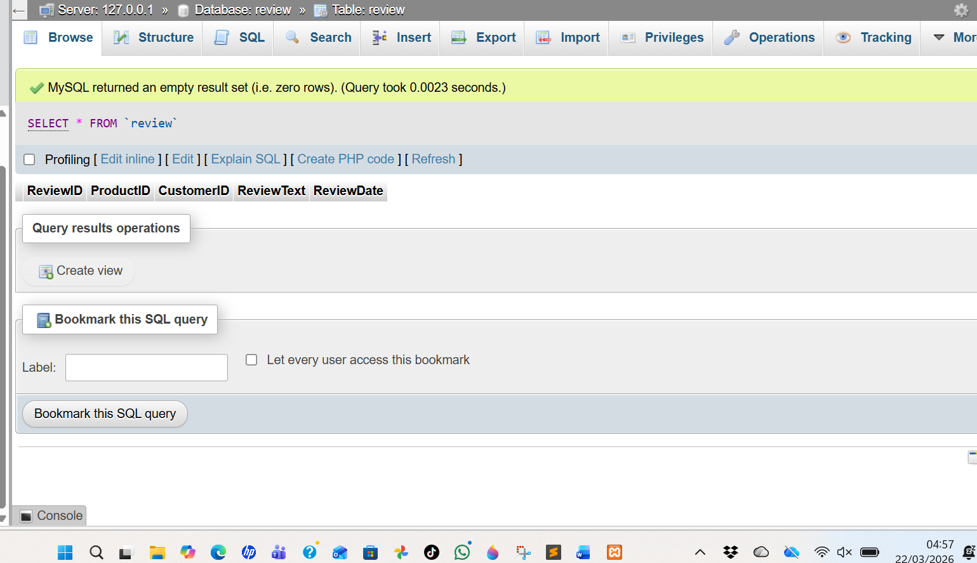
Figure 6 SQL REVIEW
constraints
In the GreenLeaf Organics database, constraints play a crucial role in maintaining the accuracy, consistency, and reliability of the data that flows through the system. Primary key constraints are used throughout the schema to ensure that every record—whether it represents a customer, product, supplier, or order—has a unique and permanent identifier. This prevents duplication and allows other tables to reference these records safely. Foreign key constraints reinforce the logical relationships between entities by ensuring that references always point to valid, existing records. For example, an order cannot exist without a corresponding customer, and an order item cannot reference a product variant that has been removed from the catalog. These constraints protect the database from orphaned or inconsistent data and help maintain the integrity of the system as it grows.
Unique constraints are also implemented to enforce business rules and prevent conflicting or duplicate information. Customer email addresses must be unique so that no two customers can register with the same contact details. Product variants rely on unique SKUs to ensure that each sellable item can be tracked accurately in inventory and supplier records. In the review system, a unique constraint on the combination of customer and product can prevent users from submitting multiple reviews for the same item, which helps maintain fairness and data quality.
Check constraints further strengthen the system by ensuring that values fall within acceptable ranges or categories. These constraints enforce rules such as requiring review ratings to fall between one and five, preventing negative inventory quantities, and ensuring that order statuses match predefined, meaningful values. They help catch errors at the moment of data entry, reducing the risk of invalid or illogical information entering the system
Many-to-many relationships, such as those between suppliers and certifications or suppliers and product variants, are implemented using junction tables with composite primary keys. These composite keys ensure that each relationship is recorded only once, preventing duplicate associations and maintaining clarity in the data. They also allow additional attributes—such as certification expiry dates or supplier-specific cost prices—to be stored without compromising the integrity of the relationship.
Finally, not-null constraints ensure that essential information is always provided. Critical fields such as product names, order dates, customer emails, and payment amounts cannot be left empty, which guarantees that every record contains the minimum data required for the system to function correctly. Together, these constraints create a robust and dependable database structure that supports GreenLeaf Organics’ operational needs while ensuring that the data remains clean, consistent, and aligned with the company’s commitment to quality and sustainability.[2]
Database Implementation
Procedures
GreenLeaf Organics should begin by assessing their operational needs, focusing on product management, supplier coordination, customer interactions, and order processing. This analysis helps define the core database requirements and ensures the system supports scalability as the business grows. Once the requirements are established, the next step is selecting a suitable relational database solution—such as MySQL or PostgreSQL—because these systems provide strong data integrity, structured relationships, and reliable performance for e‑commerce platforms.[3]
After choosing the database, the design phase involves creating an entity‑relationship model that maps out key components like customers, orders, products, suppliers, and reviews. This model guides the development of normalized tables to reduce redundancy and maintain data consistency. The final procedure is building a functional prototype that demonstrates essential features, including inventory tracking, supplier management, and customer order flows. This prototype allows GreenLeaf Organics to validate the system’s effectiveness before full implementation.
Triggers
Database triggers are automated procedures that execute in response to specific events within a table, such as inserting, updating, or deleting data. They help maintain data accuracy and enforce business rules without requiring manual intervention. By reacting instantly to changes, triggers ensure that important processes happen consistently and reliably across the system.
In practice, triggers are often used to validate data, update related tables, or log user activity for auditing purposes. For example, when a new order is placed, a trigger can automatically adjust inventory levels or record the transaction in a history table. This reduces the risk of human error and keeps the database synchronized.
Triggers are powerful tools, but they must be designed carefully to avoid unnecessary complexity or performance issues. When implemented thoughtfully, they enhance data integrity and streamline operations, making them valuable components of a well‑structured relational database.[4]
Stored Procedure and Transactional Scenario

Stored procedures for Insert, Update, and Delete operations are essential for maintaining data integrity and ensuring consistent behaviour across a relational database. Each procedure typically begins by starting a transaction, which groups the SQL statements into a single logical unit of work. This ensures that all changes succeed together or fail safely without corrupting the data.
For an Insert procedure, the transaction validates input values, inserts the new record, and commits the transaction if successful. If any constraint fails—such as duplicate keys—the procedure rolls back the transaction to prevent partial data entry.
An Update procedure follows a similar pattern, checking whether the target record exists before applying modifications. If an error occurs, the transaction is rolled back to preserve the original data.
A Delete procedure ensures that dependent records or constraints are handled correctly. By wrapping the deletion in a transaction, the system avoids orphaned data and maintains referential integrity.

Conditional rollback and commit logic is essential in real-world database operations because it ensures that only valid, complete, and consistent changes are saved. One practical use case is inventory management. When a customer places an order, the system attempts to reduce stock levels. If the requested quantity exceeds available inventory, the transaction is rolled back to prevent negative stock, ensuring data accuracy.
Another common scenario is payment processing. When an order is created, the system may insert the order record, update the customer’s balance, and log the transaction. If the payment gateway fails or validation errors occur, all related operations are rolled back so the database does not store incomplete or misleading financial data.
A third use case involves supplier updates. If multiple fields must be updated together—such as contact details and certification status—the system commits only when all updates succeed. Any failure triggers a rollback, preserving data integrity.[5]
Performance Tuning Enhancement

An effective indexing strategy begins with identifying the queries that are executed most frequently or handle the largest volumes of data. In systems such as an online store or campus club platform, performance-critical operations often include searching for products or events, retrieving user profiles, and processing orders or registrations. To optimise these tasks, primary keys are automatically indexed, but additional non-clustered indexes are created on columns commonly used in WHERE, JOIN, and ORDER BY clauses.
For example, indexing fields like email, product_name, or event_date significantly speeds up lookups and filtering. Composite indexes are used when queries rely on multiple columns together, such as retrieving orders by user_id and order_date. Care is taken to place the most selective column first to maximise efficiency.
At the same time, the strategy avoids over-indexing, which can slow down inserts and updates. Regular monitoring ensures indexes remain aligned with evolving query patterns and data growth.

Indexing significantly enhances the Campus Club’s ability to manage operational data efficiently by speeding up access to the information used most frequently. Member lookups, event searches, and attendance tracking all rely on quick filtering and retrieval. By indexing key fields such as , , and , the system can return results almost instantly, even as the database grows with new members and activities.
These performance gains are especially valuable during peak periods, such as event sign‑ups or membership renewals, when many queries are executed at once. Indexes reduce the workload on the database engine, ensuring smooth performance and preventing delays that could frustrate users or slow down administrative tasks.
Additionally, indexing supports accurate reporting by accelerating queries used for analytics, such as attendance summaries or membership trends. This allows club leaders to make timely, data‑driven decisions that improve planning and engagement.

Indexing and optimized database structures lead to noticeable improvements in query speed by reducing the amount of data the system must scan. Instead of searching entire tables, the database can use indexes to jump directly to the relevant rows, dramatically cutting down response times. This is especially beneficial for large datasets where frequent lookups—such as retrieving member details, event schedules, or registration records—would otherwise slow down operations.
Efficiency also improves because the database engine performs fewer disk reads and uses resources more effectively. Queries involving filtering, sorting, or joining tables become significantly faster, allowing the system to handle higher workloads without performance degradation. As a result, tasks like generating attendance reports or checking event availability run smoothly even during peak usage.
Overall, these improvements enhance user experience, reduce server strain, and ensure the system remains responsive as data volume and activity levels continue to grow.[6]

Conclusion and Reflection
Conclusion
The final database solution successfully meets the campus club’s operational and engagement needs by providing a structured, scalable system for managing members, events, and activities. Through a well‑designed relational model, the system ensures accurate tracking of registrations, attendance, and club resources, allowing committee members to coordinate events more efficiently. This structure also supports secure data handling, ensuring that member information is stored consistently and reliably.
In addition, the inclusion of stored procedures, triggers, and transaction handling strengthens the system’s reliability. Automated processes help maintain data integrity during updates, while conditional commit and rollback logic prevents errors from affecting the database. These features ensure that event bookings, membership updates, and financial transactions are processed safely and consistently.
Overall, the solution provides a robust foundation that enhances communication, simplifies administration, and supports the club’s long‑term growth by offering a dependable and user‑friendly data management platform.
Reflection
Developing the database solution presented several challenges, particularly in balancing data integrity with system performance. Designing relationships that supported complex operations—such as order processing, membership updates, or event management—required careful planning to avoid redundancy and ensure smooth interactions between tables. Another challenge involved implementing reliable transaction handling, especially when multiple operations needed to succeed or fail together. Ensuring that triggers and stored procedures worked harmoniously without creating conflicts also demanded thoughtful testing.
To address these issues, structured normalization techniques were applied, and robust transaction logic was introduced to manage conditional commits and rollbacks. Clear validation rules and automated triggers helped maintain consistency, while modular stored procedures simplified maintenance and improved reliability.
Looking ahead, future improvements could include adding advanced analytics, implementing role-based security, and integrating real-time dashboards. Expanding automation and exploring cloud-based scalability would further enhance performance and support long-term growth.
References
1.M. J. Hernandez, Database design for mere mortals : a hands-on guide to relational database design, Fourth edition. Boston: Addison-Wesley, 2022.
2.W. Li, “Supporting Database Constraints in Synthetic Data Generation based on Generative Adversarial Networks,” in Proceedings of the 2020 ACM SIGMOD International Conference on Management of Data, New York, NY, USA: ACM, June 2020, pp. 2875–2877. doi: 10.1145/3318464.3384414.

3.T. M. Connolly and C. E. Begg, Database Systems : a practical approach to design, implementation, and management, Sixth, Global edition. Boston: Pearson, 2015.

4.A. H. Le, T. Van Khanh, and T. N. Thuan, “Formal Analysis of Database Trigger Systems Using Event-B,” International journal of software innovation, vol. 9, no. 4, pp. 158–173, Oct. 2021, doi: 10.4018/IJSI.20211001.oa1.

5.M. Butrovich, S. Arch, W. S. Lim, W. Zhang, J. M. Patel, and A. Pavlo, “BPF-DB: A Kernel-Embedded Transactional Database Management System For eBPF Applications,” Proceedings of the ACM on management of data, vol. 3, no. 3, Art. no. 135, June 2025, doi: 10.1145/3725272

6.Hitesh Kumar SHARMA and S.C. NELSON, “Performance Enhancement using SQL Statement Tuning Approach,” Database systems journal, vol. VIII, no. 1, pp. 12–21, July 2017.

