Academic and employability skills
reflective report

Abstract: . how the learning in this module has helped me to develop my employability skills, using the feedback you received on all in-class activities.

Student name: sunanda saha
Student no: 1817751
Lecturer name: Christopher Mafuva
Module name: academic and employability skills
Module code: BMSW4001
Date: 22. 12. 2019

Table of Contents

introduction 2
what is reflective writing 2
what is reflective report 2
models of reflection 2
personal reflection 3
conclusion 5
references……………………………………………………….6
appendix………………………………………………………….7

Introduction:
I am presenting my report on how the learning in this module has helped me to develop my employability skills, for this I am going to look after some articles, journals books toward enrich my knowledge. I am going to reflect on my term one and term two academic skills which I have learnt in class and made them apply in in-class exercise and got feedback. I will provide all evidence for my research as references, quotations, and citations. Here I am going to presents some critical thinking of mine while researching and I will provide the prove of academic skills which I have learnt and applied them in in-class exercise as an appendix.

What is reflective writing:
‘The process of internally examining and exploring an issue of concern, triggered by an experience, which creates and clarifies, meaning in term of self and which results in a changed conceptual perspective’.
(Boyed, 1983)
According to Fink (2003), reflective writing ‘focuses on the writer’s learning experiences itself and attempts to identify the significance and meaning of a given learning experiences, primarily for the writer.’
(Kathpalia, 2008)
What is reflective report:
As the name recommends, reflective report is a section of writing that recapitulates a student’s critical thinking on a subject. While outdated academic writing discourages first person account, reflective reports bank on them. Reflective reports commonly used as the part of the valuation of practical develop.

Models of reflection:
There are many models of reflection:
Gibbs reflective cycle (1988)
Kolb’s experimental learning cycle (1984)
Driscoll’s model (1994,2000)
Honey and Mulford
Here I am going to discuss about the Gibb’s reflective cycle.

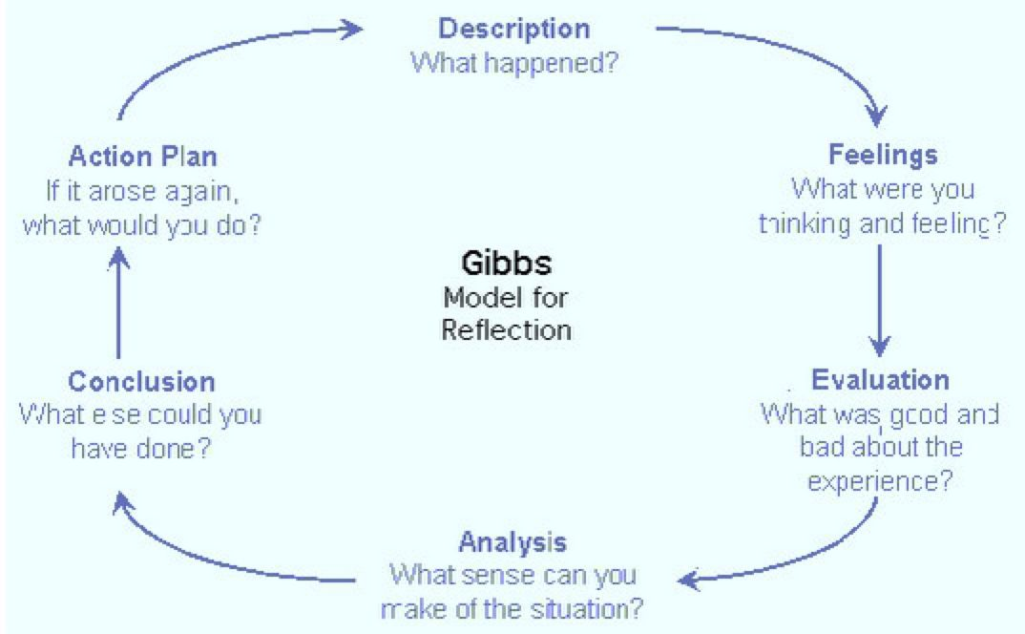
(www.bing.com, 2019).

From the picture of the model, we can guess that what he was trying to say by his model. He said that firstly we should think about the situation that what actually happens, then we should talk about what we are feeling about the circumstances, thirdly we need to think about the good and bad experiences related to the situation so that we can make the analysis it and make a fair decision. Here we need to be careful about both good and bad situation- because both have individual perception. Then at conclusion we need to think about that what else we can do to complete the task, and in action plan, we can save it in our own memory and in our own experience skills, so that we can use it later, if same situation arrives, so that find out the best way to come out from it.

Personal reflection:
Here I am going to writing a report about myself on basis of Gibb’s reflective cycle.
My name is Sunanda Saha, from India currently resides in London, United Kingdom. When I have applied for my college course, I was so nervous for my further studies as I left my studies long 10 years ago. So, it’s been challenging for me. I have good knowledge in English literature but in London education systems is far more different from my country. So very much surprising is waiting for me. I have done an essay before in my university, but when I started here, I got stuck with an idea as it feels like words is blocking in my head just, not coming out anything. In the first week of first term, everything seems easy to me. We were just introducing to each other and slightly talk about our curriculum. From second week, we were starting to learn, where we started to learn how to take notes in short form so that we can use it in our assignment. Here we learn about the main key points of sentences and diagrammatic way of note taking. I like the diagrammatic way of note taking which given me a clear view of my lecture. It also consensuses spaces to connexion the ideas by making inaccessible boxes and showing the link by diagram arrows across them. I was always made aware of plagiarism by my tutor, which is a serious academic offence. To avoid it, I learnt the method of paraphrasing and referencing.
Paraphrasing was something different to me as I have an idea of summaries. It was showing a new way of writing to me. Where I just read the whole articles and make the main points of it and put it in my own words. it helps me in my group presentation which I learnt a new as well as I never done presentation before. In presentation I used the note taking methods such as making the bullets points and make the paraphrasing of the points. I learnt how to usage the class notes to make précises of the text, it was great for me as I always struggling how to write an introduction but now, I gather an idea from class lecture and use in my assignment.
Earlier I started this course, I was blank about the Reference, from where to get it, where to use it etc. In class I came to know the importance of references in the assignment, literally I got really tensed as it looks very hard to me as a first timer, but as I started attending my classes, I am getting an idea of it as there is various method of referencing, where I need to read journals, articles, online articles, newspapers, and other articles. The referencing section in term 1 was elaborately describes that’s took long time to finish as my al friends were struggling to understand proper methods. After that I learned about quotation and citations. It was very interesting to know that single inverted comma makes a big variance when used improperly. Then we moved into Theoretical writing section where I learned about various structure of writing essays, paragraphs and journals. I was enjoying this section because it looks interesting to me as I learned now how to combine all this element for writing a good assignment or reports. Here I learned about Google Scholar, I learned how to find out the latest journals, how to save it, how to find out the references from there. So that’s interesting to me.
Then we done some in class exercise about summarising and paraphrasing, I wrote it down with confidence now, it feels good as I was feeling very much knowledgeable inside me that making me feel proud of myself and bringing up my self- confidence. After the exercise, I got feedback from my teacher where she showed me where I was little bit wrong where I can do more better, more over she was very happy about my result. Overall in first term, I learned so many things those are really very important for my whole three terms.
The second term of the course had a deeper look inside the theoretical analysis and inscription. In first week, we revised about the course of term 1 and we started continued for term two. In term two we basically focus on employability skills, so we started with an interesting subject that is cv writing. I already have knowledge about cv writing as I already have cv but many new things I learnt from this like I need to focus on job specification and person specification, when I am applying for a job. That’s opens my mind as I wasn’t aware of this thing. The teacher showed us some videos as well to getting more idea. The teacher gave us some templets as for example. That really helps me to modify my cv. Then I learned about how to write a Cover letter to attach with cv. In here I got an idea that I need to give importance of job specification and person specification to write a good cover letter. I need to read them well and then use the paraphrasing method to write a cover letter. After that I had an in-class exercise about cover letter that helps me a lot where I found out by my teacher that where I was wrong in cover letter and where I need to improvements. Then my teacher taught us about Reflective writing that plays important part in my assignment. It all about reflection of your course in your life very like interesting. Then I learn about reflection models o which I saw some videos to get clear about it and read some articles referred by my teacher. I can write an assignment on basis of reflective writing. After that we done some revision on summarising and referencing which is always important for all time. Here my teacher tried to give an idea about presentation skills, public speaking skills which I need very much in my life as I always scared of public speaking. He shows us the techniques, body language, how to be more precise when we talking in public, bad ways of speaking, how to frame it in our mind before we present it, how to make a power-point to present it, how to modify it, most effective ways of presentation. It really helps me a lot as I need to do mini prestation and group presentation. Here I learned the techniques so that I can apply it in my presentation. I was taught how to make arguments, and counter arguments. Providing evidence for arguments also important for arguments. We revised referencing lesson here once more. I learned about critical thinking, analytical thinking. There are differences between them, as when I am reading any article or journal at first, I can analyse the theories and then I can do the critical thinking. Analysing means before I am writing anything, I am getting the arguments, bringing up the arguments to support it and give an evidence to prove it. But critical thinking means I am getting the question on behalf of this article. Here I learned about most important things that question that could asked by manager while interviewing. At the last week of term, I had the mini presentation of five minutes that I done well as I used all the techniques that I taught in class. I got the feedback as my appendix.
The lesson was arranged in a way to make the students more confidence and able in both academic and employability skills. After finishing my term one and term two, I can compare myself that where I was and where I am now. When I started study after ten long years, I was thinking that it going to be hard for me to be concentrate, memorising things. But when I started my college, I was stared enjoying my college, studies, reading articles. I came to know about communication, employability skills, different academic skills, digital skills which I started to apply in my everyday life. I can write an essay or report on 2000-2500 words, by using google scholar, references, quotation, citation. I have also learnt to syndicate the knowledge I have acquired to make my writing more expressive which would let me accomplish better rankings than before. I am more confident in public speaking now. I can do my own presentation by using power-point. The teacher conducted many activities to build a confidence in us via in class exercise.
Conclusion:
I have presented my reflective report on basis of academic planner which helps me to build my employability skills. I came to know about different model of reflection, which I will apply to bringing up my employability skills. At first I read on research informed literature that helps me getting the idea about the report, then I read different article, journals, my handbook given by university, resources uploaded in Moodle which helps me to analysis all theories and make me do critical thinking about the report. After getting all the information via researching, knowing the subjects, analysing, critical thinking, I stared practical application of it which help me to improve in my academic and employability skills. For evidence of my research, I am giving all my references, and in-class exercise report, feedback got from teacher as an appendix.

References:
- Finlay, L., 2008. Reflecting on reflective practice. PBPL paper, 52, pp.1-27(accessed: 15th December,2019).

- Peter Morgan (2017) The business student’s guide to study and employability London Sage publication (accessed:20th December,2019).

- Maund,Schriek, Paul k.Tinkler (2017) Certificate in Higher Education: Skills for the Workplace Student Yearbook first edition: London (accessed: 18th December, 2019).

- online available from www.ivoryresearch.com (accessed: 17th December,2019).

- Kathpalia, S.S. and Heah, C., 2008. Reflective writing: Insights into what lies beneath. Relc Journal, 39(3), pp.300-317 (accessed:15thDecember,2019).

Boyd, E.M. and Fales, A.W., 1983. Reflective learning: Key to learning from experience. Journal of humanistic psychology, 23(2), pp.99-117 (accessed:19th December,2019).

Appendix:

Here I am attaching my in-class exercise papers and feedback received from my teacher.



