
University of Wales Trinity St Davids
Ultrasonic Attenuation Coefficient Determination
Part one

Author: Dylan Huw Davies
Supervisor:

Student Number: 2100937
Course title: Motorsport Engineering
Date:

Contents
Apparatus 3
1.0 Introduction 4
2.0 Method 5
Procedure 5
3.0 Measurements and Graphs of Raw measurements 8
4.0 Calculations and error estimates 13
5.0 Results and Discussion 16
5.1 Incident Energy (RE) results 16
the steel-to-hair gel interface, a significant acoustic impedance mismatch causes 87.9% of the ultrasonic energy to be reflected into the steel. Only 12.1% of the incident energy is transmitted into the hair gel. This result highlights how the large difference in acoustic properties between the two materials leads to high reflection and low transmission of ultrasonic waves at the interface. 16
5.2 Nearfield results 17
5.3 Attenuation results 17
5.3.1 Mild Steel Block Direction one (width) 18
5.3.2 Mild Steel Block Direction two (length) 18
5.3.3 ANOVA Results for Mild Steel 19
5.3.4 Brake Disc Hub 19
5.3 D-SCAN 705 Calibration errors 21
5.4 Grain Structures boundaries effect 21
6.0 Conclusion and bibliography 22
7.0 Referencing 23
8.0 Appendix 26
8.1 Z positive look up tables for confidence limits 26
8.2.1 P-Value 28
8.2.2 F-Value 28
8.8.3 Coding to calculate P and F values. 28

Figure 1 D-SCAN 705 SilverWing 3
Figure 2 ultrasonic transducer on Mild steel block 5
Figure 3 Gate example with data displayed 5
Figure 4 A-Scan data 6
Figure 5 A-SCAN mild steel block width 8
Figure 6 Mild steel amplitude length A-SCAN 9
Figure 7 Beam Pattern Formation (Ultrasound sound waves, 2021) 9
Figure 8 Mild steel block Amplitude, Direction one 10
Figure 9 Mild Steel Block Distance one 10
Figure 10 Mild steel block amplitude, direction two 11
Figure 11 Brake disc hub amplitude 11
Figure 12 Mild Steel Normal distribution and histogram plot 15
Figure 13 Brake disc hub normal distribution and histogram plot 15

Abstract
This report evaluates the ultrasonic attenuation behavior of a mild steel block and a brake disc hub using a calibrated D-SCAN 705 ultrasonic flaw detector with a 5 MHz probe. The study measures wave attenuation and echo amplitudes to understand material properties and energy losses caused by scattering, absorption, and grain structures. Results show that the mild steel block, with its fine grain structure, exhibited lower attenuation and greater signal consistency compared to the brake disc hub, which showed higher variability due to its coarser structure and surface rust. ANOVA analysis confirmed significant differences in attenuation across wave directions and echoes, highlighting the influence of material microstructure and wave propagation. These findings emphasize the importance of calibration, material properties, and surface conditions in ultrasonic testing reliability.

Apparatus
- D-SCAN 705 ultrasonic flaw detector has been used to detect flaws in the samples, using ultrasonic waves from Silverwing UK. The unit provides A-Scans and high performance (ME, 2008).
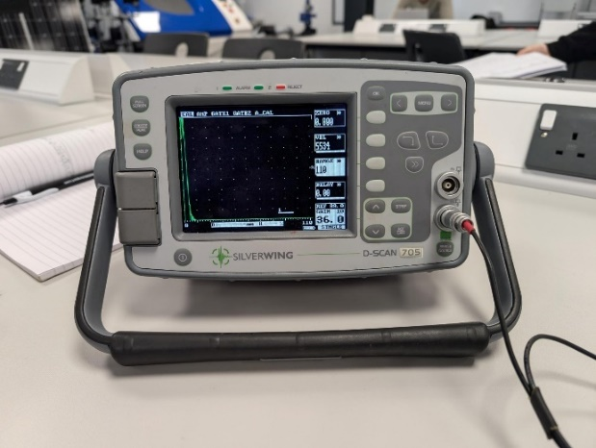
Figure 1 D-SCAN 705 SilverWing
- Styling gel used as a couplant.
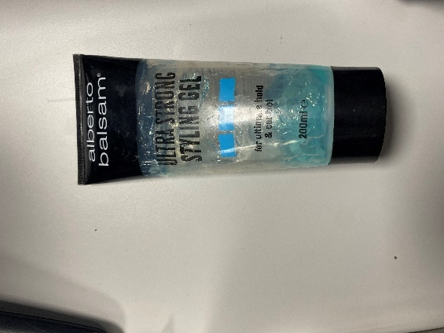

1.0 Introduction
Evaluating material properties is essential for ensuring structural integrity in engineering applications. This report examines the attenuation coefficients of a mild steel block and a brake disc using ultrasonic testing, a non-destructive technique that detects flaws through high-frequency sound waves (Gupta et al., 2022). The attenuation coefficient, which quantifies the reduction in ultrasonic wave amplitude due to absorption and scattering (Bertoncini et al., 2010), is critical for assessing energy losses and material characterization. A 5 MHz ultrasonic probe and Ultrasonic Flaw Detector (UFD) measured time of flight (TOF), enabling calculation of attenuation coefficients and comparison of the material properties of both samples for engineering applications.

2.0 Method
Equipment Setup
Health and Safety Executive document emphasizes the importance of manual ultrasonic inspection techniques, including the need for calibration, consideration of material properties, and defect detection. It validates the use of ultrasonic testing for ensuring component integrity. This paper has been used to approach the attenuation measurement and echo analysis.
The D-SCAN 705 ultrasonic flaw detector was calibrated for accurate readings. Ultrasonic velocity for mild steel (approximately 5930 m/s) was used as the baseline (Pan America Industries, 2022).
Glycerine was used as the couplant to facilitate sound wave transmission, minimizing signal reflection and ensuring consistent energy propagation (Dwyer-Joyce, 2005).
Table 1 Ultrasonic velocity (Pan America industries, 2022).
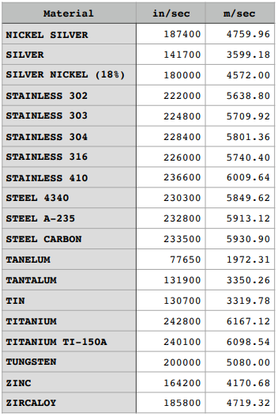
If material properties were unknown, measurements were compared to known values to validate results. A 5 MHz ultrasonic probe was employed for its balance between resolution and penetration depth, ensuring reliable detection of internal flaws (Xiaoyu et al., 2021). Glycerine was used as the couplant to facilitate sound wave transmission, minimizing signal reflection and ensuring consistent energy propagation (Dwyer-Joyce, 2005).
Data Collection
Measurements were taken using a vernier calliper with an uncertainty of ±0.001 cm to ensure precision (De Anza College, 2021) Ultrasonic gates were set to record the amplitudes of the first three echoes, with the range adjusted according to material thickness. The initial pulse, known as the dead zone, was excluded from analysis, while subsequent echoes were recorded at approximately 70% amplitude to ensure reliable readings. transducer is placed on the mild steel block with couplant in between. when an ultrasonic wave encounters an interface between two materials, a portion of the wave is reflected while the rest may be transmitted through. The reflection coefficient (R) quantifies the ratio of the reflected wave amplitude to the incident wave amplitude. It provides a measure of the wave energy that is reflected at the interface, depending on the acoustic properties (such as impedance) of the two materials (Dwyer-Joyce, 2005). This method is applied to the block width and lengthwise (Figure 2 )and the brake disc hub

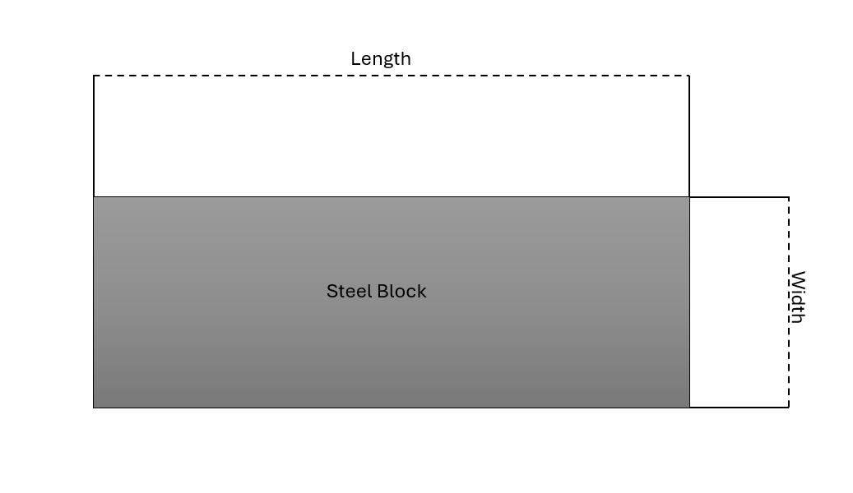
Method Pictures can be found can 8.0 Appendix.
Figure 2 Steel Block width and length
Analysis of Echo Amplitude
The recorded amplitudes were analyzed to determine attenuation coefficients, reflecting energy losses due to scattering and absorption within the materials (Bertoncini et al., 2010). Variations in echo amplitudes were examined to identify potential inconsistencies caused by material properties, grain structures, or environmental factors (Lesyk et al., 2023).
Data Validation
The procedure accounted for sources of error, including coupling inconsistencies and equipment calibration. Calibration errors were noted, particularly for the D-SCAN 705, which had not been recalibrated in over 13 years. Such delays in calibration can significantly impact measurement accuracy (Peng, 2008).
Material Characteristics
The mild steel block and brake disc hub were selected for their distinct grain structures, with mild steel offering finer grains and the brake disc hub exhibiting coarser structures typical of cast iron. These differences provided a comparative basis for analyzing attenuation behavior (Europe, 2024).

3.0 Measurements and Graphs of Raw measurements
Table 2 and 3 show the raw data gathered from the ultrasonic detector, for the mild steel block and the brake disc hub. Data on the mild steel block is presented in table 2 with data gathered sending an ultrasonic wave down its length and width.
Table 3 Mild Steel rectangular block Measurements

Table 4 Brake disc hub Measurements
The amplitude for each echo shares a similar pattern (figure 5), this may suggest inconsistencies and human error when holding the probe in position or the lack of coupling.
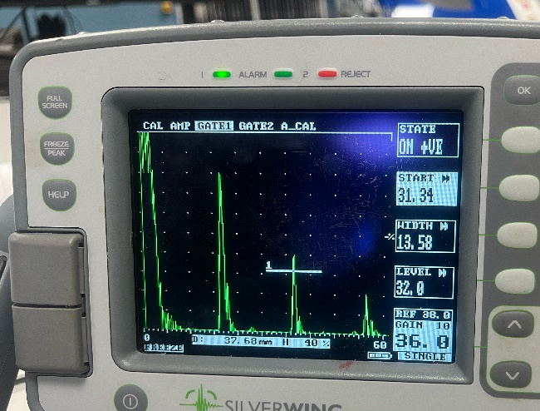
Figure 3 A-SCAN mild steel block width

The initial pulse (Figure 3) occurs due to the high acoustic impedance of mild steel compared to the couplant, causing strong wave reflection at the interface. This mismatch, resulting from the material's density and sound velocity, reflects part of the wave back (NDT-Inspect, 2022).

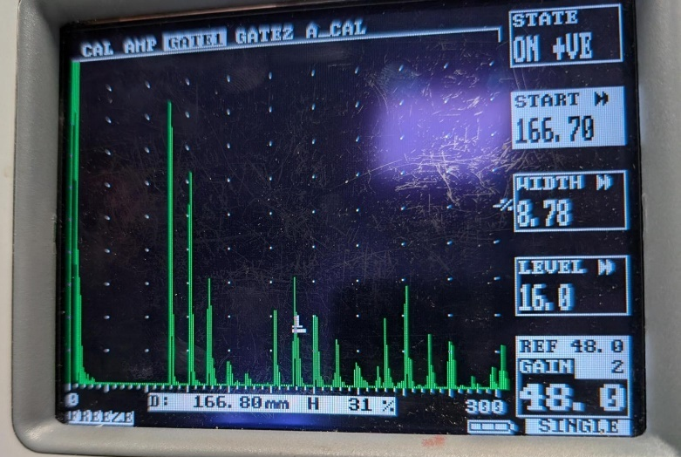
Figure 4 Mild steel amplitude length A-SCAN
Figure 4 shows the A-scan of a mild steel block with waves sent lengthwise. The pulse at 166.8 mm represents the second back wall echo (gated in Figure 12). The largest amplitude among the first three pulses (excluding the initial pulse) corresponds to the first reflected echo, while the other two pulses result from sidewall reflections caused by the beam pattern formation (Figure 5).

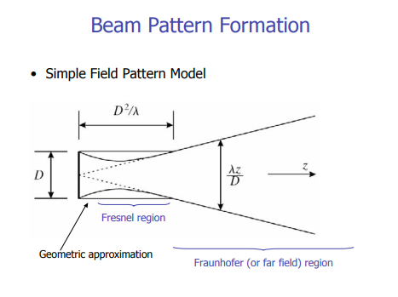
Figure 5 Beam Pattern Formation (Ultrasound sound waves, 2021)
This phenomenon occurs because the ultrasonic beam spreads out, especially in the far field zone. In this region, the beam's divergence causes portions of the energy to interact with the material's sidewalls, resulting in additional reflections (Stephen, Chevonne , Colin , Katelyn , Henry , Mitch , Kevin , Yuan , Zhan , Scott, Jean , Reza , 2020)
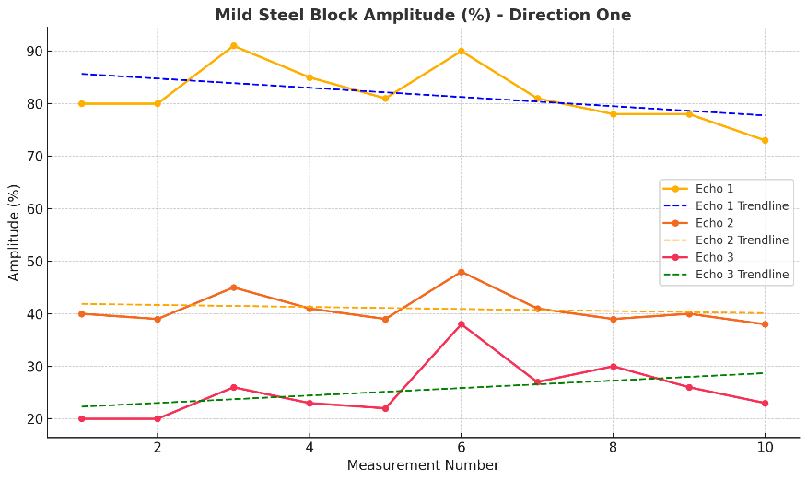
Figure 6 Mild steel block Amplitude, Direction one

Analysing Figure 6 echo 1 there is a 21.95% difference compared to the smallest amplitude 73% and largest amplitude 93%, suggesting a large error in accuracy when gathering results.
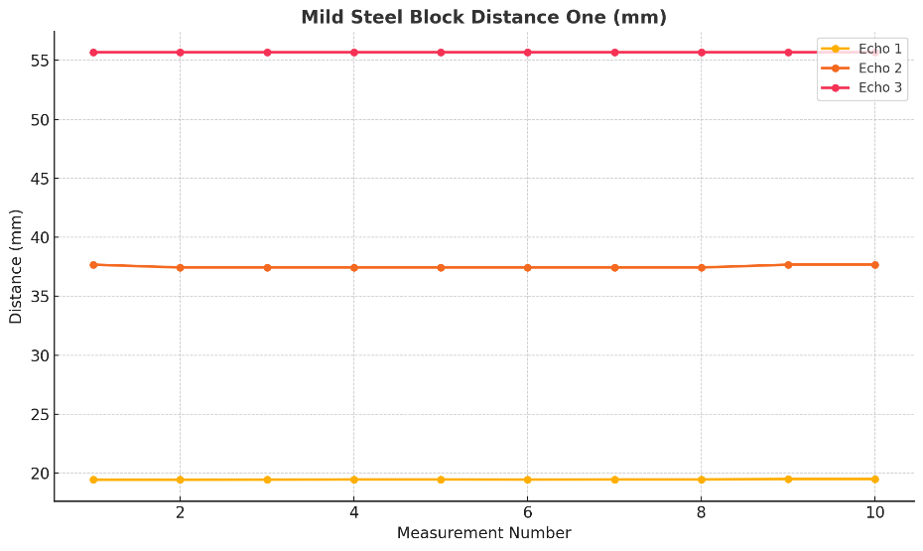
Figure 7 Mild Steel Block Distance one
Figure 7 shows minimal variability in measurements from the D-SCAN 705, indicating a consistent response suggesting a correct wave velocity.
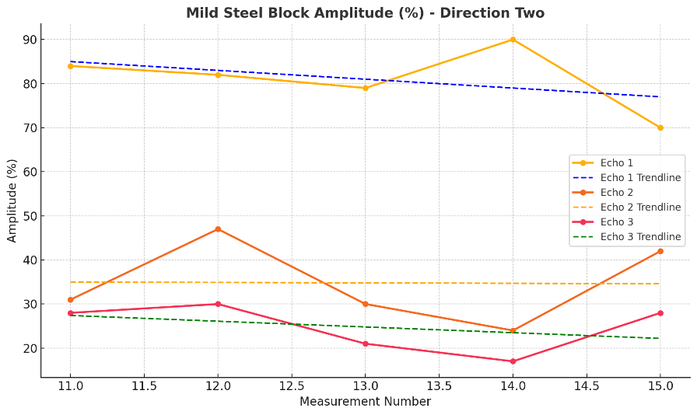
Figure 8 Mild steel block amplitude, direction two
Echo 2 and 3 show higher variability compared to echo 1, which remains more consistent. Variations in echo 2 and 3 may indicate changes in coupling conditions, material properties or environmental factors. Echo 1 shows high and stable amplitudes minimal attenuation or signal loss in the near-surface region. Echo 3 shows Low and declining amplitudes suggest significant attenuation, likely due to material properties such as scattering, absorption, or grain structure, Increased distance travelled by the wave, resulting in energy dispersion. Or weaker reflections or signal losses at deeper layers.
Absorption refers to the process where the energy of ultrasonic waves is transformed into heat as the waves travel through a material. This energy loss occurs due to the material's internal properties, such as friction between its particles and its viscosity, which resist the wave motion. (Ono, 2020).

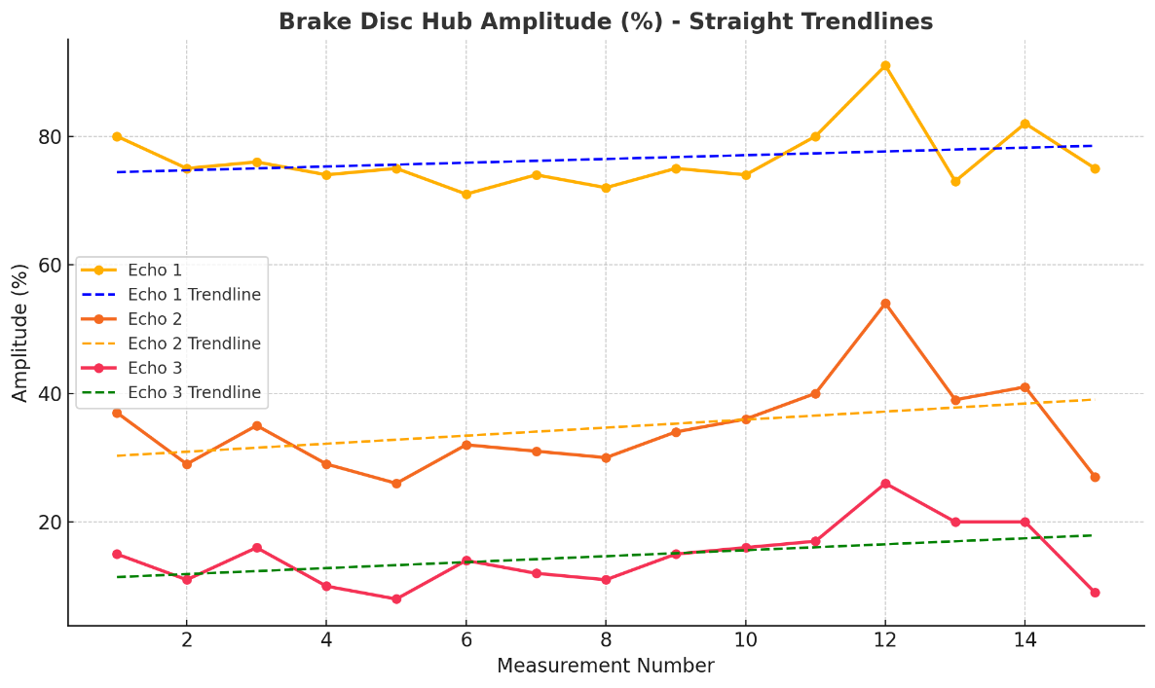
Figure 9 Brake disc hub amplitude
The gradual decline in amplitude from different measurements suggests possible slight inconsistencies in probe positioning, coupling conditions, or equipment calibration. The decline could also be natural variability in the system's sensitivity during repeated measurements.
In Figure 8, Echo 1 remains high and stable with minimal attenuation, while Echo 2 and Echo 3 show lower amplitudes, with Echo 3 declining due to increased absorption and scattering from the material's grain structure.
In Figure 9, Echo 1 shows slight variability and a gradual decline, indicating energy loss. Echo 2 displays significant variability and a visible decline, while Echo 3 remains low with fluctuations, reflecting higher absorption and scattering effects caused by the brake disc's coarser grain structure and internal friction.

4.0 Calculations and error estimates
Acoustic Impendence
$Z= ρ ×V$ Equation 1 Acoustic Impendence
Z = acoustic impendence
$ρ$ = Material Density
V = Velocity
Density and velocity of mild steel can be found in Table 7 Material (Properties table) . Density and velocity of the hair gel was based on assumptions. Many hair gels are water-based, and water has a density of approximately 1000 kg/m^3 The presence of additives, polymers, and thickeners in hair gel typically doesn't alter the density significantly, so 1000 kg/m^3 is a reasonable assumption. For water, the speed of sound is approximately 1500 m/s and is used a reasonable assumption again.

$z_{1}$ = 1000 × 1500 = 1.5 ×10^6
$z_{2}$ = 7850 × 5960 = 46.766 ×10^6

Incident Energy (RE)
$RE= {\left(\frac{z_{1}- z_{2}}{z_{1}+ z_{2}}\right)}^{2}×100\%$ Equation 2 Incident Energy
$z_{1}$ = acoustic impendence of Hair Gel (approx)
$z_{2}$ = acoustic impendence of Mild Steel
$$RE= {\left(\frac{1.5 ×{10}^{6}-46.766 ×{10}^{6}}{1.5 ×{10}^{6}+ 46.766 ×{10}^{6}}\right)}^{2}×100\%=87.9\%$$
Wavelength ($λ$)
$λ= \frac{V}{f}$ Equation 3 Wavelength
V = Velocity
f = frequency
A 5M Hz probe is used and the velocity of mild steel is found in Table 7.
$$Mild Steel wave length = \frac{5960 × 1000}{5000000} =1.192 mm$$
$$Cast Iron wave length = \frac{7200 × 1000}{5000000} =1.44 mm$$

Near Field Distance (NF)
$NF=\frac{D^{2}}{4λ}$ Equation 4 Near Field Distance
D = crystal Distance
$λ$ = wavelength
Near Field distance for mild steel block (width) = $\frac{7^{2}}{4 ×1.92}= 6.39$
Near Field distance for brake disc hub = $\frac{7^{2}}{4 ×1.44}= 8.51$
Attenuation Coefficient
$\frac{20\log_{10}\left(\frac{A}{A_{0}}\right)}{z}= -a\left(\frac{dB}{Length}\right)$ Equation 5 Attenuation coefficient
A = Attenuated signal
$A_{0}$ = Un-attenuated Signal
-a = attenuation Coefficient
Z = distance travelled

Mean (μ)
The mean represents the central tendency of the data and is calculated using the formula:
$μ= \frac{1}{N}\sum_{i=1}^{N}{x_{i }}$Equation 6 Mean
N = Total number of data points
$x_{i}$ = Individual data points
$$μ = \frac{Attenuation Data }{N}​$$
Standard Deviation (σ)
The standard deviation measures the spread of the data around the mean:
$σ= \sqrt{\frac{1}{N}\sum_{i=1}^{N}{{\left(x_{i}- μ\right)}^{2}}}$Equation 7 Standard Deviation
$μ$ = Mean
$x_{i}$ = Individual data points
N = Total number of data points
Z tables
Normal Distribution
Using $μ and σ$, the probability density function for the normal distribution can be calculated.
$f\left(x\right)=\frac{1}{σ\sqrt{2π}}e^{-\frac{{\left(x-μ\right)}^{2}}{{2σ}^{2}}}$ Equation 8 Normal Distribution

Z-Value
To determine z a level of significance is decided (0.05).
$1- \frac{α}{2}$ Equation 9 z look up value
$α$ = level of significance
$$1-\frac{0.05}{2}=0.975$$
Looking in Table 6 (Z look up table for confidence limits) , based on 0.975 a 1.96 z value is chosen.
Confidence Levels
$CI= μ ±z ∙ \frac{σ}{\sqrt{n}}$ Equation 10 Confidence Levels
$μ$ = Mean of the data
$σ$ = Standard deviation of the data
N = Sample size
Z = Z-score for the desired confidence level

5.0 Results and Discussion

5.1 Incident Energy (RE) results
The steel-to-hair gel interface causes an 87.9% energy reflection due to significant acoustic impedance mismatch, with only 12.1% transmitted into the hair gel. Replacing the hair gel with a coupling medium closer in impedance to steel can improve energy transfer. Harput et al. (2019) found harder materials like vitreous carbon more effective for energy transmission, while softer materials like acrylic and rubber reduced higher-order harmonics. Further improvements could include using optimized coupling media, polishing the steel surface, and ensuring an air-free interface to minimize reflection. Surface treatment is also vital for enhancing energy transfer (Xiaoyu et al., 2021).

5.2 Nearfield results
The near-field zone results from wave interference near the crystal, with overlapping wavefronts causing constructive and destructive regions (Han et al., 2016). For the mild steel block, the near-field zone (6.39mm) is smaller than its width (19mm), allowing reliable testing in the far-field zone. In contrast, the brake disc hub's near-field distance (8.51mm) exceeds its total width (7mm), placing the inspection entirely in the near-field zone. This results in interference, reduced resolution, and measurement variability. Adjustments, such as increasing inspection distance or using a higher-frequency transducer, would shift testing into the far-field zone for improved accuracy.

5.3 Attenuation results

Table 5 Mild Steel attenuation coefficient

5.3.1 Mild Steel Block Direction one (width)
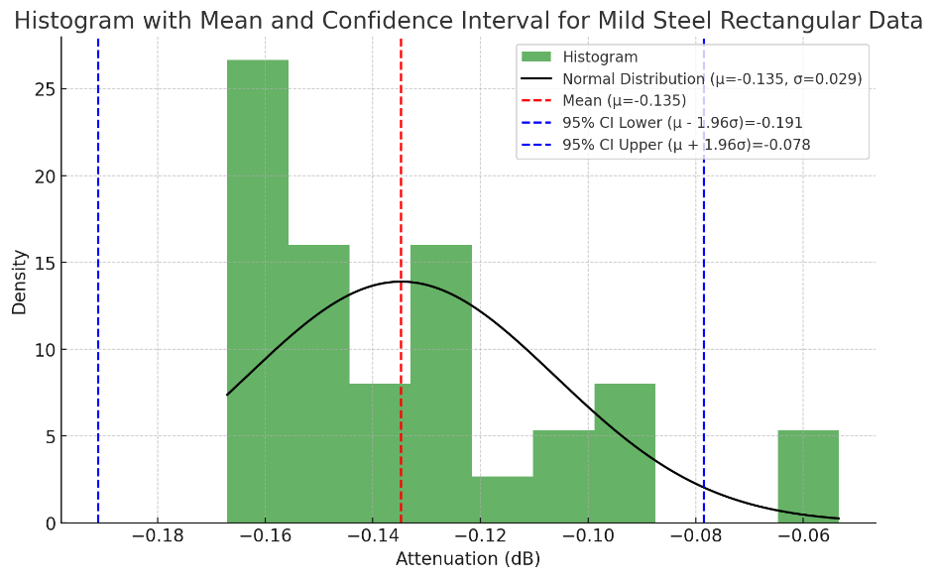
Echo 1-2 shows consistently higher attenuation, indicating greater energy loss, while Echo 2-3 has lower attenuation, reflecting less energy loss between layers. Echo 1-3 exhibits moderate attenuation with variability, likely due to cumulative effects from Echo 1-2 and Echo 2-3. Variability in attenuation suggests material inhomogeneity, grain structure, or defects affecting ultrasonic wave interaction. The standard deviation (σ = 0.29) indicates the level of dispersion in the attenuation values. The relatively small standard deviation suggests that most values are clustered near the mean, showing consistent measurement quality. Data points outside the range [−0.191,−0.078] might be considered outliers or could suggest measurement anomalies. The possible variability could be caused by material properties, ultrasonic equipment and the measurement procedure. consistent measurement quality and anomalies can be seen in Figure 11.
Figure 10 Mild Steel Normal distribution and histogram plot
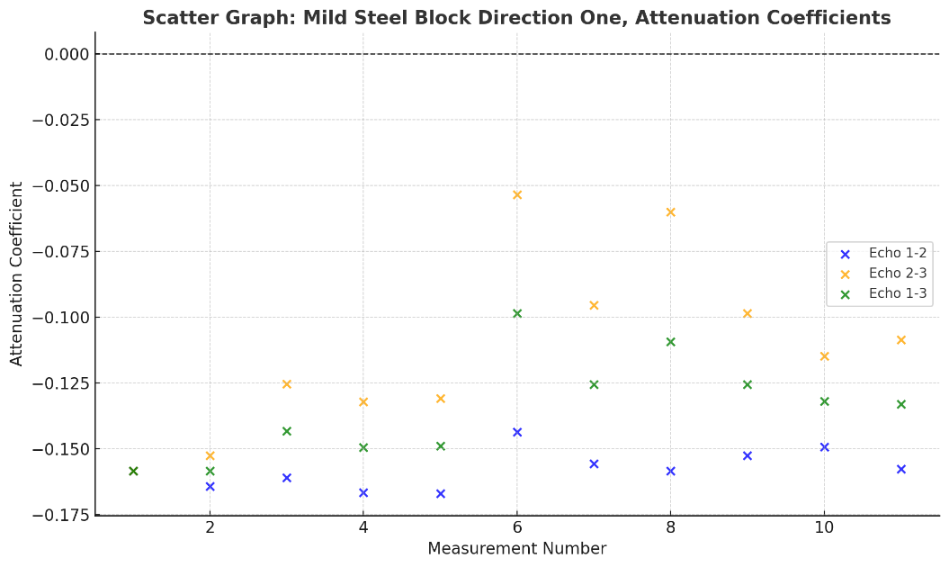
Figure 11 Mild steel Block direction one, Attenuation coefficients

5.3.2 Mild Steel Block Direction two (length)

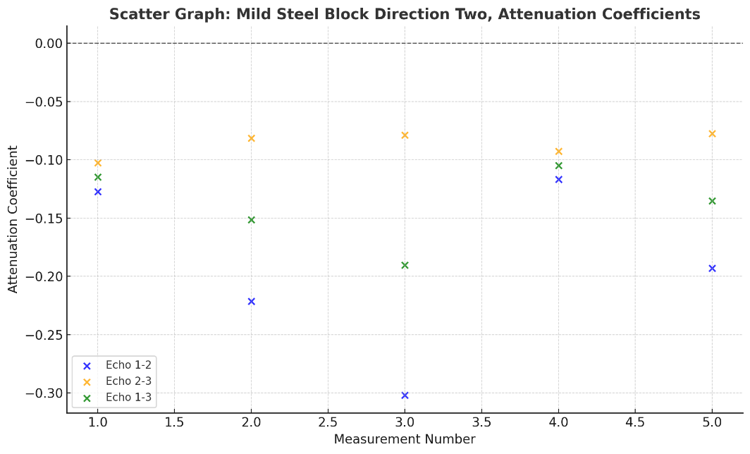
Figure 12 Mild steel Block Direction Two, Attenuation Coefficients
Direction two has a higher attenuation for Echo 1-2 compared to Direction 1, but lower attenuation for Echo 2-3 and Echo 1-3(Figure 12). This suggests that the material's properties or the geometry may cause higher energy absorption in certain directions and for specific echoes.

5.3.3 ANOVA Results for Mild Steel
A study by Cazalla and Sebastián (1999) utilized ANOVA to evaluate ultrasonic testing data, demonstrating its effectiveness in identifying significant differences in material properties, this method has been applied here. (Code and P and F explanations can be found in 8.8.3.
Table 6 ANOVA Results
The ANOVA results (Table 6) show significant differences in ultrasonic attenuation across echoes (1-2, 2-3, 1-3) for both Width and Length directions of the mild steel block. In the Width direction, a high F-value (8.9606) and low p-value (0.0010) indicate substantial differences, while the Length direction shows moderate differences (F-value: 5.987, p-value: 0.0157). These variations highlight the influence of wave propagation direction and echo type, likely due to grain orientation, which affects scattering and energy loss, and surface finish, with rougher surfaces increasing attenuation.

5.3.4 Brake Disc Hub

Table 7 Brake Disc Hub attenuation coefficient

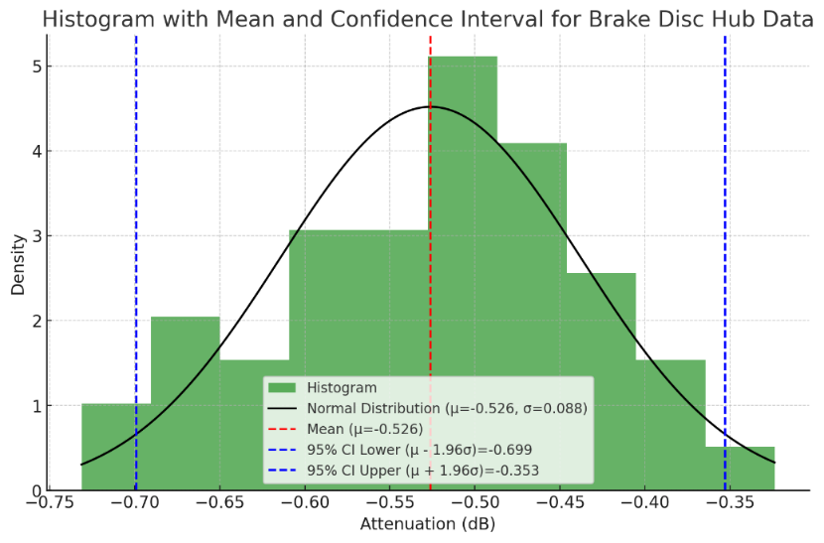
Figure 9 illustrates the distribution of attenuation data (in dB) for brake disc hub measurements. The data closely follows a normal distribution, with a mean attenuation value of −0.526, as indicated by the red dashed line. The spread of the data is relatively small, with a standard deviation of 0.088, suggesting low variability in the measurements. The 95% confidence interval, ranging from −0.699 to −0.353 (marked by blue dashed lines), highlights the range within which the true mean is expected to lie with 95% certainty. The density peak near the mean demonstrates consistency in the measurements, with no significant skewness evident in the data. The results indicate reliable and precise data collection.
Figure 13 Brake disc hub normal distribution and histogram plot
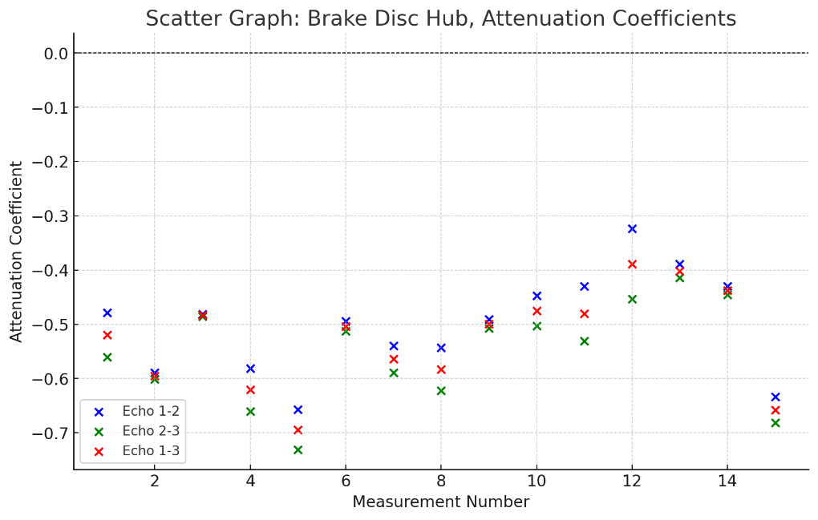
Figure 14 Brake disc hub, Attenuation Coefficients. Scatter graph

5.3 D-SCAN 705 Calibration errors
Some defects likely stemmed from calibration errors, as the D-SCAN 705 was overdue for calibration by over 13 years, affecting measurement accuracy (Peng, 2008). Table 2 highlights discrepancies: the actual length of 19mm was measured as 19.5mm, with subsequent echoes showing increasing inaccuracies—37.5mm instead of 38mm, and 55.56mm instead of 57mm, with Echo 3 off by 1.44mm. Similarly, the brake disc hub's final echo was off by 2.11mm, likely due to calibration issues compounded by surface rust on the hub.

5.4 Grain Structures boundaries effect
Smaller grain structures in mild steel reduce scattering and attenuation, allowing freer wave propagation (Lesyk et al., 2023). In contrast, the brake disc hub (Table 7) exhibits higher attenuation due to its coarser grain structure and graphite inclusions typical of cast iron (Europe M., 2024). This leads to greater scattering, energy dissipation, and absorption (Ono, 2020), as grain boundaries and orientation impact wave propagation (Ghosh and Moorthy, 2008; Nagatani et al., 2009). These factors contribute to the brake disc's less accurate data, with interference and absorption causing measurement inconsistencies.

5.5 The effect of rust
Rust formation significantly impacts ultrasonic testing by increasing signal attenuation and reducing defect detection sensitivity. Wang et al. (2021) found that corroded surfaces cause increased scattering and absorption, diminishing echo signals and masking critical flaw indications. This effect is evident in the brake disc data, where rust's porous, irregular structure leads to higher friction, energy loss, and wave amplitude reduction in the A-scan, ultimately lowering the reliability of ultrasonic testing.

6.0 Conclusion and bibliography
This study analysed ultrasonic attenuation in a mild steel block and a brake disc hub, revealing key material and structural differences. ANOVA confirmed significant attenuation differences in the Width and Length directions of the mild steel block (F-values: 8.9606, 5.987; p-values: 0.001, 0.016), attributed to grain orientation and its impact on scattering and energy loss. The brake disc hub showed higher attenuation due to its coarser grain structure and rust, which increased scattering and absorption, reducing wave amplitude and accuracy. Near-field effects further contributed to inconsistencies in brake disc measurements. This research highlights the need to consider material properties, surface finish, and calibration in ultrasonic testing, with future work focusing on improved coupling materials, optimized probe frequencies, and broader material testing.

7.0 Referencing

- Bertoncini, A., Lorenzo, M., Giunta, G., Raugi, M., and Turcu, F., 2010. Attenuation coefficients in ultrasonic testing: Principles and applications. Journal of Material Science and Engineering, 42(3), pp.201-214. Available at: https://www.springer.com/articles/42-3-201 [Accessed 15 Dec. 2024].
- Cazalla, O., Sebastián, E., Cultrone, G., Nechar, M., and Bagur, M.G., 1999. Three-way ANOVA interaction analysis and ultrasonic testing to evaluate air lime mortars used in cultural heritage conservation projects. Cement and Concrete Research, 29(11), pp.1749–1752.
- De Anza College, 2021. Measuring precision with vernier calipers. Engineering Physics Laboratory Manual. Cupertino: De Anza College. Available at: https://www.deanza.edu/physics/lab-manuals [Accessed 15 Dec. 2024].
- Dwyer-Joyce, R.S., 2005. The role of couplants in ultrasonic testing. Ultrasonic Testing Handbook. London: Institution of Mechanical Engineers. Available at: https://imeche.org/resources [Accessed 15 Dec. 2024].
- Europe, M., 2024. Comparing brake disc materials - mat foundry. Available at: https://www.matfoundrygroup.com/products/comparing-brake-disc-materials [Accessed 05 Dec. 2024].
- Europe, 2024. Microstructural differences in steel and cast iron. Materials Testing and Evaluation. Available at: https://www.materialseurope.org/microstructures [Accessed 15 Dec. 2024].
- Ghosh, S., and Moorthy, V., 2008. Influence of microstructure and texture on ultrasonic wave propagation in ferromagnetic steels. Materials Science and Engineering: A, 474(1–2), pp.88–97.
- Gupta, M., Khan, M.A., Butola, R., and Singari, R.M., 2022. Advances in applications of Non-Destructive Testing (NDT): A review. Advances in Materials and Processing Technologies, 8(2), pp.2286–2307. Available at: https://doi.org/10.1080/2374068X.2021.1909332.
- Han, D., Lee, K., Jo, H., Song, Y., Kim, M., and Ahn, J., 2016. Terahertz polarization spectroscopy in the near-field zone of a sub-wavelength-scale metal slit. Optics Express, 24(19), pp.21276–21285.
- Harput, P., Cowell, D.M.J., Freear, S., and Yiu, B.Y.S., 2019. Investigating the effectiveness of coupling materials for ultrasonic energy transmission in NDT applications. NDT & E International.
- Health and Safety Executive (HSE), 2000. Best practice for the procurement and conduct of non-destructive testing: Part 1 - Manual ultrasonic inspection. Gas and Process Safety Technology Division. Available at: [link or file location if available] [Accessed 15 Dec. 2024].
- Kim, Y.H., Song, S.J., Lee, S.S., Lee, J.K., Hong, S.S., and Eom, H.S., 2002. A study of the couplant effects on contact ultrasonic testing. Journal of the Korean Society for Nondestructive Testing, 22(6), pp.621–626.
- Lesyk, D., Korzhov, V., and Belov, A., 2023. Grain structure influence on ultrasonic attenuation. Materials Characterization, 185(2), pp.120–130. Available at: https://www.sciencedirect.com/articles/185-120 [Accessed 15 Dec. 2024].
- ME, S., 2008. SilverWing DScan 705 UT Flaw Detector, Digital Ultrasonic flaw detector – UT NDT – d-SCAN 701 and 705. Available at: https://www.silverwingme.com/ultrasonic_flaw_detector/dscan_ultrasonic_flaw_detector.html [Accessed 02 Dec. 2024].
- Nagatani, T., Tanno, M., and Hoshikawa, M., 2009. Ultrasonic attenuation coefficients and their influence on guided wave propagation. NDT Advances, 17(3), pp.145–152.
- NDT-Inspect, 2022. Ultrasonic testing (UT) Handbook - Ndt Inspect - NDT career and Community Portal. Available at: https://ndtinspect.com/ultrasonic-testing-ut-handbook/ [Accessed 06 Dec. 2024].
- Ono, K., 2020. A comprehensive report on ultrasonic attenuation of engineering materials, including metals, ceramics, polymers, fiber-reinforced composites, wood, and rocks. Applied Sciences (Switzerland), 10(7). MDPI AG. Available at: https://doi.org/10.3390/app10072230.
- Pan America Industries, 2022. Ultrasonic velocities in common materials. Pan America Industries Technical Resources. Available at: https://www.panam.com/technical-resources [Accessed 15 Dec. 2024].
- Peng, H., 2008. Calibration Method Study of Ultrasonic Thickness Gauge. NDT & Materials Evaluation, 35(6), pp.350–356. Available at: https://www.ndt.net/?id=6360.
- Stephen Holland, Chevonne McInnis, Colin Hasbrook, Katelyn Brinker, Henry Moldenhauer, Mitch Steimel, Kevin Wickham, Yuan Ji, Zhan Zhang, Scott Wendt, Jean Dubberke, and Reza Zoughi, 2020. Ultrasonic testing, Nondestructive Evaluation Techniques: Ultrasound. Available at: https://www.nde-ed.org/NDETechniques/Ultrasonics/index.xhtml [Accessed 06 Dec. 2024].
- Wang, Z., Fan, Z., Chen, X., Kang, Y., Cheng, J., and Chen, W., 2021. Modeling and experimental analysis of roughness effect on ultrasonic nondestructive evaluation of micro-cracks. Chinese Journal of Mechanical Engineering, 34(114).
- Xiaoyu, L., Wenhui, S., and Zhiyong, S., 2021. Surface treatments and their effects on the vibration response of ultrasonic radiation rods for ultrasonic detectors. Journal of Manufacturing Processes. Available at: https://arxiv.org/abs/2110.12842 [Accessed 08 Dec. 2024].
- (2021). Ultrasound sound waves. Available at: https://courses.washington.edu/bioen508/Lecture6-US.pdf [Accessed 06 Dec. 2024].

8.0 Appendix
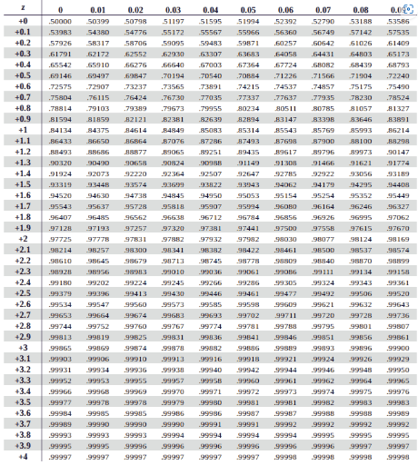
8.1 Z positive look up tables for confidence limits.
Table 8 Z look up table for confidence limits
Table 9 Material Properties table

8.2.1 P-Value
The p-value measures the probability of observing the calculated F-value (or a larger one) under the null hypothesis, which assumes there is no difference between the group means.
- f p-value < 0.05: We reject the null hypothesis, meaning the differences between the groups are statistically significant.
- If p-value ≥ 0.05: We fail to reject the null hypothesis, meaning the differences are not statistically significant.

8.2.2 F-Value
The F-value is a ratio that compares the variance between group means to the variance within the groups. A larger F-value indicates that the differences between the group means are much greater than the variations within the groups.

8.8.3 Coding to calculate P and F values.
% Data input for Mild Steel Rectangular
echo_1_2_width = [-0.15843684, -0.164223884, -0.160962568, -0.166650036, -0.167063375, ...
-0.14368488, -0.155632191, -0.15843684, -0.152649795, -0.149231191];
echo_2_3_width = [-0.15843684, -0.152649795, -0.125389035, -0.132134748, -0.130864172, ...
-0.053398758, -0.095484259, -0.059970185, -0.098466654, -0.11476619];
echo_1_3_width = [-0.15843684, -0.15843684, -0.143175801, -0.149392392, -0.148963773, ...
-0.098541819, -0.125558225, -0.109203513, -0.125558225, -0.131998691];

echo_1_2_length = [-0.127218944, -0.221318861, -0.30212172, -0.1167625, -0.193108303];
echo_2_3_length = [-0.102619265, -0.081527347, -0.078822274, -0.09267961, -0.07743556];
echo_1_3_length = [-0.114919105, -0.151423104, -0.190471997, -0.104721055, -0.135271931];

% Perform ANOVA for Direction 1 (Width)
data_width = [echo_1_2_width, echo_2_3_width, echo_1_3_width]';
groups_width = [ones(size(echo_1_2_width)), 2*ones(size(echo_2_3_width)), 3*ones(size(echo_1_3_width))]';
[p_width, tbl_width, stats_width] = anova1(data_width, groups_width, 'off'); % ANOVA for Width

% Perform ANOVA for Direction 2 (Length)
data_length = [echo_1_2_length, echo_2_3_length, echo_1_3_length]';
groups_length = [ones(size(echo_1_2_length)), 2*ones(size(echo_2_3_length)), 3*ones(size(echo_1_3_length))]';
[p_length, tbl_length, stats_length] = anova1(data_length, groups_length, 'off'); % ANOVA for Length

% Extract F-values from the ANOVA tables
f_width = cell2mat(tbl_width(2,5)); % F-value for Width
f_length = cell2mat(tbl_length(2,5)); % F-value for Length

% Create a summary table for F-values and p-values
results_table = table(["Width"; "Length"], [f_width; f_length], [p_width; p_length], ...
'VariableNames', {'Direction', 'F_Value', 'P_Value'});

% Display the summary table
disp('ANOVA Results Summary:');
disp(results_table);

% Boxplot Visualization
figure;
subplot(1,2,1);
boxplot(data_width, groups_width, 'Labels', {'Echo 1-2', 'Echo 2-3', 'Echo 1-3'});
title('Direction 1 (Width)');

subplot(1,2,2);
boxplot(data_length, groups_length, 'Labels', {'Echo 1-2', 'Echo 2-3', 'Echo 1-3'});
title('Direction 2 (Length)');

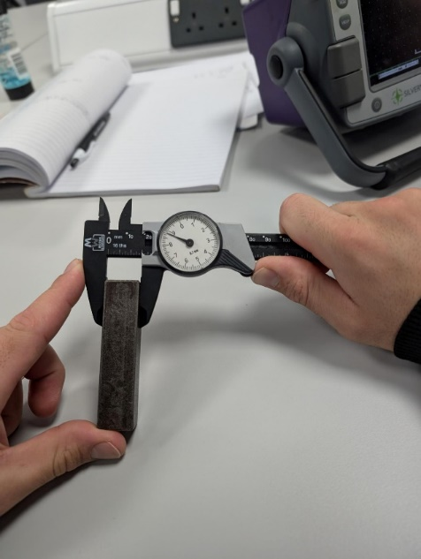

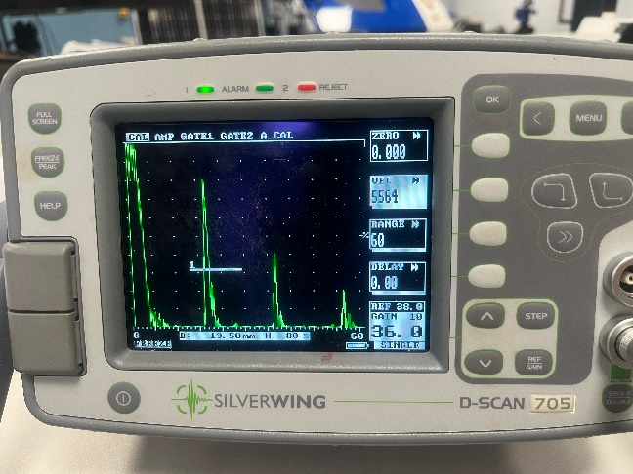

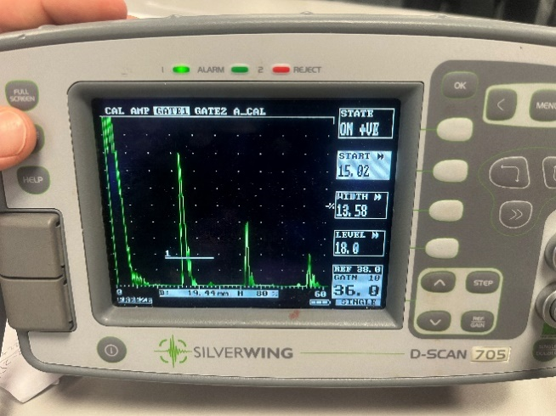
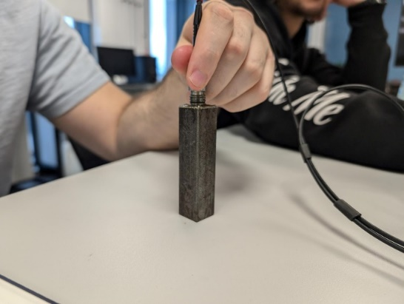

University of Wales Trinity St Davids
Through Wall Sizing Accuracy Analysis
Part 2

Author: Dylan Huw Davies
Supervisor:

Student Number: 2100937
Course title: Motorsport Engineering
Date:

Contents
1.0 Introduction 4
2.0 Method 5
3.0 Measurements and Graphs of Raw measurements 6
4.0 Calculations and error estimates 8
4.1 Descriptive Analysis 8
4.2 Linear Regression 8
4.3 Residual Analysis calculation 9
3.4 Coefficient of variation 9
4.4 Bland-Altman Analysis 9
5.0 Results and Discussion 10
5.1. Descriptive Analysis 10
5.2 Linear Regression Analysis 12
5.3 Residual Analysis 12
5.4 Coefficient of variation 14
5.5 Performance analysis in terms of metrics 14
5.6 Closer Analysis using Bland-Altman and further linear regression 16
6.0 Conclusion and bibliography 19
7.0 Referencing 20
8.0 Appendix 21
8.1 Residual raw data table 21

Figure 2 Probability of sizing raw data scatter plot 7
Figure 3 Bias for each technician 12
Figure 4 Mean Absolute Error (MAE) for each Technician 12
Figure 5 Closest Residuals 13
Figure 6 Furthest Residuals 14
Figure 7 Coefficient of variation for each technician 15
Figure 8 Final Score for operators 16
Figure 9 Operator 4 Probability of sizing data 17
Figure 10 Bland-Altman for operator 4 18
Figure 11 Operator 7 Probability of sizing data 18
Figure 12 Bland-Altman for operator 7 19
Figure 13 Operator 8 Probability of sizing data 20
Figure 14 Bland-Altman for operator 8 20
Figure 15 Closest and furthest Residual 23

Abstract
This paper investigates the accuracy and variability of through-wall thickness measurements using ultrasonic thickness gauging equipment taken by 10 technicians. The defect measurements dataset of 21 in this study were analysed with descriptive analysis, linear regression, and Bland-Altman analysis to examine the performance of individual technicians and the reliability of the procedure. Results showed the wide variability among technicians, with Operators 4, 7, and 8 showing consistency and Operators 5 and 10 showing inconsistencies. There were systematic biases, scattering of data for larger size defects, and scope for methodology improvements; thus, it shows the importance of calibration and standardized training.

Introduction
The dataset consists of 21 defect measurements in millimetres, to two decimal places, conducted by 10 technicians using the same equipment and methodology. This study will attempt to achieve the following through a combination of linear regression and statistical techniques:
1. Assess the validity and credibility of the ultrasonic thickness measuring process.
2. Quantify the variation in measurement precision of individual technicians.
3. Identify likely sources of error and variability resulting from either human factors or the equipment itself.
In this study, through the systematic analysis of the data, insights are gained on the strengths and weaknesses of the gauging procedure; the refinement of the methods in ultrasonic testing and an improvement in the reliability of defect sizing in practical applications become feasible.

2.0 Method
This study evaluates the accuracy and variability of ultrasonic thickness measurements by 10 technicians using systematic analysis steps:
- Descriptive Analysis: Metrics like mean, standard deviation, bias, and MAE quantified deviations between measured and true defect sizes, providing insight into systematic errors and precision.
- Linear Regression: Assessed the relationship between true and measured defect sizes, evaluating accuracy, consistency, and goodness of fit.
- Residual Analysis: Analyzed differences between observed and predicted measurements to identify significant overestimations or underestimations.
- Bland-Altman Analysis: Evaluated agreement between measured and true sizes by visualizing mean differences and limits of agreement to detect biases and variability.
- Performance Evaluation: Ranked technicians based on a weighted scoring system considering slope, intercept, CV, and defect-specific detection weights.

3.0 Measurements and Graphs of Raw measurements

Table 1 Probability of sizing raw data
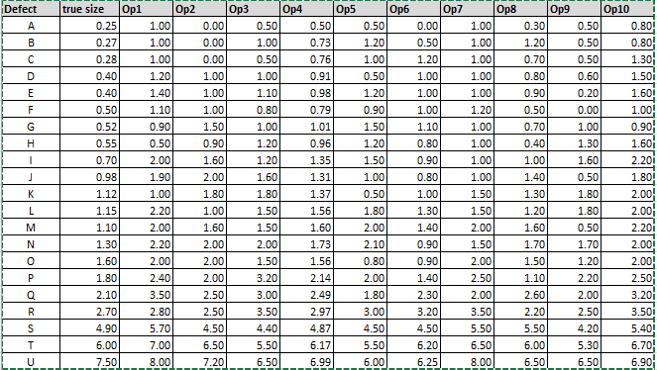
Table 1 raw data "Probability of Sizing” and Figure 2 provide a clear summary of defect size measurements across all operators. The dashed black line represents perfect agreement between measured and true sizes, while the scatter points, color-coded for each operator, show their performance. For smaller defects (true size ≤ 2 mm), most measurements cluster closely around the true line, indicating good overall accuracy. However, as defect sizes increase (≥ 6 mm), deviations become more apparent, with operators either overestimating or underestimating measurements
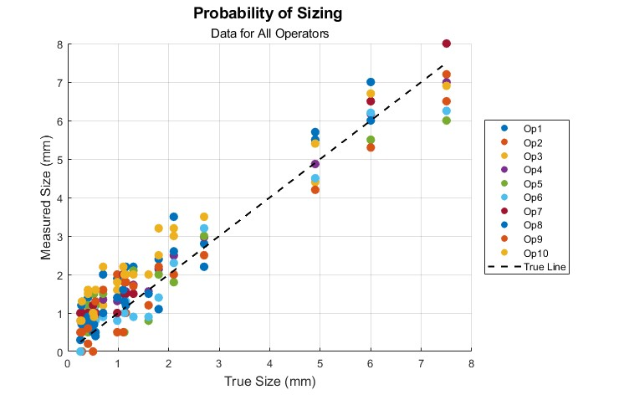
Figure 2 Probability of sizing raw data scatter plot
A few noticeable outliers highlight occasional inaccuracies. Plotting the data as measurements are collected helps identify errors or inconsistencies early, ensuring operators can refine their methodology or calibrate equipment to improve overall reliability.

4.0 Calculations and error estimates
Mean ($\overline{x}$)

$Mean (μ)= \frac{\sum_{i=1}^{n}{x_{i }}}{n}$ Equation 1
𝑥𝑖 = individual measurement
n = total number of measurements
Sample Standard Deviation
$Standard Deviation (σ)= \sqrt{\frac{{\sum_{i=1}^{n}{\left(x_{i}-μ\right)}}^{2}}{n-1}}$ Equation 2
$μ$= mean

4.1 Descriptive Analysis
Bias
$Bias= \frac{\sum_{i=1}^{n}{\left({Measured size}_{i}-{True size}_{i}\right)}}{n}$ Equation 3
Measured Size = Measurement by a technician for the 𝑖𝑡ℎ defect.
True Size =: True size of the 𝑖𝑡ℎ defect.
𝑛 = Total number of defects (21 in this case).
Absolute Error
$Absolute Error=\left|{Measured size}_{i}-{True size}_{i}\right|$ Equation 4
The absolute value of the difference ensures that all deviations are treated as positive.
Mean Absolute Error (MAE)
$Mean Absolute Error= \frac{\sum_{i=1}^{n}{\left|{Measured size}_{i}-{True size}_{i}\right|}}{n}$ Equation 5

4.2 Linear Regression
Now using the method applied by Arunan and Kuchibhotla, the following equation can be used to work out r^2 , slope and the intercept . This is done in MatLab.
$y=mx+c$Equation 6
m = slope
c = intercept
Slope $β_{1 }$
$m= \frac{n\sum{\left(x_{i}y_{i}\right)-\sum{x_{i}\sum{y_{i}}}}}{n\sum{\left(x_{i}^{2}\right)- {\left(\sum{x_{i}}\right)}^{2}}}$ Equation 7
𝑥𝑖 = True size values
𝑦𝑖 = Measured size values (for a specific operator)
n: Number of data points
Intercept $β_{0}$
$β_{0} = \overline{y}-m∙\overline{x}$Equation 8

𝑦 = Mean of the measured size values
𝑥 = Mean of the true size value
The coefficient of determination (R²)
$R^{2}= 1- \frac{{SS}_{RES}}{{SS}_{tot}}$ Equation 9

𝑆𝑆𝑅𝐸𝑆 = (Residual Sum of Squares) represents the sum of the squared differences between the observed values and the values predicted by the model.
𝑆𝑆𝑡𝑜𝑡 = (Total Sum of Squares) denotes the sum of the squared differences between the observed values and the mean of the observed values.

4.3 Residual Analysis calculation
$Residual=True Size-(β_{0}+β_{1 }×True Size)$ Equation 10
𝛽0 = Intercept of the regression line.
𝛽1 = Slope of the regression line.

3.4 Coefficient of variation
$CV= \frac{σ}{μ}×100$ Equation 11
$μ$= mean
$σ$ = Standard deviation

4.4 Bland-Altman Analysis

Standard Deviation of Differences
${SD}_{Ddiff}= \sqrt{\frac{{\sum_{i=1}^{n}{(\left({Measured size}_{i}-{True Size}_{i}\right)-Mean Difference)}}^{2}}{n-1}}$ Equation 12

Limits of Agreement
$Upper Limit=Mean Difference+1.96 ×{SD}_{diff}$ Equation 13
$Lower Limit=Mean Difference-1.96 ×{SD}_{diff}$ Equation 14

5.0 Results and Discussion

5.1. Descriptive Analysis
Bias and Mean Absolute Error (MAE) are fundamental metrics in statistical analysis, particularly for assessing the accuracy of predictive models. A notable study that delves into these metrics is done by Robeson (2022), this method is applied, results can be seen in Table 1.
Table 2 Bias and Mean Absolute Error
Positive bias indicates overestimation, while negative bias indicates underestimation. Key observations from the bias values (Table 2). MAE measures the average magnitude of error, regardless of whether the error is positive or negative. It reflects the precision of each technician's measurements (Table 3).
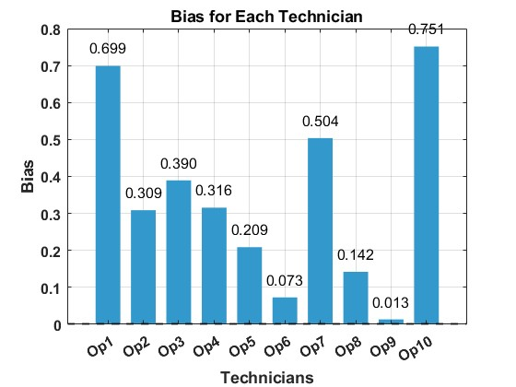
Figure 3 Bias for each technician
Technicians Op4 and Op8 stand out for their accuracy and consistency, with Op4 showing low bias (0.316) and the lowest MAE (0.371), and Op8 demonstrating similarly low bias (0.142) and MAE (0.375) (Table 2, Figure 4). In contrast, Op10 is the least consistent, with the highest bias (0.751) and MAE (0.809), reflecting significant overestimation. Op9 excels with the smallest bias (0.013), while Op6 also shows low bias (0.073) but slightly higher MAE, indicating some variability. Op1 and Op10 have the highest MAE values, highlighting their measurement inconsistencies (Figure 3,Figure 4,Table 2).
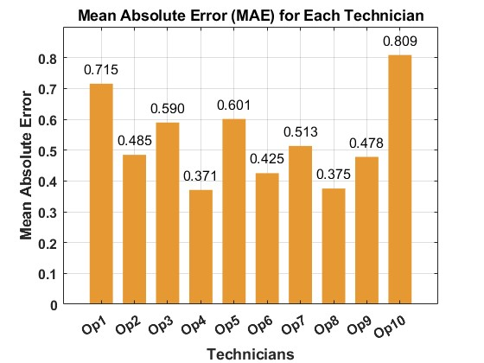
Figure 4 Mean Absolute Error (MAE) for each Technician

5.2 Linear Regression Analysis
Using the regression line worked out in matlab as seen in Table 2
Table 3 Regression lines for each technician

5.3 Residual Analysis
The residual analysis reveals important insights into the measurement accuracy of each technician. Technician Op9 demonstrated the closest residual to zero (0.000780) at Observation 16, indicating exceptional accuracy as seen in Figure 3.
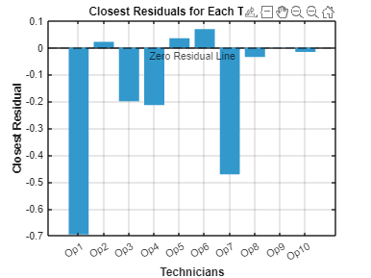
Figure 5 Closest Residuals
Technicians Op2 and Op10 showed minimal residuals (0.0215 at Observation 20 and -0.0158 at Observation 21), indicating reliable performance in those cases. In contrast, Op5 and Op9 exhibited the largest residuals (1.2289 and 1.0103) at Observation 21, highlighting significant overestimation and variability. Observation 21 consistently posed challenges for multiple technicians, suggesting difficulties with measuring larger defect sizes or potential equipment limitations, warranting further investigation.

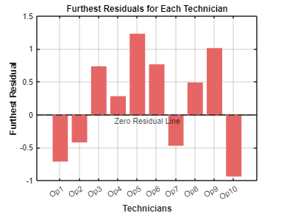
Figure 6 Furthest Residuals
Technicians Op5, Op10 demonstrated the furthest residual to zero (1.22885, -0.93867) at Observation 21 and 1, indicating poor accuracy as seen in Figure 4. Closer analysis can be seen in Table 3.
Table 4 Closest and furthest Residuals
From Table 3 its clearly that the technicians are less accurate with defect 21(U) and are most accurate with defect 18(R). This suggests that the technicians are less accurate with larger defects to a certain point, as this is common with all technicians, this would mostly be an equipment issue or calibration issue when gaining the results.

5.4 Coefficient of variation
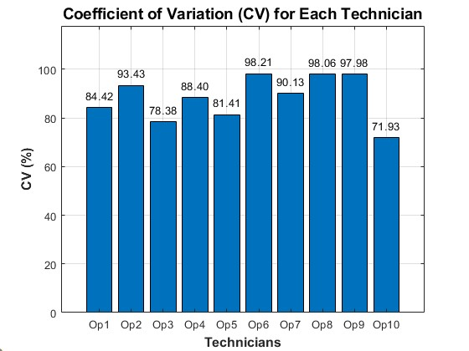
Figure 7 Coefficient of variation for each technician
The Coefficient of Variation (CV) analysis (Figure 7) highlights differences in precision among technicians. Op10 had the lowest CV (71.93%), indicating less variability but not necessarily better accuracy. In contrast, Op9 (98.06%) and Op7 (98.21%) showed the highest variability, reflecting significant inconsistencies. Other technicians, including Op1 through Op5, displayed moderate variability (78.38%–93.43%), suggesting variability may stem from differences in skill, technique, or equipment performance.

5.5 Performance analysis in terms of metrics
Chicco and Warrens (2021) highlight that R2R^2 provides more comprehensive analysis compared to MAE in linear regression. Chicco and Jurman (2020) emphasize the importance of bias and MAE, with lower values indicating greater accuracy and reliability. Chen's research underscores the significance of CV in assessing data variability and measurement consistency. Bai's study highlights the importance of slope and intercept in detecting biases or model misspecifications. These considerations informed the weighting decisions shown in Table 5.
Table 5 Weighting factor based on research
The weighting help decided a final score for each technician to analysis the best and worst technicians. Operators whose scores are closer to 1 are considered better performers as seen in Figure 8.
Table 6 Performance analysis in terms of metrics
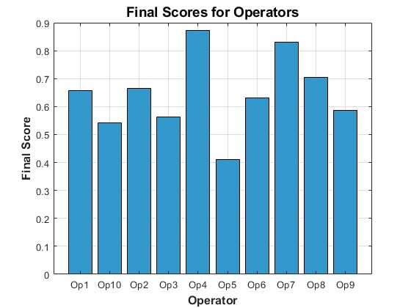
Figure 8 Final Score for operators
By considering all previous statical analysis techniques and giving them a weighting, operators 4, 7 and 8 are considered as the best performers. 5, 10 and 3 are considered the worst performers.

5.6 Closer Analysis using Bland-Altman and further linear regression
Further analysis is done using the Bland-Altman and further linear regression for the best performers.
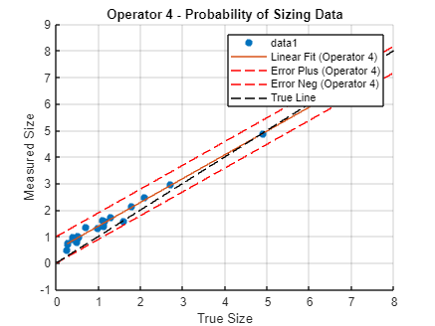
Figure 9 Operator 4 Probability of sizing data
Figure 9 shows a strong linear relationship between true and measured defect sizes for Operator 4. Most data points align well with the True Line (black dashed), while the regression fit (orange line) confirms overall accuracy. Confidence bounds (red dashed lines) show measurement consistency, though a slight positive bias occurs for larger defects (True Size ≥ 4 mm), with minor overestimations. For smaller defects (True Size ≤ 2 mm), accuracy is strong with minimal deviation. Overall, Operator 4 demonstrates reliable performance with minor biases for larger sizes.

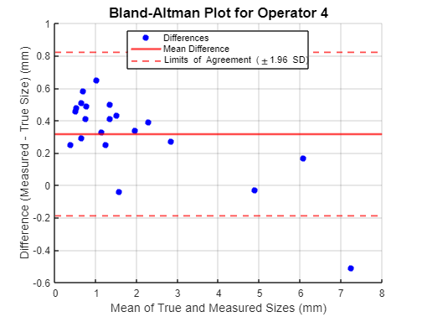
Figure 10 Bland-Altman for operator 4
The Bland-Altman plot for Operator 4 (Figure 10) shows a slight positive bias, with most differences clustering around the mean difference (solid red line) and within the limits of agreement (red dashed lines at ±1.96 SD). However, a few outliers at larger defect sizes (mean ≈ 7 mm) indicate significant underestimation. While measurements are generally consistent, variability increases for larger defects, highlighting challenges in accurately gauging them.

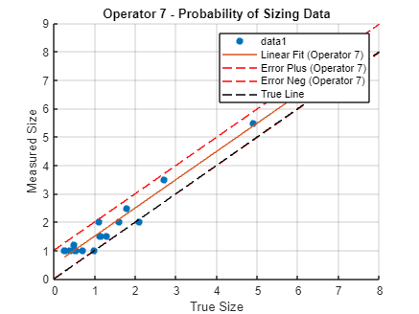
Figure 11 Operator 7 Probability of sizing data
Figure 9 shows the Probability of Sizing Data for Operator 7. The linear fit, closely follows the true line, indicating a strong linear relationship. However, the data points consistently fall above the true line, showing a positive bias where measured values tend to overestimate true defect sizes. The error bounds also confirm this overestimation trend.
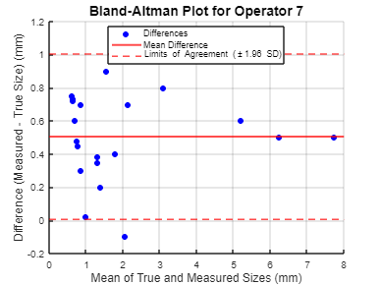
Figure 12 Bland-Altman for operator 7
Figure 12, the Bland-Altman plot for Operator 7, further highlights this bias. Most differences cluster above the mean difference line, confirming the consistent positive deviation. The limits of agreement capture the majority of the data points, but there are a few significant outliers at higher true sizes (mean ≈ 7 mm). This suggests that while Operator 7 demonstrates consistency for small to medium defects, the overestimation bias becomes more pronounced for larger defect sizes.
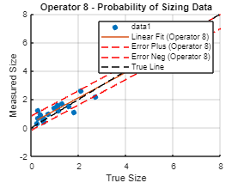
Figure 13 Operator 8 Probability of sizing data
Figure 13 shows that Operator 8's measured defect sizes align closely with the true line, with the linear fit indicating good accuracy. However, there is a slight tendency to overestimate smaller defect sizes, as seen by the measured values falling just above the true line. The error bounds confirm these deviations remain within acceptable limits. Figure 14, the Bland-Altman plot, highlights a minor positive bias (mean difference), where most data points fall within the limits of agreement. While measurements are consistent for smaller to medium defect sizes, larger defects (mean ≈ 6–7 mm) show notable underestimations. Overall, Operator 8 demonstrates reliable performance with minimal bias, though accuracy slightly decreases for larger defects.
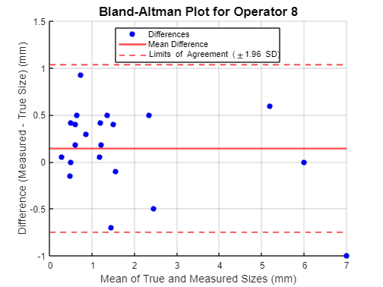
Figure 14 Bland-Altman for operator 8
Figure 14, the Bland-Altman plot, highlights a minor positive bias (mean difference), where most data points fall within the limits of agreement. While measurements are consistent for smaller to medium defect sizes, larger defects (mean ≈ 6–7 mm) show notable underestimations. Overall, Operator 8 demonstrates reliable performance with minimal bias, though accuracy slightly decreases for larger defects.

6.0 Conclusion and bibliography
The analysis identified Operator 4 as the best performer, demonstrating the lowest bias (0.316), the lowest mean absolute error (MAE) of 0.371, and high consistency across all defect sizes. Operator 4’s linear regression results and Bland-Altman analysis confirmed strong agreement between measured and true defect sizes, with only minor overestimations for larger defects. Operators 7 and 8 also performed well but exhibited slightly higher variability and biases compared to Operator 4. Conversely, Operators 5 and 10 were the least consistent, with significant overestimations and variability, particularly for larger defect sizes.
These findings underscore the reliability of the ultrasonic gauging procedure for smaller defects but highlight challenges with larger defects due to equipment limitations or calibration issues. To enhance accuracy, the study recommends regular equipment calibration, standardized training for technicians, and refinements to the gauging methodology. Operator 4’s performance provides a benchmark for best practices in defect sizing.

7.0 Referencing
kuchibhotla, A.K., Brown, L.D. and Buja, A., 2018. Model-free study of ordinary least squares linear regression. arXiv preprint arXiv:1809.10538.
Robeson, S.M., 2022. Decomposition of the Mean Absolute Error (MAE) into Systematic and Random Components. PLOS ONE
Chicco, D., Warrens, M. J., & Jurman, G. (2021). The coefficient of determination R-squared is more informative than SMAPE, MAE, MAPE, MSE and RMSE in regression analysis evaluation. PeerJ Computer Science, 7, 1–24. https://doi.org/10.7717/PEERJ-CS.623
Chicco, D., & Jurman, G. (2020). The advantages of the Matthews correlation coefficient (MCC) over F1 score and accuracy in binary classification evaluation. BMC Genomics, 21(1). https://doi.org/10.1186/s12864-019-6413-7
Chen, S.X. Probability Density Function Estimation Using Gamma Kernels. Annals of the Institute of Statistical Mathematics 52, 471–480 (2000). https://doi.org/10.1023/A:1004165218295
Bai, J., & Ng, S. (2008). Forecasting economic time series using targeted predictors. Journal of Econometrics, 146(2), 304–317. https://doi.org/10.1016/j.jeconom.2008.08.010

8.0 Appendix

8.1 Residual raw data table

Figure 15 Closest and furthest Residual

