University of Wales Trinity Saint David
Wales Institute of Science and Art


Assignment Name

Vehicle Electronics – ACHA019

Lucy Robinson

2517610

18/04/2026
Contents
1 Task 3 1
1.1 Scope Time Division Calculations (6) 1
1.2 Function Generator output square wave (6) 1
1.3 Capacitor charge and discharge wave marked at correct points. (6) 2
1.4 Basic Capacitor Calculations (6) 2
1.5 Capacitor discharge table (5) 3
1.6 Plot log(V) Gradient (5) 3
1.7 Gradient Calculations and Compare(8) 3
1.7.1 Gradient Calculations 3
1.7.2 Comparison table 4
1.8 Capacitor Uses (5) 4
1.9 Inaccuracies Question (4) 5
1.10 Risk Question (10) 5
2 References 7

Task 3
The following task explores the undertaking of a practical, which was to calculate the capacitance of a capacitor.

Scope Time Division Calculations (6)
The time per division is calculated using:
$T= \frac{Time per division}{Number of divisions}$ Equation 1 - Equation to calculate the period
Substituting the given waveform duration:
$T= \frac{40τ}{10}=4τ sec$ Equation 2 - Equation to calculate the given period
To calculate the time constant (τ)
$τ=RC$ Equation 3 - Equation to calculate the time constant
Where R = resistance and C = capacitance

Function Generator output square wave (6)
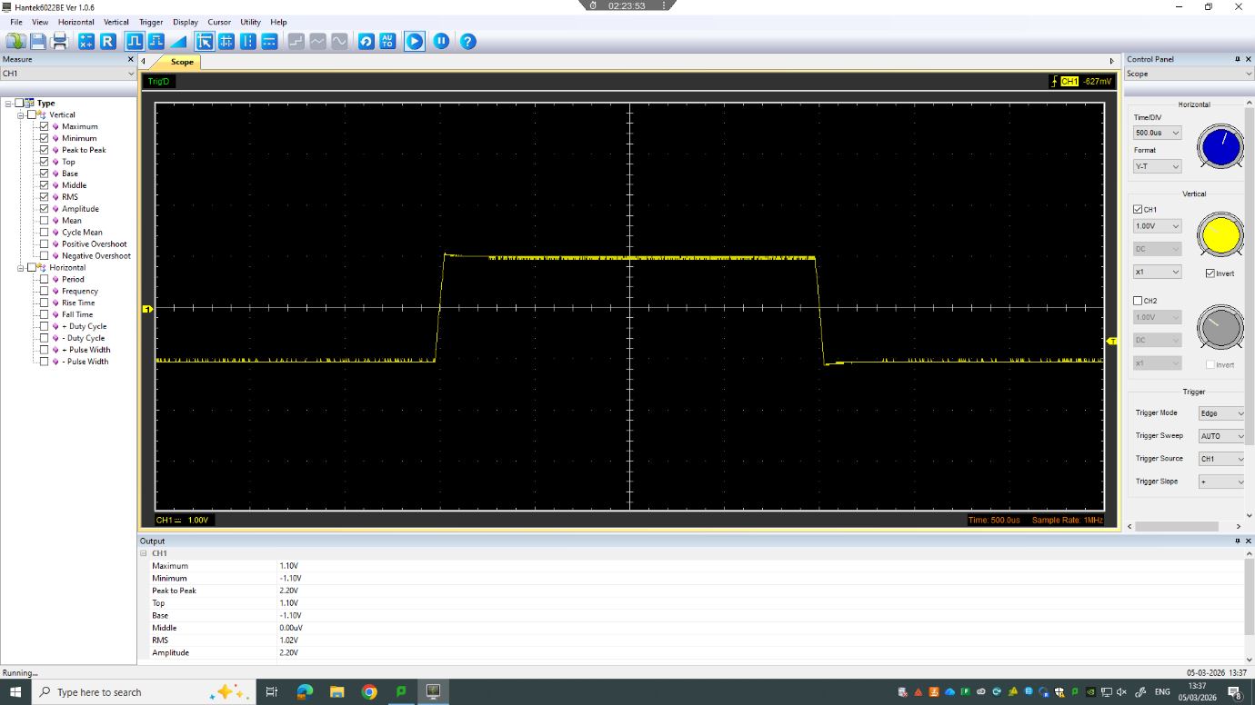
Figure 1 - Square Wave
Figure 2 - Outputs from the square wave

Capacitor charge and discharge wave marked at correct points. (6)

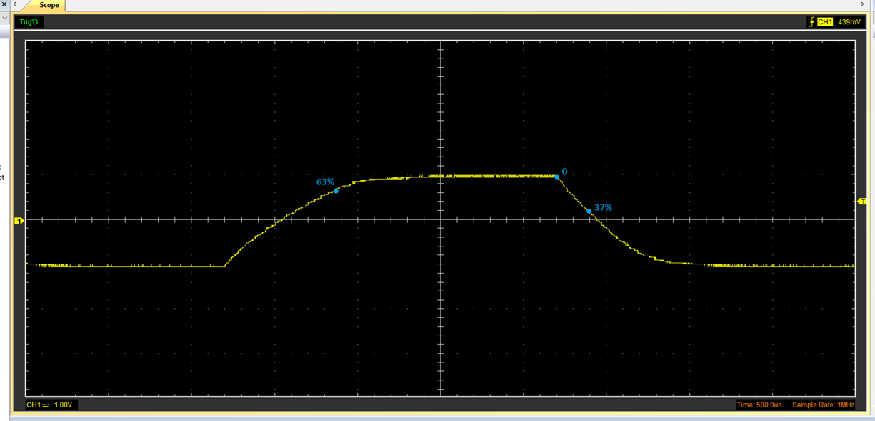
Figure 3 – Capacitor charge and discharge wave
The oscilloscope wave shows the charging and discharging behaviour of a capacitor in a circuit. During charging, the voltage increases exponentially, reaching approximately 63% of its maximum value at one time constant. During discharging, the voltage decreases exponentially, falling to approximately 37% of its initial value at one time constant. These key points have been marked on the waveform.

Basic Capacitor Calculations (6)
The capacitance is found using the time constant measured from the oscilloscope.
$τ=RC$ Equation 4 - Equation to calculate time constant using Resistance and capacitance
From the waveform, τ is taken as the time at which the capacitor reaches approximately 63% of its maximum voltage (charging) or falls to 37% (discharging).
Rearranging the equation to find capacitance:
$C=\frac{τ}{R}​$ Equation 5 - Equation to calculate the capacitance
The value of τ is read from the oscilloscope trace, and the resistance value is known from the circuit. These values are substituted into the equation to calculate the capacitance.

Capacitor discharge table (5)
Time (s) | Voltage (V) | ln (V) | dy = y2 – y1  dy = ln(V)2-ln(V)1 | dx = x2- x1  dx = Time2 – Time1 | dy/dx
0.002359 | 1.6313 | 0.48937724 | x | x | x
0.002414 | 1.3804 | 0.32237331 | -0.16700393 | 5.5E-05 | -3036.4351
0.002469 | 1.1607 | 0.14902327 | -0.17335004 | 5.5E-05 | -3151.81892
0.002524 | 0.9411 | -0.06070588 | -0.20972915 | 5.5E-05 | -3813.25721
0.002579 | 0.7529 | -0.28382286 | -0.22311699 | 5.5E-05 | -4056.67249
0.002634 | 0.596 | -0.51751461 | -0.23369175 | 5.5E-05 | -4248.94091
0.002689 | 0.4078 | -0.89697842 | -0.37946381 | 5.5E-05 | -6899.34198
0.002744 | 0.2509 | -1.38270083 | -0.4857224 | 5.5E-05 | -8831.31645
0.002799 | 0.1254 | -2.07624665 | -0.69354583 | 5.5E-05 | -12609.9241
Table 1 - Table of capacitor discharge

Plot log(V) Gradient (5)

Figure 4 - Graph showing the ln of Voltage against Time

Gradient Calculations and Compare(8)

Gradient Calculations
From the graph, the equation for the line of best fit is:
$y=-5432.3x+13.537$ Equation 6 – Equation of the line of best fit of the graph
Therefore, the gradient is -5432.3.
For a discharging capacitor:
$gradient= -\frac{1}{RC}$ Equation 7 – Equation of the gradient
Rearranging:
$RC= -\frac{1}{gradient}$ Equation 8 – Equation to calculate a time constant
$∴RC=\frac{1}{5432.3}=1.84×{10}^{-4} s$ Equation 9 – Equation calculating the time constant
Now:
$C=\frac{RC}{R}$ Equation 10 – Equation to calculate the capacitance
As the resistance is 100Ω
$C=\frac{1.84×{10}^{-4}}{100}=1.84×{10}^{-6}F$ Equation 11 – Equation calculating the capacitance of our 100Ω resistor
$$∴C=1.84μF$$

To calculate the delta:
$Delta=C_{measured}-C_{calculated}$ Equation 12 – Equation to calculate the delta

So, the percentage difference:
$\%= \frac{Delta}{Actual}×100$ Equation 13 – Equation to calculate the percentage difference

Comparison table
 | Capacitance | Delta | Percentage difference
Actual | 1 µF | x | X
Marker Calculation | 1 | 0.00 | 0%
Gradient Calculation | 1.84 | 0.84 | 84%

Capacitor Uses (5)
Capacitors are used a lot in general electrical systems, mainly because they can store and release energy quickly. One of the main uses is in power supplies, where they smooth out the voltage and ensure the output is more stable. They’re also used in filtering circuits to remove unwanted noise from signals, which is important in electronics where clean signals are needed. In timing circuits, capacitors work with resistors to control delays, which is useful in things like oscillators and flashing lights. They can also act as temporary energy storage and thus help prevent damage to circuits by absorbing sudden voltage spikes. Capacitors are used in the foregoing applications because they store and release electrical energy in a controlled way (EBSCO, 2021; ScienceDirect, 2023) .
In automotive applications, capacitors have several important roles as well. They are used in ECUs (engine control units) to help stabilise voltage and ensure reliable operation of sensors and processors by filtering out electrical noise. In ignition systems, while coils deliver the quick bursts of energy needed for spark generation, capacitors prevent unwanted arcing in components like the points in the distributor. They’re also used in car audio systems to smooth out power delivery and prevent voltage drops, thus delivering more punchy bass. As capacitors can help filter signals from sensors, so as to make readings more accurate, they are also used in start-stop systems to support quick restarts.(EBSCO, 2021)

Inaccuracies Question (5)
There are several sources of inaccuracy in the experiment, which can affect the final calculated value of the capacitance. One of the main factors is human error when reading values from the oscilloscope, as it can be difficult to accurately identify the exact point where the voltage reaches 63%, when reading values from the wave.
The oscilloscope itself can also introduce error, as its input impedance and capacitance can affect the circuit being measured, slightly altering the displayed signal. In addition, incorrect probe compensation or calibration issues can lead to inaccurate voltage and timing readings. Noise in the signal can also make the waveform less clear, increasing uncertainty.
Component limitations are another key source of error. Capacitors are not ideal and exhibit leakage, causing the voltage to decay faster than expected and affecting measurements (ScienceDirect, 2023) . They may also show non-ideal behaviour such as dielectric absorption, which can distort the charging and discharging curves (Hickson, 2025). Similarly, resistors and capacitors both have tolerances, meaning their actual values may differ from their labelled values.
Other factors include temperature variations, which can change resistance slightly, and the additional resistance of wires and connections. There may also be extra resistance introduced by the measurement setup itself, which can affect the accuracy of capacitance calculations.

Risk Question (10)
Mitigating cybersecurity risks in a vehicle’s CAN (controller area network) bus system is not just about adding one or two security features. ISO/SAE 21434:2021 makes it clear that security has to be considered across the whole vehicle lifecycle, from the initial design stage through to end of life (Konfirmity.com, 2026; Newtec.de, 2021).
One of the main ways to do this is through Threat Analysis and Risk Assessment. This involves identifying how an attacker could target the CAN bus, such as spoofing or replaying messages, and then assessing how serious those risks are. From this, manufacturers can define security goals early, rather than reacting to problems later (Rahimi, Schuelke-Leech and Mirhassani, 2025).
Another key mitigation is network design. The CAN bus has no built in security, so systems need to be structured to reduce the impact of an attack. For example, critical systems like braking and steering ECUs can be separated from non-critical systems like infotainment using secure gateways. This follows a defence in depth approach, where multiple layers of protection are used instead of relying on a single control (Bozdal et al., 2020).
Authentication and encryption are also important. Since CAN messages are not secure by default, adding message authentication codes helps ensure messages are coming from trusted sources and have not been altered. Without this, attackers could inject false messages onto the network (Bozdal et al., 2020).
At ECU level, secure hardware and software practices are required. This includes secure boot, hardware security modules, and regular testing such as penetration testing. These measures reduce the risk of compromised software spreading across the system (Newtec.de, 2021).
Secure updates are another key area, especially over the air updates. These updates must be encrypted and verified so that attackers cannot install malicious software onto ECUs (Konfirmity.com, 2026).
Finally, continuous monitoring and maintenance are essential. Even after the vehicle is in use, manufacturers need to track new threats and apply updates when needed. Advanced approaches such as intrusion detection systems can also be used to monitor CAN traffic for unusual behaviour (Andreica et al., 2024).

References
Andreica, T., Musuroi, A., Anistoroaei, A., Jichici, C. and Groza, B. (2024). Blockchain integration for in-vehicle CAN bus intrusion detection systems with ISO/SAE 21434 compliant reporting. Scientific Reports, 14(1). doi:https://doi.org/10.1038/s41598-024-58694-4.
Bozdal, M., Samie, M., Aslam, S. and Jennions, I. (2020). Evaluation of CAN Bus Security Challenges. Sensors, 20(8), p.2364. doi:https://doi.org/10.3390/s20082364.
EBSCO. (2022). Capacitors | Research Starters | EBSCO Research. [online] Available at: https://www.ebsco.com/research-starters/science/capacitors.
Hickson, I. (2025). Ian Hickson’s Capacitor Experiment. [online] Hixie.ch. Available at: https://academia.hixie.ch/bath/capacitor/home.html.
Konfirmity.com. (2026). ISO/SAE 21434: Definition, use cases, and compliance relevance (2026). [online] Available at: https://www.konfirmity.com/glossary/iso-sae-21434.
Liu, B., Wang, J., Zeng, J., Zhao, L., Wang, Y., Feng, Y. and Du, R. (2020). A Review of High Shear Wet Granulation for Better Process understanding, Control and Product Development. Powder Technology, 381. doi:https://doi.org/10.1016/j.powtec.2020.11.051.
Newtec.de. (2021). ISO/SAE 21434: Cyber security in motor vehicles. [online] Available at: https://www.newtec.de/en/knowledge/iso-sae-21434-cyber-security-in-motor-vehicles [Accessed 18 Apr. 2026].
Rahimi, N., Schuelke-Leech, B.-A. and Mirhassani, M. (2025). Cyber Threat Susceptibility Assessment for Heavy-Duty Vehicles Based on ISO/SAE 21434. IEEE Open Journal of Vehicular Technology, 6, pp.969–990. doi:https://doi.org/10.1109/ojvt.2025.3550307.
www.sciencedirect.com. (n.d.). Capacitor - an Overview | ScienceDirect Topics. [online] Available at: https://www.sciencedirect.com/topics/materials-science/capacitor.

