

University of Wales Trinity Saint David

School of Engineering

Series Hybrid Vehicle
Hybrid Powertrain and Control

ACEA7007

Christian Parry

1808165

29/11/2021

Contents
1 Abstract iii
1.1 Abbreviations iii
2 Introduction 1
2.1 Aims 1
2.2 Objectives 1
3 Background Research 2
3.1 BSFC 2
4 Methodology 4
4.1 Track Selection 4
4.2 Velocity 4
4.3 Resistive Forces 6
4.3.1 Acceleration Resistance 6
4.3.2 Aerodynamic Resistance 6
4.3.3 Gradient Resistance 6
4.3.4 Rolling Resistance 7
4.3.5 Total Resistive Forces vs Time 8
4.4 Tractive Power 8
4.5 Fuel Consumption 9
5 Discussions 11
5.1 Potential Hybridisation 11
6 Conclusions 12
7 Appendices 13
7.1 Vehicle Specifications 13
8 References 15

Abstract

This report will analyse the fuel consumption of a Renegade DX10 offroad buggy, seen in Figure 1, over the duration of an offroad experience lap, in order to understand the energy usage and the future potential to hybridise the system.
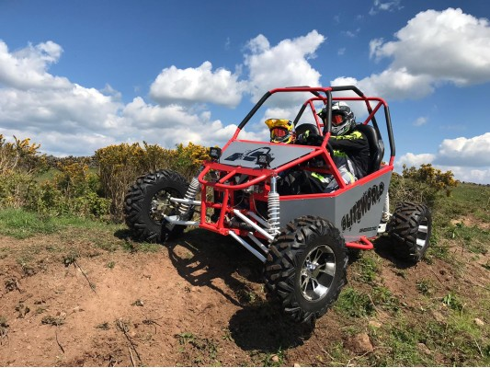
Figure 1 – Blitzworld Renegade DX10 300CC Buggy (Blitzworld, 2021)

Abbreviations

A - Cross-Sectional Area
BSFC – Brake Specific Fuel Consumption
Cd - Coefficient of Drag
Fd - Drag Force
MPG – Miles Per Gallon
MPH – Miles Per Hour
p - Air Density (1.226 Kg/m^-3)
v - velocity

Introduction

Aims
The aim of this report is to outline the forces exerted on the buggy over the course of a lap to then calculate the fuel consumption. For the purpose of safety the vehicle has been limited to a maximum speed of 30mph to ensure the occupants experience the thrill of driving offroad whilst remaining relatively safe.

Objectives
Calculate multiple items of data such as:
- Speed over duration of lap
- Acceleration Resistance
- Gradient Resistance
- Rolling Resistance
- Aerodynamic Resistance
- Maximum and Average Power Requirements
- Explore reasoning for producing a hybrid buggy

Background Research

BSFC
BSFC is a measure of how efficient a vehicles engine is operating at burning the fuel to produce power. To obtain a BSFC value the calculation required is seen below,
$$BSFC= \frac{Fuel Mass Flow Rate (\frac{Kg}{s})}{Engine Power (BHP)}$$
For this investigation it is required to assume some BSFC data based on a normally aspirated petrol engine.
The BSFC table used for a rough guide was the data seen in Table 1, analysing the table shows that the point where its most efficient in its burning of the fuel is at mid rpm. Another graph which shows the relationship between BSFC and power/pressure is the BSFC map seen in Figure 2.
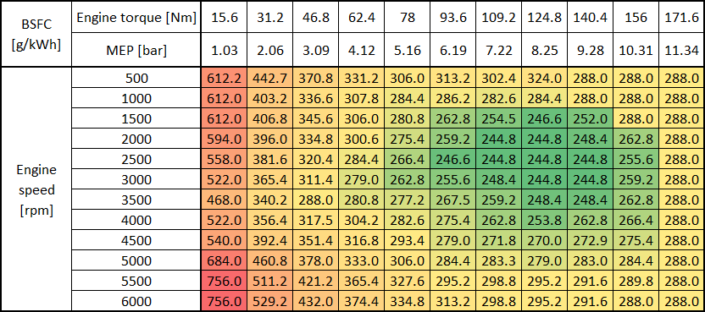
Table 1 – Example BSFC Data (X-Engineer, 2021)
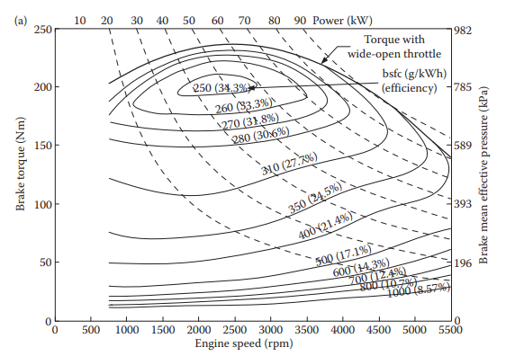
Figure 2 – BSFC Map (BMEP/RPM/Torque) (Ehsani, 2018)
Using the two previous BSFC plots for inspiration the following two BSFC tables were produced for use in this research, Table 2 with power and rpm, and Table 3 with torque and rpm.
Table 2 – BSFC (Power/RPM)
Table 3 – BSFC (Torque/RPM)

Methodology

Track Selection
The track chosen for this project was a tight and twisty track with lots more elevation change than the minimum of 20m required. The track length is 2069m which equates to around a 3-minute lap, with a mix of 3 different surface types (Gravel, Soil/Dirt, Sand) to offer a challenge to the drivers. It was produced using both google earth (Google Earth, 2021) and then a further software called AllTrails (All Trails, 2021) which smoothed out GPS co-ordinates to produce a more refined curve structure for the corners. This data provided GPS points at a set distance from each other around the track producing distances and elevations for each point, the data was then used to make a basic track outline as seen in Figure 3.
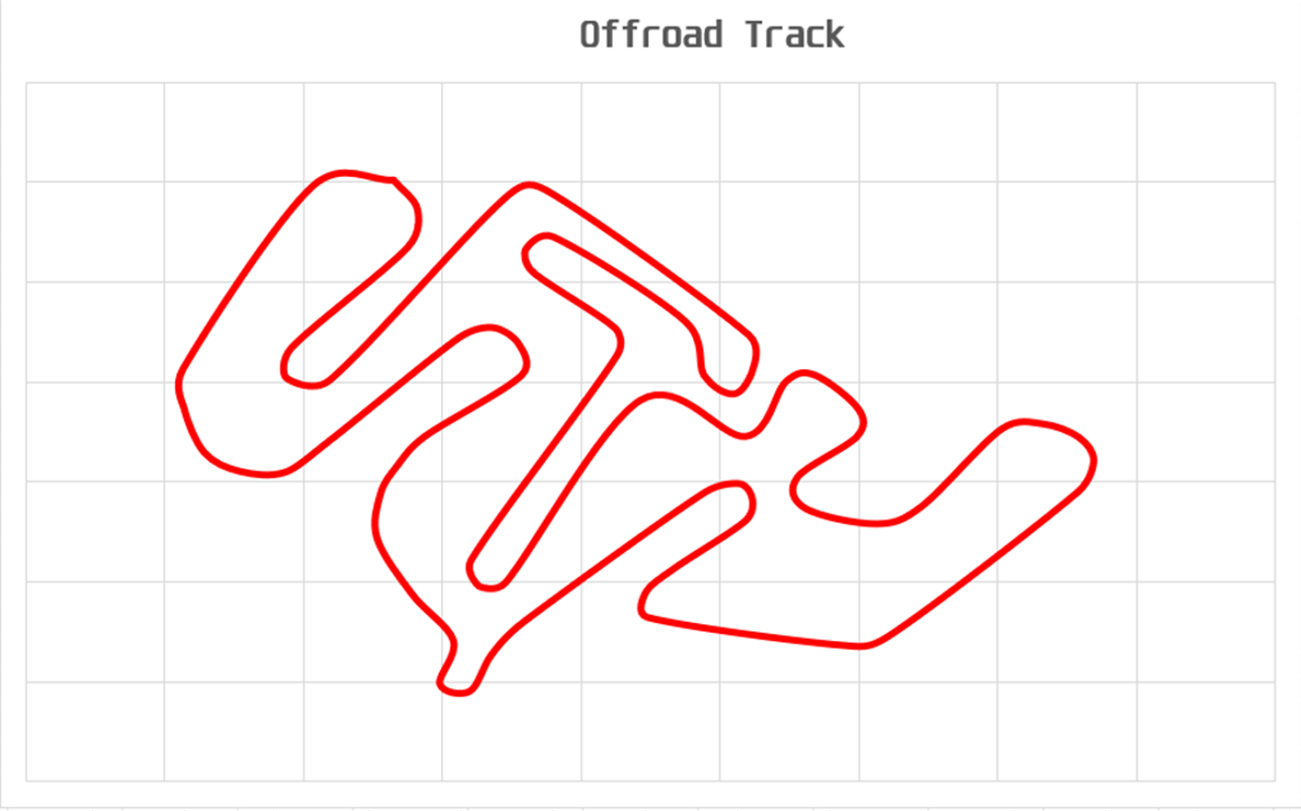
Figure 3 – Offroad Track Map

Velocity
The velocity values used for this track were assumed based off the severity of the corner radius. The author used their driving knowledge to assess the distance between corners and then the tightness of the corners to come up with some assumed values for speed.
This data was then used to calculate the time values using the SUVAT equation.

Equation 1 – SUVAT Equations (Novenalunasolitaria, 2020)

The values calculated were then plotted against time to produce a velocity vs time graph as seen in Figure 4. This graph showed the assumed velocities increasing and decreasing across a whole lap.

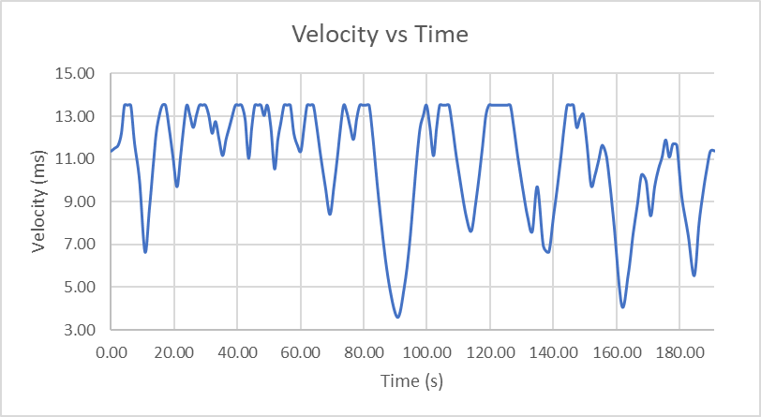
Figure 4 – Velocity vs Time Graph

Resistive Forces

Acceleration Resistance
Using the accelerations calculated with SUVAT it was possible to work out the resistance to acceleration due to the mass of the vehicle. This is due to Newton’s second law, as seen in Equation 2.
$$F=MA$$
Equation 2 – Newtons Second Law (Newton, 1687)
The Mass of the vehicle was provided by the company as being 365kg as seen in the Appendices, the mass of two occupants were then added assuming the weight to be the world average of 62kg per person (Rettner, 2013) plus a 29L fuel tank, calculated using a fuel density of 720Kg/m^3 plus a 5kg tank were also added to provide a total mass of 517.2Kg with a 40:60 weight bias front to rear.

Aerodynamic Resistance
The aerodynamic resistance of the buggy was calculated using the aerodynamic drag equation seen in Equation 3.
$$F_{D}=\frac{1}{2}pv^{2}C_{D}A$$
Equation 3 – Aerodynamic Resistance/Drag Equation (Wright Brothers, 1900/1905)
The Cd value for the equation was assumed to be 0.6, this is a high value and was based off similar shaped vehicles where the values were available (Racing Car Tech, n.d.). For example, a Lotus/Caterham 7; which features a similar vehicle body shape to the buggy, with a slim body and exposed roll protection above which disrupts the airflow, suffers from very high drag with a cd value of 0.75 (Classic Cars, n.d.).

Gradient Resistance
Using the elevation data provided by the co-ordinates from the Google Earth/All Trails map, the baseline elevation could be calculated showing the elevation changes from zero, as seen in Figure 5.
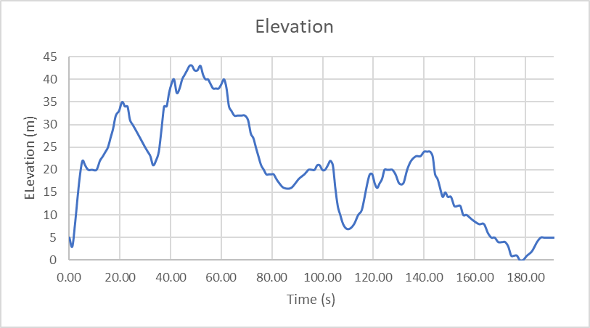
Figure 5 – Baseline Elevation vs Time
Using these new data points the gradient between each point on the track could be calculated these gradient values were then converted into angles before then being used in Equation 4 to calculate the resistive force of the gradient.
$$Force=m.g.sin⁡(θ)$$
Equation 4 – Free-Body Diagram Equation

Rolling Resistance
The three rolling resistances for the track were values retrieved from Table 4.
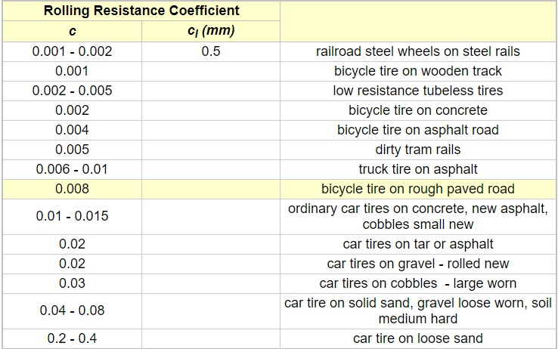
Table 4 – Rolling Resistance Coefficients (Engineering-Toolbox, 2021)
These values were then inserted into Equation 5 – Rolling Resistance
$$Rolling Resistance=RR Coefficient*(m.g)$$
Equation 5 – Rolling Resistance

Total Resistive Forces vs Time
The most important graph of this report/investigation is the total resistive forces vs time, seen in Figure 6, as it shows the total amount of power required to overcome the resistance. The largest resistive force on the buggy is the gradient resistance, which is as expected on a track with lots of elevation changes.
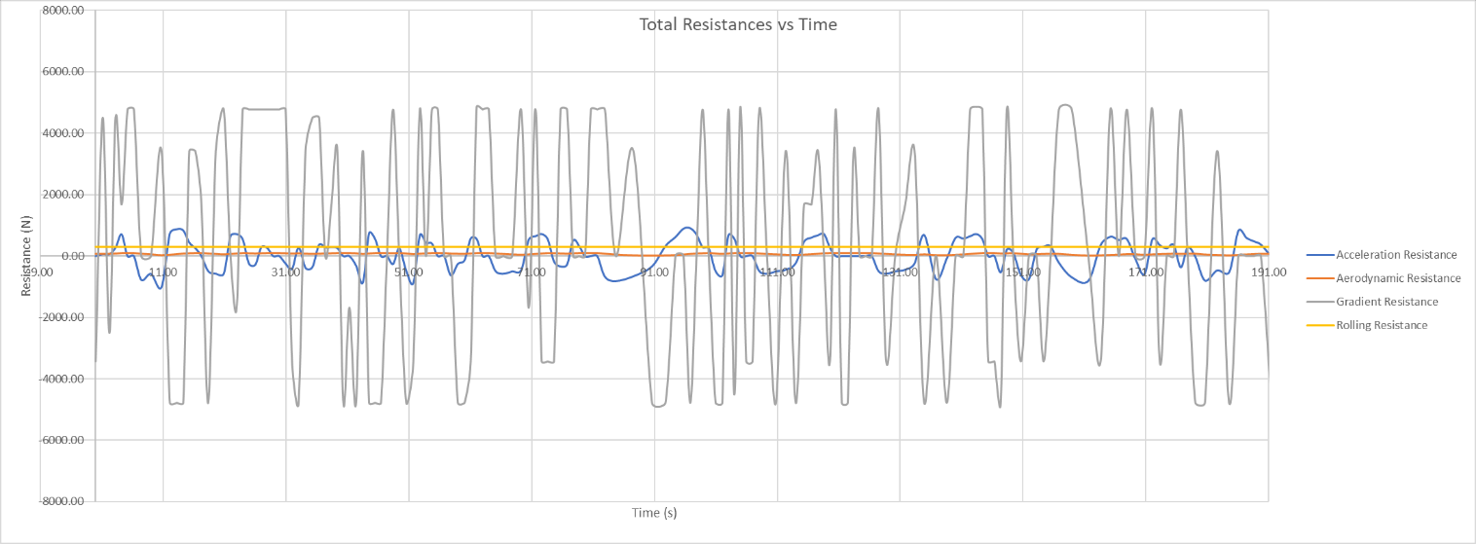
Figure 6 – Total Resistance Forces vs Time

Tractive Power
With the total resistive forces calculated it was now possible to calculate the maximum tractive power. To do this the estimated speed was multiplied by the total resistive power for each step of the track, the total power required can be seen in Figure 7.
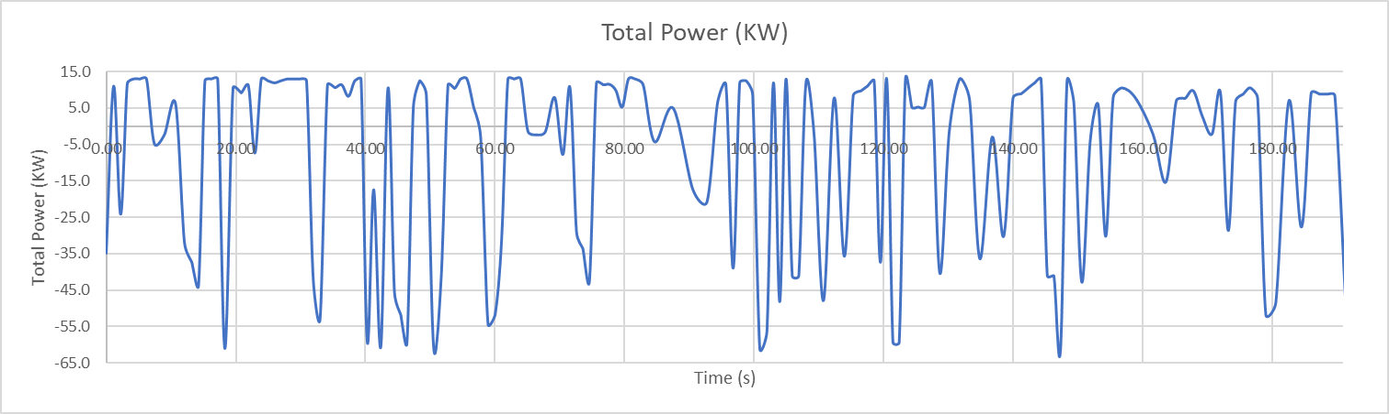
Figure 7 – Total Power (KW) vs Time (s)
The maximum tractive power was also calculated for each of the three surfaces the buggy will be running on, as seen in Table 5. The values for mu for the different surfaces were retrieved from (Engineering Toolbox, 2021).
Tractive Force (N)
Gravel | Soil | Sand
1826.54352 | 2070.0827 | 1095.926
Table 5 – Maximum Tractive Force
These values were then used to calculate the maximum acceleration possible on the three surfaces as seen in Table 6.
Maximum Acceleration (m/s)
Gravel | Soil | Sand
3.5316 | 4.00248 | 2.11896
Table 6 – Maximum Acceleration on Surfaces
The maximum power was calculated which came out to be 13.14Kw, additionally, the average power was worked out for the lap and it was 6.14Kw.

Fuel Consumption
When working out the fuel consumption of the buggy it is important to consider the rpm and gear the buggy will be in at every point. In this investigation the gear ratios are fixed based off the overall vehicle top speed, with gear 1 being used from 0 – 4ms, gear 2 for 4 – 8ms and then gear 3 being used for anything over 8ms up to the maximum speed of 13.4ms. The RPM was then worked out for each point based on a lookup table that was produced, which can be seen in the excel spreadsheet accompanying this report.
This data was then used to lookup the rpm in the BSFC table and then the power separately so the match function could be used to return the correct BSFC value from the table. The BSFC table used can be seen in Table 7.
Table 7 – BSFC Values
The values returned for BSFC could now be used to calculate the fuel usage across a lap of the track. First of all the values calculated for fuel usage are Litres/Hour, converting them to seconds makes the data more representative of the lap. These totals can then be added together to produce a cumulative fuel usage across a lap, as seen in Figure 8.
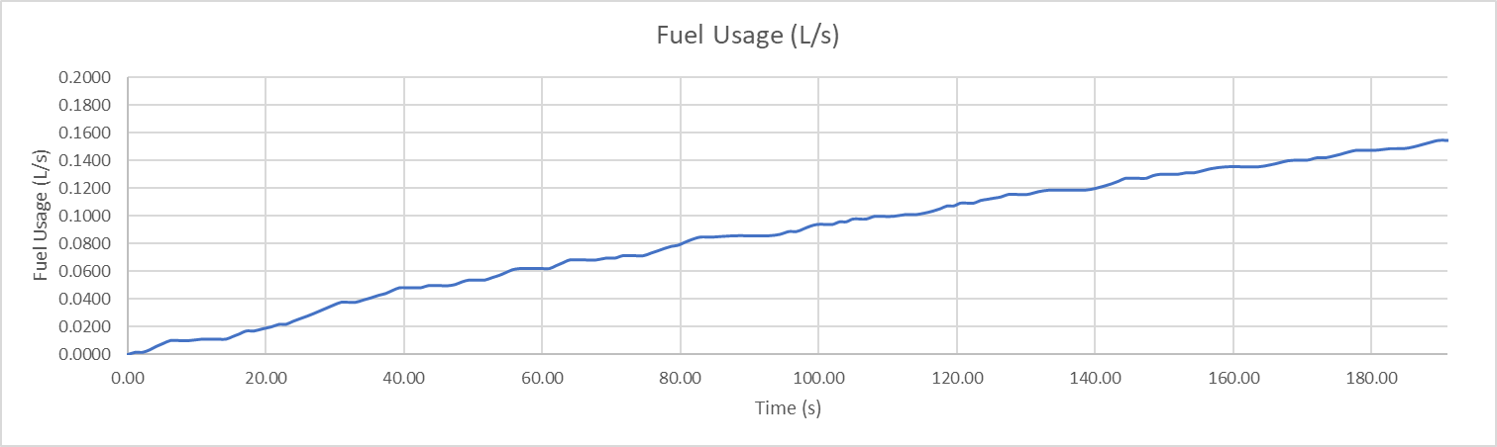
Figure 8 – Fuel Usage over the duration of a lap (litres/second)
This total value can then be used to work out the mpg of the buggy which will dictate how many laps it can complete before running out of fuel in its 6.4-gallon fuel tank. The MPG calculation can be seen in Table 8, using the MPG calculated multiplied by the fuel tank size gives the total mileage the vehicle can travel on a fuel tank.
Table 8 – MPG Calculation
$$Total Mileage Per Tank=38.129*6.4=244.03 Miles$$
Equation 6 – Total Mileage per tank equation
Dividing the value calculated above by the track length gives the total number of laps, as seen below in Equation 7.
$$Total Number of Laps=\frac{244.03}{1.2931}=188 Laps$$
Equation 7 – Number of Laps per tank
The total number of laps the buggy can complete on one tank of fuel is 188 laps, this value is only an approximation based on the assumptions made.

Discussions

Potential Hybridisation
As seen in the previous section the buggy is already a very efficient vehicle capable of achieving a modest MPG which allows it to be used for an extensive period of time. This could detract from the need to investigate hybridisation as the vehicle can already cover long distances. The main benefit of hybridisation on this vehicle would be in saving on consumables as you would end up using less fuel and wouldn’t wear brake pads as much as it currently does. The opportunity to use regenerative braking on all the declines would certainly make for an interesting proposition to compare to the current buggy, especially to see how much longer a hybrid buggy would be able to travel. Of course, going hybrid wouldn’t be without its drawbacks, the additional weight of the battery packs/motors would certainly affect the vehicles handling on the course and its ability to traverse up the steep slopes in this particular course. Another issue could be the costs involved, if the potential savings don’t outweigh the costs of implementing the system, then it’s not financially viable to proceed with the hybridisation.

Conclusions
To conclude this investigation into the hybridisation of the Renegade DX10 300cc Off-Road buggy, there are many different variables affecting whether hybridisation is the right way to go with this vehicle. To start with it can already complete a whole days worth of laps at the experience centre, which is plenty adequate enough to carry on with, as it is already. However, with the increased emphasis worldwide on being sustainable and environmentally friendly by cutting down on emissions, it is in Blitzworld’s best interests to make changes to become as sustainable/eco-friendly as possible. Especially with the future ban on fossil fuel vehicles (BBC, 2020), it could possibly lead to reputational damages to the company if they are not seen to be with the climate change movement and making a positive change by hybridising their vehicle. So, in this scenario it would certainly be worthwhile investigating installing a hybrid system into a buggy to compare to the standard buggy.

Appendices

Vehicle Specifications
Safety:
• Roll Cage Bolt on Brush Cage
• Frame Material Steel
• Safety Harness 4 Strap British Safety Harness
• Seats Easy Clean Vinyl Bucket Race Seats
• Headlights None (Rear Stop light only)
• Seat Runners YES - Drivers Seat
• Brakes Hydraulic Disc Front & Rear
• Handbrake Yes
• Petrol Tank Material Stainless Steel
• Bulkheads Steel to Engine Bay
• Horn Yes
• Passanger Grip Handles Yes
• UK Certification UK Approved KIt Car Manufacturer
Warrranty:
• Warranty Duration 1 Year Parts
Service & Repair:
• Parts Availability On Shelf - Next Day Blitzworld
Engine Specification:
• Engine Type 4-Stroke Single Cylinder
• Engine'cc' 278cc
• Fuel Type 4 Stoke Petrol
• Power 18 HP @ 6500 rpm
• Torque 22 Nm @ 5500 rpm
• Power to Weight Ratio 49.3 hp @ Ton
• Transmission Automatic CVT with F/N/R
• Drive 2WD Rear Fixed Axle via Chain
• Diff Lock Locked Rear Axle
• Reverse Yes
• Oil Cooling Sump
• Engine Cooling Liquid Cooled
• Exhaust Custom Built Stainless Steel with removable baffle
• Clutch CVT Drive
• Start Key
Electrics:
• ECU Type No ECU - Carb
Dimensions:
• Length o/all 2620mm
• Width o/all 1650mm
• Height o/all 1620mm
• Weight (kgs) 365 Kgs
• C.O.G Very Low
• Ground Clearance 300mm
• Wheel Centres 1940mm
• Petrol Tank Capacity 29 Litres 6.4 Gallons
Build Features:
• Steering Side LHD
• Power Steering Not Required - Light
• Wheel Sizes 12" ATV Front & 10" ATV Rear
• Wheel Material Alloy
• Bolting Centres 4 /110
• Steering Wheel Steel & Polyurethane
• Steering Type Rack & Pinion
• Frame Colour Red
• Panel Colour Silver - can be custom painted
• Mudguards Fitted Side, Bonnet & Firewall
• Dashpanel Speedo Start Ignition Key Only
• Front Suspension Custom Made Rebound Damped Coil Over adjustable Strut
• Rear Suspension Custom Made Rebound Damped Coil Over adjustable Strut
• Front Tyres 24x8x12
• Rear Tyres 23x10.5x12 or 25x10x12 more clearance
• Winch Options

References
All Trails. (2021, 11 11). All Trails. Retrieved from All Trails: https://www.alltrails.com/
BBC. (2020, November 18). Ban on new petrol and diesel cars in UK from 2030 under PM's green plan. Retrieved from BBC: https://www.bbc.co.uk/news/science-environment-54981425
Blitzworld. (2021, 11 29). DX Renegade buggy 300cc. Retrieved from Blitzworld: https://www.blitzworld.co.uk/DX10-renegade-300cc-automatic-buggy
Classic Cars. (n.d.). Classic Cars - Lotus 7. Retrieved from Classic Cars: https://classiccars.fandom.com/wiki/Lotus_7
Ehsani, M. (2018). Modern Electric, Hybrid Electric, and Fuel Cell Vehicles. Boca Raton: Taylor and Francis Group.
Engineering Toolbox. (2021, 11 29). Friction Co-efficients. Retrieved from The Engineering Toolbox: https://www.engineeringtoolbox.com/friction-coefficients-d_778.html
Engineering-Toolbox. (2021, 11 29). Rolling Resistance. Retrieved from The Engineering Toolbox: https://www.engineeringtoolbox.com/rolling-friction-resistance-d_1303.html
Google Earth. (2021, 11 11). Google Earth. Retrieved from Earth: https://www.google.co.uk/intl/en_uk/earth/
Newton, I. (1687). Philosophiæ Naturalis Principia Mathematica.
Novenalunasolitaria. (2020, October 31). Worksheet. Retrieved from https://novenalunasolitaria.blogspot.com/2020/10/rearranging-equations-worksheet-physics.html
Racing Car Tech. (n.d.). Aerodynamics Data Table. Retrieved from Racing Car Tech: http://tech-racingcars.wikidot.com/aerodynamics
Rettner, R. (2013, May 30). The Weight of the World: Researchers Weigh Human Population. Retrieved from Live Science: https://www.livescience.com/36470-human-population-weight.html
Wright Brothers. (1900/1905). Modern Drag Equation. Retrieved from NASA - Wright Brothers: https://wright.nasa.gov/airplane/drageq.html
X-Engineer. (2021, 11 11). Brake Specific Fuel Consumption (BSFC). Retrieved from X-Engineer: https://x-engineer.org/brake-specific-fuel-consumption-bsfc/

