BMSW4003
Digital Skills and Research Methods

Contents
Introduction 3
Research Background 3
Aims and Objectives of This Research 5
Aims of This Research 5
Literature Review – Virtual Learning Environment 6
Method 7
Research Approach 7
Collection method of data 8
Sampling method 8
Method of their analysis 8
Ethical considerations 8
Analysis 9
Conclusion 15
References 17

Introduction
A virtual learning environment is an academic concept that has been relevant in the context of academic career and progression in universities and colleges since the introduction of computer-generated academic curricula. In recent times, the COVID-19 pandemic has caused a serious disruption in the traditional way of contacting classes and assignments. This has catapulted the importance of a virtual learning environment to the forefront sense now students and teachers can engage in lectures, assignment submission and personal counselling without having to be present in a physical environment. The report has undertaken the investigation of the importance of a virtual learning environment and has applied the case study to the students of the University of Wales Trinity through a mixture of both primary and secondary data collection methods. The report will particularly focus on the results of a questionnaire survey in form of a primary data collection method and the existent literature review of a virtual learning environment in form of a secondary data collection method.

Research Background
“The impact of VLE- Moodle on students’ learning experience at the University of Wales Trinity students of the Saint David London Campus students has been selected as the title of the research.
The COVID-19 pandemic has caused an unforeseen level of disruption in the education system all app over the world. By March 25, 2020, more than 1.3 billion students were impacted since governments all over the world instructed the closure of schools, colleges and universities for an indefinite period of time with a view to stopping the spread of the COVID-19 virus (Weforum, 2022). This was particularly staggering for four tertiary education level students since their academic progression was being hampered which put them into an uncertain situation regarding their career progression indefinitely.

Subsequently, both academic institutions and students were quick to realise the importance of a virtual learning environment in order to continue their education. According to one particular report, the demand for online learning via a particular education platform known as Coursera saw an unprecedented level of growth during the onset of the COVID-19 pandemic.
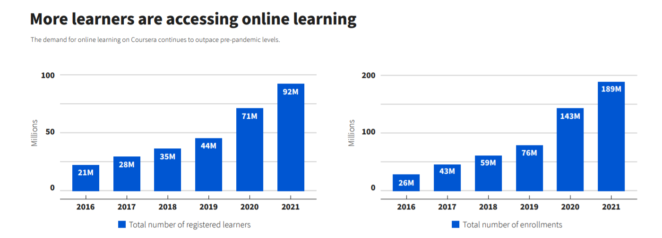
The above graph reveals that modern 90 million individuals enrolled and registered as accredited learners on the digital platform in order to continue their academic and personal education progression. Also, in terms of comfort and ease of access, the virtual learning environment is also gaining popularity among both students and teachers (Weforum, 2022).
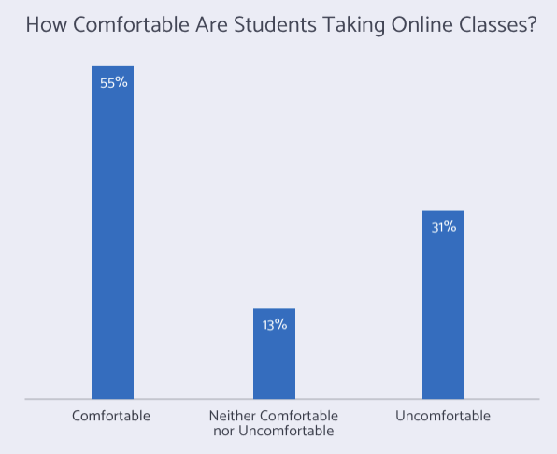
The above figure shows that more than half of the students are comfortable taking online classes whereas only 30% of the total respondents felt uncomfortable taking online classes. This only reiterates the importance of a virtual learning environment as a key platform for delivering academic instruction and enrolment. The chosen topic is also important in the sense that, the virtual learning environment is here to stay even if the advent of the COVID-19 pandemic is gradually disappearing.

Aims and Objectives of This Research

Aims of This Research
The key aim of the research is to investigate the total impact of the virtual learning environment on the students of the University of Wales Trinity Saint David London.
Objectives
The key research objectives are described below:
- To identify the positive impact of a virtual learning environment on the students of the University of Wales Trinity Saint David London.
- To identify the negative impact of the virtual learning environment on the students of the University of Wales Trinity Saint David London.
- To identify the feet between the student's learning patterns and the virtual learning environment that has been implemented by the university authority.
- To suggest some creative ways to overcome the challenges of the virtual learning environment at the University campus.

Literature Review – Virtual Learning Environment
traditionally, the virtual learning environment is referred to as a technology that facilitates learning both through virtual meetings and face-to-face interaction (Stiles, 2000). The virtual learning environment is thereby characterised by a learning environment which comprises a lot of computers, the practical usage of the Internet, exchange of views, the interaction between the users and access of the users to defined types of academic and personal files (Kumar et al., 1998). In addition to this, the students can also be in the same room but they might be never in a situation to experience any type of physical contact (Phungsuk, 2017). By doing this, the virtual learning environment creates an enabling collaboration as well as activities of learning through defined types of gamification of academic activities.
In this kind of setting, students are given the opportunity to receive the course sheets and slideshow in pdf format, which enables them to gain a basic comprehension of the material even when they are participating in the online class (Livingstone et al., 2008). In addition, the instructor is responsible for collecting electronic homework and other assignments. Through the use of the university site, the students submitted their completed assignments. In addition, the professors post their outcome reports along with some criticism on their own ID portals (Koskela, 2005). When students attend virtual classrooms, however, both they and their professors must overcome a number of obstacles in order to be successful. Sometimes there are disruptions to internet service, and other times there are issues with the power. In order to create a significant distraction for both the instructors and the pupils. There were several concerns raised over the use of technology. They are some of the threats to enterprises that may have a negative influence on their operations (Thamarana, 2016). As a result of the fact that educational institutions also run businesses, the provision of instruction to students via the online learning system is fraught with difficulties. The pupils were more engaged in their academic work as a result of the system. Because the students are so actively involved in the lessons, it is not difficult for them to comprehend what is being covered in the lectures. in order to provide them with the chance to use their creativity while interacting with the actual world (Bayne, 2008). The students also take tests in the form of case studies, which helps them sharpen their memories and develop a higher degree of critical thinking about the subject matter.

Method

Research Approach
There are typically two types of research methods. They are quantitative research methods and qualitative research methods. A quantitative research method can be identified as a research technique in which data and information are collected in the form of numbers and figures that can be measured in different types of quantifiable metrics there are different types of data collection methods under the quantitative research approach. There are, questionnaires, surveys, statistical inferences and many more. The quantitative research approach is concerned with the actual facts and figures about a particular research problem (Cavana et al., 2001). On the other hand, a qualitative research method can be identified as a research technique in which information and data are gathered in the form of texts that cannot be actually measured in any type of quantifiable metrics. There are also a few well-known data collection methods under the quantitative research approach. They are interviews, focus groups, literature reviews and ethnographic style research approaches. The qualitative research method is mainly used by the researcher to provide a commentary through deductive reasoning on a particular research problem. In the case of this particular research project, both quantitative and qualitative research approaches will be undertaken. The primary research will be based on the quantitative research method and the secondary research will be based on the qualitative research method (Lee and Lings, 2008).

Data Collection
For the primary research method, this research project will use a questionnaire survey. The questionnaire is a method of data collection in which the respondents are required to answer a particular response question according to the set of options provided by the researcher. On the other hand, for secondary research purposes, this research project will use a literature review published on different types of journal papers and articles.

Sampling method
The approach of randomly selecting participants for the study has been employed. A total of 50 students equally divided in male and female groups will participate in the survey. The student participants were chosen at random. However, both males and females made up 50% of the total responders. Students were made to feel at ease throughout the data collection process. No pressure was put on the pupils to participate in the survey. The researcher also conceals the pupils' identities and personal information.

Method of their analysis
The researcher will use a spreadsheet program in order to create the illustration of graphs and charts in relation to the data and responses collected from the questionnaire. Therefore, Microsoft excel will be used in this regard. Using the report's graph chart, which was shown with the relevant data, we were able to evaluate the output of our spreadsheet programme.

Ethical considerations
The confidentiality of the participants was successfully maintained as a result of the fact that the identifiable information and data of the respondents were not disclosed throughout the process of completing the study. In addition, the study has been given the appropriate leeway to gather the participants' thoughts on the research issue in order to bolster the report's credibility and credibility is strengthened by the genuineness of the research.

Analysis
Question 1: The learning method through VLE is appropriate.
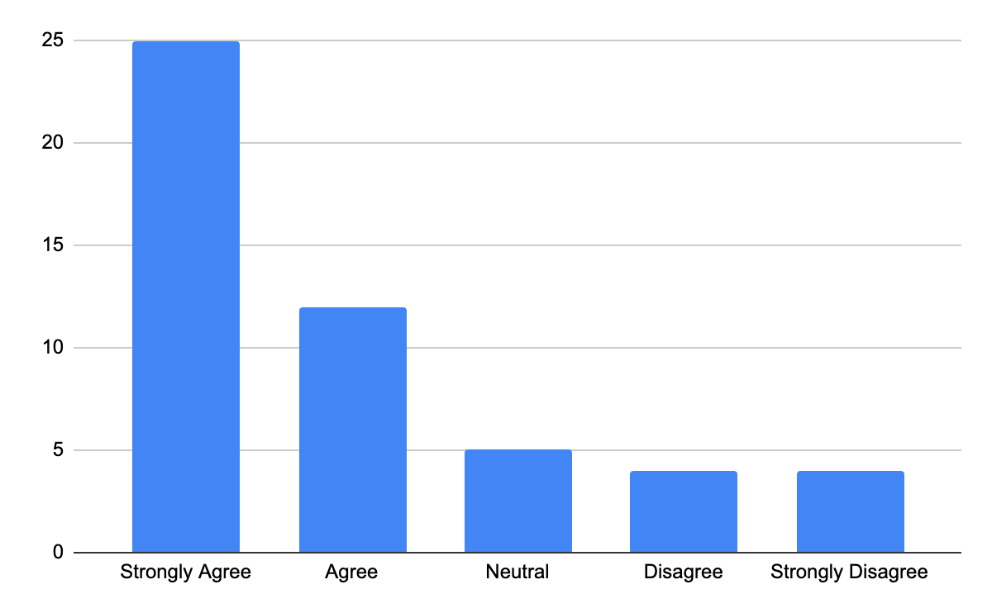
It is observable from the graph that around half of the respondents strongly agree with the question statement. Another 25% of the respondents agree with the question statement. The rest is almost evenly distributed among the neutral, disagree and strongly disagree segments.
Question 2: VLE has an overall positive impact on the students.
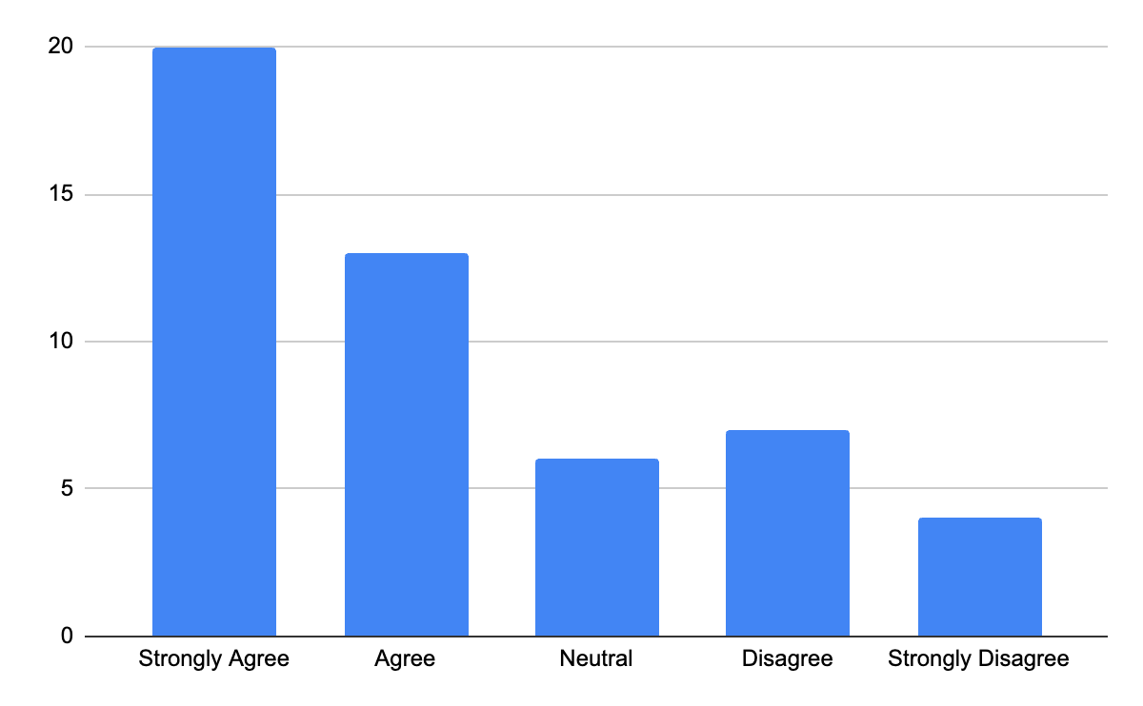

The graph shows that 20 respondents strongly agree with this question statement. This account for almost 40% of the entire respondent population. Another 13 respondents agree with this question statement. On the other hand, seven students disagree with the question statement followed by another four who strongly disagree.
Question 3: I prefer VLE over traditional learning.
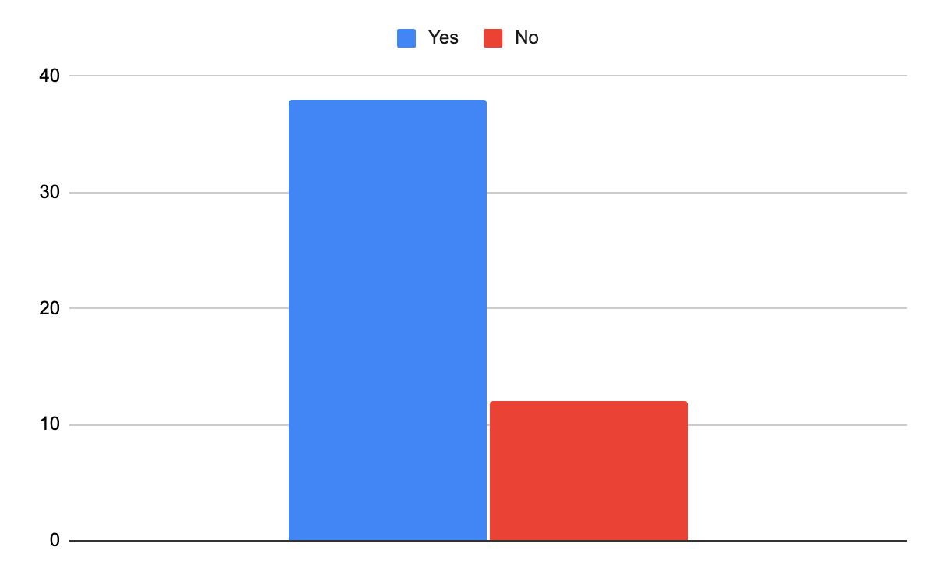

More than 3/4th of the respondents say that they prefer VLE over the traditional learning method according to the graph.
Question 4: VLE saves a lot of time.
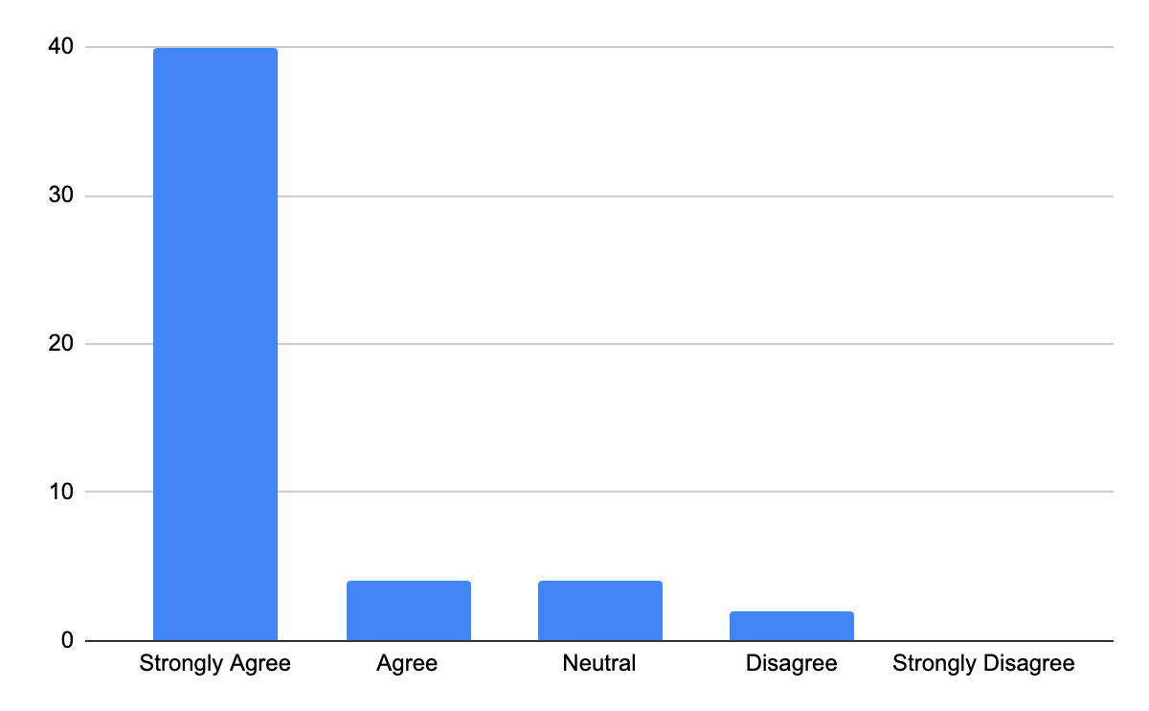
There was an overwhelming response in favour of the question that 40 respondents strongly feel VLE saves their time. Only 2 respondents disagree with this statement whereas none of the students strongly disagree with this.
Question 5: VL environment is comfortable.
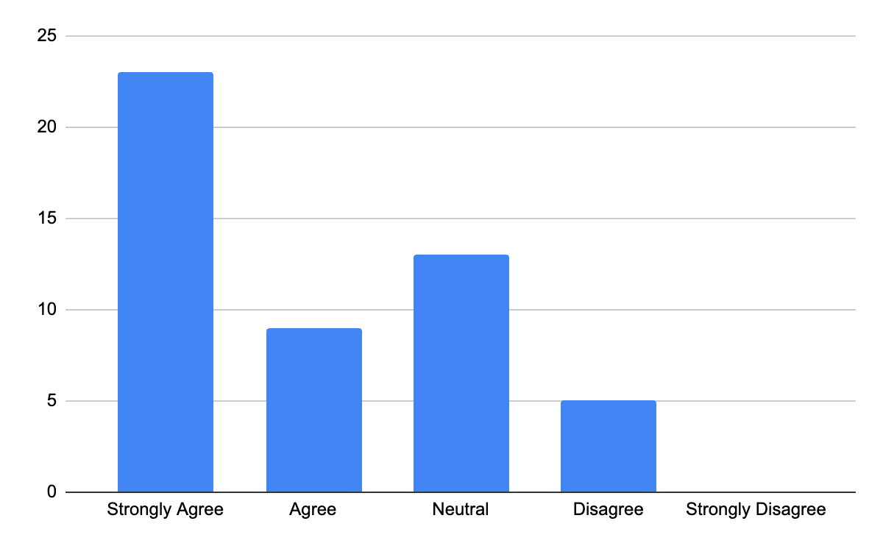
In response to this question, the students have remained mostly positive about the comfort of the virtual learning environment. 23 students strongly agreed whereas 9 students agreed with this question statement. However, a large part of the respondent population, 13 remained neutral.
Question 6: Shifting to VLE was bothersome at first
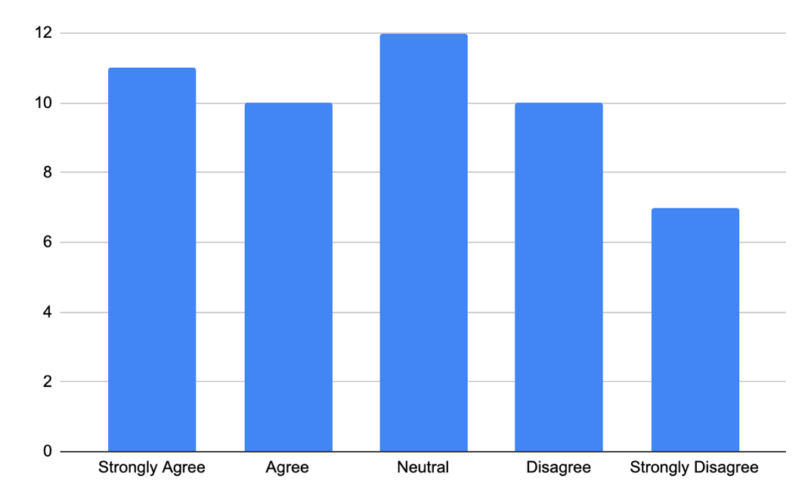

Further shifting to virtual learning environment was bothersome at the initial phase has resulted in an evenly dispersed response from the respondent population. 11 students strongly agree whereas 10 students only agree. The majority of the students have remained neutral to this question however.
Question 7: I have prior experience of VLE
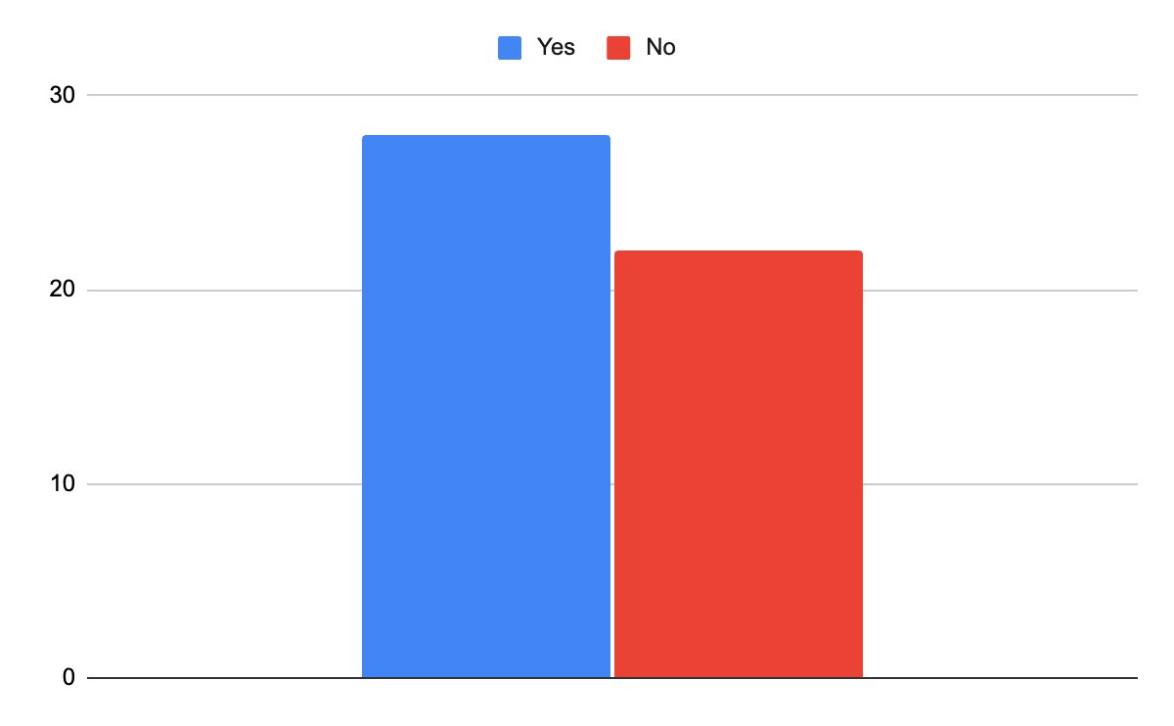
When the students were asked if they had prior experience in using the virtual learning environment, 28 students replied in the positive while 22 students replied in the negative.
Discussion
The collected data and information from the questionnaire survey have resulted in a positive impression of the impact of the virtual learning environment on the study of the students at the University. This can be reiterated that a virtual learning environment will help the students in the long run in making their attempts at study more efficient than before.

Conclusion
As a direct consequence of the significant alterations that the COVID-19 circumstance has wrought upon the educational system, there is a growing desire among the general public in acquiring knowledge via the use of the virtual technique. Since the epidemic that swept the globe, the use of online education has skyrocketed. The term "virtual learning" refers to the process of teaching pupils via the use of digital technology. People may teach one other via video conferencing software like Skype, Zoom, or another tool of a similar kind. In addition, the convenience of being at home while continuing to participate in class is beneficial to the students. The learners' potential for understanding is enhanced as a result.

References
Bayne, S., 2008. Higher education as a visual practice: seeing through the virtual learning environment. Teaching in Higher Education, 13(4), pp.395-410.
Cavana, R., Delahaye, B. and Sekeran, U., 2001. Applied business research: Qualitative and quantitative methods. John Wiley & Sons.
Koskela, M., Kiltti, P., Vilpola, I. and Tervonen, J., 2005. Suitability of a Virtual Learning Environment for Higher Education. Electronic Journal of e-Learning, 3(1), pp.23-32.
Kumar, A., Pakala, R., Ragade, R.K. and Wong, J.P., 1998, November. The virtual learning environment system. In FIE'98. 28th Annual Frontiers in Education Conference. Moving from'Teacher-Centered'to'Learner-Centered'Education. Conference Proceedings (Cat. No. 98CH36214) (Vol. 2, pp. 711-716). IEEE.
Livingstone, D., Kemp, J. and Edgar, E., 2008. From multi-user virtual environment to 3D virtual learning environment. ALT-J, 16(3), pp.139-150.
Lee, N. and Lings, I., 2008. Doing business research: a guide to theory and practice. Sage.
Phungsuk, R., Viriyavejakul, C. and Ratanaolarn, T., 2017. Development of a problem-based learning model via a virtual learning environment. Kasetsart Journal of Social Sciences, 38(3), pp.297-306.
Stiles, M.J., 2000. Effective learning and the virtual learning environment. In Proceedings: EUNIS 2000–Towards Virtual Universities, Instytut Informatyki Politechniki Poznanskiej.
Thamarana, S., 2016. Role of E-learning and Virtual Learning Environment in English language learning. Teaching English Language and Literature: Innovative Methods and Practices, ELTAI Tirupati, pp.61-62.
World Economic Forum. 2022. These 3 charts show the global growth in online learning. [online] Available at: <https://www.weforum.org/agenda/2022/01/online-learning-courses-reskill-skills-gap/> [Accessed 20 August 2022].
World Economic Forum. 2022. The COVID-19 pandemic has changed education forever. This is how. [online] Available at: <https://www.weforum.org/agenda/2020/04/coronavirus-education-global-covid19-online-digital-learning/> [Accessed 20 August 2022].

Appendix
Research Questions | Strongly Agree | Agree | Neutral | Disagree | Strongly Disagree
Question 1: The learning method through VLE is appropriate
Question 2: VLE has an overall positive impact on the students
Question 3: I prefer VLE over traditional learning
Question 4: VLE saves a lot of time
Question 5: VL environment is comfortable
Question 6: Shifting to VLE was bothersome at first
Question 7: I have prior experience of VLE

